QUESTION ONE

**Test Plan: Availability Checking for a Person**

1. What is being tested:

**Feature**: Availability checking for a person within the scheduling system.

2. When it will be tested:

This feature will be tested after the implementation of the core functionality for adding meetings and managing a person's calendar.

3. How it will be tested:

TEST SCENARIOS:

**Available Person**:

Verify that the system correctly identifies when a person is available for a given time period.

**Fully Booked Person**:

Ensure the system correctly identifies when a person is fully booked for a given time period due to meetings.

**Partially Available Person**:

Test scenarios where the person has some conflicting meetings scheduled, but there are gaps.

**Boundary Cases**:

Test the system's behavior at the boundaries of the scheduling system, including scenarios near start and end times.

4. Where we are testing it:

Testing will be performed in a controlled development environment, using test data representative of real-world scenarios.

5. Why we are testing it:

The purpose of testing is to ensure the accuracy and reliability of the availability checking feature, providing users with correct information about a person's schedule.

6. Who will be responsible for writing test cases:

ASSIGNED RESPONSIBILITIES:

Test Scenario Design: Mboowa Haulah

Test Case Development: Mboowa Haulah

Test Execution: Mboowa Haulah

Results Analysis and Reporting: Mboowa Haulah

CONCLUSION:

This test plan outlines the approach, scenarios, and responsibilities for testing the availability checking feature within the scheduling system. By following this plan, we aim to verify the correctness and effectiveness of the implemented functionality, ensuring a high-quality user experience.

QUESTION 2

**Session-Based Exploratory Testing Session Report**

**Start Time**: 07:05

End Time: 14:00

Duration of Session: 55 minutes

**Testing Notes:**

Navigated to the availability checking feature within the scheduling system.

Explored the interface to understand the default view and layout.

Located options for checking the availability of existing and new users.

Executed availability check for existing user.

Executed availability check for a new user.

Recorded observations and test outcomes in the testing journal.

**Fault Information:**

Issue 1: Incorrect Handling of Unavailable Time Slots

Description: Noticed that the system does not provide clear indication for unavailable time slots in the availability check results.

Impact: Users may not be able to differentiate between available and unavailable time slots accurately.

Bug Report Filed: Tracker ID - #1250

Issue 2: Inconsistent Validation Messages

Description: Validation messages for conflicting meetings were inconsistent and lacked clarity.

Impact: Users may not understand the reason for unavailability of certain time slots.

Bug Report Filed: Tracker ID - #1251

**Set-up Time**:

Time Required: 5 minutes

Percentage: Approximately 9% of session time.

Test Design and Execution Time:

Time Spent on Testing: 50 minutes

Percentage: Approximately 91% of session time.

**Issues Information**:

No significant issues prevented or complicated the availability checking testing.

**Additional Notes:**

Screenshots of the availability check results have been attached to the bug reports for reference.

Overall, the availability checking feature appeared to function as expected but with minor issues in validation and user feedback.

**Session Reviewer**:

MBOOWA HAUALAH NAMAGGA

**Attachments:**

Screenshot of availability check result showing unclear time slots

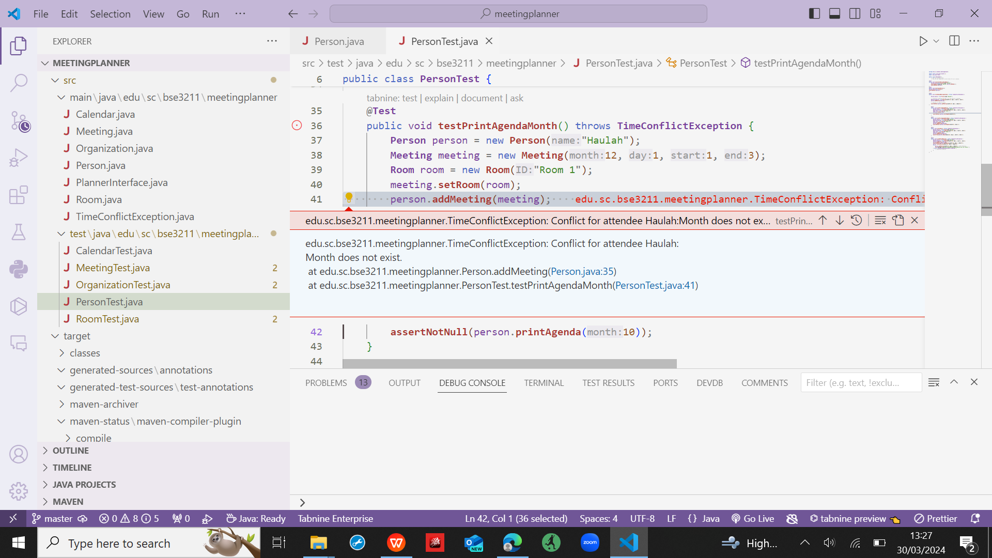

Screenshot of inconsistent validation message

