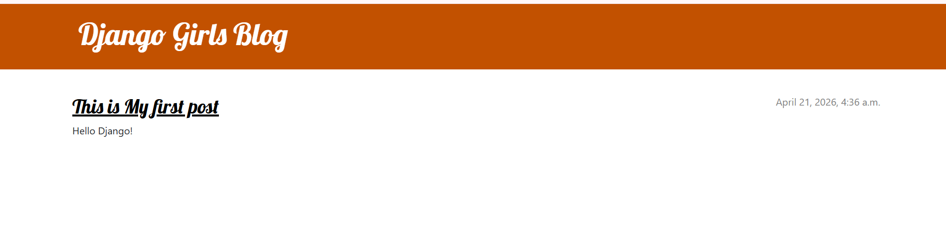
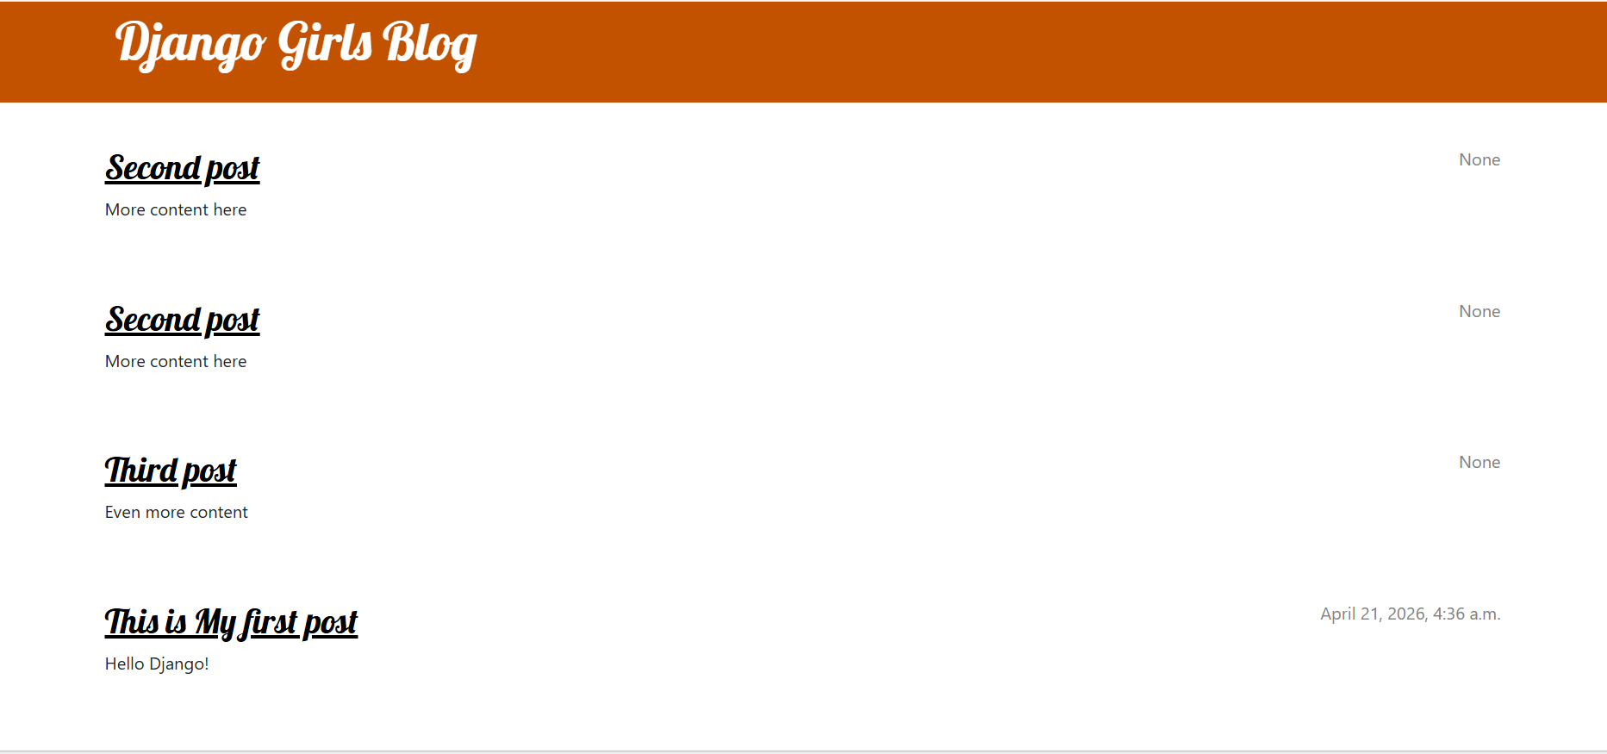
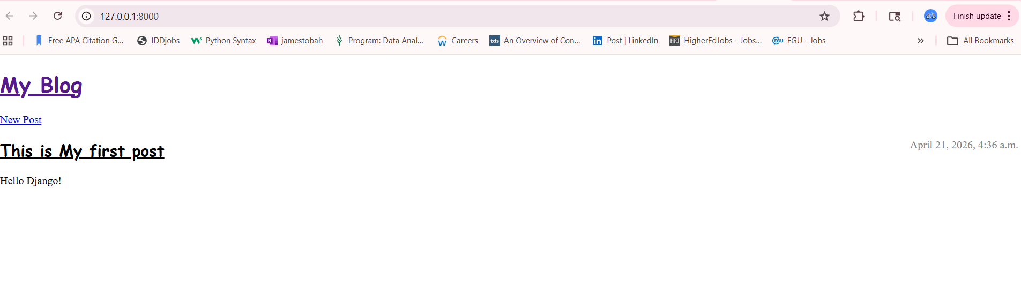

Github: https://github.com/Mbouna90/Module5_Django_project

