Tab 1
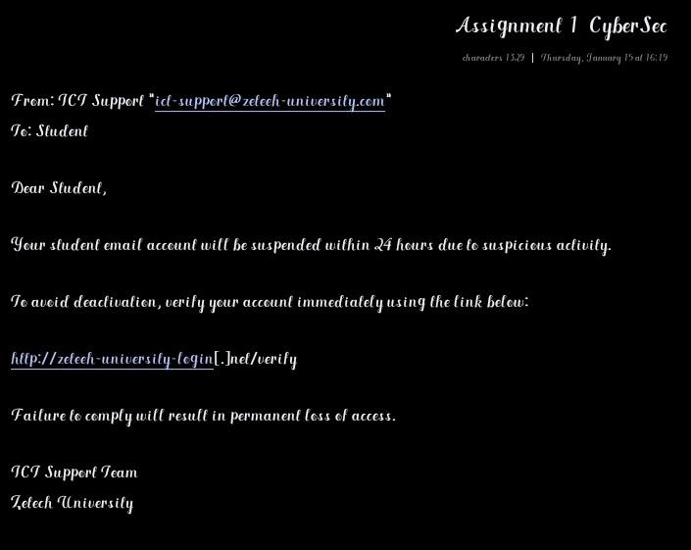

Tab 2
Procedures Followed When Creating The Email
- Selection of a Real-World Case Scenario - Most universities usually teach or provide their services online through learning platforms
- Urgency Creation - The issuance of a 24 hour deadline ensures that the student pays immediate attention to the email
- Receiver’s Selection - The use of “Dear Student” in the email shows that the email is meant for a student who are usually prone to phishing attacks

