OPELSS
ODEL e-Lab Support System
Administrator
User Manual & Training Guide
A step-by-step guide for administering OPELSS.
Prepared by the ODEL Acceleration Unit
Version 1.0

Contents

Welcome
As a System Administrator you have full control of OPELSS. In addition to everything an HQ Trainee can do, you manage the building blocks of the system — provinces, labs and user accounts — and you have access to the Audit Log that records who changed what.

Logging In
- Open the OPELSS web address and enter your email and password.
- Click “Sign In”.
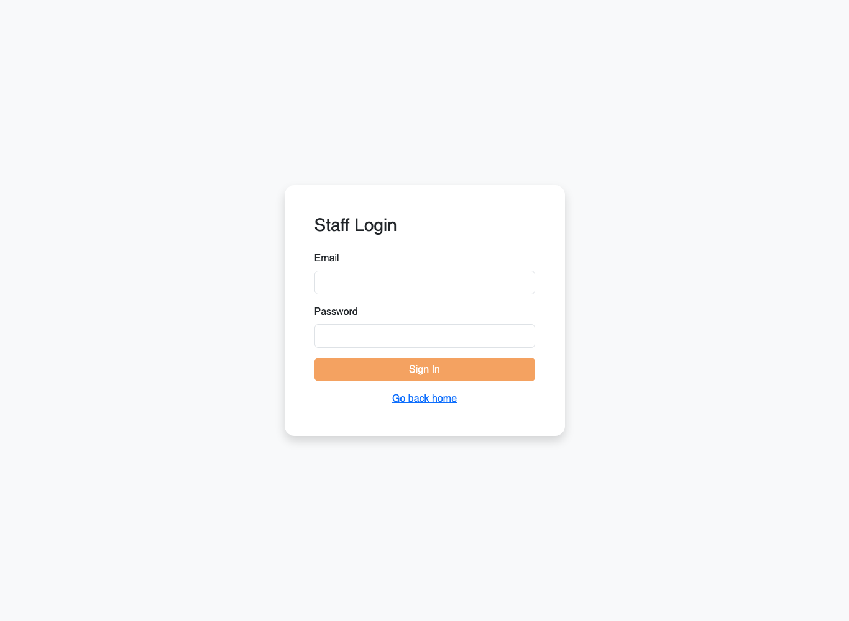
The OPELSS login screen.

Your Dashboard
Your dashboard gives organisation-wide totals and a “Manage System” button that takes you to the Admin Console.
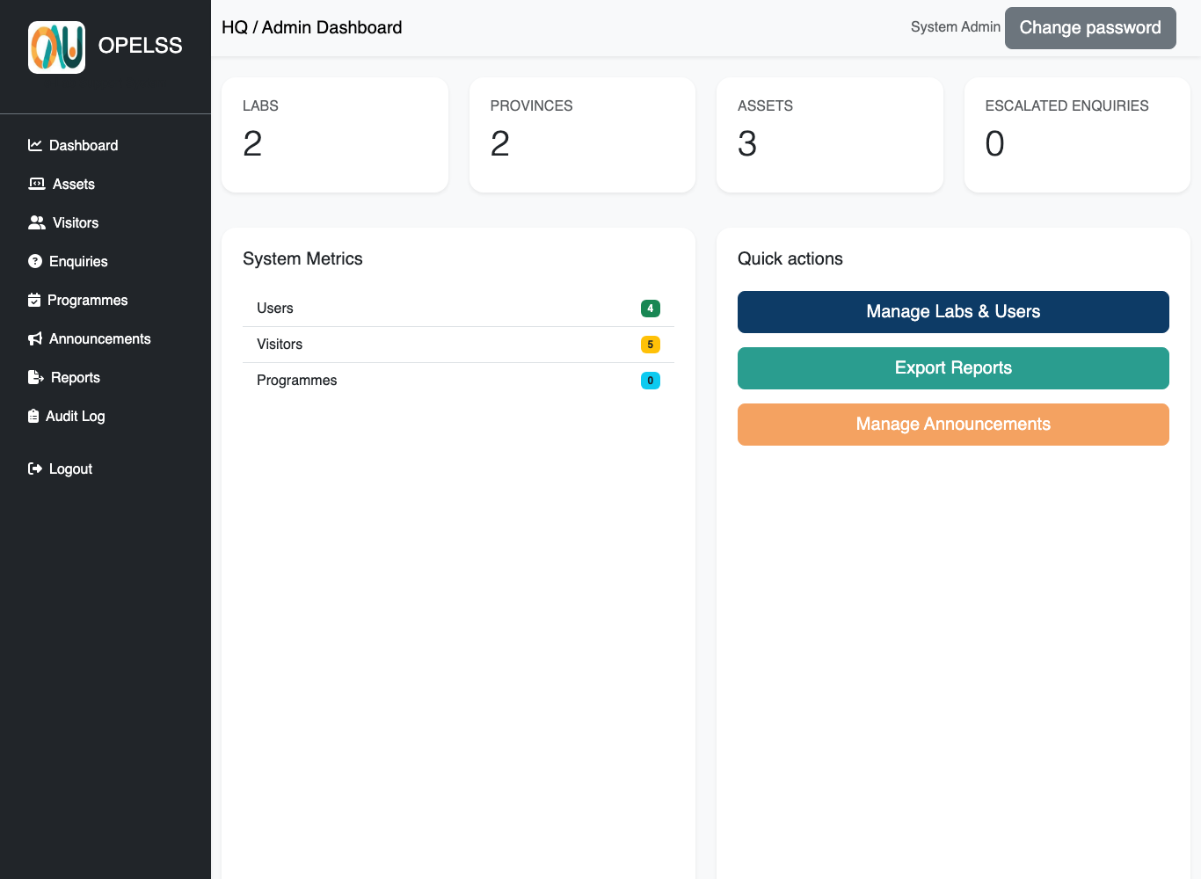
The Admin dashboard.

The Admin Console
Open the Admin Console from the “Manage System” button on your dashboard. From here you manage Provinces, Labs and Users.
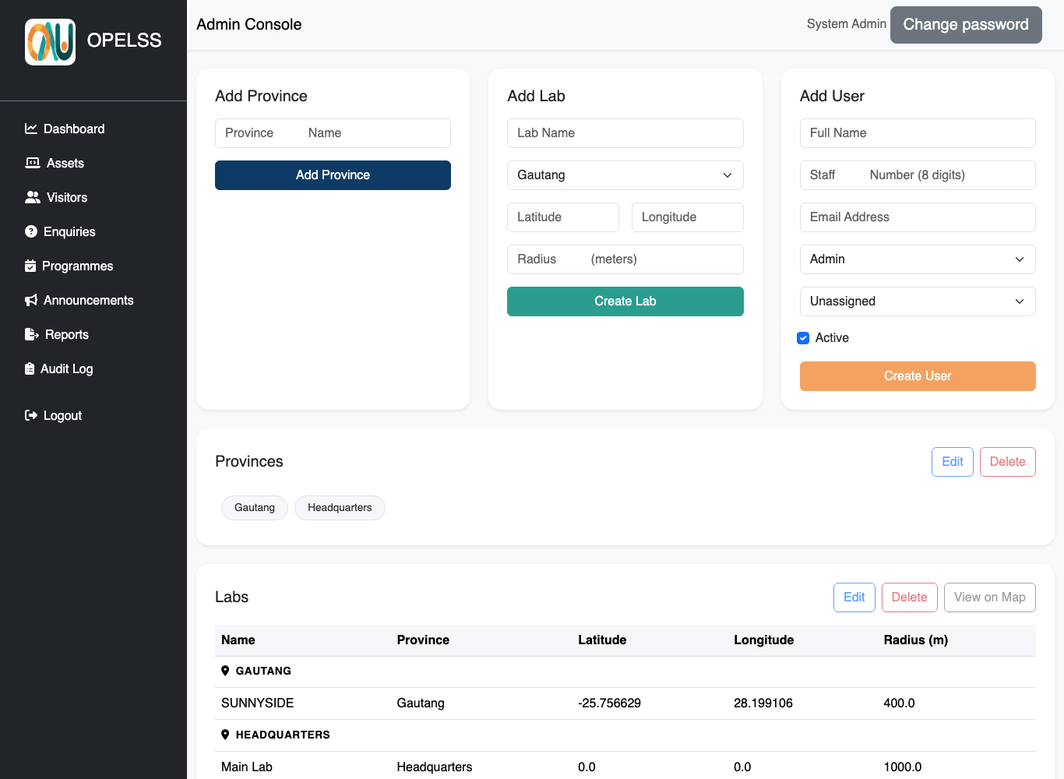
The Admin Console — add provinces, labs and users; manage existing ones below.

Provinces
- Use “Add Province” to create a province (the region a lab belongs to).
- Existing provinces are listed below; select one and use Edit or Delete.
Note: A province cannot be deleted while labs are still linked to it. Move or remove those labs first.

Labs
Labs are the physical computer labs. Each lab has a location used for the Lab Trainee attendance and login checks.
- Click “Add Lab” and enter the lab name and its province.
- Enter the Latitude, Longitude and Radius (in metres). These define the lab’s geofence.
- Save. Existing labs appear in the table; select one to Edit or Delete.
Why the geofence matters: Lab Trainees can only log in and clock in when they are within the Radius of the lab’s Latitude/Longitude. Set these accurately — if they are wrong, trainees may be unable to sign in. A typical radius is a few hundred metres.
Note: A lab cannot be deleted while it still has linked records (users, assets, visitors, enquiries, programmes or attendance). Clear or move those first.

Users
Create and manage the people who use OPELSS.
- Click “Add User”. Enter their full name, an optional 8-digit staff number, and email address.
- Choose their Role: Admin, HQ Trainee or Lab Trainee.
- For a Lab Trainee you must assign a lab. Leave “Active” ticked so they can log in.
- Save. The system generates a temporary password — share it with the user, who should change it on first login.
- To manage an existing user, select them and use Edit, Delete, or Reset Password.
Tip: Assigning the correct lab to a Lab Trainee is essential — they only see that lab, and their login is checked against that lab’s location.

The Audit Log
The Audit Log answers the question “who did that?”. It records every create, update and delete on Assets, Enquiries and Labs — showing who did it, what they did, and when. This menu is available to Admins only.
- Click “Audit Log” in the left menu.
- Use the filters — Action (Created / Updated / Deleted), Entity (Asset / Enquiry / Lab), User, and a date range — to find what you need, then click Apply.
- Each row shows the time, the user and their role, the action, and a description of the affected record.
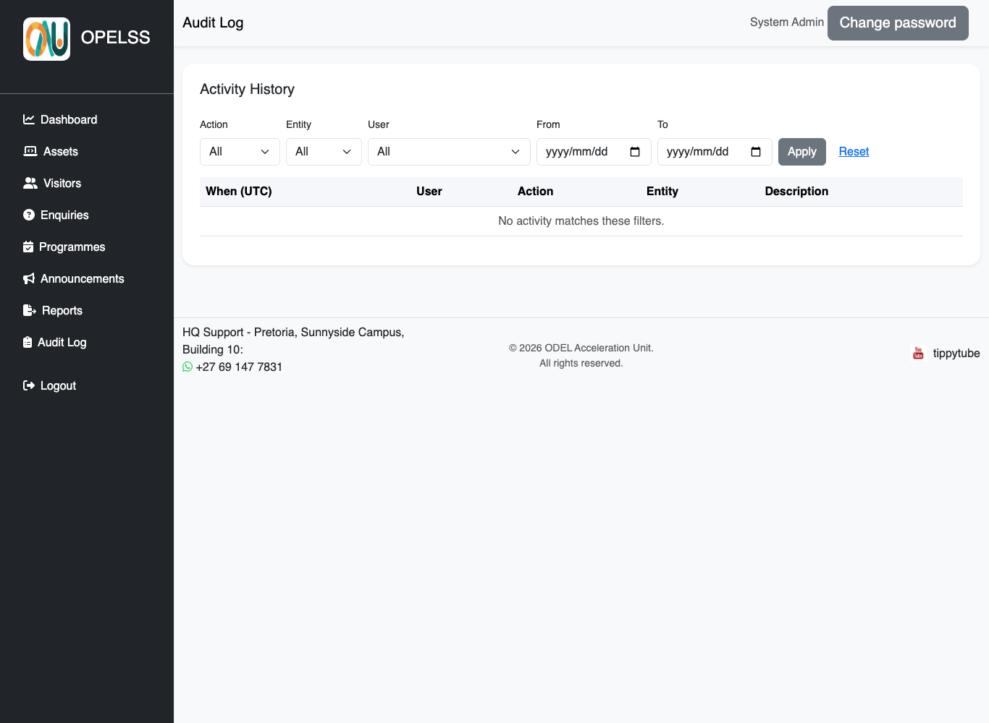
The Audit Log, filtered to show who changed what and when.
Good to know: The audit trail keeps the name of the person and the record even after the record is deleted, so the history is never lost. The log is read-only — it cannot be edited.

Everyday Records (Assets, Visitors, Enquiries)
As an Admin you can also use all the day-to-day pages. They work exactly as they do for HQ Trainees — with the full set of filters (Category, Status/Date, Lab, Province) and the “Export to Excel” option.
- Assets — view, filter, add, edit, delete and export equipment across all labs.
- Visitors — log and manage visitors, filter by category, date, lab and province, and export.
- Enquiries — manage and escalate student enquiries from any lab.
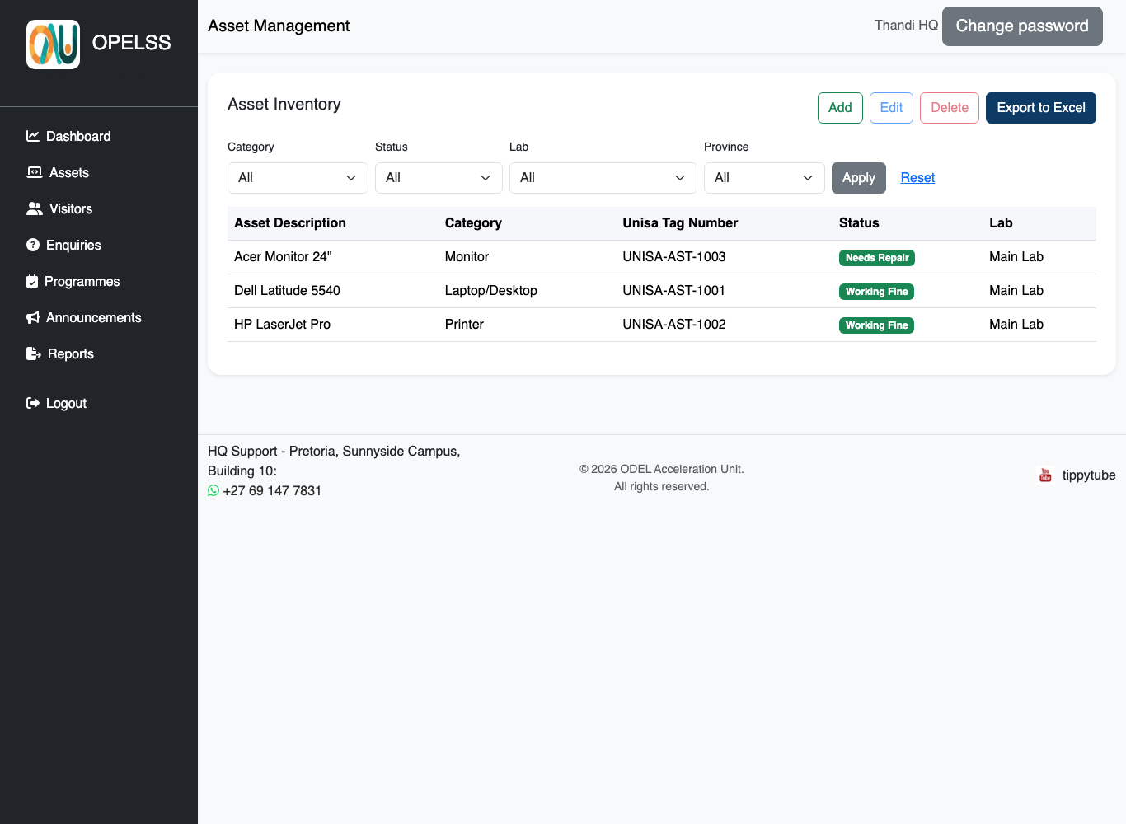
Example: the Assets page with the full filter set, available to Admins and HQ Trainees.

Announcements & Reports
- Announcements — publish notices with an optional poster image.
- Reports — generate and export consolidated reports across the network.

Changing Your Password
When your account is first created, an administrator gives you a temporary password. You should change it to something only you know.
- Click the grey “Change password” button at the top-right of any page.
- Enter your current password, then your new password.
- Click Save. Your new password takes effect immediately.
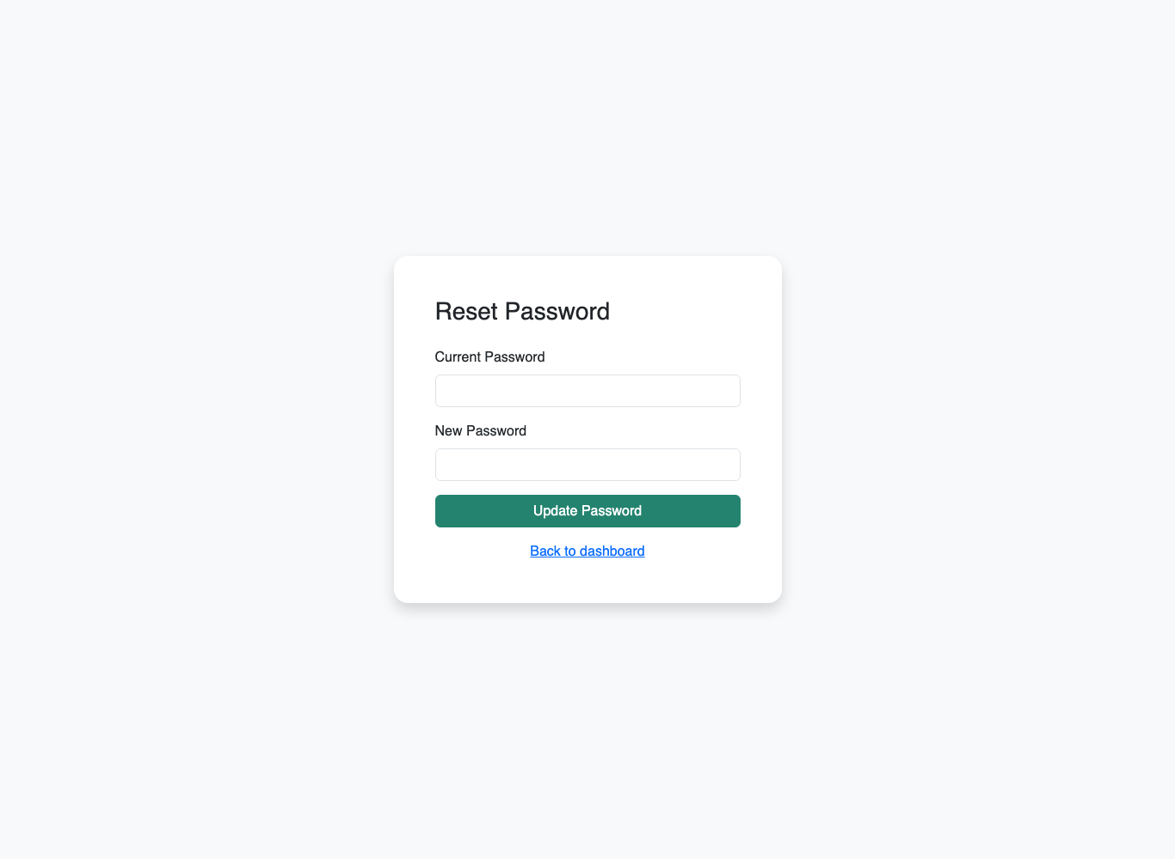
The Change Password screen (reached from the top-right button).
Tip: Choose a strong password you don’t use anywhere else, and never share it. The system keeps an audit trail of actions, so your account represents you.

Logging Out
When you are finished, always log out — especially on shared lab computers.
- Click “Logout” at the bottom of the left-hand menu.
- You will be returned to the login screen.

Administrator Responsibilities
- Keep lab locations and radii accurate so trainees can log in.
- Create accounts with the least access needed for each person’s role.
- Use the Audit Log to review changes if something looks wrong.
- Deactivate (or delete) accounts for people who leave.

