OPELSS
ODEL e-Lab Support System
HQ Trainee
User Manual & Training Guide
A step-by-step guide for monitoring the lab network in OPELSS.
Prepared by the ODEL Acceleration Unit
Version 1.0

Contents

Welcome
OPELSS (the ODEL e-Lab Support System) gives the head-office team a single view across every lab in the network. As an HQ Trainee you can monitor all labs, filter and export records, publish announcements, and generate reports.
Unlike Lab Trainees, you are not tied to one lab — you see information for every lab and province, and you can filter to focus on any of them.

Logging In
- Open the OPELSS web address in your browser.
- Enter your email address and password, then click “Sign In”.
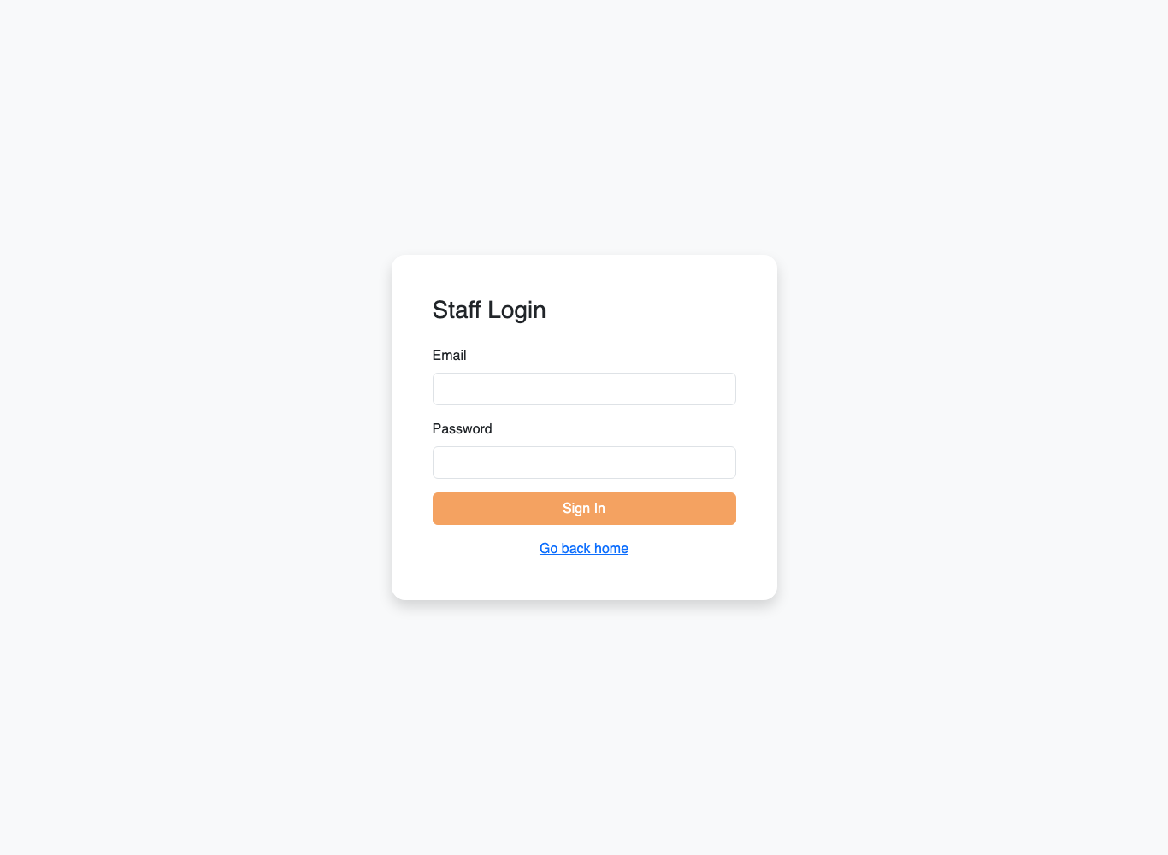
The OPELSS login screen.

Your Dashboard
Your dashboard summarises the whole network: total labs, provinces, users, assets, visitors, enquiries and the number of escalated enquiries that need attention.
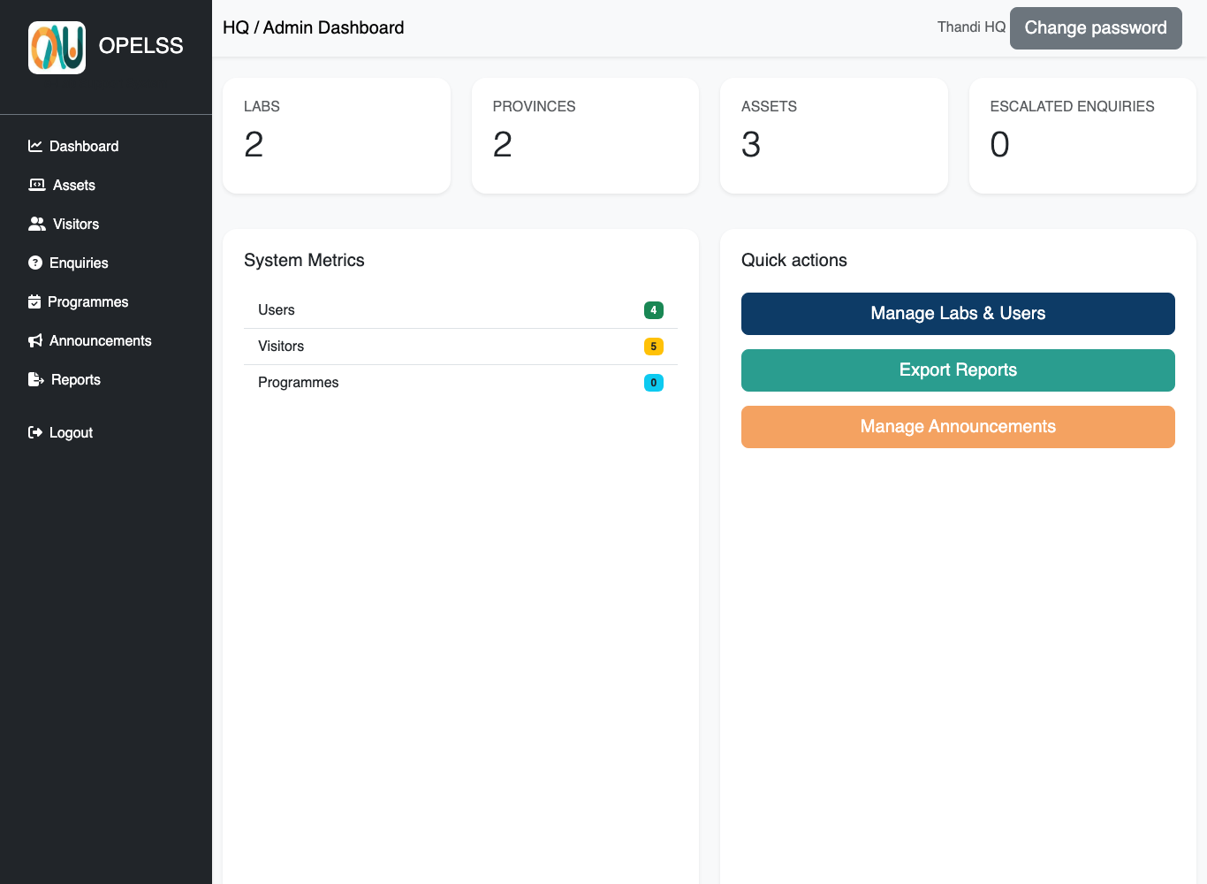
The HQ / Admin dashboard with organisation-wide totals.

Assets
The Assets page lists equipment across all labs.

Filtering
You have the full set of filters: Category, Status, Lab and Province. Choose any combination and click Apply to narrow the list. Use Reset to clear them.
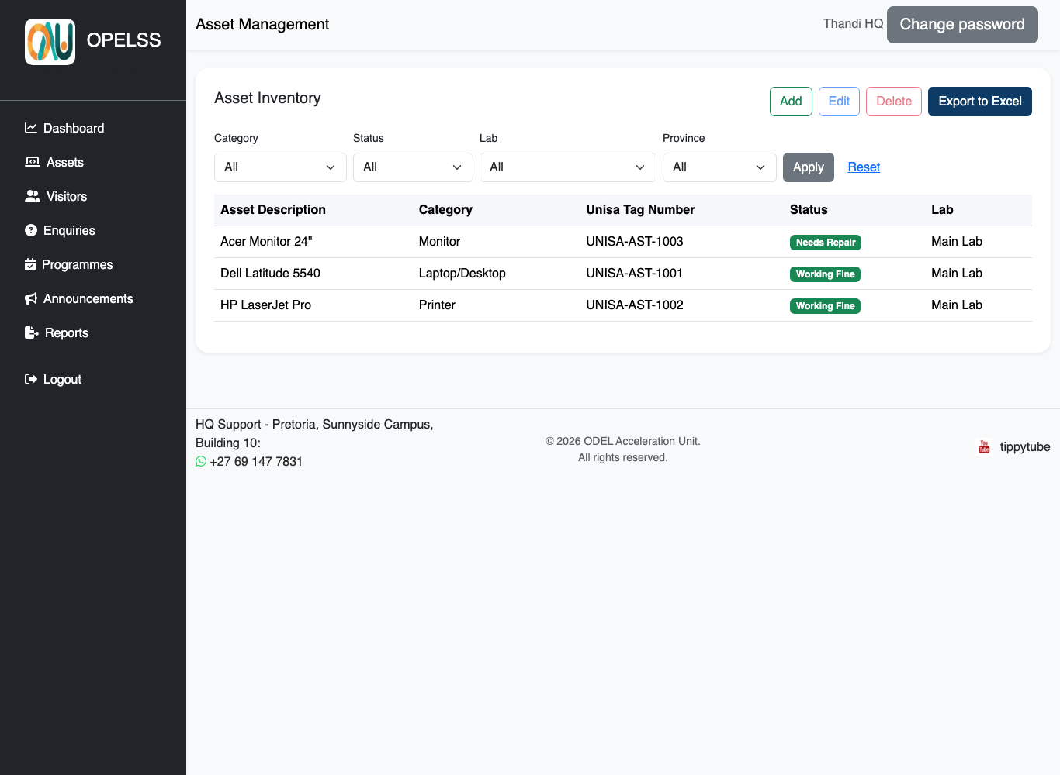
The Assets page with the full filter set and the Export button.

Exporting
Click “Export to Excel” to download the currently filtered list as a spreadsheet — useful for reporting and audits. (The export respects whatever filters you have applied.)

Adding and editing
- Click “Add” to register a new asset.
- Select a row, then “Edit” or “Delete” to change or remove it.

Visitors
The Visitors page shows visitor logs from every lab. You can filter by Category, date range, Lab and Province, and export the results to Excel.
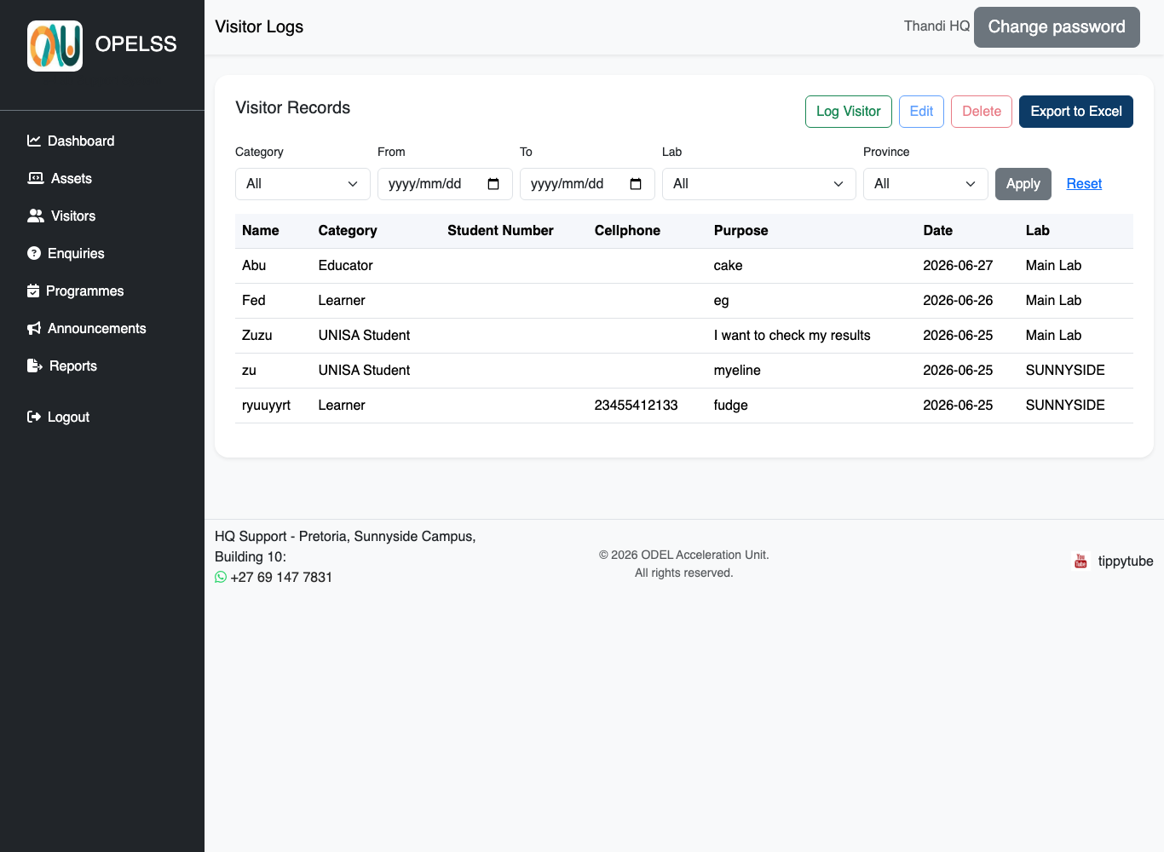
The Visitors page with full filters and export.
- Use the filters to focus on a category, period, lab or province, then click Apply.
- Click “Log Visitor” to capture a visitor, or select a row to Edit or Delete.
- Click “Export to Excel” to download the filtered list.

Enquiries
Here you can see and manage student enquiries from all labs, update their status, and escalate items that need head-office attention.
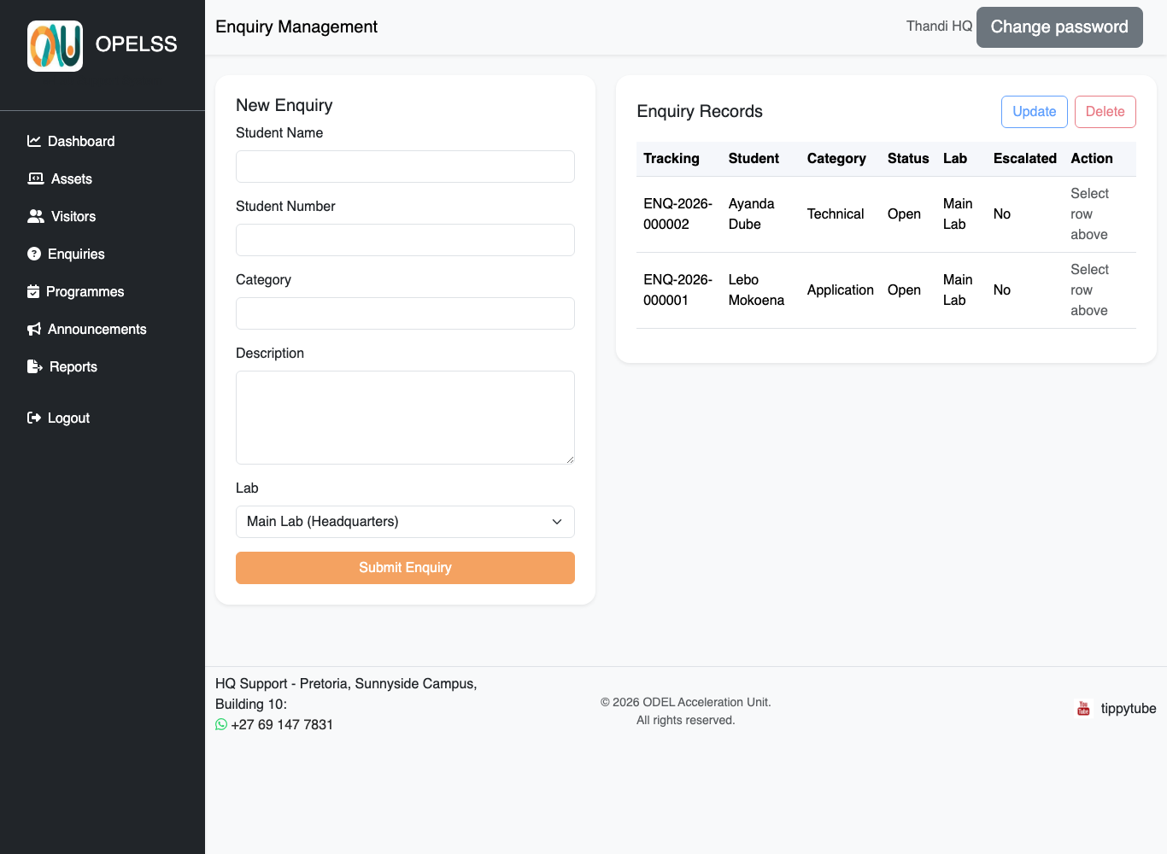
The Enquiries page.

Announcements
Announcements let you publish notices to the system. This menu is available to HQ Trainees and Admins only.
- Click “Announcements” in the left menu.
- Create a new announcement with a title and message, and an optional poster image.
- Published announcements are visible to users across the system.
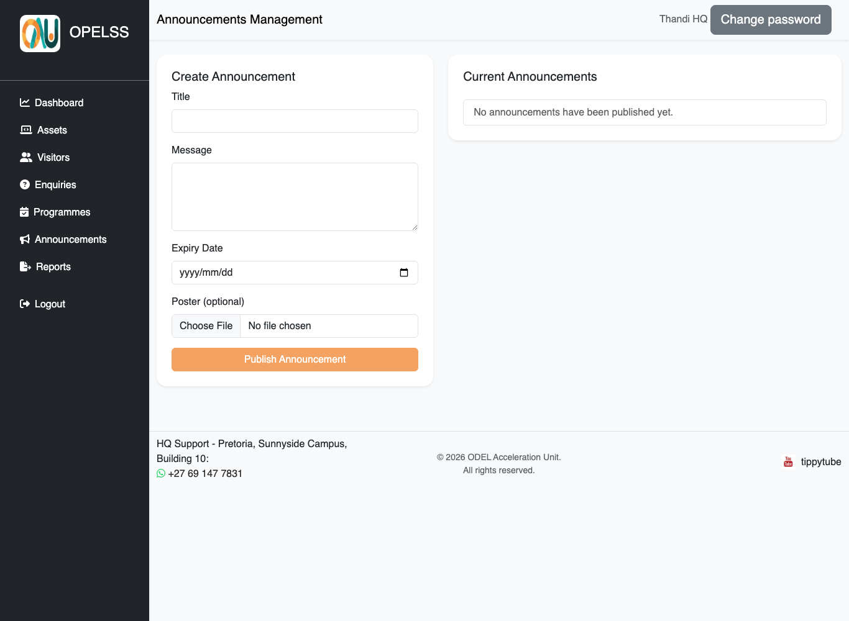
The Announcements management page.

Reports
The Reports page lets you generate and export consolidated reports across the network. Choose the report you need and export it.
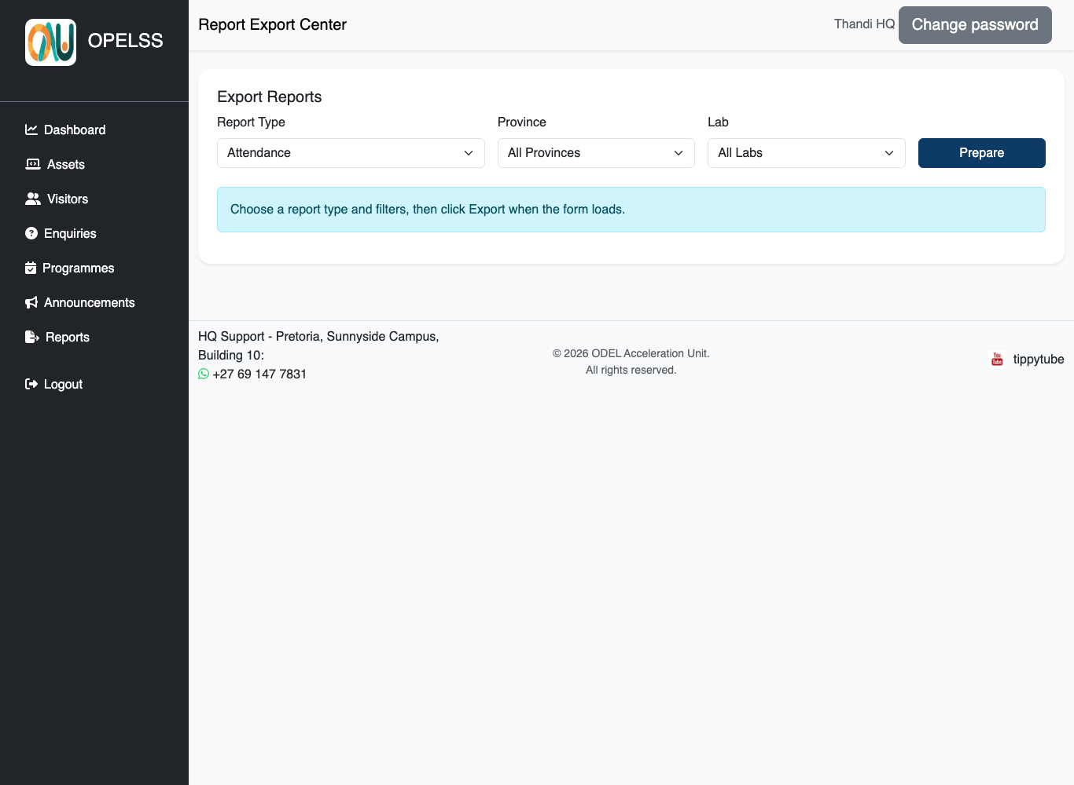
The Reports page.

Changing Your Password
When your account is first created, an administrator gives you a temporary password. You should change it to something only you know.
- Click the grey “Change password” button at the top-right of any page.
- Enter your current password, then your new password.
- Click Save. Your new password takes effect immediately.
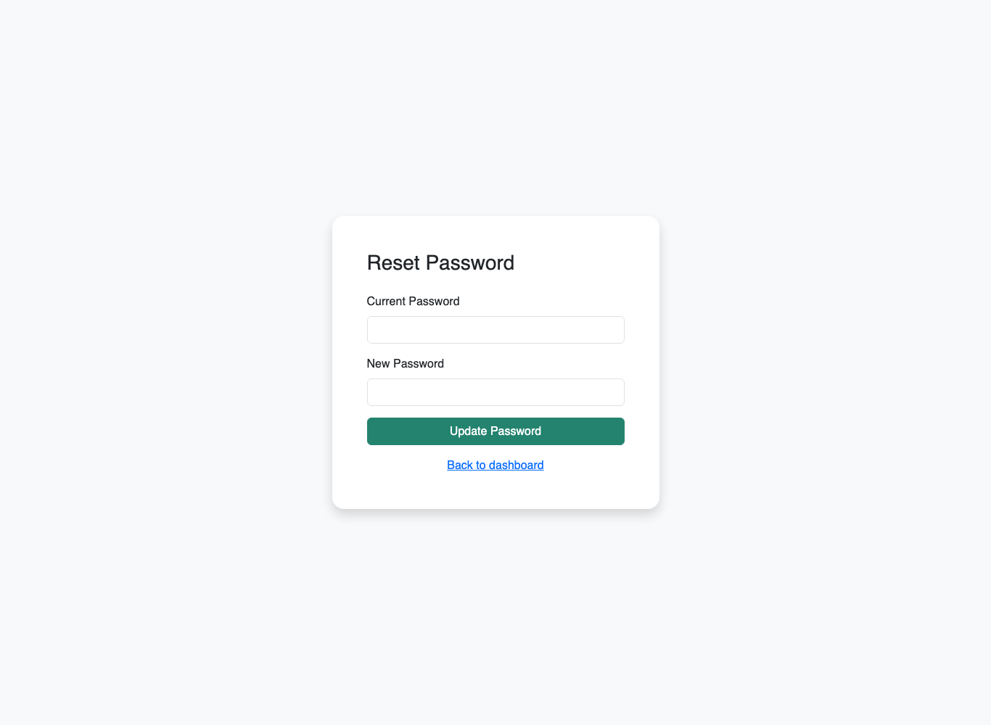
The Change Password screen (reached from the top-right button).
Tip: Choose a strong password you don’t use anywhere else, and never share it. The system keeps an audit trail of actions, so your account represents you.

Logging Out
When you are finished, always log out — especially on shared lab computers.
- Click “Logout” at the bottom of the left-hand menu.
- You will be returned to the login screen.

Need Help?
For account problems, new lab set-up, or anything you cannot do from your menu (such as creating users or labs), contact a System Administrator — those functions are reserved for the Admin role.

