OPELSS
ODEL e-Lab Support System
Lab Trainee
User Manual & Training Guide
A step-by-step guide for running your lab in OPELSS.
Prepared by the ODEL Acceleration Unit
Version 1.0

Contents

Welcome
OPELSS (the ODEL e-Lab Support System) is the tool you use to run the day-to-day operations of your computer lab. As a Lab Trainee you use it to mark your attendance, keep the lab’s asset register up to date, log visitors, capture student enquiries, and record lab programmes.
Everything you see in OPELSS is limited to your own assigned lab — you only see and manage records for the lab you work in.
Good to know: Your account is created for you by an administrator, who also assigns you to a lab and gives you a temporary password.

Logging In
- Open the OPELSS web address in your browser.
- Enter your email address and password.
- Click “Sign In”.
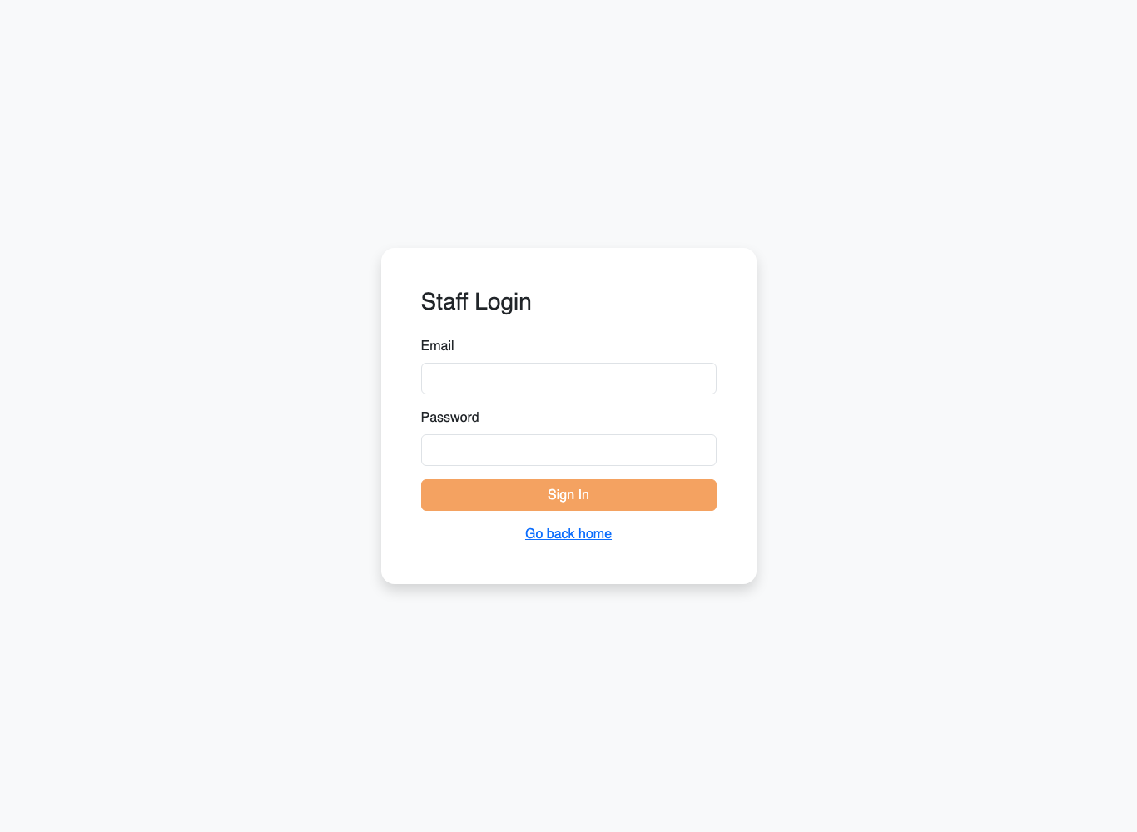
The OPELSS login screen.
Important — location check: As a Lab Trainee you can only log in while you are physically inside your lab. When you sign in, the system checks your device’s location against your lab’s location. Please allow location access in your browser, otherwise login will be refused.

Your Dashboard
After logging in you land on your Dashboard. It shows a snapshot of your lab: how many days you have attended this month, and the number of assets, visitors, enquiries and programmes recorded for your lab.
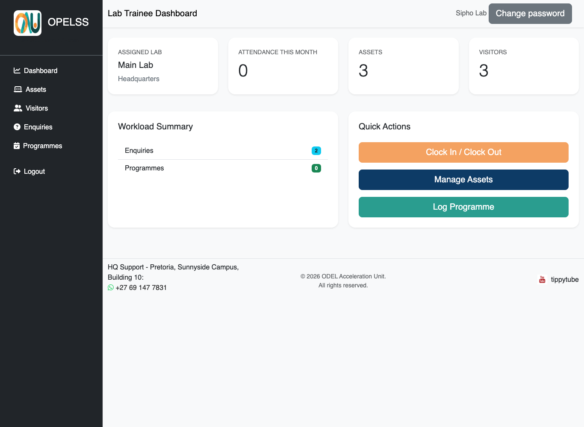
The Lab Trainee dashboard.

Attendance — Clocking In and Out
Use the Attendance page to record the days and hours you work. The Attendance menu item is only available to Lab Trainees.
- Click “Attendance” in the left menu.
- Click “Clock In” when you start your shift, and “Clock Out” when you finish.
- Your monthly record builds up automatically. You can export it as a PDF timesheet using the export button.
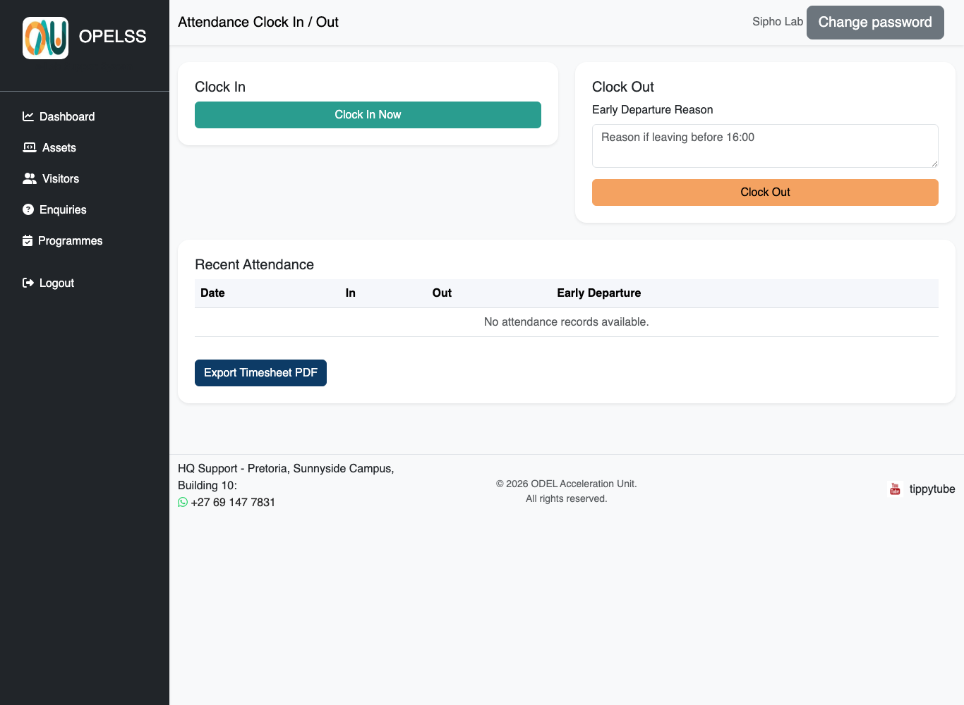
The Attendance page where you clock in and out.
Location check: Clocking in also confirms you are inside the lab, so make sure location access is allowed.

Assets
The Assets page is the equipment register for your lab — computers, printers, monitors and so on.

Viewing and filtering
The table lists every asset in your lab. Use the Category and Status filters at the top to narrow the list, then click Apply.
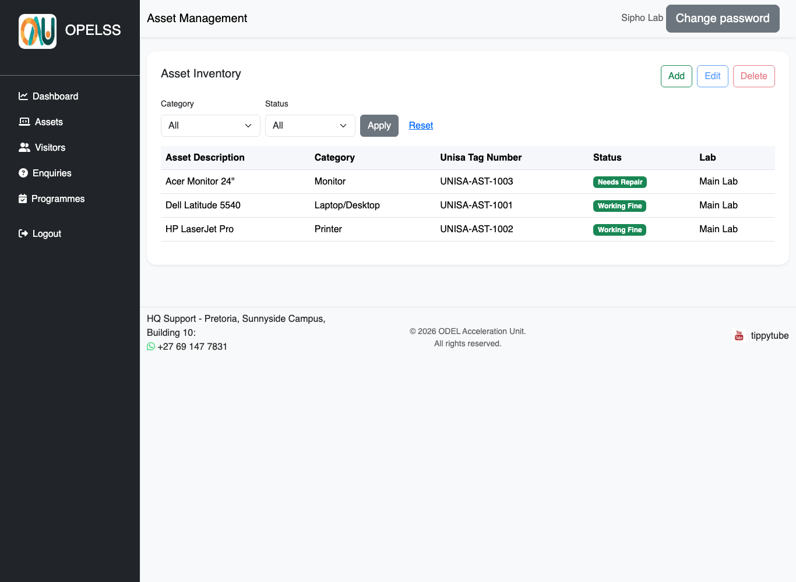
The Assets page for a lab.

Adding, editing and deleting
- Click “Add” to register a new asset. Fill in the description, category, UNISA tag number and status, then save.
- To change an asset, click its row to select it, then click “Edit”.
- To remove an asset, select its row and click “Delete”, then confirm.

Visitors
Use the Visitors page to log everyone who visits your lab.
- Click the green “Log Visitor” button. A form opens in the middle of the screen.
- Enter the visitor’s name and choose a Category: UNISA Student, Educator, Learner or Other.
- If you choose UNISA Student, a Student Number box appears — enter the 8-digit student number. For any other category, a Cellphone box appears instead.
- Enter the purpose of the visit, the date and the lab, then click “Log Visitor”. The visitor appears in the records table.
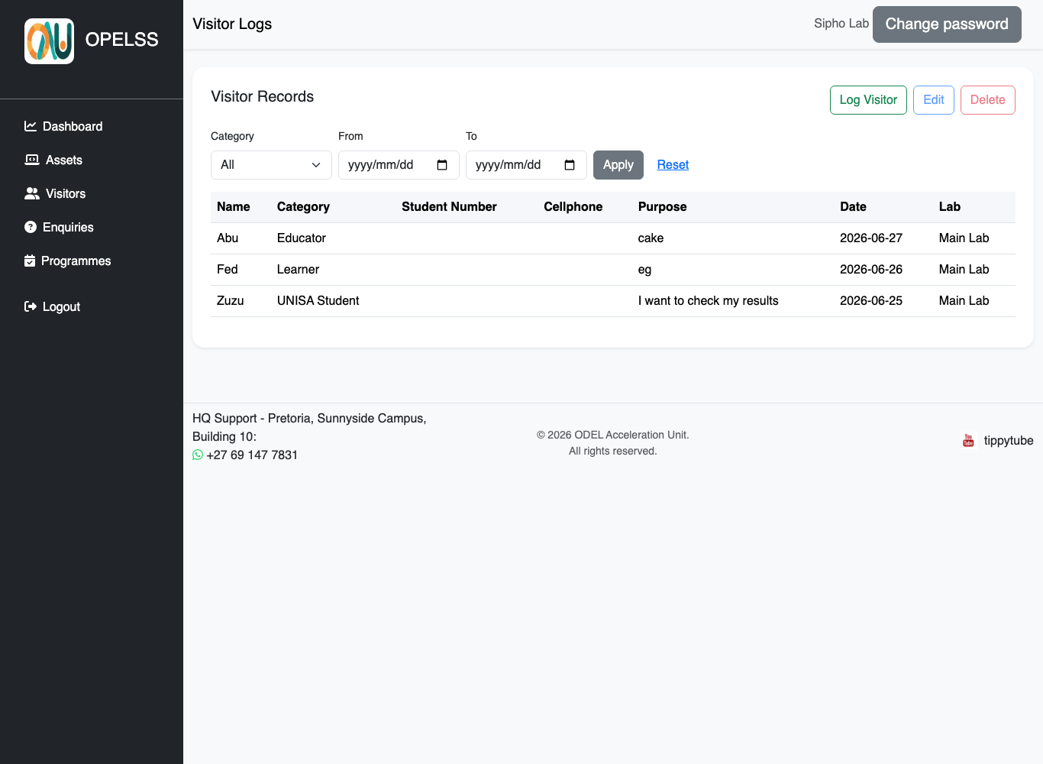
The Visitor Records page. The green “Log Visitor” button opens the form.
Tip: Select a row and use Edit or Delete to correct or remove a visitor entry. Use the Category and date filters to find past visits.

Enquiries
The Enquiries page records questions and support requests from students. Each enquiry is given a unique tracking number so it can be followed up.
- Capture a new enquiry with the student’s name, number, category and a description.
- The system assigns a tracking number (for example ENQ-2026-000001).
- Open an enquiry to update its status (for example Open or Escalated) and add a resolution note once it is dealt with.
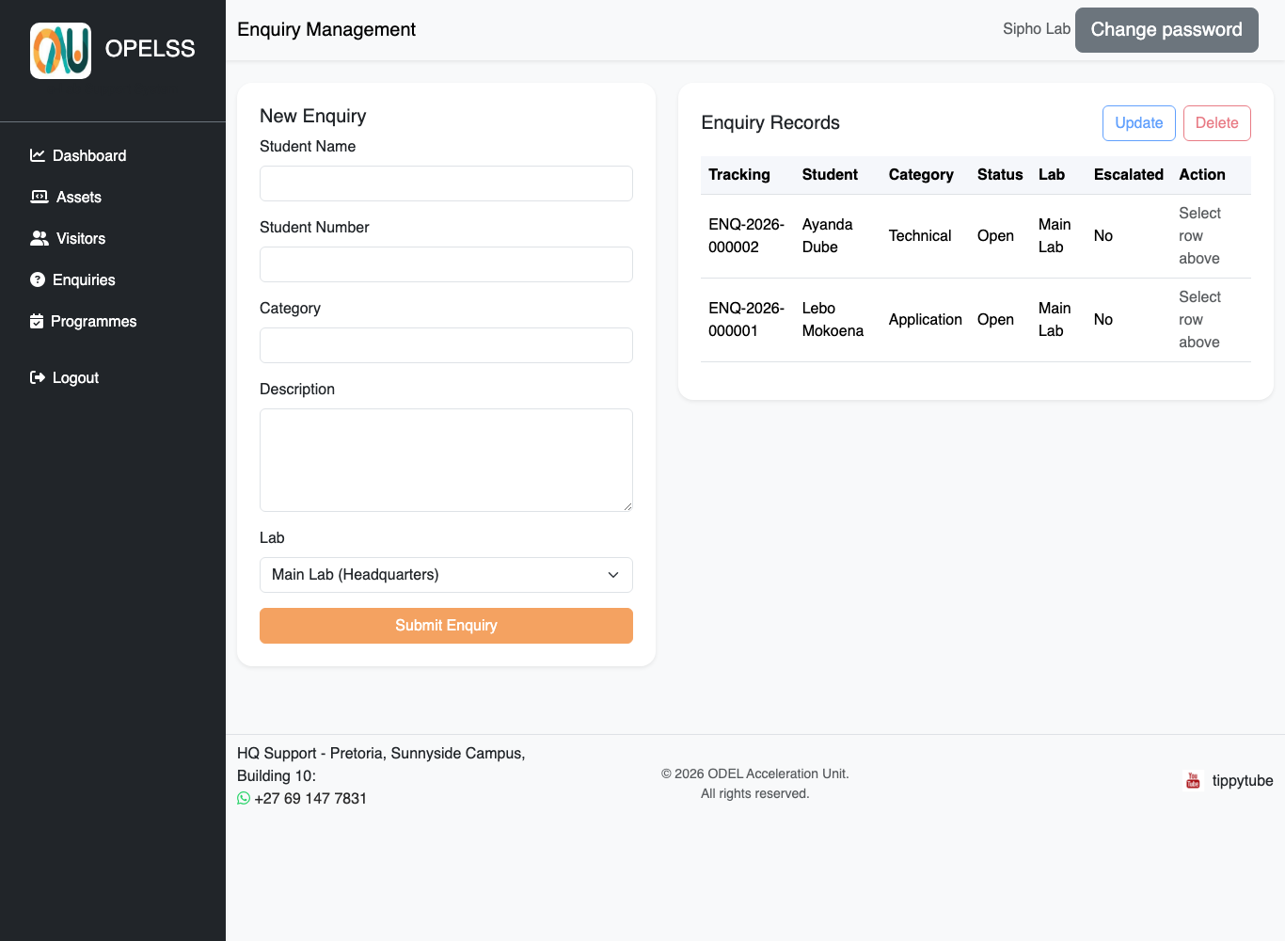
The Enquiries page.

Programmes
Use the Programmes page to record the community programmes and sessions you run in your lab — what the programme was, when it ran, how many people attended, and who facilitated it.

Logging a programme
- Click the green “Log Programme” button. A form opens in the middle of the screen.
- Fill in the programme title, objective and target audience.
- Enter the attendance count and describe the activities that were done.
- Choose the date, start time and end time.
- Under “Facilitated By”, select everyone who ran the programme. To select more than one person, hold Ctrl (or Cmd on a Mac) while clicking each name.
- Click “Log Programme”. The programme appears in the table straight away.

Recording who facilitated
“Facilitated By” is the record of who actually ran the programme. You must select at least one person, and you can select as many as you need — if three people ran a session together, select all three.
This is separate from who captured the record. If you log a programme that a colleague ran, select your colleague under “Facilitated By” — not yourself. This is what HQ uses to see who delivered which programmes, so it is worth getting right.
Anyone with an OPELSS account can be selected as a facilitator.

Finding a programme
Use the filters above the table to narrow the list, then click “Apply”:
- From and To — show only programmes that ran between two dates.
- Facilitated By — show only the programmes a particular person ran.
Click “Reset” to clear the filters and see everything again.

Editing and deleting
- To change a programme, click its row to select it, then click “Edit”. You can update any detail, including adding or removing facilitators.
- To remove a programme, select its row, click “Delete”, then confirm.
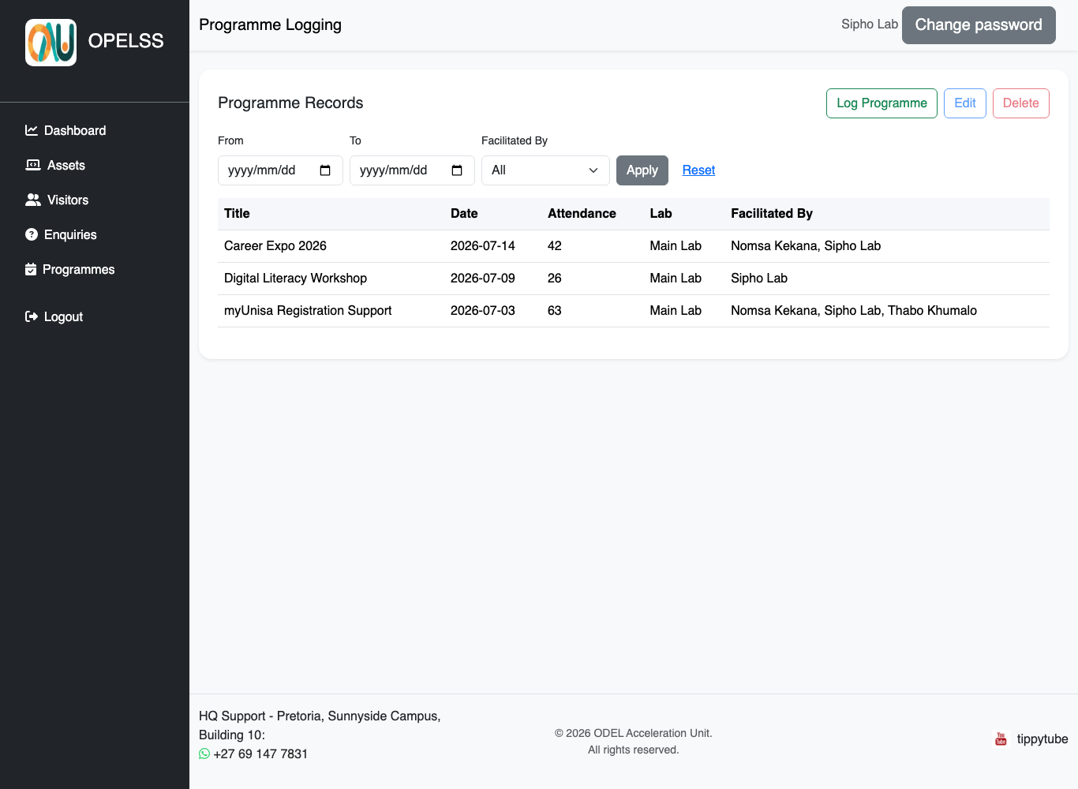
The Programmes page.

Changing Your Password
When your account is first created, an administrator gives you a temporary password. You should change it to something only you know.
- Click the grey “Change password” button at the top-right of any page.
- Enter your current password, then your new password.
- Click Save. Your new password takes effect immediately.
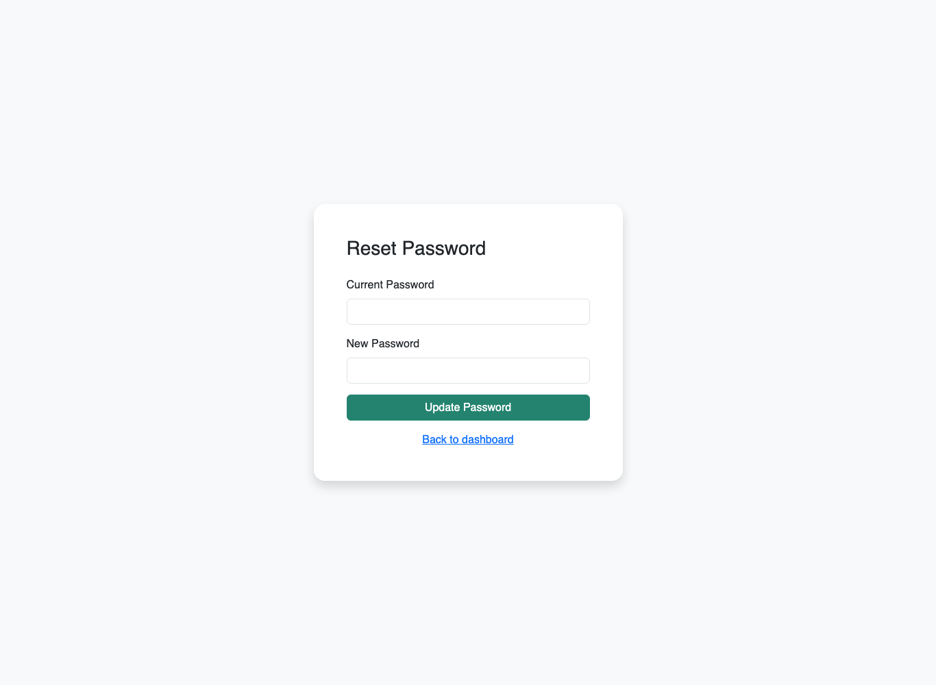
The Change Password screen (reached from the top-right button).
Tip: Choose a strong password you don’t use anywhere else, and never share it. The system keeps an audit trail of actions, so your account represents you.

Logging Out
When you are finished, always log out — especially on shared lab computers.
- Click “Logout” at the bottom of the left-hand menu.
- You will be returned to the login screen.

Need Help?
If you are locked out, cannot see your lab, or something does not look right, contact your HQ support team. They can check your account, your lab assignment and your access.

