Python outputs

2.
Variety: Howden
Grown in: Castelfiorentino, Tuscany, Italy
5. 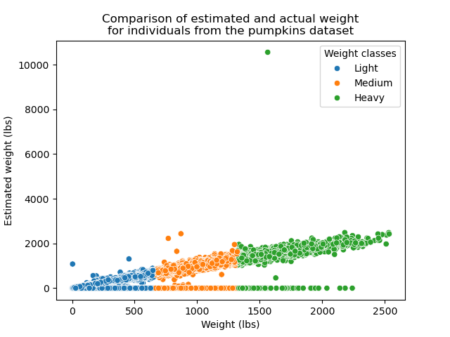
Comparison of estimated and actual weights of pumpkins in lbs. Colour is based on weight class. Large amount of points had no estimated weight, whilst one had one over 10000>lbs. May represent a misinput of data.
7. The highest mean weight of the pumpkins from the 3 countries is 349.2647030836827kg from Canada.
The lowest mean weight of pumpkins based on these groups is 90.5519604499173kg from the variety Casper originating in Japan.
8.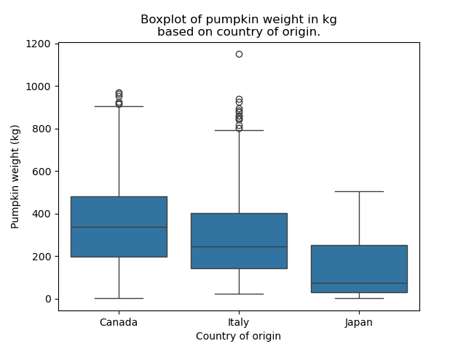
General boxplot showing pumpkin weight in kg on the y axis and country of origin on the x axis.
9.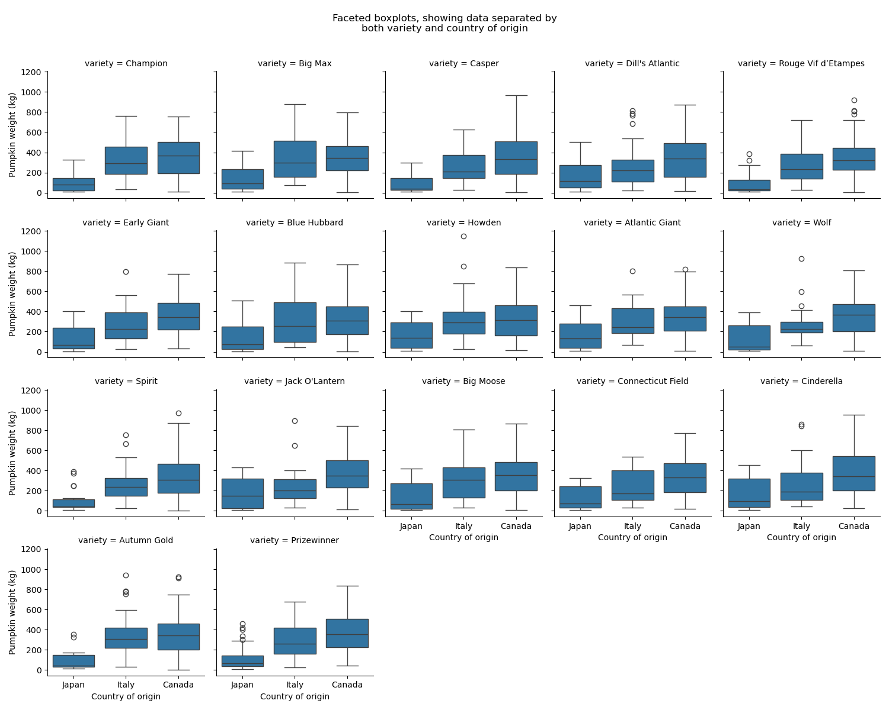
Boxplots showing the weight of pumpkins in kg on the y axis, and country of origin on the x axis. Plots are divided into facets based on variety.

