Python outputs

2.
Variety: Howden
Grown in: Castelfiorentino, Tuscany, Italy
5. 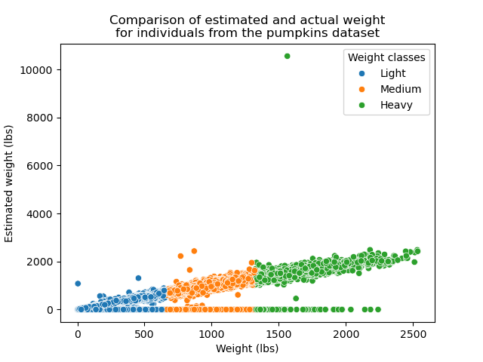
7. The highest mean weight of the pumpkins from the 3 countries is 349.2647030836827kg from Canada.
The lowest mean weight of pumpkins based on these groups is 90.5519604499173kg from the variety Casper originating in Japan.
8.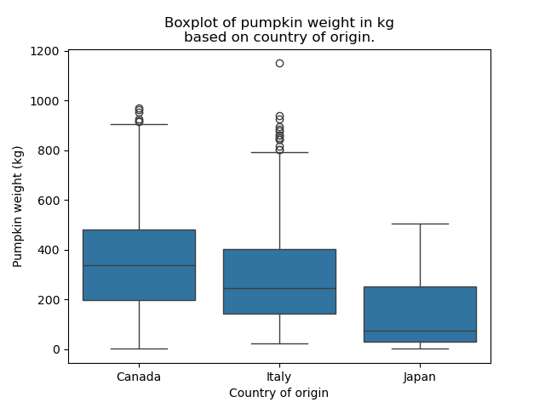

9.