It is the hour for despair. The writer sits, crumpled and waiting. The sun sets. He lays his head upon his desk. A *plot*—he must have a *plot*. The public, ravenous for story, has no use for his fine observations and his subtle characterizations. A *plot:* his publishers require it, his wife demands it—there is a child now. Slowly, miserably, he gouges the words out of himself.

George Gissing’s 1891 novel, “New Grub Street,” is one of the most pitiless portraits of the writing life in any age. Set among London’s hacks, grinds, and literary “women of the inkiest description,” the story follows Edwin Reardon’s nervous and financial collapse as he struggles to complete a book that might sell. His friend, the sleek and cynical Jasper Milvain, regards his efforts as so much unnecessary fuss. “Literature nowadays is a trade,” Milvain maintains, a matter of deft pandering. Find out what the reader wants and supply it, for God’s sake, with style and efficiency.

It’s not just the writer’s usual demons—skimpy word rates, self-doubt, the smooth ascension of one’s enemies—that torture Reardon but the strictures of the three-volume frigate that dominated Victorian novel-writing. The triple-decker, as it was called, was the form of much work by the likes of Charlotte Brontë, George Eliot, Benjamin Disraeli, and Anthony Trollope: typically nine hundred octavo pages divided into volumes of three hundred pages each, handsomely printed and bound. “The three volumes lie before me like an interminable desert,” Reardon moans. “Impossible to get through them.” Gissing lifted such laments from his own diary; “New Grub Street” was itself a triple-decker, Gissing’s eighth, and he used every available trick to stretch it, wheezily, to length. “The padding trade,” Trollope called literature at the time.

As luxury items, unaffordable for outright purchase by most readers, triple-deckers were championed by Mudie’s Select Library, a behemoth of British book distribution. For its founder, Charles Edward Mudie, who often bought the bulk of a print run and could demand commensurate discounts from publishers, the appeal was plain: since his subscribers—at least those paying the standard rate of a guinea a year—could borrow only one volume at a time, each triple-decker could circulate to three times as many subscribers. Publishers were equally fond of the form, which allowed them to stagger printing costs. A tantalizing first volume could drum up demand for subsequent volumes, and help pay for them.

A great many of the Victorian novel’s distinctive features seem expressly designed to fill up that “interminable desert” and entice the reader to cross it: a three-act structure, swelling subplots and vast casts, jolting cliffhangers, and characters with catchphrases or names that signal their personalities, rendering them memorable across nine hundred pages. (Dickens’s naming a bounder Bounderby, in “Hard Times,” is one shameless example.) Fictional autobiographies and biographies—“Villette,” “Jane Eyre,” “Adam Bede”—worked well with the demands of the triple-decker; a life story could enfold any necessary digressions and impart to them a sense of narrative unity.

The triple-decker prevailed until, toward the end of the nineteenth century, Mudie’s became frustrated with a glut of books and began requesting single-volume novels from publishers. With the rise of mass-market paperbacks printed cheaply on pulp paper, new forms were born (pulp fiction, anyone?), with their own dictates, their own hooks and lures for the reader. But, then, style has always shadowed modes of distribution in the history of the novel, from magazine serials to the Internet. In “Everything and Less: The Novel in the Age of Amazon” (Verso), the literary scholar Mark McGurl considers all the ways a new behemoth has transformed not only how we obtain fiction but how we read and write it—and why. “The rise of Amazon is the most significant novelty in recent literary history, representing an attempt to reforge contemporary literary life as an adjunct to online retail,” he argues.

Amazon—which, as its founder, Jeff Bezos, likes to point out, is named for the river that is not only the world’s largest but larger than the next five largest rivers combined—controlled almost three-quarters of new-adult-book sales online and almost half of all new-book sales in 2019, according to the *Wall Street Journal*. Unlike Mudie’s, it’s also a publisher, with sixteen book imprints. Amazon Crossing is now the most prolific publisher of literary translations in the United States, and Audible, another Amazon property, is the largest purveyor of audiobooks. The social-media site Goodreads, purchased by Amazon in 2013, hosts more than a hundred million registered users and, McGurl ventures, may be “the richest repository of the leavings of literary life ever assembled, exceeded only by the mass of granular data sent back to home base from virtually every Kindle device in the world.” But what McGurl considers the “most dramatic intervention into literary history” is yet another Amazon division, Kindle Direct Publishing (K.D.P.); it allows writers to bypass traditional gatekeepers and self-publish their work for free, with Amazon taking a significant chunk of any proceeds.

As book historians like Ted Striphas and Leah Price have written, there is nothing new in the notion of the book as a commodity; books were the first objects to be sold on credit. They were early to be bar-coded, allowing for inventory to be tracked electronically, which made them well suited to online retail. “Everything and Less” takes glancing notice of this history; McGurl’s real interest is in charting how Amazon’s tentacles have inched their way into the relationship between reader and writer. This is clearest in the case of K.D.P. The platform pays the author by the number of pages read, which creates a strong incentive for cliffhangers early on, and for generating as many pages as possible as quickly as possible. The writer is exhorted to produce not just one book or a series but something closer to a feed—what McGurl calls a “series of series.” In order to fully harness K.D.P.’s promotional algorithms, McGurl says, an author must publish a new novel every three months. To assist with this task, a separate shelf of self-published books has sprung up, including Rachel Aaron’s “2K to 10K: Writing Faster, Writing Better, and Writing More of What You Love,” which will help you disgorge a novel in a week or two. Although more overtly concerned with quantity over quality, K.D.P. retains certain idiosyncratic standards. Amazon’s “Guide to Kindle Content Quality” warns the writer against typos, “formatting issues,” “missing content,” and “disappointing content”—not least, “content that does not provide an enjoyable reading experience.” Literary disappointment has always violated the supposed “contract” with a reader, no doubt, but in Bezos’s world the terms of the deal have been made literal. The author is dead; long live the service provider.

The reader, in turn, has been reborn as a consumer in the contemporary marketplace, the hallmarks of which are the precision and the reliability with which particular desires are met. “A digital existence is a liquid existence, something like mother’s milk, flowing to the scene of need,” McGurl writes. That’s what Bill Gates promised the Web would do: provide “friction-free capitalism.” Can the ease of procuring a product translate into an aesthetic of its own? The critic Rob Horning has called the avoidance of friction “a kind of content in itself—‘readable books’; ‘listenable music’; ‘vibes’; ‘ambience’ etc.” On Amazon, the promise of easy consumption is even more pointed: with the discernment of algorithms, books aren’t just readable; they’re specifically readable *by you.*

Hence McGurl’s focus on the explosion of genre fiction—the bulk of fiction produced today. Here we find the estuary where books merge with Amazon’s service ethos, its resolve to be “Earth’s most customer-centric company.” Genre has, of course, always been an organizing principle in book marketing. The shiny embossed titles of the books on the spinning rack at an airport kiosk promise a hit of reliable pleasure to readers craving a Robert Ludlum thriller or a Nora Roberts love story. But Amazon brings such targeting to the next level. Romance readers can classify themselves as fans of “Clean & Wholesome” or “Paranormal” or “Later in Life.” And Amazon, having tracked your purchases, has the receipts—and will serve you suggestions accordingly. These micro-genres deliver on a hyper-specific promise of quality, but also end up reinforcing the company’s promise of quantity. What else does genre guarantee but variations on a trusted formula, endlessly iterated to fill up a Kindle’s bottomless library?

VIDEO FROM THE NEW YORKER

**[Crossword Puzzles with a Side of Millennial Socialism](https://www.newyorker.com/video/watch/crossword-puzzles-with-a-side-of-millennial-socialism" \t "_blank)**

Genre is, in particular, the key to having one’s book “discovered” on Amazon, where titles are neatly slotted into an intricate grid of categories. McGurl presents these developments with great serenity. He does not fret about the pressure the grid might apply, the potential for exclusion or homogeneity in what books get recommended. His core assumption is that Amazon gives readers the books they want, and his curiosity lies in discerning the function of such genres, the “needs” that they address. Exploring romance fiction, which seems to inspire scorn, in part because of the bingeing and the “bad” reading with which it is associated, McGurl wonders why the desire for repetition earns derision. After all, he notes, many pleasures are born of repetition, perhaps none more so than reading—as children, we clamor to hear the same stories again and again.

McGurl has himself been following the same story, in a way: the history of American fiction seen in relation to the institutions that sustain it. In “The Novel Art” (2001), he examined fiction’s elevation to high art, as modernist writers warily sought to distinguish their work from popular fiction in an age of mass literacy. In “The Program Era” (2009), he turned to the centrality of creative-writing departments to postwar literature, and their imprint on style. He is attuned to America’s signature queasiness about class, pleasure, and mass culture that constellates around reading and education. In “Everything and Less,” this takes the form of wild anthropological delight as he explores genres, and micro-genres, long dismissed by most mainstream scholarship and criticism.

[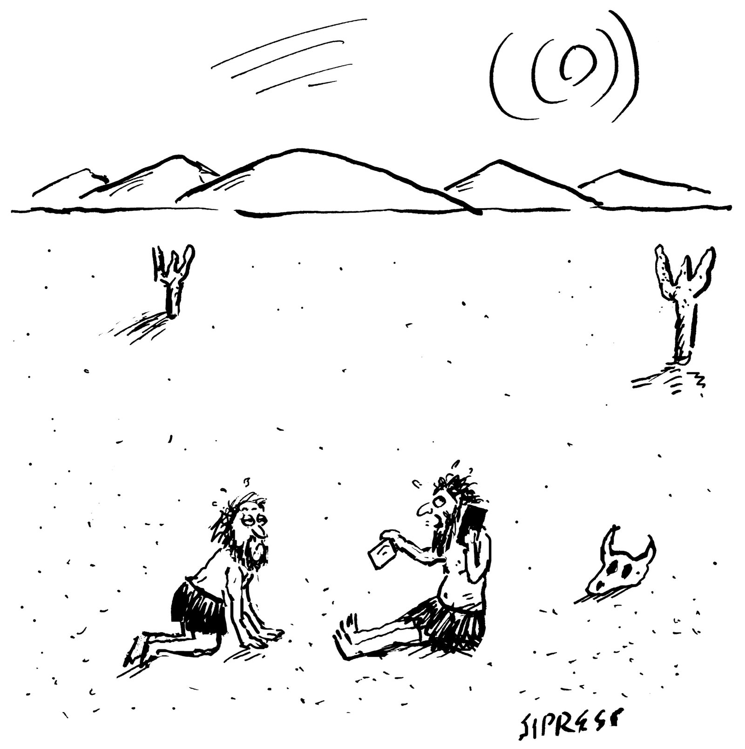](https://www.newyorker.com/cartoon/a25683)*“That’s right—a gallon of sparkling and a gallon of still. Are you ready for the credit card?”*

Cartoon by David Sipress

In these badlands, McGurl unearths inviting weirdness, surreal experimentation, kinky political utopias, and even sweetness. There is the performance art of one Dr. Chuck Tingle, with his signature gay-porn “tinglers,” such as “Bigfoot Pirates Haunt My Balls.” And McGurl is charmed by Penelope Ward and Vi Keeland’s romance “Cocky Bastard.” (“There is no justice in the literary field—this novel is far superior to ‘Fifty Shades of Grey,’ let alone the idiotic ‘Cocky Roomie,’ with a real sense of humor as well as a sidekick role filled by a blind baby goat.”) He reports on “the opportunistic efflorescences” at the far reaches of the K.D.P. universe—how the group sex in “The House of Enchanted Feminization,” for example, represents “a lunge toward erotic collectivity and community if not communism.”

Everywhere he looks, he finds allegories for Amazon. Zombie fiction—the genre he says is most in demand—might represent how Amazon regards its customers, all insatiable appetite. Meanwhile, the Adult Baby Diaper Lover (A.B.D.L.) books might be “the quintessential Amazonian genre of literature.” A typical story—take “Seduce, Dominate, Diaper,” by Mommy Claire—stars an alpha male now blissfully subdued by the maternal ministrations of the book’s heroine. The man’s infantilization exemplifies the customer’s dependence on Amazon, which, like any good mother of an infant, seeks to “minimize the delay between demand and gratification.” There’s also a thrilling edge to Mommy—a threat of punishment, of bondage—which acts as “a helpful reminder that Amazon’s customer obsession is ultimately an investment in its own market power.”

ADVERTISEMENT

McGurl’s claims themselves have an inviting weirdness—if not always coherence. I found myself writing sternly in the margins: “Not every orgy is a ‘collective.’ ” I wondered, too, at his notion of the “success” of K.D.P. writers. One survey of self-published writers found that half make less than five hundred dollars a year. But McGurl does not include the voices of K.D.P. writers themselves (save for the well-rewarded science-fiction writer Hugh Howey, an unofficial spokesman for self-publishing). He speaks of their innovations but not of their material reality. What of today’s Edwin Reardons? Never before have so many people made so little from their writing. Nor do we hear about writers who feel ambivalent about using Amazon as a platform to begin with, or who feel cheated or exploited.

McGurl’s aim, to be sure, is provocation more than persuasion. He does not argue; he insinuates, teases, tousles, wrinkles. He makes himself cozy in the conditional mode, from which he can spin out thought experiments and later state them as fact. His quiver is full of qualifiers—“speculative to be sure,” “a stretch, surely.” Even his thesis about the primacy of Amazon in transforming literary culture is casually walked back (it’s merely “a way of framing the story of contemporary fiction in such a way as to throw a particular set of heretofore under-examined realities into relief”), only to be reasserted one page later. His defense is built in: “Who among us is completely coherent?”

Inconsistencies and small mistakes begin to gather underfoot. Stephenie Meyer’s “Twilight” series is not a trilogy. Maggie Nelson’s “The Argonauts” is a memoir, not an example of autofiction. “Bemused” is not a synonym for “amused,” and Max Weber was hardly pointing out the “acetic” character of the Protestant capitalists, whatever their astringencies. Even McGurl’s opening argument hinges on an error. Drawing from Brad Stone’s 2013 book about the rise of Amazon, “The Everything Store,” McGurl writes of Bezos, “It would not be entirely crazy to say that we owe the existence of the company to his reading of Kazuo Ishiguro’s literary novel ‘The Remains of the Day.’ ”

The claim is that Bezos dared to leave his job at an investment firm only after reading Ishiguro’s story of an English butler who realizes that he has squandered his own life in service to others. But Bezos actually read “The Remains of the Day” a year after starting Amazon. His wife at the time, MacKenzie Bezos, left a nine-hundred-word, one-star review of “The Everything Store” on Amazon, in which she dryly stated her credentials—“Jeff and I have been married for 20 years”—and corrected the record. The error was fixed in subsequent printings of Stone’s book, but it dangles here—revealing McGurl’s eagerness to establish Amazon as a “literary endeavor” in its own right.

How does literary fiction fit into McGurl’s account of this literary endeavor? He conceives of it as another genre (its features include “discussable interpretive problems”), and identifies overlap with mass-market romance. A version of the alpha billionaire of “Fifty Shades of Grey” can be found in the “beta intellectual” lurking in Adelle Waldman’s “The Love Affairs of Nathaniel P.” Appropriately skeptical of capitalism, conversant in feminism, and endlessly self-obsessed, such men do not want to whip women, McGurl writes, “just to waste their time.” It’s the sort of playful observation McGurl makes easily and well; why doesn’t he look deeper? He scarcely addresses the particular economy of literary fiction or the influence of publishing conglomerates. He glides over Amazon’s scheme to target indie presses, the Gazelle Project, named after Bezos’s comment that Amazon “should approach these small publishers the way a cheetah would pursue a sickly gazelle.” (Amazon’s lawyers later had the Gazelle Project renamed—perhaps even more chillingly—the Small Publisher Negotiation Program.) The literary novelist properly enters McGurl’s story only when he considers how Amazon has heralded an “age of *surplus fiction*.” In 2018, some 1.6 million books were reportedly self-published—all this on top of the tens of thousands released by traditional publishing houses. How can a writer work within this flood? It’s not an entirely new quandary. One of the “women of the inkiest description” from “New Grub Street” surveys the deluge of her own era with dismay: “When already there was more good literature in the world than any mortal could cope with in his lifetime, here was she exhausting herself in the manufacture of printed stuff which no one even pretended to be more than a commodity for the day’s market. What unspeakable folly!”

McGurl sees two strategies: align with the profusion, go maximalist, write an epic—or resist, find recourse in autofiction, scale the world down to the figure of the writer. The argument loses some lustre when one recalls that McGurl made a similar claim in his previous book, “The Program Era,” arguing that postwar writers responded to feelings of class anxiety in M.F.A. programs by becoming either maximalists (he cites Joyce Carol Oates) or minimalists (Raymond Carver). It loses a little more when you reflect that most literary fiction is neither.

Still, the impossible surplus of books could explain a certain miasma of shame that emanates from much contemporary fiction. Saul Bellow once said that novelists sought a definition of human nature in order to justify the ongoing existence of their craft. Recent novels, however, are marked by mortification. In Sally Rooney’s “Beautiful World, Where Are You,” Alice is an extremely successful writer who holds her books to be “morally and politically worthless.” (Her boyfriend, incidentally, works in what could be an Amazon warehouse.) There is Linda, a struggling writer in Tony Tulathimutte’s “Private Citizens,” who wonders bleakly “what writing can survive?” or the writer-narrator of Anna Moschovakis’s “Eleanor, or, The Rejection of the Progress of Love,” who wrings her hands over her manuscript. “I cited my book’s many unoriginal traits: its episodic structure, its banal storyline tracing the alienation of the individual in late capitalism, and more,” she tells us. “But what really embarrassed me was that I imagined a readership at all.”

That anxiety is surely stoked by the easy digital intimacy between author and reader—readers readily conferring stars and comments, which are situated right at the point of sale. And, just as Gissing’s struggle with the triple-decker became a subject of his triple-decker, authorial anxiety in the age of digital intimacy has itself become a distinctive theme of contemporary literary fiction. By fostering that intimacy—not to mention stalking and squeezing small publishers, undercutting bookstores, and killing off competitors—Amazon has, in a sense, made all writers K.D.P. writers, working off the same publicity playbook. True, writers have always striven to be noticed (Guy de Maupassant once sent a hot-air balloon over the Seine to advertise his new short story), but so many of today’s writers, maximalist or minimalist or middling, feel obligated to maintain a feed of chatty updates, “friendly” communiqués, and newsletters, the direct appeals cut with self-deprecation to solicit and cultivate readers. It’s the note of self-awareness we hear in Lauren Oyler’s “Fake Accounts,” when she wryly titles a section “Middle (Nothing Happens),” as if managing the reader’s expectations. Or the note of self-doubt that nags at the novelist-narrator in Claire Vaye Watkins’s “I Love You but I’ve Chosen Darkness,” who finds her conviction in her work curdling and runs away while travelling to give a book reading. “Only connect” reads the epigraph of E. M. Forster’s “Howards End,” but increasingly it is Amazon that dictates to the writer the modes, methods, and imperatives of this connection.

And yet “Everything and Less” tells one story while seeming to enact another. For all the ways McGurl anatomizes the novel as a commodity in the age of Amazon, one is left observing something else entirely—all the ways in which the novel cannot be commodified. The novel is an intransigently private form, and this may be the real story of the book: McGurl’s surprise and delight as he ventured to the so-called margins of literary life and found more than he expected. That’s the nature of the novel; you have to cross its threshold without completely knowing what lies within. Mere ownership does not constitute possession. ♦

Published in the print edition of the [November 1, 2021](https://www.newyorker.com/magazine/2021/11/01), issue, with the headline “All You Can Read.”