UNICC
WORKFORCE READINESS — STRATEGIC BENCHMARKING
AI-Core Role Specifications: UNICC against Private Sector and UN-System Peers
April 2026
A companion paper to the Workforce Readiness in an AI-Enabled Operating Environment discussion paper (March 2026). Anchored on the AI-Core (strict-tier) methodology applied consistently across UNICC's PD library, UN-system peer postings, and private-sector benchmarks.
DRAFT | For Milena's Review

Executive Summary
The headline picture. UNICC's PD library contains 7 of 373 staff PDs (1.9%) that qualify as AI-Core — roles where AI or machine learning is the primary function of the work. UN Secretariat tech postings sit at 4.0%, UN Funds & Programmes at 5.4%, UNOPS at 18.6%, UNDP at 35.3%, World Bank Group at 40.0%, and the Cisco/G7 private-sector ICT benchmark at 78%. UNICC is below the slowest-moving cohort in the UN system, and an order of magnitude behind UNDP and World Bank.
The structural finding. Aggregate percentages obscure the more strategically consequential pattern. Of 7 staff AI-Core PDs, 6 are concentrated in the AI/ML Unit and a small cluster of data-science specialist roles. The largest functions in the library — Cybersecurity (97 PDs), Digital Workplace (34), Enterprise Apps (33), Network (31), Project Management (18) — contain zero AI-Core specifications, despite each being a function where AI integration has been a defining feature of industry practice over the past 18 months. UNICC has built an AI Centre of Excellence; the rest of the operating model has not yet recognised that AI exists.
The void-filling risk. Private-sector ICT providers operate at 78% AI-Core integration in G7 economies — Cisco, Microsoft, Accenture, Eightfold, IBM, SAP, and the broader Cisco AI Workforce Consortium. UN clients increasingly have the procurement option to buy the AI-augmented IT services UNICC provides, from providers whose role specifications already reflect AI as the default. Within the UN system, UNDP has integrated AI down to entry-level positions; UNICC at 1.9% has zero AI-Core P2 roles in 106 P2 PDs. The competitive question for UNICC is not whether private-sector and UNDP capability will be available to UN clients — it already is and will be — but whether UNICC's documented capability profile will read as a credible alternative to either.
The implication for ManCom. PD refresh is the documentation track of a broader workforce response — necessary to set recruitment criteria and partner-facing positioning, but not on its own sufficient to build the capability the PDs would require. Capability development, recruitment-criteria changes, and workforce-structural decisions are complementary tracks belonging in the Piciorea workforce strategic plan and the operating-model conversation. The recommended PD-track trajectory targets the high-volume, AI-absent functions first — approximately 195 PDs in Cybersecurity, Digital Workplace, Enterprise Apps, and Network — and reaches UNDP's current AI-Core position by Year 4 under Scenario C. The escalation path is full PD library refresh on a 12-18 month timeline if the UNDP gap fails to narrow within the first twelve months.

1. The Private Sector is Moving Fast
This section establishes the trajectory the UN system is being measured against, and the procurement alternative UN clients have available. Five external data points define the pace of AI integration into role specifications across the broader labour market. They are presented in increasing order of relevance to UNICC's positioning.
Lightcast posting data, summarised in the Stanford AI Index 2026, shows AI postings growing 73% year-on-year between 2023 and 2024, and 109% between 2024 and 2025. Within the tech-only subset, AI references appear in 8-13% of postings across major markets (Singapore 4.7%, Spain 3.3%, US 2.6%, UK 1.9% across all postings — concentrating in tech). The trajectory is steep, accelerating, and global.
PwC's Global AI Jobs Barometer 2025 (analysing approximately one billion job advertisements globally) reports that skills are changing 66% faster year-on-year in AI-exposed roles than in non-AI-exposed roles, that AI-exposed roles command a 56% wage premium, and that productivity growth in AI-exposed industries runs at approximately four times the rate of non-exposed industries. A static PD library is not maintaining its current relative position — it is falling behind at an accelerating rate.
LinkedIn's 2025-26 Workforce data reports 70% year-on-year growth in postings requiring AI literacy, projects that 70% of skills required by current jobs will change by 2030, and reports 177% growth in members adding AI skills to their profiles since 2023. The supply-side and demand-side signals are moving together at comparable rates.
The World Economic Forum Future of Jobs Report 2025 surveyed approximately 1,000 large employers across 55 economies. 86% expect AI to transform their business by 2030; 85% plan to upskill their workforce; 77% plan upskilling specifically for AI.
The Cisco AI Workforce Consortium (Accenture, Cornerstone, Eightfold AI, Google, IBM, Indeed, Intel, Microsoft, SAP) published the 'ICT in Motion' study in September 2025. It found that 78% of in-demand ICT roles in G7 economies require AI skills as either a core or supporting competency. The Consortium's membership overlaps substantially with UNICC's strategic vendor relationships — the figures represent the bar UNICC's own technology partners are operating to and recruiting against.

Source | Year | Headline figure
Lightcast / Stanford AI Index | 2025-26 | AI postings growing 73%/109% YoY; 8-13% of tech postings reference AI
PwC Global AI Jobs Barometer | 2025 | Skills changing 66% faster YoY in AI-exposed roles; 56% wage premium
LinkedIn Workforce data | 2025-26 | 70% YoY growth in AI-literacy demand; 177% growth in AI-skilled members since 2023
WEF Future of Jobs | 2025 | 86% of large employers expect AI transformation by 2030; 77% plan AI-specific upskilling
Cisco AI Workforce Consortium | 2025 | 78% of G7 in-demand ICT roles require AI skills

These five sources converge on a single picture. AI integration into role specifications is now standard practice in G7 ICT, growing at double-digit rates per year, and treated by the major employers UNICC interacts with as the default rather than the exception. UN clients have access to this capability today through commercial procurement, from providers whose role specifications already reflect AI as the default. The strategic question for UNICC is whether the UN-system providers — UNICC included — will continue to be the credible default for UN organisations' IT services, or whether the gap between UN-system documentation and private-sector practice becomes large enough that UN clients increasingly source AI-augmented IT services from elsewhere. The pace at which that gap is opening is the subject of Sections 2 and 3.

2. UNICC PD Library at the AI-Core Bar

2.1 Aggregate findings
The UNICC PD analysis (April 2026) reviewed 567 unique PDs across the full library — 373 staff PDs, 82 consultant profiles, 112 procurement profiles. Detection used a strict-tier regex (artificial intelligence, machine learning, deep learning, neural network, NLP, large language model, generative AI, foundation model, computer vision, prompt engineering, named AI tools — ChatGPT, Claude, Gemini, GitHub Copilot, M365 Copilot) with explicit false-positive masking and contextual quality-control on every match.
Of 33 raw regex matches, 9 PDs (1.6% of the full corpus) were classified AI-Core after contextual QC, 13 were AI-Adjacent (substantive but not primary-function references), and 11 were False-Match. The headline figure for direct comparison to UN peers is the staff-only AI-Core count: 7 of 373 staff PDs, or 1.9%. This reconciles cleanly with the original parent paper finding of 11 of 371 (3.0%) — both numbers are valid; the 1.9% is the stricter cut.

2.2 Where the AI-Core PDs are
Of nine AI-Core PDs across the full library, six are concentrated in two specific places: the AI/ML Unit (3 of 19 PDs in Quality/Training, 16%) and data-science specialist roles in Development (4 of 110 PDs, 4%). Other AI-Core PDs are the Chief of AI Hub and an IT Officer (Data Science) role. UNICC has built a small dedicated AI Unit and appointed AI-titled specialists. AI references have not propagated out of these specialist roles into the broader operating model.

2.3 Where the AI-Core PDs aren't
The function-level breakdown is the most strategically consequential finding in the analysis. Figure 1 shows the AI-Core distribution across the largest functional areas of the UNICC PD library.
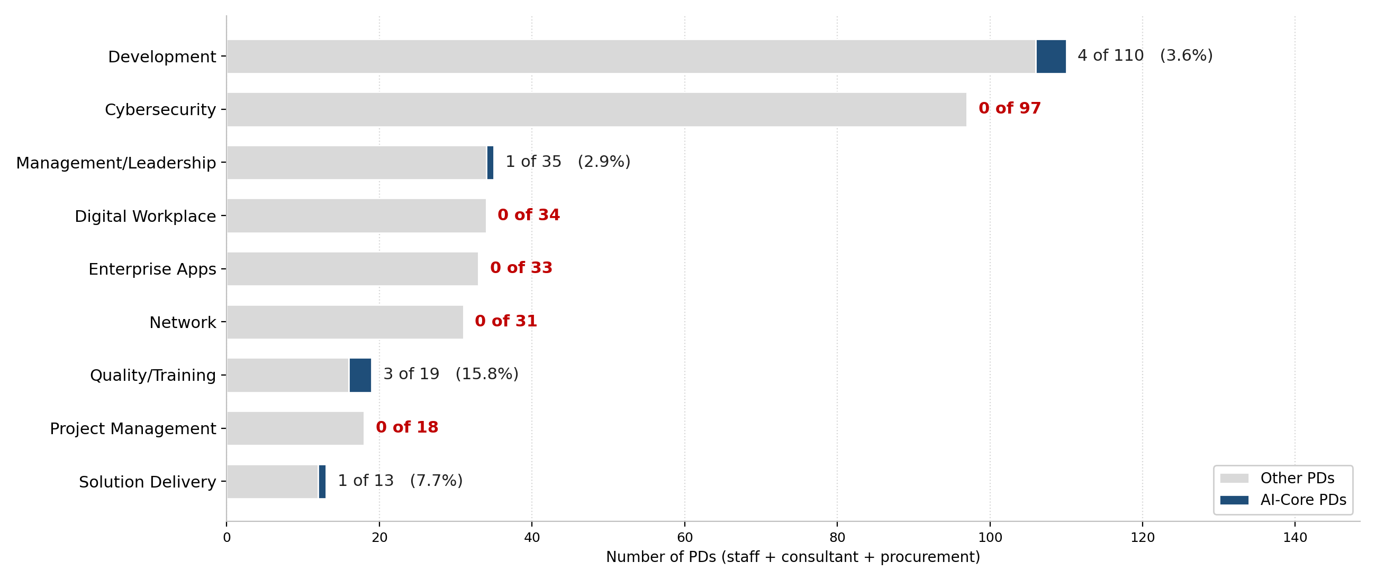
Figure 1: UNICC PD library by functional area, AI-Core distribution. Cybersecurity, Digital Workplace, Enterprise Apps, Network, and Project Management — collectively 213 PDs (38% of the library) — contain zero AI-Core specifications.

Function | Total PDs | AI-Core | AI-Core % | Note
Development | 110 | 4 | 3.6% | Includes 3 AI/ML Unit data-science roles
Cybersecurity | 97 | 0 | 0.0% | Zero AI-Core in UNICC's largest function
Management/Leadership | 35 | 1 | 2.9% | Chief, AI Hub
Digital Workplace | 34 | 0 | 0.0% | M365/Copilot landscape
Enterprise Apps | 33 | 0 | 0.0% | SAP/ServiceNow/Oracle AI products in GA
Network | 31 | 0 | 0.0% | Zero
Quality/Training | 19 | 3 | 15.8% | AI/ML Unit base
Project Management | 18 | 0 | 0.0% | Zero
Solution Delivery | 13 | 1 | 7.7% | Data Solution Architect

The pattern is the AI Centre of Excellence model. Cybersecurity has zero AI-Core PDs in 97 documents — despite AI-driven threat detection, automated incident response, and LLM-assisted threat hunting being defining features of cybersecurity practice. CrowdStrike Charlotte AI is in production. Microsoft Security Copilot is in production. Every major SIEM and XDR product has shipped AI assistant capabilities. Digital Workplace covers M365, where Copilot is the live partner-facing AI integration point and where UNICC has paid licences. Enterprise Apps covers the SAP/ServiceNow/Oracle estate, where AI products are in or approaching general availability. The PD library does not yet describe the work as AI exists in any of these functions.

2.4 The entry-level pipeline gap
A second pattern surfaces in the grade-level breakdown. UNICC's seven staff AI-Core PDs are distributed: 1 P5, 1 P4, 3 P3, 1 G7, 1 grade unknown. The most populated grade in the staff library — P2, with 106 PDs — contains zero AI-Core specifications. UNICC has built AI capability at senior and mid-senior levels but has not designed AI-native entry-level roles. By contrast, UNDP's recent tech postings include 'AI Innovation Intern', 'Urban Data and AI Specialist (Green Transition)', 'Digital, AI and Innovation Internship: Global Call for 2026' — AI-native roles down to entry and intern level. The pipeline that should grow into mid-level AI capability does not yet exist in UNICC's documentation.

3. UN-System Peer Comparison
Strict-tier AI-Core analysis was applied to 856 UN-system tech postings issued between 1 August 2025 and 28 April 2026, across 47 distinct organisations, drawn from the aggregated UN jobs board. Figure 2 places UNICC's PD-stock figure on the same axis as the peer flow figures.
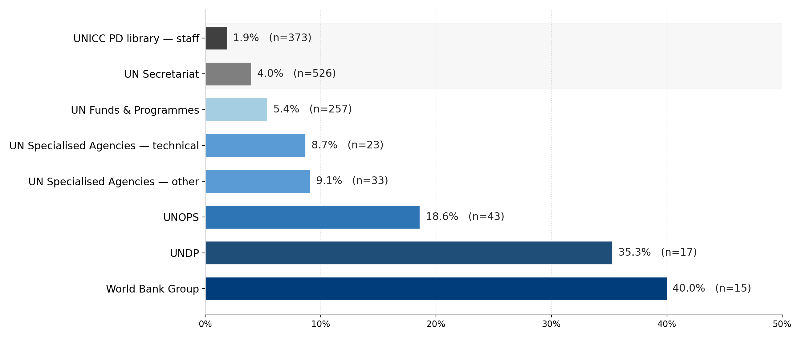
Figure 2: UNICC strategic landscape at the AI-Core bar. UNICC figure is stock (April 2026 PD library); peer figures are flow over the 9-month window August 2025 to April 2026.

3.1 Group level

Group | Tech postings | AI-Core | AI-Core %
UNICC PD library — staff (baseline) | 373 | 7 | 1.9%
UN Secretariat | 526 | 21 | 4.0%
UN Funds & Programmes | 257 | 14 | 5.4%
UN Specialised Agencies (technical) | 23 | 2 | 8.7%
UN Specialised Agencies (other) | 33 | 3 | 9.1%
Bretton Woods / IFI | 17 | 6 | 35.3%
Private sector ICT (Cisco/G7) | — | — | 78.0%

The UN Secretariat at 4.0% across n=526 is the most reliably-measured cohort and the natural analogue to UNICC's institutional position. UNICC at 1.9% sits below this figure even on the favourable stock-versus-flow comparison. The Bretton Woods cohort at 35.3% is dominated by World Bank Group (15 of 17 postings); the UN Funds & Programmes group at 5.4% is largely carried by UNDP and UNOPS, with other agencies in the group sitting at or below the Secretariat rate.

3.2 Agency level

Agency | Tech postings | AI-Core | AI-Core %
World Bank Group | 15 | 6 | 40.0%
UNDP | 17 | 6 | 35.3%
UN Office for Disaster Risk Reduction (UNDRR) | 7 | 2 | 28.6%
Office for the Coordination of Humanitarian Affairs | 8 | 2 | 25.0%
ITU | 5 | 1 | 20.0%
UN Office for Project Services (UNOPS) | 43 | 8 | 18.6%
UNICEF | 106 | 4 | 3.8%
UN Environment Programme (UNEP) | 41 | 1 | 2.4%
World Food Programme (WFP) | 85 | 1 | 1.2%
Office of Information and Communications Technology | 9 | 0 | 0.0%
UNRWA — Information Management HQ Amman | 19 | 0 | 0.0%
IOM | 23 | 0 | 0.0%
UNCTAD | 42 | 0 | 0.0%
WIPO | 9 | 0 | 0.0%
WHO | 11 | 0 | 0.0%

UNDP at 35% is the closest UN-system peer to UNICC. Same recruitment frameworks, same procurement constraints, similar mandate. Its AI-Core postings include 'AI Innovation Intern', 'Urban Data and AI Specialist (Green Transition)', 'Tech Lead Analyst, Software Engineering and Data Science', 'Digital, AI and Innovation Internship: Global Call for 2026'. The depth of integration — down to entry and intern level — is the substantive difference between UNDP and UNICC.
World Bank Group at 40% demonstrates the achievable ceiling within a multilateral framework. Its AI-Core postings include 'Software Engineer' with explicit AI / generative AI / Copilot requirements, 'Associate Software Engineer' with AI / ML / NLP / LLM / generative AI specifications. The bar is unambiguous; these are AI-Core roles by any reasonable definition.
Among UNICC's closest organisational analogues, AI-Core references are absent. OICT (the UN Secretariat's central IT function), UNRWA Information Management HQ, IOM, UNCTAD, WHO, WIPO — none have AI-Core postings in the window. This is the cohort UNICC's stock figure most resembles. It is not a cohort in motion.

4. Convergence Trajectory
Figure 3 shows four illustrative scenarios for UNICC's PD library trajectory, anchored on peer reference points re-measured at the strict tier.
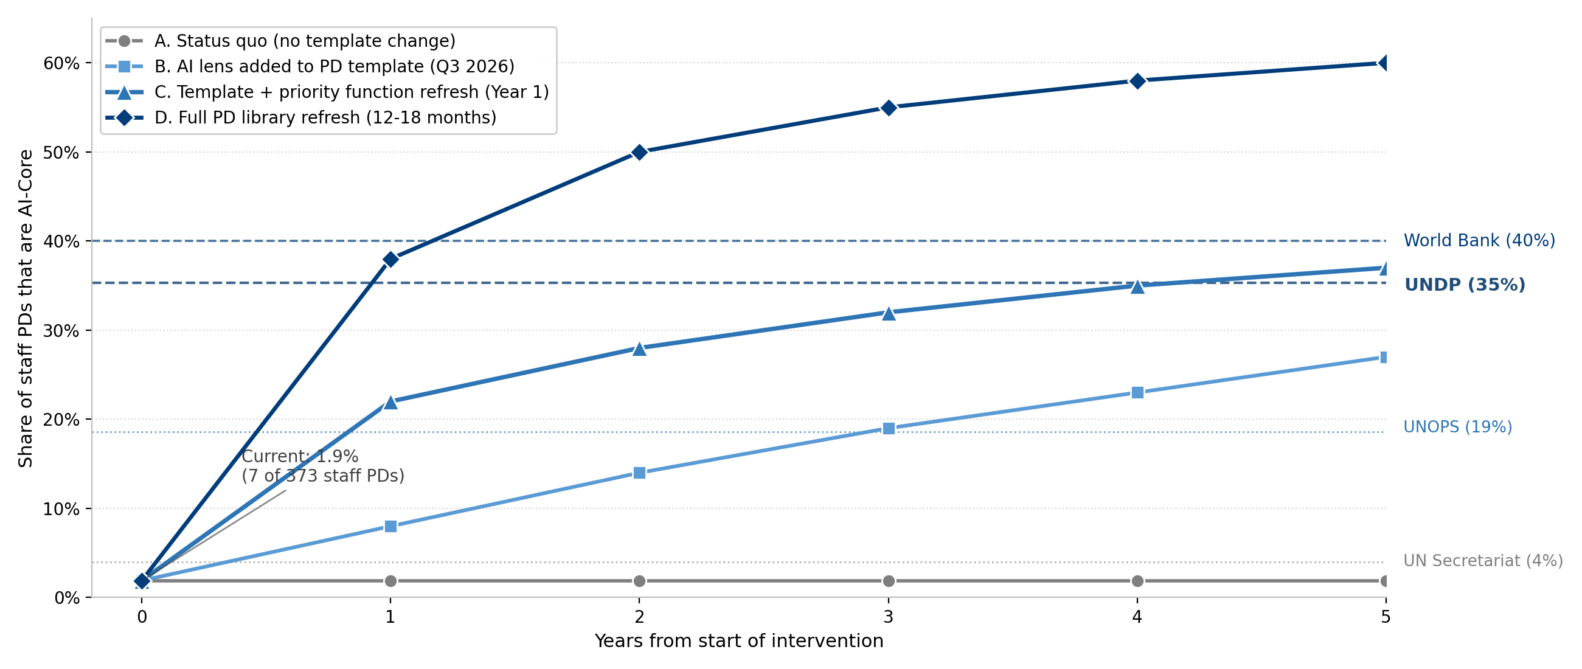
Figure 3: UNICC PD AI-Core convergence trajectory by scenario, with peer reference lines. Peer figures are themselves moving and shown as point-in-time anchors.

Scenario | Year 1 | Year 5 | Reaches
A. Status quo (no template change) | 1.9% | 1.9% | Nothing — relative gap widens
B. AI lens added to PD template (Q3 2026) | 8% | 27% | UNOPS-equivalent by Year 3
C. Template + priority function refresh (Year 1) | 22% | 37% | UNDP-equivalent by Year 4
D. Full PD library refresh (12-18 months) | 38% | 60% | World Bank / private-sector parity by Year 2

Scenario A is the only scenario under which UNICC's relative position deteriorates over the window; it should not be the working plan. Scenario B is the parent paper's existing recommendation; it does not catch UNDP within the strategic window. Scenario C is calibrated to the function-level finding in Section 2.3 — refresh the approximately 195 PDs in Cybersecurity, Digital Workplace, Enterprise Apps, and Network during Year 1 — and reaches UNDP's current position by Year 4. Scenario D is the escalation path.

5. The Boundary of What PD Refresh Can Do
PD refresh is the documentation track of a broader workforce response. It sets recruitment criteria, performance evaluation expectations, and partner-facing positioning. It does not, on its own, build the capability the refreshed PDs would then require. Refreshing Cybersecurity PDs to demand AI-Core competencies that the workforce does not yet have creates an expectations gap on top of the capability gap. The honest version of the workforce response has at least four tracks running in parallel.

Track | Owner | Question it answers
1. PD library refresh | HR + Section Chiefs | Are role specifications current?
2. Capability assessment | HR + Data and AI | Which staff have which AI-relevant skills today?
3. Skills development programme | Learning + Data and AI | How do we close the gaps the assessment identifies?
4. Workforce structural decisions | ManCom + HR | Which roles need redesign, redeployment, or different sourcing?

This document is scoped to track 1. The other three tracks belong in the Piciorea workforce strategic plan and the operating-model conversation in progress with the Director of HR. The recommendation in Section 6 is the PD-track ask only; it should be read alongside the broader workforce-response context, not as a substitute for it.

6. Recommendation
The recommended PD-track response is Scenario C: refresh the priority high-volume, AI-absent functions during Year 1 — approximately 195 PDs across Cybersecurity, Digital Workplace, Enterprise Apps, and Network — in parallel with the AI lens being added to the PD template in Q3 2026.

Element | Detail
Owner | Director of HR (PD classification programme), with input from Section Chiefs on priority function selection and from the Director of Data and AI on AI-Core specification language. The Chief of AI Hub should be consulted on the AI-Core bar to ensure alignment with the unit's published taxonomy.
Deliverable | (a) PD template change incorporating an AI lens, by Q3 2026; (b) refresh of approximately 195 PDs in priority functions (Cybersecurity, Digital Workplace, Enterprise Apps, Network), by Q4 2027; (c) consultant TOR refresh in parallel, completing by Q2 2027 given annual contract cycles.
Decision criterion | Quarterly review of UNICC JVN flow at the AI-Core bar, against UNDP, UNOPS, and World Bank Group strict-tier figures from the same UN aggregator data. Track is on plan if UNICC's quarterly JVN AI-Core rate is rising and the UNDP gap is narrowing.
Escalation | Move to Scenario D (full PD library refresh, 12-18 months) if (i) the UNDP gap fails to narrow within the first twelve months of execution, or (ii) UNDP's own figure moves materially upward (more than 10 percentage points within two quarters).
Out of scope | Capability assessment, skills development programme, and workforce structural decisions are complementary tracks belonging in the Piciorea workforce strategic plan and the operating-model conversation. This recommendation does not preempt those tracks; the four tracks should be sequenced together by ManCom.

7. Limitations and Next Steps

7.1 Limitations
Four limitations apply and should be noted in any external presentation.
First, the stock-versus-flow asymmetry. UNICC's 1.9% is a stock figure (full PD library); peer figures are flow figures (postings issued during the 9-month window). The asymmetry pulls in UNICC's favour — flow rates over-represent recent issuance while UNICC's stock includes older PDs. A flow-versus-flow comparison using UNICC's recent JVN data is the recommended next step.
Second, agency-level samples are small. UNDP at n=17 and World Bank Group at n=15 produce robust directional findings but precise percentages should be read with sample-size caveats. Directional findings are stable across alternative sample windows; precise percentages are not.
Third, PD refresh is a documentation metric, not a capability metric. UNDP at 35% AI-Core does not mean 35% of UNDP staff are AI-capable; it means UNDP has formally specified 35% of recent tech postings as AI-native roles. The gap between documentation and capability exists at every organisation.
Fourth, peer figures are themselves moving. UNDP at 35% and World Bank at 40% are point-in-time anchors as of April 2026; both are likely higher one year out given the trajectories in Section 1. The convergence model treats them as static reference lines for clarity; the strategic implication is that UNICC's required pace is at least as fast as the trajectories shown.

7.2 Recommended next steps
Three follow-on activities would strengthen the analysis and prepare the ground for the chosen trajectory.
Complete the UNICC JVN flow analysis at the AI-Core bar over the same 9-month window using the regex set in the Annex. Produces the flow-versus-flow comparison to UN-system peers that resolves the stock-versus-flow asymmetry. Expected resourcing: one HR analyst for one week.
Implement the quarterly measurement programme described in main paper Section 8, anchored on the AI-Core bar. Output: a quarterly dashboard tracking UNICC's measured position against the peer reference points presented here. Total incremental effort: low tens of person-days across HR, Learning, and Data and AI.
Refresh the peer comparison every six months. The aggregated UN jobs board API supports the methodology; a six-monthly refresh keeps the convergence model anchored against current rather than April 2026 peer positions and lets ManCom track whether the bifurcation observed in v1 (UNDP and the rest of the UN system pulling away from the Secretariat) is sustained.

Annex: Detection methodology
The following pattern set, applied to combined title-and-description text with re.IGNORECASE, defines the AI-Core bar throughout this document. The same set was applied to the UNICC PD library (with contextual QC layered on top to discard peripheral mentions) and to UN-system peer postings.

# Strict tier — AI-Core terminology
r"\bartificial\s+intelligence\b"
r"\bmachine\s+learning\b"
r"\bdeep\s+learning\b"
r"\bneural\s+network"
r"\bnatural\s+language\s+processing\b"
r"\blarge\s+language\s+model"
r"\bgenerative\s+AI\b|\bGenAI\b|\bgen[\s\-]AI\b"
r"\bfoundation\s+model"
r"\bcomputer\s+vision\b"
r"\bprompt\s+engineer"
r"\b(ChatGPT|Claude|GPT-?\d|Gemini|GitHub\s+Copilot|Microsoft\s+365\s+Copilot|M365\s+Copilot|Cursor|Anthropic|OpenAI)\b"

# False positives — masked BEFORE detection
r"\bAIDS\b|avian\s+influenza|\bAI\s+breeding\b|\bartificial\s+insemination\b"
Workflow: (1) substitute false-positive matches with a sentinel token; (2) run strict patterns against title-plus-description text; (3) flag a posting as AI-Core if any strict pattern matches. For the UNICC PD analysis, an additional contextual QC step reviewed each match in surrounding context and discarded peripheral mentions.

Sources
¹ UNICC Workforce Readiness in an AI-Enabled Operating Environment (March 2026 paper); UNICC AI-Core Strict-Tier Analysis (April 2026 workbook).
² Aggregated UN jobs board API. Full archive (include_all=true) retrieved 28 April 2026, 15,799 records, filtered to posted_date ≥ 2025-08-01, UN-system filter applied, tech filter applied (856 records).
³ Stanford AI Index Report 2026 (Lightcast posting data); PwC Global AI Jobs Barometer 2025; LinkedIn Workforce data 2025-26; WEF Future of Jobs Report 2025; Cisco AI Workforce Consortium ICT in Motion 2025.
⁴ UNDP Digital Strategy 2022-2025; World Bank Group ITS departmental materials referenced in active job postings (April 2026 snapshot).

