**Vascular Network Analysis User’s Manual**

1. **Set Up (only needed once)**
2. Download Vascular Network Analysis MATLAB files and modified Fiji plug-in from GitHub repository by selecting *Clone or download🡪Download ZIP*
3. Go to *Downloads*, left-click on the *VNA-master* zip file, select *Extract All…*, and choose a folder to store the files in by selecting *Browse...*
4. Download latest version of Fiji (ImageJ extension) at <https://imagej.net/Fiji/Downloads>
5. Copy *AnalyzeSkeleton_-3.1.4-SNAPSHOT.jar* from the *VNA-master* folder and paste it into Fiji’s plugin directory. This is most likely *C:\Users\*your user account here*\Fiji\fiji-win64\Fiji.app\plugins*. Delete the existing skeleton plugin. This is most likely named *AnalyzeSkeleton_- #.#.#* (the #’s will be vary depending on which version is currently installed).
6. Download latest version of MATLAB at <https://www.mathworks.com/downloads/>
7. Open MATLAB. Select the *Browse for folder* icon () on the top left side of the screen, open the *VNA-master* folder, and select the *MATLAB_Code* folder to make it the working directory.
8. **Generate Segmented and Binary Images of the Vessels in the Scan**

*Note: These steps are used to generate images from the uCT manufacturer (ScanCo) software. If you are using a different software to generate images, skip this section and go to the Appendix.*

1. Open the measurement in the evaluation software
2. Contour the area of interest
3. Run any script file to generate a segmented binary AIM
   1. Press the ‘T…’ button or navigate to Evaluation>3D Evaluation
   2. Select any script file (suggest #1: 3D Segmentation of 1 VOI, 1 solid object)
   3. If needed adjust VOI box to contain all contours
   4. If needed adjust threshold to select only vessels
   5. Press ‘Start Evaluation’
4. Once operation is complete, export the segmented binary AIM as DICOMs
   1. Go to File>Select Measurement
   2. Change Display from ‘ISQ’ to ‘All Files’
   3. Navigate to the correct scan
   4. Select the most recent segmented file. Most likely named something like DK0:[MICROCT.DATA.00000XXX.0000YYYY]C000ZZZ_SEG.Aim;F

where XXX is the sample number, YYYY is the measurement number, ZZZZ is the control number, and F is the iteration version. Select the highest value of F if multiple scripts have been run on this measurement.

* 1. Press the ‘T…’ button or navigate to Evaluation>3D Evaluation
  2. Select script file #8:Create Dicoms
  3. Alter the VOI until the area of interest (entire scan) is selected
  4. Press ‘Start Evaluation’

1. Use FileZilla (separate protocol) or other FTP software to copy the dicoms to your local server.
2. **Running the Vascular Network Analysis (VNA) Protocol**
3. Open Fiji
4. Import the DICOMs
   1. Going to *File🡪Import🡪Image Sequence…*
   2. Select the first image (DICOM) in the data set.
   3. Convert the data to 8 bit grayscale by selecting the settings shown below.

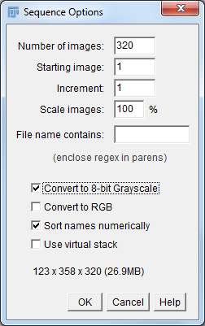

* 1. Click OK.
  2. The images should display as a sequence.

1. Skeletonize the data
2. Go to *Plugins*🡪*Skeleton*🡪*Skeletonize (2D/3D)*
3. The result should look like the following

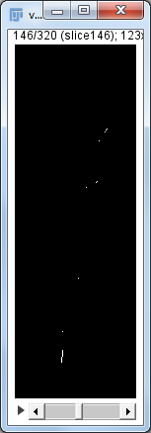

1. Analyze the skeleton
2. Go to *Analyze🡪Skeleton🡪Analyze Skeleton (2D/3D)*
3. Make sure the options are selected as follows

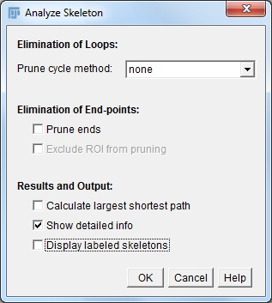

1. Save the produced data
   1. 2 windows should appear named “Branch information” and “Results” as shown below. Save each window as a .csv file by going to *File🡪Save as…* with whatever names you would like.

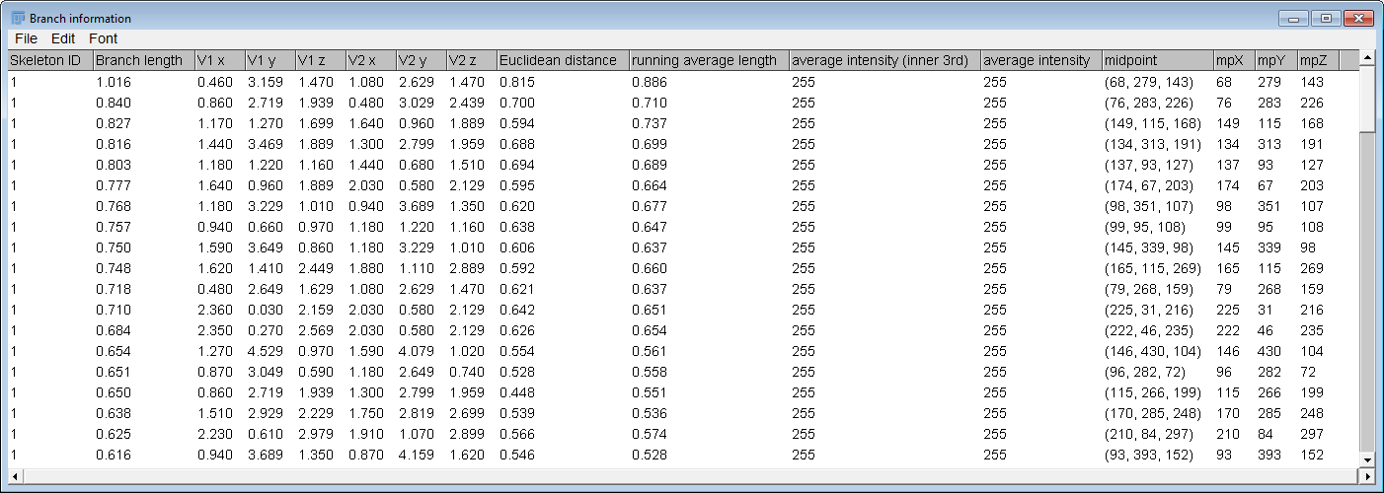

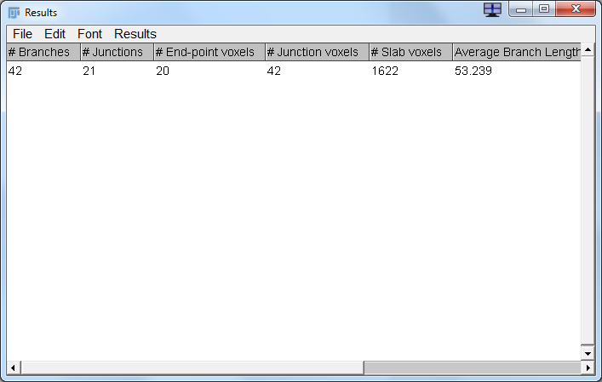

1. Exit out of Fiji, but DO NOT save the image stack. It is now skeletonized, and you will need the non-skeletonized image stack for the next module.
2. Vascular Analysis
3. Open Vascular Network Analysis .m file (MATLAB Code) in MATLAB.
4. Select ‘Run’ to get the GUI to open. Change folders if necessary.
5. Click *Browse* next to the label *Branch Information*. Input the *Branch Information* file (.csv) by navigating to it in the directory and clicking open.
6. Click *Browse* next to the label *Upload Raw Data*. Navigate to the location where you saved the segmented, binary image sequence (Not skeletonized).
7. Click the first image in the sequence and click Open.
8. After a few moments, a value will appear in the *Resolution (mm/voxel)* box. If this is incorrect, manually set it to the correct value.
9. If the data set is large (many slices in the z direction), check the *Accelerate Distance Transform* box BEFORE clicking run. This speeds up a lengthy computation with very minimal changes in accuracy.
10. Click Run.
11. After the program is finished processing, the results box will populate as seen below. You can toggle between mm and voxels by checking and unchecking the *mm/voxel* box. Histograms of the diameters and individual vessel lengths can be seen in the *Histogram* box. If the histogram is set to “manual”, it will require that you set a nonzero value for the *Number of Bins:* box. Data can be viewed and exported in the *View/Export* box.
12. Make sure to select ‘Export’ to save the summarized data in an excel spreadsheet

NOTE WELL: *Histogram* and *View* buttons **WILL NOT WORK** in MATLAB 2013. Please upgrade the MATLAB license to 2016 or above.

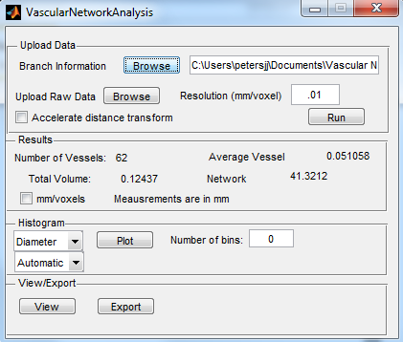

**Appendix**

If you start with grayscale images, use the following steps to crop and threshold the images, then resume from **step III.C**

1. Make the data segmented and binary
2. Open Fiji
3. Open the scans by going to *File🡪Import🡪Image Sequence…*
4. Select the first image (DICOM) in the data set.
5. Convert the data to 8 bit grayscale by selecting the settings shown below.



1. Click OK.
2. The data should display as a sequence.
3. Crop out any area that you do not want analyzed using the selection tools and Edit>clear or Edit>clear outside.
4. Threshold the data by going to *Image🡪Adjust🡪Threshold…*
   1. Use the sliders to eliminate as much noise as possible without removing too much of the vessels.

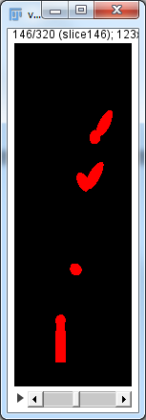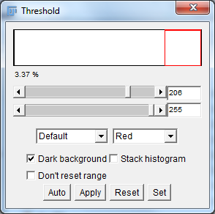

* 1. Click Apply.
  2. On the next window, change the settings to the following (probably just deselect *Calculate threshold for each image*) and click OK

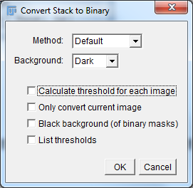

* 1. The result should look like the following
  2. 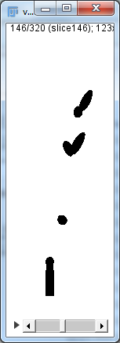

1. Save the thresholded data as TIFFs in the directory of your choice by going to *File🡪Save as🡪Image Sequence…* and selecting the settings shown below

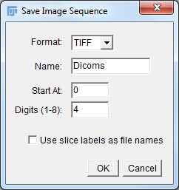

1. Continue on from **step III.C**

Any questions can be directed to vnamcbridegagyi@gmail.com