**Entry 1 - October 21, 2016**

I’ll definitely stick with my current project. I really believe in the idea and I think with the right amount of polish and thought that this project can be a great representation of my abilities on my portfolio. Frankly nothing looks on my portfolio is particularly good in my opinion, and I have no web development projects so I need to fill that beast quickly to get a portfolio. More time polishing one thing seems prudent.

**Entry 2 – November10, 2016**

I’m very unsure of what this should look like. Admittedly I haven’t though enough about this project in the interim, but I’ve been struggling with an appearance. I know I want it to rely less on text in the space, but what’s the motif? Right now I’m almost imagining a reasonably accurate representation of urban decay. Buildings around and such. And the gun is adjacent to you and fires…How that data is ever seen by the player is a mystery. If I go for realism it’s hard to justify crazy big bullets, but the big bullets are how I intended to show the data if users pan the cursor over them? But if they can’t see the bullets? I just need feedback. I’m designing in a vacuum.

**Entry 3 – November 14, 2016**

I’m super glad I can count on Ben to speak up in class. It sucks but he’s probably the only other student that provides constant feedback, and I’m glad he had an opinion. I’m going to abstract. What form that takes is open, but it does solve a great many problems I had before. I can treat the page like a normal web page rather than a VR thing. I can also rely heavier on text, eliminating the need for anything about the app to be learned. I also liked the feedback of incorporating more city data, or all the data in some way. I’m going to mull on that, I’m not quite sure what the solution is, but I’ll consider it.

**Entry 4 – November 18, 2016**

I definitely should have gotten this project on Github sooner. Before this point all of my work was being passed back and forth on Dropbox. I don’t hate that solution actually, but with a sufficiently complicated project the ability to roll back on commits saves lives.

That should be obvious though, but I definitely held back because it’s not quite as seamless as Dropbox. I literally don’t need to do anything and Dropbox works. Oh well.

**Entry 5 – November 19, 2016**

Ok I think I got almost the entire new interface done. It’s changed a ton so here’s a short summery of the reasons and decisions I made today.

1. No Sound
   1. This is the easiest to explain. Basically, I couldn’t figure out how audio on the web works. Specifically, I couldn’t get the same sound file to play overtop of itself. I wanted a super fast animation and SFX intro to the site, where the gun animates and you hear a gunshot for each injury and death. But if I can’t overlap SFX originating from the same file this gets more complex, and I didn’t want to solve for that rabbit hole.
2. No Animation
   1. Also easy to explain but way more confusing. I still can’t get new models in A-Frame to render properly. I think it has something to do with Maya. I used Maya to convert old models to DAE, but that never worked. The reason I think it’s Maya is because I also couldn’t take the gun model, which was ALREADY a DAE file and export that as two separate DAEs. In every single instance the textures failed and didn’t render. I dearly hope that A-Frame puts some work into this part of its engine.
3. Bullets Around Gun
   1. This basically makes up for not having sound or animation. I wanted to find a reason why I should use A-Frame at all, because without that it’s basically just a picture. But the bullets are super cool. I didn’t write the code that does that though, that credit goes to ngokevin on Github. His [K-Frame](https://github.com/ngokevin/kframe) component included a randomizer part that has a “random-spherical-position” function that I copied. I don’t know how to do 3D rotation math, so this would have been extremely difficult for me to do on my own. As it stands, I just took this one function and used it.
4. Flatter Layout
   1. I actually really liked Jay’s suggestion about Muller Brockmann and tried to match some of his start aesthetics and pallets. That’s where the overall layout was inspired by, particularly the used of the squares and angling them on their sides to give a somewhat jagged, teeth-like appearance.
5. Incident Cards
   1. So I basically threw out any notion that this app would be used like a 3D scene. I basically concluded that viewing data and viewing a 3D scene on your phone like that are largely incompatible. That doesn’t mean that it’s impossible, but I’m not trying to solve that UX problem right now. Pictured right is an example of exactly that, and one of the least straightforward UI’s ever created for a movie.

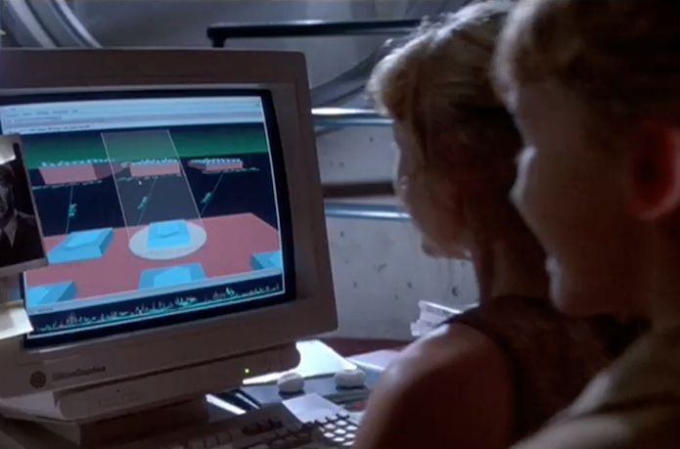

1. Color Palette
   1. Again, this was inspired by Brockmann’s work, but I specifically wanted red because of its connotations with danger, violence and blood.
2. Blank Cards
   1. These are the grey/dark grey squares between the ones with incidents. I included those because I wanted to give the cards I did have a little breathing room, and often a single city actually couldn’t fill enough cards to go below the fold, so when that happened I felt the screen was just a little empty. I wanted to make sure I conveyed that the machine wasn’t broken, it’s just there were very few shootings recently.

**Entry 6 – November 23, 2016**

I spent a little more time on the web scraping problem today and I think I proved to myself that I can do this, even if it’s complex. I had a lot of trouble relying on the off-the-shelf options from NPM, and It doesn’t help that gun violence archive’s webpage doesn’t use a ton of id’s or unique classes, so It’s hard to parse, but I eventually found one that just scrapes tables. I think I can use it to get at least the source, because that’s been my biggest frustration with getting this data. They don’t fill in their sources in the CSV’s you can export!

**Entry 7 – December 3, 2016**

Ok so never mind. Those off the shelf options mostly didn’t work. They didn’t really give me the opportunity to modify them as much as I needed too, and that problem of unique ids kept coming up. But I have a better solution now. There’s an npm module called Cheerio that’s a dependency for some of the ones I’m using, and it basically lets me load a web page remotely and scrape data with JQuery commands. It’s beautiful, and I’ve been able to get each requisite part that I need from the page. I just need to store that data properly.

**Entry 8 – December 4, 2016**

I managed to get the program scraping new data on startup. I don’t have time before this deadline tomorrow to figure out how to set this up on server and have it running continuously, but given that I’ve been unable to get access to a more permanent server location it’s not the worst to have this aspect missing. I’ll just leave the code commented and submit a version of this code that should work on a local machine.

Plus! Dropdown location picking! It’s not a full-featured input but it’s at least partway there. I ended up using materialize for it’s dropdown code because I didn’t’ have time to figure that out but I did have time to style it to match my aesthetic.