McCall Tucker

Written Thesis

As a classically trained artist and, more recently, a web developer, the goal of my work is to unify my various fields of interest; by creating a form of art that is as much as painting as it is a website, and vice verse. In particular, I am creating visionary artwork illustrated with the languages of the world wide web (HTML, CSS, and Javascript) and consider myself a part of those who are pioneering the field of 3D CSS, which is still in its infancy. I intend for the theme to highlight a sort of digital alchemical transition of the objects and colors within it, which exist in relation to the languages the describe and built it.

I think it is important to have some historical perspective of my path as an artist to appreciate my intentions with this thesis. Just a few years ago, 2D art my was primary (and only) real artistic medium. With strong importance placed on the ‘craft’ of the artwork, I created a wide array of different multimedia work on canvas using mediums such as graphite, ink, acrylic, and (sometimes) oil. Using sacred symbols, shapes, patterns, and highly saturated colors, I created work hoping to somehow depict and animate a connection to the sacred, awe, wonder, and the infinite as well as unifying gritty street art with psychedelia. For years I traveled to shows and music festivals across the country as a live performance artist, and began to learn to mix my slow and careful studio ‘stroke’ with the energy of the music and my environment at these shows. Because I would carefully sketch out an idea before one of these shows, and then illustrate this framework with the energy from my environment as a live painter; these artworks often have an underlying thematic clash with geometry and chaos; or of the left and right hemispheres of the brain. I find this sort of unison, where white meets black or fire meets water, to be one of the most exciting things to illustrate and capture in a piece of art.

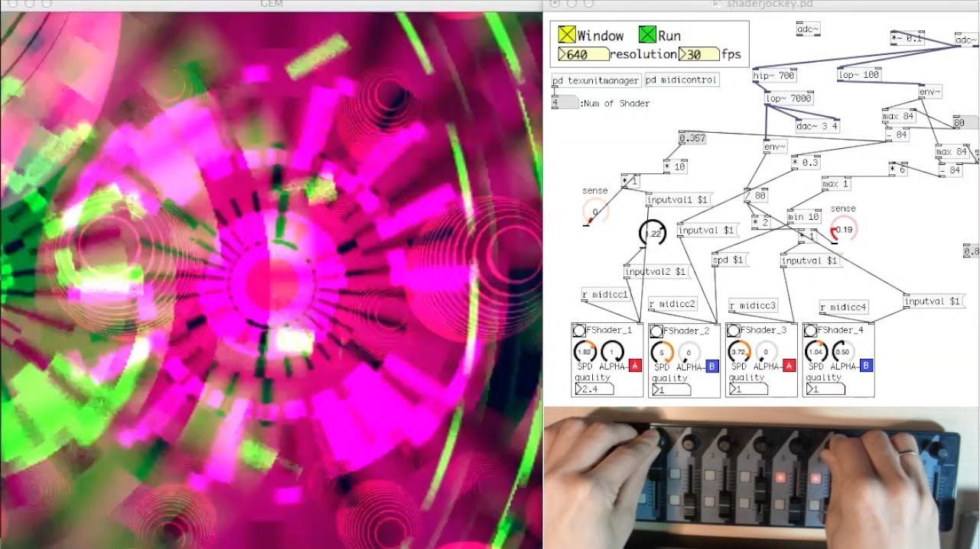  
Pure Data Gem Visualizer from ShaderJockey (GLSL Shader VJ), Youtube

As time passed, I began exploring other ways I could find this point of contrast in the same artwork, and began delving into the digital realm, hoping to unify these ‘analog’ forms of artwork with digital ones. I began experiment with software such as the ‘Pure Data gem visualizer’ to create shapes and animations extremely close the very root of all motion graphics, by defining specific X,Y,X coordinates in a virtual space, and RGB color mapping. I realized that this scientific approach of creating a visual form holds significant potential to me as an artist.

Artists such as ‘Android’ Jones were of great inspiration to me, as he would playfully combine his visionary artwork with different interactive (digital) mediums for his audience.

As time passed, my interests in this left brained approach took precedence, and I took up another associates degree in electronic media technology at UC blue ash. I began experimenting and learning other elements as well, such as animating my drawings over time, and the radically different approach you must take in order to keep motion looking truly ‘lifelike’, as well as a number of other approaches of creating and manipulating things digitally. My favorite, however, was a series of web development courses I took which introduced me to the languages that make up the Internet. Since that point I have been passionately pursuing this path, and was hired as a full time web developer last year. With such a range of different interests and mediums, the goal has consistently been to find this point where these fields converge; this point of unity and contrast, and to focus on that intersection.

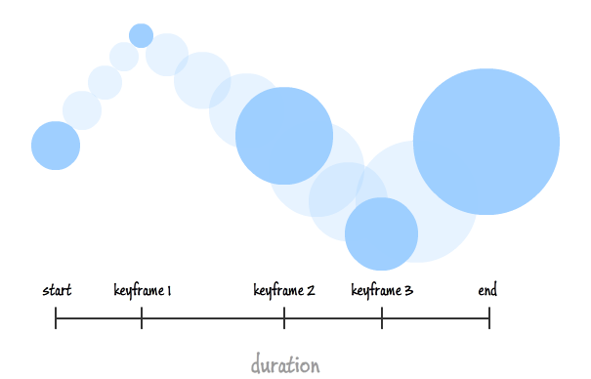  
CSS Animations (aka Keyframe Animations), Kiurpa

For this thesis in particular, my motivation was to create a painting with references to my older style, only limited to a very specific medium; this medium being the languages that make up the world wide web. I chose a centerpiece from one of my favorite old canvas paintings, “The eye of Horus”, created in 2012. Using his multiple arms as a foundation for a series of geometric blocks, I began creating this painting/website. In each block, I used the very limiting techniques CSS offers to create 5 different polygons, and a circle, which was a feat unto itself (the pentagon and octagon in particular). Using the experimental ‘key-frames’ code, I began animating these blocks to spin infinitely along their axis, and to move through a progression of 10 colors along the color wheel, on repeat over 10 second intervals. On mouse hover, I was able to successfully enable 45 degree rotation on both the X and Y axes, only to stop off mouse hover. Because the world of 3D CSS development is still in its infancy a majority of browsers still somewhat buggy if you push being to push thing as far this thesis does. I believe I was actually the first person to discover a bug that exists in both the Chrome and Firefox browsers due to the convoluted arrangement I was required to use to enable these features, which was only noticed when multiple layers of these transition and animation effects were used simultaneously. As a result, I was forced to write my code for one browser or the other, and chose to use the Chromium based browser as the foundation for this work. I felt that this progression along the color wheel and of the various rotating polygons in each hand successfully captured this notion of malleable alchemical objects inhabiting the space above each hand. As a background, I chose a manipulated photograph of space to set the stage this theme as well.

In the future, I hope to expand on this piece with more JavaScript to enable possibilities such as light and shadow on the polygons, and to add more complexity to their movement. One suggestion I really like from my critique was creating click functions on each of the shapes that would substitute the center figure with a different variation of itself, such as a businessman, or a creature, to further this notion a of multi-dimensional form. To do some of this, I need to familiarize myself with the JavaScript ‘canvas’ element, and certainly have my work cut out for me in the upcoming semester.

Works Cited

*ShaderJockey (GLSL Shader VJ) on Pure Data GEM*. Digital image. *YouTube*. Cellectronic, 3 Jan. 2015. Web.

*CSS Animations (aka Keyframe Animations)*. Digital image. *Kirupa*. Kirupa, 7 Oct. 2015. Web.