I’ve only ever used Eclipse, and so these instructions are for eclipse. The are largely based on these instructions : **Configure Eclipse to edit a plugin** at <https://www.micro-manager.org/wiki/Writing_plugins_for_Micro-Manager>

These steps assume that you have already followed these instructions:

* 1. *Download and install FIJI31.*
  2. *Download and configure Micro-Manager29,30 as a FIJI plugin31.* 
     1. *From the directory into which micromanager was downloaded, copy all of the “libmmgr_dal” files and paste them into the Fiji.app directory. Similarly, copy the “mmplugins” directory and the “mmautofocus” directory from the micromanager directory to the Fiji.app directory.*
     2. *Copy the “plugins/Micro-Manager” directory from the micromanager main directory to the “plugins” directory in the Fiji.app directory.*

Copy the BioreactorController folder to your Eclipse workspace, then follow the next 5 steps to get eclipse to actually recognize it (taken from this link: http://stackoverflow.com/questions/3924229/adding-existing-project-folders-to-the-project-explorer-in-eclipse”

1. From the main menu bar, select **File > Import**. The Import wizard opens.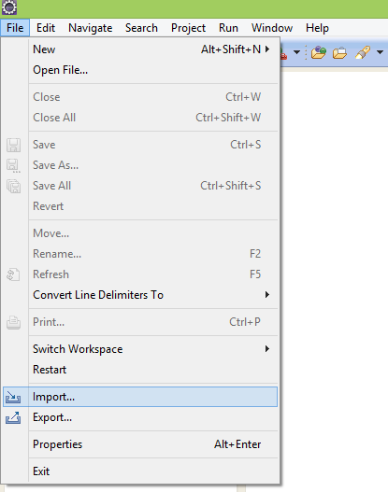
2. Collapse or click **+** in **General > Existing Project into Workspace** and click **Next**.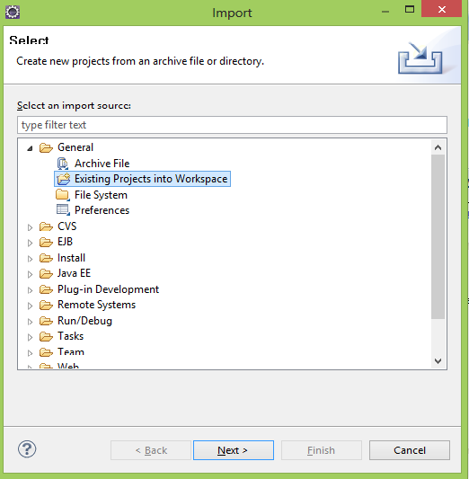
3. Choose either **Select root directory** or **Select archive file** and click the associated **Browse** to locate the directory or file containing the projects.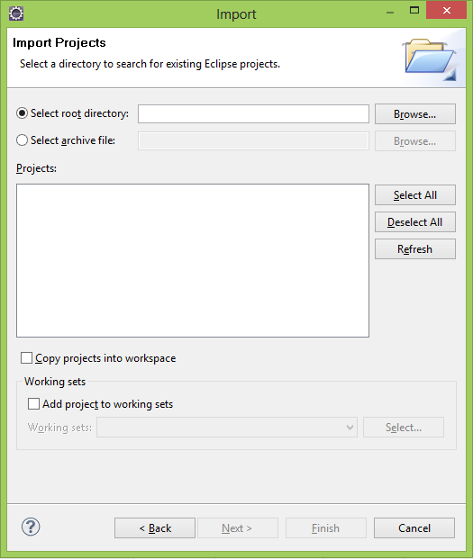
4. Under **Projects** select the project or projects which you would like to import. 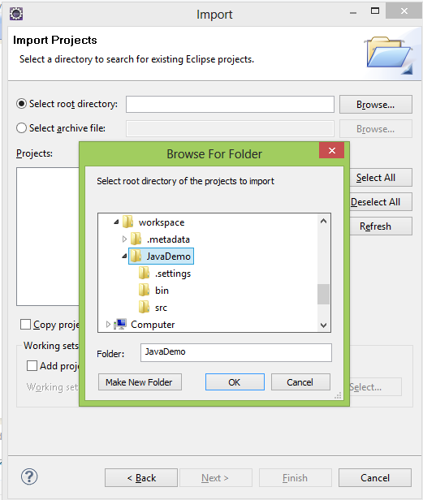
5. 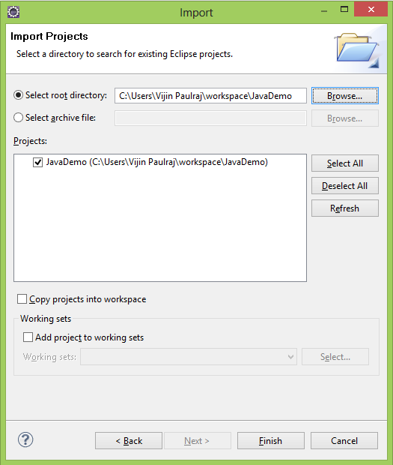Click **Finish** to start the import.

Ok, now you should have the project in the folder. Open the “src” folder, and navigate to the “.java” files. You will likely see a bunch of import error like this:

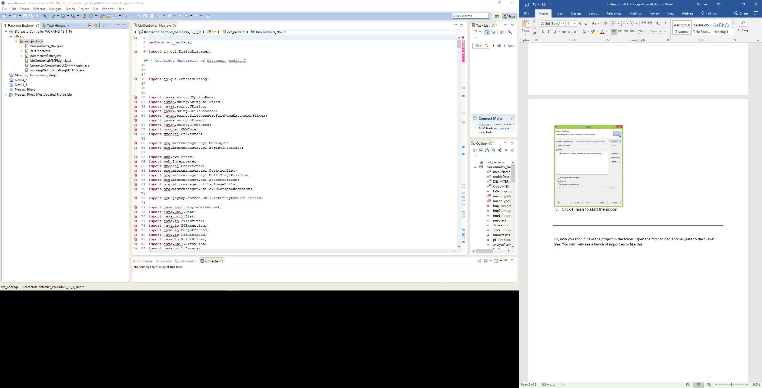

This code references external JARs from micromanager and imageJ, and so the build path needs to be configured.

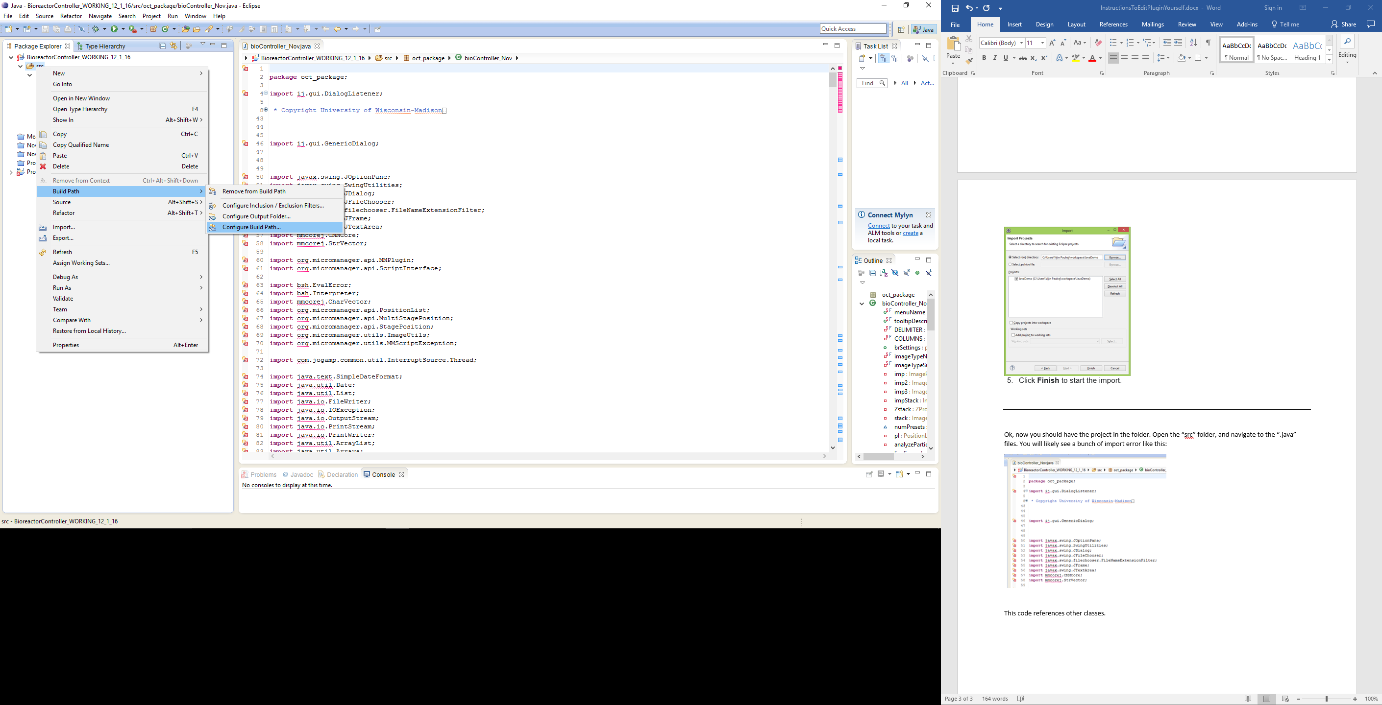

And then add External JARs…

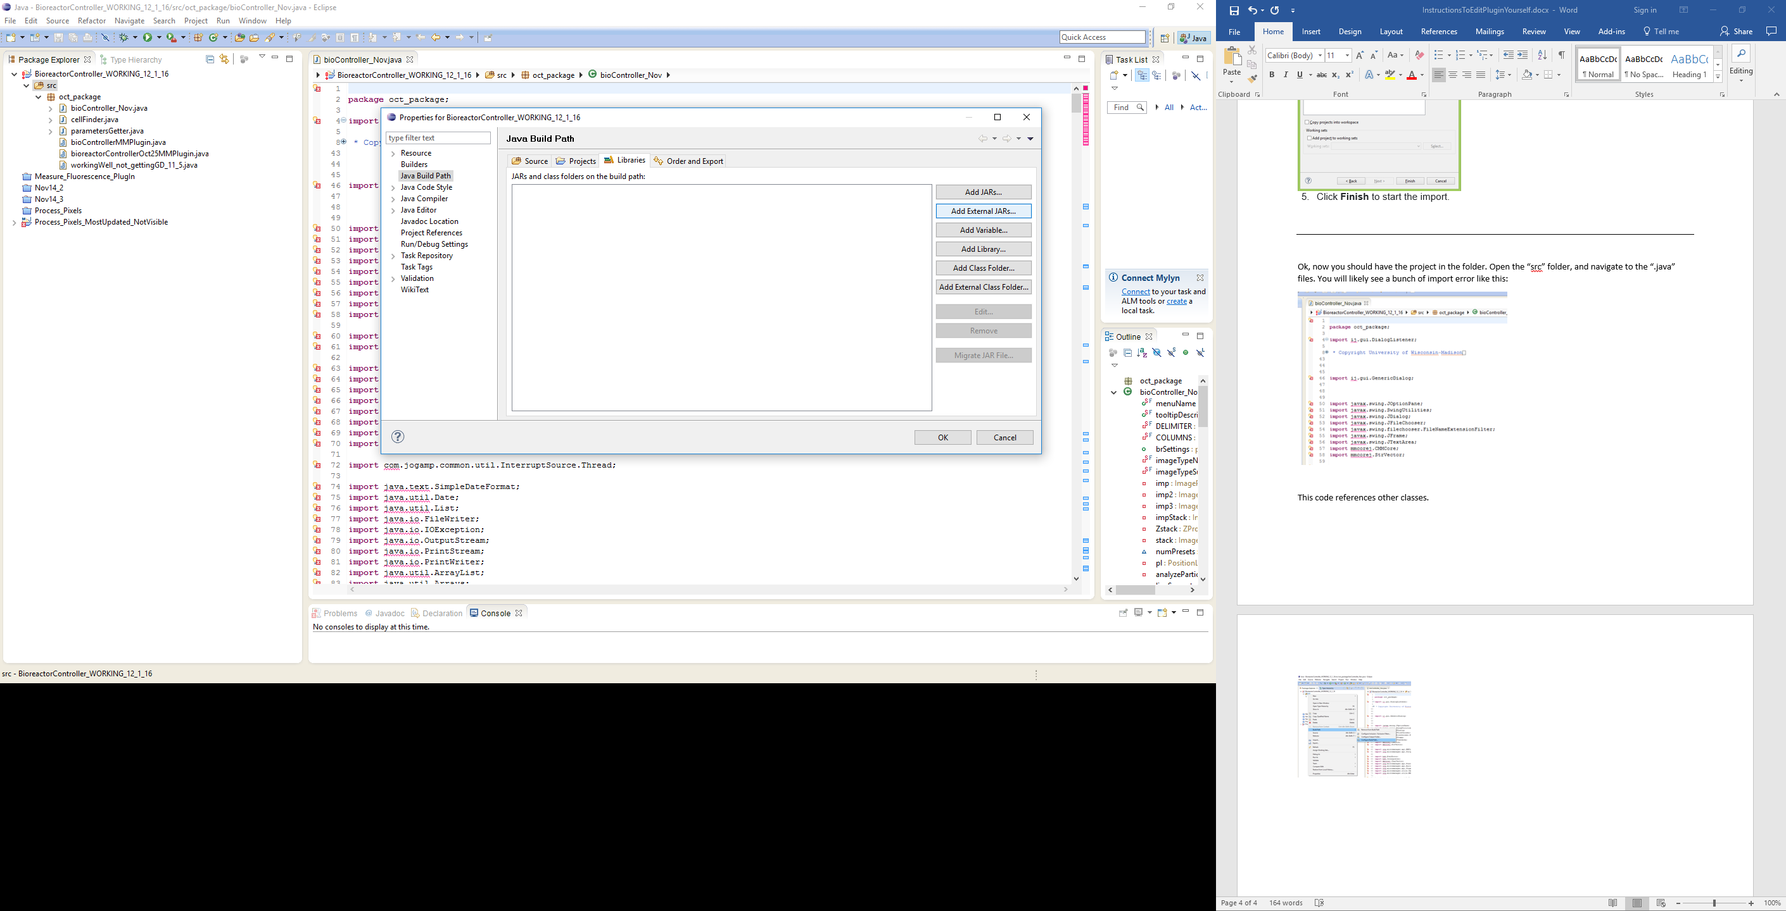

This part is a bit tedious. Add every JAR in the FIJI download folder. To do this quickly, click one and then hold shift + ↓ to select many, or use Ctrl+a in Windows to select all.

* Everything in the “jars” folder of the FIJI download.
* Everything in the “plugins\Micro-Manager” folder of the FIJI download.
* Everything in the “plugins” folder. I just did Ctrl+a in Windows to select all jars and subfolders. Note that this instruction might be redundant with the one above. I specify the one above to ensure that it is definitely included.

Next, ensure that you use the same JRE as FIJI by :

Add FIJI’s JRE to Eclipse

1. Window -> Preferences; under Java, select Installed JREs and click Add...
   1. Use Standard VM
   2. Set the JRE Home to C:\Users\Cameron\Downloads\fiji-win64\Fiji.app\java\win64\jdk1.8.0_66\jre (or similar).
   3. Eclipse should fill in the rest.
   4. Consider making thismanager JRE the default, or when you create projects make sure to select this as the JRE
   5. Click Finish
2. Check the checkbox next to the newly-added JRE.

Then, ensure that the project uses that same JRE:

Project > Properties > Java Build Path > Libraries

Add Library... > JRE System Library

Click “Alternate JRE:”, the “Installed JREs”, then select the newly added FIJI JRE, the click “Ok” and then “Finish”

Ok, now there should not be errors. If you have errors, a Google search of the error will usually return a StackOverflow page that describes exactly how to fix it. Good luck!