TECHNICAL SECURITY ASSESSMENT REPORT
Password Cracking Assessment:
John the Ripper vs. NetworkWalks Online Password Cracker
Dictionary Attack Against Password-Protected PDF Documents

Report Title | Password Security Assessment — Dictionary Attack Against Password-Protected PDF Files
Prepared By | Solomon Isaiah Diri
Program | NetworkWalks Cybersecurity Internship
Instructor | Waqas Karim (CCIE)
Batch | B083
Week / Topic | Week 03 — Dictionary Attack on Password-Protected PDF
Date | September 20, 2026
Classification | Internal / Training Use Only — Not for External Distribution
Document Version | 1.0
Note: All target files, credentials, and flags in this report belong to a controlled NetworkWalks training lab. No production systems or third-party data were involved.

Table of Contents

1. Executive Summary
This report documents a password-recovery lab completed during Week 3 of the NetworkWalks cybersecurity internship (Batch B083). The objective was to recover the passwords protecting three lab-issued, password-encrypted PDF files using a dictionary attack, and to compare an industry-standard offline cracking tool — John the Ripper, operated through the Johnny GUI — against NetworkWalks' browser-based password-cracking simulator.
All three target files were cracked successfully using both approaches, and each success was confirmed by a captured lab flag. The recovered passwords (good-luck, password1, and 1qaz2wsx) were all common, low-entropy strings drawn from standard wordlists, demonstrating that dictionary attacks remain highly effective against weak or predictable passwords regardless of the underlying document encryption strength. The exercise reinforces that wordlist coverage — not the sophistication of the cracking tool — is typically the deciding factor in a successful attack, and that password strength, not encryption algorithm alone, is the primary control against this class of threat.

2. Scope and Objectives
The scope of this assessment was limited to a controlled training environment provided by NetworkWalks. It covered the following objectives:
- Extract the John the Ripper–compatible $pdf$ hash from each password-protected PDF.
- Understand the mechanics of a dictionary attack using NetworkWalks' browser-based cracking simulator as a conceptual walkthrough.
- Perform an offline dictionary attack against each extracted hash using John the Ripper (Johnny GUI).
- Compare recovery outcomes and speed between the simulator and the industry-standard tool.
- Document key observations, risk implications, and defensive recommendations.
No production systems, third-party data, or files outside the lab-issued set were accessed at any point during this exercise.

3. Lab Environment and Tools
Component | Details
Host | Personal Windows PC
Cracking Engine | John the Ripper 1.9.0-jumbo-1 (Windows build), operated through the Johnny GUI
Hash Extraction (Online) | Online HashCrack — web-based converter that extracts the John-compatible $pdf$ hash from a password-protected PDF
Hash Extraction (Local) | pdf2john.pl, bundled with the Jumbo build of John the Ripper
Concept Walkthrough | NetworkWalks' “Password Cracker Through Dictionary Attacks” browser lab (networkwalks.com/password-cracker/)
Wordlists | Simulator's built-in 100-password list and fasttrack.txt (221 words); a larger breach-derived dictionary for the John the Ripper run
Targets | Three lab-issued password-protected PDF files: My locked pdf1.pdf, My locked pdf2.pdf, My locked pdf3.pdf

4. Technical Background: PDF Encryption and the $pdf$ Hash Format
PDF supports password-based encryption using either RC4 or AES, depending on the security-handler revision declared in the file. Tools built around John the Ripper's pdf2john logic — including the Online HashCrack converter used in this lab — parse a locked PDF's encryption dictionary and output a single $pdf$-prefixed hash string that encodes the security-handler revision, key length, permission flags, and the document's U/O security values.
That hash string contains everything John the Ripper needs to attempt recovery: the original PDF is not touched again once the hash is extracted, so the entire attack runs offline. From that point, it is a standard dictionary attack — each candidate word is hashed using the same algorithm that protected the PDF, and the result is compared against the stored hash. A match recovers the plaintext password; every other candidate is discarded without effect on the target file.

5. Methodology

5.1 Extracting the Password Hash
Each locked PDF was uploaded to Online HashCrack's converter, which returned a $pdf$-format hash string ready for use with John the Ripper. The same result can be produced locally, without relying on a third-party service, using the pdf2john script bundled with the Jumbo build of John:
perl pdf2john.pl "My Locked PDF2.pdf" > pdf_hash.txt

5.2 Concept Validation: Browser-Based Dictionary-Attack Simulator
Before running the production-grade tool, a sample $pdf$ hash was pasted into NetworkWalks' web-based Password Cracker lab, which mirrors John the Ripper's own logic: hash every word in a candidate list and compare it against the target hash. The first attempt, run against the built-in list and fasttrack.txt (221 words), returned ACCESS DENIED — the actual password was not present in that list. This confirmed the core limitation of any dictionary attack: it only succeeds when the true password exists in the wordlist being used.

5.3 Cracking with John the Ripper (Johnny GUI)
Johnny was pointed at the local john.exe (Jumbo build) executable, confirmed as John the Ripper version 1.9.0-jumbo-1. Each extracted PDF hash file was loaded and attacked in dictionary mode. The command-line equivalent of the operation Johnny performs under the hood is:
john --format=PDF --wordlist=<wordlist.txt> pdf_hash.txt
john --show --format=PDF pdf_hash.txt
All three PDF challenges were cracked using this method, with each recovered password displayed directly in Johnny's Passwords tab, and each success unlocking a corresponding NetworkWalks lab flag (see Section 6, Results).

6. Results
The following tables summarize the passwords and flags recovered for each target file, first using John the Ripper and then using the NetworkWalks online cracker.
Table 1. Results — John the Ripper (Johnny GUI)
Target File | Method | Recovered Password | Flag Captured
My locked pdf1.pdf | John the Ripper (Johnny GUI), dictionary mode | good-luck | nw{cybersecurity_flag_captured_2608}
My locked pdf2.pdf | John the Ripper (Johnny GUI), dictionary mode | password1 | nw{networkwalks_persistence_jtr_270521}
My locked pdf3.pdf | John the Ripper (Johnny GUI), dictionary mode | 1qaz2wsx | nw{networkwalks_flag_260821_1}
Table 2. Results — NetworkWalks Online Password Cracker
Target File | Method | Recovered Password | Flag Captured
My locked pdf1.pdf | NetworkWalks online cracker | Password1 | nw{networkwalks_flag1_jtr_270521_1}
My locked pdf2.pdf | NetworkWalks online cracker | Password1 | nw{networkwalks_persistence_jtr_270521}
My locked pdf3.pdf | NetworkWalks online cracker | 1qaz2wsx | nw{networkwalks_flag_260821_1}

7. Evidence

7.1 John the Ripper Evidence
My locked pdf1.pdf
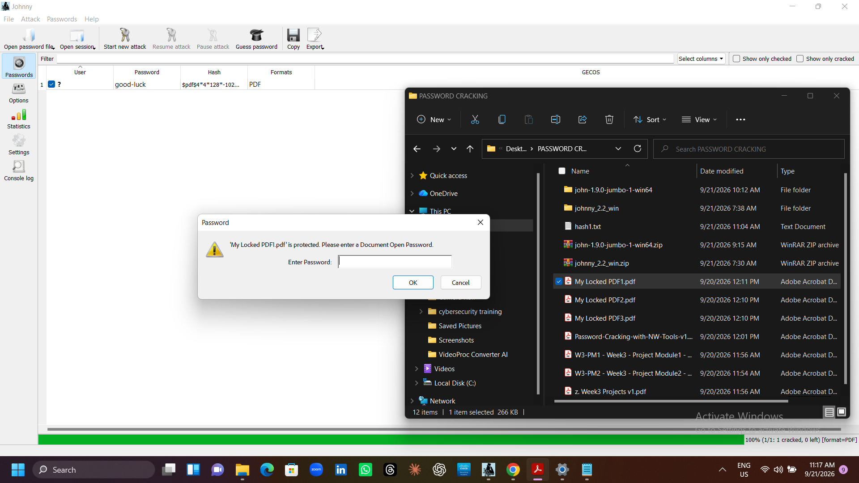
Figure 1. Johnny GUI — dictionary attack configuration for pdf1.
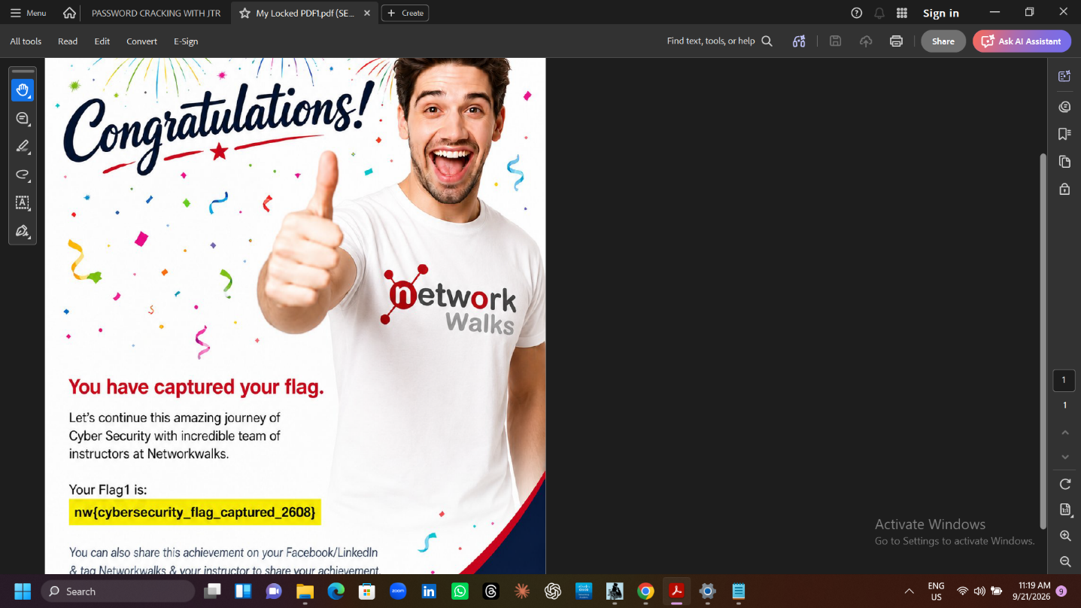
Figure 2. Johnny GUI — recovered password displayed in the Passwords tab for pdf1.
My locked pdf2.pdf
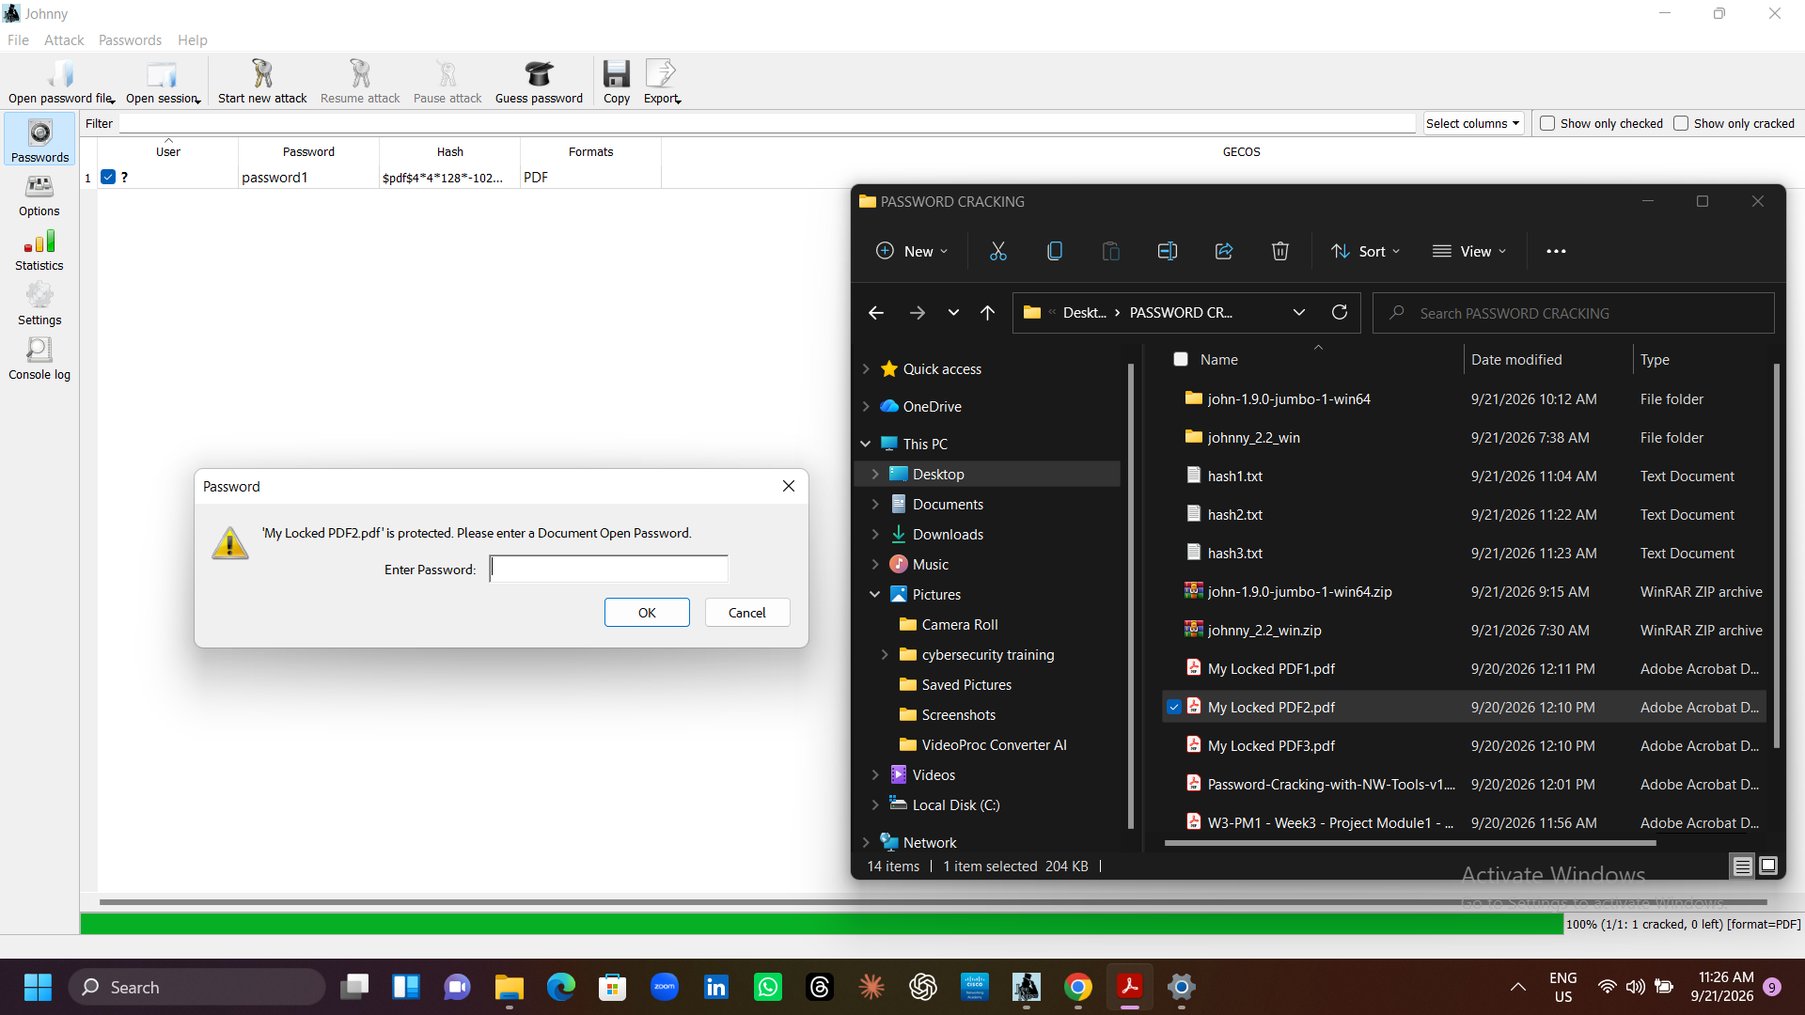
Figure 3. Johnny GUI — dictionary attack configuration for pdf2.
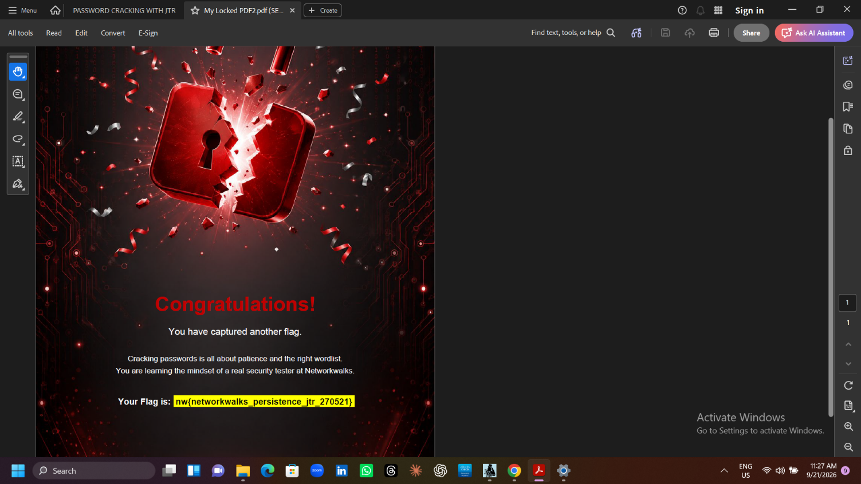
Figure 4. Johnny GUI — recovered password displayed in the Passwords tab for pdf2.
My locked pdf3.pdf
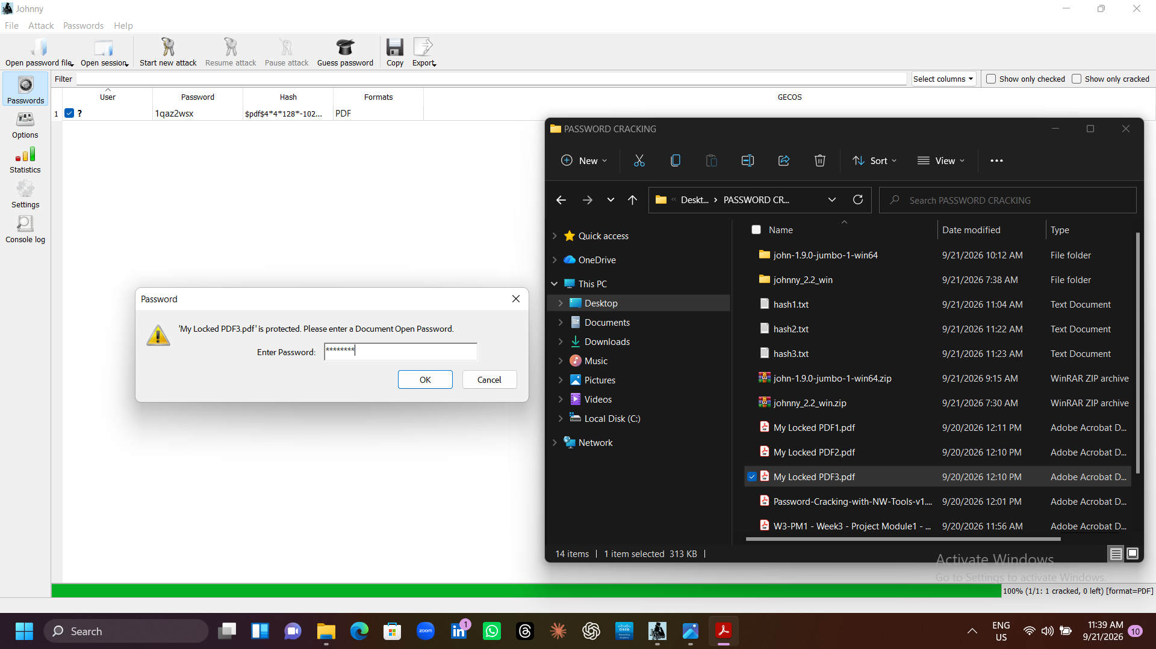
Figure 5. Johnny GUI — dictionary attack configuration for pdf3.
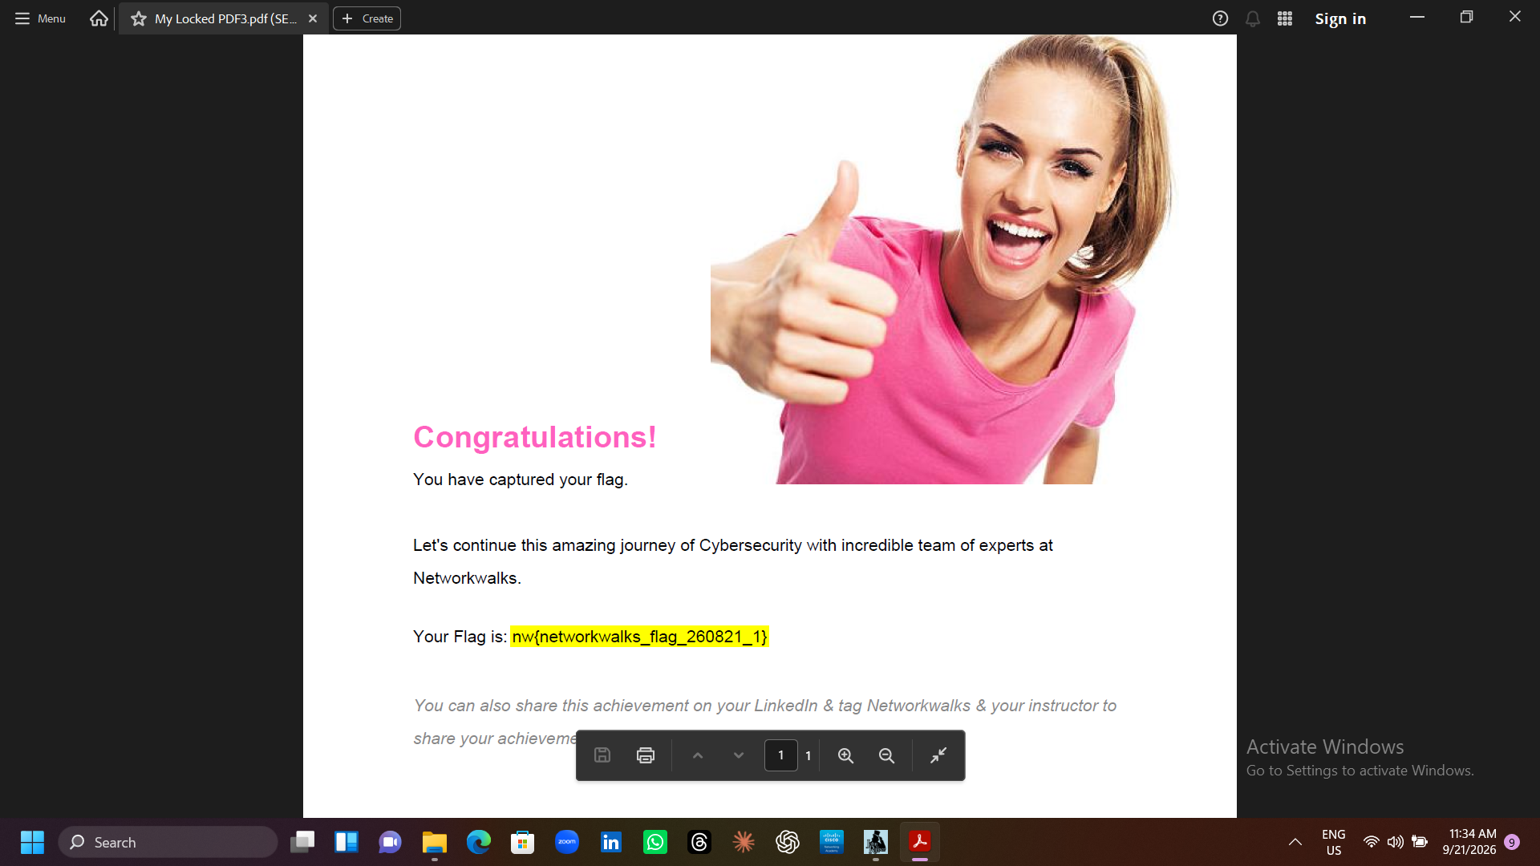
Figure 6. Johnny GUI — recovered password displayed in the Passwords tab for pdf3.

7.2 NetworkWalks Online Cracker Evidence
My locked pdf1.pdf
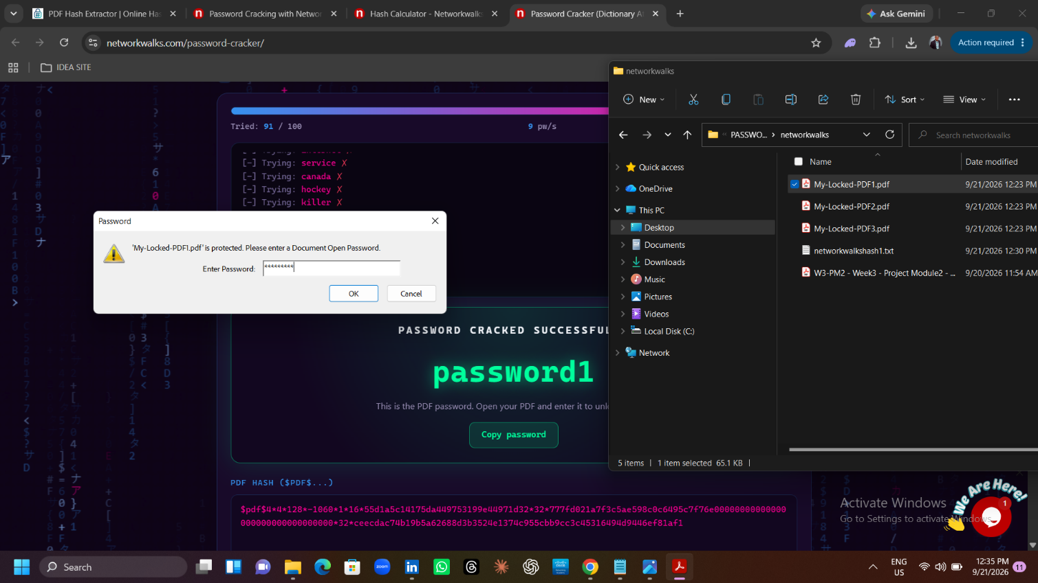
Figure 7. NetworkWalks online cracker — attack in progress for pdf1.
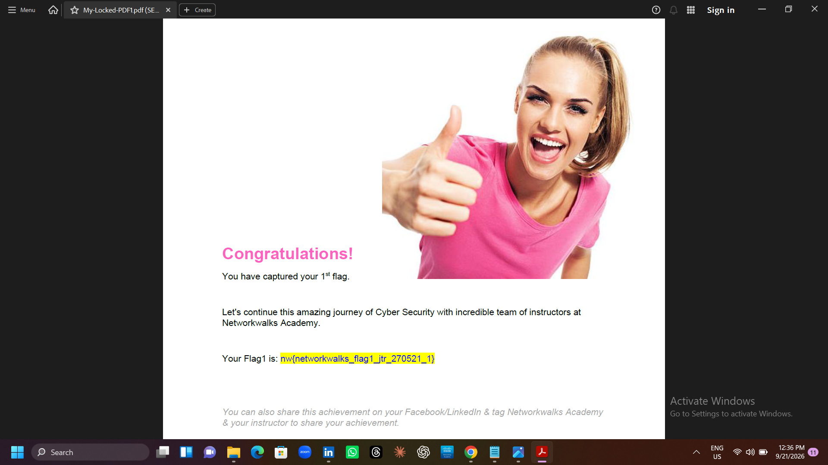
Figure 8. NetworkWalks online cracker — recovered password and flag for pdf1.
My locked pdf2.pdf
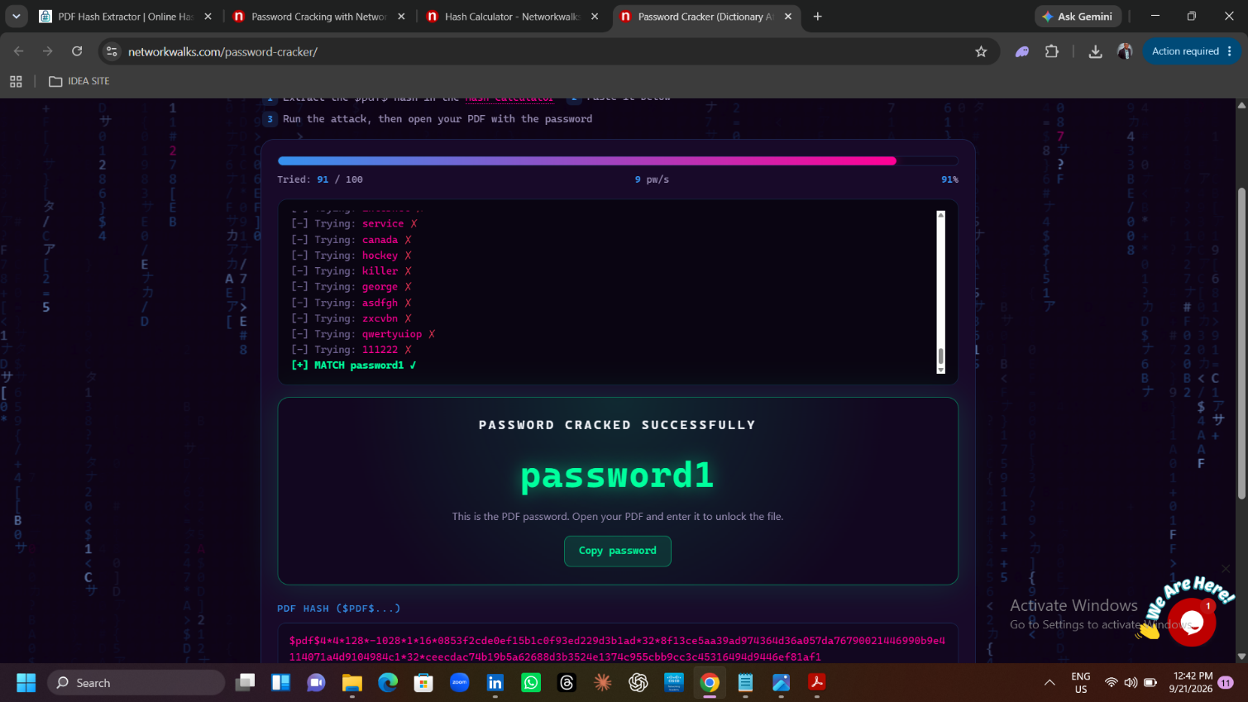
Figure 9. NetworkWalks online cracker — attack in progress for pdf2.
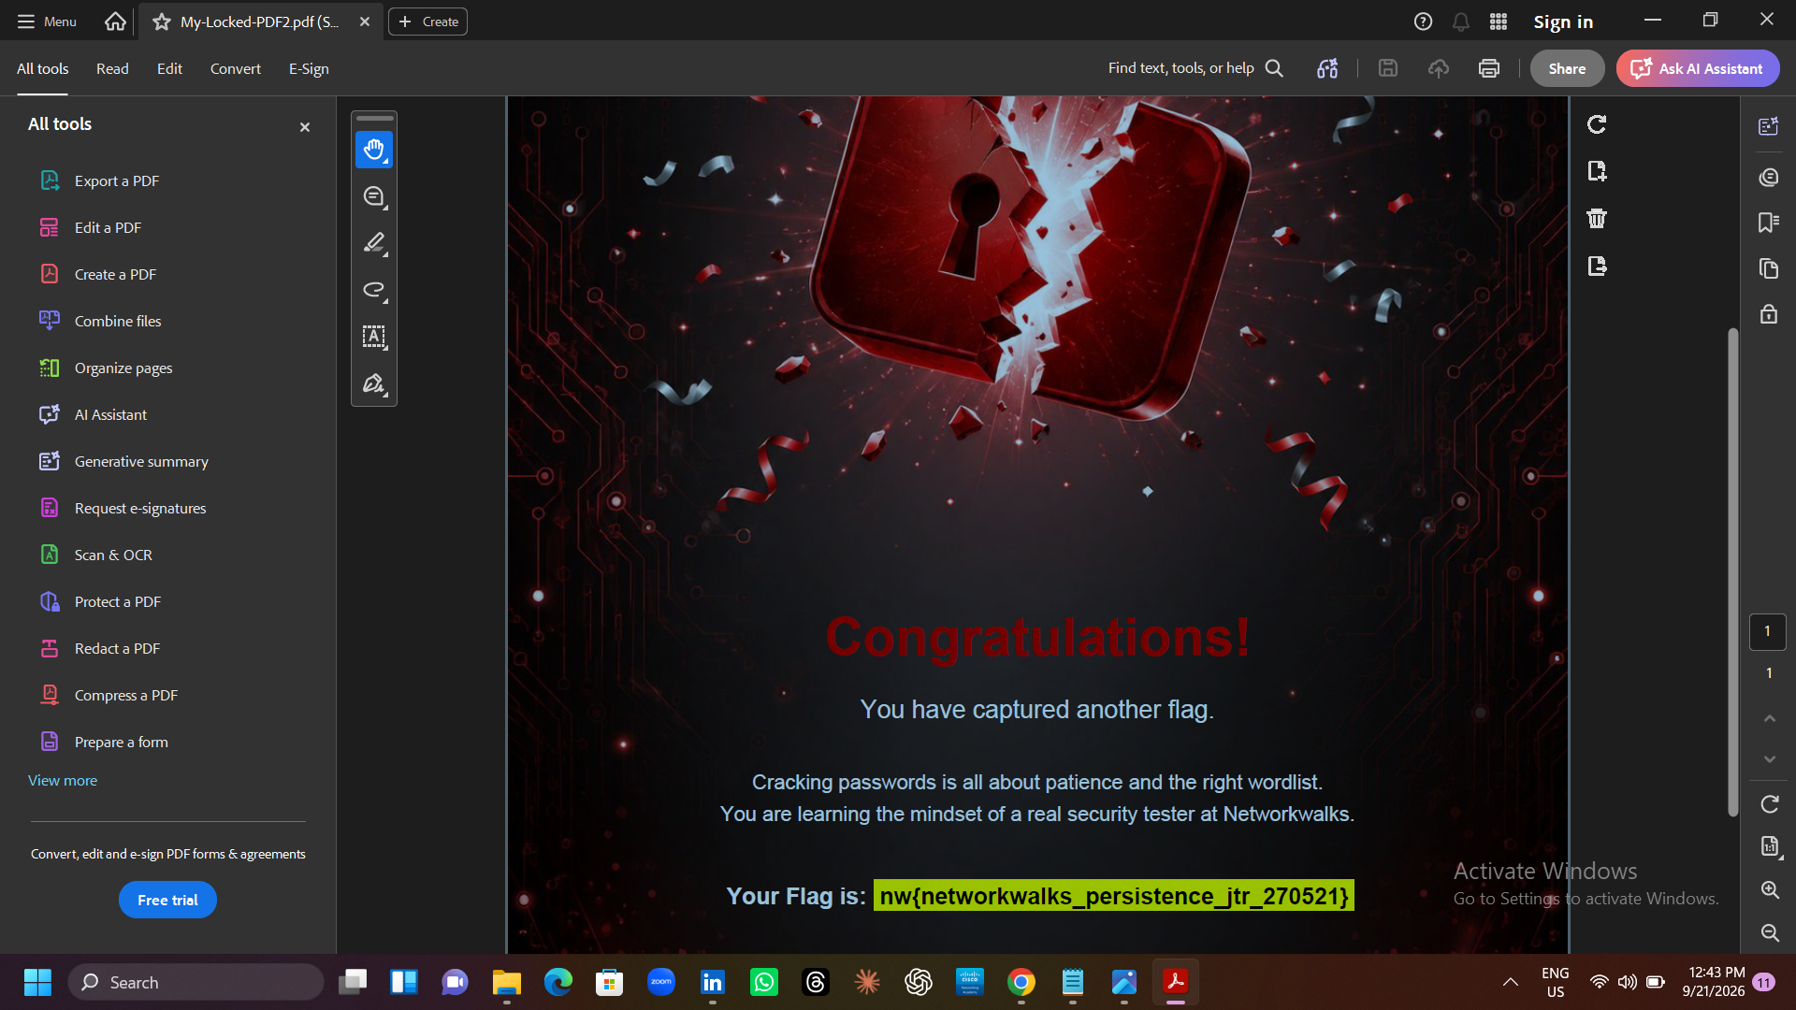
Figure 10. NetworkWalks online cracker — recovered password and flag for pdf2.
My locked pdf3.pdf
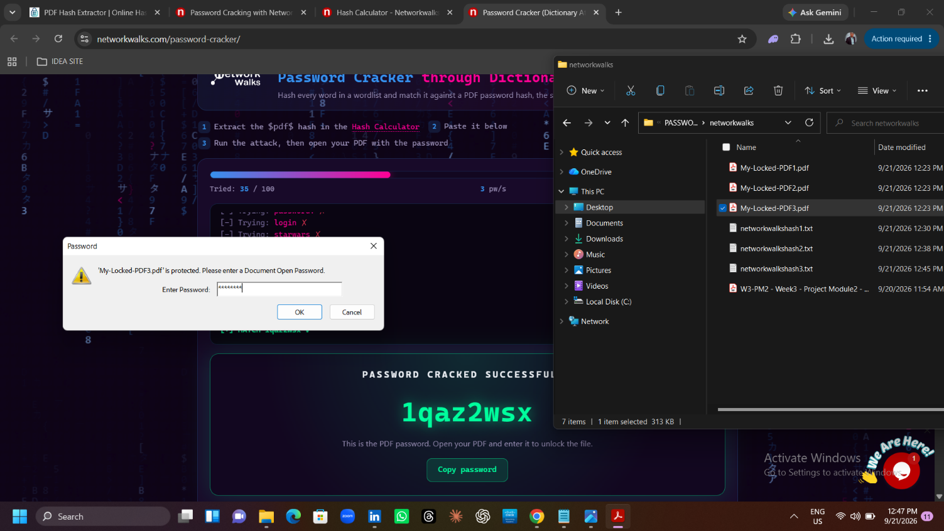
Figure 11. NetworkWalks online cracker — attack in progress for pdf3.
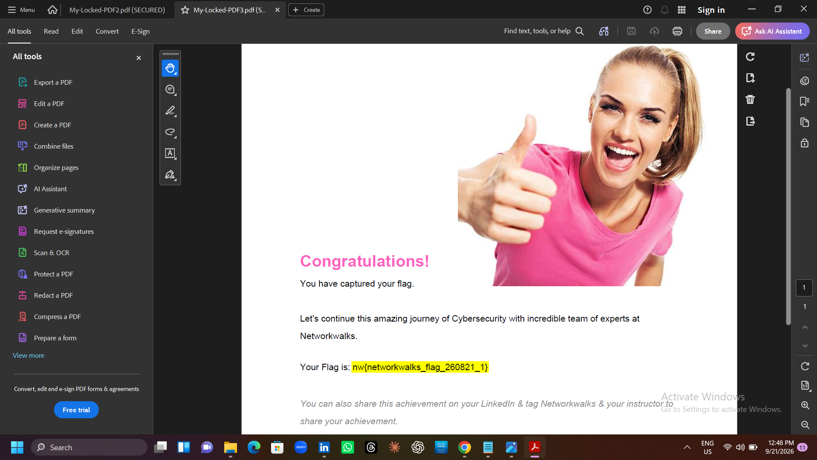
Figure 12. NetworkWalks online cracker — recovered password and flag for pdf3.

8. Key Observations and Learning Outcomes
- All three recovered passwords — good-luck, password1, and 1qaz2wsx — were common, predictable strings, demonstrating how quickly a basic dictionary attack defeats them once an appropriate wordlist is used.
- The browser simulator's failed first attempt versus the production tool's success on the same class of hash illustrates that wordlist coverage, not the sophistication of the cracking tool itself, is usually the deciding factor in a dictionary attack.
- “1qaz2wsx” is a keyboard-walk pattern that appears visually complex but is present in virtually every large breach-derived wordlist — a reminder that visual complexity does not equal real entropy.
- Extracting the $pdf$ hash only reads the file's encryption dictionary; it does not modify or damage the PDF, which is why offline recovery attempts are fast and safe to repeat.

9. Risk Assessment
Each recovered password is rated against a simple qualitative scale based on how quickly it would fall to a standard breach-derived wordlist in an offline attack. All three targets fell within seconds of an appropriately scoped dictionary, and are therefore rated High risk from a password-strength standpoint, independent of the encryption algorithm protecting the file.
Target File | Recovered Password | Weakness Pattern | Risk Rating
My locked pdf1.pdf | good-luck | Dictionary word | High
My locked pdf2.pdf | password1 | Dictionary word + digit | High
My locked pdf3.pdf | 1qaz2wsx | Keyboard-walk pattern | High

10. Mitigation and Defensive Recommendations
- Avoid dictionary words and keyboard-walk patterns for PDF or document passwords; use a long, random passphrase instead.
- Where possible, use AES-256 (PDF 2.0 / ISO 32000-2) encryption rather than legacy RC4 or 128-bit schemes, which fall to offline attack far more quickly.
- Do not rely on a document password as the sole control for sensitive files — pair it with access restrictions at the storage or sharing layer.
- Exercise caution when uploading real, sensitive PDFs to third-party “hash extractor” web tools outside a lab context, as the service can see the file's contents; this workflow is appropriate for training data only, never for confidential documents.
- Use a password manager to generate and store strong, unique document passwords instead of memorable patterns.

11. Conclusion
This lab connected the theory of dictionary attacks — first practiced in NetworkWalks' browser simulator — to a real-world, industry-standard tool, John the Ripper, operated through the Johnny GUI. All three password-protected PDFs were successfully cracked end to end: hash extraction, dictionary-mode attack, and recovery of the plaintext password, each confirmed by a captured lab flag. The exercise reinforced both the mechanics of offline PDF password recovery and the practical lesson that common, predictable passwords remain the weakest link in a document's security, regardless of the strength of the underlying encryption.

12. Appendix: Command Reference
Commands used or referenced during this assessment, for reproducibility:
# Extract John-compatible hash from a password-protected PDF
perl pdf2john.pl "My Locked PDF2.pdf" > pdf_hash.txt
# Run a dictionary attack against the extracted hash
john --format=PDF --wordlist=<wordlist.txt> pdf_hash.txt
# Display recovered password(s)
john --show --format=PDF pdf_hash.txt

