# Federal University of Technology Minna

## Geology Department

### 

### Answers to Physics 322 Assignment

### By Geology Department (Group 5)

**Submitted**

**to**

**Mr Yusuf Abubakar Sadic**

**Date:**

**19th December 2022**

### Group 5

### Group 5 names

# Phy-322 Assignment

* Phy-322 Assignment
  + Questions
  + Answers
    - 1. Give all possible definitions of Crystal that you know.
    - 2. Give two definitions of amorphous materials.
    - 3. Give three definitions of a lattice.
    - 4. Give two definitions of Bravais lattice.
    - 5. Define what is meant by basic/basis cell.
    - 6. List two definitions of the primitive unit cell.
    - 7. Draw the basic vector that represents the primitive unit cell in the following 3D order
    - 8. Give full atomic coordinates of the Cesium Chloride (CsCl) structure.
    - 9. Derive the atomic coordinates of the HCP structure other than the method used in class.
    - 10. Calculate the atomic packing fraction of
      * Hexagonal-Closed Packed structure
      * Packing Fraction
    - 11. Given the basic vector of Body-Centered Cubic lattice in real space with the expression.
      * I. Determine the reciprocal lattice vectors.
  + —
  + —
  + —

## Questions

1. Give all possible definitions of Crystal that you know.
2. Give two definitions of amorphous materials.
3. Give three definitions of a lattice.
4. Give two definitions of Bravais lattice.
5. Define what is meant by basic/basis cell.
6. List two definitions of the primitive unit cell.
7. Draw the basic vector that represents the primitive unit cell in the following 3D order

* Body-Centered Cubic (BCC)
* Face-Centered Cubic (FCC)
* Hexagonal-Closed Packed (HCP)
  1. Give full atomic coordinates of Cesium Chloride (CeCl) structure.

1. Derive the atomic coordinates of the HCP structure other than the method used in class.
2. Calculate the atomic packing fraction of

* Hexagonal Crystal lattice
* Hexagonal-Closed Packed structure

1. Given the basic vector of Body-Centered Cubic lattice in real space with the expression.

$$a1=\frac{a}{2}x+\frac{a}{2}y−\frac{a}{2}z$$

$$a2=−\frac{a}{2}x+\frac{a}{2}y+\frac{a}{2}z$$

$$a3=\frac{a}{2}x−\frac{a}{2}y+\frac{a}{2}z$$

* Determine the reciprocal lattice vectors.
* Draw the diagram of the Body-Centered System, showing the appropriate primitive basis vectors.

## Answers

### 1. Give all possible definitions of Crystal that you know.

* A crystal or crystalline solid is a solid material whose constituents (such as atoms, molecules, or ions) are arranged in a highly ordered microscopic structure, forming a crystal lattice that extends in all directions.
* A crystal is a solid material in which atoms, ions and molecules are arranged in regularly repeating pattern that extends in all three spatial dimensions,
* A crystal is any solid crystalline substance, and thus has a regular and ordered internal arrangement of atoms, ions or molecules.
* A crystal is a solid substance that is composed of atoms, ions, and molecules that are arranged in a regular geometric pattern. In general, “crystal” is used to describe materials that have a regular repeating and symmetrical atomic structure  
  ***Rerfrence***[*Open AI Chat GPT-3*](https://chat.openai.com/chat)

### 2. Give two definitions of amorphous materials.

* An amorphous material is a solid material that lacks long-range order in its atomic structure.
* A solid in which the constituent particles do possess a regular three-dimensional arrangement.
* An amorphous material can also be defined as a solid that has a somewhat random internal arrangement of atoms, ions and molecules, which gives them a glassy appearance. Examples of amorphous solids include glass, plastics, and many types of rubber.  
  ***Rerfrence***[*Open AI Chat GPT-3*](https://chat.openai.com/chat)

### 3. Give three definitions of a lattice.

* A lattice is a regularly repeating arrangement of points in three-dimensional space, that is usually occupied by atoms, ions or molecules.
* A lattice can also be defined as a three-dimensional array of points that form a regular and repeating pattern. ***Rerfrence***[*Open AI Chat GPT-3*](https://chat.openai.com/chat)
* A set of mathematical points to which the crystal is attached.  
  ***Rerfrence*** *Solid State Physics Kittle*

### 4. Give two definitions of Bravais lattice.

* A Bravais Lattice is an array of discrete points that look the same in all directions and orientations that look the same in all directions.  
  ***Reference***[*byjus.com*](https://byjus.com/chemistry/bravais-lattice/)
* A Bravais Lattice is the basic building block from which all crystals can be constructed. ***Reference***[*libretexts.org*](https://chem.libretexts.org/Bookshelves/Analytical_Chemistry/Physical_Methods_in_Chemistry_and_Nano_Science_(Barron)/07%3A_Molecular_and_Solid_State_Structure/7.01%3A_Crystal_Structure)

### 5. Define what is meant by basic/basis cell.

A basic cell or basis cell is the smallest unit cell that can be used to construct the entire crystal lattice without gaps or overlaps. It is a three-dimensional structure that is repeated in a crystal lattice to create the overall crystal structure. The basic cell is characterized by the lengths of its sides and the angles between them, and it is used to define the fundamental geometry of the crystal lattice. The arrangement of atoms within the basic cell determines the overall properties of the crystal, such as its hardness, electrical conductivity, and thermal conductivity.

### 6. List two definitions of the primitive unit cell.

* A primitive unit cell is a basic building block of a crystal lattice. It is the smallest unit cell that can be used to construct the entire crystal lattice without gaps or overlaps.
* A primitive unit cell is a three-dimensional structure that is repeated in a crystal lattice to create the overall crystal structure. It is the smallest unit cell that can be used to construct the entire crystal lattice without gaps or overlaps, and it is characterized by the lengths of its sides and the angles between them. ***Rerfrence***[*Open AI Chat GPT-3*](https://chat.openai.com/chat)

### 7. Draw the basic vector that represents the primitive unit cell in the following 3D order

* Body-Centered Cubic (BCC)  
  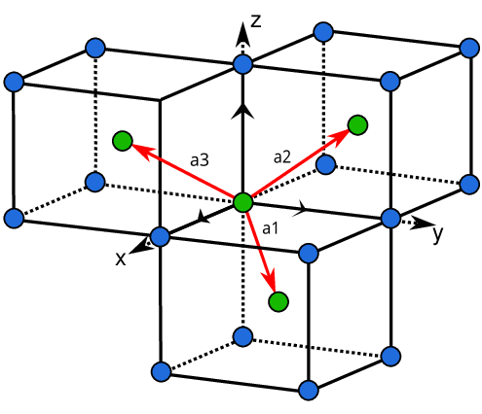

where x, y and z are the basis vectors.

* Face-Centered Cubic (FCC)  
  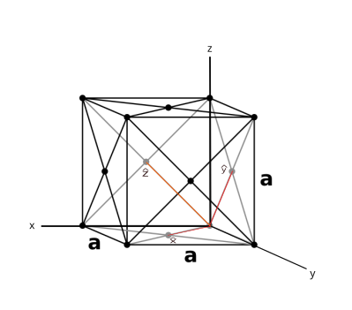

where x, y and z are the basis vectors

* Hexagonal-Closed Packed (HCP)

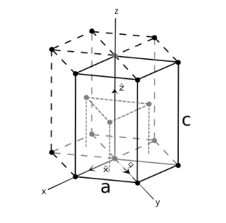where x, y and z are the basis vectors

### 8. Give full atomic coordinates of the Cesium Chloride (CsCl) structure.

Cesium chloride (CsCl) has a Body-Centered structure.

* It has two primitive cells in a cubic unit and each unit cell has two molecule basis of CsCl
* . The position of the Cl ion is at (0 0 0) and the Cs ion is at ($\frac{1}{2}\frac{1}{2}\frac{1}{2}$)
* The Cs are situated at the body center and the eight Cl ions are at the corner of the unit cell. Similarly, if we extend the unit cell we can see a Cl ion is surrounded by 8 Cs ions. Thus the coordinate number of CsCl is 8.

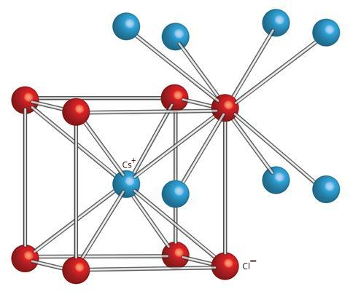

### 9. Derive the atomic coordinates of the HCP structure other than the method used in class.

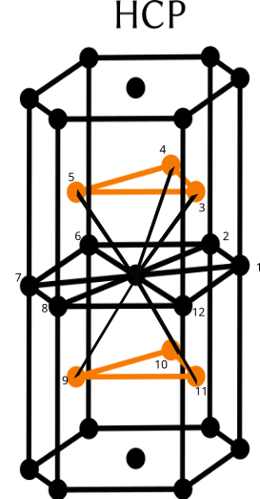  
From the above diagram, we can see that the Hexagonal-Closed Packed structure has a Coordination number of twelve(12).

### 10. Calculate the atomic packing fraction of

* Hexagonal Crystal lattice
* Hexagonal-Closed Packed structure

Consider the diagram bellow  
  
From the diagram above we notice that each atom at the edge of the hexagon is shared between six cells

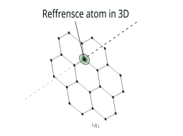

* 3 cells at the top
* 3 cells at the bottom  
   each of the 12 edge atoms contributes a total of atoms to the cell
* we can also see that each of the face atoms is being shared between two adjacent unit cells, thus the two face atoms (at the top and the bottom), contribute a total of atoms.
* we also see that the three inner atoms are not shared with any other unit cell and thus contribute a full atom each to the unit cell
* this means the effective number of atoms in HCP is

#### Packing Fraction

the packing fraction of a Hexagonal-Closed Packed structure is given by

- Solving for the volume occupied by the atoms in the cell  
the total volume occupied by atoms in a unit cell is given by

where is the effective number of atoms in the cell  
and is the total volume occupied by atoms in a unit cell

- Solving for the volume of the unit cell

the volume of the unit cell for HCP is given by

- calculating the area of the base hexagon consider the hexagon bellow 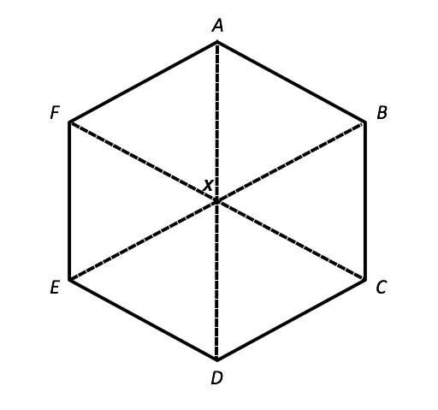  
from the above diagram, we can see that six equilateral triangles make up the hexagons, therefore the area of one triangle multiplied by 6 will give us the area of the hexagon the area of a triangle is

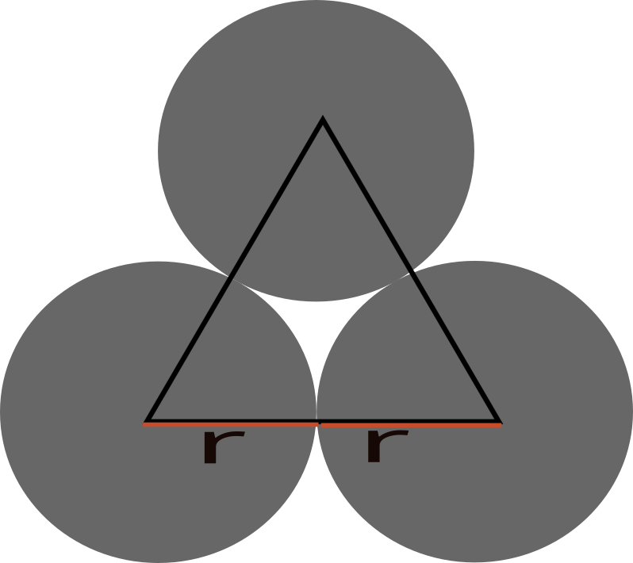

from the diagram above, the distance between two touching atoms   
using pythagoras theorem we can solve for the height of the triangle

$$a^{2}={\left(\frac{1}{2}a\right)}^{2}×h^{2}$$

$$h=\frac{a\sqrt{3}}{4}$$

thus the area of the triangle $A$ is

$$A=\frac{1}{2}×a×{\left(\frac{1}{2}a\right)}^{2}×h^{2}$$

$$\frac{\sqrt{3}a^{2}}{4}$$

multiplied by 6, the area of the hexagon $A_{h}$ is

$$A_{h}=\frac{3\sqrt{3}a^{2}}{2}$$

the volume of HCP = $A_{h}×C$ where $C$ is the height of the HCP lattice

$$C=\frac{4r\sqrt{2}}{\sqrt{3}}$$

$$∴PF=\frac{6×\frac{4}{3}π×{\left(\frac{a}{3}\right)}^{3}}{\frac{3a^{2}\sqrt{3}}{2}×C}$$

$$theatomicpackingfractionPF=0.75$$

#### Hexagonal-Closed Packed structure

Consider the diagram bellow

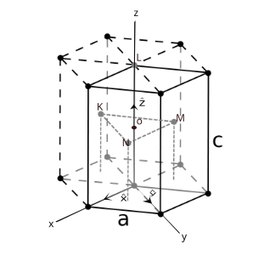  
From the diagram above we notice that each atom at the edge of the hexagon is shared between six cells

  
* 3 cells at the top * 3 cells at the bottom  
 each of the 12 edge atoms contributes a total of atoms to the cell

we can also see that each of the face atoms is being shared between two adjacent unit cells, thus the two face atoms (at the top and the bottom), contribute a total of atoms.

we also see that the three inner atoms are not shared with any other unit cell and thus contribute a full atom each to the unit cell

this means the effective number of atoms in HCP is

#### Packing Fraction

the packing fraction of a Hexagonal-Closed Packed structure is given by

- Solving for the volume occupied by the atoms in the cell  
the total volume occupied by atoms in a unit cell is given by

where is the effective number of atoms in the cell  
and is the total volume occupied by atoms in a unit cell

- Solving for the volume of the unit cell

the volume of the unit cell for HCP is given by

- calculating the area of the base hexagon consider the hexagon bellow   
from the above diagram, we can see that six equilateral triangles make up the hexagons, therefore the area of one triangle multiplied by 6 will give us the area of the hexagon the area of a triangle is



from the diagram above, the distance between two touching atoms   
using pythagoras theorem we can solve for the height of the triangle

$$a^{2}={\left(\frac{1}{2}a\right)}^{2}×h^{2}$$

$$h=\frac{a\sqrt{3}}{4}$$

thus the area of the triangle $A$ is

$$A=\frac{1}{2}×a×{\left(\frac{1}{2}a\right)}^{2}×h^{2}$$

$$\frac{\sqrt{3}a^{2}}{4}$$

multiplied by 6, the area of the hexagon $A_{h}$ is

$$A_{h}=\frac{3\sqrt{3}a^{2}}{2}$$

recall that the volume of the cell for HCP is given by the area of the base (Ah) multiplied by the height (C)

the volume of HCP = $A_{h}×C$ where $C$ is the height of the HCP lattice

C can be calculated by multiplying the length of LO (which is half of C) in the diagram above by by 2

$$C=\frac{4r\sqrt{2}}{\sqrt{3}}$$

$$∴PF=\frac{6×\frac{4}{3}π×{\left(\frac{a}{3}\right)}^{3}}{\frac{3a^{2}\sqrt{3}}{2}×C}$$

$$∴PF=6×\frac{4}{3}π×\frac{a}{8}×\frac{2}{3\sqrt{3}×C}$$

$$∴PF=\frac{6πa}{9\sqrt{3}×C}$$

$$theatomicpackingfractionPF=0.75$$

$$theatomicpackingpercentage=75\text{\%}$$

### 11. Given the basic vector of Body-Centered Cubic lattice in real space with the expression.

$$a1=\frac{a}{2}x+\frac{a}{2}y−\frac{a}{2}z$$

$$a2=−\frac{a}{2}x+\frac{a}{2}y+\frac{a}{2}z$$

$$a3=\frac{a}{2}x−\frac{a}{2}y+\frac{a}{2}z$$

#### I. Determine the reciprocal lattice vectors.

  
The Reciprocal lattice of BCC are given by:

|  |
| --- |
|  |

|  |
| --- |
|  |

|  |
| --- |
|  |

|  |
| --- |
|  |

#### The reciprocal lattice of BCC are

$${\vec{a}}_{1}=\frac{2π\left({\vec{a}}_{2}×{\vec{a}}_{3}\right)}{a_{1}⋅\left({\vec{a}}_{2}×{\vec{a}}_{3}\right)}=\frac{2π⋅\frac{a^{2}}{2}\left(\hat{x}+\hat{y}\right)}{\frac{a^{3}}{2}}=\frac{πa^{3}\left(\hat{x}+\hat{y}\right)}{\frac{a^{3}}{2}}=\frac{2π}{a}\left(\hat{x}+\hat{y}\right)$$

$${\vec{a}}_{2}=\frac{2π\left({\vec{a}}_{3}×{\vec{a}}_{1}\right)}{a_{1}⋅\left({\vec{a}}_{2}×{\vec{a}}_{3}\right)}=\frac{2π⋅\frac{a^{2}}{2}\left(\hat{y}+\hat{z}\right)}{\frac{a^{3}}{2}}=\frac{πa^{3}\left(\hat{y}+\hat{z}\right)}{\frac{a^{3}}{2}}=\frac{2π}{a}\left(\hat{y}+\hat{z}\right)$$

$${\vec{a}}_{2}=\frac{2π\left({\vec{a}}_{1}×{\vec{a}}_{2}\right)}{a_{1}⋅\left({\vec{a}}_{2}×{\vec{a}}_{3}\right)}=\frac{2π⋅\frac{a^{2}}{2}\left(\hat{x}+\hat{z}\right)}{\frac{a^{3}}{2}}=\frac{πa^{3}\left(\hat{x}+\hat{z}\right)}{\frac{a^{3}}{2}}=\frac{2π}{a}\left(\hat{x}+\hat{z}\right)$$

#### II. Draw the diagram of the Body-Centered System, showing the appropriate primitive basis vectors.



BCC Lattice

BCC System showing appropriate primitive basis vectors.

Source [Research Gate](https://www.researchgate.net/figure/The-body-centred-cubic-BCC-reciprocal-lattice-of-a-FCC-lattice-shown-in-Fig-13_fig2_264872465)

**Refrences:**

Wilson, A. J. C. (1 February 1954). "Introduction to Solid-State Physics by C. Kittel". Acta Crystallographica. 7 (2): 224. doi:10.1107/S0365110X54002666. ISSN 0365-110X.

^ Bates, L. F. (1 January 1954). "Introduction to Solid State Physics by C. Kittel". Acta Crystallographica. 7 (1): 144. doi:10.1107/S0365110X54000448. ISSN 0365-110X.

^ Standley, K. J. (April 1954). "Introduction to solid state physics". Journal of the Mechanics and Physics of Solids. 2 (3): 213. doi:10.1016/0022-5096(54)90027-7.

^ Muldawer, Leonard (October 1953). "Introduction to solid state physics". Journal of the Franklin Institute. 256 (4): 387–388. doi:10.1016/0016-0032(53)90624-3.

^ Dexter, David L. (November 1953). "Introduction to Solid State Physics". American Journal of Physics. 21 (8): 650. Bibcode:1953AmJPh..21..650K. doi:10.1119/1.1933590. ISSN 0002-9505.

^ Masi, J. F. (1 August 1954). "Introduction to Solid State Physics". Physics Today. 7 (8): 18–19. Bibcode:1954PhT.....7h..18K. doi:10.1063/1.3061720. ISSN 0031-9228.

^ anonymous (14 August 1954). "Introduction to Solid State Physics by Prof. Charles Kittel. Pp. xiii + 396. (New York: John Wiley and Sons, Inc.; London: Chapman and Hall, Ltd., 1953.) 56s. net". Nature. 174 (4424): 287. doi:10.1038/174287a0. ISSN 1476-4687. S2CID 5520806.

^ Jones, G. O. (January 1955). "Review of Introduction to Solid State Physics". Science Progress (1933- ). 43 (169): 129. ISSN 0036-8504. JSTOR 43423448.

^ Hellwarth, R. W. (June 1957). "Introduction to Solid State Physics". Physics Today. 10 (6): 43–44. Bibcode:1957PhT....10f..43K. doi:10.1063/1.3060399. ISSN 0031-9228.

^ Bates, L. F. (July 1957). "Review of Introduction to Solid State Physics Second edition". Science Progress (1933- ). 45 (179): 557–558. ISSN 0036-8504. JSTOR 43424566.

^ anonymous (December 1956). "Introduction to solid state physics". Journal of the Franklin Institute. 262 (6): 517. arXiv:2101.01780. doi:10.1016/0016-0032(56)90703-7.

^ Woolley, J.C. (January 1957). "Introduction to solid state physics". Journal of the Mechanics and Physics of Solids. 6 (1): 83. doi:10.1016/0022-5096(57)90051-0.

^ Jones, H. (1 May 1957). "Introduction to Solid State Physics by C. Kittel". Acta Crystallographica. 10 (5): 390. doi:10.1107/S0365110X57001280. ISSN 0365-110X.

^ Fan, H. Y. (May 1957). "Introduction to Solid State Physics". American Journal of Physics. 25 (5): 330. Bibcode:1957AmJPh..25..330K. doi:10.1119/1.1934457. ISSN 0002-9505.

^ Walker, Charles T. (24 February 1967). Kittel, Charles (ed.). "Solid State Physics over 13 Years". Science. 155 (3765): 991. doi:10.1126/science.155.3765.991.b. ISSN 0036-8075. JSTOR 1720868. S2CID 239828066.

^ Holcomb, Donald F. (June 1967). "Introduction to Solid State Physics". American Journal of Physics. 35 (6): 547–548. Bibcode:1967AmJPh..35..547K. doi:10.1119/1.1974177. ISSN 0002-9505.

^Hook, J.R.; Hall, H.E. (2010). Solid State Physics. Manchester Physics Series (2nd ed.). John Wiley & Sons. ISBN 9780471928041.

^ West, Anthony R. (1999). Basic Solid State Chemistry (2nd ed.). Wiley. p. 1. ISBN 978-0-471-98756-7.

^ International Tables for Crystallography (2006). Volume A, Space-group symmetry.

^ a b c Encyclopedia of Physics (2nd Edition), R.G. Lerner, G.L. Trigg, VHC publishers, 1991, ISBN (Verlagsgesellschaft) 3-527-26954-1, ISBN (VHC Inc.) 0-89573-752-3

^ "4. Direct and reciprocal lattices". CSIC Dept de Cristalografia y Biologia Estructural. 6 Apr 2017. Retrieved 18 May 2017.

^ Edington, J. W. (1975). Electron Diffraction in the Electron Microscope. doi:10.1007/978-1-349-02595-4. ISBN 978-0-333-18292-5.

^ Ashcroft, N.; Mermin, D. (1976). "Chapter 7". Solid State Physics. Brooks/Cole (Thomson Learning, Inc.). ISBN 978-0030493461.

^ a b Donald E. Sands (1994). "§4-2 Screw axes and §4-3 Glide planes". Introduction to Crystallography (Reprint of WA Benjamin corrected 1975 ed.). Courier-Dover. pp. 70–71. ISBN 978-0486678399.