Federal University of Technology Minna

Assignment:
Give accounts of the evidence of evolution and the application of evolution in Geology and other disciplines, with diagrams where necessary.

Written by
Ezekiel Victor
2018/1/74521PL

SUBMITTED TO
THE DEPARTMENT OF GEOLOGY
SCHOOL OF PHYSICAL SCIENCE
LECTURER
Dr Y.B ALKALI

What Is evolution?
In simple terms, evolution is the change in the genetic makeup of a population over time in response to their environment. This process is driven by natural selection, which is the process, by which certain traits become more or less common in a population based on their ability to help an organism survive and reproduce.
According to the theory of evolution, all organisms share a common ancestor, and over time, organisms have evolved and diverged due to the process of natural selection.

Evidences of Evolution
There is a vast amount of evidence for evolution, and this evidence comes from many different fields of study, including paleontology, anthropology, genetics, and more. Some of the key pieces of evidence for evolution include:
- Fossil records:
Fossil records provide evidence of evolution as they show existence of change of species over time. When paleontologists discover fossilized remains of an organism, they can use the age of the rock in which the fossils were found to determine how old the fossils are. By comparing the characteristics of these fossils to those of other organisms, paleontologists can see how the organisms are related and how they might have evolved and changed over time.
Image 1.0 bellow shows the evolutionary process as seen in the fossils of horses.
  - The oldest fossils show the earlier horses to be only about 0.4m tall and had four long toes, and their molar teeth indicate that they probably ate soft leaves.
  - As climate became drier, and grasslands slowly replaced the marshes, they became taller to see predators while they fed in tall grass. Eventually they reached a height of about 1.6m.
  - They evolved a single large toe that eventually became a hoof to evade predators
  - Their molars became longer and covered with hard cement to allow them grind tough grass and grass seeds without wearing out their teeth.
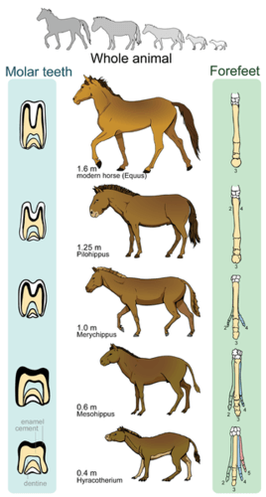
Image 1.0
(evolution in horses)

- Comparative Anatomy:
Comparative anatomy is the study of the anatomy of different species and how it relates to their evolutionary history. It can provide evidence for evolution because it allows scientists to compare the physical characteristics of different species, and infer how they are related.
Similarities found in different species can be homologous or analogous. Both provide evidence of evolution.
  - Homologous structures are similar between related organisms because they were inherited from a common ancestor. These structures may not have the same function in the multiple descendants.
Image 1.1 bellow shows upper appendages of several different mammals. They all have the same basic pattern of bones, although they now have different functionality.
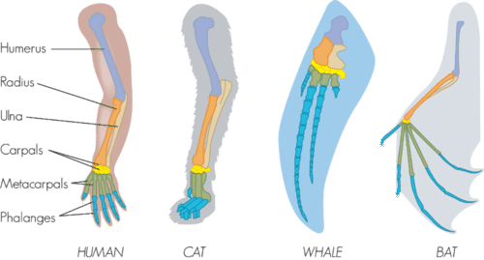
Image 1.1 (Homologous relationship in mammals)
  - Analogous structures are similar between unrelated organisms because they evolved to do the same job, not because they evolved from a common ancestor
Image 1.2 bellow the wings of birds and bats look similar on the outside, and have the same function, however wings evolved independently in the two organisms, which becomes apparent when you compare the patter of bones inside the wings.
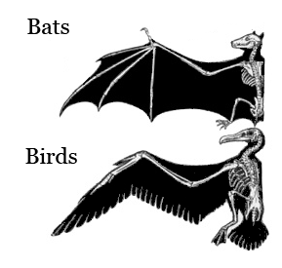

Image 1.2 (Analogous relationship in birds and bat)
- Comparative Embryology:
Comparative embryology is the study of the similarities and differences in the embryos of different species. For example when scientists compare the development of different species, they often find that certain stages of evolution are similar in different species.
Similarities between embryos are likely evidence of common ancestry. As seen in image 1.3 bellow, all vertebrate embryos have gill slits and tails. All the embryos in the figure bellow except for fish loose their gill slits by adulthood, and some of them loos their tail. In humans, the tail is reduced to a tail bone. Thus the similarities that organisms share as embryos may no longer be present by adulthood.
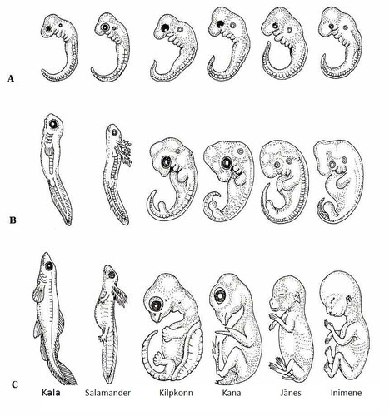

Image 1.3 (comparative embryology in vertebrates)

- Molecular Biology:
Molecular biology is the study of the molecular level processes that occur in living organisms. It can provide evidence for evolution because it allows scientists to compare the molecular characteristics of different species an infer how they are related.
For example, when scientists compare the DNA of different species, they often find that the DNA of different species is similar in many ways. This can be taken as evidence that these organisms share a common ancestry and have evolved from a common ancestor.
At the most basic level, all living organisms share:
  - The same genetic material (DNA)
  - The same, or highly similar genetic codes
  - The same basic process of gene expression (transcription and translation)
These shared features suggest that all living organisms are descended from a common ancestor, and that this ancestor had DNA as it’s genetic material, used the genetic code, and expressed it’s genes by transcription and translation. Present-day organisms all share these features, because they were “inherited” from the ancestor.
Homologous genes: Biologists often compare the sequences of related genes found in different species (often called homologous or orthologous genes) to figure out how those species are evolutionarily related to one another.
The basic idea behind this approach is that two species have the "same" gene because they inherited it from a common ancestor. For instance, humans, cows, chickens, and chimpanzees all have a gene that encodes the hormone insulin, because this gene was already present in their last common ancestor.

In general, the more DNA differences in homologous genes between two species, the more distantly the species are related. For instance, human and chimpanzee insulin genes are much more similar (about 98% identical) than human and chicken insulin genes (about 64% identical), reflecting that humans and chimpanzees are more closely related than humans and chickens.

- Natural Selection:
Natural selection is the process by which certain traits become more or less common in a population based on their ability to help an organism survive and reproduce. It is one of the main mechanisms of evolution, and it can serve as evidence for evolution because it explains how species change over time.
The idea of natural selection is that populations of organisms are constantly facing new challenges and opportunities in their environment. Those individuals with traits that are well-suited to their environment are more likely to survive and reproduce, while those with less advantageous traits are less likely to survive and reproduce. This means that over time, the traits that are advantageous for survival and reproduction will become more common in the population, while those that are less advantageous will become less common.
For example, consider a population of birds that live on a island with a lot of seeds as a food source. If some of the birds in this population happen to have long beaks that are well-suited for cracking seeds, they will be more likely to survive and reproduce. As a result, the trait for long beaks will become more common in the population over time. This is an example of natural selection at work, and it is consistent with the idea that populations of organisms can evolve over time.
Overall, natural selection is an important piece of evidence for evolution because it explains how species can change over time in response to their environment.

Application of evolution in Geology and other disciplines
Aside from being a sound explanation for many things, the theory of evolution has very useful applications on Geology and various other fields of study. Some of which include
Geology
Darwin began to conceive of the immensity of Earth's time when he observed the rate of coastal erosion and compared it with the vast thickness of geologic strata. In Darwin’s words, "What an infinite number of generations which the mind cannot grasp, must have succeeded each other in the long roll of years! Now turn to our richest geological museums, and what a paltry display we behold". At the same time, he realized how few of the lives that have been lived were actually preserved as fossils.
Darwin sought to explain why intermediate forms were not usually seen in geologic formations and came, in part, to the conclusion that species lasted longer than it took for formations to accumulate and that formations themselves were relatively sparsely distributed in time. He also realized that time within formations was not uniform: "It would seem that each separate formation, like the whole pile of formations in any country, has been intermittent in its accumulation" (Ibid, p. 295). Both of these insights, like many made by Darwin, were strikingly modern.
One of Darwin's contemporaries, Charles Lyell, published "Principles of Geology," the first book to discuss the Earth as we do today. Lyell described Earth as a series of gradual processes, not solely the catastrophes envisioned by previous workers. He established important ideas about earthquakes and volcanoes, and his picture of Earth history as a grand procession of change would greatly influence the thinking of one of the world's foremost naturalists, Charles Darwin.
"Principles of Geology" appeared just before Darwin's voyage on the Royal Navy ship HMS Beagle, prompting him to make careful observations of geological events including earthquakes and volcanoes during his journey. Darwin's most direct geological contribution was his explanation of the origin of atolls, the annular coral islands that dot the western Pacific Ocean. He observed many different kinds of islands and realized each represented a developmental sequence—from the earliest stages as reef-ringed, extinct volcanic peaks, to the latest stages of barely submerged coral reefs with central lagoons. Although Darwin was only partially correct when he attributed the evolution of the islands to reef growth and erosion, his explanation played an important role in future understanding of seafloor spreading and the now widely accepted theory of plate tectonics, which describes the large-scale movement of the Earth's outermost shell.
Most people think of evolution as relating to biology and paleontology. What they don't realize is that most paleontologists are also geologists, who use fossils to date rocks and study past environments. Darwin's Theory of Evolution is the structure that supports these efforts.
Biostratigraphy is the science of dating rocks by the fossils they contain, and it was just getting started in Darwin's time. Scientists noticed that certain types of fossils appear in the same sequences everywhere in the geologic record. They reasoned this was because certain organisms lived only at specific times. This meant the sequence of fossils could be used to date rocks relative to each other and to correlate the age of rocks from place to place. It was application of a Darwinian idea—that the sequence of fossils through time represents successive events of evolutionary change and extinction—that put the geologic science of biostratigraphy on a much stronger footing. Later, this relative time scale of fossil sequences would be calibrated with radiometric dates.
Other geologic sciences also use Darwinian principles. For example, taphonomy and paleoecology rely on understanding evolution and natural selection to determine past environmental conditions. Taphonomy looks at how organisms decay and become fossilized over time, and paleoecology uses fossils to reconstruct information about past ecosystems.
Much of what we know about past climates, including the temperature record, humidity, rainfall and other factors, comes from our understanding of fossils. Evolution and natural selection allow us to interpret changes in the form and species of plants as the climate changed. We rely on this knowledge to understand how plants respond to climate and how that response might be recorded in the fossil record. Because the Theory of Evolution helps us understand fossils in their environments, geologists' interpretations of the rocks are far richer and more nuanced than they could be without it.
Darwin's theory revolutionized and became the foundation for all of biology, but for the reasons mentioned above, it was just as much the foundation for geology as well. The inexorable changes that Lyell wrote of were echoed by Darwin in the Theory of Evolution and, in turn, echoed back to geologists in a coherent sense of how Earth—and the life upon it—changed; when those changes occurred; and, how what we see today, is a product of that long history.

Biology
A clear understanding of evolutionary biology is essential for professionals in all biological fields . Current research initiatives to deepen knowledge of the genetic basis of complex characters, recent advances in developmental morphology, and attempts to generate a comprehensive phylogenetic tree of life all draw heavily on evolutionary insights. Evolutionary biology is also contributing to ongoing advances in the study of human origins and behavior. Finally, there has been a long-term interplay between evolutionary theory and nonbiological fields such as statistics, economics, and computation.
In addition to its centrality in biology and its contributions to basic science, evolutionary biology addresses a wide array of current and emerging societal needs, ranging from biomedical applications to conservation efforts. For example, it provides a solid scientific framework for understanding the emergence of antibiotic resistance in pathogenic bacteria and for analyzing the emergence and epidemiology of novel diseases, such as HIV. Evolutionary biology also provides a scientific basis for policy decisions concerning the conservation of rare and endangered species, the adaptive implications of invasive species or new genetic varieties (including genetically engineered organisms), and the genetic responses to human perturbation of the environment.

Computer Science
As evolution can produce highly optimized processes and networks, it has many applications in computer science. Here, simulations of evolution using evolutionary algorithms and artificial life started with the work of Nils Aall Barricelli in the 1960s, and was extended by Alex Fraser, who published a series of papers on simulation of artificial selection. Artificial evolution became a widely recognised optimisation method as a result of the work of Ingo Rechenberg in the 1960s and early 1970s, who used evolution strategies to solve complex engineering problems. Genetic algorithms in particular became popular through the writing of John Holland. As academic interest grew, dramatic increases in the power of computers allowed practical applications, including the automatic evolution of computer programs. Evolutionary algorithms are now used to solve multidimensional problems more efficiently than software produced by human designers, and also to optimize the design of systems.
An example of evolutionary principles being applied in computer science is Evolutionary computation

Evolutionary computation
In computer science, evolutionary computation is a family of algorithms for global optimization inspired by biological evolution, and the sub-field of artificial intelligence and soft computing studying these algorithms. In technical terms, they are a family of population-based trial and error problem solvers with a metaheuristic or stochastic optimization character.

The concept of mimicking evolutionary processes to solve problems originates before the advent of computers, such as when Alan Turing proposed a method of genetic search in 1948 .

Turing's B-type u-machines resemble primitive neural networks, and connections between neurons were learnt via a sort of genetic algorithm. His P-type u-machines resemble a method for reinforcement learning, where pleasure and pain signals direct the machine to learn certain behaviors. This same techniques were used to create the now popular AI ChatGPT3.

Conclusion
Evolution is a very active process, and even as we go about are day to day activities it continues to occur. From the gained tolerance of some people to diseases like malaria, to the recent wave of artificial intelligence (AI) that possess the ability to learn and evolve, evolution is actively taking place around us and is playing a big role in our lives. And the more we understand evolution and it’s causes, the more we can use it to satisfy our needs.

References:
nsf.gov: Darwin's Missing Rock and the Increasing Precision of Earth Time —
Darwin's understanding of geologic time helps zero in on elusive rock layer.
By Kirk R. Johnson

nsf.gov: Charles Darwin's Impact on Geology
Evolutionary ideas have both direct and indirect effects on geosciences
By Judith Totman Parrish

academic.oup.com: Evolution and Today's Society
By Thomas R. Meagher

Flexbooks: Evidence for Evolution FlexBooks 2.0 > CK-12 College Human Biology

Khan-Academy: Evidence for evolution: anatomy, molecular biology, biogeography, fossils, & direct observation.
Wikipedia: Evolutionary Computation
Chat GPT3

