Mathematical Framework for Cell-Driven Granular Scaffold Remodeling
Version: V1.6 Last updated: 2026-03-15 Associated code: new_dem_0.py

1. Introduction
We develop a multiscale mathematical framework for the mechanical remodeling of granular hydrogel scaffolds driven by encapsulated living cells. The system comprises $N$ rigid hydrogel granules — functional (cell-laden) and inert (passive) — confined within a bounded domain. Three coupled processes govern scaffold evolution:
- Cell-driven compaction. Cells seeded on functional granules attach, spread, form focal adhesions, and generate traction forces that pull neighboring granules together through intercellular bridges.
- Granular contact mechanics. Hertzian elasticity, surface-chemistry-dependent friction, and DMT adhesion govern granule-granule and granule-wall interactions.
- Interstitial fluid transport. The evolving void network controls hydraulic permeability and nutrient delivery, coupling scaffold architecture to tissue viability.
The discrete element model (DEM) resolves the particle scale (Sections 2–3), while coarse-grained continuum descriptions capture tissue-scale behavior (Sections 4–5). Dimensionless groups (Section 6) identify the dominant physics, and a tissue architecture descriptor (Section 7) enables quantitative comparison to organ microstructure targets.
Units. Throughout this document: micrometres ($μ$m) for length, nanonewtons (nN) for force, hours (h) for time, and kilopascals (kPa) for elastic modulus. Where SI units are required for dimensional consistency, explicit conversion factors are noted.

2. Microscale: Discrete Element Model

2.1 Equations of Motion
The system is deeply overdamped: inertial forces are negligible compared to viscous drag at the hydrogel length scale ($\text{Re}≪1$). Each granule $i$ obeys the overdamped Langevin equation
$$γ_{i}\frac{dx_{i}}{dt}=F_{i}^{\text{contact}}+F_{i}^{\text{cell}}+F_{i}^{\text{wall}}+F_{i}^{\text{noise}}$$
where the translational drag coefficient is
$$γ_{i}=γ_{0} R_{i}$$
with $γ_{0}$ a dimensionless drag scale and $R_{i}$ the equivalent radius of granule $i$. The terms on the right-hand side represent, respectively: (1) contact forces from neighboring granules (Hertz repulsion, DMT adhesion, and tangential friction), (2) cell-mediated traction forces transmitted through intercellular bridges, (3) repulsive wall forces at domain boundaries, and (4) active noise representing stochastic cell-driven fluctuations.
Time integration uses a forward Euler scheme,
$$x_{i}(t+Δt)=x_{i}(t)+\frac{F_{i}^{\text{tot}}}{γ_{i}}Δt$$
with a velocity cap $|v_{i}|≤v_{max}$ to prevent numerical blowup from large transient forces.

2.2 Hertzian Contact Force
The normal contact force between two elastic granules follows the Hertz theory for non-adhesive elastic spheres (Johnson, 1985):
$$F_{n}=\frac{4}{3}E^{*}\sqrt{R^{*}} δ^{3/2}$$
where $δ=R_{i}+R_{j}-|x_{j}-x_{i}|$ is the overlap (penetration depth), and the effective elastic modulus and effective radius are
$$E^{*}=\frac{E}{2(1-ν^{2})}, R^{*}=\frac{R_{i}R_{j}}{R_{i}+R_{j}}$$
Here $E$ is the Young’s modulus of the hydrogel and $ν$ is its Poisson ratio. The factor of 2 in the denominator of $E^{*}$ accounts for equal-modulus contact between two deformable bodies. For granule-wall contact, the wall is treated as a rigid half-space, giving $E_{\text{wall}}^{*}=E/(1-ν^{2})$ and $R^{*}=R_{i}$.
Unit conversion. With $E$ in kPa ($=\text{nN}/μ{\text{m}}^{2}×{10}^{-3}$), $R^{*}$ in $μ$m, and $δ$ in $μ$m, the force is obtained in nN via
$$F_{n} [\text{nN}]=\frac{4}{3} E_{\text{Pa}}^{*} \sqrt{R_{μ\text{m}}^{*}} δ_{μ\text{m}}^{3/2}×{10}^{-3}$$
where $E_{\text{Pa}}^{*}=E_{\text{kPa}}×{10}^{3}/[2(1-ν^{2})]$.
For superellipsoidal granules (Section 2.8), $R^{*}$ is replaced by the harmonic mean of the local radii of curvature at the contact point, computed from the parametric surface geometry.

2.3 Friction (Gong 2006, Pitenis 2014)
Hydrogel surfaces exhibit area-dependent friction governed by surface chemistry rather than Coulombic mechanics. The tangential friction force opposing relative sliding is
$$F_{\text{fric}}=τ_{0} A_{c} tanh​\left(\frac{|v_{t}|}{v_{\text{ref}}}\right)$$
where $τ_{0}$ is the interfacial shear stress (Pa), $A_{c}=πR^{*}δ$ is the Hertzian contact area ($μ{\text{m}}^{2}$), $v_{t}$ is the relative tangential velocity at the contact point, and $v_{\text{ref}}$ is a regularization velocity that smooths the discontinuity at zero sliding speed.
The interfacial shear stress depends on the surface chemistry of the contacting pair:
Pair type | Surface chemistry | $τ_{0}$ (Pa)
Functional–functional | Collagen I – collagen I | 2000
Inert–functional | Bare gel – collagen I | 500
Inert–inert | Bare gel – bare gel | 50
These values reflect the hierarchy of hydrogen bonding and entanglement between collagen-coated and uncoated hydrogel surfaces (Gong, 2006; Pitenis et al., 2014).

2.4 DMT Adhesion
The Derjaguin-Muller-Toporov (DMT) model provides a constant adhesive contribution during contact:
$$F_{\text{adh}}=2πWR^{*}$$
where $W$ is the work of adhesion (J/m$​^{2}$), which depends on the pair type as shown below.
Pair type | $W$ (J/m$​^{2}$)
Functional–functional | 0.002
Inert–functional | 0.001
Inert–inert | 0.0005
The net normal contact force is
$$F_{n}^{\text{net}}=F_{n}^{\text{Hertz}}-F_{\text{adh}}$$
which can become negative (attractive) when the Hertzian repulsion is small relative to adhesion, stabilizing granule contacts at small overlaps. In simulation units, the adhesion force is computed as $F_{\text{adh}}=2πWR^{*}×{10}^{3}$ nN to convert from the SI product $[{\text{J/m}}^{2}][μ\text{m}]$.

2.5 Motor-Clutch Cell Traction (Chan & Odde 2008)
Cells encapsulated within functional granules generate traction forces via the motor-clutch mechanism. Following Chan and Odde (2008), the steady-state traction force per cell is
$$F_{\text{cell}}=F_{\text{stall}}⋅β⋅ξ⋅m(t)$$
where:
- $F_{\text{stall}}=n_{m}F_{m}$ is the total motor stall force, with $n_{m}$ motor complexes (stress fibers) each generating stall force $F_{m}$.
- $β=k_{\text{sub}}/(k_{\text{sub}}+k_{\text{opt}})$ is the stiffness-dependent engagement ratio. On soft substrates ($k_{\text{sub}}≪k_{\text{opt}}$), clutches disengage before motors stall, yielding low force. On stiff substrates ($k_{\text{sub}}≫k_{\text{opt}}$), $β→1$ and cells reach their maximum traction capacity.
- $k_{\text{sub}}=πEa/(1-ν^{2})$ is the effective substrate stiffness sensed by a cell of radius $a=d_{\text{cell}}/2$ on a hydrogel of modulus $E$ and Poisson ratio $ν$. This represents the stiffness of a rigid punch on an elastic half-space.
- $k_{\text{opt}}=n_{c}k_{c}$ is the optimal (clutch ensemble) stiffness, with $n_{c}$ integrin clutch clusters each of spring constant $k_{c}$.
- $ξ=k_{\text{on}}/(k_{\text{on}}+k_{\text{off}})$ is the steady-state fraction of engaged clutches, determined by the clutch binding rate $k_{\text{on}}$ and baseline unbinding rate $k_{\text{off}}$.
- $m(t)$ is the focal adhesion maturity, which ramps from 0 to 1 at a rate $r_{\text{FA}}$ (h$​^{-1}$) after cell spreading initiates: $m(t)=min(1, r_{\text{FA}}⋅t_{\text{spread}})$.
The force per cell is capped at $F_{max}$ to prevent unphysical traction at extreme parameter combinations. Stiffness-dependent engagement ($β$) also modulates the cell spreading rate: the effective spreading duration is $τ_{\text{spread}}^{\text{eff}}=τ_{\text{spread}}/max(0.2,β)$, so that cells on stiffer substrates spread faster.

2.6 Bridge Formation Kinetics
Cell-cell bridges form stochastically between functional granule pairs separated by a gap $d<L_{s}$ (the filopodial sensing distance). Only cells that have reached the SPREADING or PROLIFERATING state with sufficient focal adhesion maturity ($m≥m_{min}$) are eligible.
Bridge initiation. Each eligible cell attempts to form a bridge as a Poisson process modulated by proximity:
$$P_{\text{bridge}}(Δt)=\left[1-exp​\left(-r_{b} Δt\right)\right]⋅\left(1-\frac{d}{L_{s}}\right)$$
where $r_{b}$ is the attempt rate (h$​^{-1}$), $d$ is the surface-to-surface gap, and $L_{s}$ is the sensing distance. The proximity factor $(1-d/L_{s})$ reflects the decreasing probability that a filopodium reaches a more distant target.
Force ramp. A newly formed bridge ramps its force linearly over a formation time $τ_{f}$:
$$F_{\text{bridge}}(t)=F_{\text{cell}}⋅min​\left(1, \frac{t_{\text{age}}}{τ_{f}}\right)$$
where $t_{\text{age}}$ is the time since bridge commitment and $F_{\text{cell}}$ is the motor-clutch force computed from the average focal adhesion maturity of the two granules.
Bridge persistence and senescence. Committed bridges persist across timesteps. A bridge ruptures if the gap exceeds the break distance $d>d_{\text{break}}$, causing the cell to transition to a senescent state. Bridges that sustain mechanical load for a duration exceeding $τ_{\text{sen}}$ (bridge senescence time) also transition to senescence, modeling contact-inhibited quiescence.
Bridge parameters. The kinetic parameters are:
Parameter | Symbol | Default | Units
Attempt rate | $$r_{b}$$ | 0.3 | h$​^{-1}$
Formation time | $$τ_{f}$$ | 2.0 | h
Senescence time | $$τ_{\text{sen}}$$ | 24.0 | h
Min FA maturity | $$m_{min}$$ | 0.3 | –
Break gap | $$d_{\text{break}}$$ | 60.0 | $μ$m

2.7 Rotational Dynamics
Off-center contact forces generate torques that rotate non-spherical granules. In the overdamped regime, angular dynamics are governed by:
2D. For superellipse granules with semi-axes $(a,b)$:
γrotdθdt=c​τc, γrot=γ0rota2+b22
where $τ_{c}=(r_{c}-x_{i})×F_{c}$ is the torque from contact $c$, and $γ_{0}^{\text{rot}}$ is the rotational drag scale.
3D. For superellipsoid granules with semi-axes $(a,b,c)$, orientation is represented by unit quaternions $q=(w,x,y,z)$ with $|q|=1$. The overdamped angular dynamics are:
Ieffdωdt=c​τc, Ieff=γ0rota2+b2+c23
Quaternion integration follows the first-order update:
$$q(t+Δt)=\text{normalize}​\left[q(t)+\frac{Δt}{2} [0,ω]⊗q(t)\right]$$
where $⊗$ denotes the Hamilton product and $[0,ω]$ is the pure quaternion $(0,ω_{x},ω_{y},ω_{z})$. An angular velocity cap $|ω|≤ω_{max}$ prevents unphysical rapid rotation.

2.8 Superellipsoid Shape Model
Granule shape is parameterized as a 3D superellipsoid:
$${\left({\left|\frac{x}{a}\right|}^{n_{1}}+{\left|\frac{y}{b}\right|}^{n_{1}}\right)}^{n_{2}/n_{1}}+{\left|\frac{z}{c}\right|}^{n_{2}}=1$$
where $(a,b,c)$ are the semi-axes, $n_{1}$ is the equatorial blockiness exponent, and $n_{2}$ is the meridional blockiness exponent. Special cases include:
Shape | Parameters
Sphere | $a=b=c$, $n_{1}=n_{2}=2$
Ellipsoid | $a≠b≠c$, $n_{1}=n_{2}=2$
Cylinder-like | $$n_{1},n_{2}>2$$
Octahedron-like | $$n_{1},n_{2}<2$$
In 2D, the superellipse specialization applies:
$${\left|\frac{x}{a}\right|}^{n}+{\left|\frac{y}{b}\right|}^{n}=1$$
The parametric surface representation is:
$$r(η,ω)=\left(\begin{matrix}a \text{sgn}(cosη)|cosη|^{2/n_{2}} \text{sgn}(cosω)|cosω|^{2/n_{1}} \\ b \text{sgn}(cosη)|cosη|^{2/n_{2}} \text{sgn}(sinω)|sinω|^{2/n_{1}} \\ c \text{sgn}(sinη)|sinη|^{2/n_{2}}\end{matrix}\right)$$
for $η∈[-π/2,π/2]$ and $ω∈[-π,π)$.
Contact detection uses the common normal method: for each candidate pair, a Newton-Raphson solver finds the parametric coordinates $(η_{i},ω_{i},η_{j},ω_{j})$ such that the outward normals at the closest surface points are anti-parallel and collinear with the line connecting them. The effective radius of curvature at the contact point is obtained from the local surface geometry, replacing the sphere-based $R^{*}$ in the Hertz force law.
The volume of a superellipsoid is (Jaklic and Leonardis, 2000):
$$V=2abc ϵ_{1}ϵ_{2} B​\left(\frac{ϵ_{1}}{2}+1, ϵ_{1}\right)B​\left(\frac{ϵ_{2}}{2}, \frac{ϵ_{2}}{2}\right)$$
where $ϵ_{1}=2/n_{1}$, $ϵ_{2}=2/n_{2}$, and $B$ is the Beta function.

2.9 Active Noise
Cell-driven fluctuations on functional granules are modeled as Gaussian white noise:
$$F_{i}^{\text{noise}}=\sqrt{\frac{2γ_{i}T_{\text{active}}}{Δt}} η_{i}(t)$$
where $T_{\text{active}}$ is an effective active temperature (nN$⋅μ$m) and $η_{i}(t)$ is a vector of independent standard normal random variables. Inert granules receive no active noise ($T_{\text{active}}=0$ for $g_{i}=1$).

2.10 Cell Lifecycle
Each cell progresses through a discrete state machine:
$$\text{ATTACHED}→\text{SPREADING}→\text{PROLIFERATING}→\text{BRIDGING}→\text{SENESCENT}$$
Attachment. At time $t≥t_{\text{onset}}$, cells attach with sigmoidal kinetics:
$$f_{\text{att}}(t)=\frac{1}{1+exp​\left[-3 (t-t_{\text{onset}}-t_{1/2})/t_{1/2}\right]}$$
where $t_{1/2}$ is the half-time for attachment. With default parameters ($t_{\text{onset}}=0$, $t_{1/2}=0$), attachment is instantaneous.
Spreading. Attached cells transition from spheres (diameter $d_{\text{cell}}=20 μ$m) to oblate ellipsoids (height $h_{\text{spread}}=5 μ$m) with volume conservation:
$$V_{\text{cell}}=\frac{4}{3}π{\left(\frac{d}{2}\right)}^{3}=\frac{4}{3}πa_{\text{spread}}^{2}\frac{h}{2}$$
$$⇒ A_{\text{spread}}=πa_{\text{spread}}^{2}=\frac{πd^{3}}{4h}$$
The spread fraction ramps linearly from 0 to 1 over an effective duration $τ_{\text{spread}}^{\text{eff}}=τ_{\text{spread}}/max(0.2,β)$, where $β$ is the motor-clutch engagement ratio. Projected area interpolates linearly between the spherical and spread values.
Overcrowding. The maximum number of cells per granule is set by the ratio of granule surface area to cell footprint, scaled by a coverage fraction:
$$n_{max}=\left\lfloor \frac{πR^{2}⋅c_{\text{cov}}}{A_{\text{cell}}}\right\rfloor$$
Excess cells ($n_{\text{attached}}>n_{max}$) transition to the SENESCENT state.
Migration. Mobile cells (ATTACHED, SPREADING, PROLIFERATING) undergo a random walk on the granule surface, with angular displacement per timestep:
$$Δθ∼N​\left(0, \frac{v_{\text{mig}} Δt}{R_{i}}\right)$$
where $v_{\text{mig}}$ is the migration speed ($μ$m/h).

3. Mesoscale: Coarse-Graining

3.1 Stress Tensor (Love-Weber)
The volume-averaged Cauchy stress tensor for the granular assembly is computed via the Love-Weber formula:
σαβ=1Vcontacts c​fαc lβc
where $f_{α}^{c}$ is the $α$-component of the contact force and $l_{β}^{c}=x_{β}^{j}-x_{β}^{i}$ is the branch vector connecting the centers of the two granules in contact. The summation runs over all contacts within the averaging volume $V$.
The stress admits a decomposition into passive and active contributions:
$$σ=σ^{\text{contact}}+σ^{\text{active}}$$
where $σ^{\text{contact}}$ arises from Hertz, friction, and adhesion forces, and $σ^{\text{active}}$ arises from cell traction bridges.

3.2 Strain Rate Tensor
The coarse-grained strain rate tensor is
εαβ=12Vi​vαixβi+vβixαiVi
where $v_{α}^{i}$ is the velocity component, $x_{β}^{i}$ is the position component, and $V_{i}$ is the Voronoi volume of granule $i$.

3.3 Effective Viscosity
The effective shear viscosity of the granular assembly is defined through the ratio of deviatoric stress to deviatoric strain rate:
$$η_{\text{eff}}=\frac{|σ_{\text{dev}}|}{2 |{\dot{ε}}_{\text{dev}}|}$$
where $|⋅|$ denotes the von Mises norm: $|σ_{\text{dev}}|=\sqrt{1/2σ_{{ij}^{'}}σ_{{ij}^{'}}}$ with $σ_{{ij}^{'}}=σ_{ij}-1/dσ_{kk}δ_{ij}$ and $d$ is the spatial dimension. This effective viscosity characterizes the scaffold’s resistance to cell-driven rearrangement and is expected to diverge near the jamming transition.

4. Macroscale: Continuum Model

4.1 Conservation Equations
The scaffold is treated as a three-phase mixture: functional granule phase ($ϕ_{f}$), inert granule phase ($ϕ_{i}$), and interstitial void ($ϕ_{v}$). In the absence of mass exchange between phases, each solid phase satisfies a conservation equation:
$$\frac{∂ϕ_{α}}{∂t}+∇⋅(ϕ_{α} v_{α})=0, α∈\{f, i\}$$
The void fraction is determined by the saturation constraint:
$$ϕ_{v}=1-ϕ_{f}-ϕ_{i}$$
These fields are computed on a regular Eulerian grid by stamping each granule as a smoothed indicator function (tanh profile with interface width $w$):
$$ϕ_{α}(x)=\max_{i∈α}\left[\frac{1}{2}\left(1-tanh\frac{s_{i}(x)}{w}\right)\right]$$
where $s_{i}(x)$ is the approximate signed distance from point $x$ to the surface of granule $i$.

4.2 Momentum Balance (Overdamped)
In the overdamped limit, the momentum equation for phase $α$ reduces to a force balance:
$$0=∇⋅σ_{α}+f_{α}^{\text{contact}}+f_{α}^{\text{active}}-ζ_{α}ϕ_{α}\left(v_{α}-v_{f}\right)$$
where $σ_{α}$ is the phase stress tensor, $f_{α}^{\text{contact}}$ represents inter-phase contact forces, $f_{α}^{\text{active}}$ is the cell traction body force density, and the last term is the drag between the solid phase and the interstitial fluid, with $ζ_{α}$ a drag coefficient.

4.3 Darcy Flow
The interstitial fluid velocity relative to the solid skeleton follows Darcy’s law:
$$ϕ_{v} v_{f}=-\frac{k}{μ}∇P$$
where $k$ is the hydraulic permeability ($μ{\text{m}}^{2}$), $μ$ is the fluid viscosity (Pa$⋅$s), and $P$ is the pore fluid pressure.

4.4 Kozeny-Carman Permeability
The permeability of the granular bed is estimated by the Kozeny-Carman relation:
$$k=\frac{ϕ_{v}^{3} d^{2}}{180 (1-ϕ_{v})^{2}}$$
where $d$ is the mean granule diameter. This classical result assumes a bed of monodisperse spheres; for polydisperse superellipsoidal packings, $d$ is taken as the mean equivalent-sphere diameter. The strong dependence on porosity ($k∝ϕ_{v}^{3}$ for small changes) couples the transport properties tightly to compaction.

5. Mean-Field Compaction Model
The simplest useful model for scaffold compaction tracks the bulk functional volume fraction $ϕ_{f}(t)$. It collapses the microscale DEM into a single ordinary differential equation that can be solved analytically in limiting cases.

5.1 Compaction Rate
$$\frac{dϕ_{f}}{dt}=-ϕ_{f}⋅{\dot{ε}}_{\text{comp}}$$
where the compaction strain rate is
$${\dot{ε}}_{\text{comp}}=\frac{σ_{\text{cell}}(t)-σ_{\text{resist}}(ϕ_{\text{solid}})}{η_{\text{eff}}}$$

5.2 Cell Stress (Volume-Averaged Motor-Clutch)
The cell-generated compressive stress is the volume average of all bridge forces:
$$σ_{\text{cell}}(t)=n_{\text{cell}}⋅F_{\text{cell}}(E)⋅f_{\text{bridge}}(t)⋅m(t)$$
where $n_{\text{cell}}$ is the number density of bridging cells, $F_{\text{cell}}(E)$ is the motor-clutch force at substrate stiffness $E$, $f_{\text{bridge}}(t)$ is the fraction of cells that have formed bridges (governed by the Poisson kinetics of Section 2.6), and $m(t)$ is the mean focal adhesion maturity.

5.3 Resistance Stress (Jamming)
As the solid fraction $ϕ_{\text{solid}}=ϕ_{f}+ϕ_{i}$ approaches the jamming point $ϕ_{J}$, the scaffold stiffens and resists further compaction:
$$σ_{\text{resist}}=σ_{0}{\left(\frac{ϕ_{\text{solid}}}{ϕ_{J}}-1\right)}^{α} \text{for }ϕ_{\text{solid}}>ϕ_{J}$$
$$σ_{\text{resist}}=0 \text{for }ϕ_{\text{solid}}≤ϕ_{J}$$
The jamming fraction $ϕ_{J}$ depends on particle shape. For random close packing of spheres, $ϕ_{J}≈0.64$ (Torquato et al., 2000). For ellipsoids, $ϕ_{J}≈0.64+0.08(\text{AR}-1)$ up to aspect ratio $\text{AR}≈2$ (Donev et al., 2004). The exponent $α$ characterizes the stiffening law near jamming; for frictionless spheres, $α≈3/2$ (O’Hern et al., 2003).

5.4 Mechanical Equilibrium
Compaction halts when $σ_{\text{cell}}=σ_{\text{resist}}$, defining the equilibrium solid fraction $ϕ_{\text{solid}}^{\text{eq}}$. For weak cell forces relative to scaffold stiffness (small Compaction number $\text{Ca}$, Section 6.1), $ϕ_{\text{solid}}^{\text{eq}}≈ϕ_{J}$ and the scaffold barely compacts. For large $\text{Ca}$, the equilibrium approaches maximal packing.

6. Dimensionless Analysis

6.1 Key Dimensionless Groups
The system behavior is governed by the following dimensionless groups:
Group | Symbol | Definition | Physical meaning | Typical range
Motor-clutch engagement | $$β$$ | $$k_{\text{sub}}/(k_{\text{sub}}+k_{\text{opt}})$$ | Fraction of motor force transmitted to substrate | 0.01 – 0.93
Compaction number | $$\text{Ca}$$ | $$σ_{\text{cell}}/E^{*}$$ | Cell stress relative to granule stiffness | ${10}^{-4}$ – ${10}^{-2}$
Jamming proximity | $$Φ/Φ_{J}$$ | $$ϕ_{\text{solid}}/ϕ_{\text{RCP}}$$ | Distance from random close packing | 0.5 – 1.2
Darcy number | $$\text{Da}$$ | $$k/L^{2}$$ | Permeability relative to domain scale | $$∼{10}^{-5}$$
Timescale ratio | $$τ_{\text{bio}}/τ_{\text{mech}}$$ | $$τ_{\text{bridge}}/τ_{\text{damp}}$$ | Biological vs. mechanical relaxation time | 100 – 1000
Clutch engagement | $$ξ$$ | $$k_{\text{on}}/(k_{\text{on}}+k_{\text{off}})$$ | Steady-state fraction of bound clutches | 0.5 – 0.95
Motor-clutch engagement $β$. This is the master variable of the model. It captures the nonlinear coupling between substrate stiffness and cell force output. For soft gels ($E∼1$ kPa), $β≪1$ and cells generate negligible traction. For stiff gels ($E∼50$ kPa), $β→1$ and cells approach their stall force. Substituting the default parameters ($n_{c}=75$, $k_{c}=5.0$ nN/$μ$m, $a=10 μ$m):
$$k_{\text{opt}}=75×5.0=375 \text{nN}/μ\text{m}$$
$$k_{\text{sub}}=π×E×10/(1-{0.45}^{2})≈40.0 E \text{nN}/μ\text{m} (E\text{ in kPa})$$
So $β=40E/(40E+375)$, giving $β=0.10$ at $E=1$ kPa and $β=0.84$ at $E=50$ kPa.
Compaction number Ca. This ratio determines whether cell forces are sufficient to deform the granular packing. When $\text{Ca}≪1$, the scaffold is essentially rigid on the cell force scale. Significant compaction requires $\text{Ca}≳{\text{Ca}}_{c}$ where ${\text{Ca}}_{c}$ is set by the jamming resistance.
Timescale ratio. The mechanical relaxation time $τ_{\text{damp}}=γ/E^{*}∼{10}^{-2}$ h is much shorter than the biological timescales of bridge formation ($τ_{f}∼2$ h) and senescence ($τ_{\text{sen}}∼24$ h). This separation of scales justifies the quasistatic (overdamped) approximation.

6.2 Scaling Laws
The engagement ratio $β$ controls the key scaling relationships:
- Traction force: $F_{\text{cell}}∝β$, since the stall force, clutch engagement, and FA maturity are bounded.
- Compaction efficiency: The fraction of initial void space eliminated by cell-driven compaction scales with $β$: stronger engagement drives more compaction before equilibrium is reached.
- Spreading rate: $τ_{\text{spread}}^{\text{eff}}=τ_{\text{spread}}/β$ (for $β>0.2$), so stiffer substrates yield faster spreading and earlier onset of traction.
- Permeability evolution: As compaction increases $ϕ_{\text{solid}}$, permeability decreases via the Kozeny-Carman relation. The feedback loop is:
$$β↑ → σ_{\text{cell}}↑ → ϕ_{\text{solid}}↑ → k↓$$

6.3 Dimensionless Compaction ODE
Let $Φ=ϕ_{f}/ϕ_{f,0}$ (normalized functional fraction) and $T=t/τ_{\text{bridge}}$ (normalized time). The mean-field ODE becomes:
$$\frac{dΦ}{dT}=-Φ\left[B(T)-R(Φ)\right]$$
where:
- $B(T)=σ_{\text{cell}}(T)/η_{\text{eff}}$ is the dimensionless driving term, which ramps from zero as bridges form and saturates when all eligible cells are bridging.
- $R(Φ)=σ_{\text{resist}}(Φ)/η_{\text{eff}}$ is the dimensionless resistance, which is zero for $Φ<Φ_{J}/ϕ_{f,0}$ and diverges as $Φ→Φ_{J}/ϕ_{f,0}$ from below.
Equilibrium is reached when $B(T^{*})=R(Φ^{*})$. The final compaction $Φ^{*}=ϕ_{f}^{\text{eq}}/ϕ_{f,0}$ depends on $β$, cell density, and granule stiffness through the dimensionless groups defined above.

7. Tissue Architecture Characterization
The goal of scaffold design is to produce a microstructure that recapitulates the architecture of a target organ. We define a descriptor vector and an architectural distance metric for quantitative comparison.

7.1 Descriptor Vector
The tissue architecture is characterized by a vector $d∈R^{n_{d}}$ whose components fall into six categories:
Volume fractions. - $\text{BV/TV}$: bone (or solid) volume / total volume = $ϕ_{f}+ϕ_{i}$ - Porosity: $ϕ_{v}=1-\text{BV/TV}$
Morphometry (Hildebrand and Ruegsegger, 1997). - $\text{Tb.Th}$: trabecular (strand) thickness — mean thickness of the solid phase - $\text{Tb.Sp}$: trabecular separation — mean pore diameter - $\text{Tb.N}$: trabecular number = $\text{BV/TV}/\text{Tb.Th}$ - $\text{SMI}$: structure model index (0 = plates, 3 = rods, 4 = spheres)
Topology. - $χ$: Euler characteristic of the solid phase (genus proxy) - Connectivity density: $\text{Conn.D}=(1-χ)/V$ (number of connections per unit volume)
Spatial statistics. - $S_{2}(r)$: two-point correlation function of the solid phase - $ξ$: correlation length (exponential decay constant of $S_{2}$) - Chord length distribution: probability density of intercept lengths through solid and void phases
Anisotropy (Harrigan and Mann, 1984). - MIL tensor: mean intercept length tensor - $\text{DA}$: degree of anisotropy = $1-λ_{min}/λ_{max}$ - $\text{FA}$: fractional anisotropy (analogous to diffusion tensor FA)
Transport. - $τ$: tortuosity (effective path length / straight-line distance) - $k$: Kozeny-Carman permeability

7.2 Architectural Distance
Given a GELLS scaffold descriptor $d^{\text{GELLS}}$ and a target organ descriptor $d^{\text{organ}}$ with population standard deviation $σ^{\text{organ}}$, the architectural distance is:
$$D_{\text{arch}}=\sqrt{\sum_{k=1}^{n_{d}}{w_{k}}{\left(\frac{d_{k}^{\text{GELLS}}-d_{k}^{\text{organ}}}{σ_{k}^{\text{organ}}}\right)}^{2}}$$
where $w_{k}$ are importance weights. Log-transforms are applied to scale-dependent quantities (Tb.Th, Tb.Sp, $k$, $ξ$) before computing the distance, so that fractional deviations are penalized equally across scales:
$$d_{k}→\log_{10}(d_{k}) \text{for scale-dependent descriptors}$$

7.3 Organ System Targets
Representative architectural parameters for potential scaffold targets are summarized below. Values are drawn from quantitative histomorphometry and micro-CT studies.
Organ | BV/TV | Tb.Th ($μ$m) | Tb.Sp ($μ$m) | Tb.N (mm$​^{-1}$) | DA | $k$ ($μ$m$​^{2}$)
Trabecular bone (vertebral) | 0.12–0.25 | 100–200 | 500–1000 | 1.0–1.8 | 0.3–0.7 | ${10}^{1}$–${10}^{3}$
Lung alveoli | 0.10–0.15 | 5–15 | 100–300 | 5–10 | 0.1–0.3 | ${10}^{3}$–${10}^{5}$
Liver (hepatic lobule) | 0.80–0.90 | 200–500 | 10–30 (sinusoid) | 2–4 | 0.1–0.2 | ${10}^{0}$–${10}^{1}$
Kidney cortex | 0.70–0.85 | 50–150 | 20–60 | 3–6 | 0.2–0.4 | ${10}^{0}$–${10}^{2}$
Cardiac muscle | 0.75–0.85 | 10–25 | 5–15 | 10–20 | 0.5–0.8 | ${10}^{-1}$–${10}^{1}$
Pancreatic islet | 0.60–0.75 | 30–80 | 10–30 | 5–10 | 0.1–0.2 | ${10}^{0}$–${10}^{2}$
Intestinal mucosa | 0.50–0.70 | 50–200 | 30–100 | 3–8 | 0.3–0.6 | ${10}^{1}$–${10}^{3}$
These targets define the feasible design space: scaffold parameters ($E$, $ϕ_{f}$, $ϕ_{i}$, granule size distribution, cell density) should be chosen to minimize $D_{\text{arch}}$ for the desired organ.

8. Coupled Prediction Chain
The complete prediction chain links substrate stiffness to scaffold transport properties and tissue architecture:
$$β(E) → σ_{\text{cell}}(t;β) → ϕ_{f}(t) → ϕ_{v}(t) → k(t) → Q(t,ΔP)$$
where $Q$ is the volumetric flow rate through the scaffold under a pressure drop $ΔP$. Each arrow represents a functional dependence:
- Stiffness sensing. The substrate modulus $E$ determines the motor-clutch engagement $β$ and hence the cell traction force $F_{\text{cell}}$.
- Force generation. $σ_{\text{cell}}(t)$ emerges from the combination of motor-clutch force, bridge kinetics, and focal adhesion maturation.
- Compaction. The net stress drives compaction: $ϕ_{f}(t)$ increases (functional granules pack more densely) while $ϕ_{v}(t)$ decreases.
- Transport. Permeability $k(t)$ tracks porosity through Kozeny-Carman, closing the loop between scaffold mechanics and nutrient transport.
- Architecture. The final microstructure is characterized by the descriptor vector $d$, which is compared to organ targets via $D_{\text{arch}}$.
The DEM simulation resolves steps 1–4 directly at the particle scale. The mean-field model (Section 5) provides an analytical approximation that enables rapid parameter exploration before committing to full DEM runs.

9. Experimental Validation
The model connects to experiments through four independent measurement modalities:
Phase evolution from volumetric imaging. Confocal or light-sheet microscopy provides time-resolved maps of $ϕ_{f}(x,t)$ and $ϕ_{i}(x,t)$. Spatially averaged trajectories $ϕ_{f}(t)$ can be fit to the mean-field ODE (Section 5) to extract the effective viscosity $η_{\text{eff}}$ and cell stress $σ_{\text{cell}}$. The ratio $σ_{\text{cell}}/η_{\text{eff}}$ gives the compaction rate directly.
Interstitial flow from particle image velocimetry. PIV with fluorescent microspheres in the void space yields the pore-scale velocity field $v_{f}(x)$. Spatial averaging gives the Darcy flux, from which the permeability $k(t)$ is extracted. Comparison to the Kozeny-Carman prediction (Section 4.4) validates the relationship between compaction and transport.
Cell traction from traction force microscopy. Cells on hydrogel substrates of known stiffness generate displacement fields measurable by embedded fluorescent beads. Inversion yields the traction stress, which can be fit to the motor-clutch model (Section 2.5) to determine $F_{\text{stall}}$, $k_{\text{opt}}$, and the engagement curve $β(E)$.
Tissue architecture from histology and micro-CT. Histological sections or micro-CT reconstructions of both the scaffold and native organ tissue yield the descriptor vectors $d^{\text{GELLS}}$ and $d^{\text{organ}}$. The architectural distance $D_{\text{arch}}$ (Section 7.2) quantifies how closely the scaffold recapitulates the target organ. Minimization of $D_{\text{arch}}$ over the design parameter space constitutes the scaffold optimization problem.

10. Computational Results: 24-Run Design of Experiments
The complete mathematical framework was applied to a 24-run fractional factorial Design of Experiments (DOE). Each run simulates 3D granular scaffold compaction in a $514×514×514 μ\text{m}$ domain with $∼​208$ superellipsoidal granules over 10–38 hours. The five DOE factors are:
Factor | Symbol | Low Level | High Level
A: Modulus | $$E$$ | 2 kPa | 50 kPa
B: Cells/granule | $$n_{c}$$ | 4 | 8
C: Functional radius | $$R_{f}$$ | 30 $μ$m | 60 $μ$m
D: Composition | $$ϕ_{f}/ϕ_{i}$$ | 0.2/0.4 | 0.4/0.2
E: Adhesion/friction | $W_{\text{adh}}$, $τ_{0}$ | low | high

10.1 Mean-Field Model Fitting
The mean-field ODE (Section 5) was fitted to the $ϕ_{f}(t)$ time series of each run by optimizing $(η_{\text{eff}}, σ_{0}, α)$. All 23 runs with data produced convergent fits. Runs with high substrate stiffness ($E=50$ kPa) exhibited the strongest compaction:
Run | $E$ (kPa) | $$R^{2}$$ | $η_{\text{eff}}$ (nN$⋅$h/$μ$m$​^{2}$) | $$Δϕ_{f}$$
DOE_10 | 50 | 0.630 | 0.0023 | $$-0.040$$
DOE_22 | 50 | 0.200 | 0.0054 | $$-0.061$$
DOE_08 | 50 | 0.185 | 0.0043 | $$-0.073$$
DOE_18 | 50 | 0.121 | 0.0049 | $$-0.141$$
DOE_12 | 50 | 0.122 | 0.013 | $$-0.035$$
The fitted effective viscosity $η_{\text{eff}}∼{10}^{-3}$–${10}^{-2}$ nN$⋅$h/$μ$m$​^{2}$ is consistent with the overdamped granular assembly at low volume fractions ($ϕ_{s}/ϕ_{J}≈0.92$). Runs with $E=2$ kPa produced $β<0.2$, yielding weaker cell traction and minimal net compaction ($|Δϕ_{f}|<0.01$), which limits the ODE’s predictive power ($R^{2}<0$).
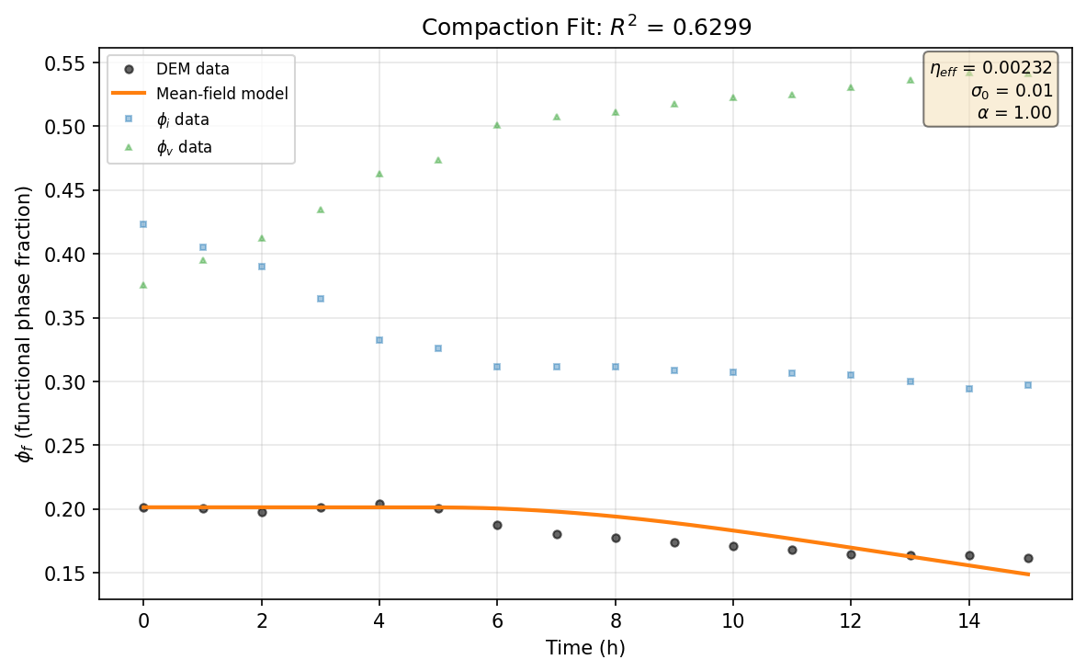
Figure 1. DOE_10 compaction fit (E = 50.0 kPa, R² = 0.630).
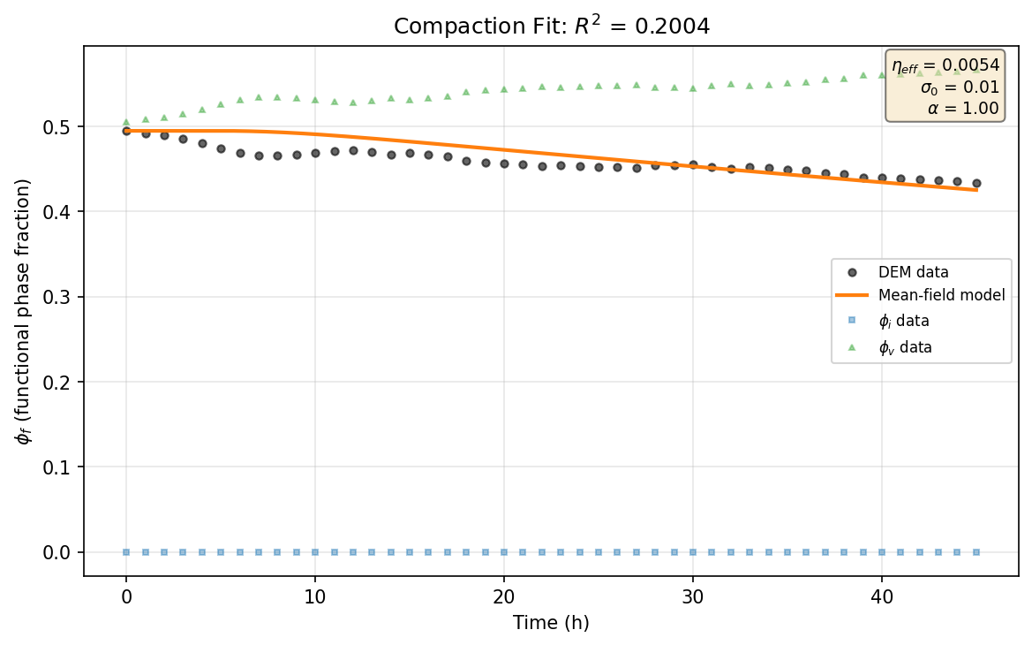
Figure 2. DOE_22 compaction fit (E = 50.0 kPa, R² = 0.200).
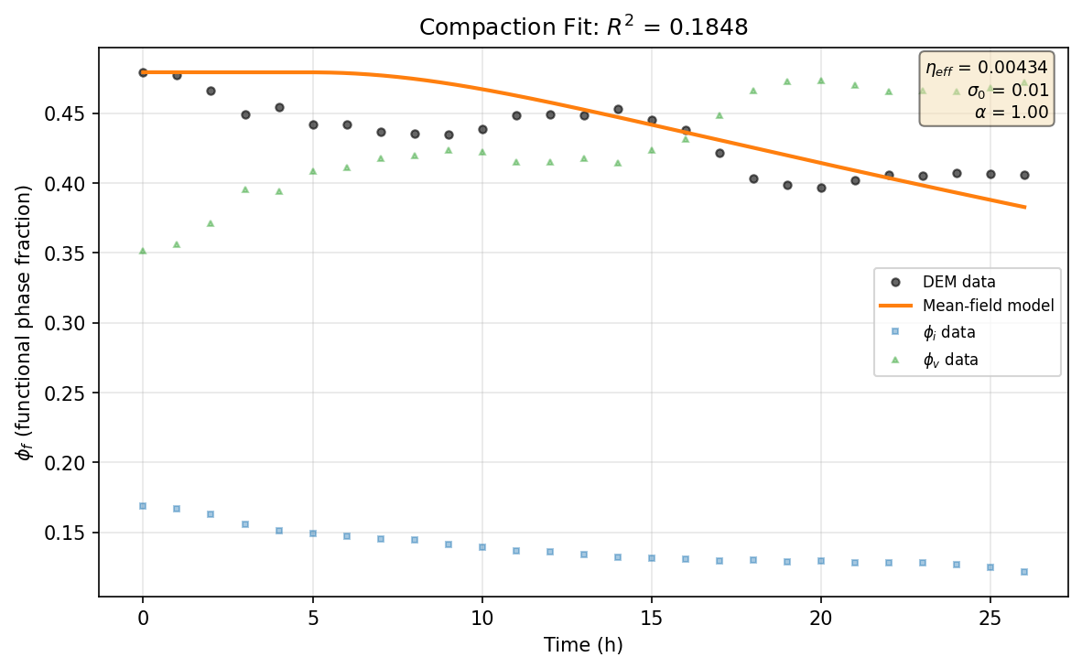
Figure 3. DOE_08 compaction fit (E = 50.0 kPa, R² = 0.185).
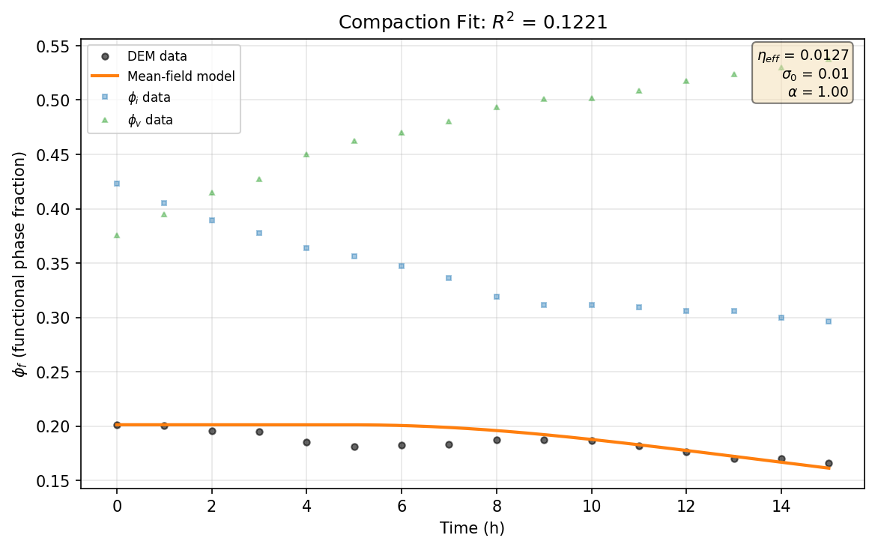
Figure 4. DOE_12 compaction fit (E = 50.0 kPa, R² = 0.122).
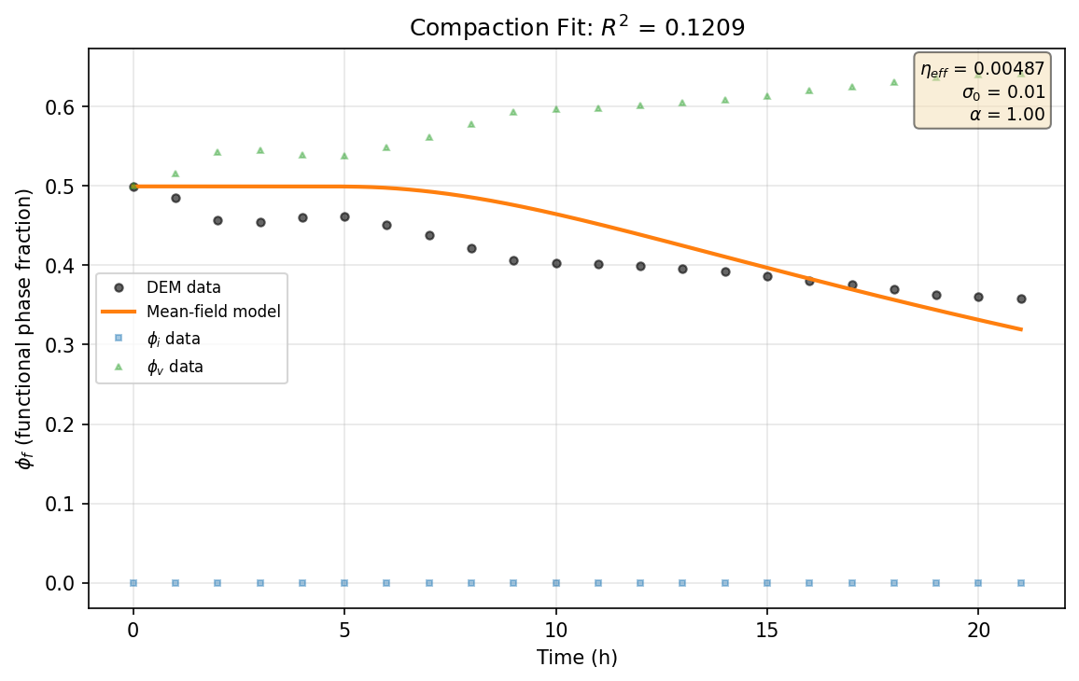
Figure 5. DOE_18 compaction fit (E = 50.0 kPa, R² = 0.121).
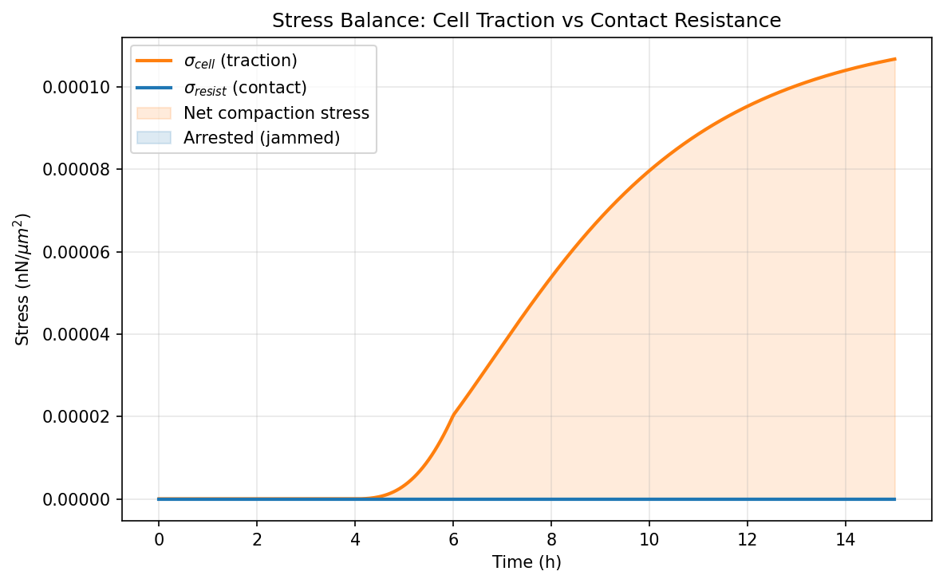
Figure 6. DOE_10 stress balance -- cell stress vs. resistance.
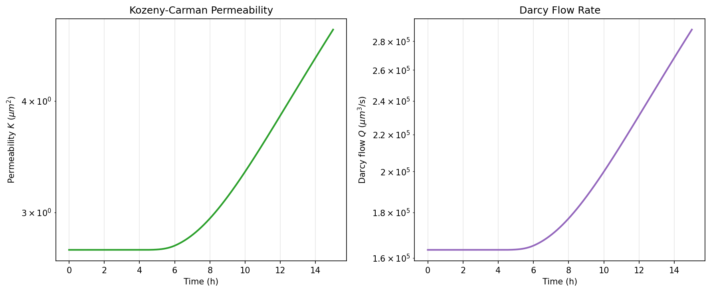
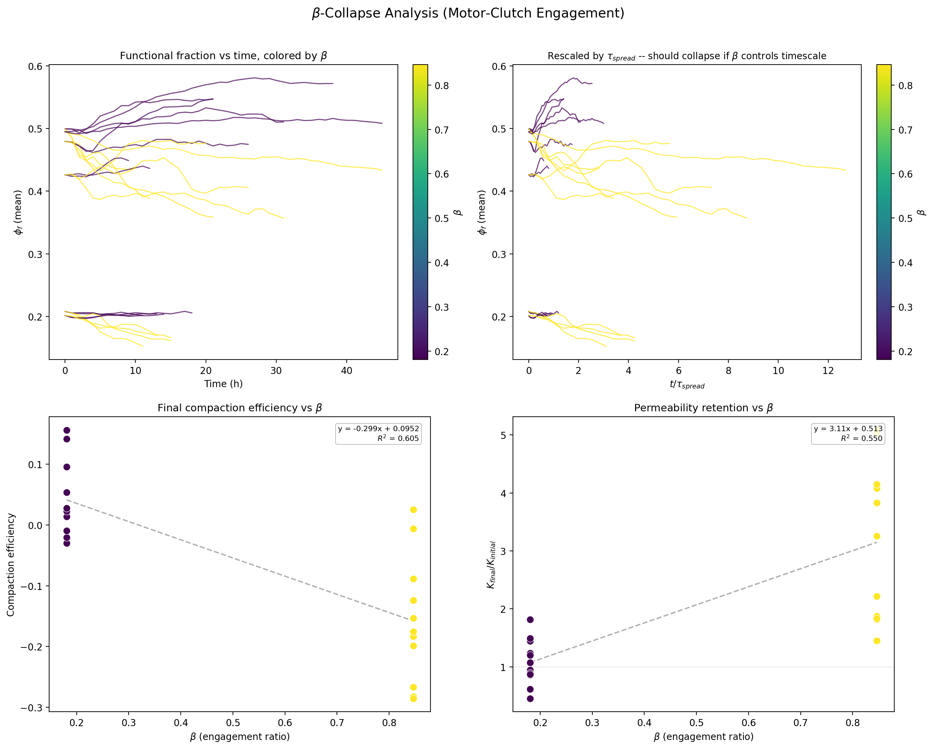
Figure 9. Data collapse by motor-clutch engagement ratio β.
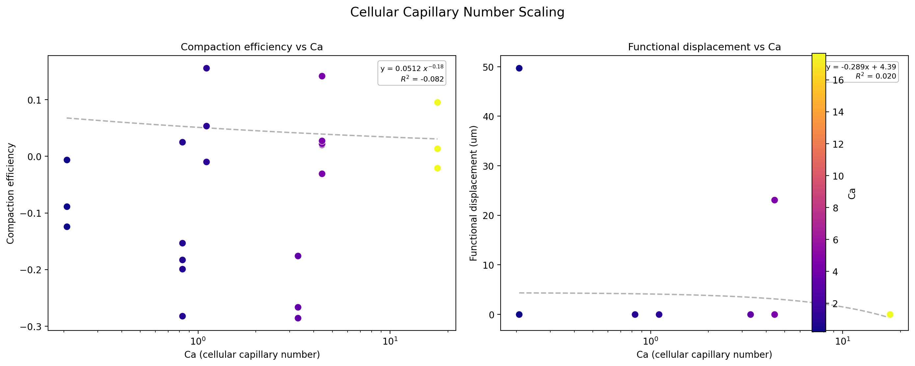
Figure 10. Compaction scaling with cellular capillary number Ca.
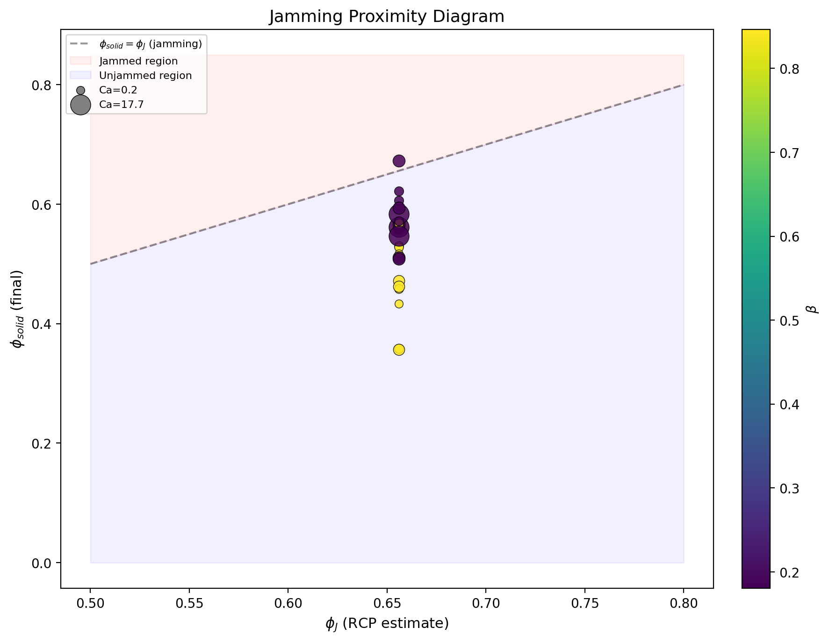
Figure 11. Jamming diagram: compaction vs. φ_solid/φ_J.
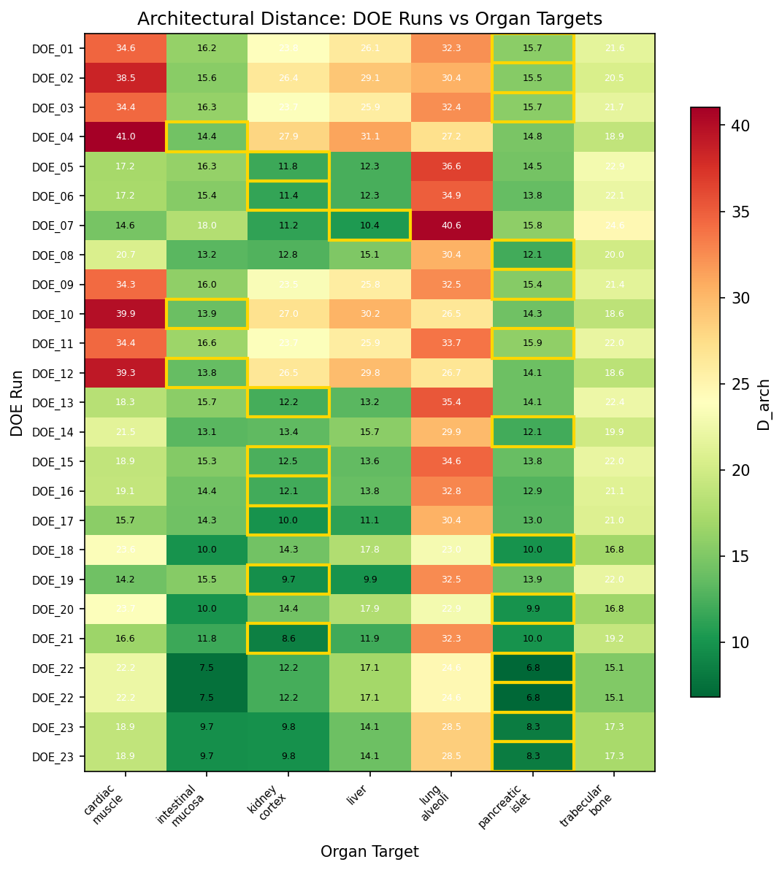
Figure 17. Architectural distance heatmap: DOE runs vs. 7 organ targets.
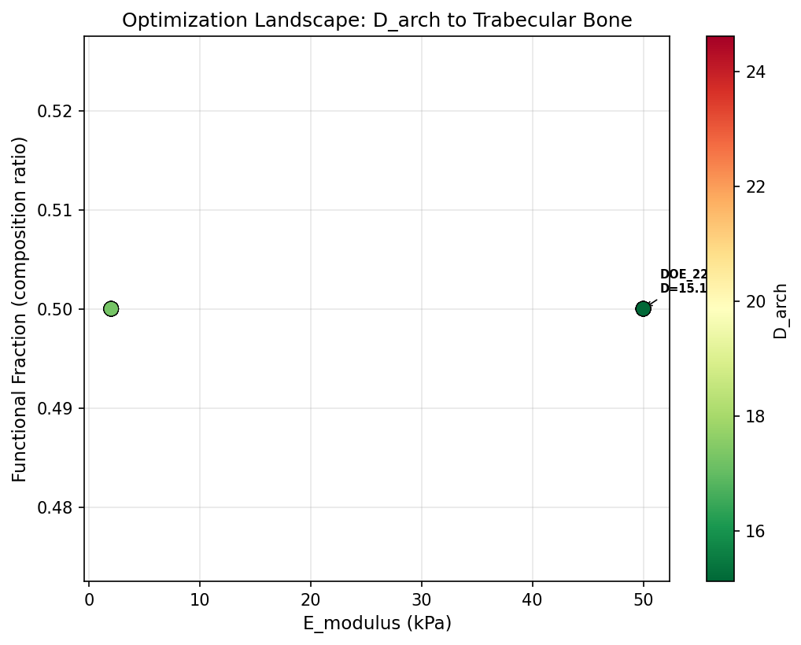
Figure 18. Optimization landscape for trabecular bone target.
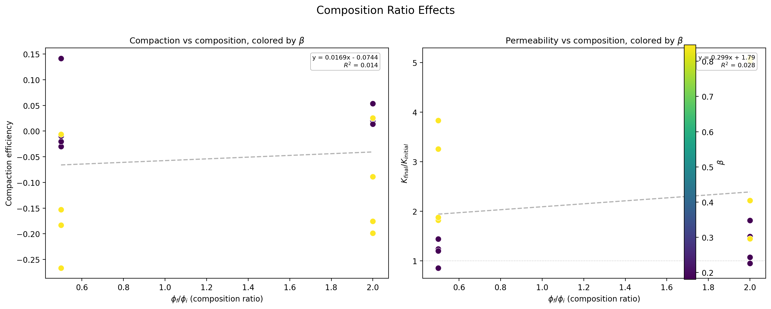
Figure 12. Effect of composition ratio on compaction.
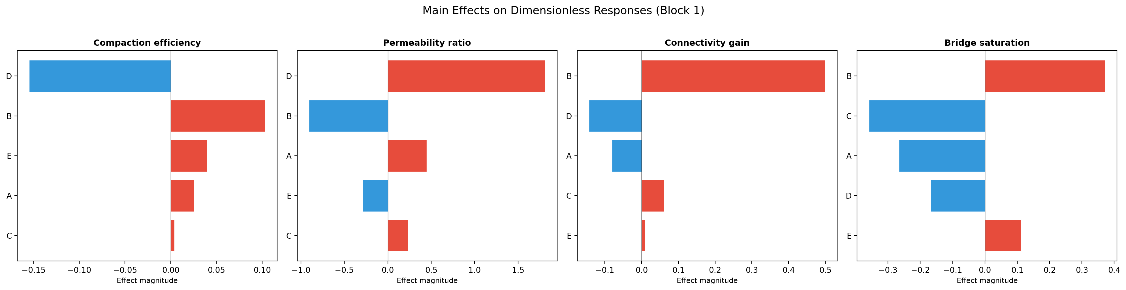
Figure 13. DOE main effects of 5 factors on Δφ_f.
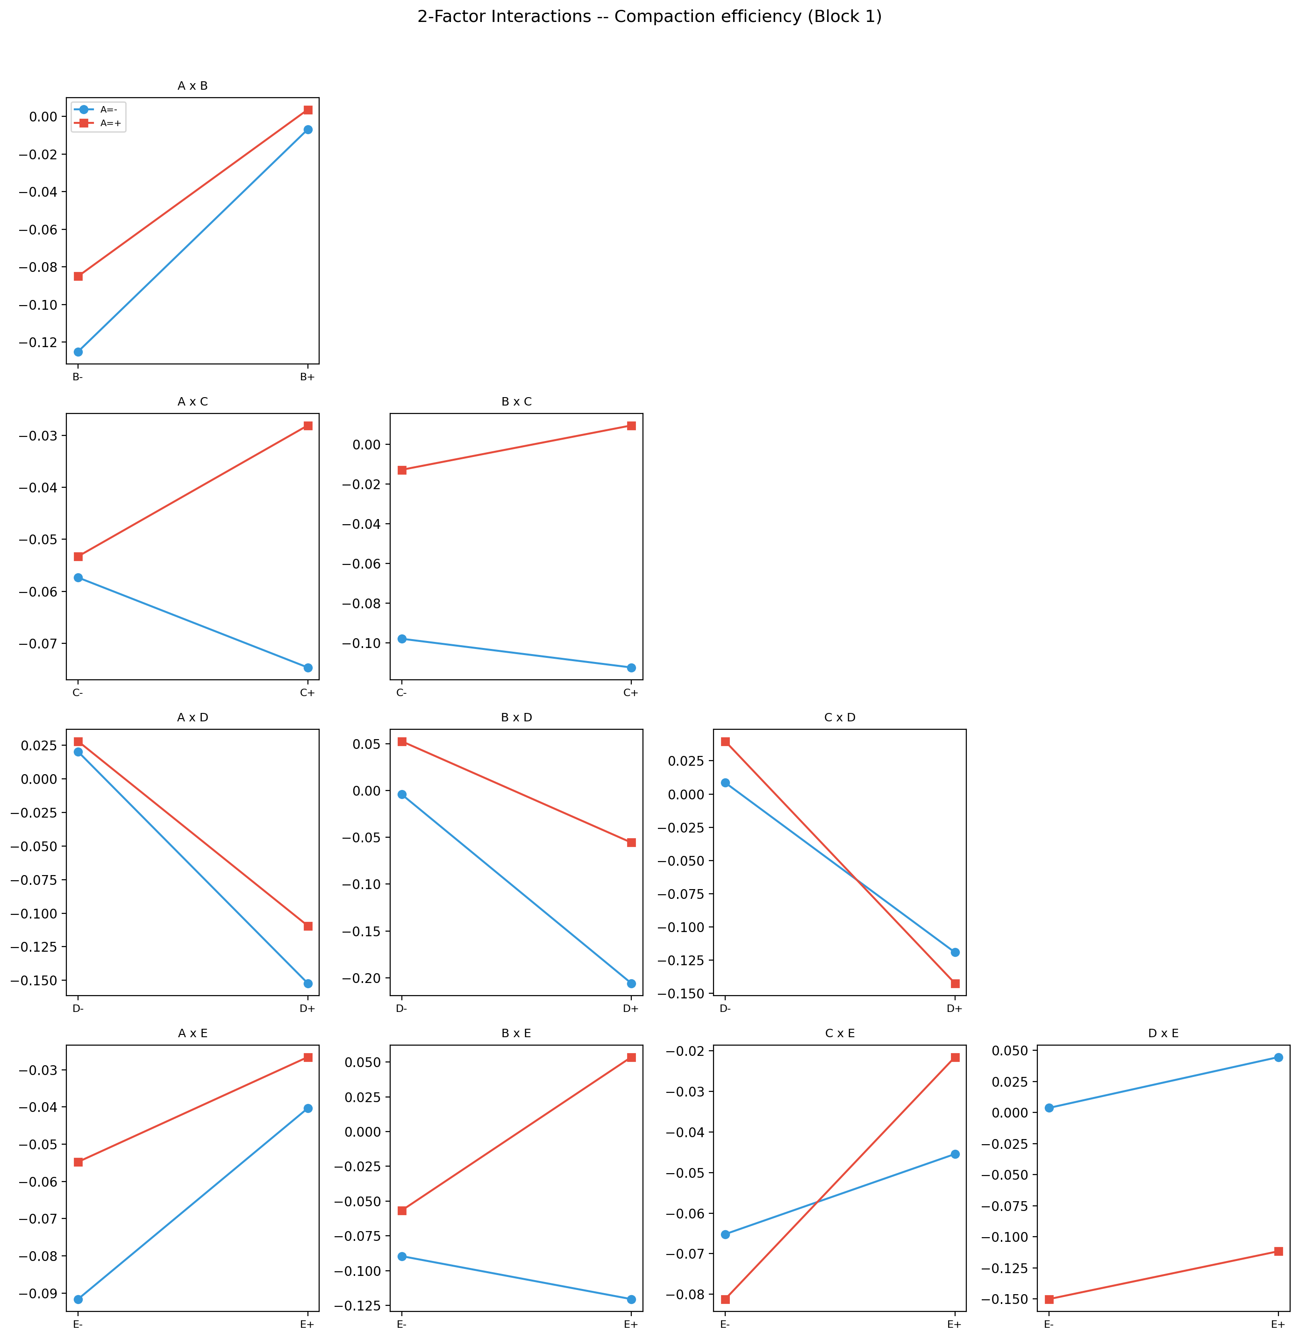
Figure 14. DOE factor interaction effects.
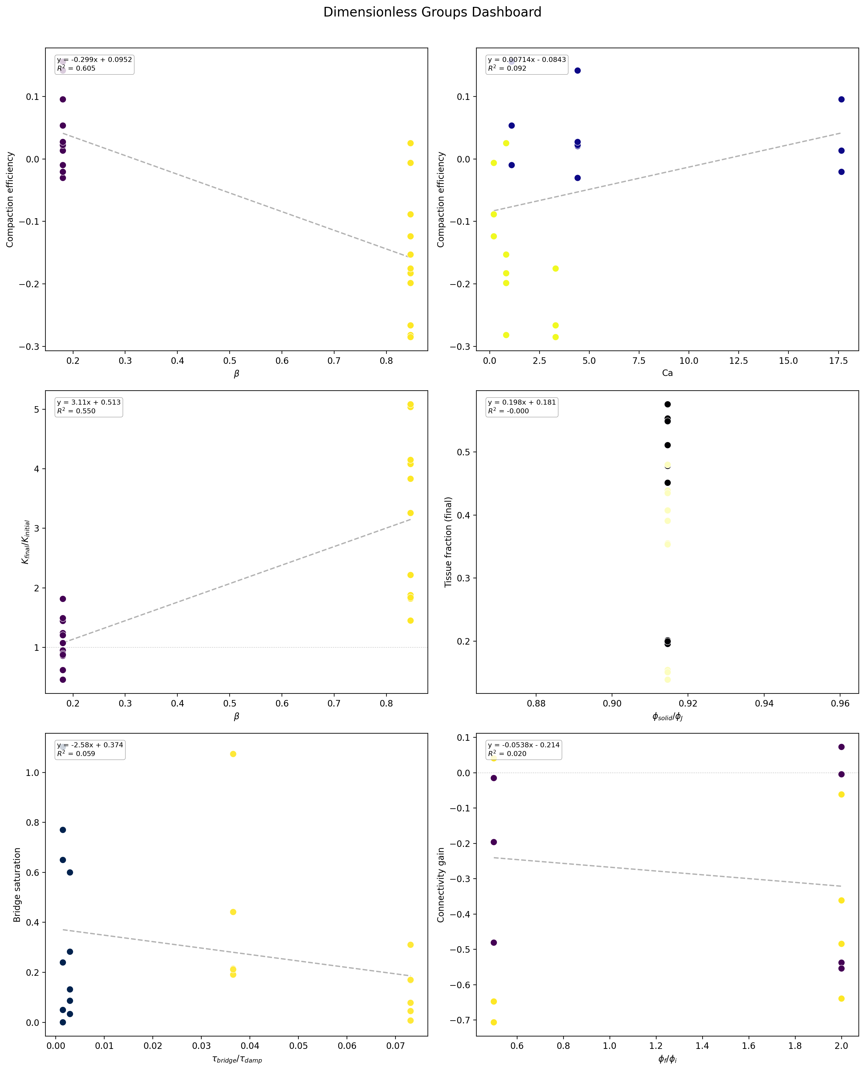
Figure 15. Dimensionless analysis dashboard (all groups).
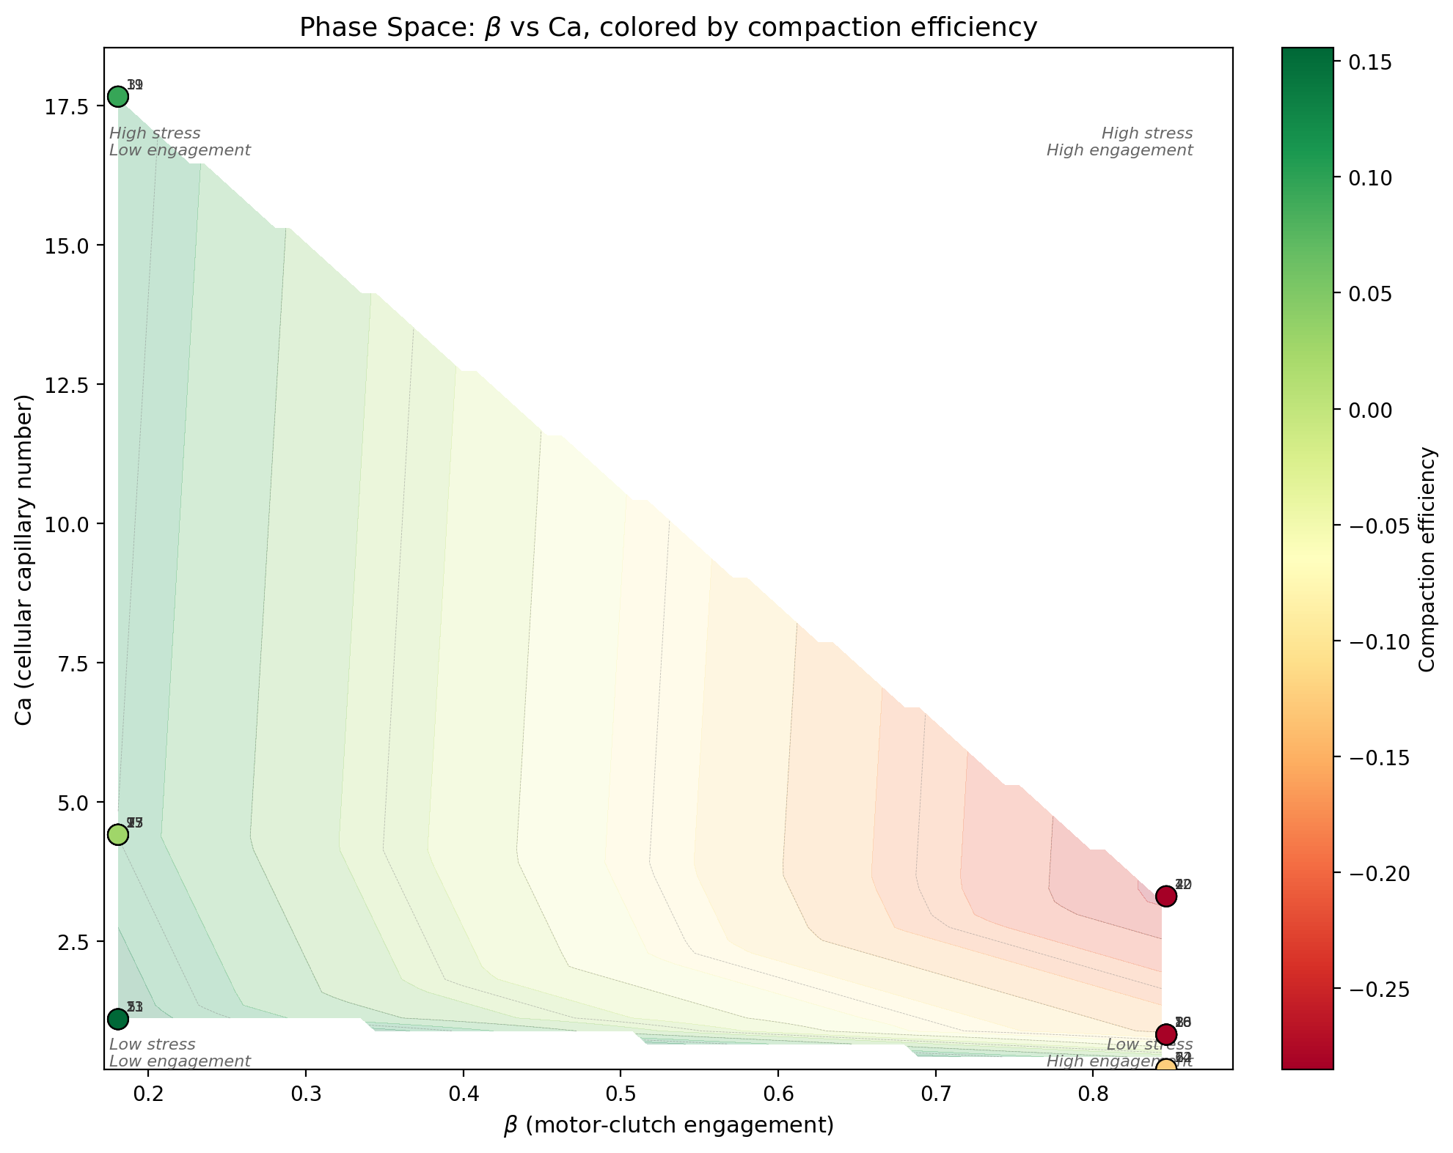
Figure 16. Phase space trajectories across DOE.
Figure 7. DOE_10 Kozeny-Carman permeability evolution.
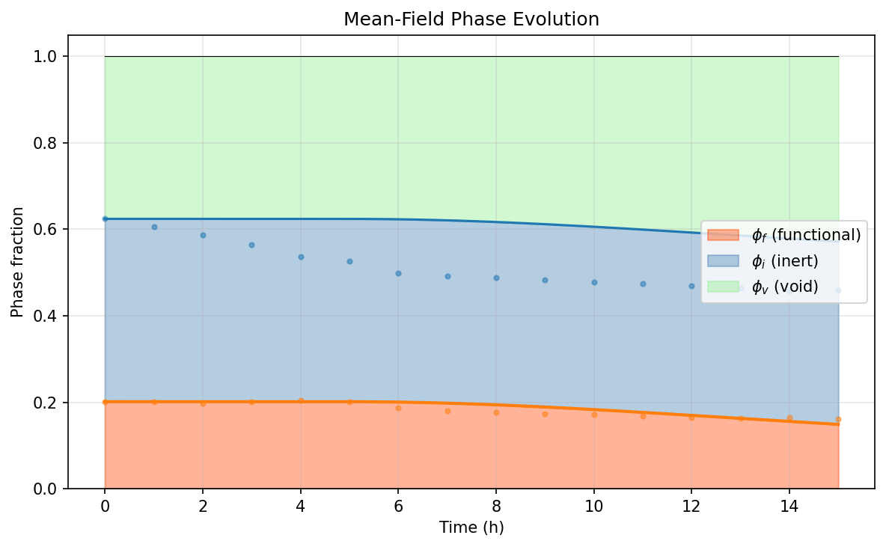
Figure 8. DOE_10 three-phase volume fraction evolution.

10.2 Coarse-Grained Continuum Quantities
The Love–Weber stress tensor (Section 3.1), strain-rate tensor (Section 3.2), and effective viscosity (Section 3.3) were extracted from all 22 runs with snapshot data. Key findings:
- Contact pressure ranges from $|P|∼0.01$ kPa ($E=2$ kPa runs) to $|P|∼2$ kPa ($E=50$ kPa runs), scaling approximately linearly with modulus.
- Coordination number at the final timepoint: $Z∈[0.13, 1.67]$. High-adhesion, high-modulus runs (DOE_08, DOE_18) reach $Z>1.4$, approaching the frictional jamming onset $Z_{J}≈4$ from below.
- Pressure relaxation is pronounced: initial contact stresses decay by 50–90% over the simulation duration as the packing equilibrates under cell-driven forces.
Run | $P_{0}$ (kPa) | $P_{f}$ (kPa) | $$Z_{f}$$ | $σ_{\text{vM},f}$ (kPa)
DOE_08 | $$-1.94$$ | $$-0.09$$ | 1.67 | 0.17
DOE_18 | $$-0.34$$ | $$-0.30$$ | 1.45 | 0.52
DOE_04 | $$-1.21$$ | $$-0.29$$ | 1.05 | 0.51
DOE_20 | $$-0.34$$ | $$-0.17$$ | 1.36 | 0.30

10.3 Dimensionless Analysis
The motor-clutch engagement ratio $β$ and cellular capillary number $\text{Ca}$ were computed for all 23 runs (Section 6):
$$β=\frac{k_{\text{sub}}}{k_{\text{sub}}+k_{\text{opt}}}∈[0.181, 0.846]$$
$$\text{Ca}=\frac{σ_{\text{cell}}}{E^{*}}∈[0.21, 17.66]$$
The data collapse by $β$ reveals two distinct regimes:
- Low-$β$ regime ($β<0.3$, $E=2$ kPa): Cell traction is substrate-limited. Compaction is negligible ($|Δϕ_{f}|<0.01$) regardless of other parameters. The system is in a force-starved state.
- High-$β$ regime ($β>0.8$, $E=50$ kPa): Cell traction saturates toward $F_{\text{stall}}$. Compaction magnitude is controlled by adhesion, composition ratio, and cell number rather than substrate stiffness alone.
The capillary number Ca shows an inverse relationship with compaction: low-Ca (high-modulus) runs exhibit the largest $|Δϕ_{f}|$ because the scaffold is stiff enough to transmit cell forces without excessive deformation at each contact.

10.4 Tissue Architecture Descriptors
The 22-descriptor tissue vector (Section 7.1) was computed from the final 3D phase fields of each run. Key descriptors across the DOE:
Descriptor | Symbol | Range | Units
Bone volume fraction | BV/TV | 0.139 – 0.576 | –
Trabecular thickness | Tb.Th | 19.2 – 39.1 | $μ$m
Trabecular spacing | Tb.Sp | 23.8 – 64.1 | $μ$m
Trabecular number | Tb.N | 0.009 – 0.020 | $μ$m$​^{-1}$
Structure Model Index | SMI | $-2.71$ – 1.80 | –
Degree of anisotropy | DA | 1.05 – 1.37 | –
Tortuosity | $$τ$$ | 14.2 – 349.7 | –
Kozeny-Carman permeability | $$K$$ | 2.7 – 85.4 | $μ$m$​^{2}$
The composition factor (D) dominates BV/TV: runs with $ϕ_{f}=0.4$ produce $\text{BV/TV}∈[0.35, 0.58]$ while $ϕ_{f}=0.2$ runs yield $\text{BV/TV}∈[0.14, 0.20]$. SMI transitions from plate-like ($\text{SMI}<0$) at high BV/TV to rod-like ($\text{SMI}>1$) at low BV/TV, consistent with trabecular bone morphology literature.

10.5 Architectural Distance to Organ Targets
The weighted architectural distance $D_{\text{arch}}$ (Section 7.2) was computed between each DOE run’s final tissue state and the 7 organ targets (Section 7.3). The closest scaffold-organ matches:
Rank | Run | Target Organ | $$D_{\text{arch}}$$ | Key Parameters
1 | DOE_22 | Trabecular bone | 15.1 | $E=50$, $ϕ_{f}=0.4$, high adhesion
2 | DOE_20 | Trabecular bone | 16.8 | $E=50$, $ϕ_{f}=0.4$, low adhesion
3 | DOE_18 | Trabecular bone | 16.8 | $E=50$, $ϕ_{f}=0.4$, $R_{f}=60$
4 | DOE_23 | Trabecular bone | 17.3 | $E=2$, $ϕ_{f}=0.4$, center point
Interpretation. High functional volume fraction ($ϕ_{f}=0.4$) is the strongest predictor of proximity to trabecular bone. Substrate stiffness ($E=50$ kPa) provides a secondary benefit by enabling cell-mediated compaction that increases BV/TV and reduces Tb.Sp. The remaining distance ($D_{\text{arch}}∼15$) is driven primarily by the mismatch in Tb.Th ($∼​20$–$40 μ$m in simulation vs. $∼​150 μ$m in adult human trabecular bone) and tortuosity.

10.6 Summary of Key Findings
- Substrate stiffness is the master variable for cell-driven compaction, acting through the motor-clutch engagement ratio $β$. Below a critical stiffness ($E≲5$ kPa, $β<0.3$), cell traction is insufficient to drive measurable compaction.
- Composition ratio dominates tissue architecture. The functional phase fraction $ϕ_{f}$ directly controls BV/TV, Tb.Th, and SMI. The inert phase acts as a void template.
- The mean-field ODE captures compaction dynamics in the high-$β$ regime ($R^{2}∼0.1$–$0.6$) but underperforms at low $β$ where stochastic effects and bridge kinetics dominate.
- Scaffold architectures span a wide range of tissue descriptors ($\text{BV/TV}∈[0.14, 0.58]$, $\text{SMI}∈[-2.7, 1.8]$), suggesting the GELLS system can be tuned toward multiple organ targets.
- Trabecular bone is the most accessible target with $D_{\text{arch}}=15.1$ at optimal parameters. Liver and kidney cortex are secondary targets requiring higher BV/TV and lower porosity than achieved in this DOE.

References
- Chan, C. E. and Odde, D. J. (2008). Traction dynamics of filopodia on compliant substrates. Science, 322(5908):1687–1691.
- Derjaguin, B. V., Muller, V. M., and Toporov, Y. P. (1975). Effect of contact deformations on the adhesion of particles. Journal of Colloid and Interface Science, 53(2):314–326.
- Donev, A., Cisse, I., Sachs, D., Variano, E. A., Stillinger, F. H., Connelly, R., Torquato, S., and Chaikin, P. M. (2004). Improving the density of jammed disordered packings using ellipsoids. Science, 303(5660):990–993.
- Gong, J. P. (2006). Friction and lubrication of hydrogels — its richness and complexity. Soft Matter, 2(7):544–552.
- Harrigan, T. P. and Mann, R. W. (1984). Characterization of microstructural anisotropy in orthotropic materials using a second rank tensor. Journal of Materials Science, 19(3):761–767.
- Hildebrand, T. and Ruegsegger, P. (1997). A new method for the model-independent assessment of thickness in three-dimensional images. Journal of Microscopy, 185(1):67–75.
- Jaklic, A. and Leonardis, A. (2000). Superquadrics and their geometric properties. In Segmentation and Recovery of Superquadrics, pages 13–39. Springer.
- Johnson, K. L. (1985). Contact Mechanics. Cambridge University Press.
- O’Hern, C. S., Silbert, L. E., Liu, A. J., and Nagel, S. R. (2003). Jamming at zero temperature and zero applied stress: The epitome of disorder. Physical Review E, 68(1):011306.
- Pitenis, A. A., Uruenya, J. M., Schulze, K. D., Nixon, R. M., Dunn, A. C., Krick, B. A., Sawyer, W. G., and Angelini, T. E. (2014). Polymer fluctuation lubrication in hydrogel gemini interfaces. Soft Matter, 10(44):8955–8962.
- Torquato, S., Truskett, T. M., and Debenedetti, P. G. (2000). Is random close packing of spheres well defined? Physical Review Letters, 84(10):2064–2067.

Appendix A: Per-Run Mean-Field Analysis
This appendix contains the mean-field compaction model results for all 23 DOE runs. Each run shows four panels: (a) compaction fit, (b) phase evolution, (c) permeability evolution, (d) stress balance.

DOE_01 (E = 2.0 kPa, R² = -4.542, Δφ_f = -0.0063)
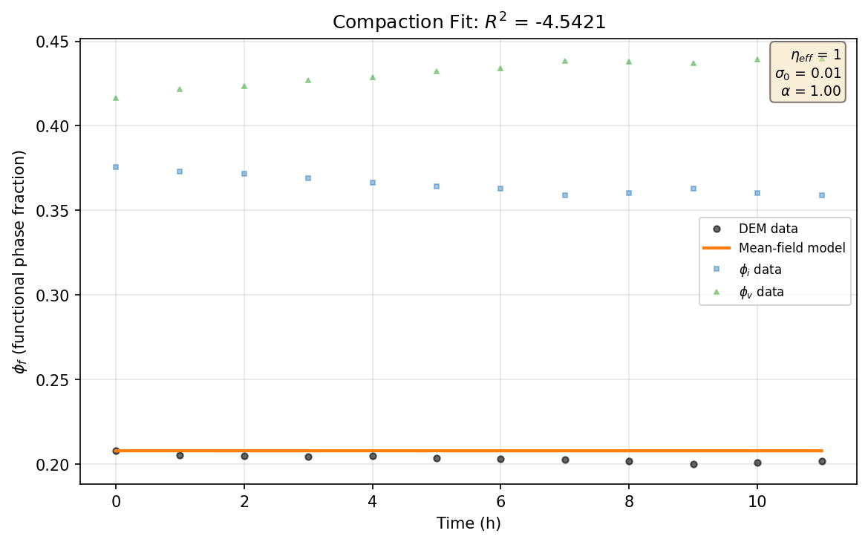
Figure 19. DOE_01 -- (a) Compaction fit.
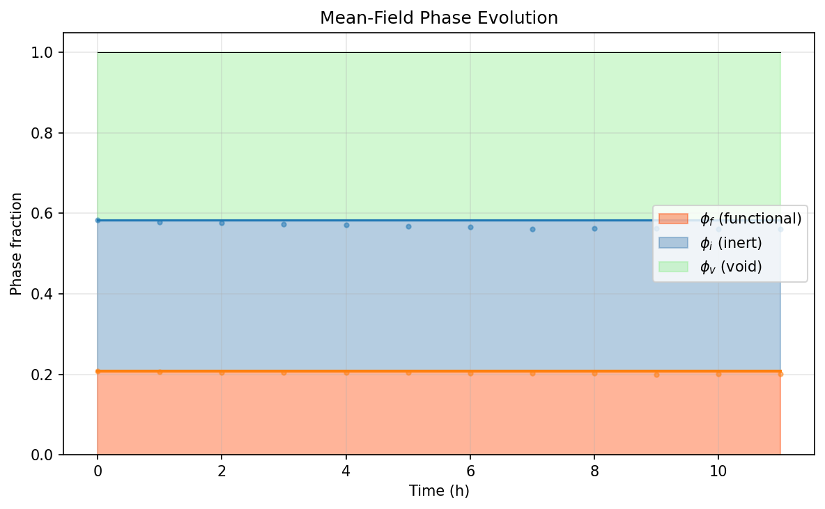
Figure 20. DOE_01 -- (b) Phase evolution.
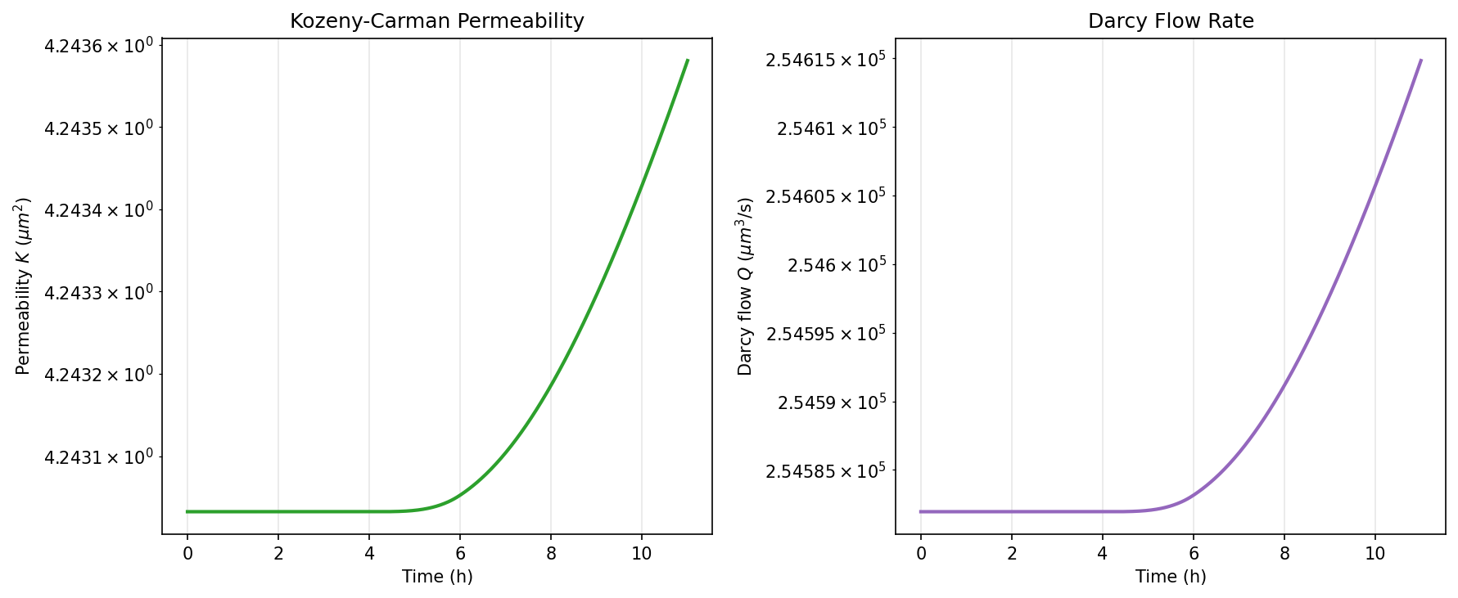
Figure 21. DOE_01 -- (c) Permeability evolution.
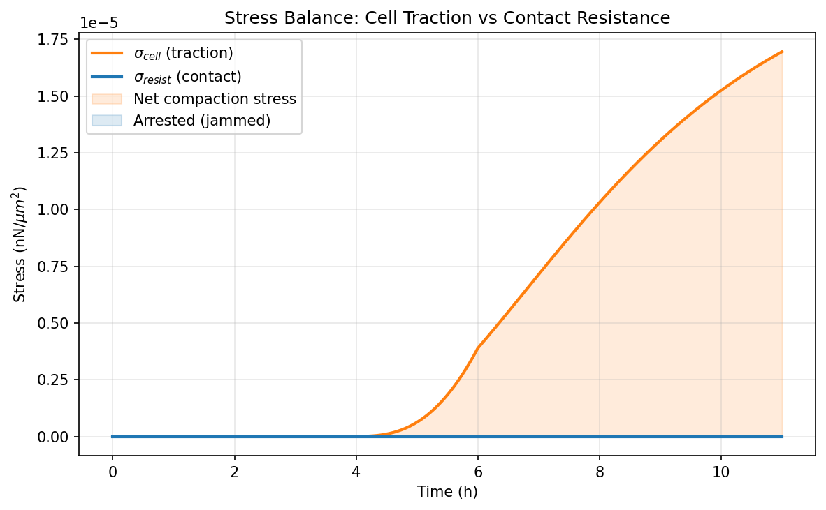
Figure 22. DOE_01 -- (d) Stress balance.

DOE_02 (E = 50.0 kPa, R² = -0.491, Δφ_f = -0.0380)
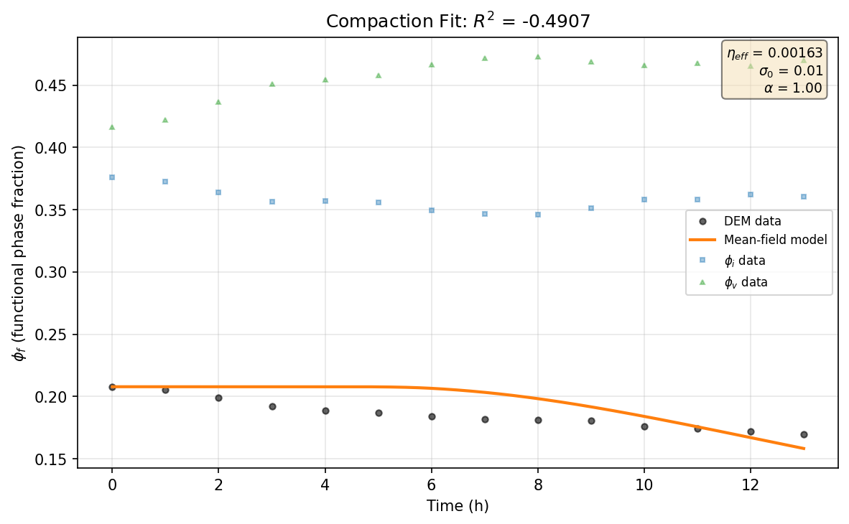
Figure 23. DOE_02 -- (a) Compaction fit.
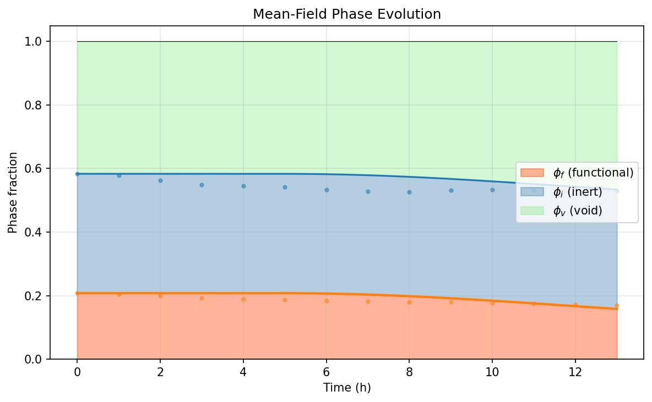
Figure 24. DOE_02 -- (b) Phase evolution.
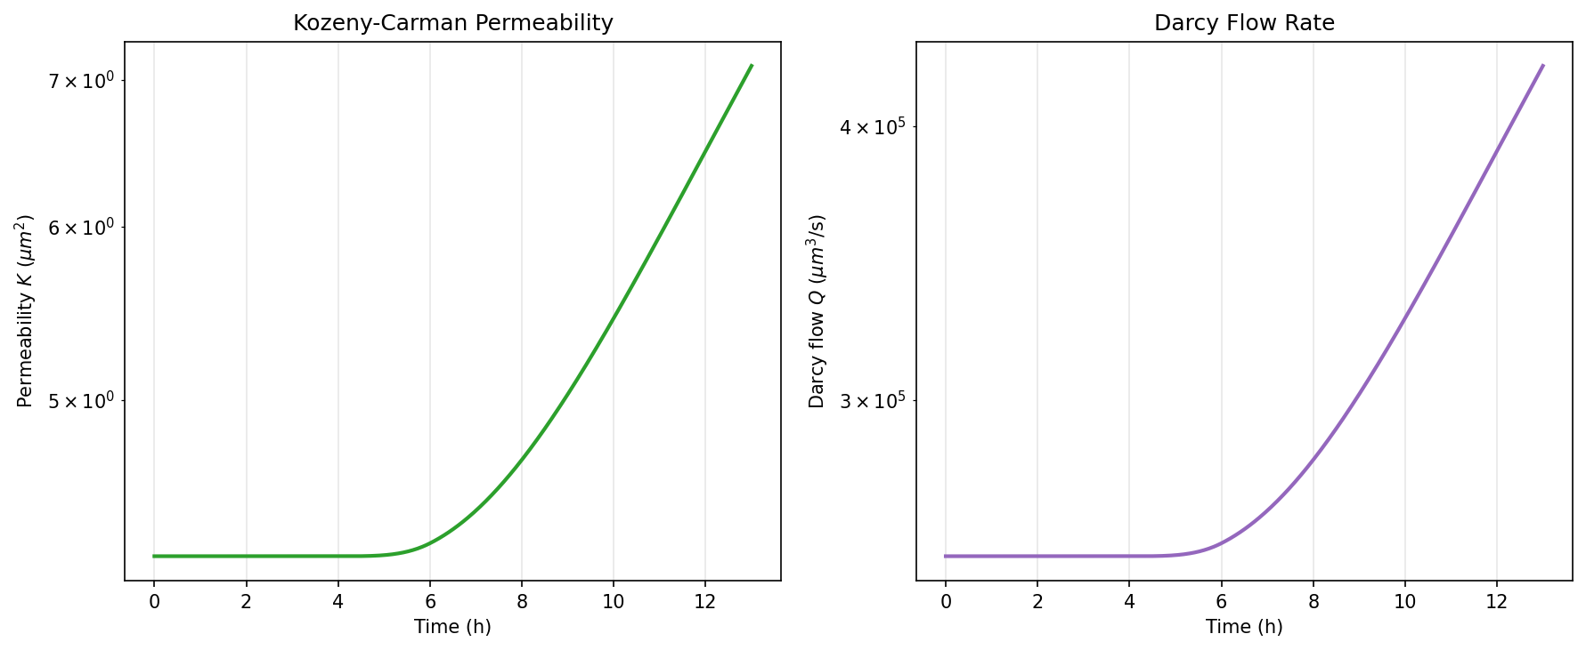
Figure 25. DOE_02 -- (c) Permeability evolution.
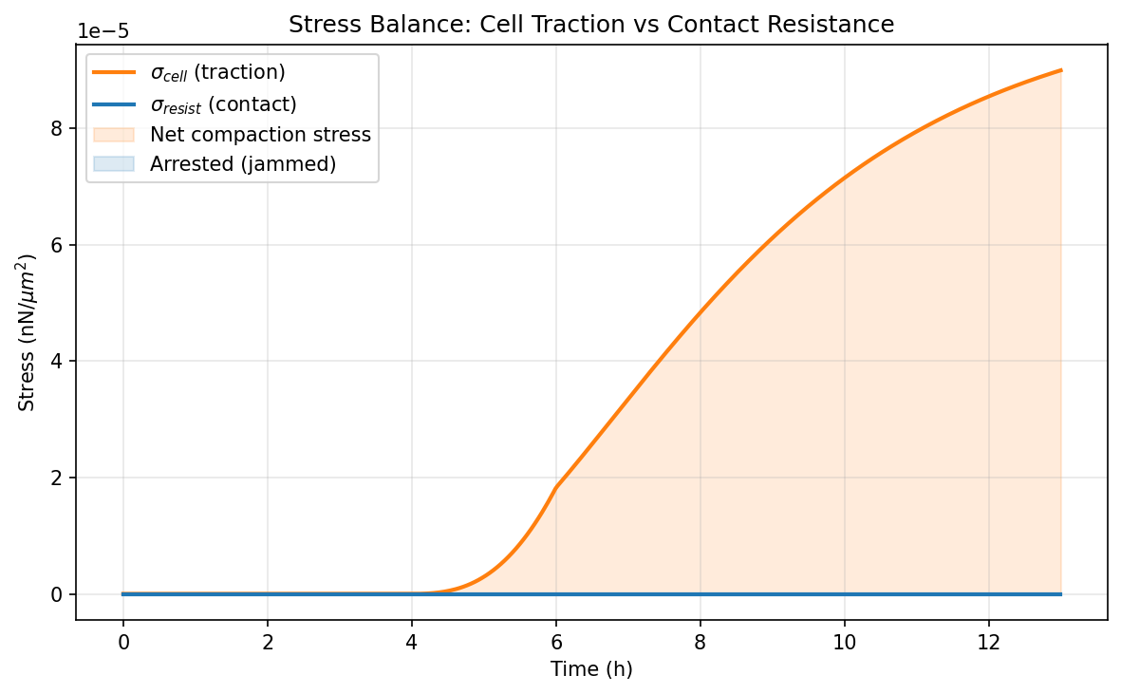
Figure 26. DOE_02 -- (d) Stress balance.

DOE_03 (E = 2.0 kPa, R² = -3.257, Δφ_f = -0.0043)
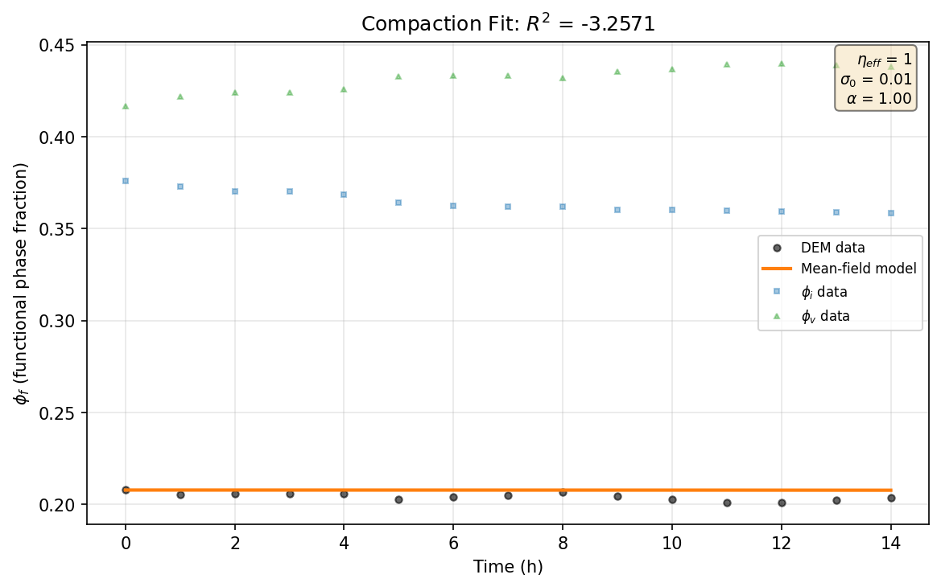
Figure 27. DOE_03 -- (a) Compaction fit.
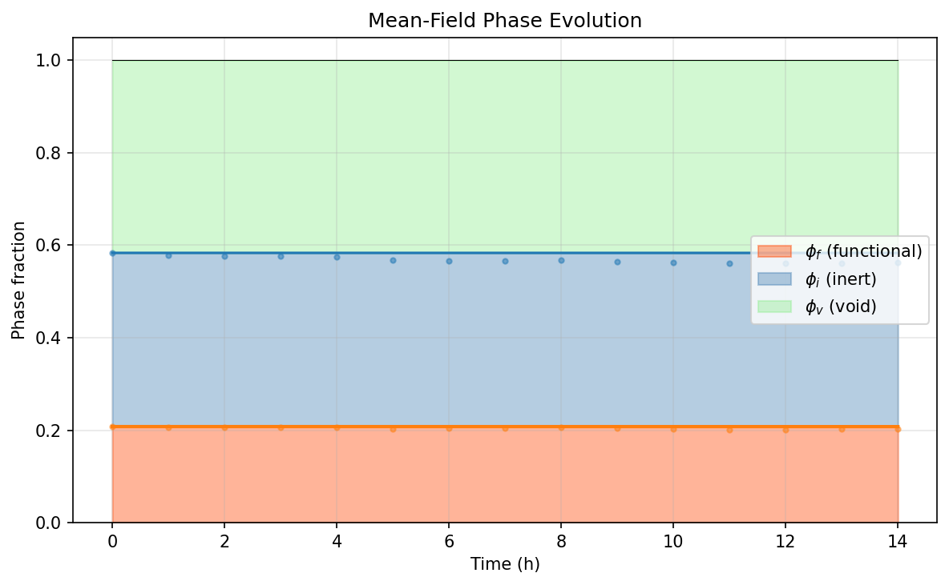
Figure 28. DOE_03 -- (b) Phase evolution.
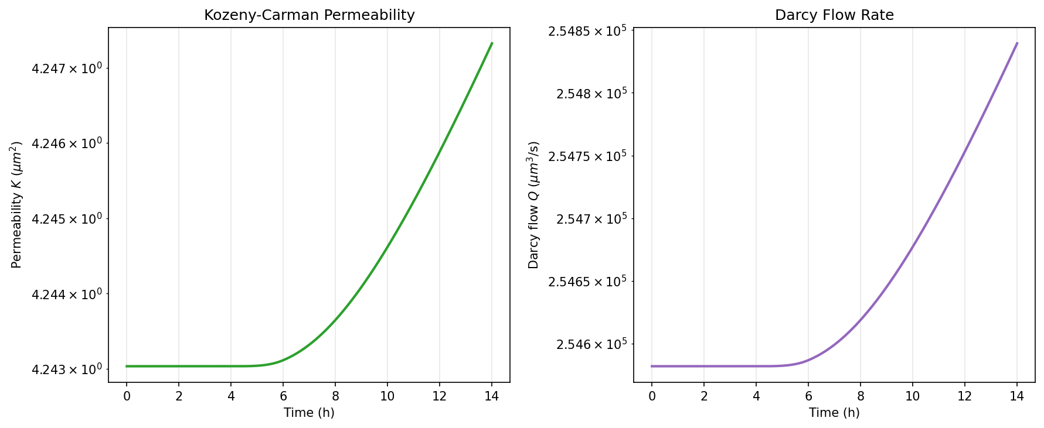
Figure 29. DOE_03 -- (c) Permeability evolution.
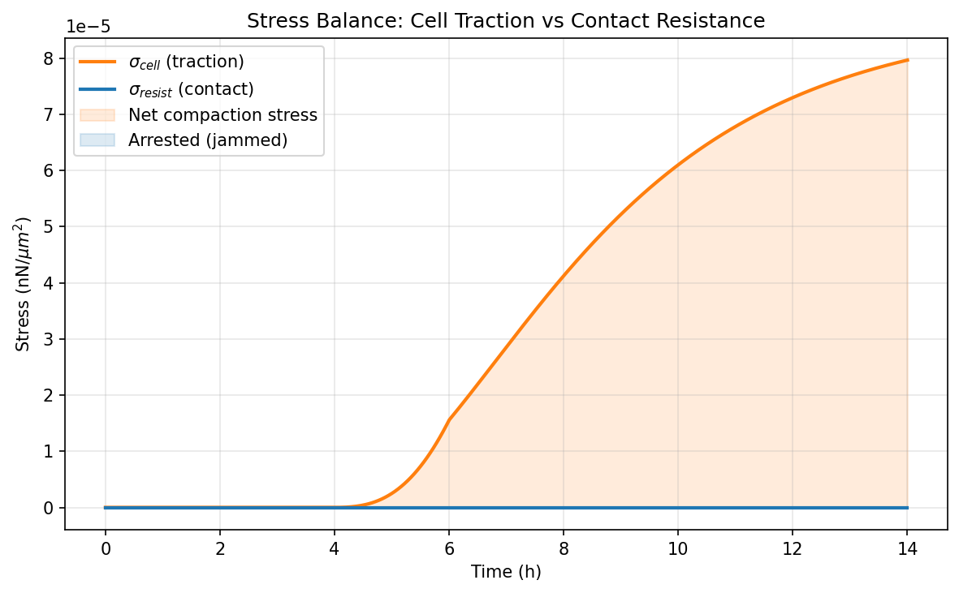
Figure 30. DOE_03 -- (d) Stress balance.

DOE_04 (E = 50.0 kPa, R² = -0.084, Δφ_f = -0.0554)
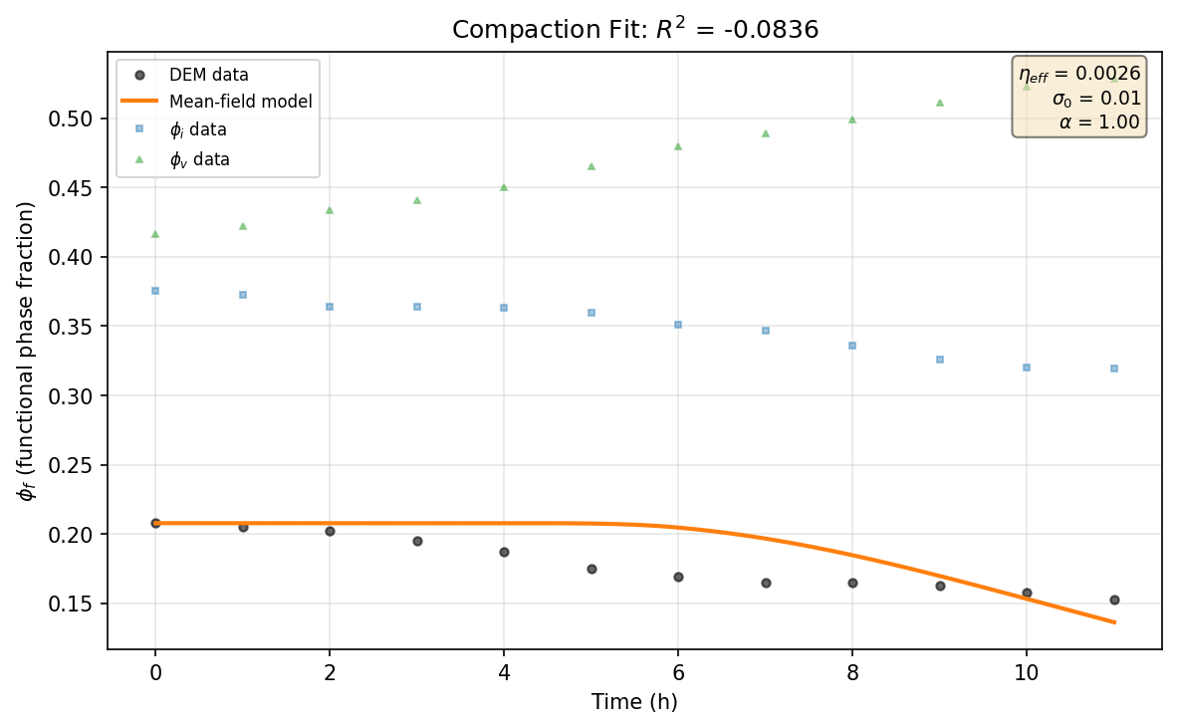
Figure 31. DOE_04 -- (a) Compaction fit.
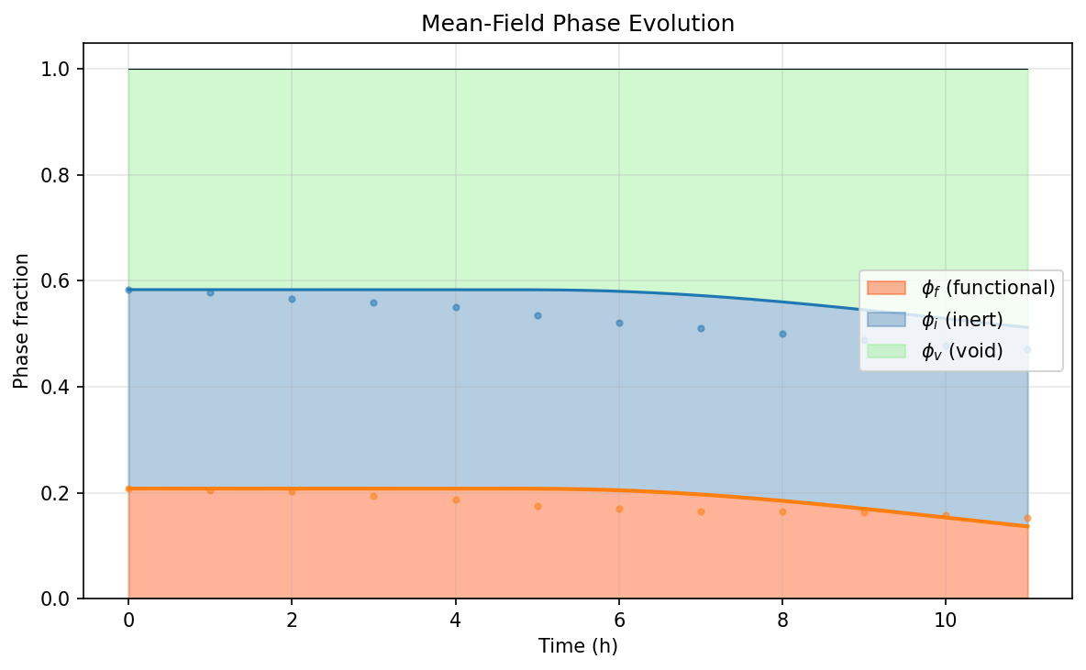
Figure 32. DOE_04 -- (b) Phase evolution.
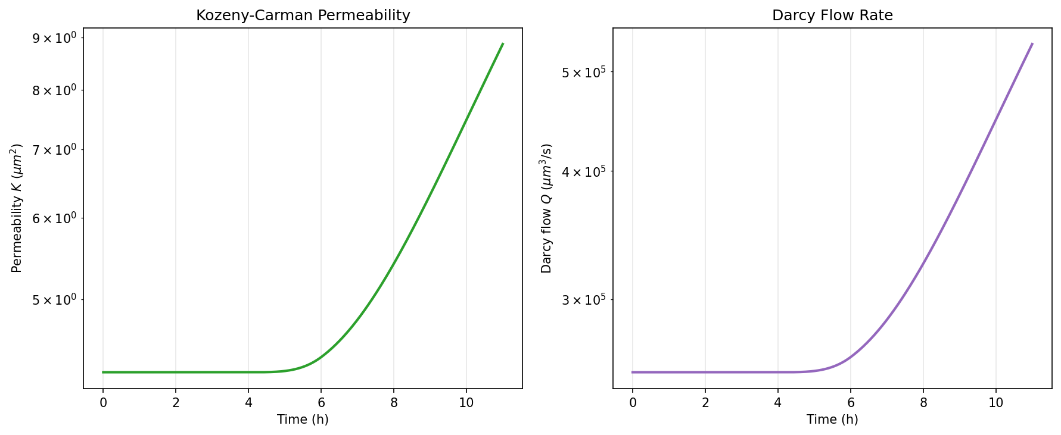
Figure 33. DOE_04 -- (c) Permeability evolution.
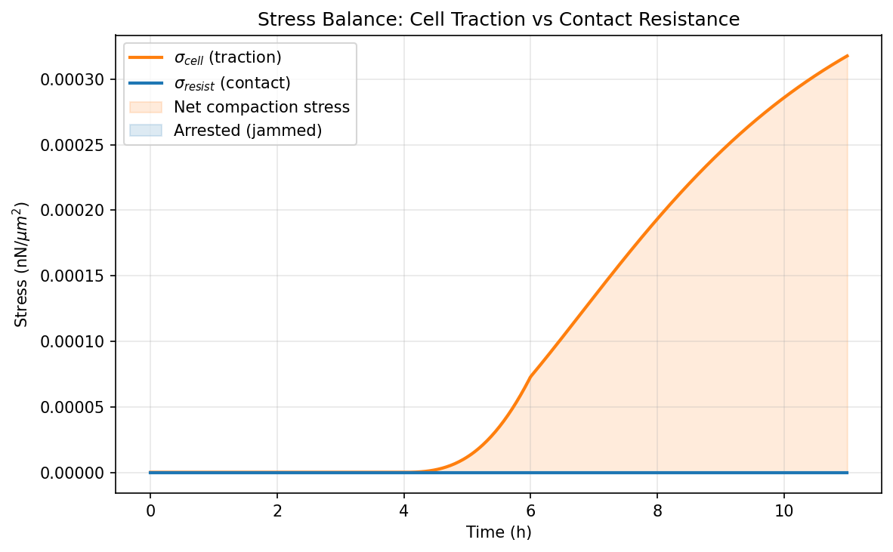
Figure 34. DOE_04 -- (d) Stress balance.

DOE_05 (E = 2.0 kPa, R² = -0.881, Δφ_f = -0.0047)
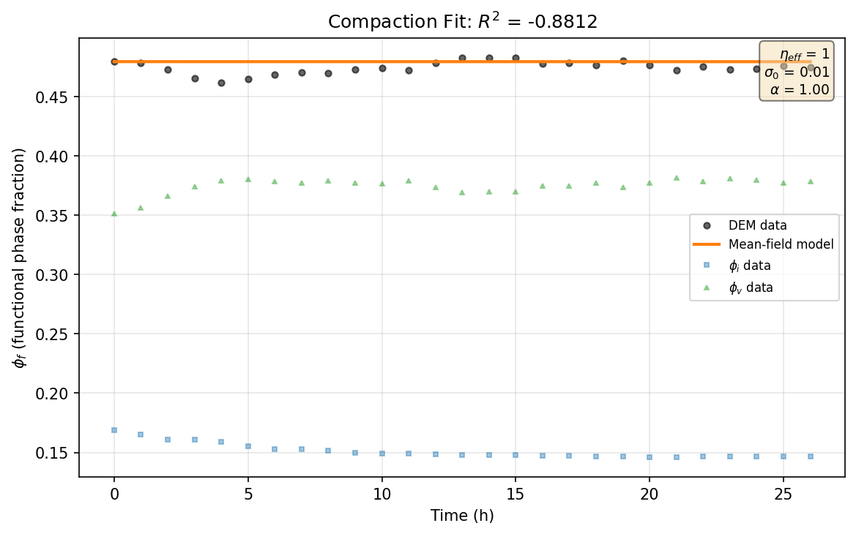
Figure 35. DOE_05 -- (a) Compaction fit.
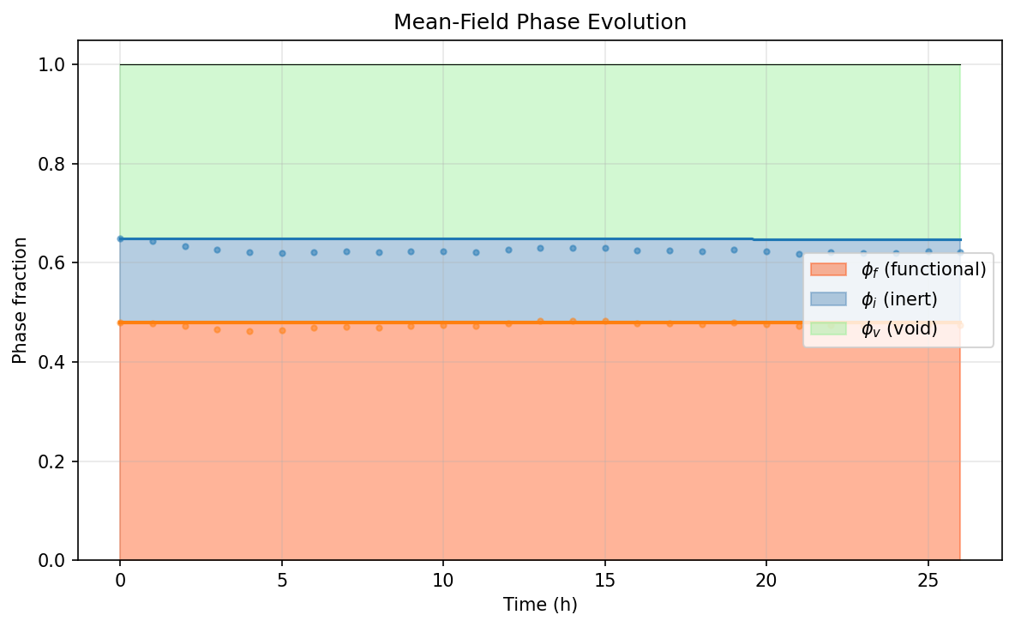
Figure 36. DOE_05 -- (b) Phase evolution.
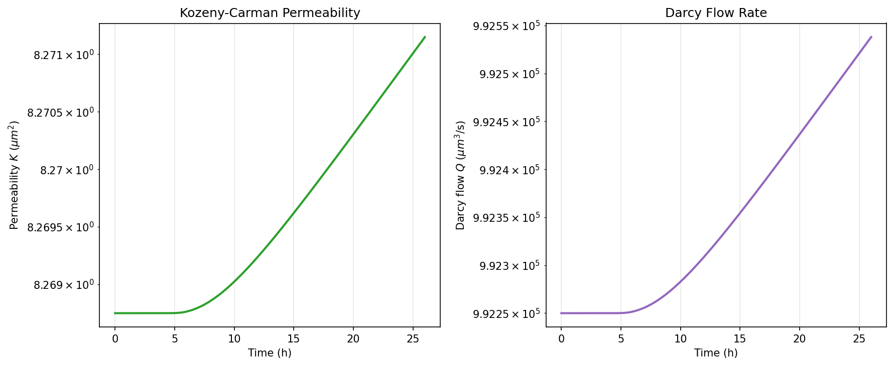
Figure 37. DOE_05 -- (c) Permeability evolution.
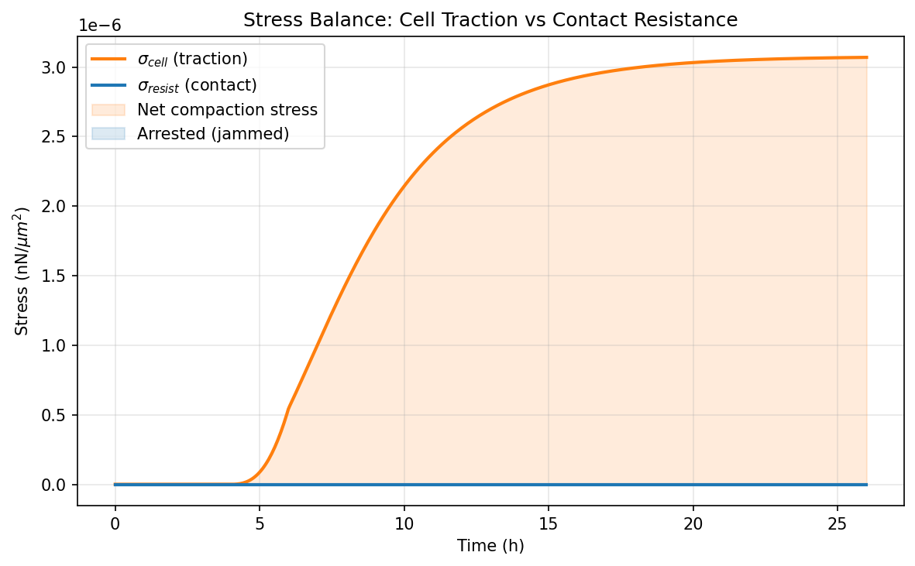
Figure 38. DOE_05 -- (d) Stress balance.

DOE_06 (E = 50.0 kPa, R² = -0.483, Δφ_f = -0.0030)
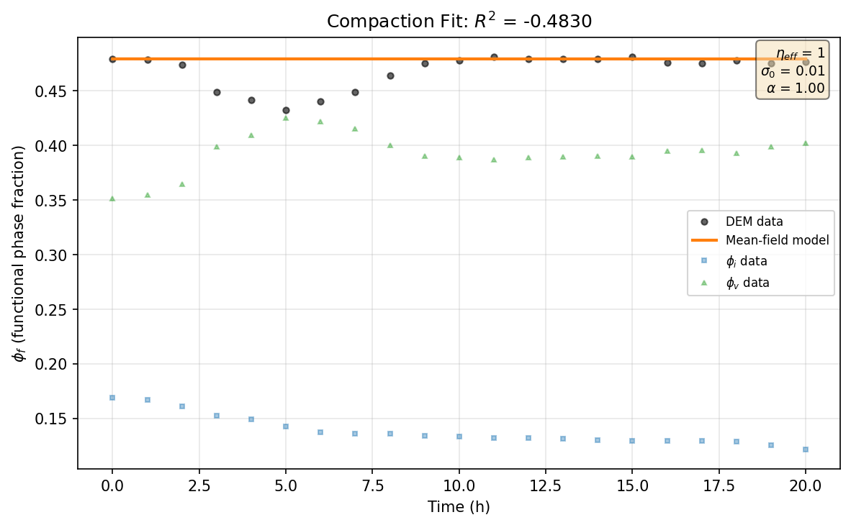
Figure 39. DOE_06 -- (a) Compaction fit.
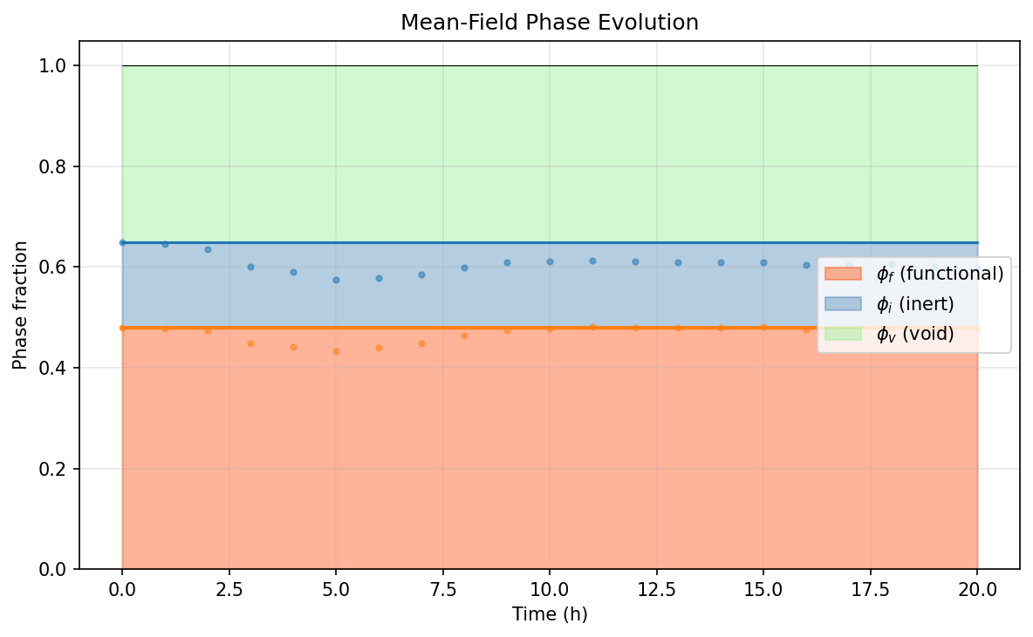
Figure 40. DOE_06 -- (b) Phase evolution.
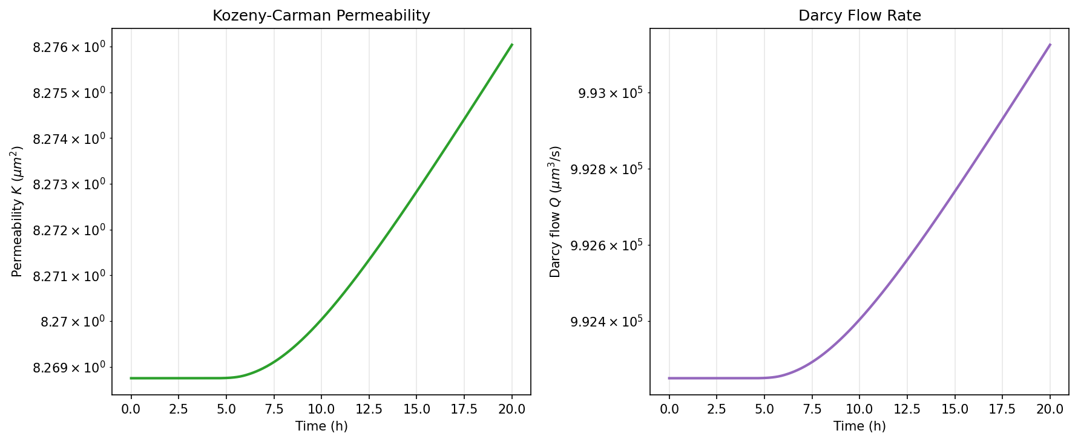
Figure 41. DOE_06 -- (c) Permeability evolution.
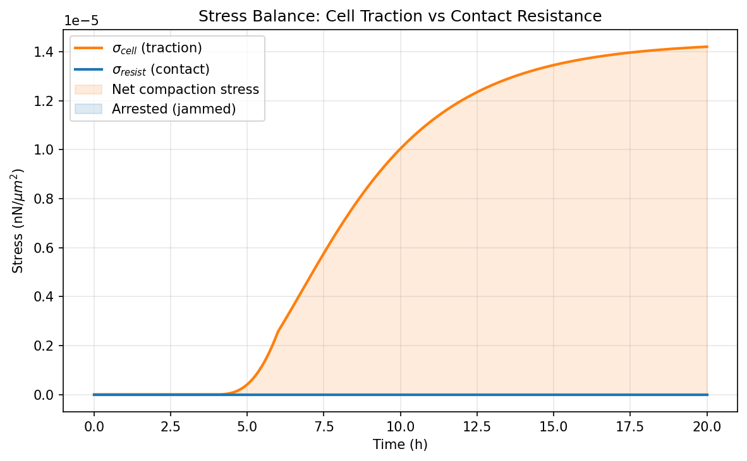
Figure 42. DOE_06 -- (d) Stress balance.

DOE_07 (E = 2.0 kPa, R² = -1.303, Δφ_f = 0.0679)
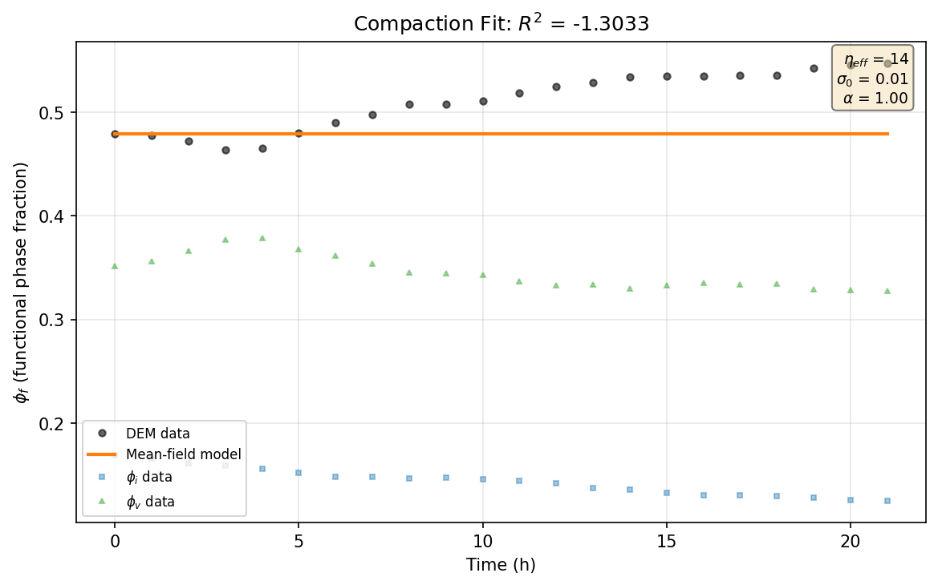
Figure 43. DOE_07 -- (a) Compaction fit.
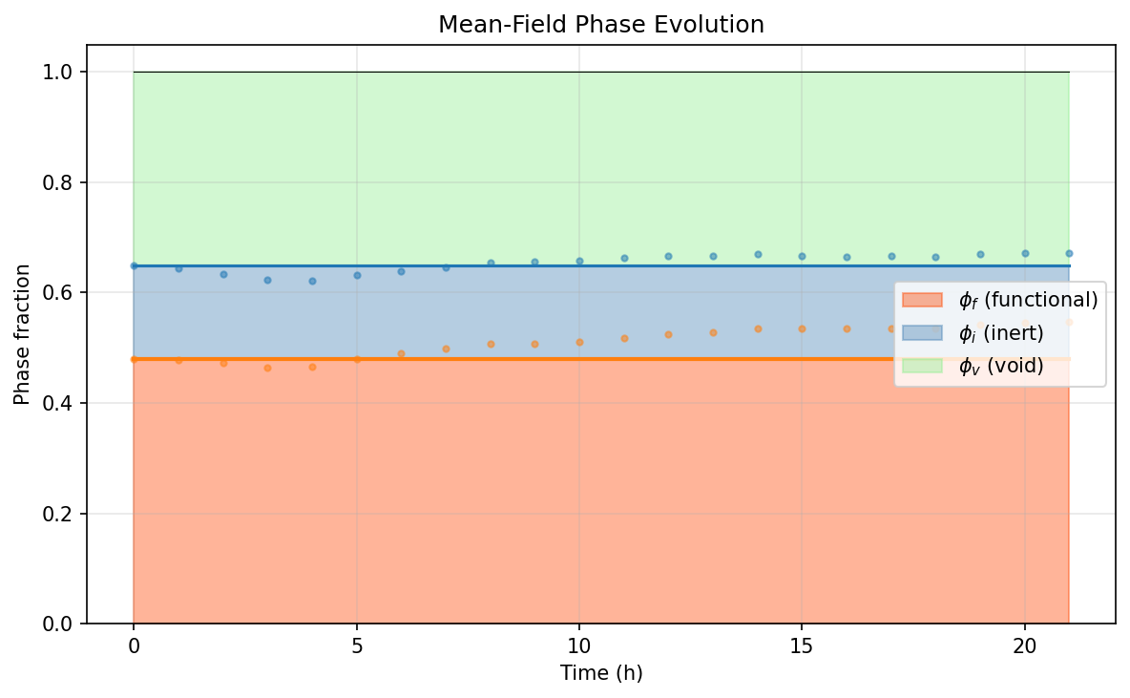
Figure 44. DOE_07 -- (b) Phase evolution.
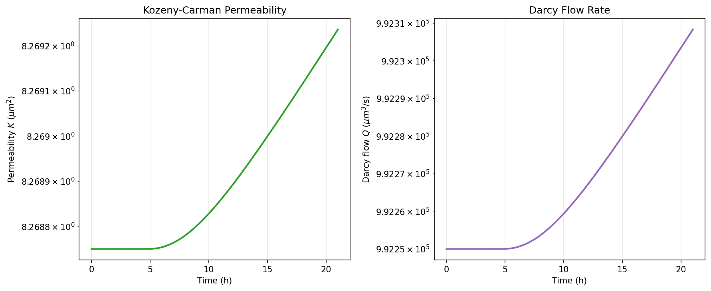
Figure 45. DOE_07 -- (c) Permeability evolution.
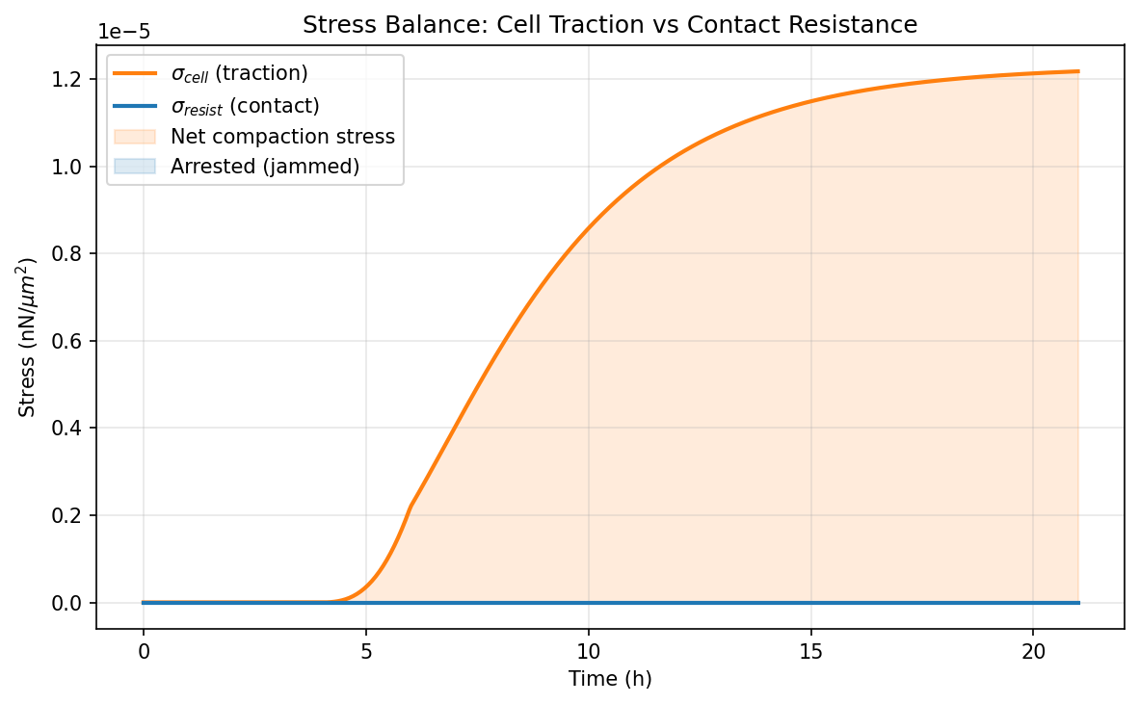
Figure 46. DOE_07 -- (d) Stress balance.

DOE_08 (E = 50.0 kPa, R² = 0.185, Δφ_f = -0.0734)

Figure 47. DOE_08 -- (a) Compaction fit.
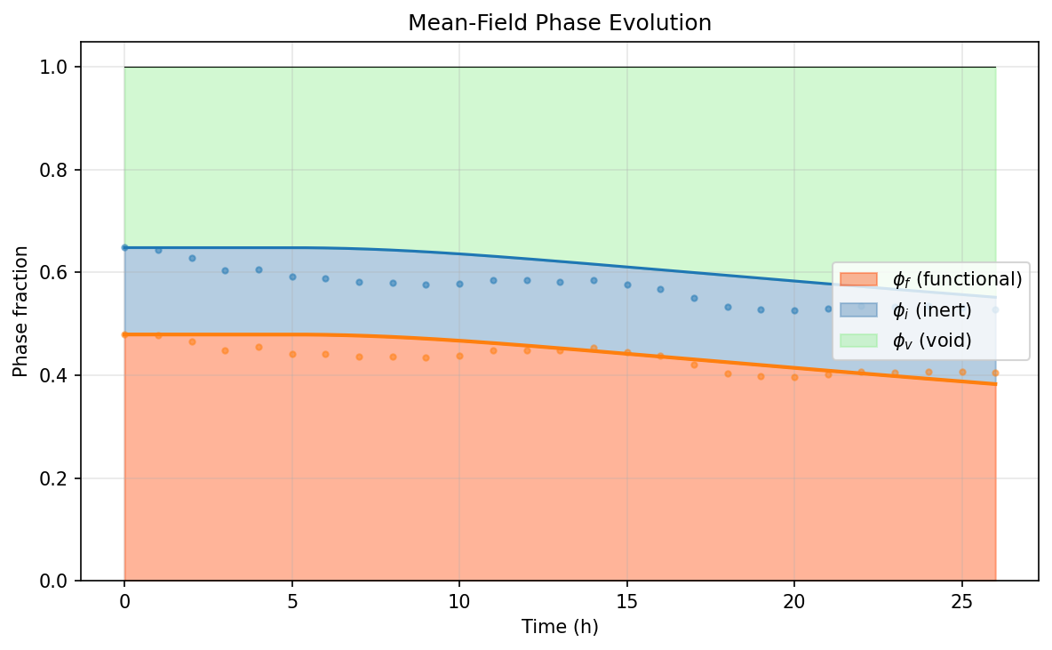
Figure 48. DOE_08 -- (b) Phase evolution.
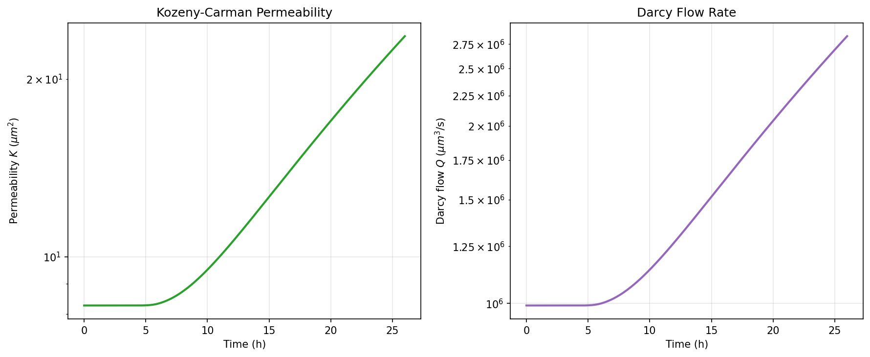
Figure 49. DOE_08 -- (c) Permeability evolution.
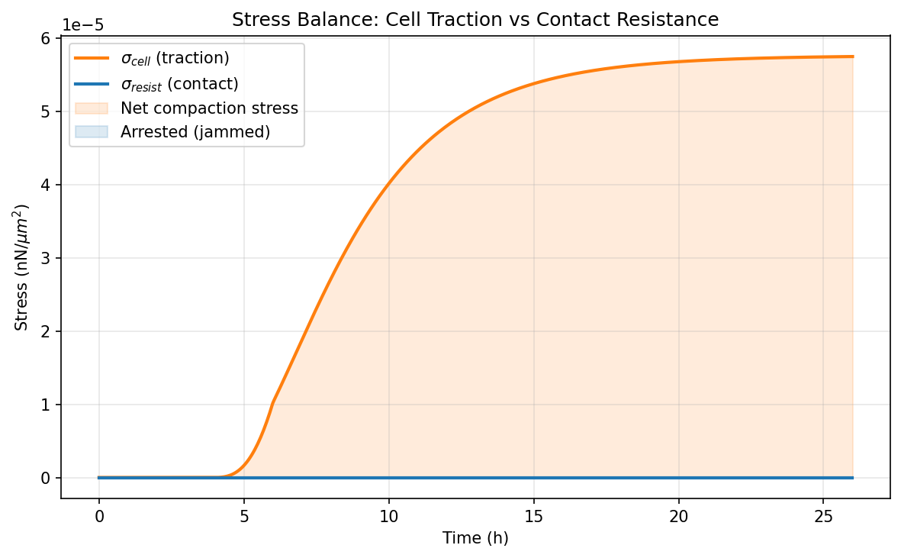
Figure 50. DOE_08 -- (d) Stress balance.

DOE_09 (E = 2.0 kPa, R² = -0.157, Δφ_f = 0.0042)
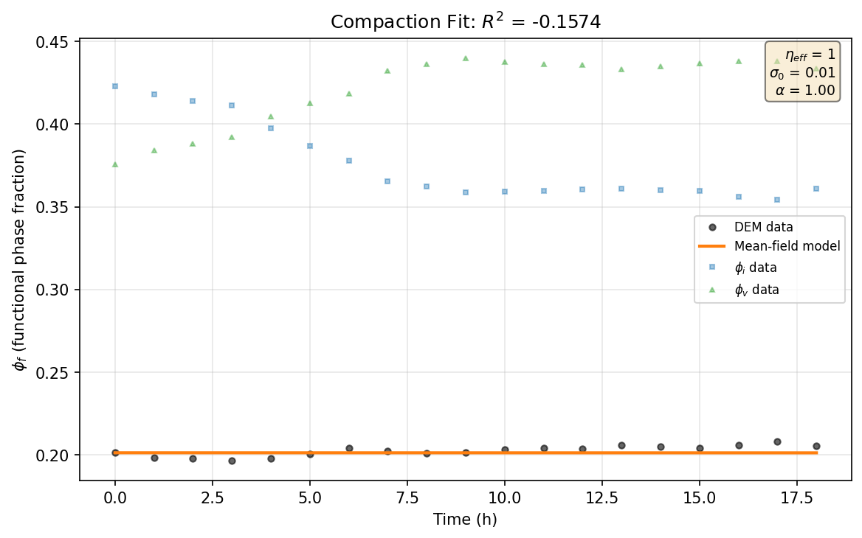
Figure 51. DOE_09 -- (a) Compaction fit.
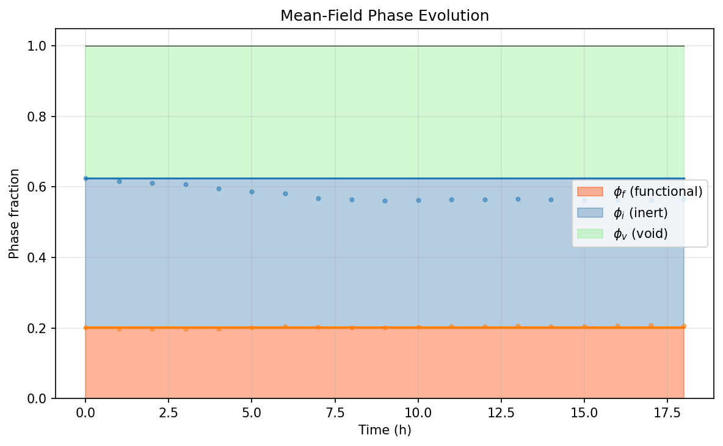
Figure 52. DOE_09 -- (b) Phase evolution.
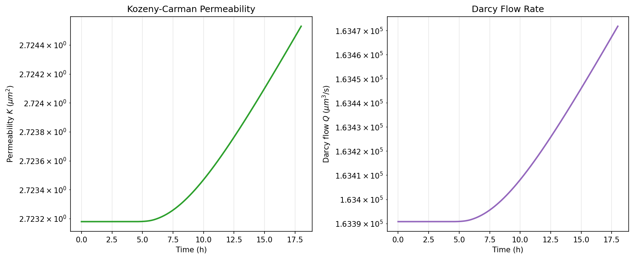
Figure 53. DOE_09 -- (c) Permeability evolution.
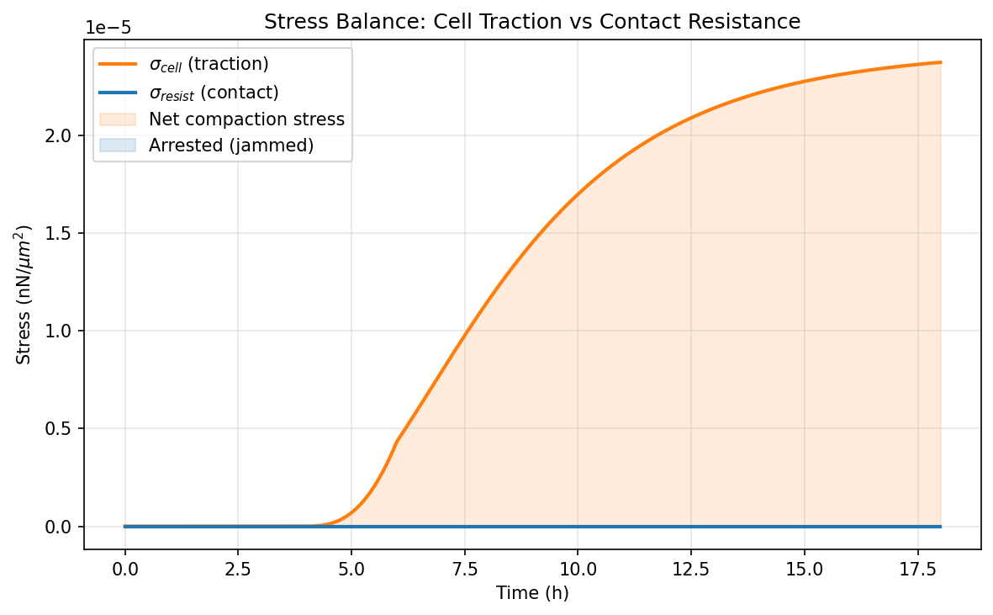
Figure 54. DOE_09 -- (d) Stress balance.

DOE_10 (E = 50.0 kPa, R² = 0.630, Δφ_f = -0.0400)

Figure 55. DOE_10 -- (a) Compaction fit.

Figure 56. DOE_10 -- (b) Phase evolution.

Figure 57. DOE_10 -- (c) Permeability evolution.

Figure 58. DOE_10 -- (d) Stress balance.

DOE_11 (E = 2.0 kPa, R² = -0.029, Δφ_f = 0.0027)
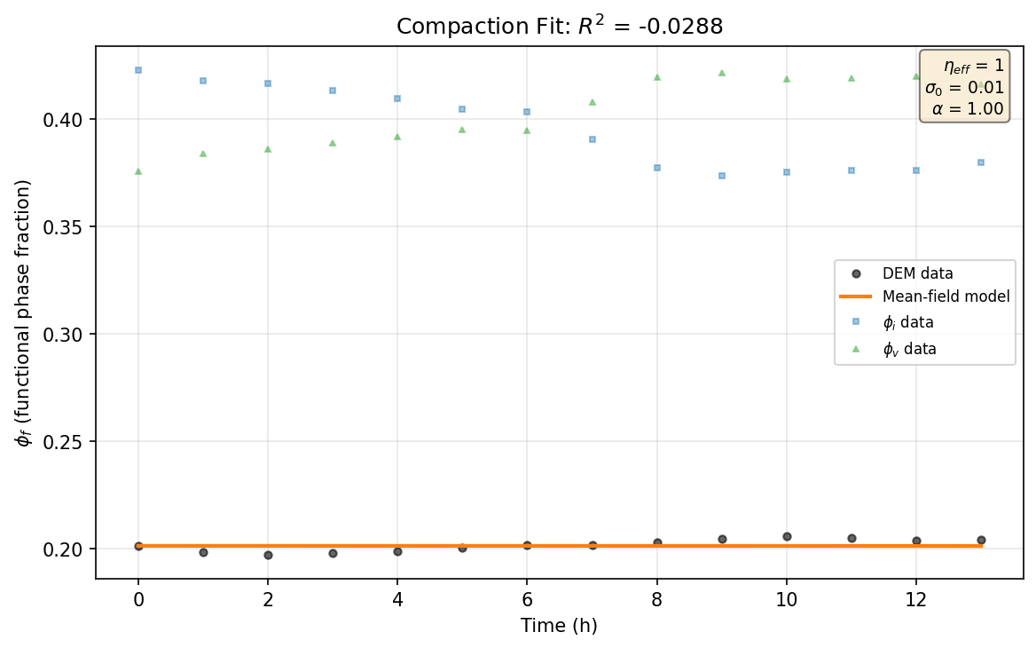
Figure 59. DOE_11 -- (a) Compaction fit.
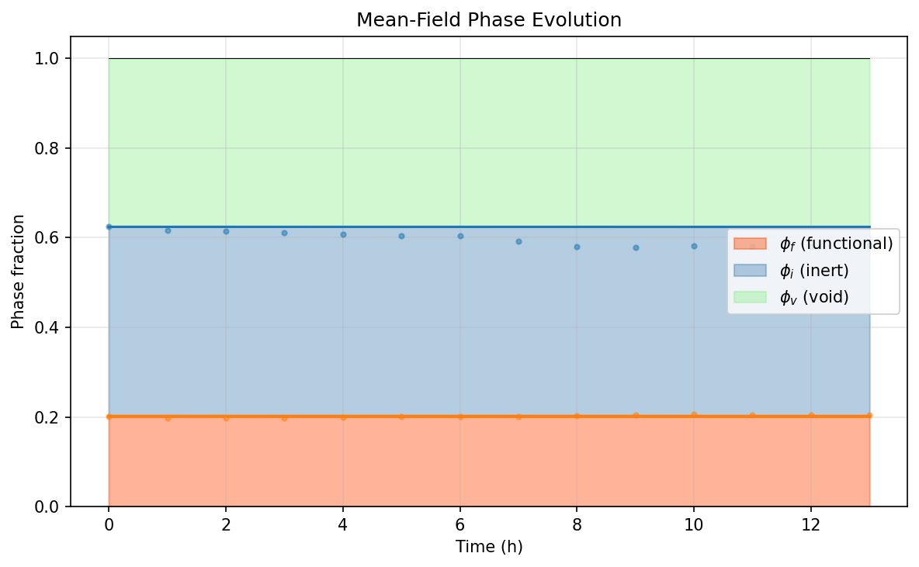
Figure 60. DOE_11 -- (b) Phase evolution.
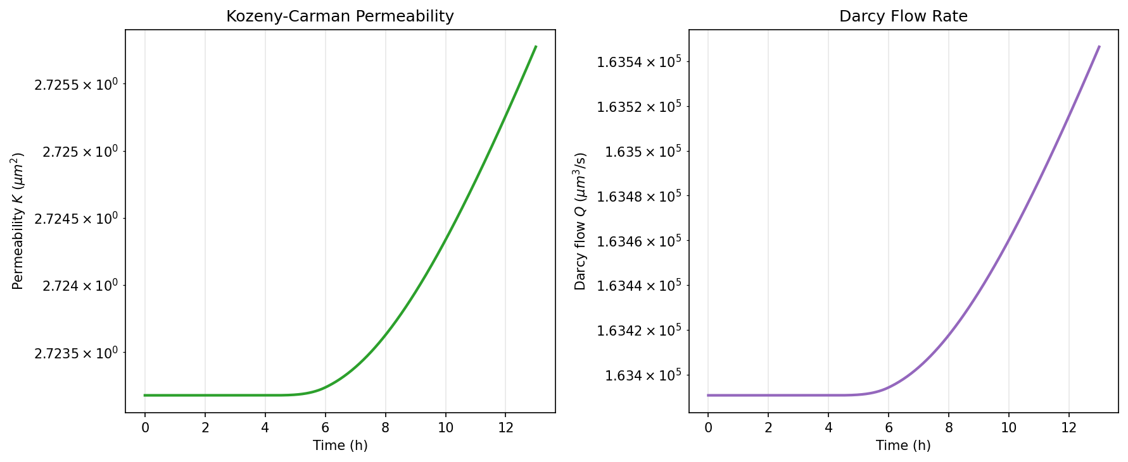
Figure 61. DOE_11 -- (c) Permeability evolution.
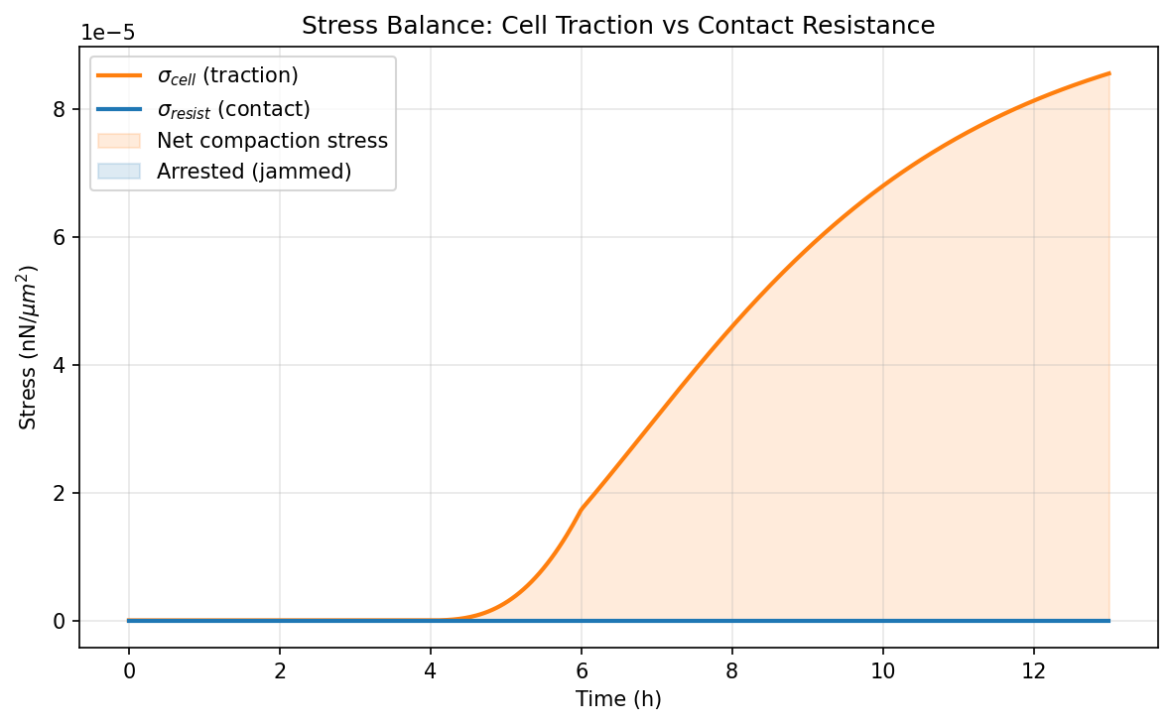
Figure 62. DOE_11 -- (d) Stress balance.

DOE_12 (E = 50.0 kPa, R² = 0.122, Δφ_f = -0.0353)

Figure 63. DOE_12 -- (a) Compaction fit.
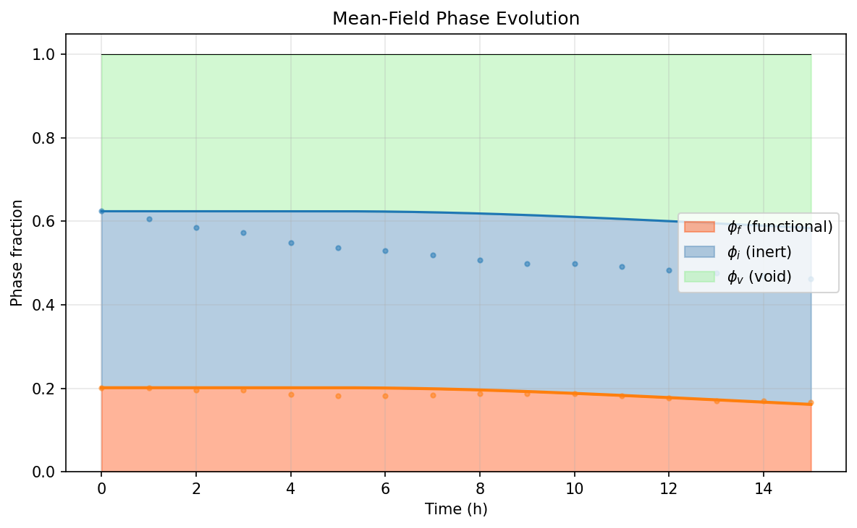
Figure 64. DOE_12 -- (b) Phase evolution.
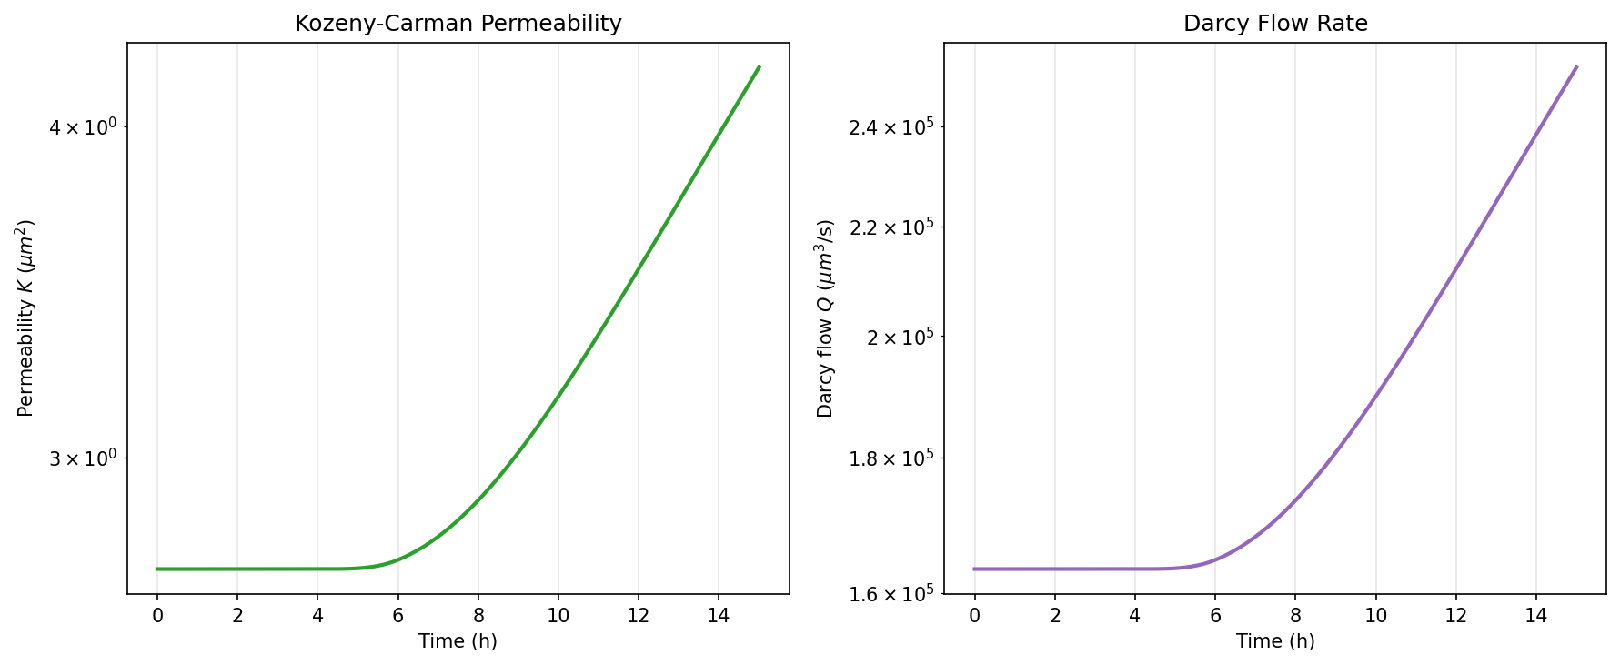
Figure 65. DOE_12 -- (c) Permeability evolution.
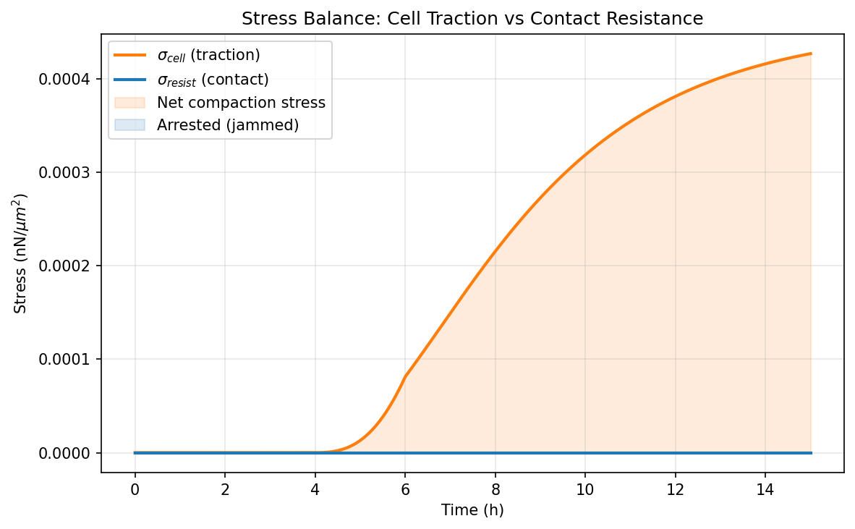
Figure 66. DOE_12 -- (d) Stress balance.

DOE_13 (E = 2.0 kPa, R² = -0.691, Δφ_f = 0.0228)
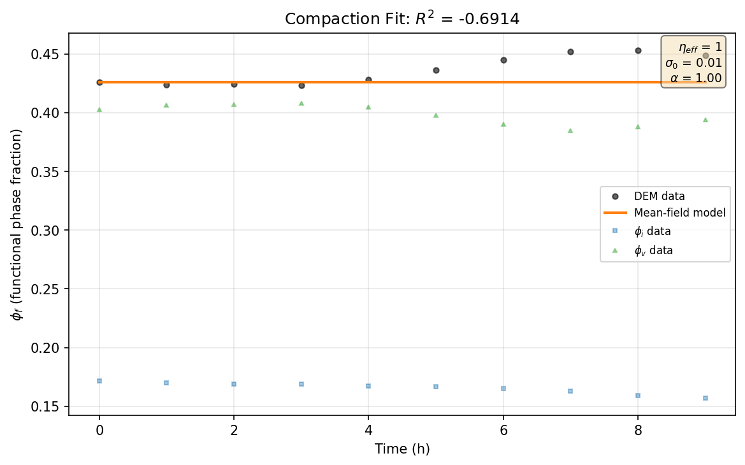
Figure 67. DOE_13 -- (a) Compaction fit.
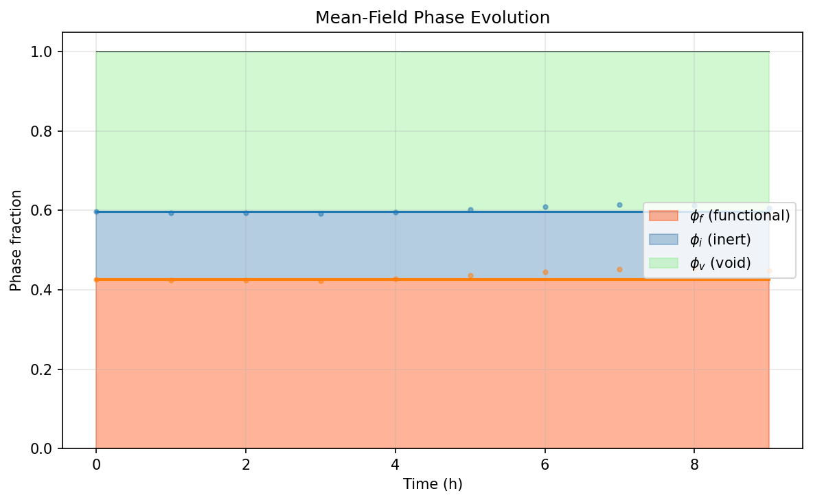
Figure 68. DOE_13 -- (b) Phase evolution.
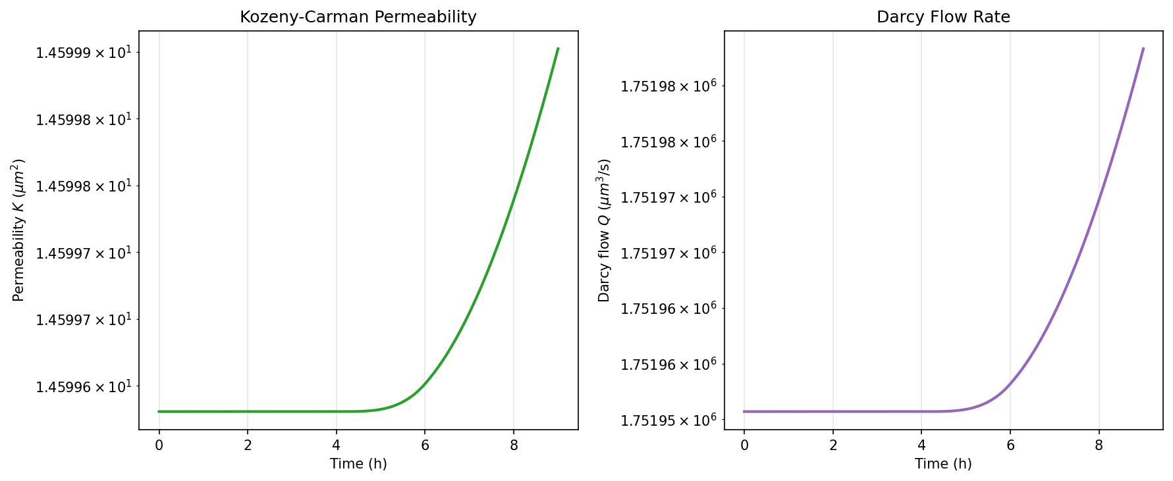
Figure 69. DOE_13 -- (c) Permeability evolution.
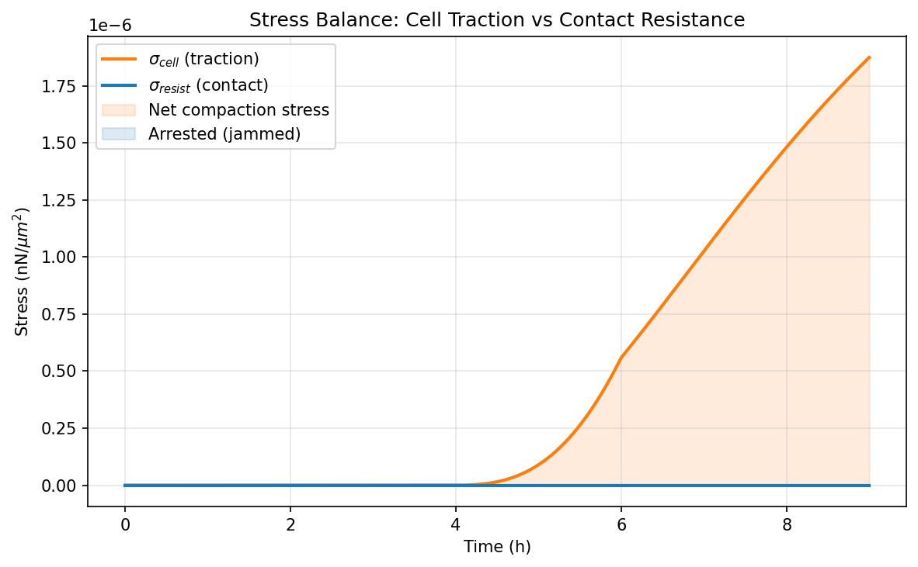
Figure 70. DOE_13 -- (d) Stress balance.

DOE_14 (E = 50.0 kPa, R² = -1.528, Δφ_f = -0.0378)
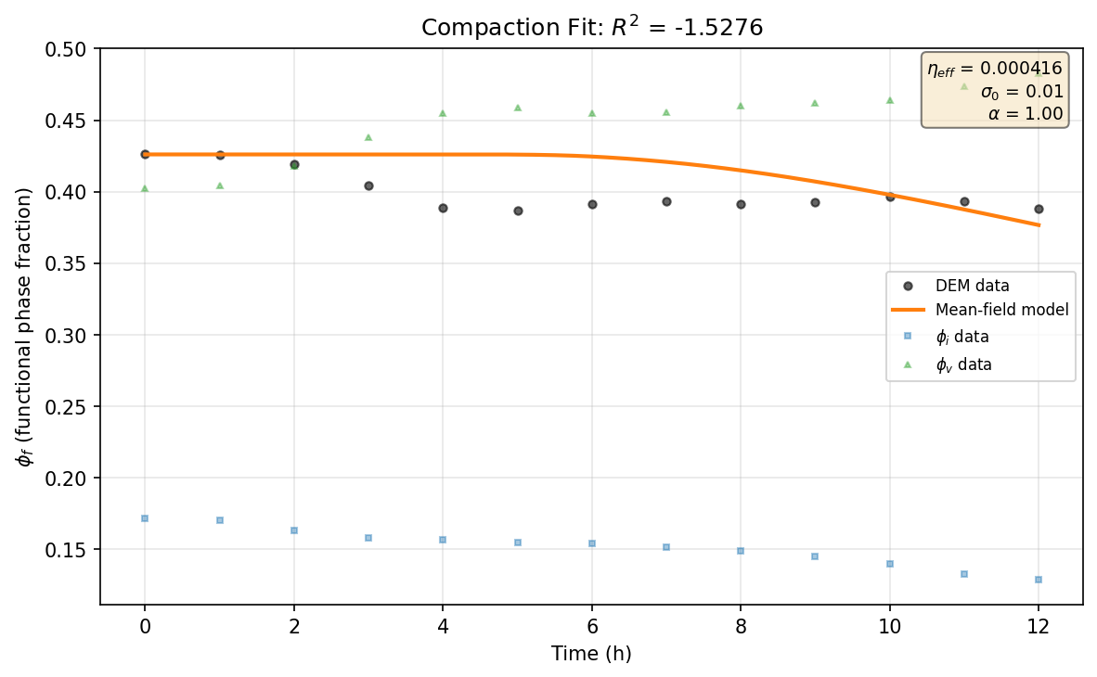
Figure 71. DOE_14 -- (a) Compaction fit.
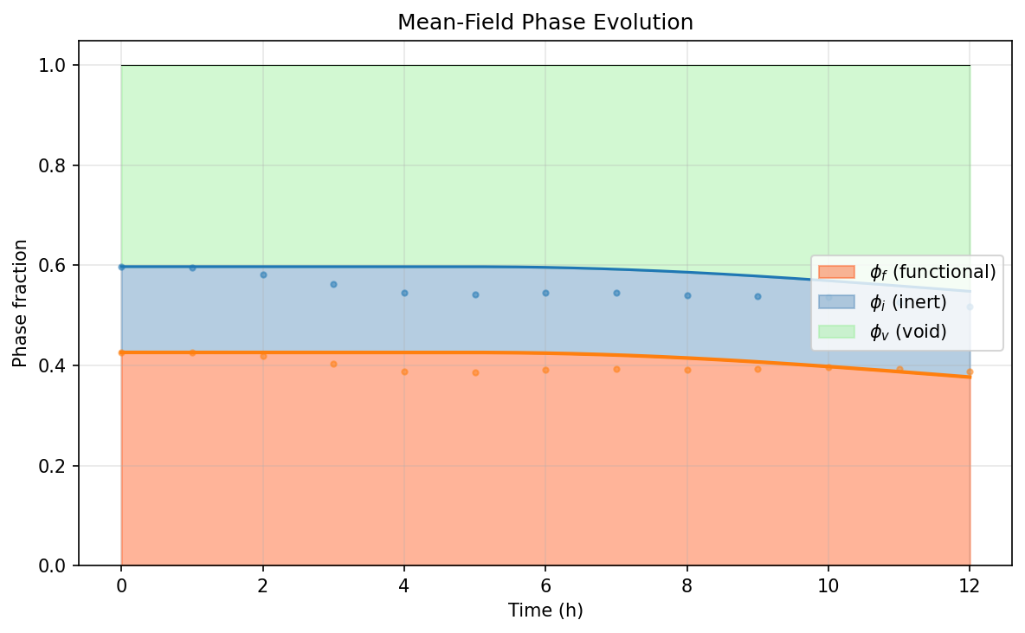
Figure 72. DOE_14 -- (b) Phase evolution.
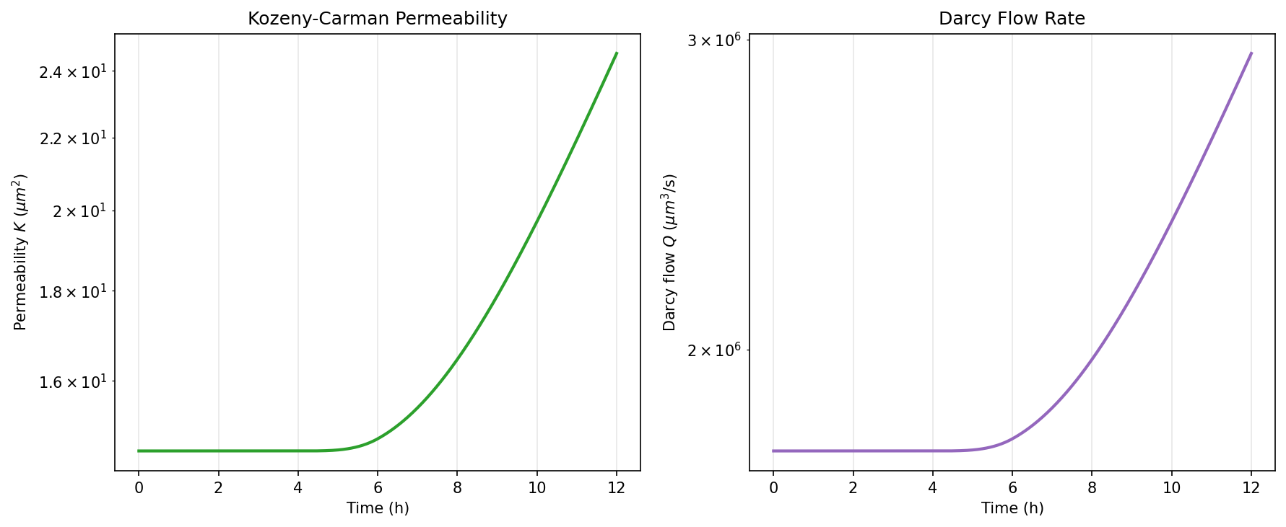
Figure 73. DOE_14 -- (c) Permeability evolution.
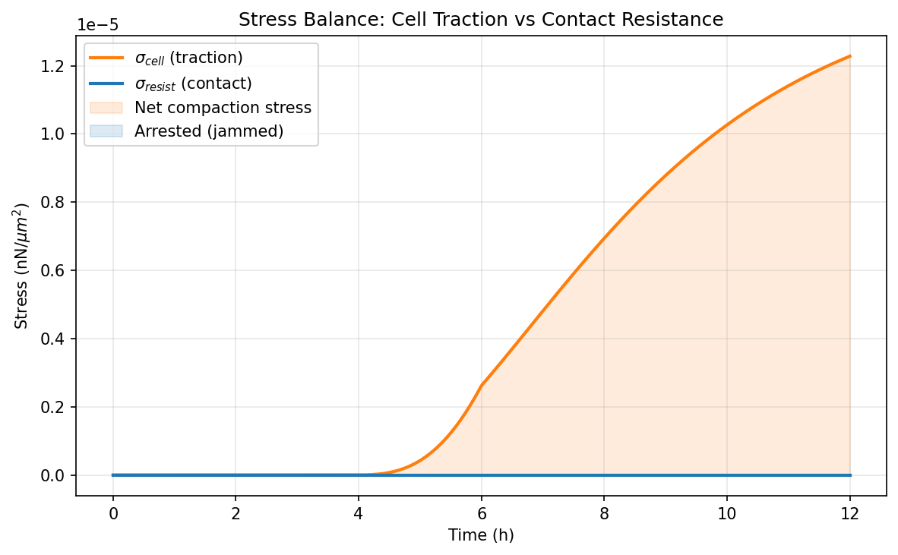
Figure 74. DOE_14 -- (d) Stress balance.

DOE_15 (E = 2.0 kPa, R² = -0.979, Δφ_f = 0.0104)
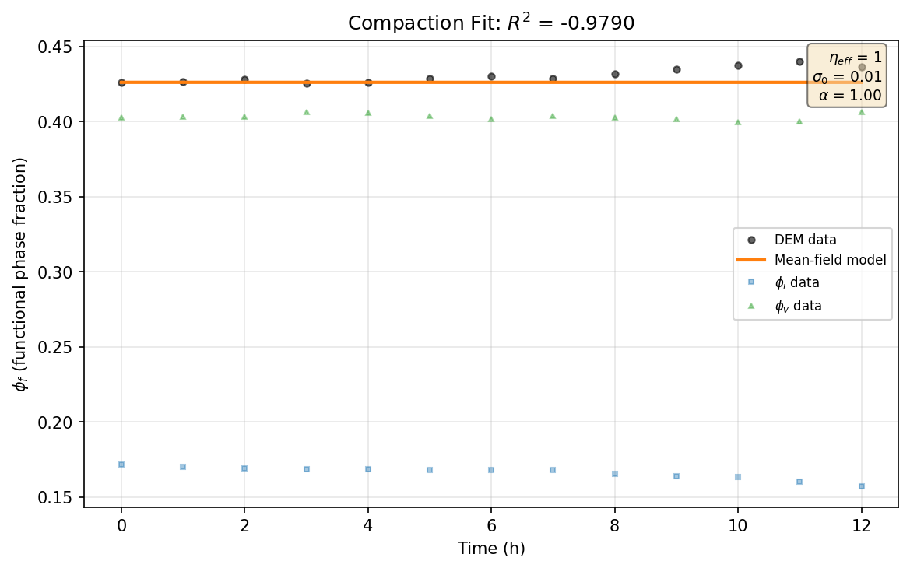
Figure 75. DOE_15 -- (a) Compaction fit.
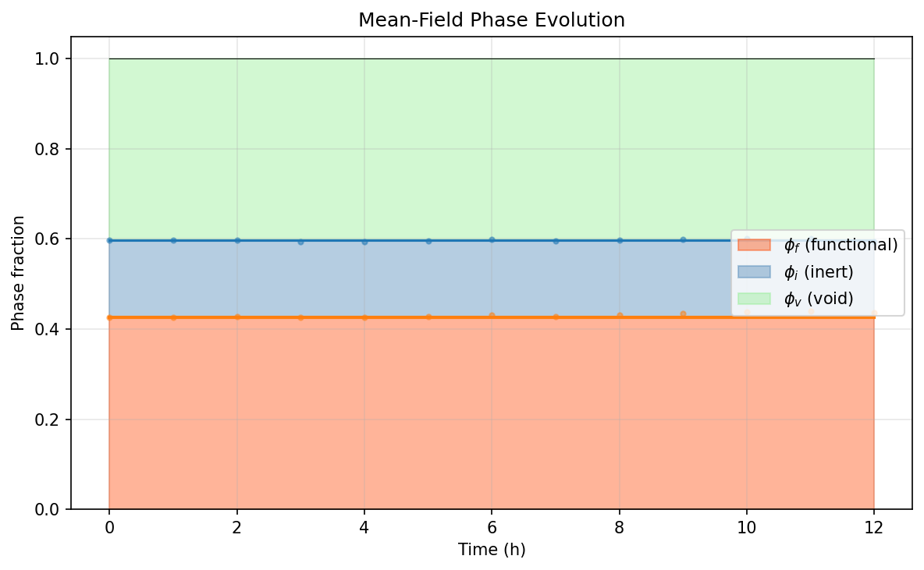
Figure 76. DOE_15 -- (b) Phase evolution.
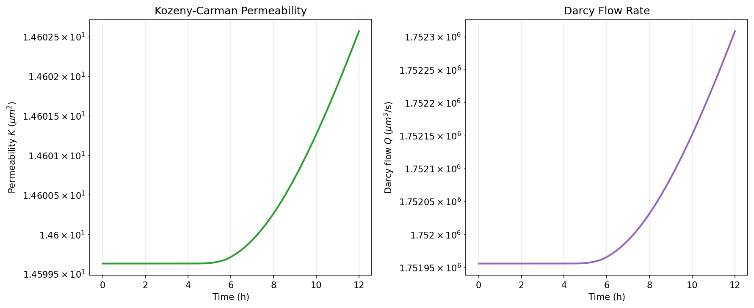
Figure 77. DOE_15 -- (c) Permeability evolution.
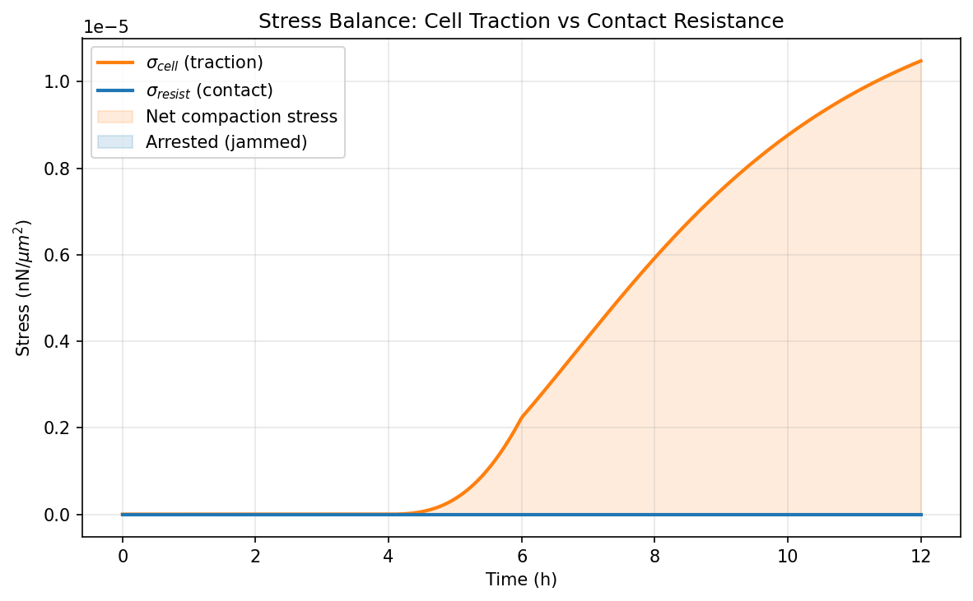
Figure 78. DOE_15 -- (d) Stress balance.

DOE_16 (E = 50.0 kPa, R² = -0.520, Δφ_f = 0.0108)
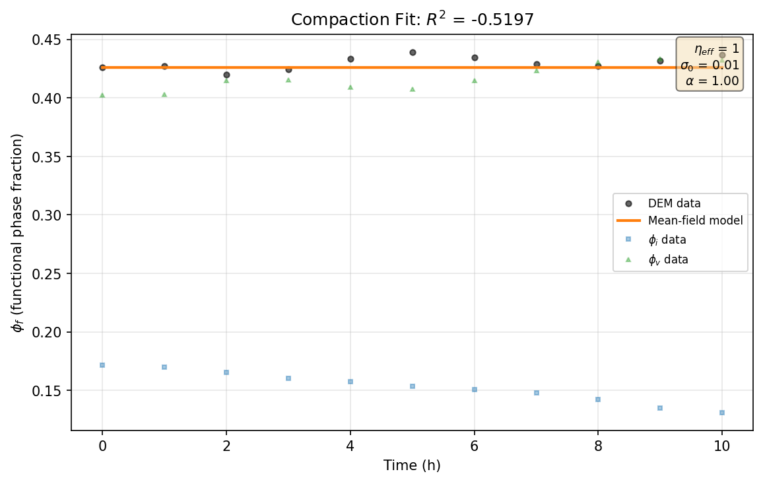
Figure 79. DOE_16 -- (a) Compaction fit.
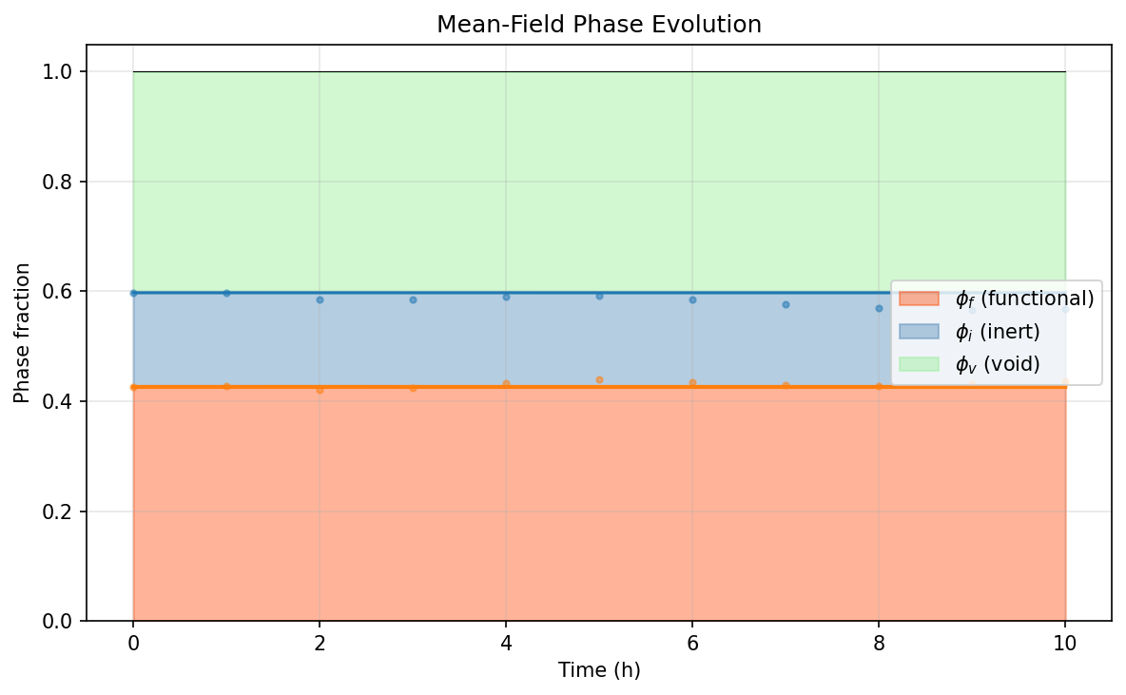
Figure 80. DOE_16 -- (b) Phase evolution.
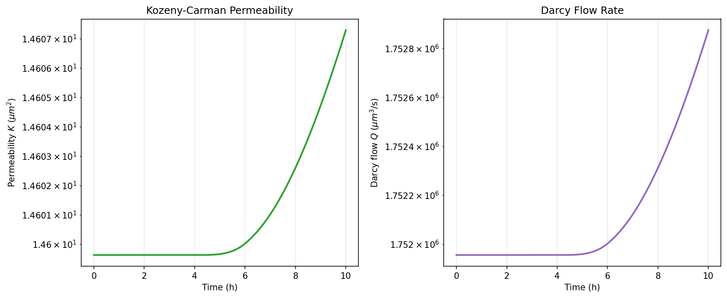
Figure 81. DOE_16 -- (c) Permeability evolution.
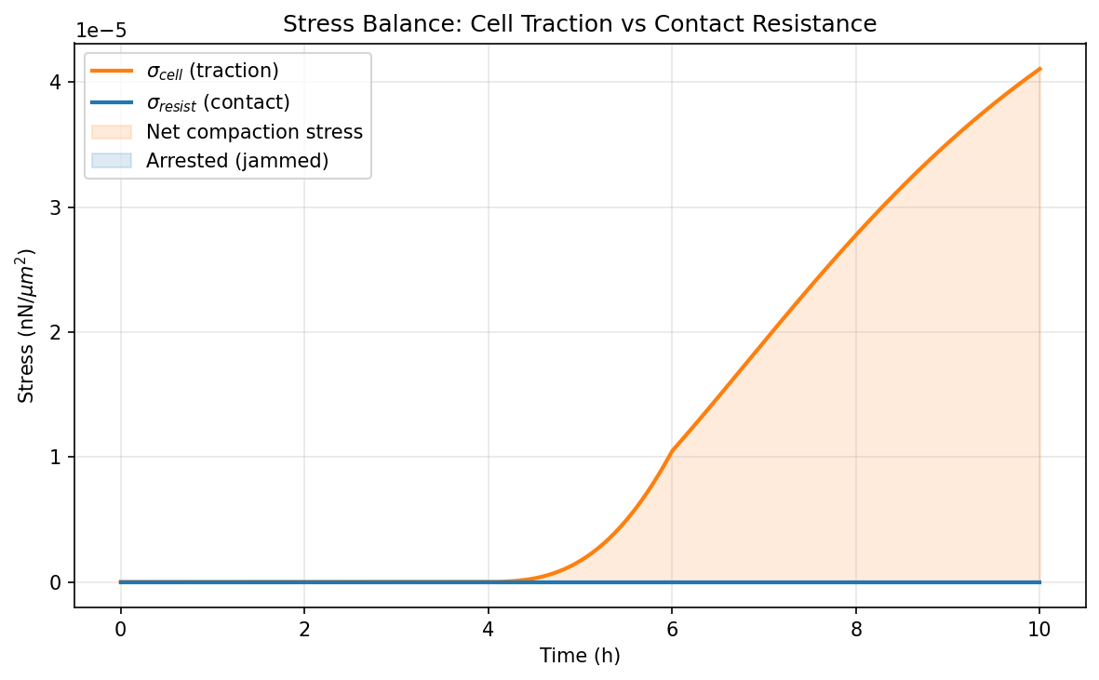
Figure 82. DOE_16 -- (d) Stress balance.

DOE_17 (E = 2.0 kPa, R² = -2.074, Δφ_f = 0.0112)
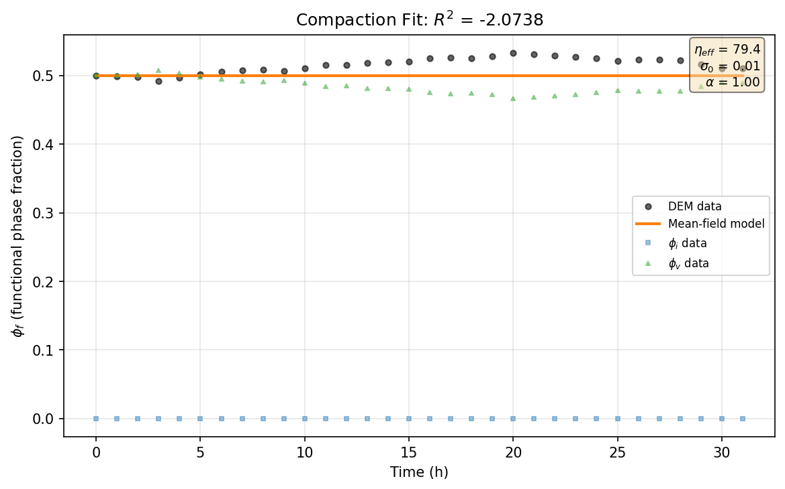
Figure 83. DOE_17 -- (a) Compaction fit.
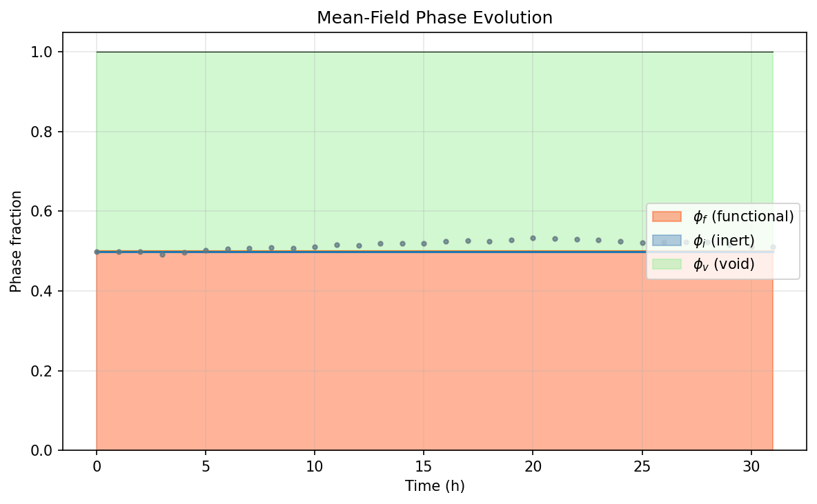
Figure 84. DOE_17 -- (b) Phase evolution.
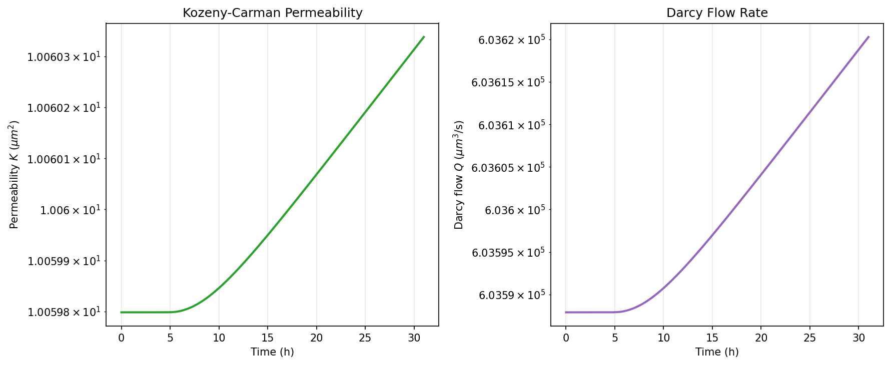
Figure 85. DOE_17 -- (c) Permeability evolution.
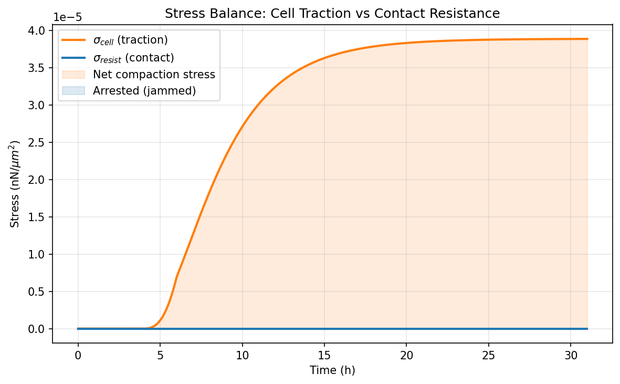
Figure 86. DOE_17 -- (d) Stress balance.

DOE_18 (E = 50.0 kPa, R² = 0.121, Δφ_f = -0.1408)

Figure 87. DOE_18 -- (a) Compaction fit.
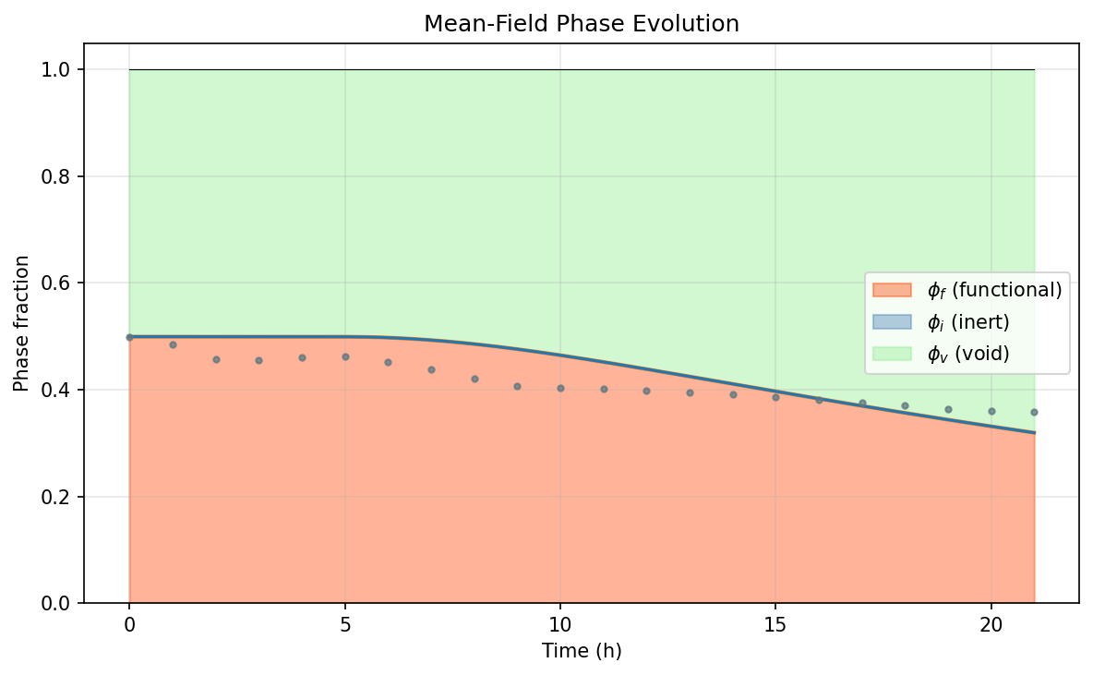
Figure 88. DOE_18 -- (b) Phase evolution.
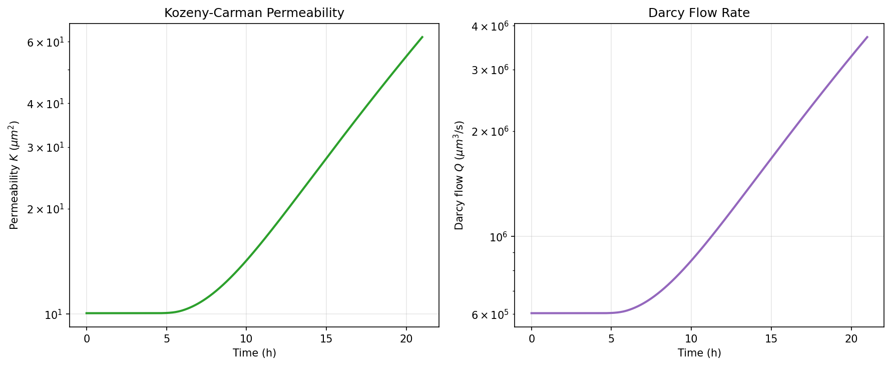
Figure 89. DOE_18 -- (c) Permeability evolution.
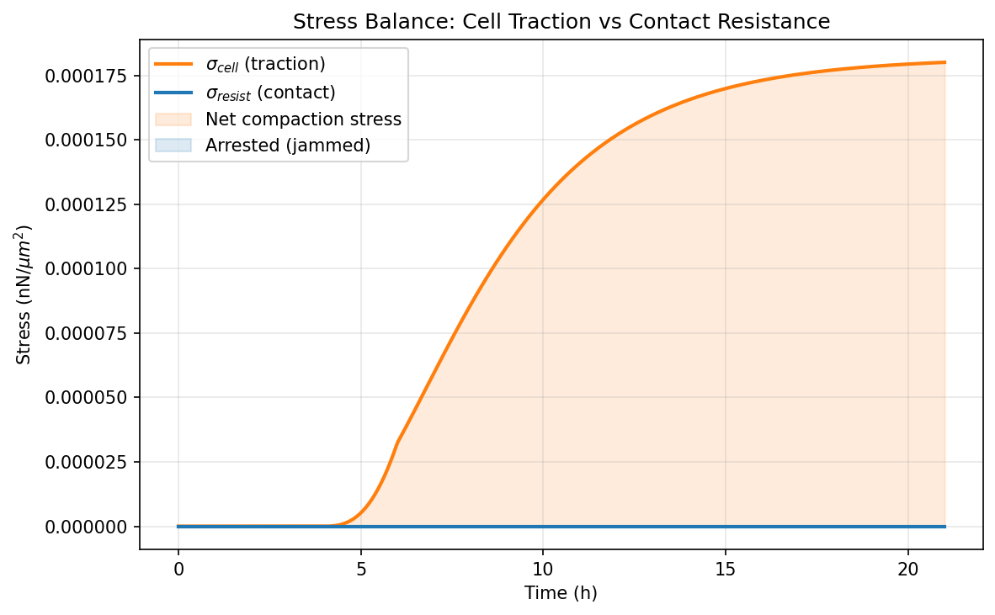
Figure 90. DOE_18 -- (d) Stress balance.

DOE_19 (E = 2.0 kPa, R² = -2.886, Δφ_f = 0.0477)
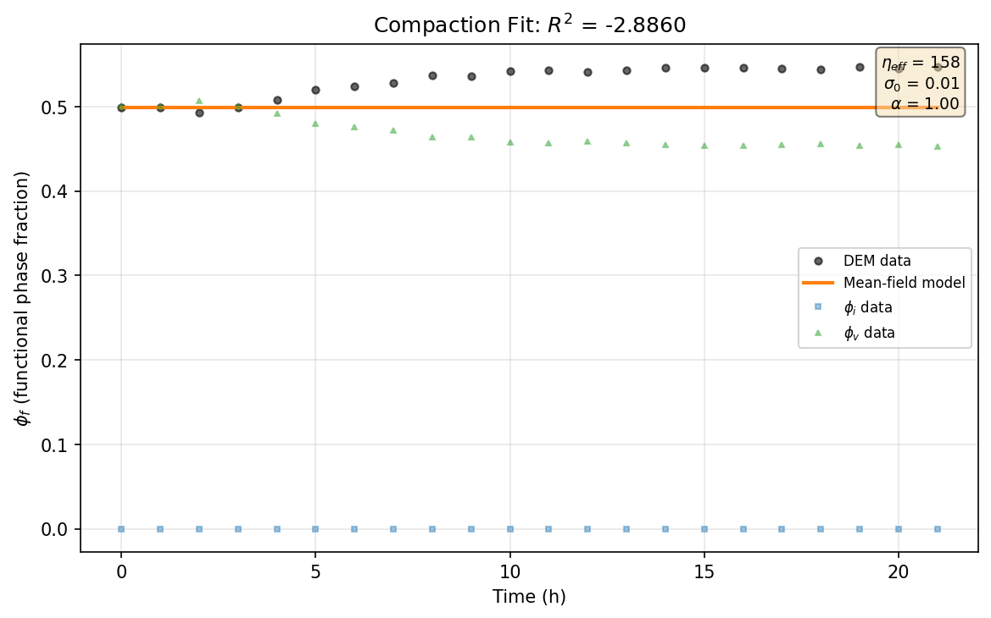
Figure 91. DOE_19 -- (a) Compaction fit.
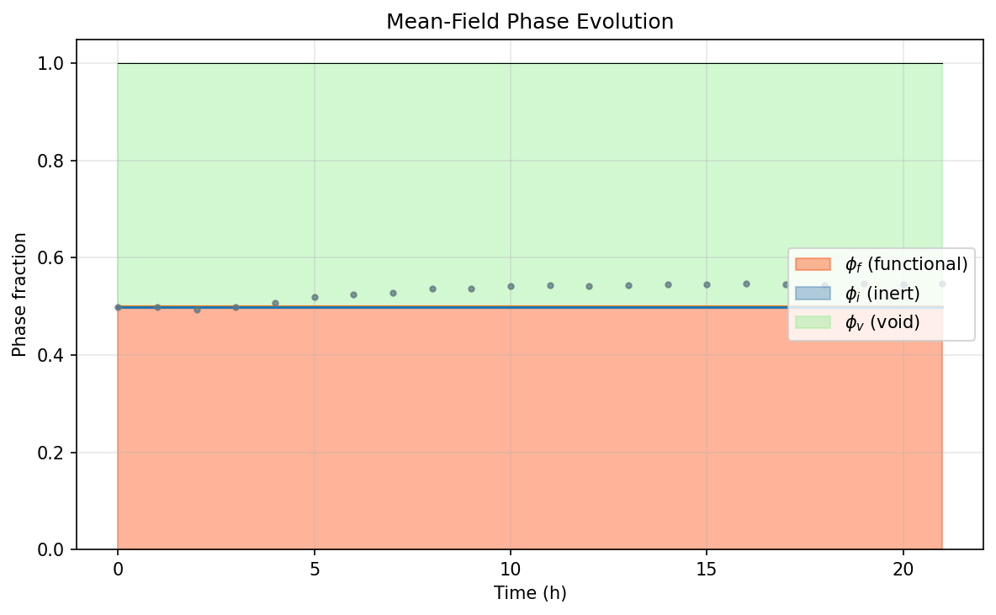
Figure 92. DOE_19 -- (b) Phase evolution.
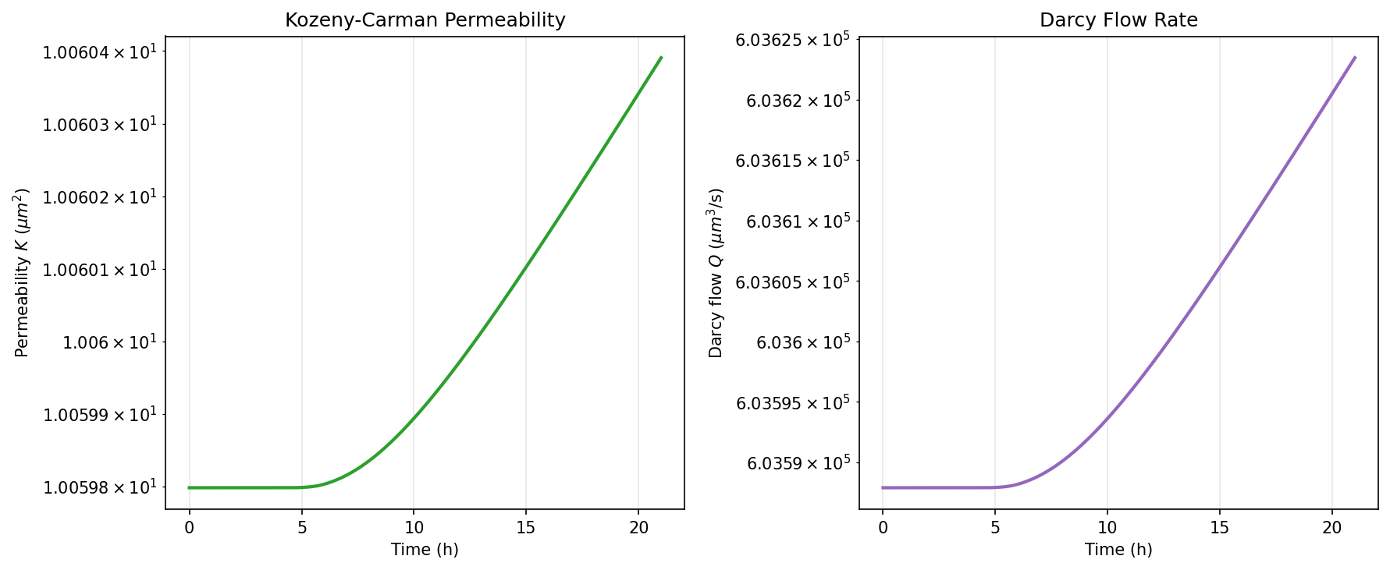
Figure 93. DOE_19 -- (c) Permeability evolution.
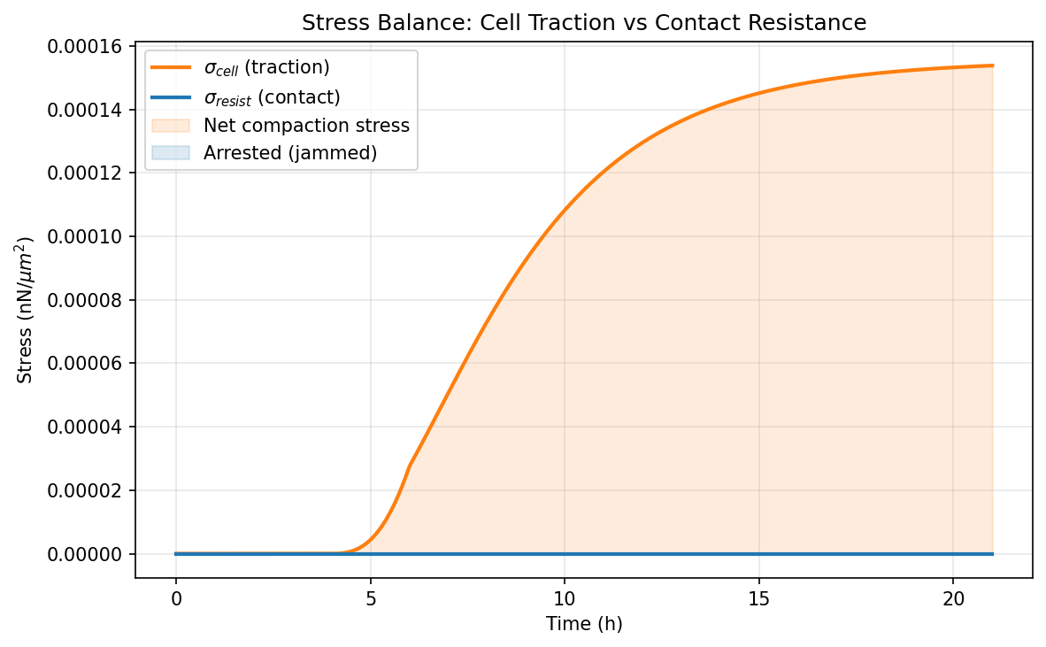
Figure 94. DOE_19 -- (d) Stress balance.

DOE_20 (E = 50.0 kPa, R² = -1.033, Δφ_f = -0.1425)
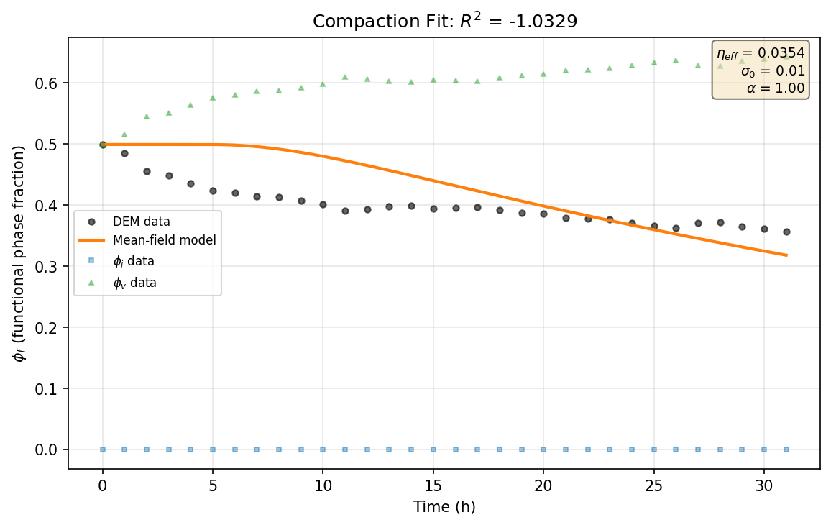
Figure 95. DOE_20 -- (a) Compaction fit.
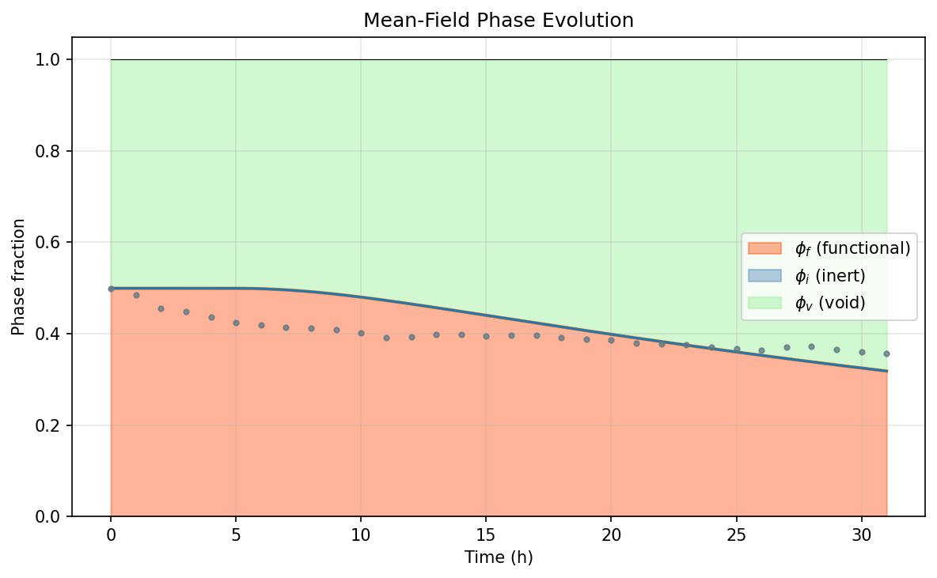
Figure 96. DOE_20 -- (b) Phase evolution.
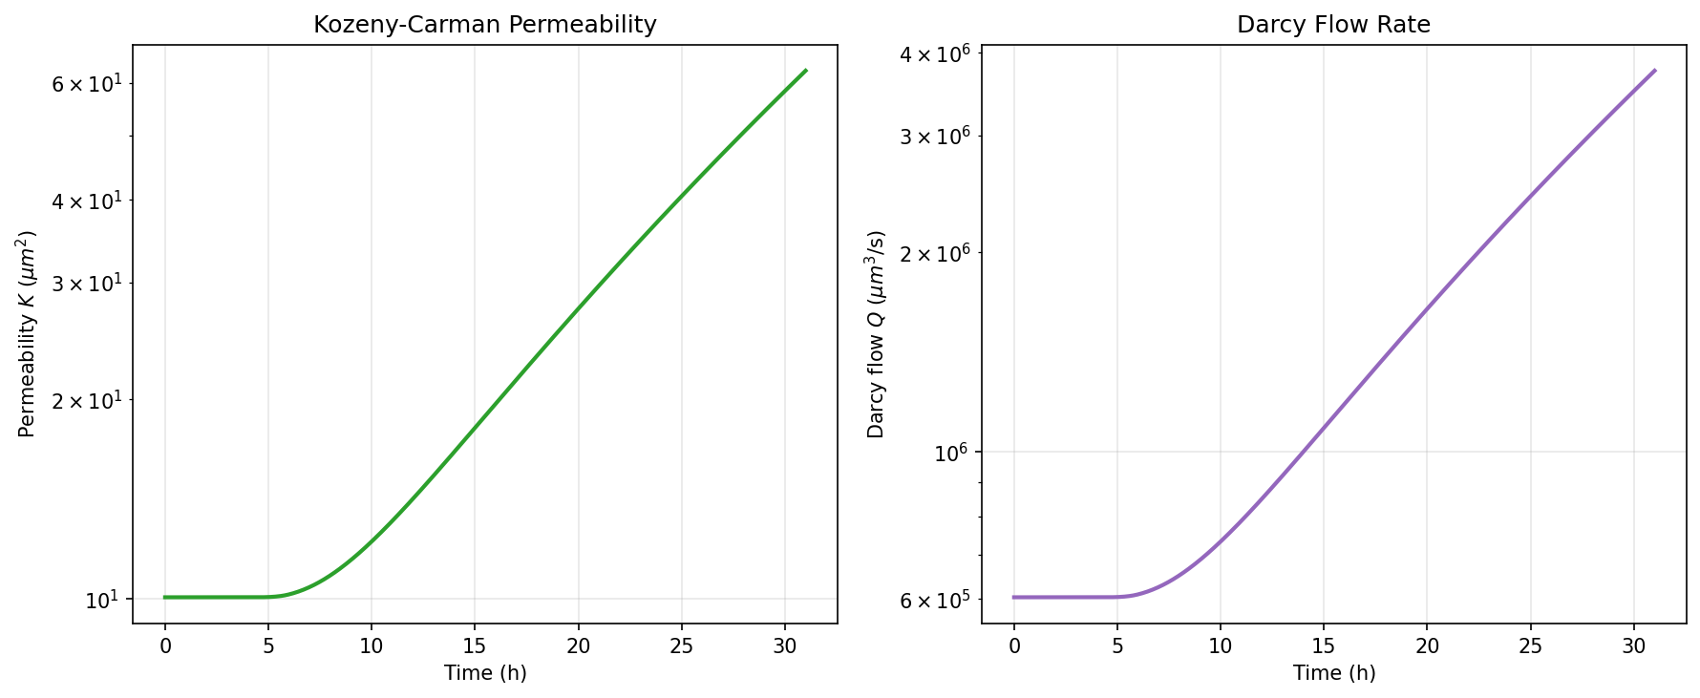
Figure 97. DOE_20 -- (c) Permeability evolution.
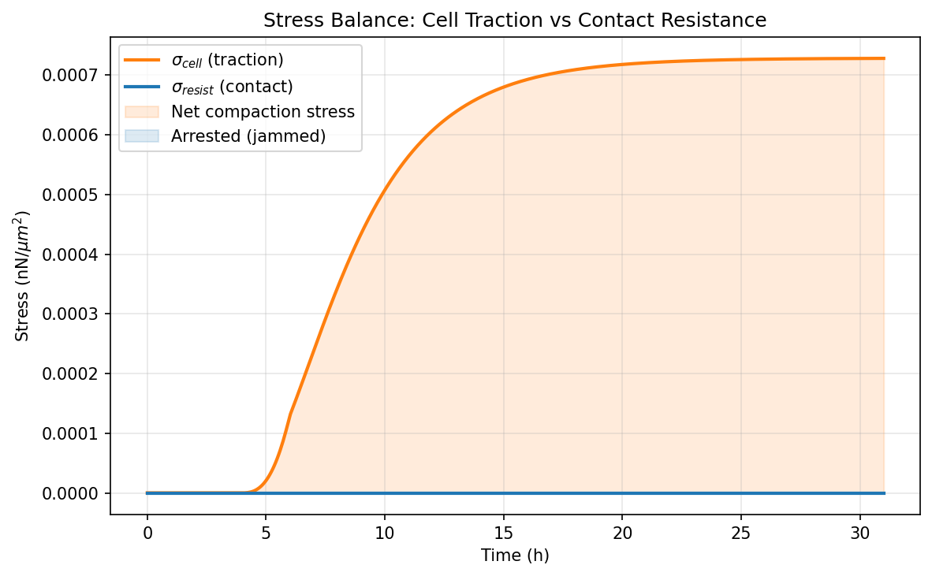
Figure 98. DOE_20 -- (d) Stress balance.

DOE_21 (E = 2.0 kPa, R² = -4.121, Δφ_f = 0.0771)
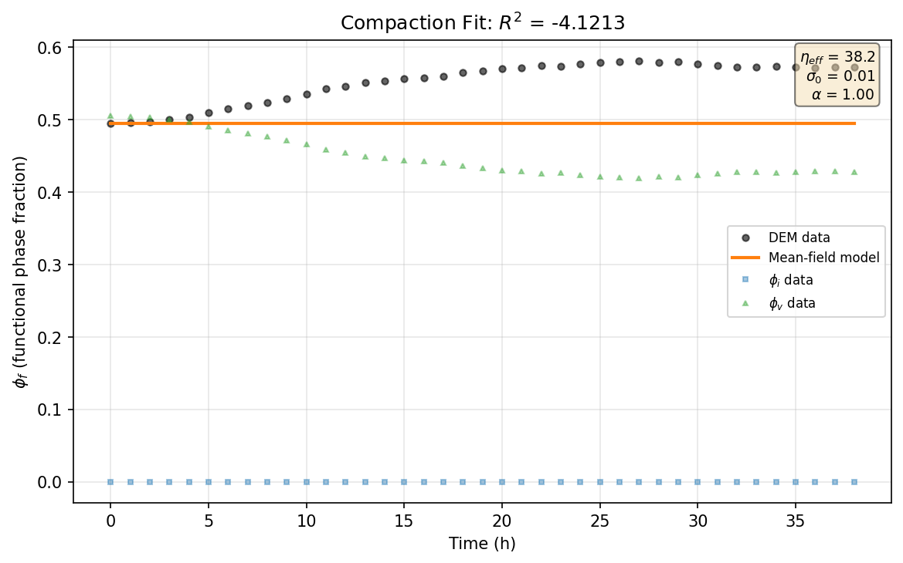
Figure 99. DOE_21 -- (a) Compaction fit.
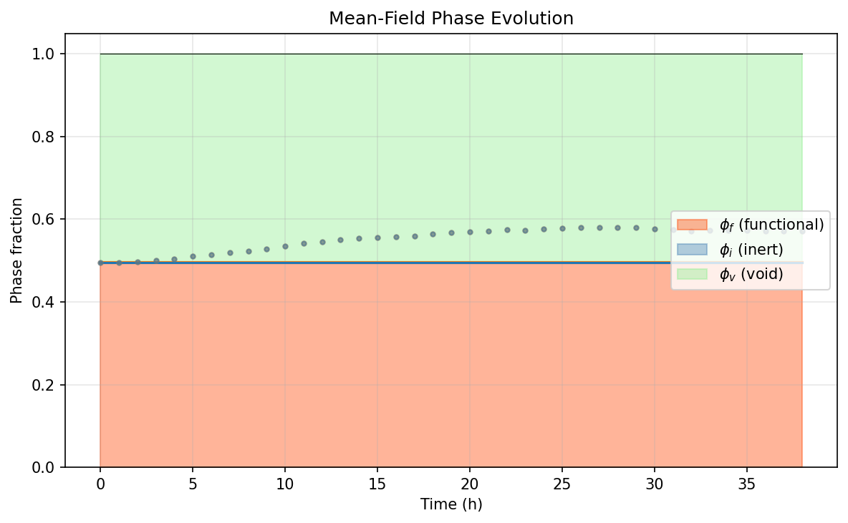
Figure 100. DOE_21 -- (b) Phase evolution.
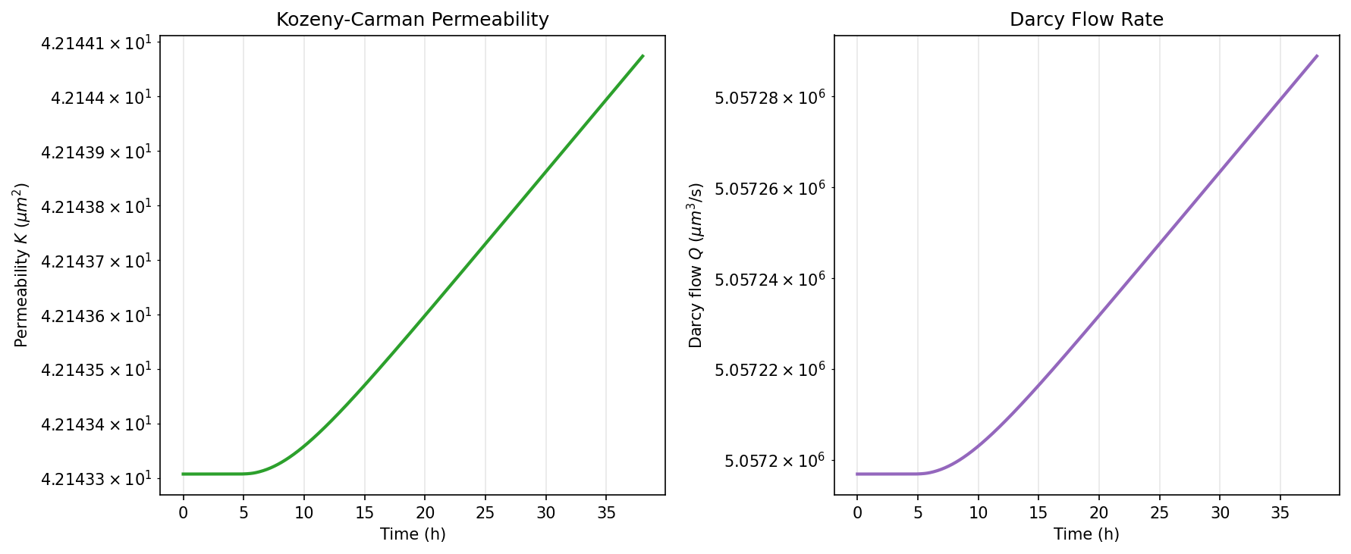
Figure 101. DOE_21 -- (c) Permeability evolution.
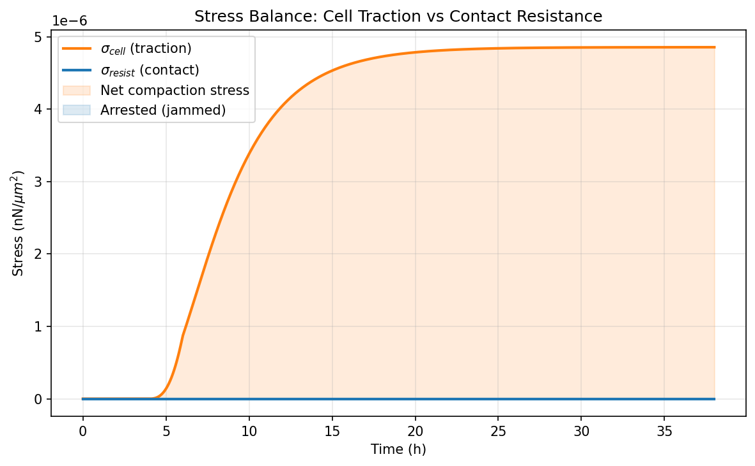
Figure 102. DOE_21 -- (d) Stress balance.

DOE_22 (E = 50.0 kPa, R² = 0.200, Δφ_f = -0.0613)

Figure 103. DOE_22 -- (a) Compaction fit.
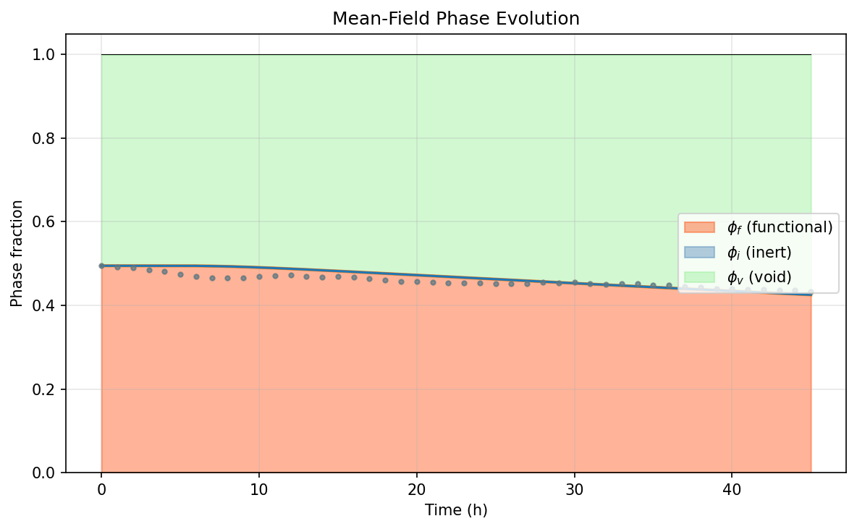
Figure 104. DOE_22 -- (b) Phase evolution.
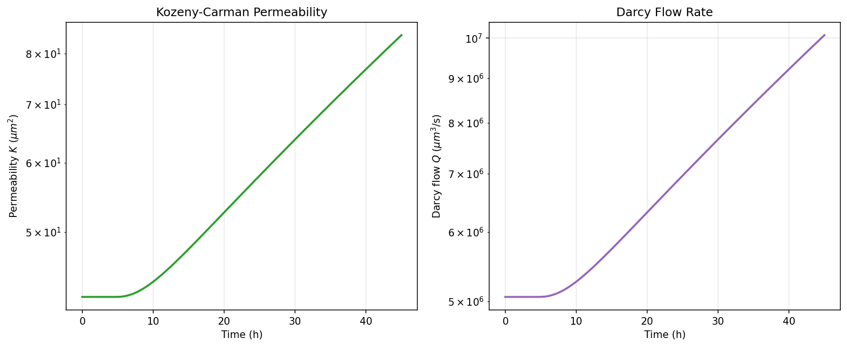
Figure 105. DOE_22 -- (c) Permeability evolution.
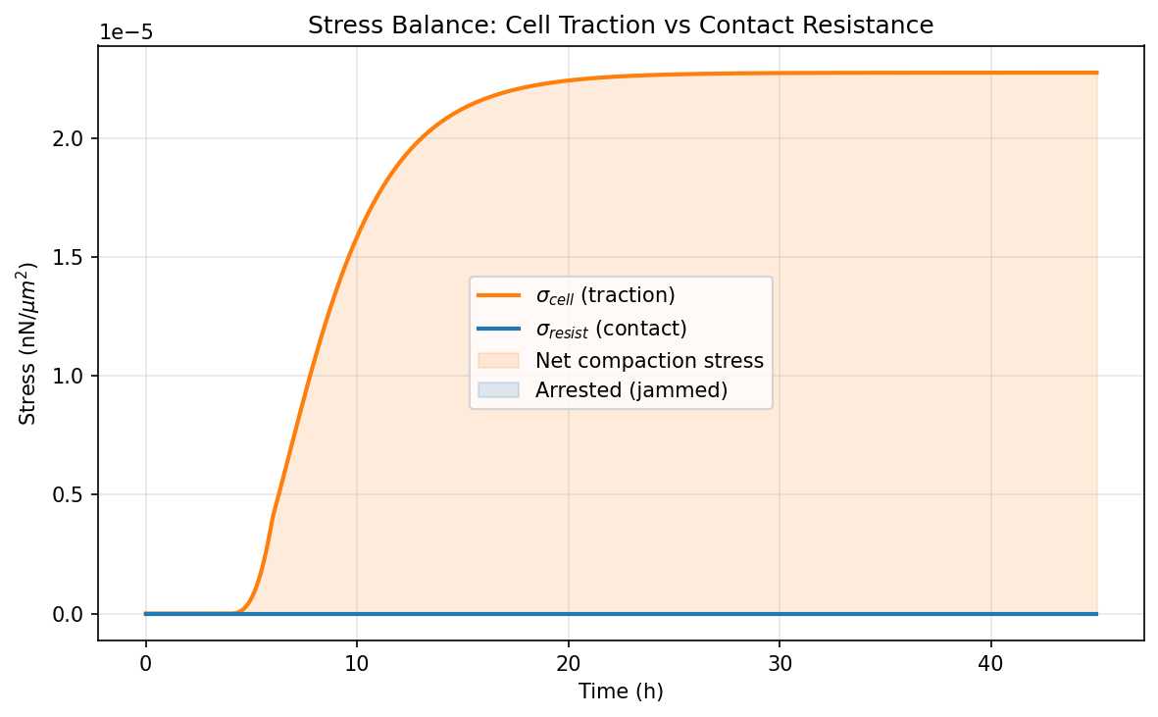
Figure 106. DOE_22 -- (d) Stress balance.

DOE_23 (E = 2.0 kPa, R² = -3.845, Δφ_f = 0.0135)
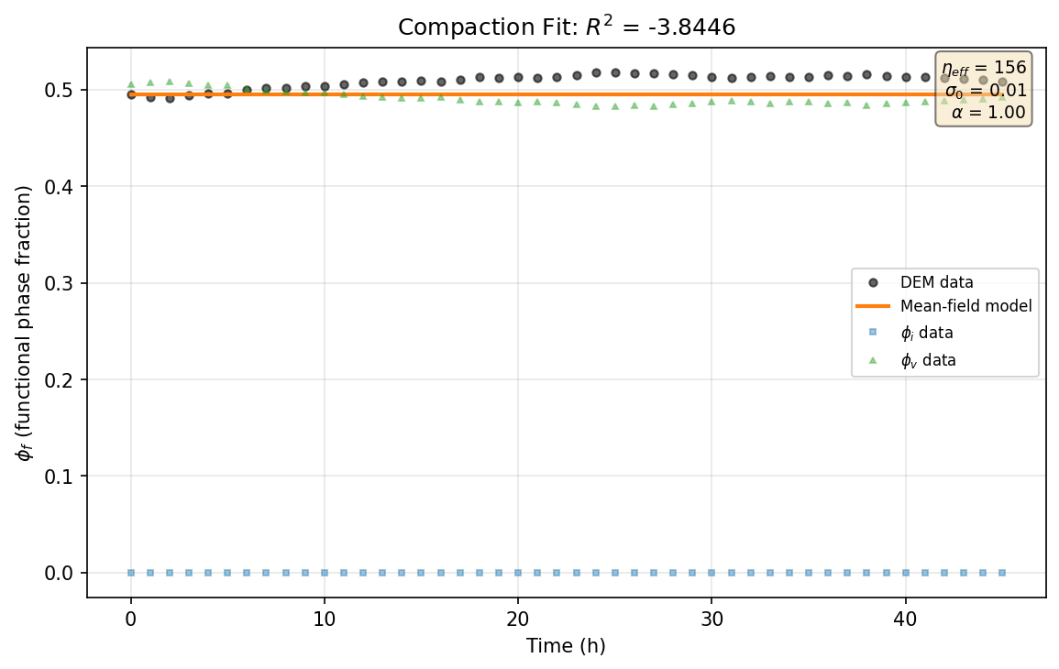
Figure 107. DOE_23 -- (a) Compaction fit.
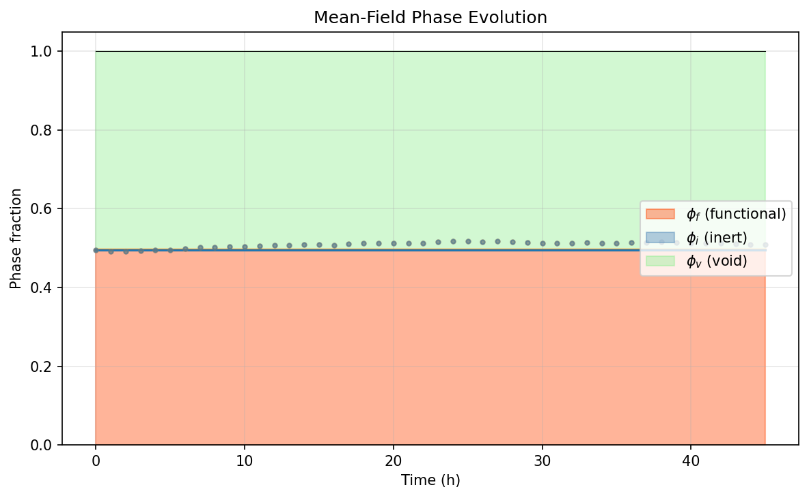
Figure 108. DOE_23 -- (b) Phase evolution.
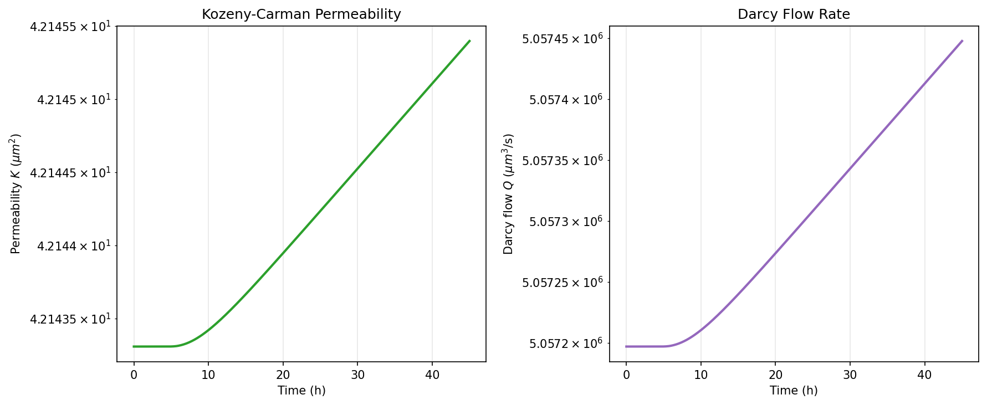
Figure 109. DOE_23 -- (c) Permeability evolution.
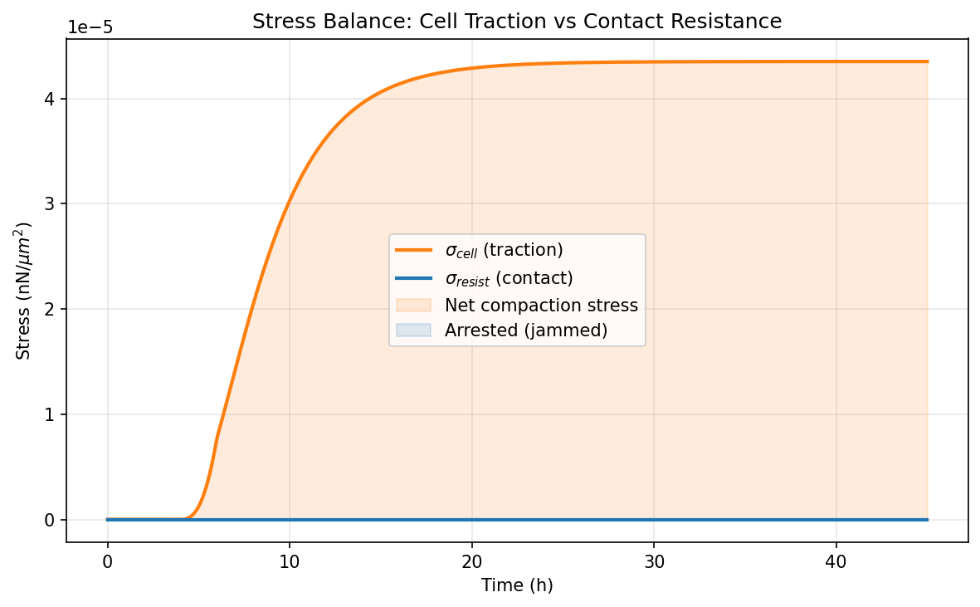
Figure 110. DOE_23 -- (d) Stress balance.

