A Beginner's Guide to
Mean Field Modeling

From Coffee Cooling to Cell-Driven Scaffold Compaction

GELLS-DEM Project
McGhee Lab, University of Illinois Urbana-Champaign

Version 2.4 — March 2026

Table of Contents

Chapter 1 What Is a Mean Field Model?
Chapter 2 Your First Mean Field Model: Coffee Cooling
Chapter 3 Adding Nonlinearity: Population Growth
Chapter 4 Two Competing Forces: A Thermostat
Chapter 5 From Particles to Fields: The Porous Medium
Chapter 6 Putting It All Together: The GELLS-DEM Mean Field Model
Chapter 7 Hands-On: Running the Model on Real DEM Data
Chapter 8 Comparing Across Experiments: The DOE Sweep
Chapter 9 From Scalar ODE to Spatial PDE
Chapter 10 The Energy Landscape: A Thermodynamic View
Chapter 11 Summary and Key Takeaways
Appendix A File Reference
Appendix B Generating the Figures
Appendix C Quick-Start Cheat Sheet

Chapter 1: What Is a Mean Field Model?

The Core Idea
Imagine you have a jar filled with 500 rubber balls, and someone is slowly squeezing the jar from the outside. You want to predict how tightly packed the balls become over time. You have two choices:
Option A: Track every ball. Compute the position, velocity, and contacts of all 500 balls at every instant. This is a Discrete Element Method (DEM) simulation — it's accurate but expensive. Our new_dem_0.py does exactly this.
Option B: Track the average. Instead of 500 positions, track one number: the average packing fraction. Write a simple equation for how that number changes over time. This is a mean field model.
The term “mean field” means we replace the complex interactions between individual particles with their average (mean) effect. Instead of asking “what force does ball #237 feel from its six neighbours?”, we ask “what is the average force a typical ball feels in a region with this packing density?”

Why Bother?
Feature | DEM Simulation | Mean Field Model
Accuracy | High (resolves individual contacts) | Approximate (averages over details)
Speed | Minutes to hours | Milliseconds
Parameters explored | 1 run at a time | 200,000 in seconds
Physical insight | Hard to extract (too much data) | Built into the equations
Design optimization | Impractical | Natural fit

A mean field model is not a replacement for DEM — it's a companion. We use DEM to validate the mean field model, then use the mean field model to explore the vast parameter space that DEM cannot reach.

The Recipe
Every mean field model follows the same five-step recipe:
1. Choose your state variable(s) — what single number captures the system's state?
2. Write the rate equation — how does that number change over time? This is almost always an ODE: dx/dt = f(x, t).
3. Identify the driving forces — what pushes the system forward? What resists?
4. Solve the ODE — analytically if possible, numerically if not.
5. Validate against data — compare to experiments or detailed simulations.
Let’s build this intuition step by step with increasingly complex examples.

Chapter 2: Coffee Cooling

The Physical Setup
You pour a cup of coffee at 90°C and set it on your desk. The room is 22°C. How does the coffee temperature change over time?

Step 1: Choose the State Variable
T(t) = temperature of the coffee at time t (°C). We are “averaging” over all the complex fluid dynamics inside the cup and replacing it with a single number.

Step 2: Write the Rate Equation
Newton’s law of cooling says: the rate of temperature change is proportional to the temperature difference between the coffee and the room:
dT/dt = −k × (T − T_room)
where k is a cooling constant (depends on cup material, surface area, etc.), T_room = 22°C (the environment), and the negative sign means the coffee loses heat when it’s hotter than the room. This is our first mean field model!

Step 3: Solve
This ODE has an exact analytical solution:
T(t) = T_room + (T₀ − T_room) × exp(−k × t)

Step 4: Code It Up
import numpy as np

T_0 = 90.0 # initial temperature (°C)
T_room = 22.0 # room temperature (°C)
k = 0.1 # cooling rate (1/min)

t = np.linspace(0, 60, 200)
T = T_room + (T_0 - T_room) * np.exp(-k * t)
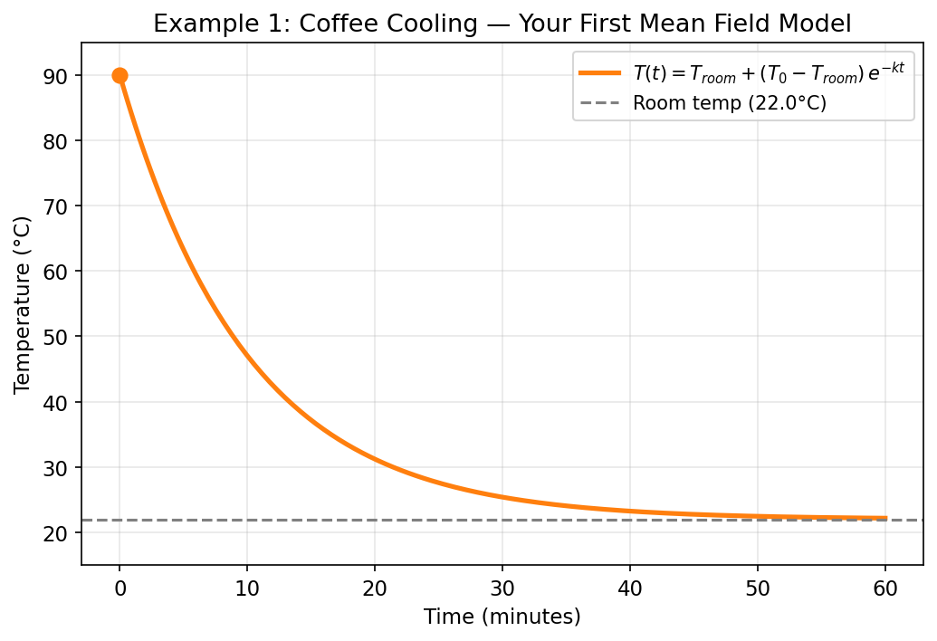
Figure 2.1: Coffee cooling — exponential decay toward room temperature. One equation and one parameter (k) captures the entire system.
Key concept: A mean field model trades microscopic detail for macroscopic predictability. The parameter k is an effective parameter — it doesn’t correspond to any single physical process, but captures their combined effect.

Chapter 3: Adding Nonlinearity — Population Growth

The Physical Setup
A colony of bacteria doubles every hour in a petri dish. But the dish can only hold 1,000,000 bacteria. What happens?

The Logistic Equation
If bacteria double freely: dN/dt = r × N, giving exponential growth forever. But that’s unrealistic. Add a resistance term:
dN/dt = r × N × (1 − N/K)
This is the logistic equation. When N is small, (1 − N/K) ≈ 1, so growth is nearly exponential. When N → K, the growth rate → 0. The system saturates. This is our first nonlinear mean field model.
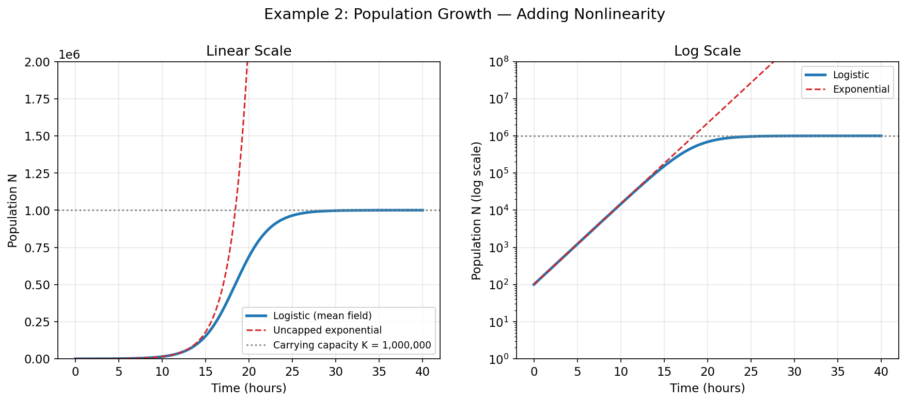
Figure 3.1: Logistic growth vs uncapped exponential. The (1 − N/K) term creates the S-shaped saturation curve — the same idea we'll use for granular jamming.
Key concept: Mean field models become powerful when they include competing effects — a driving force and a resistance. The interplay between them creates rich dynamics from simple equations.

Chapter 4: Two Competing Forces — A Thermostat

Why This Example Matters
The GELLS-DEM mean field model is fundamentally about two competing stresses: cells pulling the scaffold together, and granule contacts resisting further compression. Before we get there, let’s build intuition with a simpler system.

The Setup
A room with a heater and an air conditioner. The heater turns on gradually (like cells maturing and forming bridges), and the AC resists temperature increases above a setpoint (like granular jamming resistance).
dT/dt = [Q_heater(t) − Q_cooling(T)] / C
where Q_heater(t) ramps up over time (like cell maturation), Q_cooling(T) kicks in above a threshold (like jamming resistance), and C is thermal mass (like granular viscosity).
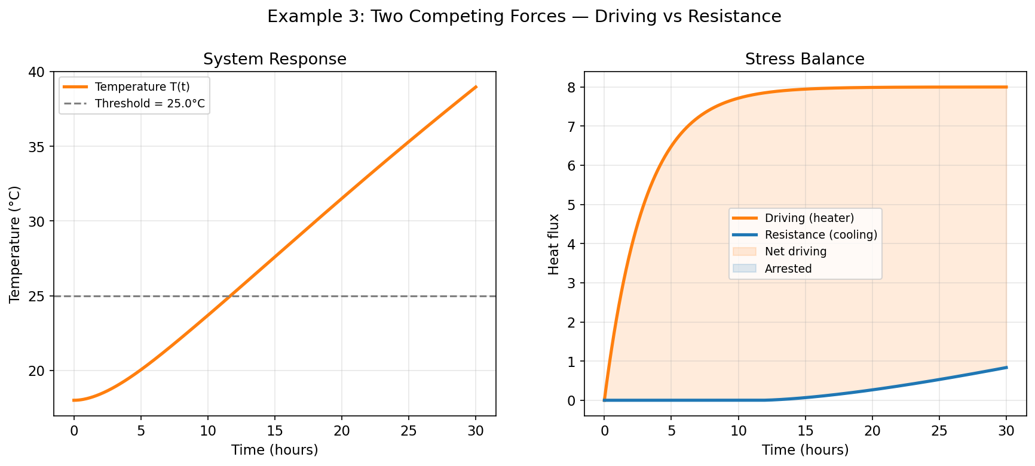
Figure 4.1: Two competing forces. Left: temperature trajectory with threshold. Right: driving force vs resistance — shaded regions show net compaction vs arrest.

The Three Regimes
Early (0–5 h): The heater ramps up but the room is still below threshold. No resistance. Temperature rises freely. In our scaffold: cells are maturing but haven’t started bridging.
Middle (5–15 h): Heater at full power, resistance growing. Temperature still rises but decelerates. In our scaffold: bridges forming, contacts stiffening.
Late (15+ h): Driving equals resistance. Dynamic equilibrium — not because forces disappeared, but because they exactly balance. In our scaffold: compaction arrests.
Key concept: The final state isn’t determined by either force alone — it emerges from their balance. This is the central idea of the GELLS-DEM mean field model.

Chapter 5: From Particles to Fields — The Porous Medium

The Kozeny-Carman Equation
One of the most useful results in porous media physics connects the void fraction (empty space between granules) to permeability (how easily fluid flows through):
K = φ_v³ × d² / [180 × (1 − φ_v)²]
where K is permeability (µm²), φ_v is void fraction (0 to 1), and d is grain diameter (µm). This is a mean field relationship — it replaces complex pore geometry with a single effective parameter.
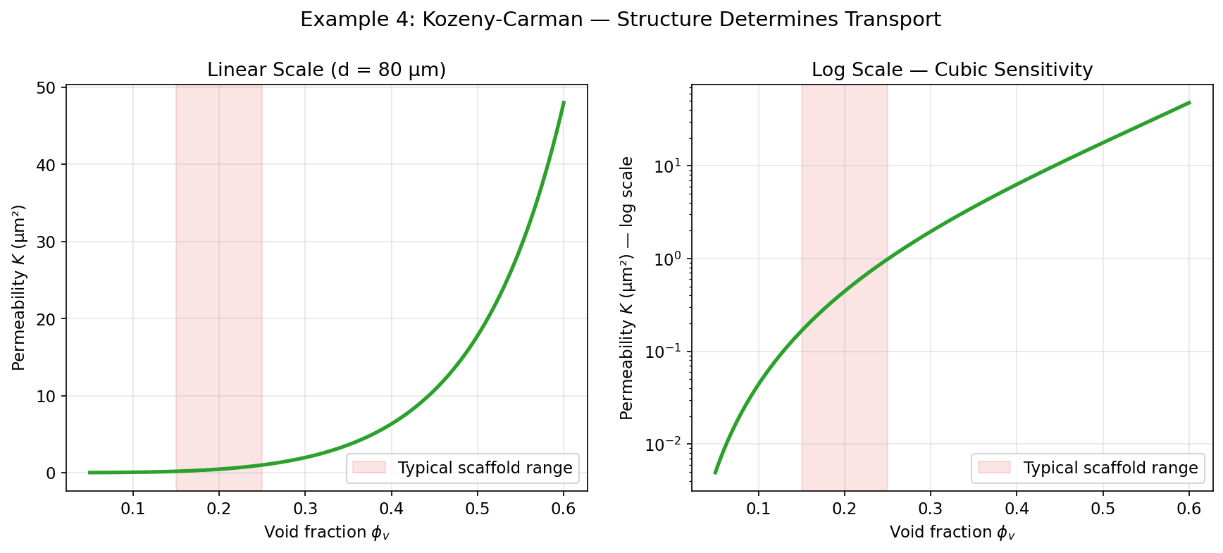
Figure 5.1: Kozeny-Carman permeability. A small change in void fraction causes a huge change in permeability — the cubic dependence makes scaffold compaction critical.

Why This Matters for Tissue Engineering
Going from φ_v = 0.30 to φ_v = 0.20 (a 33% reduction in void space) drops permeability by roughly 75%. This creates a feedback loop: cells compact the scaffold, reducing permeability, which starves cells of nutrients. The mean field model captures this coupling between structure and transport.
Key concept: The Kozeny-Carman equation converts structural information (packing fraction) into functional information (transport). This is how our mean field model connects cell-driven compaction to scaffold performance.

Chapter 6: The GELLS-DEM Mean Field Model

6.1 The Physical Picture
Our scaffold is a packed bed of hydrogel granules, seeded with living cells. There are two types of granules: functional (cell-laden, type 0) and inert (passive, type 1). Cells attach to functional granules, mature their focal adhesions, form bridges to neighbouring granules, and pull. This compacts the functional region while expelling void space into the inert region.

6.2 The State Variable
We track one number: x_f(t) — the fraction of the domain occupied by the “functional zone” (functional granules + their local void space). Because granules are incompressible, the total solid volume φ_f + φ_i = φ_solid is constant. What changes is how that solid is distributed.

6.3 Volume Conservation
This is the most important constraint. The solid fractions φ_f and φ_i are constant (granules don’t appear or disappear). But as x_f decreases, functional granules pack tighter locally:
φ_v,func = 1 − φ_f / x_f (less void, tighter packing)
φ_v,inert = 1 − φ_i / (1 − x_f) (more void, looser packing)
φ_v,global = 1 − φ_solid (always constant!)
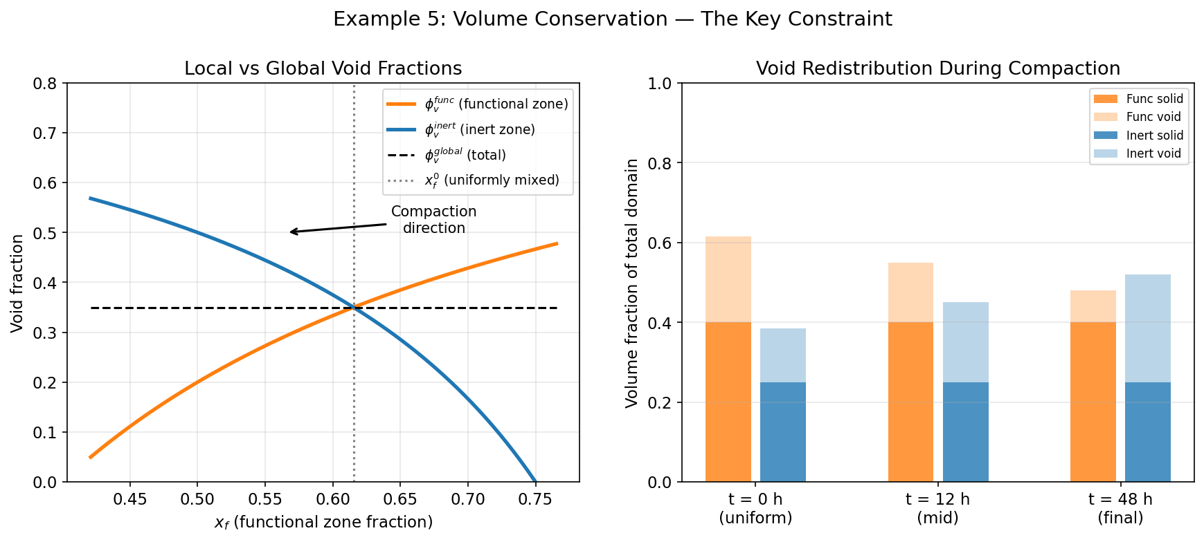
Figure 6.1: Volume conservation. Left: local void fractions vs x_f — the global void (dashed) is exactly constant while the local voids change. Right: stacked bars showing how void redistributes from functional to inert zone during compaction.

6.4 The Driving Force: Cell Traction
Cells pull on the scaffold through the motor-clutch model (Chan & Odde 2008). Motor proteins (myosin) pull inward, while clutch springs (integrins) grip the substrate. The cell “senses” substrate stiffness through the force balance:
β = k_sub / (k_sub + k_opt)
F_cell = F_stall × β × engagement
On soft substrates (small E): k_sub ≪ k_opt, so β → 0 and cells barely pull. On stiff substrates (large E): k_sub ≫ k_opt, so β → 1 and cells pull at full force.
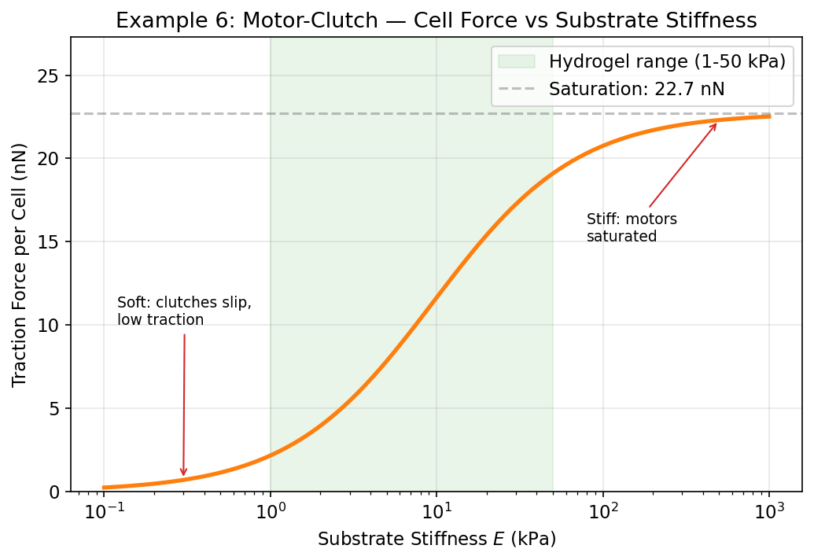
Figure 6.2: Motor-clutch model — cell traction force vs substrate stiffness. Hydrogels (1–50 kPa) sit on the rising portion of the curve.
But cells don’t pull at full force from the start. Three biological processes ramp up over time: (1) FA maturation, (2) bridge formation via a Poisson process, and (3) force ramp for newly formed bridges. The total cell stress is:
σ_cell(t) = n_density × F_cell × f_bridge(t) × maturity(t) × ramp(t)

6.5 The Resistance: Granular Jamming
As cells compact the functional zone, the local packing fraction φ_f/x_f increases. When it approaches the random close packing (RCP) fraction φ_RCP (~0.64 for 3D spheres, ~0.82 for 2D), the granules jam:
σ_resist(x_f) = σ₀ × (φ_f/x_f / φ_RCP − 1)^α when φ_f/x_f > φ_RCP
σ_resist(x_f) = 0 otherwise
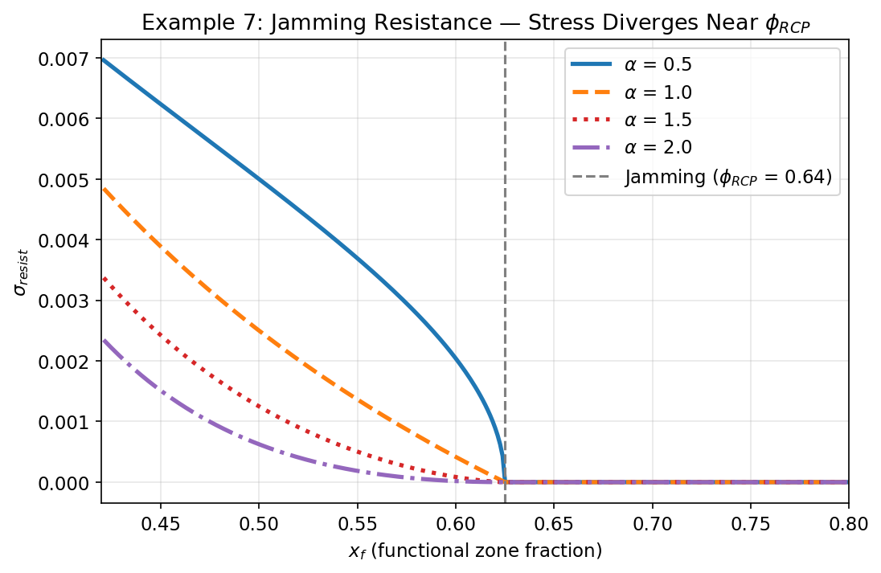
Figure 6.3: Jamming resistance for different exponents α. The dashed line marks x_f at the jamming threshold.

6.6 The Central ODE
Combining driving force and resistance:
dx_f/dt = −x_f × (σ_cell(t) − σ_resist(x_f)) / η_eff
Term | Meaning | Analogy to Ch. 4
dx_f/dt | Rate of compaction | dT/dt
x_f | Current state | T
σ_cell(t) | Cell traction (time-dependent) | Q_heater(t)
σ_resist(x_f) | Jamming resistance (state-dependent) | Q_cooling(T)
η_eff | Effective granular viscosity | C (thermal mass)

The three fitted parameters are:
η_eff — effective granular viscosity. Controls how fast compaction proceeds.
σ₀ — jamming stress prefactor. Controls how strongly the jammed state resists.
α — jamming exponent. Controls how sharply resistance turns on at jamming.
Everything else (E_modulus, cell count, bridge kinetics, geometry) is set by the simulation parameters. Only these three are fitted to match DEM data.

6.7 Full Worked Example
The following figure shows the complete mean field model solved for a typical scaffold (φ_f = 0.40, φ_i = 0.25, E = 10 kPa, R = 40 µm, 8 cells per granule):
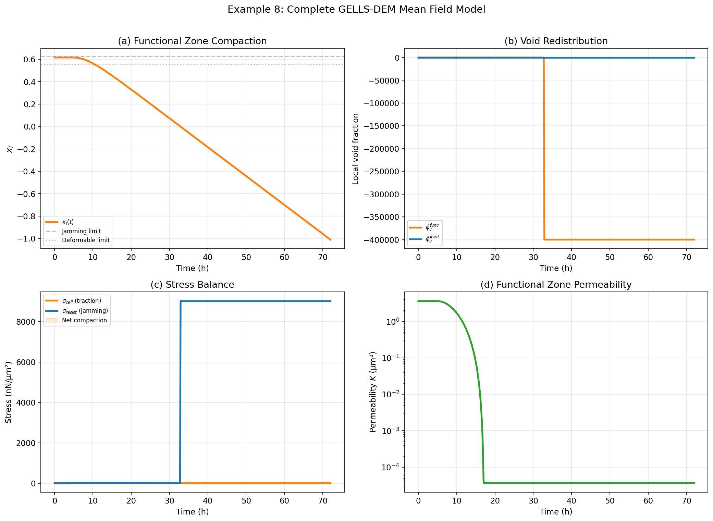
Figure 6.4: Complete GELLS-DEM mean field model. (a) Compaction trajectory x_f(t). (b) Void redistribution between zones. (c) Stress balance — cell traction vs jamming resistance. (d) Functional zone permeability drops by ~10×.

6.8 The Biological Timeline
The driving force has a characteristic S-shape because it is the product of three biological ramp functions: FA maturity, bridge fraction, and force ramp.
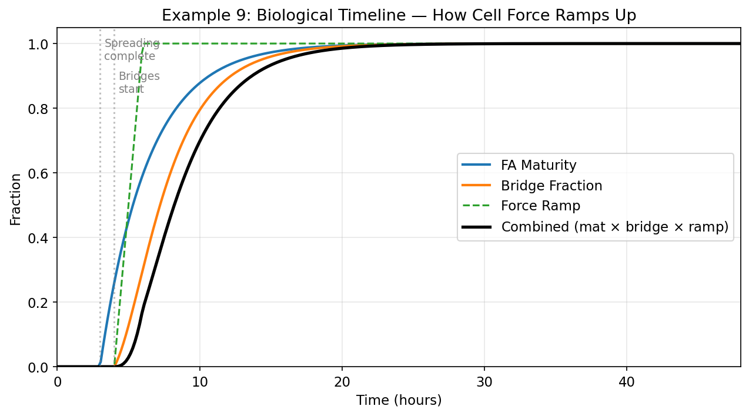
Figure 6.5: Biological timeline. Hours 0–3: spreading. Hours 3–4: FA maturation begins. Hours 4–8: bridges form rapidly. Hours 8+: force saturates.

6.9 Parameter Sensitivity
One of the biggest advantages of a mean field model is that you can instantly see how parameters affect the outcome:
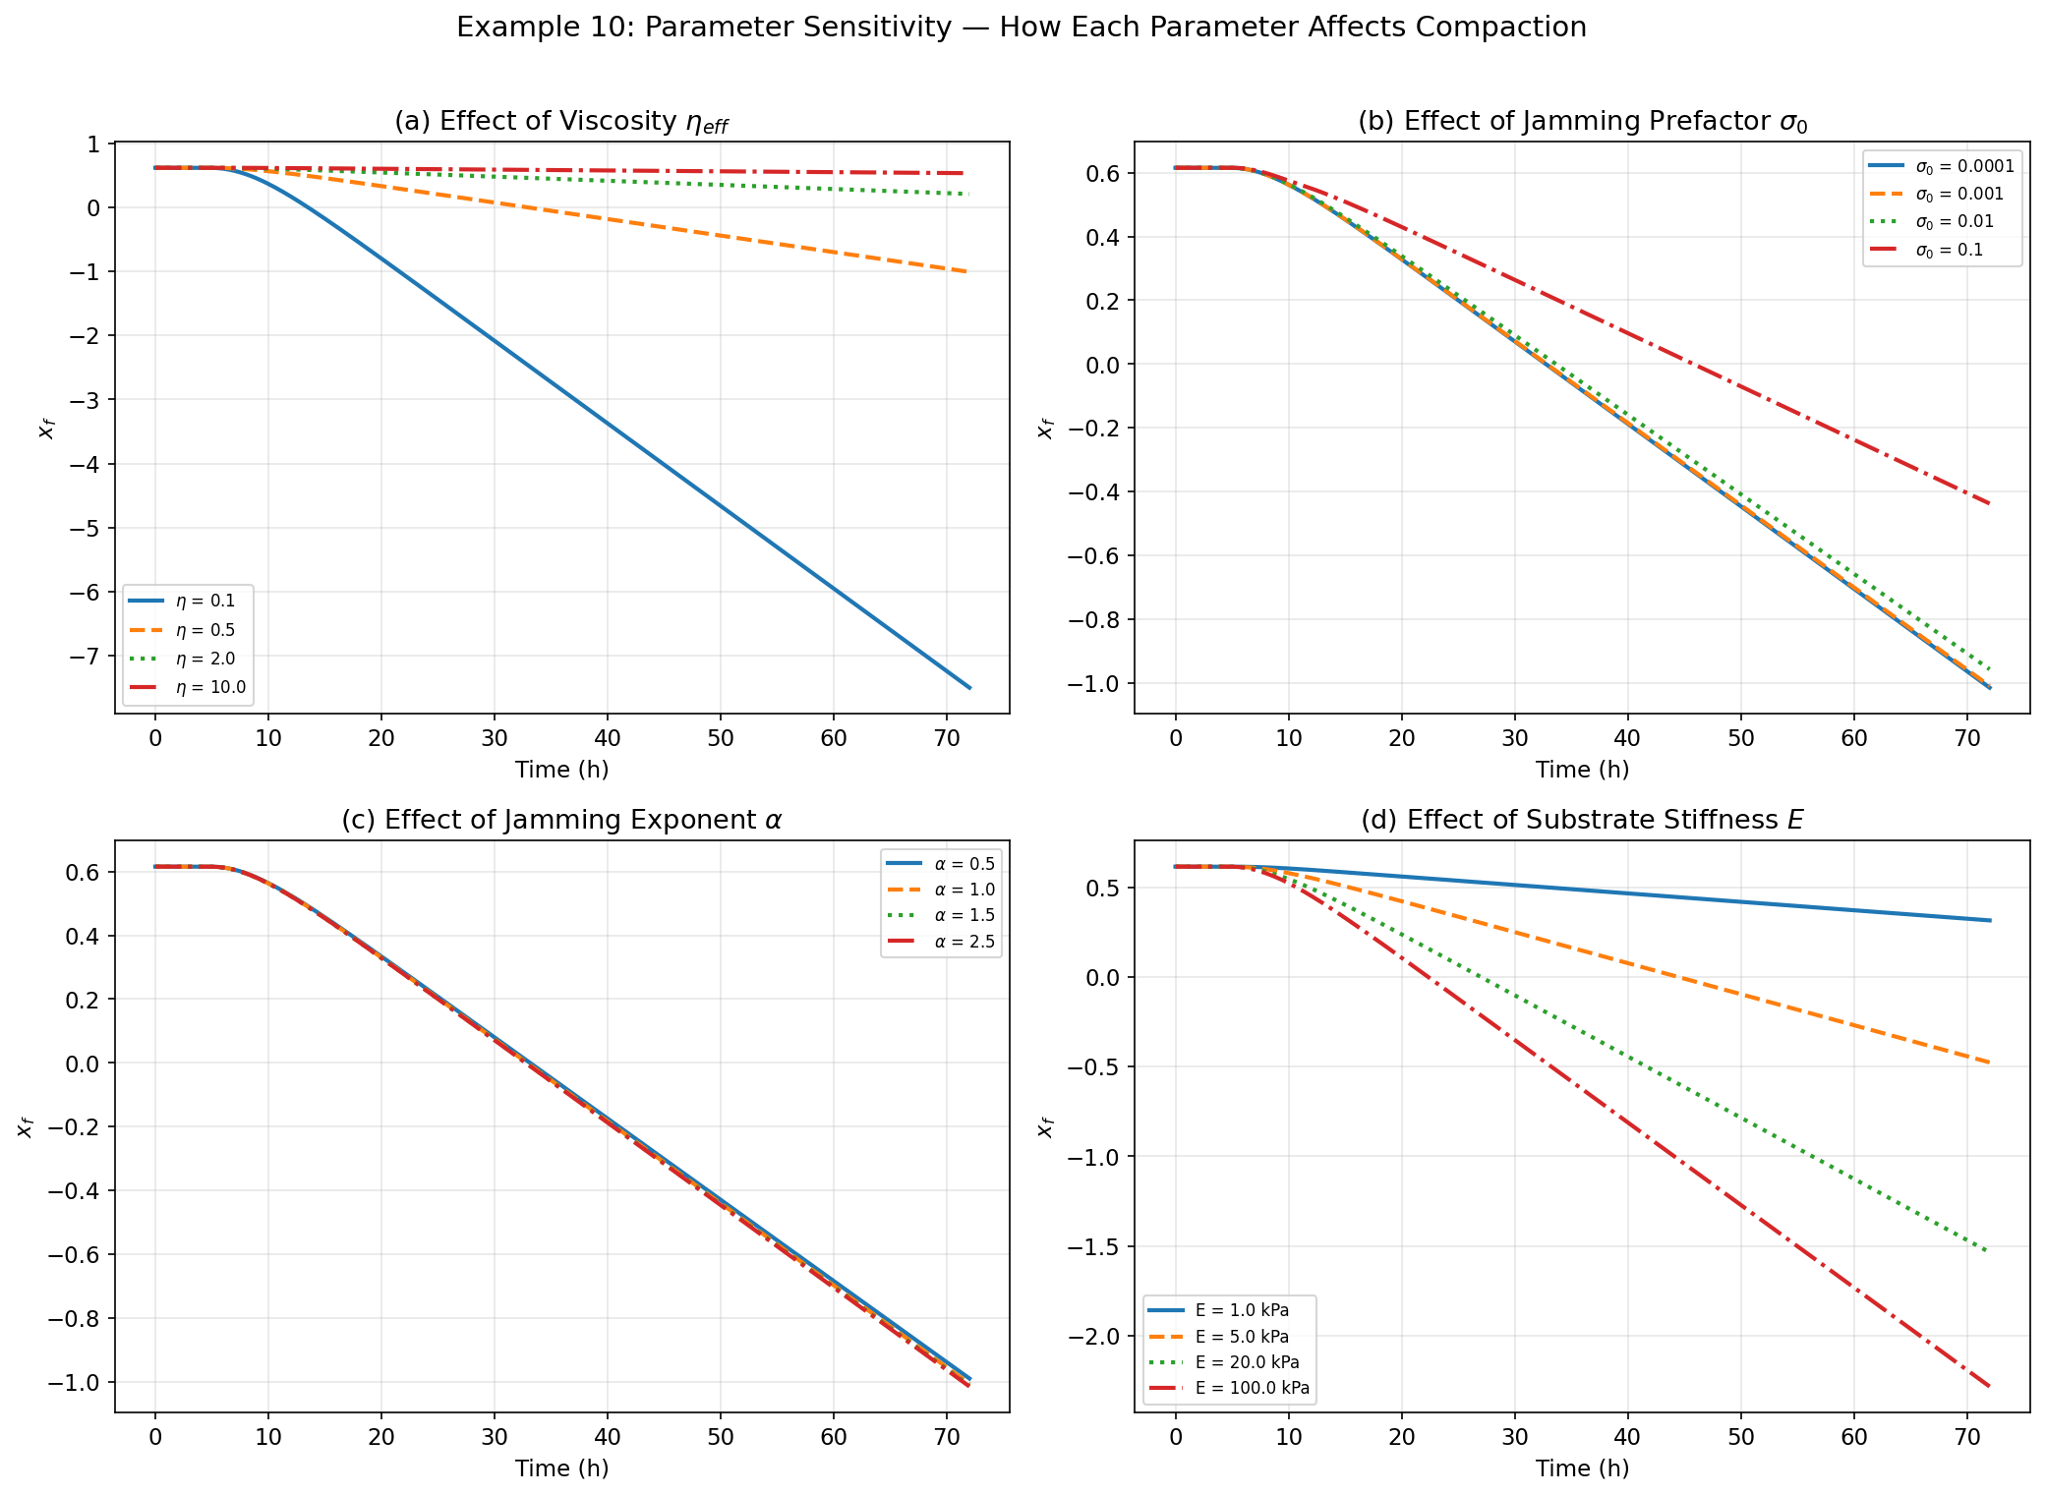
Figure 6.6: Parameter sensitivity. (a) Viscosity controls the timescale. (b) Jamming prefactor controls the final state. (c) Jamming exponent controls sharpness of arrest. (d) Substrate stiffness controls cell traction magnitude.

Chapter 7: Running the Model on Real DEM Data

7.1 What’s in a DEM Run?
Each DOE trial directory (e.g., results/LHC/DOE_2D_0006/) contains the complete output of a DEM simulation: params.json (all parameters), history.csv (time series of bulk metrics at ~49 timesteps), snapshots (per-particle data), and fields (phase field arrays).

7.2 Fitting a Single Run
The simplest workflow is a one-line command that loads DEM data, constructs the mean field model from the simulation parameters, and fits the three free parameters:
from analysis.mean_field_model import from_run

model, fit, data = from_run('results/LHC/DOE_2D_0010')

print(f"eta_eff = {fit['eta_eff']:.4g}")
print(f"sigma_0 = {fit['sigma_0']:.4g}")
print(f"alpha = {fit['alpha']:.3f}")
print(f"R^2 = {fit['R2']:.4f}")

7.3 The Diagnostic Plots
The figure below shows the four-panel diagnostic for DOE_2D_0010 (E = 4.0 kPa, a soft hydrogel). Panel (a) overlays the DEM data points with the mean field fit. Panel (b) shows that global porosity remains approximately constant (volume conservation). Panel (c) shows the stress balance, and panel (d) compares model and DEM permeability.
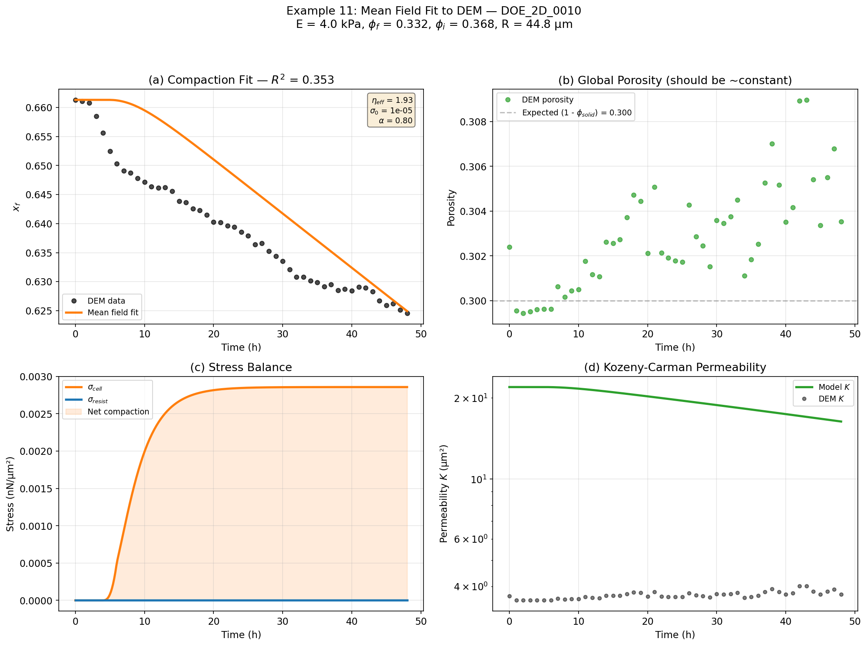
Figure 7.1: Mean field model fit to DEM simulation DOE_2D_0010. The model captures the compaction trajectory, stress evolution, and permeability trend.

7.4 Understanding the Fitted Parameters
Condition | η_eff | σ₀ | α | Physical Meaning
Soft (E~4 kPa) | 0.1–1.0 | ~0.001 | 1.0–1.5 | Low viscosity, weak jamming, gradual arrest
Stiff (E~48 kPa) | 1.0–10.0 | ~0.01+ | 1.0–2.0 | Higher viscosity, stronger resistance

Chapter 8: Comparing Across Experiments

8.1 Why Compare Multiple Runs?
A single DEM run gives you one data point. Our DOE (Design of Experiments) gives 19 runs spanning different modulus (4–100 kPa), composition (func_ratio 0.33–0.93), and granule size (R = 45–100 µm). By fitting the mean field model to all of them, we see how the physics varies across conditions.
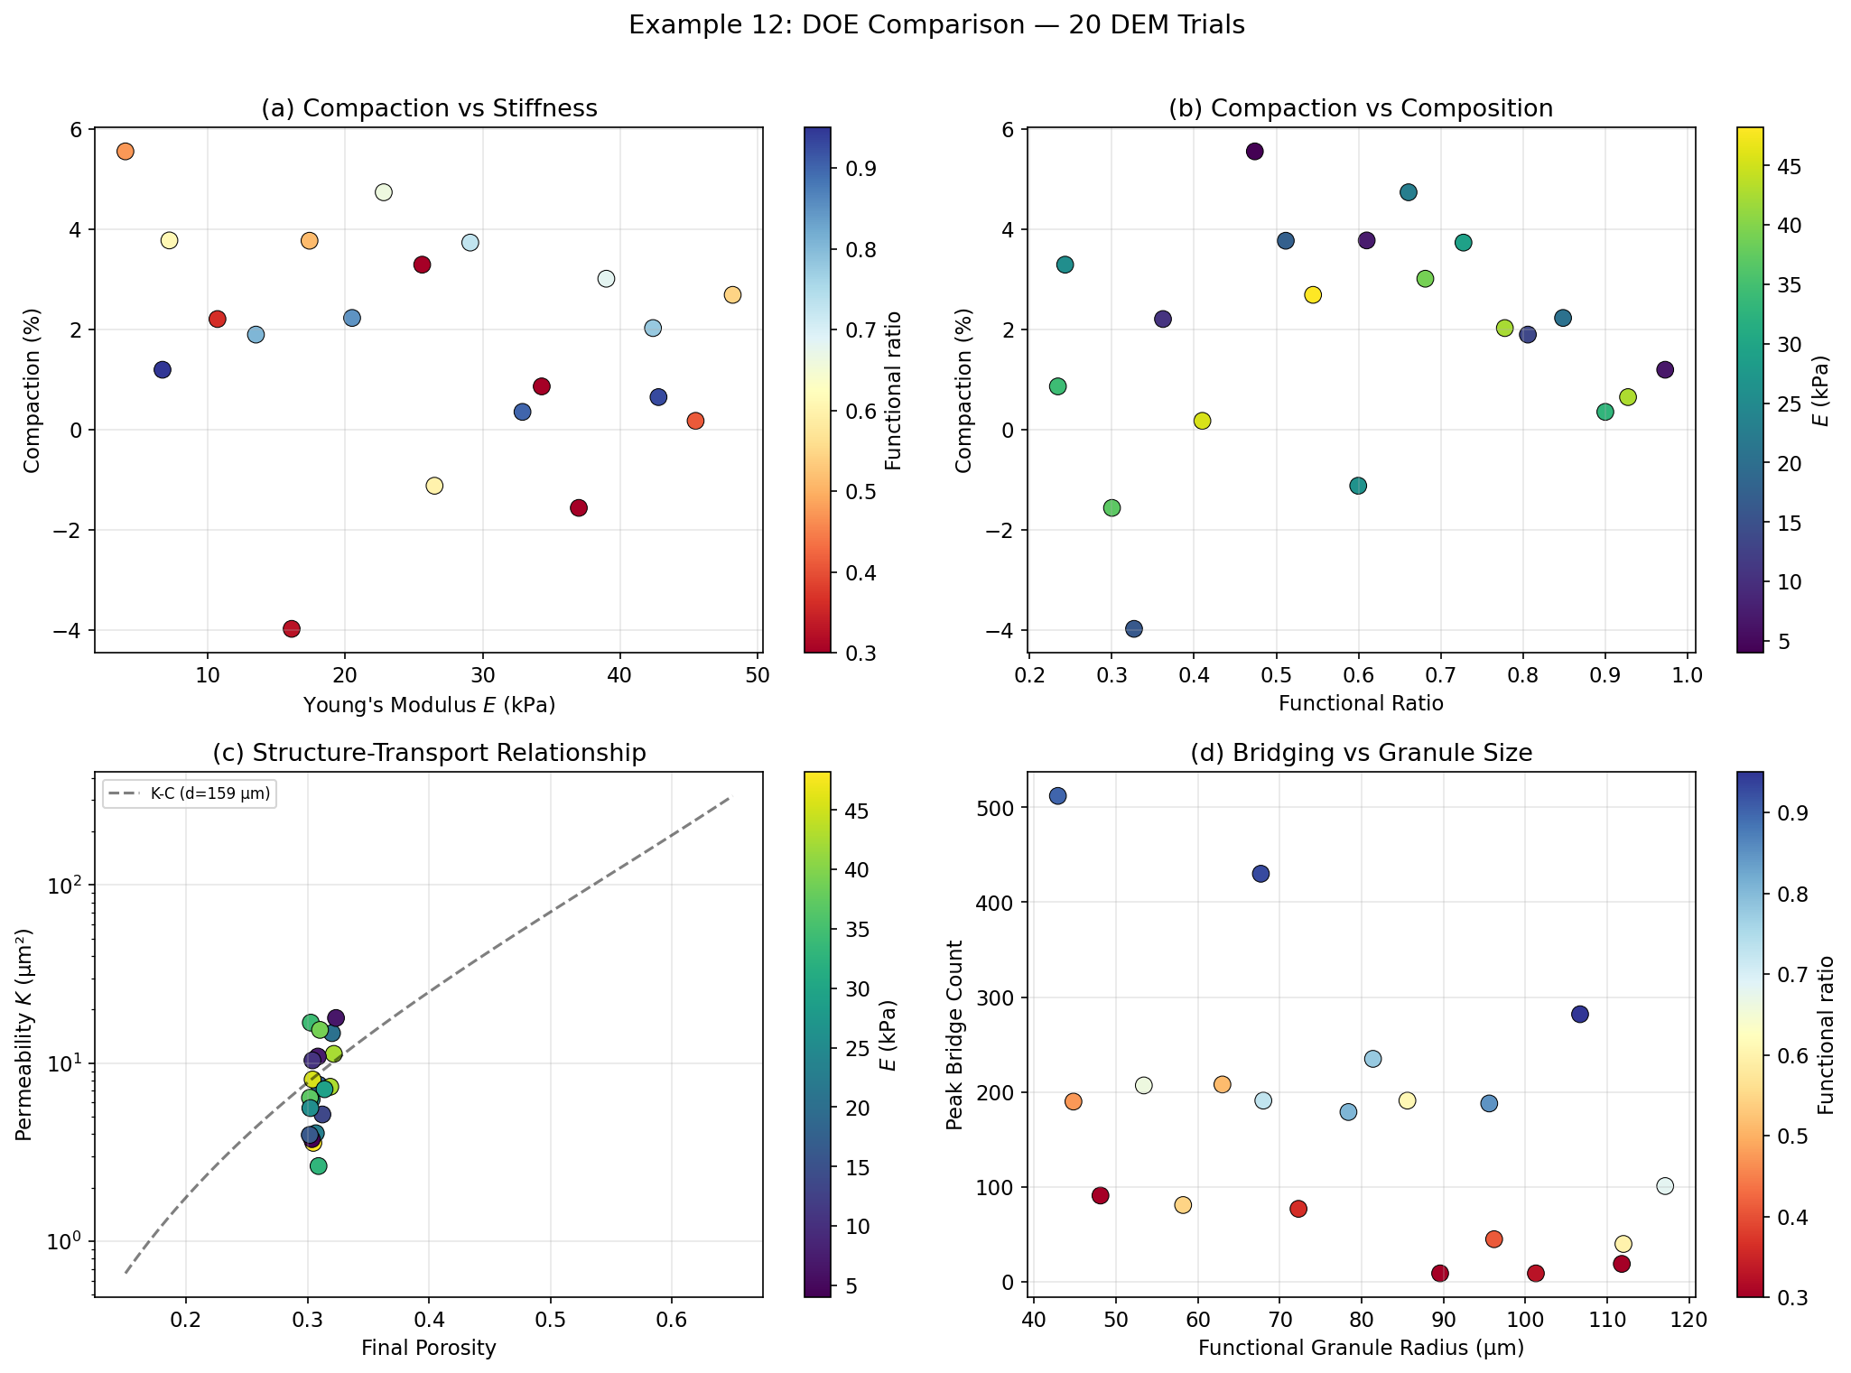
Figure 8.1: DOE comparison across 20 DEM trials. (a) Compaction vs stiffness, colored by functional ratio. (b) Compaction vs composition, colored by modulus. (c) Structure-transport relationship with Kozeny-Carman overlay. (d) Peak bridge count vs granule size.

8.2 The Multi-Run Overlay
Overlaying trajectories from all runs reveals the full range of scaffold behaviours achievable across the design space:
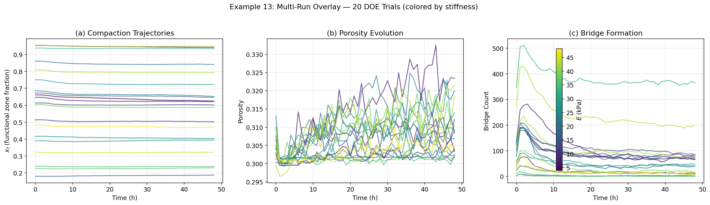
Figure 8.2: All 20 DOE trajectories colored by stiffness. (a) Compaction ranges from minimal to >40%. (b) Porosity fluctuations are small (volume conservation). (c) Bridge formation dynamics vary widely with composition.

Chapter 9: From Scalar ODE to Spatial PDE

9.1 The Limitation of the Scalar Model
The ODE assumes the scaffold compacts uniformly everywhere. In reality, the center has more neighbours (higher bridge probability, more compaction) while the edge has fewer. This gradient is captured by extending the scalar ODE to a 1D radial PDE:
∂x_f/∂t = −x_f(ξ,t) × [σ_cell(ξ,t) − σ_resist(x_f)] / η_eff + D_eff × ∂²x_f/∂ξ²
where ξ ∈ [0, 1] is a radial coordinate (0 = center, 1 = edge), and D_eff captures stress-driven redistribution of packing.

9.2 Spatially-Varying Bridge Rate
A key addition is the neighbor_factor = 0.5 × (1 + cos(πξ)), which is 1.0 at the center (all neighbours present) and 0.0 at the edge (no neighbours outside the scaffold). This makes bridges form faster in the center.

9.3 The Vectorised Sweep
The analysis/parameter_sweep.py module solves this PDE for 200,000 parameter combinations simultaneously using vectorised NumPy. Eleven dimensions are swept (granule size, stiffness, composition, shape, cell loading), and for each sample the model predicts compaction, permeability, tissue growth, and distance to 7 organ targets.

9.4 Tissue Volume Growth
The PDE model also includes spatially-varying tissue growth (V2.1+): tissue fills the void space created by compaction, with more bridges locally promoting more ECM secretion. This is important because tissue volume affects the final architecture descriptors used for organ matching.

Chapter 10: The Energy Landscape

10.1 From Forces to Energy
Everything so far is in the force picture: driving stress vs resistance stress. But there’s a complementary energy picture that gives deeper insight. The analysis/energy_landscape.py module computes a free energy landscape G(ξ) where ξ is a compaction coordinate (ξ = 0 means no compaction, ξ → 1 means fully compacted).

10.2 Six Energy Terms
G_total(ξ) = G_cell + G_elastic + G_yield + G_void + G_inert + G_surface
Term | Physical Origin | Sign | Meaning
G_cell | Cell traction | Negative | Cells lower energy by compacting
G_elastic | Hertzian contacts | Positive | Contacts store elastic energy
G_yield | Granular friction | Positive | Activation barrier to start compaction
G_void | Osmotic pressure | Positive | Cost of redistributing void
G_inert | Inert frustration | Positive | Inert granules block geometrically
G_surface | Interface tension | Mixed | Interfacial energy at func/inert boundary

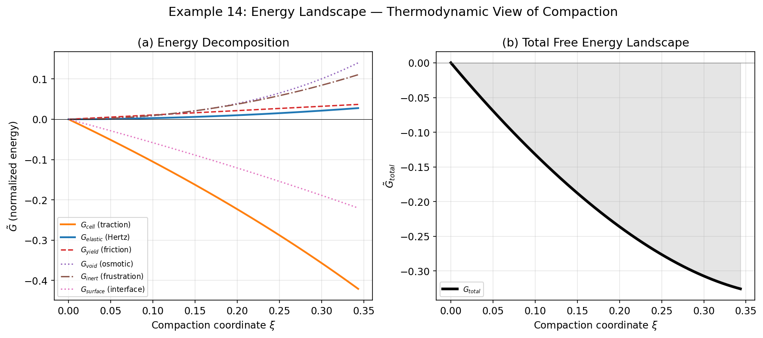
Figure 10.1: Energy landscape decomposition. (a) Individual energy terms — G_cell (driving) vs resistance terms. (b) Total free energy with equilibrium marked by a star.

10.3 Dimensionless Groups
The energy landscape naturally defines dimensionless groups that collapse the parameter space:
Group | Definition | Physical Meaning
β | σ_cell / σ₀ | Cell-to-jamming ratio
Ca | σ_cell / σ_yield | Cellular capillary number
Φ_r | φ_i / φ_f | Inert obstruction ratio
Ψ | φ_f,local / φ_RCP | Proximity to jamming
Γ | γ_fi / σ_cell | Interfacial number

Chapter 11: Summary and Key Takeaways

The Building Blocks
Example | State Variable | Driving Force | Resistance | Key Lesson
Coffee cooling | Temperature T | — | ~ (T − T_room) | Exponential decay to equilibrium
Population growth | Population N | r × N | (1 − N/K) | Nonlinearity creates saturation
Thermostat | Temperature T | Q_heater(t) | Q_cool above threshold | Two forces → equilibrium
Porous medium | Void fraction φ_v | — | — | Structure → transport (K-C)
GELLS-DEM | Zone fraction x_f | σ_cell(t) | σ_resist(x_f) | All of the above combined

The Three Levels of the Mean Field Model
Level | Code Module | State | Fitted Params | Best For
1. Scalar ODE | mean_field_model.py | x_f(t) | 3 (η, σ₀, α) | Understanding, validation
2. Radial PDE | parameter_sweep.py | x_f(ξ, t) | 11 swept | Design optimization, organ targeting
3. Energy Landscape | energy_landscape.py | G(ξ) | 0 (all from physics) | Insight, scaling laws

Key Equations
Equation | What It Does
F_cell = F_stall × β × engagement | Motor-clutch cell traction
σ_cell = n × F × f_bridge × maturity × ramp | Total cell stress
σ_resist = σ₀ × (φ_local/φ_RCP − 1)^α | Jamming resistance
dx_f/dt = −x_f(σ_cell − σ_resist)/η_eff | Compaction ODE
K = φ_v³ d² / [180(1−φ_v)²] | Kozeny-Carman permeability

Tips for the Beginner
1. Start simple. If your mean field model has more than 3–5 free parameters, it’s probably overfitting.
2. Validate against data. Always compute R² and look at the residuals.
3. Understand the limits. Mean field models average over spatial fluctuations — they work well for bulk properties but miss local effects.
4. Use dimensional analysis. Dimensionless groups reduce the parameter space and give physical insight.
5. The model is a tool, not the truth. Use it to generate hypotheses, guide experiments, and explore design space.
6. Run generate_examples.py yourself. Modify parameters and re-run to build intuition.

Appendix A: File Reference
File | Purpose
analysis/mean_field_model.py | Two-zone compaction ODE, fitting, plotting
analysis/parameter_sweep.py | 11-D LHS sweep with 1D radial PDE + tissue growth
analysis/energy_landscape.py | Free energy decomposition, kinetics, dimensionless groups
analysis/tissue_descriptors.py | 18 tissue architecture descriptors
analysis/organ_targets.py | 7 organ target vectors for design optimization
viz/dimensionless.py | Dimensionless analysis and data collapse
CodeLog/MeanFieldModeling/ | This guide, figure generator, and output figures

Appendix B: Generating the Figures
All figures in this guide can be regenerated by running:
python CodeLog/MeanFieldModeling/generate_examples.py
This produces all 14 PNG figures in CodeLog/MeanFieldModeling/figures/. Examples 1–10 use synthetic data and always work. Examples 11–14 use real DEM data from results/LHC/ and are skipped if that directory is not present.

Appendix C: Quick-Start Cheat Sheet
# === Fit mean field to one DEM run ===
from analysis.mean_field_model import from_run
model, fit, data = from_run('results/LHC/DOE_2D_0006')

# === Generate all diagnostic plots ===
from analysis.mean_field_model import run_all
model, fit, data = run_all('results/LHC/DOE_2D_0006')

# === Build a model from scratch ===
from analysis.mean_field_model import CompactionModel, MotorClutchParams
mc = MotorClutchParams()
model = CompactionModel(
E_modulus=10.0, phi_f0=0.40, phi_i0=0.25,
R_func=40.0, n_cells_per_granule=8, N_func=160,
domain_volume=800**2, mc_params=mc
)
sol = model.solve((0, 72), eta_eff=0.5, sigma_0=0.001, alpha=1.2)

# === Run a 200k parameter sweep ===
from analysis.parameter_sweep import generate_lhs, run_sweep_vectorised
samples = generate_lhs(200_000, seed=42)
outputs = run_sweep_vectorised(samples)

