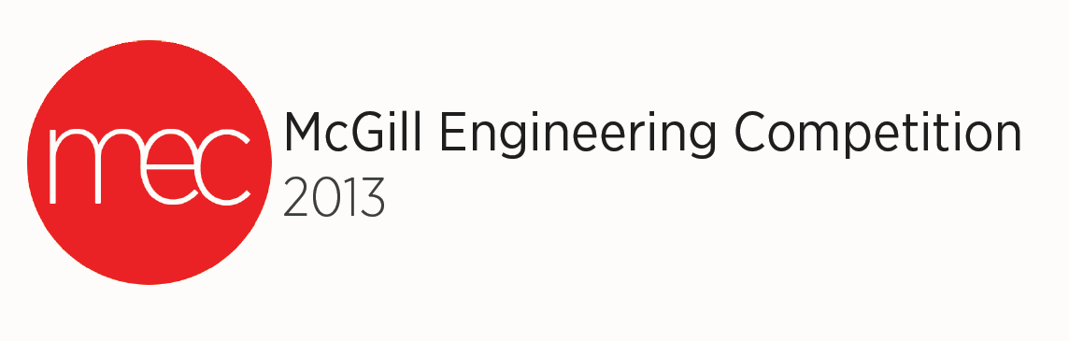

ReEngineering

**Introduction**

**Context**

Do not criticize most major subway stairs of Montreal, as they could become a source of electricity!

The company you work for wants you to find a solution for recovering energy through the use of stairs Montreal subway. It may be common stairs or escalators. The hardware design of the stairs is left free to choose.

Your mandate is to find a way to recover energy from the stairs. This role will be to supply in part the energy needed for the lighting in the subway or electrical equipment. It must be a local production for local use.



*Figure 1: Metro Staircase [1]*

**Competition**

**Competition**

Reengineering is the act of taking an existing engineering concept to make it more efficient. In other words, at this stage of the competition, participants will work on the reorganization and innovation of an object of everyday life, in order to ensure a positive change in society.

You must apply it to one of the following concepts. You are encouraged to include your calculations to demonstrate the feasibility of a marketing your new concept. In a team of 2 engineering students, you will have four hours for the reengineering of the selected case. You will have to present the idea to the judges as well as hand in a report of a maximum of four pages (excluding the title page and appendices).

**Presentation**

Participants will have a period of 13 minutes to present their ideas in front of the jury. During the presentation phase, teams will describe the process used to arrive at the final solution. This period will be followed by a maximum of 7 minutes of questions from the judges.

**Note:** Teams are encouraged to use PowerPoint to accompany their presentations.

**Equipment**

Throughout the conceptual period each team has the right to the following:

* Adequate work space ,
* Paper and pencils / pens to write ,
* A computer with software for report writing and the development of the presentation (e.g. Microsoft Office)
* Internet access via computer.
* USB key
* Books, notes taken during class or any other document.

During the reporting period

* A digital projector
* A whiteboard

NB: At the end of the design period, participants must submit their electronic documents on a storage device. It is the responsibility of the competitors to check with the organizers that the format of electronic data is compatible with the available computers.

**Evaluation Criteria**

|  |  |
| --- | --- |
| **Evaluation Criteria** | **Percentage (%)** |
| **Solution** | **/55%** |
| Proposed improvements (utility, originality) | 20% |
| Characteristics of technical improvements (plan, feasibility, choice of materials) | 20% |
| Impact of improvements | 10% |
| Marketing | 5% |
| **Report** | **/15%** |
| Professionalism | 5% |
| Results in compliance with expectations | 10% |
| Penalties for grammar and spelling mistakes (-1% per mistake) | Maximum -10% |
| **Presentation** | **/20%** |
| Voice, articulation and respect for time | 10% |
| Visual aids | 10% |
| **Innovation** | **/10%** |
| **Total** | **/100%** |