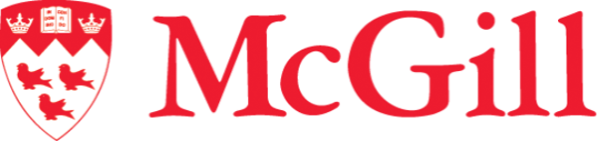

Design Team Internship
Timeline

Anne-Sophie Nadeau
Luca Abruzzese

May 13, 2026

Week 1: May 11 - May 17
- Multimatic data Analysis and Report/Testing Plan for validating 7 degrees of freedom car
- Create/Finalize Github project and workflow
- Research into quasi steady state lap simulation

Week 2: May 18 - May 24
- Research into quasi steady state lap simulation
- Working in UML Diagram – Defining classes and relationships between them
- Working on Half car vehicle model on simulink

Week 3: May 25 - May 31
- Working on half car vehicle model on simulink
- Working on 7 degree of freedom vehicle model on simulink

Week 4: June 1 - June 7
- Finalizing 7 degree of freedom vehicle model,

Week 5: June 8 - June 14
- Validate half car, and 7 degree of freedom model

Week 6: June 15 - June 21
- Michigan Competition

Week 7: June 22 - June 28
- UML Diagram Finalized
- Begin coding of quasi steady state Lap sim

Week 8: June 29 - July 5
- Coding of quasi steady state Lap sim
Week 9: June 6 - July 12
- Coding of quasi steady state Lap sim

Week 10: July 13 – July 19
- Coding of quasi steady state Lap sim

Week 11: July 20 – July 26
- Coding of quasi steady state Lap sim

Week 12: July 27 – August 2
- Validate quasi steady state Lap sim

Week 13: August 3 – August 9
- Validate quasi steady state Lap sim

Week 14: August 10 – August 16
- Final Documentation

Week 15: August 17 – August 23
- Final Documentation

Week 16: August 24 – August 30
- Final Documentation + Buffer Week

