Christian McGovern, 1/28/18, Program which allows the insert, display, deletion, modification and search of a symbol table.

1. Code commented and indented. Header added.
2. 4 action screenshots:

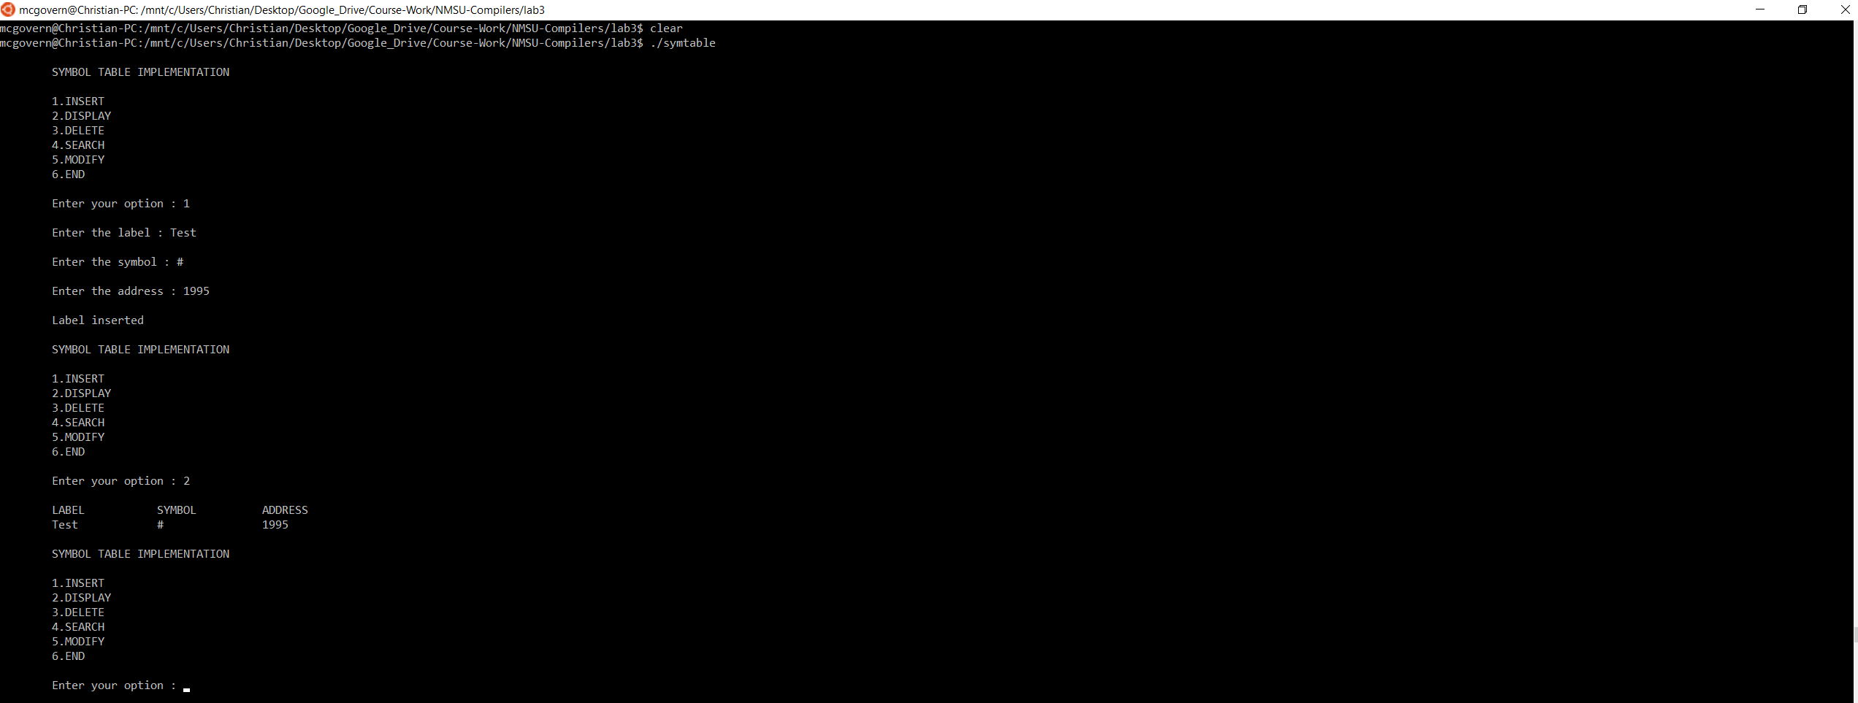

(INSERT function demonstration)

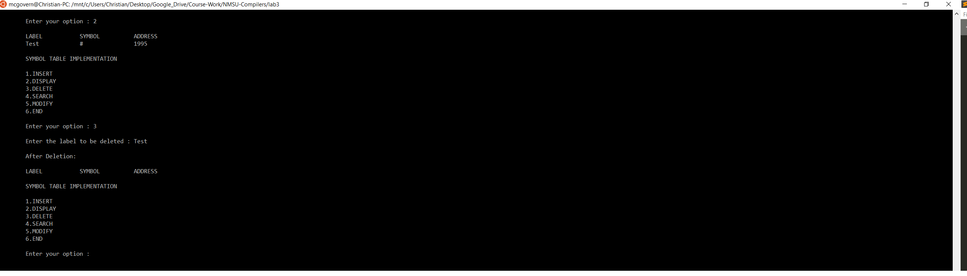

(DELETION function demonstration)

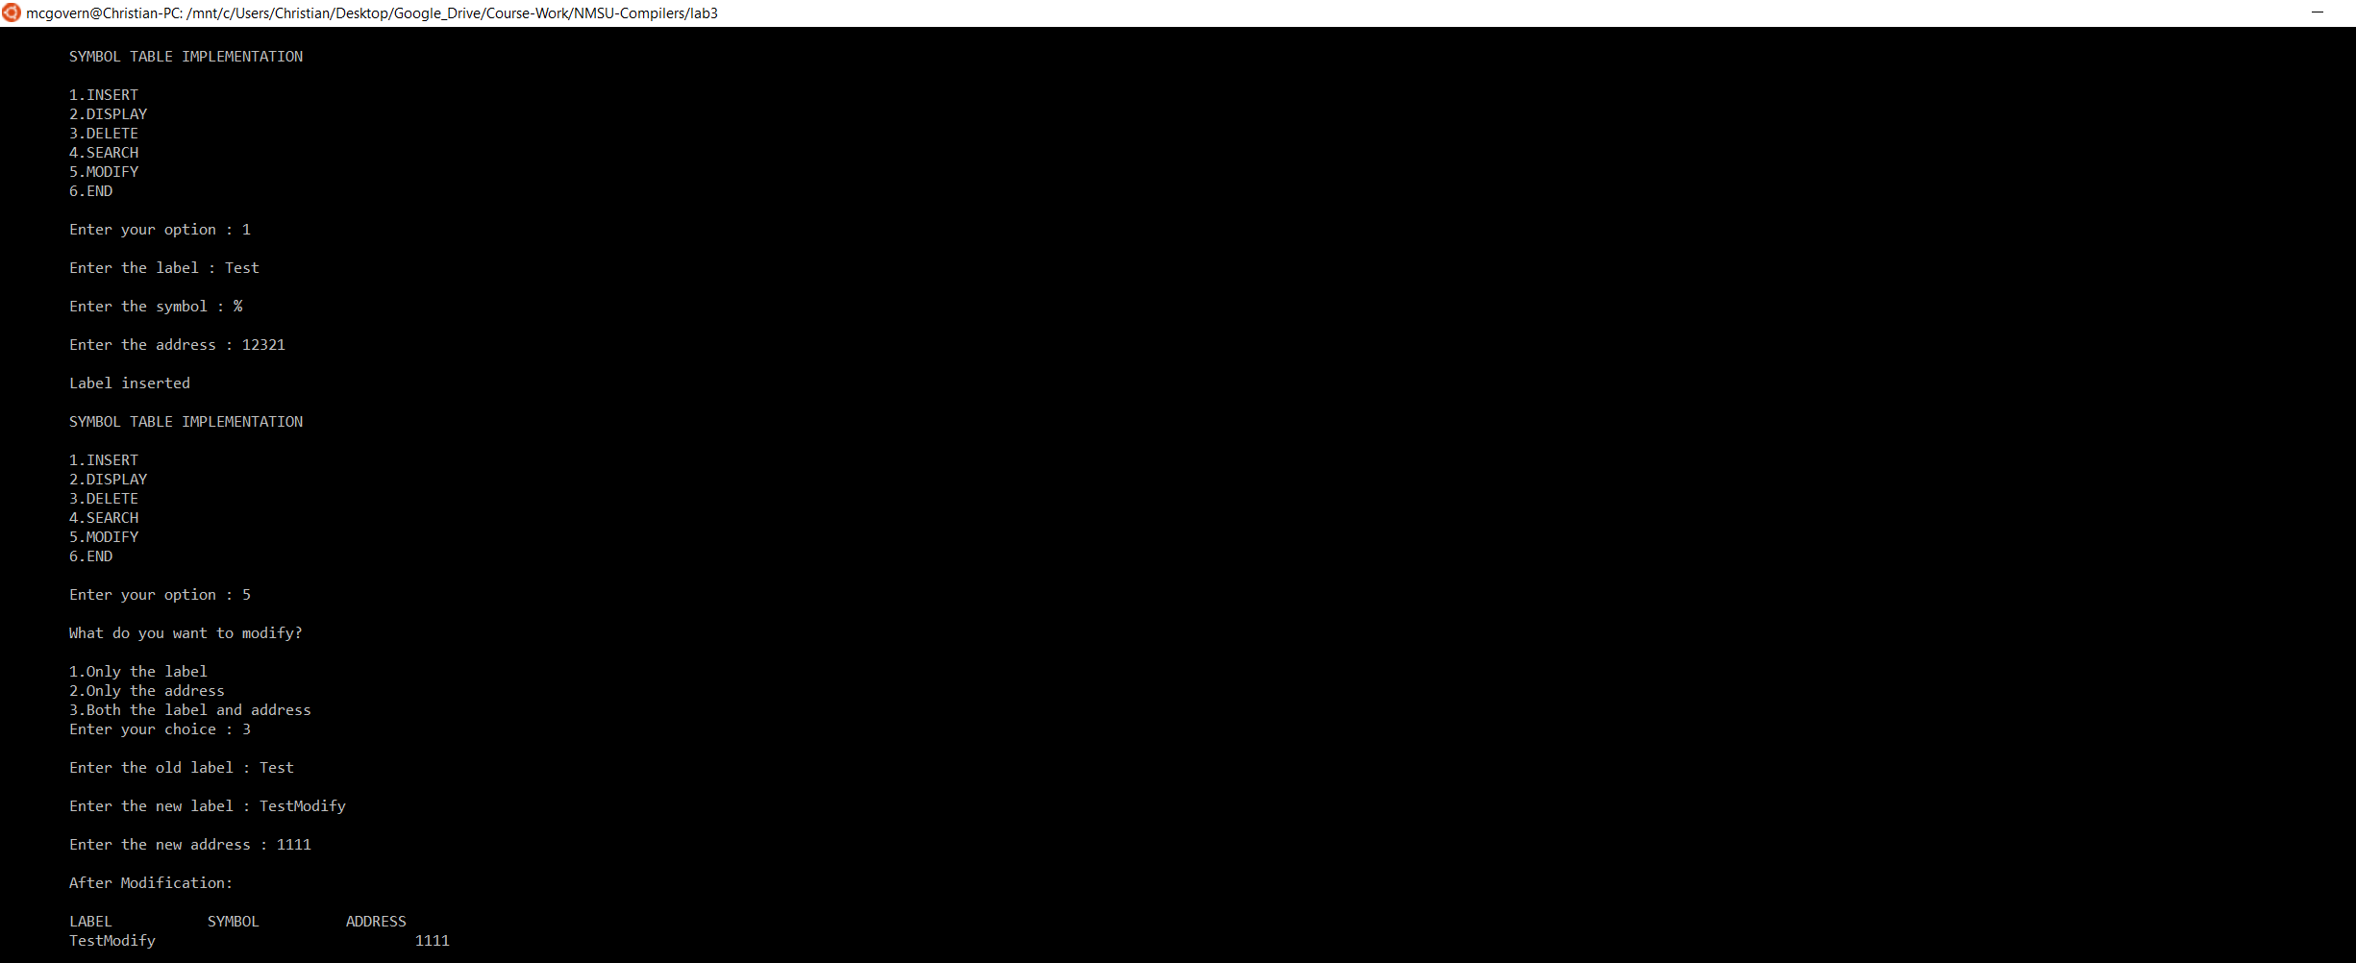

(MODIFY function demonstration)

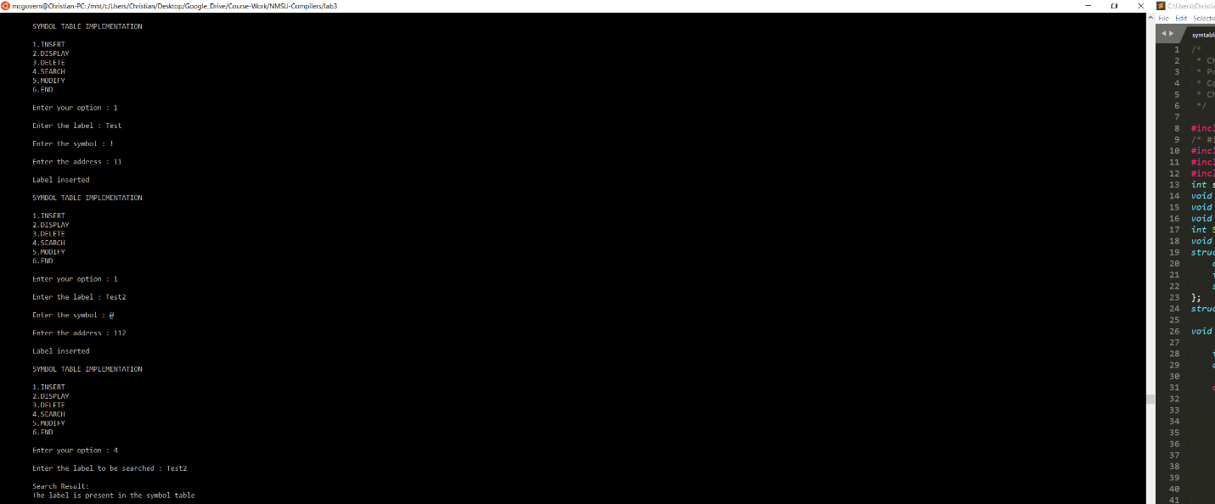

(SEARCH function demonstrated)

1. The main structure of the code is called SymbTab{}, Its fields are 2 char arrays. An int, and a struct data type for the pointer next. Also 2 struct Symbtab pointers called first and last declared outside SymbTab{}. The structure is built around using pointers and accessing the data from anywhere in the program, in this case it is accessed from all the functions.
2. Malloc() is a function which allocates memory dynamically. We use malloc() because what if we do not know how much data is going to be used? Instead of using a static number and guessing we can use malloc to allocate memory whenever we need it. In the case of our symtable.c, it is used to dynamically allocate memory for the size of our struct SymbTab.