3005. Conversions

Time Limit: 1.0 Seconds Memory Limit: 65536K
Total Runs: 1632 Accepted Runs: 975

Conversion between the metric and English measurement systems is relatively simple. Often, it involves either multiplying or dividing by a constant. You must write a program that converts between the following units:
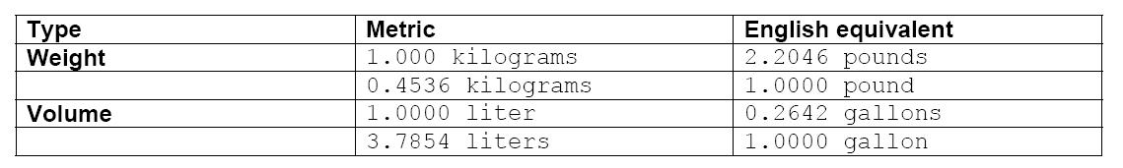

Input
The first line of input contains a single integer N, (1 ≤ N ≤ 1000) which is the number of datasets that follow.
Each dataset consists of a single line of input containing a floating point (double precision) number, a space and the unit specification for the measurement to be converted. The unit specification is one of kg, lb, l, or g referring to kilograms, pounds, liters and gallons respectively.

Output
For each dataset, you should generate one line of output with the following values: The dataset number as a decimal integer (start counting at one), a space, and the appropriately converted value rounded to 4 decimal places, a space and the unit specification for the converted value.

Sample Input
5
1 kg
2 l
7 lb
3.5 g
0 l

Sample Output
1 2.2046 lb
2 0.5284 g
3 3.1752 kg
4 13.2489 l
5 0.0000 g

