BandsNearMe

Work in Progress

Team 7

Spring 2017

Fahad Alsaudee

James Lindsey

Samuel McGuire

Merrillee Palmer

Terrance Santilli  
John Schumm  
Rachel Snyder

Table of Contents

Contents

Overview 4

Design Document Responsibilities 4

Design Rationale 5

High-Level Design 6

A. High-Level Design Diagram 6

A.1 Solution 7

A.2 Platform 7

A.3 System 7

A.4 Product 7

A.5 Service 7

A.6 Process 8

B. Architecture Style 8

C. High-Level System Architecture Diagram 8

D. Decomposition Diagram 9

Detailed Design 12

Login 12

Logout 12

Search 12

Save Favorites and Suggest Similar Bands 13

Get user statistics 14

Notifications 14

Review 15

Create Profile 15

View Profile 16

Edit and Update Profile 16

Bulk Data Input 17

Create Show at Location 18

Assumptions and Risks 19

Assumptions: 19

Risks 19

# Overview

The project is an app that allows users to find live music in their area that will be displayed through the Google Maps API. It also allows users to search for a venue or band’s profile. Additionally, this app will give users an overview of both the bands and the venues in which they play. These overviews will include information like when a venue has happy hour and what genre of music a band plays, a rating system for both the bands and the venues and allow individual users to write reviews on the bands and venues.

Currently the principals that we are focusing the most on for this project are usability and rapid development. Our app needs to be easy to use and understand so that it will appeal to the largest user base and needs to accomplish this before the Symposium on April 21st. We will require development for both a web and a mobile front end with a database supplying the backend for both of them.

## Design Document Responsibilities

|  |  |
| --- | --- |
| Sam McGuire | * Overview |
| John Schumm | * High level diagram |
| Rachel Snyder | * PowerPoint Presenter * Detailed Design |
| Merrillee Palmer | * PowerPoint Presenter’s * Detailed Design |
| Terrance Santilli | * Decomposition |
| Fahad Alsaudee | * Design Rationale |
| James Lindsey (Leader) | * Architecture Description / Diagram * Assumptions and Risks |

# 

# Design Rationale

* Having both a web and a mobile app requires twice as much support staff but gives users an option and allows for a backup user experience. A mobile client is necessary considering the nature of the application. However, the web client also gives access to a more traditional I/O setup when band and venue users are entering new shows.
* Utilizing the Google Maps API for our location services saves a significant amount of time, effort, and memory. However, it makes both client applications heavily dependent on a third party.
* Having a single database leaves the app less secure, less easily recoverable and more vulnerable to being overloaded. However, it requires less maintenance and is it easier to reduce redundancy and conflicts.
* Having a single login/create profile page for bands venues and individual users will require more work on the developer's part, but will give the users a more seamless experience.

# High-Level Design

## A. High-Level Design Diagram

HighLevelDiagram.png

### A.1 Solution

Our given problem from the customer, was to be able to search and find bands that will be performing around the user’s location. A given solution was to use google maps integrated on a mobile app for the user’s phone, that will show the user on a map bands performing in their area. To accommodate this, bands and venues must register, or “create”, their shows on either the mobile app or the web client. In the case of a band’s tour or a venue’s monthly line-up, we also decided it was necessary to create a way to bulk import shows.

### A.2 Platform

The user should be allowed to on the go find bands close to them, so we concluded that a mobile app would best serve that need. However, we decided a website for the customer to update their information for the users on the mobile application.

### A.3 System

Through the various operations that the user performs on the app, the database is called to add, retrieve, and update data. We also implement a web server for our web client that is running Microsoft IIS. The user can log onto their profile through the web browser and their actions will be sent to the web server which then communicates with the database.

### A.4 Product

The products is an app that can be downloaded on an android device and a web page that is accessible on supported browsers. The app allows the user to search for bands that are performing in the area. The app will use the Google Maps API which will help locate the user’s current location and display any venues and performances in the area. The web application is available for use for any band, venue, or administrator that has a profile. It gives the users an easier way to edit their profile and upload data.

### A.5 Service

We are servicing two kinds of clients: web and mobile. Our database is running SQL Server. For the mobile users, the client application is connecting directly to the database. For web users, the supported web browsers connect to the web server hosting our web client. The web server then connects to the database.

### A.6 Process

We are using a client-server based process that will connect the user to upcoming shows and shows already being performed in real time. By doing this we are always editing and updating the database which will keep the user in-the-know with new booked performances or canceled performances with a certain band or venue.

## B. Architecture Style

We are using a client-server architecture style. Our web and database servers will connect to two unique types of clients: mobile and web. The users on the mobile application perform various actions and requests will be sent to the SQL Server database to update/retrieve data. The web based portion connects the user to a web server that will communicate with the database to perform many of the same actions as the mobile client.

## C. High-Level System Architecture Diagram



## D. Decomposition Diagram



We chose to use create a functional decomposition diagram. The diagram is broken up into all of the functions users are able to do. Descriptions of the functions are given below.

GUI: The main GUI will contain two buttons, allowing the user to either login or create an account.

Create Account: User will choose a username and password and account type, and click “Create Account.” The database is then checked to see if the username is unique. If it is not, a message will appear letting the user know, and to input another username. Once a unique username is chosen, the user will be directed to the homepage for their account type.

Login: The login screen will contain text fields allowing the user to enter their username and password.

Verify: After entering their information, the user will select “login” and the inputted information will be verified with the database. If the information entered is incorrect the user will be brought back to the login screen, if it is correct, the account type is checked and the user is brought to their appropriate homepage for their account type.

There are four account types: Individual User, Band, Venue, and Administrator. Depending on their account type, the user is granted the appropriate permissions.

All account types - Search: On the homepage, the user can search and apply filters to search for venues and bands only. The user can then select a venue or band and be brought to that venue or band’s profile.

All account types - Logout: On the homepage, the user can click a logout button that will sign their account out of the app and will redirect them to the Login/Create account screen.

All account types - Review: Upon visiting a band or venue profile, the user can click a “review” button that will allow the user to rate the venue or band on a 1 to 5-star rating. Upon rating, the band or venue’s profile will be updated with their newest rating.

All account types - Notifications: Upon visiting a band or venue profile, the user can click a “notifications” button. This button brings up a menu that allows the user select to be alerted by phone alert, text message, and/or email whenever the band will be playing or whenever the venue will be hosting a show.

Band, Venue, Administrator accounts - Bulk Data Import: If a user has multiple shows that they need to create at once, they will be able to input mass data that will create the shows in one action.

Individual User, Administrator accounts - View User Profile: The user can view their profile which shows the user’s favorites as well as personal details.

Venue, Band accounts - Create Show at Location: User can click “Create Show” which will bring them to a screen allowing them to input all the details about the show. Upon creation, the band/venue profile should be updated to list the show.

Individual User, Band, Venue accounts - Update User/Band/Venue Profile: User can click “Edit Profile” which will bring them to a new page that will be slightly different depending on account type. This page lists the user’s information in editable text fields that the user can type new information in. The page will also consist of “Save” and “Cancel” buttons. Upon clicking save, the information will be updated in the database, and the user’s profile will be updated. Upon clicking cancel, all text from the editing page will be disregarded and the user’s information will remain the same.

Individual User - Save Favorites: Upon visiting a band’s profile, a user can click “favorite” which will add that band to a user’s favorites list. Based on the band that was marked “favorite,” the user may be presented with suggestions of similar bands.

Administrator - Get User Statistics: Administrators will be able to click a button that will bring up a menu allowing them to choose what type of statistics they would like to view. Statistics will be displayed in forms of graphs.

* Sign up rate: Admin will input a date range which will return the number of accounts created in that time span.
* Traffic: Admin can specify a day and will see a bar graph showing the number of users on at each hour throughout that day.
* Types of Users: Upon choosing this statistic, the administrator will see a graph showing the current number of users for each account type: band, venue, individual user, and administrators.

# 

# Detailed Design

## Login

The different users can enter their credentials and the software will check them against the database, if everything checks out the user will see the main page of the application and have access to permissions in the application associated with their account.

## Logout

The different users can logout from their profile from their home page. The user will be disconnected from the database.



## Search

The individual user can search for shows in the area. The user enters the search criteria in the search bar from their homepage. The user can search by venue, band, or location. The database checks the records for the search results. If there are entries that match the search criteria, the results are displayed. The results will come up in the Google Maps API.

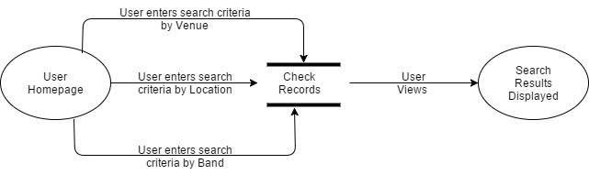

## Save Favorites and Suggest Similar Bands

The individual user can save their favorite bands and venues in order to make it easier to find events pertaining to them in the future. This is done via the band or venue homepage, in which an individual user will see a star that they may click. Once clicked, that venue or band will be linked to the user’s profile page. If the user clicked a band to favorite, the system checks the database for similar bands using the band’s genre information. Similar bands are retrieved, and then displayed for the user to view. The user may now navigate to their profile page where they may view their favorite bands and venues.

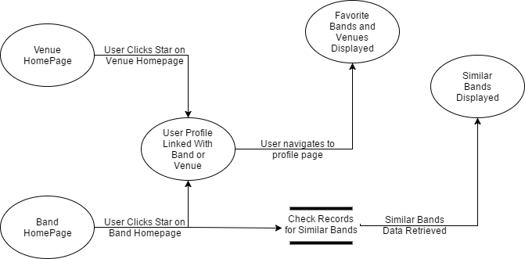

## Get user statistics

Administrators with proper login can access user statistics. They can access Traffic Data within a specified date and time range, Sign-up rate Data within a specified date range, and Types of Users Data. From their homepage, the Administrator will select which type of statistics they wish to retrieve from the dropdown box, and enter the specifications if required. The system then retrieves the information and displays it for the Administrator to view in a helpful chart and graph format. We will use Google’s Charts API to display the retrieved data for the administrator.

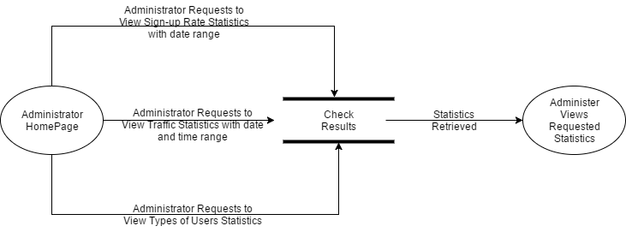

## Notifications

Users can set up notifications for the bands they choose. The user navigates to the desired band profile page and clicks on the notification button. A notifications page pops up and the user can choose the email, text or phone alert button. The system then uses the profile information of the user and sets up the notifications for that band and will notify the user if he or she is within 15 miles of that band playing.

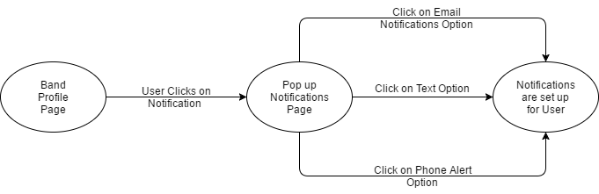

## Review

Individual users can review both bands and venues. The user does this by navigating to the desired band or venue page. The user then clicks the amount of stars the user wishes to give the band or venue as a review. A review page pops up and the user is able to write an optional text review. The user clicks submit and the review is posted to the band or venue page.

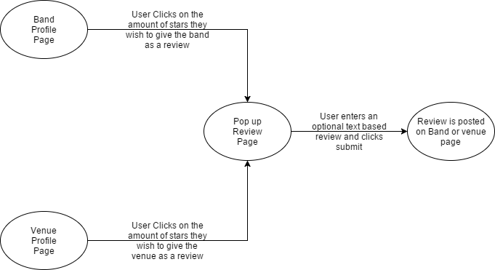

## 

## Create Profile

The users create a new account and are redirected to a window or page that has them create a new profile. Once a user has finished filling out the necessary information on a form layout, and confirmed to save their profile, the user data will get saved to their profile records in the database. 

## 

## View Profile

Users may wish to view their profile to validate the information on their page or to get to the edit profile screen. For the user to see this information, the request for the user’s information is sent to the database and then the request is seen on the user’s profile page.



## 

## Edit and Update Profile

A user wants the ability to be able to edit their profile information so that other users may be able to see updated information about the user. This is accomplished by the user going to their profile page, which displays user’s information from the database. The user can then alter any of the information on this page and then save their changes, this sends the changes to be saved in the database, the user is then redirected to the ‘View Profile’ screen where all changes can be seen by all users. The profile has been updated.



## Bulk Data Input

Both bands and venues have the ability to create a show at a venue with a band. The bands and venues log into their profiles via web browser and then will navigate to the request show tab on their profile. This will direct them to a page where the user can upload a file that will be parsed to determine which venues, bands, and time of the performances will be held. The user also has the option to use the forms provided to create shows if they do not have a file to upload. Once the data is entered, a notification will be sent to either the venue or the band to accept or reject the request.



## Create Show at Location

Both bands and venues have the ability to start a request for a show to be added. Bands will navigate to the desired venue page and click the request show button. A show details page will pop up and the band will enter the desired date, time, and set list. A message will be delivered to the venue and they can either accept or reject the request. If the request is accepted, the show will be added to the database. If the request is rejected, the show will not be added. Venues will navigate to the desired band page and click the request set button. A show details page will pop up and the venue will enter the desired date, time, and set length. A message will be delivered to the band and either accept or reject the request. If the request is accepted, the show will be added to the database. If the request is rejected, the show will not be added.

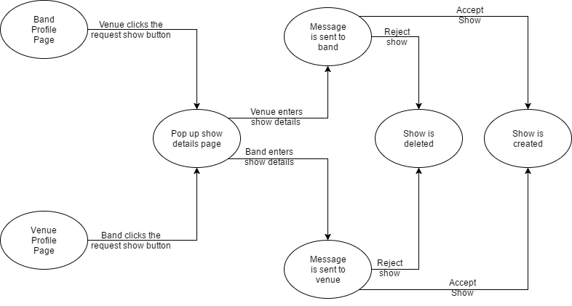

# 

# 

# Assumptions and Risks

## Assumptions:

* We are assuming that the users are running supported versions of Android and supported web browsers (current versions of Google Chrome, Mozilla Firefox, and Microsoft Edge)
* We are assuming that the Web servers are functioning when users are trying to access the web client.
* We are assuming that the SQL Server is functioning when users are trying to access the database.

## Risks

* SQL Injection in the Login field is always a concern.
* We are relying on the Google Maps API for our location services. If the service goes down or if they alter their Place IDs in a large update (there’s a warning in Google’s developer pages) the app will not function.
* Our statistics charts are also derived from an API, Google Charts. Utilizing another Google API comes with its own concerns about dependence.