Sex determination Pathway Analysis using Diallel Data
Point = Alison
PI Michelle Arbeitmann
co-PI Lauren

For RO1 due Feb 5 2012

Interested in pathway building around sex determination genes. Following 10 genes selected based on Bruce Baker:

dsx FBgn0000504
fl(2)d FBgn0000662
fru FBgn0004652
her FBgn0001185
ix FBgn0001276
msl-2 FBgn0005616
snf FBgn0003449
Sxl FBgn0003659
tra FBgn0003741
tra2 Fbgn0003742

**note that will probably have a few more added from Michelle...

Fit, CG8007, CR32998 rna , rox2, CR32665

SAS libnames:
Fru /mclab/Fru_network/sasdata
diallel /mclab/diallel
GCA /mclab/GCA compare paper/SAS/all_mel_results/assemble_mel_results

Generate dataset for sex determination pathway building

SAS program diallel_sex_det_path_build_v2.sas generates a premanent dataset (called fru.results_diallel_sex_det) of the above 10 sex determination genes from the Diallel = parental means (diallel.mean_female_parents.sas7bdat and diallel.mean_male_parents.sas7bdat). Since these 2 input datasets have results and probeuid's only, need to add annotation. I couldn't find correct annotation files in microarray_platform_information so ended up using gca.all_results.sas7bdat to 'create' one.

Genes selected based on presence of above name in 'gene' column

There are multiple fusionID for all but a few of these genes

added new variable 'gene_2 'that is a concatenation between gene and trans_num variable sot that each row is unique. Created new dataset (fru.diallel_sex_det_path_build.sas7bdat) for transposing. Transposed dataset called fru.flip_diallel_sex_det_path_build.sas7bdat

Input dataset = diallel.mean_female_parents.sas7bdat
diallel.mean_male_parents.sas7bdat
gca.all_results.sas7bdat
interim perm dataset= fru.results_diallel_sex_det.sas7bdat
fru.diallel_sex_det_path_build.sas7bdat
Output datasets= fru.flip_diallel_sex_det_path_build.sas7bdat

Decide whether to collapsing gene transcripts into fewer numbers where possible

SAS program diallele_sex_det_path_step2.sas first runs a proc corr between all combinations of transcripts in fru.flip_diallel_sex_det_path_build.sas7bdat to determine which transcripts are correlated. This information, along with known biological information and information from flybase, used to determine if possible to collapse transcripts into a fewer number.

Sxl: Highly correlated = Sxl_local1, Sxl_local4 Sxl_local6. Sxl_local2 and Sxl_local5 also correlated with Sxl_local1, Sxl_local_4 and Sxl_6. Sxl_local3 not correlated with any other Sxl. Sxl_local6 contains female specific fbtr# and Sxl_local5 contains male specific fbtr#. Given this information, I collapse into 3 groups:

Sxl_1a = Sxl_local1, Sxl_local4 and Sxl_local_6 ~female
Sxl_2a = Sxl_local2 and Sxl_local5 ~male
Sxl_3a= Sxl_local3 ~other

Sxl sex specific transcripts according to flybase
FBtr0100201 | CG18350-RB | m
FBtr0100203 | CG18350-RD | f
FBtr0100206 | CG18350-RF | m
FBtr0100208 | CG18350-RH | m
FBtr0100210 | CG18350-RJ | f
FBtr0100211 | CG18350-RK | m
FBtr0100212 | CG18350-RL | f

Fru: Fru_global1 highly correlated to fru_local1 and fru_local4. Fru_local1 is highly correlated to fru_global1, fru_local4, fru_local5 and fru_local6. Fru_local2 and fru_local3 are highly correlated with each other but not with anything else. Note that couldn't use flybase to separate male and female specific transcripts. Collapse fru into 2 groups:

Fru_1a = Fru_global1, fru_local1, fru_local4, fru_local_5 and fru_local6
fru_2a = Fru_local2 and fru_local3 ;

Fru sex specific transcripts according to flybase
FBtr0083645 | CG14307-RG | m
FBtr0083641 | CG14307-RB | m
FBtr0083643 | CG14307-RE | m
FBtr0301284 | CG14307-RN | m
FBtr0083644 | CG14307-RF | f
FBtr0083640 | CG14307-RH | f
FBtr0083642 | CG14307-RC | f

Dsx: According to flybase transcripts, dsx_local2 =- male. dsx_global1 is not correlated with dsx_local1 but is correlated with dsx_local2. dsx_local1 is correlated with dsx_local2. dsx_local2 is correlated with dsx_globa1 and with dsx_local1. Do not try and collapse.

dsx_local2 = ~male
dsx_local1 = ~female
dsx_global1 = both

Dsx sex specific transcripts according to flybase
Fbtr0081761 | CG11094-RC | f
FBtr0081760 | CG11094-RB | f
FBtr0081759 | CG11094-RA | m

Tra: Have 1 tra that contains both transcripts below.

Tra x sex specific transcripts according to flybase
Fbtr0075364 | CG16724-RA | f
FBtr0100244 | CG16724-RB | Not sex specific

Tra2: have 2 possible tra2's, both highly correlated and both contain male and non-sex specific transcripts. Collapse into 1 tra2

Tra2_1a = tra2_global1 and tra2_local1

Tra2 sex specific transcripts according to flybase
FBtr0089616 | CG10128-RE | m
FBtr0089615 | CG10128-RD | m
FBtr0089618 | CG10128-RB | Not sex specific
FBtr0089621 | CG10128-RG | Not sex specific
FBtr0089617 | CG10128-RA | Not sex specific
FBtr0089620 | CG10128-RF | Not sex specific
FBtr0089619 | CG10128-RC | Not sex specific

fl(2)d: both highly correlated but leave as 2

Collapse transcripts

SAS program sex_det_pathway_build_step3.sas carries out collapsing of appropriate genes identified in above step.

Datain = fru.flip_diallel_sex_det_path_build.sas7bdat
dataout = fru.diallel_collapse_both_sexes.sas7bdat

Proc corr and proc glm to identify components of sex determination pathway from diallele data.

Starting Structural Equation Models (JMF)

Male and female data were split so that they could be modeled separately and various structural equations were modeled diallele_sex_det_path_split_set_step3.sas
Datain = fru.diallel_collapse_both_sexes.sas7bdat
dataout = work.female_diallel_collapse.sas7bdat
work.male_diallel_collapse.sas7bdat

A large glm wih all of the factors were fit for both females and males. Factors were rotated through to determine what was significant. For example her would look like this.
proc glm data = female_diallel_collapse plots=none;
model
Fru_1a Fru_2a
Sxl_1a Sxl_2a Sxl_3a
Tra2_1a
dsx_global1 dsx_local2 dsx_local1
fl_2_d_global1 fl_2_d_local1
her_
ix_
msl_2_global1
snf_
tra_global1 = her_;
run; quit;

In summary of the information above provided by Alison, using information from flybase and our probes are are able to separate a few of the classes into female or male specific:

Female Factors | Male Factors
Sxl_1a | Sxl_2a
dsx_local1 | dsx_local2
 | msl_2_global1

Female Equations (Images exported from /mclab/Fru_network/reports/network_analysis/diallel_network_figures.svg):
Began by looking at SNF since SNF is at the top of the fru network. The partial correlations of SNF with all other factors resulted in (Sxl_1a, tra2_1a, fl(2)d_local1, and her) being significant. So these factors were tested using sequential sums of squares.

Example GLM statement:
proc glm data=female_diallel_collapse plots=none;
model her_ tra2_1a = sxl_1a snf_;
run;quit;

SNF (numbers == sequential SS pvalue, solid lines are set relationships, dotted are tested relationships)
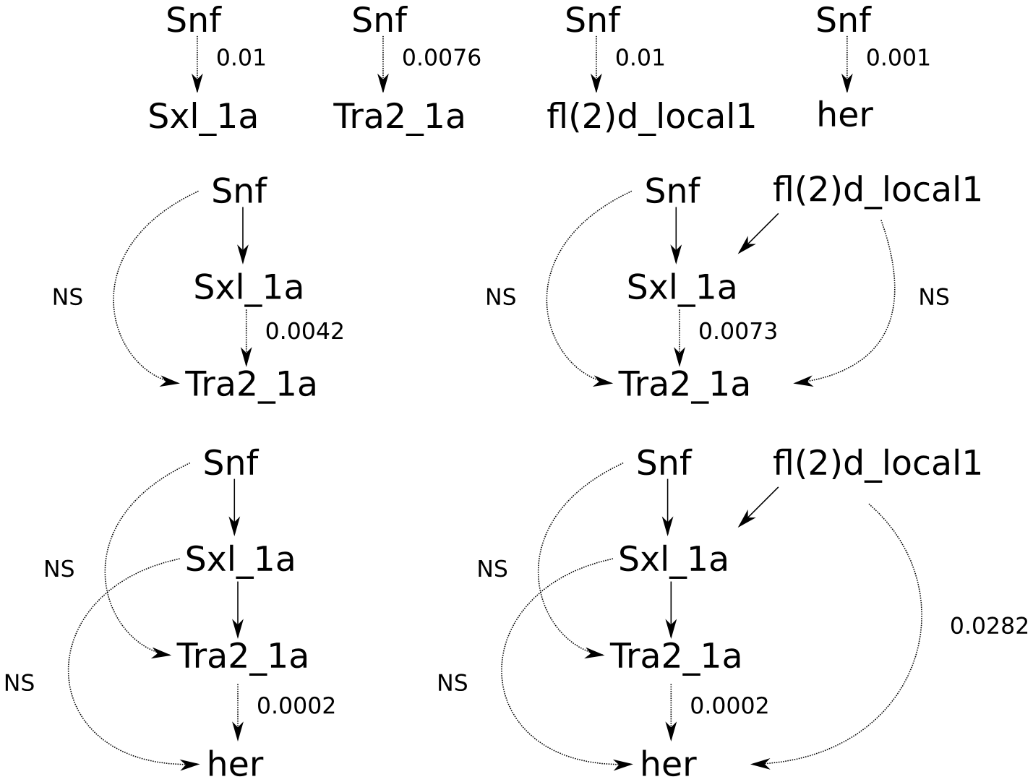
For these tests I ordered fl(2)d_local1 after SNF and before Sxl_1a. Interesting that in the bottom right figure fl(2)d_local1 remains significant to her even with the inclusion of tra2_1a. This suggests that there is unknown relationship of fl(2)d_local1 to her. Next focused on fl(2)d_local1 at the top of the pathway.

For fl(2)d_local1 the partial SS resulted in (Sxl_1a, Sxl_2a, tra_global1, tra2_1a, fl(2)d_global1, her, and SNF) being significant. Since I already looked at SNF above it was left out.

fl(2)d_local1 (numbers == sequential SS pvalue, solid lines are set relationships, dotted are tested relationships)

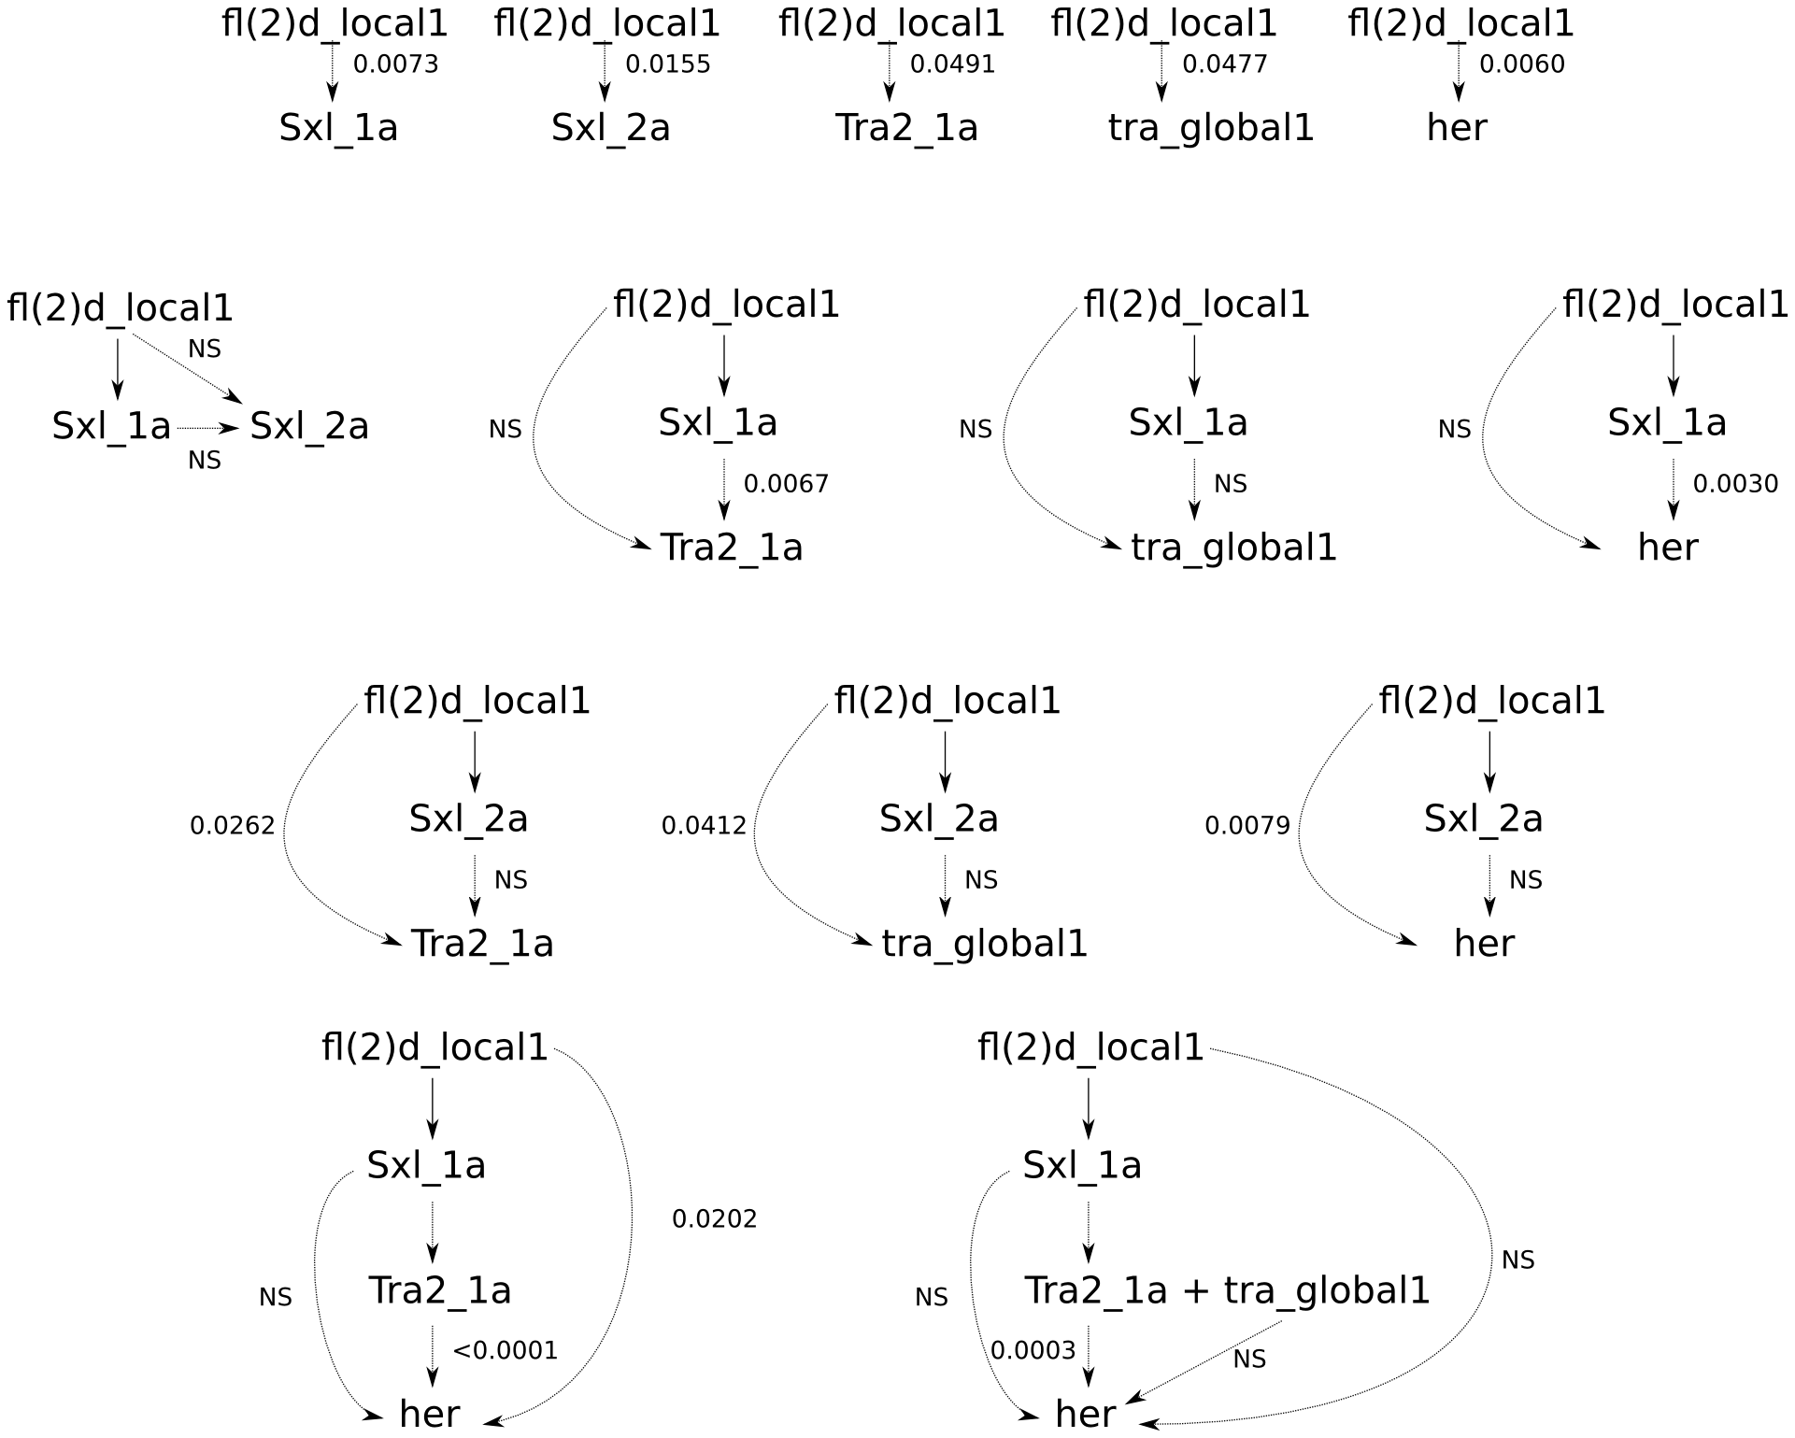
While Sxl_2a was associated with fl(2)d_local1, when included in the model it had no significance. This is expected because it is a male factor. In the bottom right figure depending on if you include tra_global1 before or after tra2_1a it will be significant.

