|  |
| --- |
| The SAS System |

The FREQ Procedure

|  |  |  |  |  |  |  |  |  |  |  |  |  |  |  |  |  |  |  |  |  |  |  |  |  |  |  |  |  |  |  |  |  |  |  |  |  |  |  |  |  |  |  |  |  |  |  |  |  |  |  |  |  |  |  |  |  |  |  |  |  |  |  |  |  |  |  |  |  |  |  |  |  |  |  |  |  |  |  |  |  |  |  |  |  |  |  |  |  |  |  |  |  |  |  |  |  |  |  |  |  |  |
| --- | --- | --- | --- | --- | --- | --- | --- | --- | --- | --- | --- | --- | --- | --- | --- | --- | --- | --- | --- | --- | --- | --- | --- | --- | --- | --- | --- | --- | --- | --- | --- | --- | --- | --- | --- | --- | --- | --- | --- | --- | --- | --- | --- | --- | --- | --- | --- | --- | --- | --- | --- | --- | --- | --- | --- | --- | --- | --- | --- | --- | --- | --- | --- | --- | --- | --- | --- | --- | --- | --- | --- | --- | --- | --- | --- | --- | --- | --- | --- | --- | --- | --- | --- | --- | --- | --- | --- | --- | --- | --- | --- | --- | --- | --- | --- | --- | --- | --- | --- | --- | --- |
| |  |  |  |  |  | | --- | --- | --- | --- | --- | | |  | | --- | | **Frequency** | | **Percent** | | **Row Pct** | | **Col Pct** | | | | **Table of flag_sig_line_m1 by flag_sig_line_m2** | | | | | | --- | --- | --- | --- | --- | | **flag_sig_line_m1** | **flag_sig_line_m2** | | | | | **0** | **1** | **2** | **Total** | | **0** | |  | | --- | | 8871 | | 79.16 | | 86.50 | | 94.55 | | |  | | --- | | 728 | | 6.50 | | 7.10 | | 78.11 | | |  | | --- | | 656 | | 5.85 | | 6.40 | | 73.54 | | |  | | --- | | 10255 | | 91.51 | |  | |  | | | **1** | |  | | --- | | 327 | | 2.92 | | 61.24 | | 3.49 | | |  | | --- | | 101 | | 0.90 | | 18.91 | | 10.84 | | |  | | --- | | 106 | | 0.95 | | 19.85 | | 11.88 | | |  | | --- | | 534 | | 4.77 | |  | |  | | | **2** | |  | | --- | | 184 | | 1.64 | | 44.12 | | 1.96 | | |  | | --- | | 103 | | 0.92 | | 24.70 | | 11.05 | | |  | | --- | | 130 | | 1.16 | | 31.18 | | 14.57 | | |  | | --- | | 417 | | 3.72 | |  | |  | | | **Total** | |  | | --- | | 9382 | | 83.72 | | |  | | --- | | 932 | | 8.32 | | |  | | --- | | 892 | | 7.96 | | |  | | --- | | 11206 | | 100.00 | | | **Frequency Missing = 858** | | | | | |

Statistics for Table of flag_sig_line_m1 by flag_sig_line_m2

| **Test of Symmetry** | |
| --- | --- |
| **Statistic (S)** | 417.6801 |
| **DF** | 3 |
| **Pr > S** | <.0001 |

| **Kappa Statistics** | | | | |
| --- | --- | --- | --- | --- |
| **Statistic** | **Value** | **ASE** | **95% Confidence Limits** | |
| **Simple Kappa** | 0.1725 | 0.0098 | 0.1533 | 0.1917 |
| **Weighted Kappa** | 0.2060 | 0.0111 | 0.1843 | 0.2278 |

Effective Sample Size = 11206  
Frequency Missing = 858

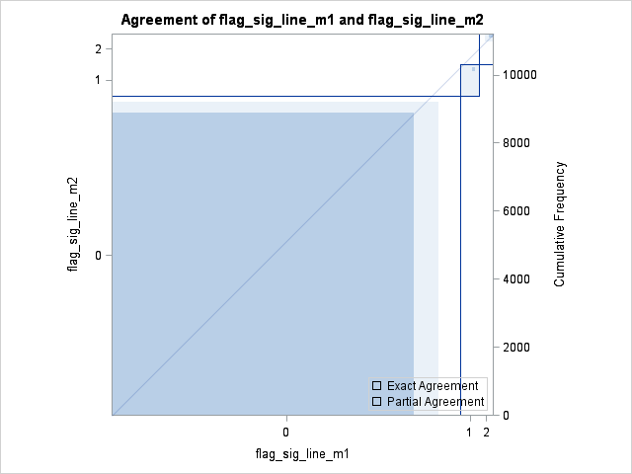

|  |  |  |  |  |  |  |  |  |  |  |  |  |  |  |  |  |  |  |  |  |  |  |  |  |  |  |  |  |  |  |  |  |  |  |  |  |  |  |  |  |  |  |  |  |  |  |  |  |  |  |  |  |  |  |  |  |  |  |  |  |  |  |  |  |  |  |  |  |  |  |  |  |  |  |  |  |  |  |  |  |  |  |  |  |  |  |  |  |  |  |  |  |  |  |  |  |  |  |  |  |  |
| --- | --- | --- | --- | --- | --- | --- | --- | --- | --- | --- | --- | --- | --- | --- | --- | --- | --- | --- | --- | --- | --- | --- | --- | --- | --- | --- | --- | --- | --- | --- | --- | --- | --- | --- | --- | --- | --- | --- | --- | --- | --- | --- | --- | --- | --- | --- | --- | --- | --- | --- | --- | --- | --- | --- | --- | --- | --- | --- | --- | --- | --- | --- | --- | --- | --- | --- | --- | --- | --- | --- | --- | --- | --- | --- | --- | --- | --- | --- | --- | --- | --- | --- | --- | --- | --- | --- | --- | --- | --- | --- | --- | --- | --- | --- | --- | --- | --- | --- | --- | --- | --- |
| |  |  |  |  |  | | --- | --- | --- | --- | --- | | |  | | --- | | **Frequency** | | **Percent** | | **Row Pct** | | **Col Pct** | | | | **Table of flag_sig_line_m1 by flag_sig_line_m7** | | | | | | --- | --- | --- | --- | --- | | **flag_sig_line_m1** | **flag_sig_line_m7** | | | | | **0** | **1** | **2** | **Total** | | **0** | |  | | --- | | 7229 | | 79.70 | | 86.88 | | 94.60 | | |  | | --- | | 568 | | 6.26 | | 6.83 | | 78.67 | | |  | | --- | | 524 | | 5.78 | | 6.30 | | 74.22 | | |  | | --- | | 8321 | | 91.74 | |  | |  | | | **1** | |  | | --- | | 273 | | 3.01 | | 64.08 | | 3.57 | | |  | | --- | | 73 | | 0.80 | | 17.14 | | 10.11 | | |  | | --- | | 80 | | 0.88 | | 18.78 | | 11.33 | | |  | | --- | | 426 | | 4.70 | |  | |  | | | **2** | |  | | --- | | 140 | | 1.54 | | 43.34 | | 1.83 | | |  | | --- | | 81 | | 0.89 | | 25.08 | | 11.22 | | |  | | --- | | 102 | | 1.12 | | 31.58 | | 14.45 | | |  | | --- | | 323 | | 3.56 | |  | |  | | | **Total** | |  | | --- | | 7642 | | 84.26 | | |  | | --- | | 722 | | 7.96 | | |  | | --- | | 706 | | 7.78 | | |  | | --- | | 9070 | | 100.00 | | | **Frequency Missing = 2994** | | | | | |

Statistics for Table of flag_sig_line_m1 by flag_sig_line_m7

| **Test of Symmetry** | |
| --- | --- |
| **Statistic (S)** | 325.5565 |
| **DF** | 3 |
| **Pr > S** | <.0001 |

| **Kappa Statistics** | | | | |
| --- | --- | --- | --- | --- |
| **Statistic** | **Value** | **ASE** | **95% Confidence Limits** | |
| **Simple Kappa** | 0.1670 | 0.0110 | 0.1455 | 0.1885 |
| **Weighted Kappa** | 0.2020 | 0.0125 | 0.1775 | 0.2265 |

Effective Sample Size = 9070  
Frequency Missing = 2994

WARNING: 25% of the data are missing.

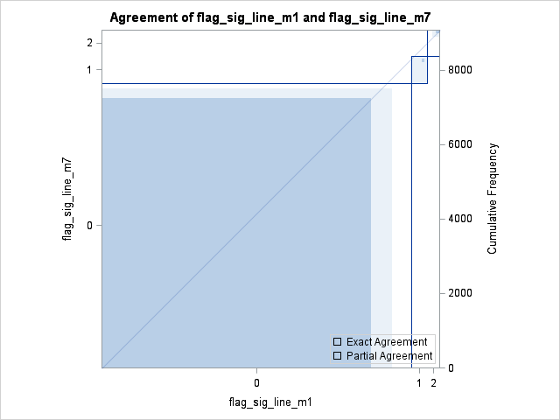

|  |  |  |  |  |  |  |  |  |  |  |  |  |  |  |  |  |  |  |  |  |  |  |  |  |  |  |  |  |  |  |  |  |  |  |  |  |  |  |  |  |  |  |  |  |  |  |  |  |  |  |  |  |  |  |  |  |  |  |  |  |  |  |  |  |  |  |  |  |  |  |  |  |  |  |  |  |  |  |  |  |  |  |  |  |  |  |  |  |  |  |  |  |  |  |  |  |  |  |  |  |  |
| --- | --- | --- | --- | --- | --- | --- | --- | --- | --- | --- | --- | --- | --- | --- | --- | --- | --- | --- | --- | --- | --- | --- | --- | --- | --- | --- | --- | --- | --- | --- | --- | --- | --- | --- | --- | --- | --- | --- | --- | --- | --- | --- | --- | --- | --- | --- | --- | --- | --- | --- | --- | --- | --- | --- | --- | --- | --- | --- | --- | --- | --- | --- | --- | --- | --- | --- | --- | --- | --- | --- | --- | --- | --- | --- | --- | --- | --- | --- | --- | --- | --- | --- | --- | --- | --- | --- | --- | --- | --- | --- | --- | --- | --- | --- | --- | --- | --- | --- | --- | --- | --- |
| |  |  |  |  |  | | --- | --- | --- | --- | --- | | |  | | --- | | **Frequency** | | **Percent** | | **Row Pct** | | **Col Pct** | | | | **Table of flag_sig_line_m2 by flag_sig_line_m7** | | | | | | --- | --- | --- | --- | --- | | **flag_sig_line_m2** | **flag_sig_line_m7** | | | | | **0** | **1** | **2** | **Total** | | **0** | |  | | --- | | 7640 | | 84.23 | | 100.00 | | 99.97 | | |  | | --- | | 0 | | 0.00 | | 0.00 | | 0.00 | | |  | | --- | | 0 | | 0.00 | | 0.00 | | 0.00 | | |  | | --- | | 7640 | | 84.23 | |  | |  | | | **1** | |  | | --- | | 2 | | 0.02 | | 0.28 | | 0.03 | | |  | | --- | | 718 | | 7.92 | | 99.72 | | 99.45 | | |  | | --- | | 0 | | 0.00 | | 0.00 | | 0.00 | | |  | | --- | | 720 | | 7.94 | |  | |  | | | **2** | |  | | --- | | 0 | | 0.00 | | 0.00 | | 0.00 | | |  | | --- | | 4 | | 0.04 | | 0.56 | | 0.55 | | |  | | --- | | 706 | | 7.78 | | 99.44 | | 100.00 | | |  | | --- | | 710 | | 7.83 | |  | |  | | | **Total** | |  | | --- | | 7642 | | 84.26 | | |  | | --- | | 722 | | 7.96 | | |  | | --- | | 706 | | 7.78 | | |  | | --- | | 9070 | | 100.00 | | | **Frequency Missing = 2994** | | | | | |

Statistics for Table of flag_sig_line_m2 by flag_sig_line_m7

| **Test of Symmetry** | |
| --- | --- |
| **Statistic (S)** | 6.0000 |
| **DF** | 3 |
| **Pr > S** | 0.1116 |

| **Kappa Statistics** | | | | |
| --- | --- | --- | --- | --- |
| **Statistic** | **Value** | **ASE** | **95% Confidence Limits** | |
| **Simple Kappa** | 0.9976 | 0.0010 | 0.9957 | 0.9995 |
| **Weighted Kappa** | 0.9984 | 0.0007 | 0.9971 | 0.9997 |

Effective Sample Size = 9070  
Frequency Missing = 2994

WARNING: 25% of the data are missing.

