# Meta-Analysis

Metabolomics experiments have variations in sample acquisition, extraction, and data acquisition (Gouveia et al., 2021) with many large-scale experiments subdividing the samples into smaller batches of samples.

The meta-analysis tool uses metafor (Meta-Analysis Package for R (Viechtbauer, 2010) ) to calculate batch-level summary statistics and model estimates. We note that the version wrapped here for Galaxy has been tested using the standardized mean difference (SMD) to estimate the effect size, unbiased estimates of the sampling variance (UB) and a fixed effects (FE) model.

More details about the Metafor package can be found here:

Viechtbauer, W. (2010). Conducting meta-analyses in R with the metafor package. Journal of Statistical Software, 36(3), 1-48. https://doi.org/10.18637/jss.v036.i03

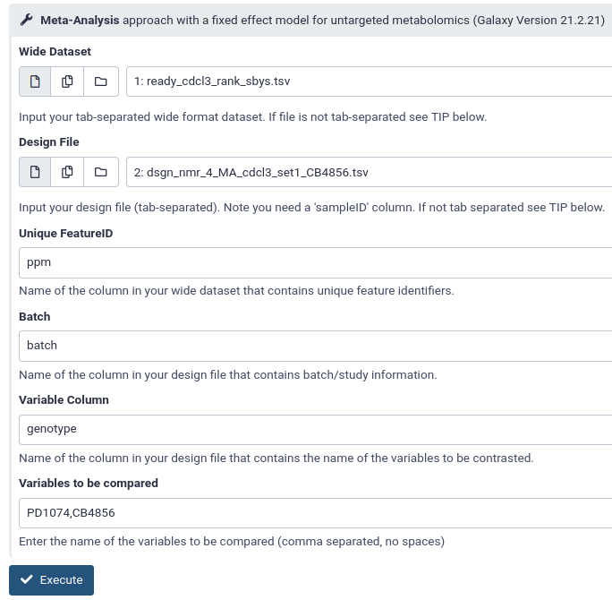

1. Select the **Wide Dataset** from the drop-down menu.
2. Select the **Design File** from the drop- down menu.
3. In the **Unique Feature ID** text box, type the name of the column in your **Wide Dataset** containing unique feature identifiers.
4. In the **Batch** text box, type the name of the column in your **Design File** that contains batch/study information.
5. Under the **Variable Column** text box, type the name of the column in your **Design File** that contains the name of the variable to be contrasted.
6. Under the **Variables to be Compared**, type the name of the variables to be compared (ie genotypes) separated by a comma (no spaces).
7. Click **Execute.**

**Output**

This tool outputs two files:

* A summary TSV file that contains the statistical metrics of the batch effect on the compared variables. It contains the following columns:
  + **Unique Feature ID**
  + **effect :** The calculated Effect Size (Standardized Mean Difference) between the experimental and control treatments
  + **se :** Corresponding Standard Errors
  + **z_value :**  test statistics
  + **p_value**
  + **ci_low :** lower bounds of confidence intervals
  + **ci_upper :** upper bounds of confidence intervals
* A TSV report file file containing a description of how much variability and heterogeneity has been calculated for each sample, and what the results of the Fixed-Effects model were.

Gouveia, G.J. et al. Long-Term Metabolomics Reference Material. *Anal Chem* **93**, 9193-9199 (2021).

# Add Group Rank

The Add Group Rank tool takes in a file in wide format and ranks the sample values from highest to lowest value, generating a new file containing the rankings. The user may have the values be ranked individually, or they may set a number of bins to group the ranked values into. For example, if there are 100 samples, and the user wants 10 bins, the tool will output a file with each of the 100 samples grouped into a ranking that ranges from 1-10 for each column.

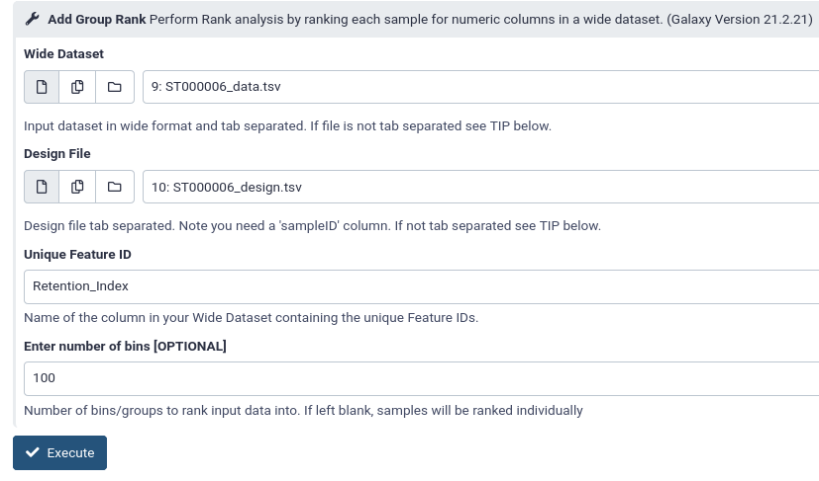

1. Select the **Wide Dataset** from the drop-down menu.
2. Select the **Design File** from the drop- down menu.
3. In the **Unique Feature ID** text box, type the name of the column in your **Wide Dataset** containing unique feature identifiers.
4. **[OPTIONAL] Enter the number of bins** to rank the sample values in the input dataset into.

**Output**

This tool outputs one file:

- A TSV file containing the rankings for each sample in a each column