**Use Case** (Write down a paragraph describing which users will use this program, and which actions they may have.)

The users for the Mastermind program consist of gamers and the game administrator. The user interacts with the program by entering characters onto the console. They either accept if they want to play the game or not, and input a certain number and sequence of peg colors to see if they inputted the right code. The game administrator can change the number of pegs the secret code will have, the type of colors in the game, and the number of chances the gamer gets to guess the secret code.

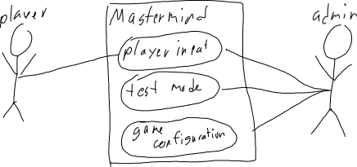

**Class Diagram**

There will be four classes, SecretCodeGenerator, GameConfiguration, Driver and Game. The Driver class will have the main method and will taken in a string array of arguments. If and only if the first argument is a 1, will the game be run in test mode. Test mode reveals the secret code at the start of the game to debug or examine if the code is working. Driver will also invoke the Game constructor. The Game class consists of all the variables needed to run the game, including but not limited to secret code, game colors, number of guesses, number of pegs, history of inputs, and whether if the code has been guessed or not. It will also include methods that will check if it is a valid guess, store the guess and it’s corresponding black and white pegs, getting the private variables, and a game reset. SecreCodeGenerator will create the secret code that the player needs to guess. The game configuration class dictates the colors, number of pegs, and the number of guess the player gets.

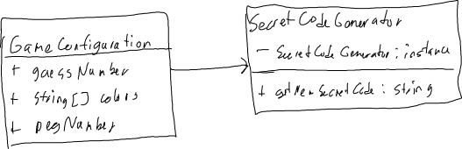

**Sequence Diagram/FlowChart**

