Mobile Programming
Shukirillaev Mukhammadsodik
Version 2

Questions |  | Outputs
1 | 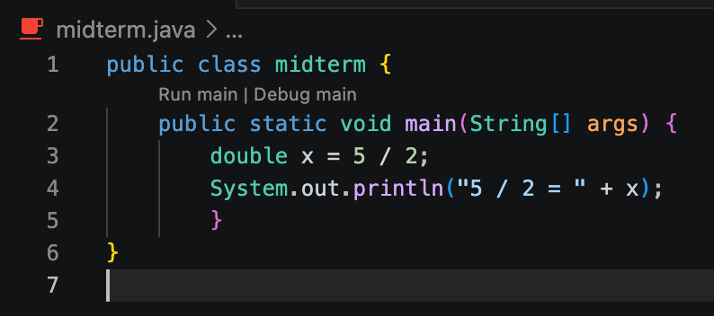 | 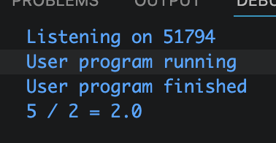 | The variable x will have the value 2.0, not 2.5.
2 | 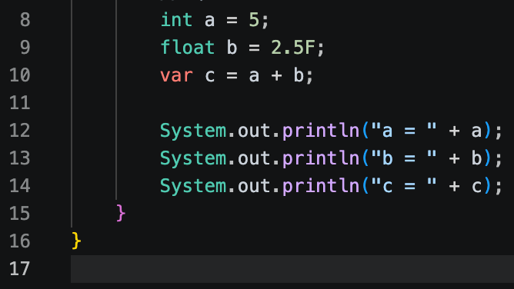 | 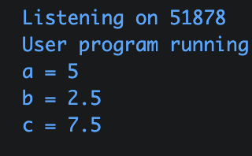 | When you add values of different numeric types, Java promotes the narrower type to the wider type
3 | Why String is immutable? | Once a String is created, Java just doesn't let you change it because strings get shared and reused under the hood, so if one thing changed it, everything else pointing to the same string would break. It's basically a safety thing.
4 | What is Unicode and why Java uses it? | Unicode is basically a universal standard that assigns a unique number to every character in every language so whether it's English, Arabic, Korean, or even emojis, they all have a code. Java uses it so your program can handle text from any language without things breaking, which makes sense since Java was built to run anywhere on any machine.
5 | 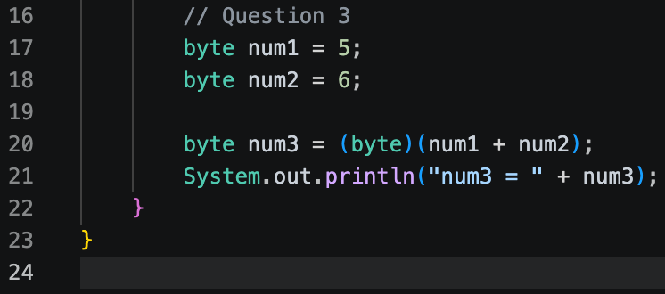 | 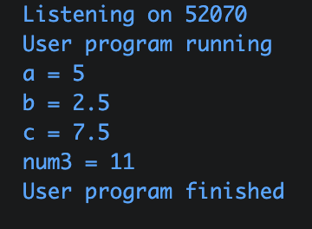 | Cannot assign int to byte
6 | What does indexOf() return? | It returns the index (position) of the first occurrence of a character or sub-string you're looking for and if it doesn't find it, it returns -1.
7 | Which storage is best for real-time sync? | Firestore (cloud based), it's the best for mobile apps, works seamlessly with both Android and iOS, and real-time listeners update your UI instantly whenever data changes.
8 | Difference between:  • local storage  • cloud storage | Local storage, data lives on the device (SQLite, SharedPreferences, Room), super fast, works offline, but gone if you uninstall or switch phones.  Cloud storage data lives on a server (Firestore, AWS, Supabase), accessible from anywhere, syncs across devices, but needs internet and costs money at scale.
Debugging Questions
9 | 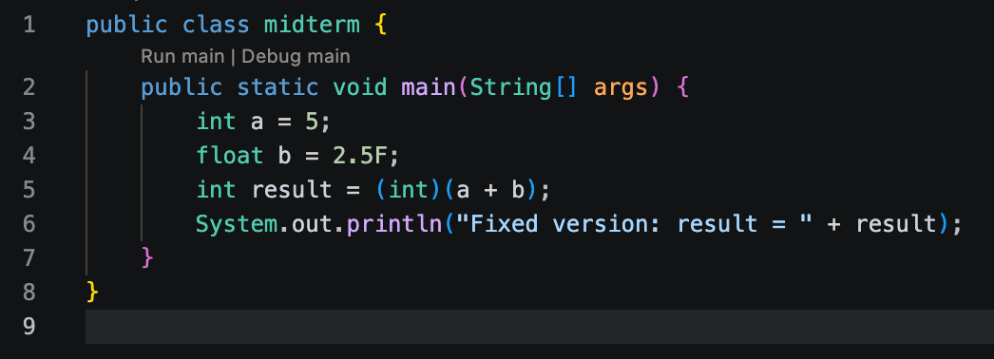 | 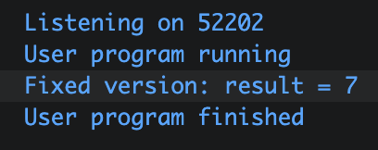 | The error is:  Cannot assign float to int
10 | 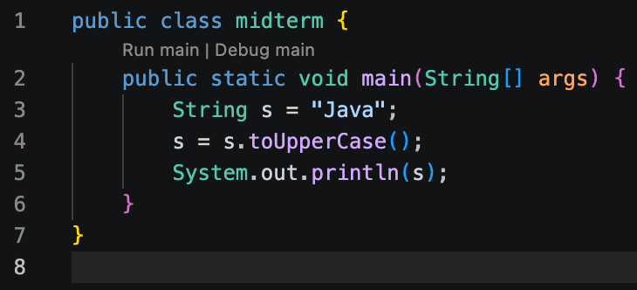 | 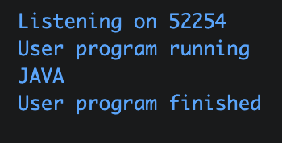 | The issue is: Strings are immutable in Java
11 | 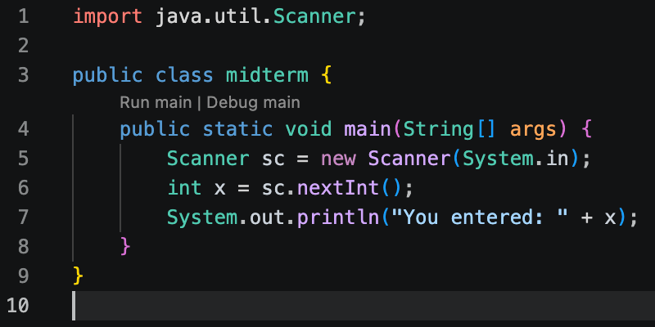 | The issue is missing import for Scanner.
12 | 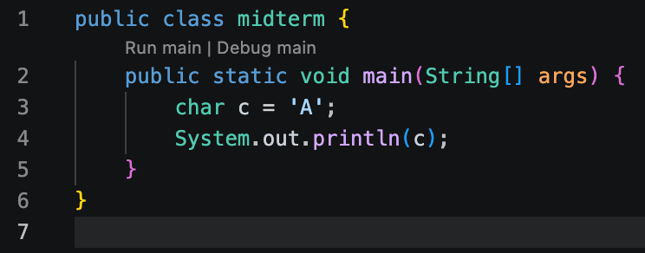 | 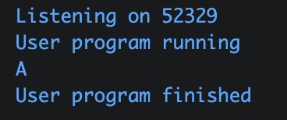 | Just needed a change for the double commas to single ones
13 | 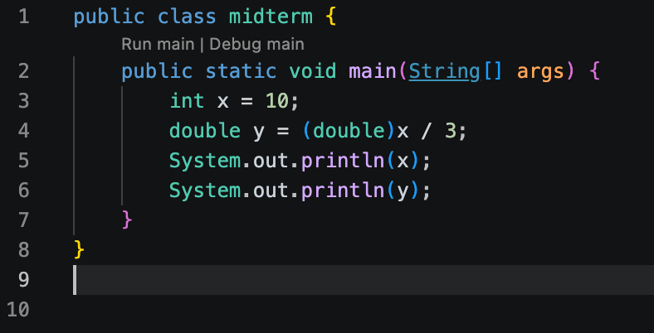 | 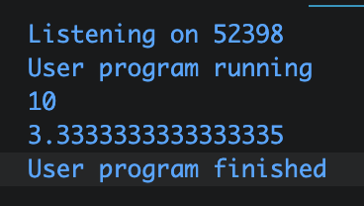 | There is no error. The x datatype is changing to double when assigning it to y
14 | 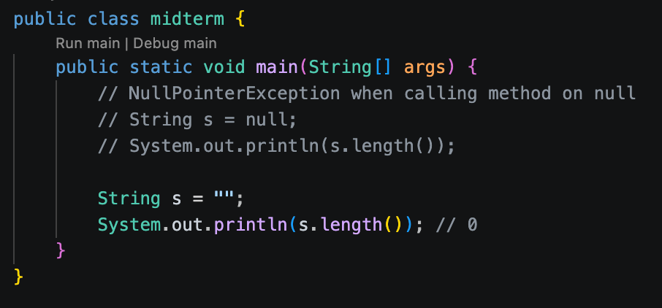 | 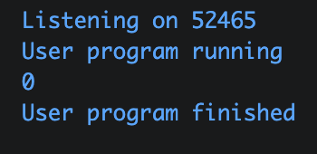 | null = 0, so in Java we should do it like this  <---
15 | 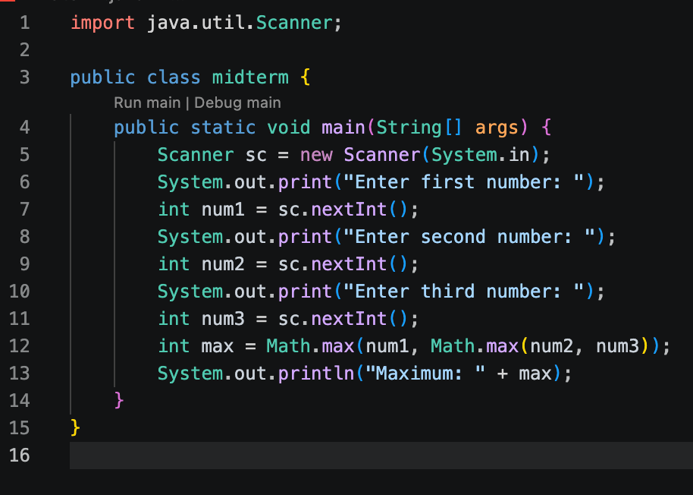 | 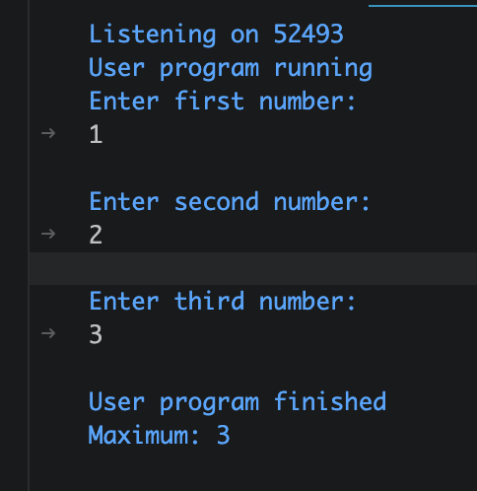 | Input 3 numbers  Print max
16 | 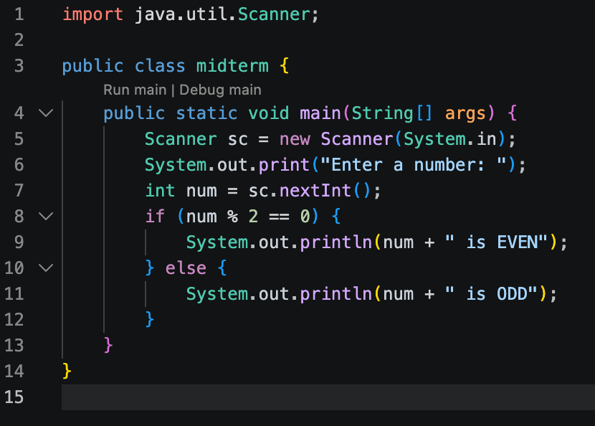 | 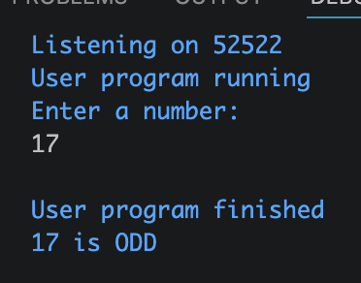 | Check if number is even or odd
17 | 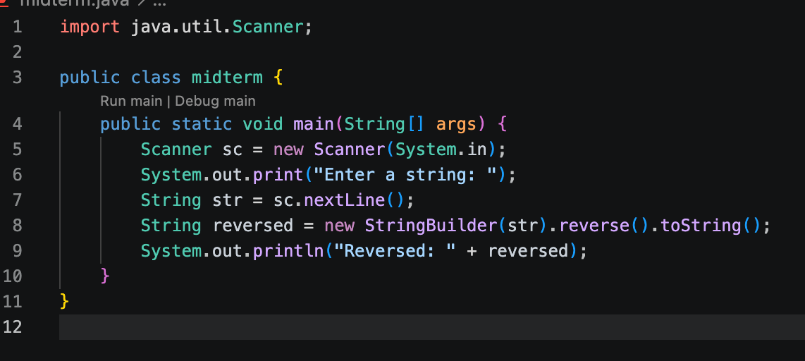 | 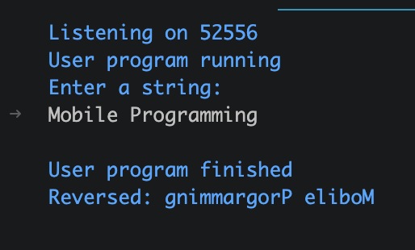 | Reversing a string
18 | 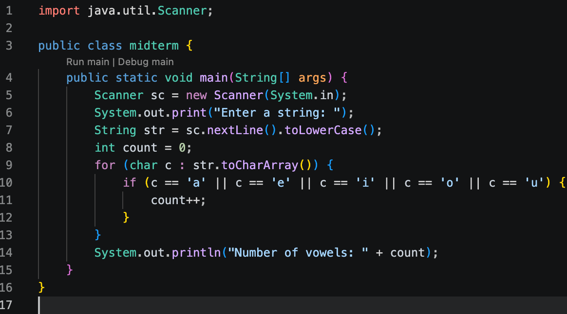 | 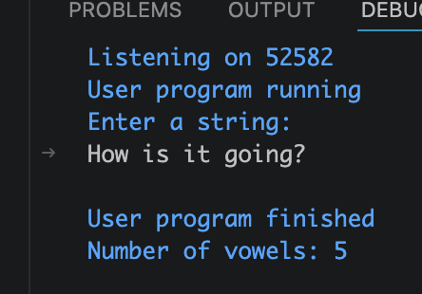 | Counting vowels
19 | 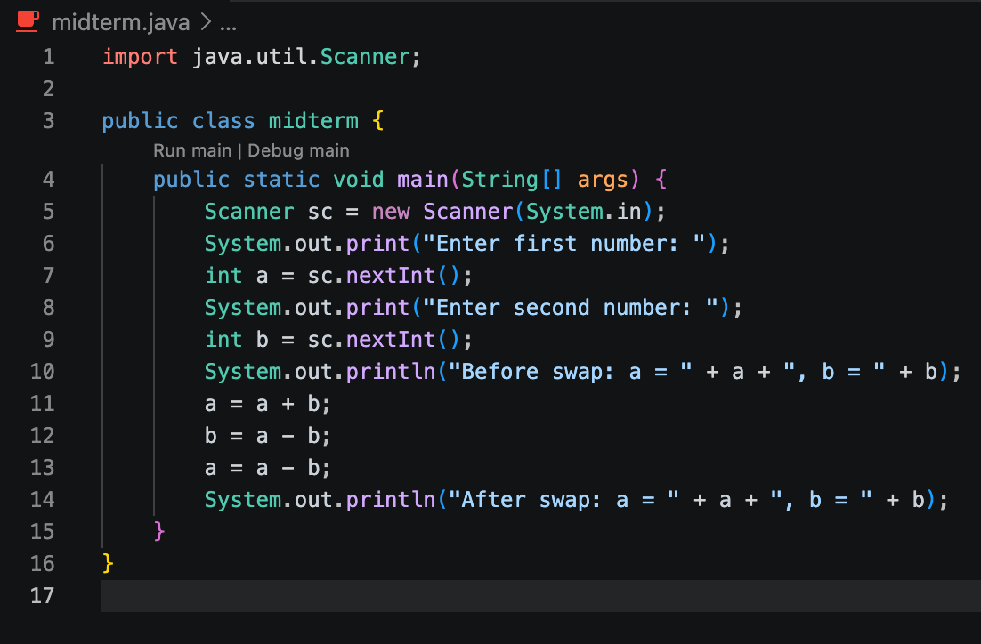 | 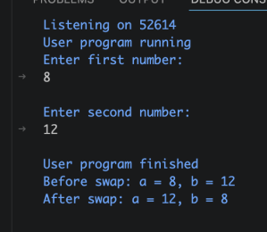 | Swapping without 3rd variable
20 | 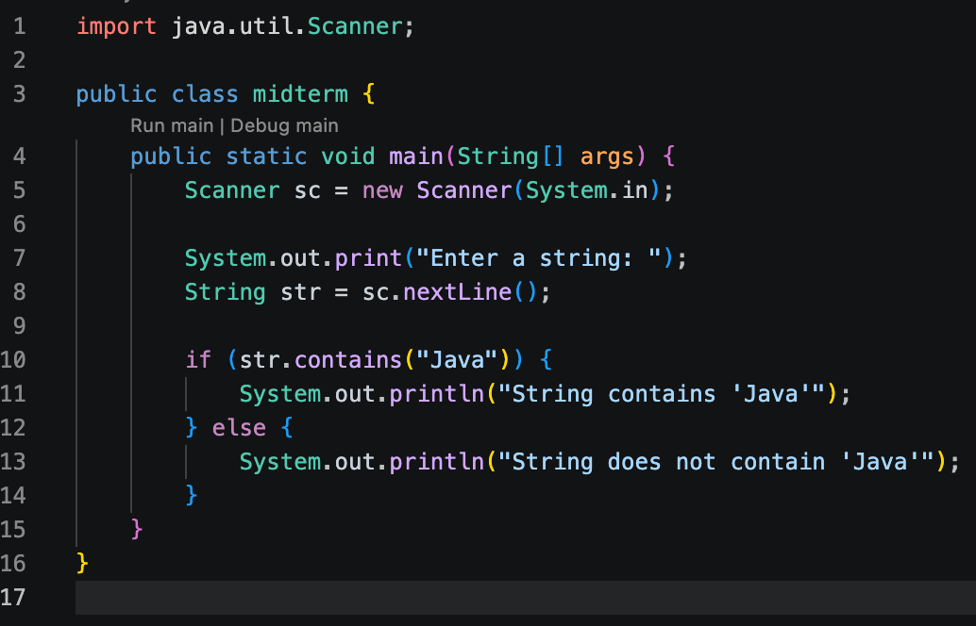 | 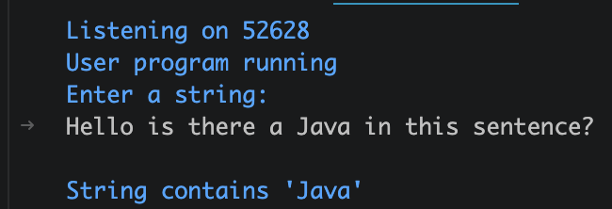 | If “Java” is in the string

