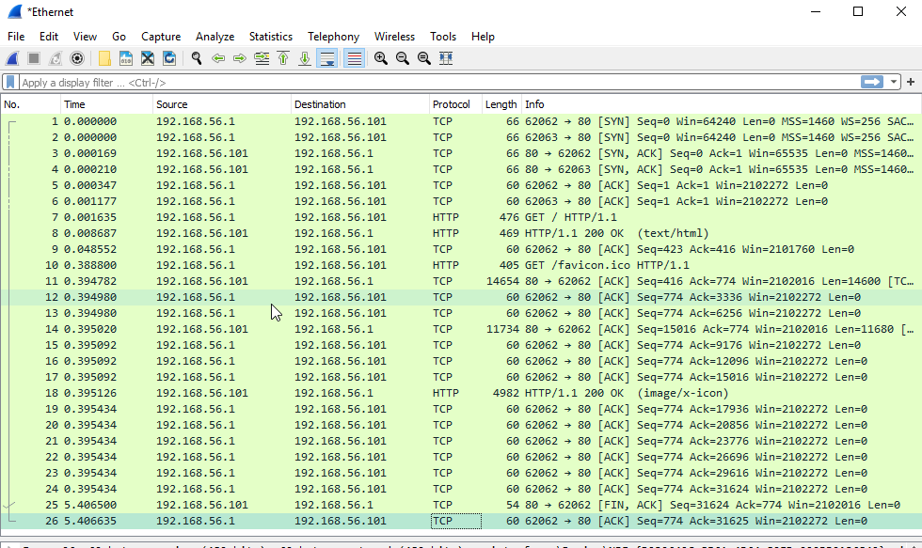

8)   WHAT IS THE FULL PATH OF DocumentRoot DIRECTORY ON YOUR WINDOWS 10 VM?

* C:\xampp\htdocs\index.html

9)   WHAT IS THE IP ADDRESS OF YOUR HOST COMPUTER (the lab computer), and HOW DID YOU FIND THIS INFORMATION?

* 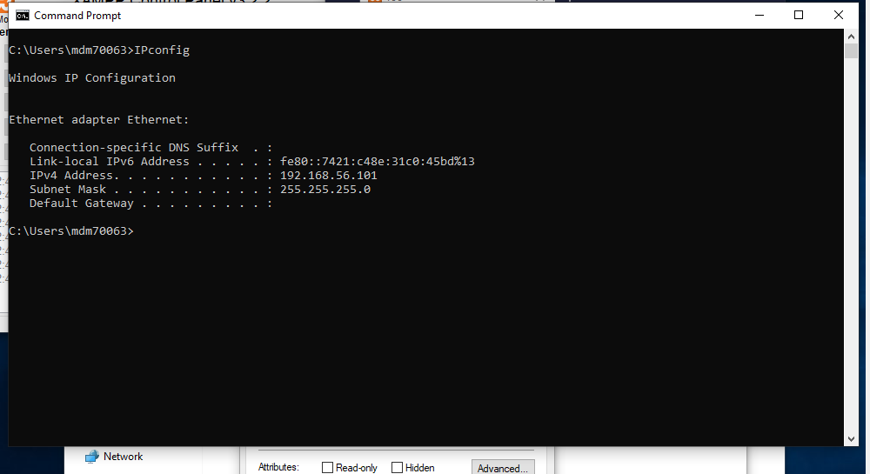

13)   IN THE TCP THREE-WAY HANDSHAKE THAT BEGINS THE EXCHANGE OF THIS WEB PAGE, WHICH IP ADDRESS INITIATES COMMUNICATION (sends the first packet)? Hence, we will refer to this as packet 0.

(Hint: The TCP Three-Way Handshake can be identified from the TCP Flags used in the first 2 packets… SYN, SYN/ACK)

* 192.168.56.1

14)   WHAT ARE THE INITIAL TCP SEQUENCE NUMBERS USED BY EACH SIDE OF THE WEB PAGE EXCHANGE?

* 0 and 1

15)   HOW MANY PACKETS INTO THE CONVERSATION (how many packets after “packet 0”) IS THE PACKET WHICH CONTAINS THE TEXT OF THE WEB PAGE index.html?

* seven

16)   a.   WHAT IS THE FIRST LINE OF THE HTTP HEADER IN THE PACKET WHICH CONTAINS THE TEXT OF THE WEB PAGE index.html?

* 

b.   DOES THIS LINE OF THE HEADER INDICATE SUCCESS OR FAILURE?

* success

17)   a.   HOW MANY PACKETS INTO THE CONVERSATION CONVERSATION (how many packets after “packet 0”) IS THE PACKET WHICH CONTAINS THE GET REQUEST FROM THE Host Computer TO THE Windows 10 VM?

* nine

b.   WHAT IS THE FIRST LINE OF THE GET REQUEST HTTP HEADER (starts with the word “GET”)?

* 

c.   WHAT TEXT IS IN THE “User-Agent” FIELD OF THIS HEADER? (What do you think this User-Agent field indicates?)

* 
* This tells you what os and web browser is used to view the HTML

18)   WHICH SIDE (Host Computer or Windows 10 VM) IS THE FIRST TO SIGNAL AN END TO THE CONVERSATION (in other words, sends the TCP Fin flag)?

* Windows VM signals first to end the conversation. IP 192.168.56.101

19)   WHAT ARE THE TCP FLAGS OF THE LAST PACKET SENT IN THE CONVERSATION? WHICH COMPUTER (Host or VM) SENDS THIS PACKET?

* 

20)   NOW THAT THE Windows 10 VM IS ON THE “INTERNAL NETWORKING,” OPEN A BROWSER INSIDE THE VM AND ACCESS http://www.csun.edu

DOES THIS SUCCEED? WHY OR WHY NOT?

* It will not work because there is no route from the VM to the internet.