# Title

Shaomei, Sam, Stefan, Sarah, Robin (if 16S), Josh (with code, maybe trees), Karthik, Rex, Tijana

# Abstract

# Introduction

# Results/Discussion

**Overview of Dataset**

205 metagenome assembled genomes (MAGs) were recovered from metagenomic time series in Trout Bog and Lake Mendota as described in Bendall, et al (Figure 1). These MAGs range in completeness from 50 to 99% complete and passed quality checks for contamination. 102 MAGs were recovered from Lake Mendota, a eutrophic lake in Madison, WI. Bacteroidetes and Actinobacteria comprise the highest numbers of MAGs in Lake Mendota. MAGs from the Trout Bog epilimnion and hypolimnion were assembled separately. 31 MAGs were recovered from the epilimnion, with Betaproteobacteria and Actinobacteria as the mostly frequently observed MAGs, while 69 MAGS were recovered from the hypolimnion. In the hypolimnion, Betaproteobacteria, Verrucomicrobia, Actinobacteria, and Bacteroidetes comprise the majority of MAGs. Several MAGs in the epilimnion and hypolimnion of Trout Bog appear to be from the same population based on high average nucleotide identities (supplemental). Other groups of interest found in this dataset are Planctomycetes, Cyanobacteria, and Tenericutes in Lake Mendota and Elusimicrobia, Saccharibacteria, and Ignavibacteria in Trout Bog. The phylogenetic distribution of MAGs is consistent with the classifications of metagenomic reads for each site, as quantified using Kraken (supplemental figure).

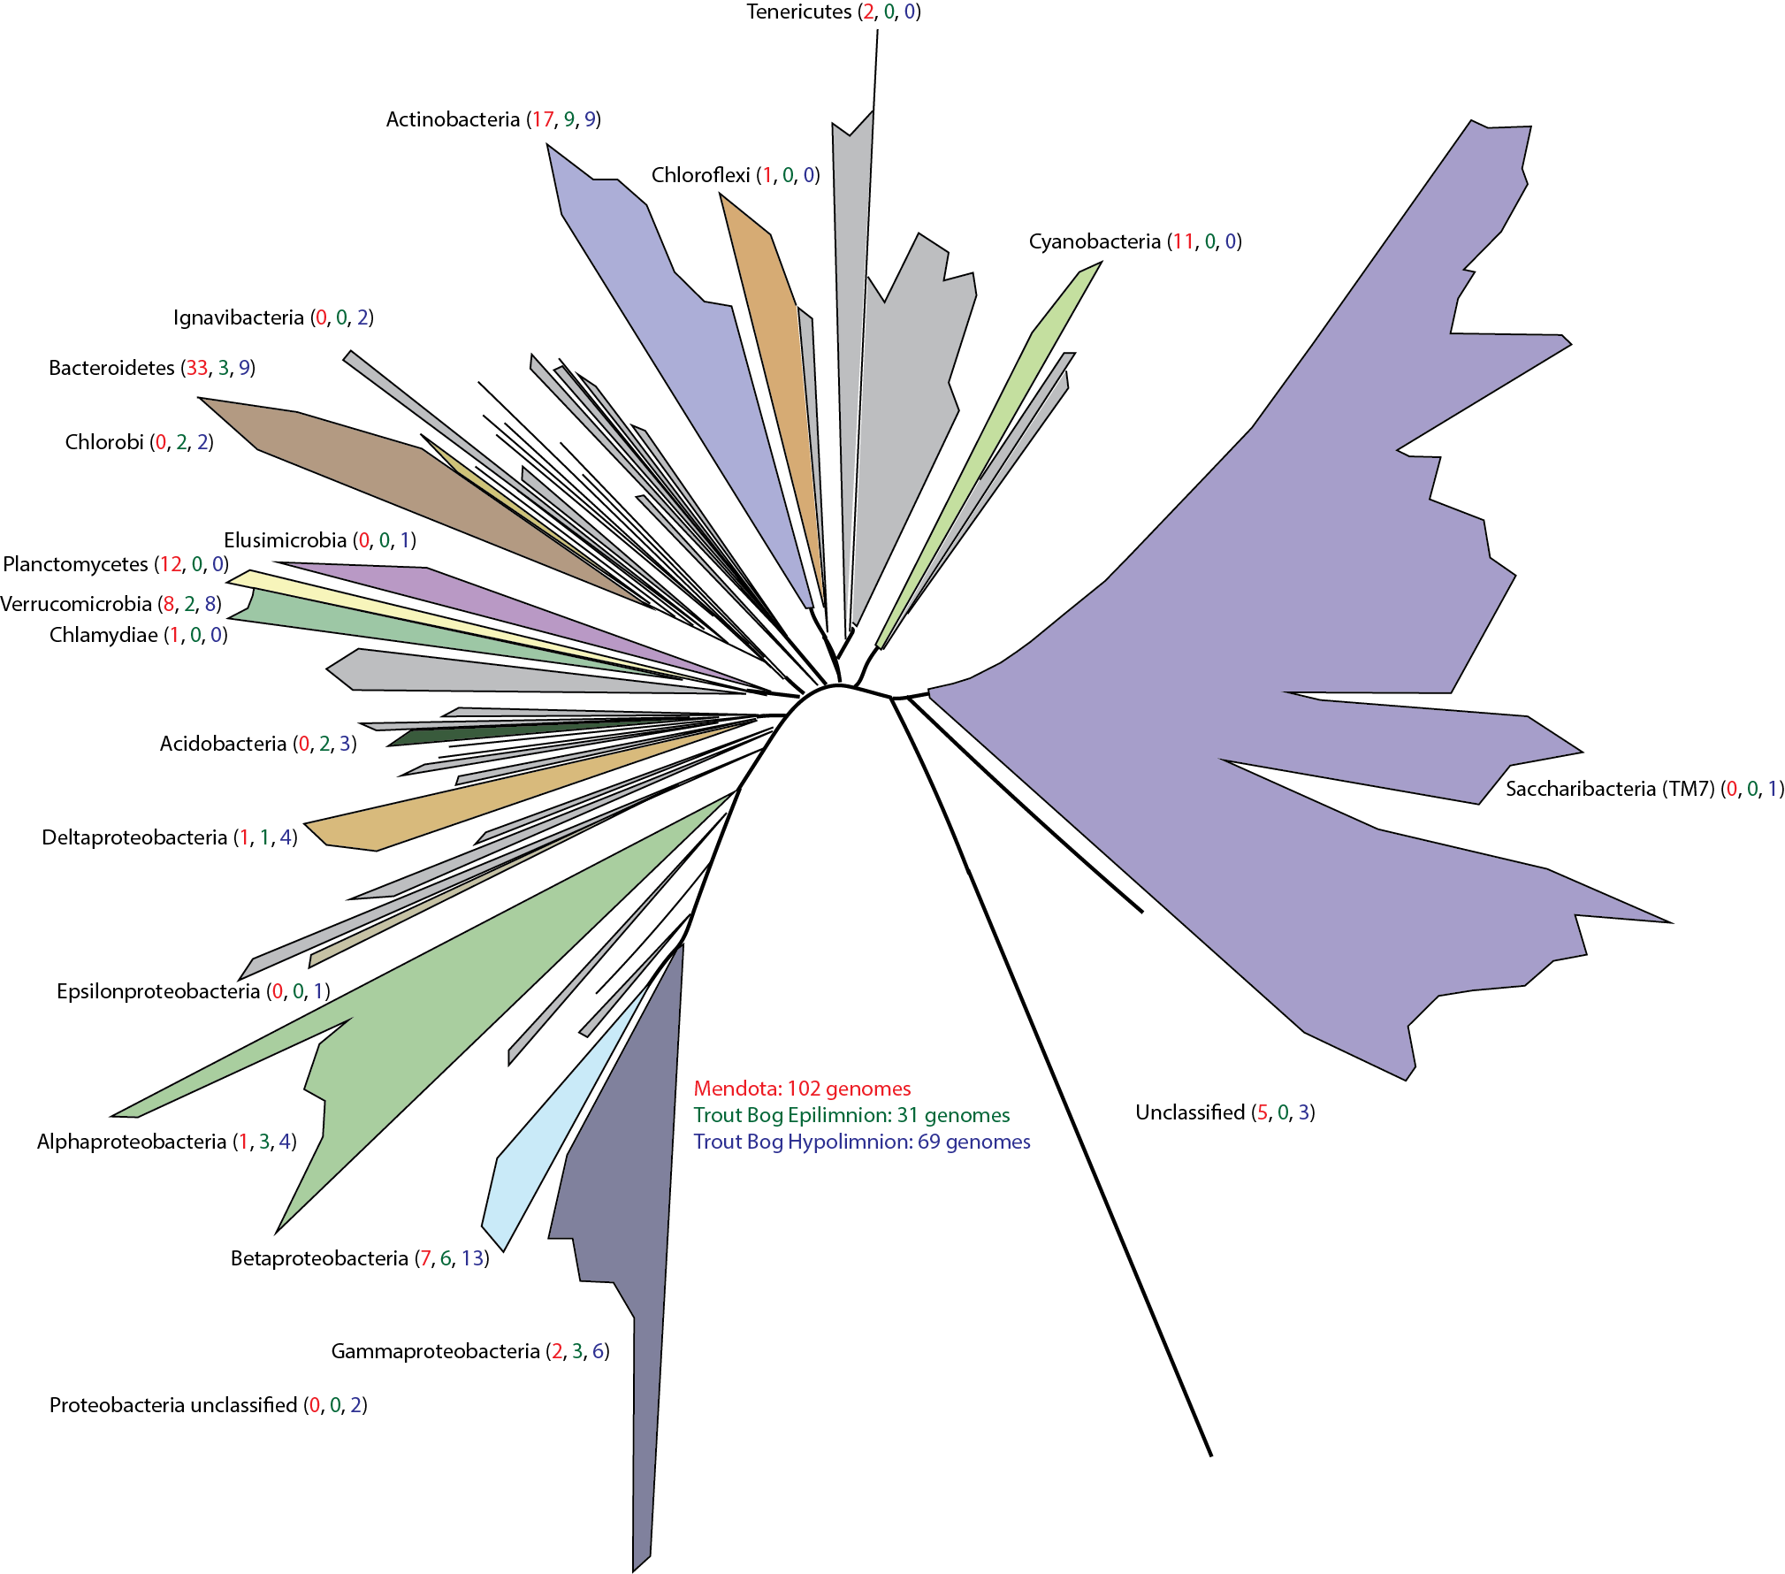

**Figure 1. Phylogeny of MAGs.** 205 MAGs were recovered from our freshwater metagenomic time series. The taxonomic classification of each MAG is overlaid on the tree of life adapted from Hug, et al. Colored branches indicate the presence of a MAG from that lineage, and colored numbers after the classification report how many MAGs were recovered from each site in the following order: Lake Mendota (red), Trout Bog epilimnion (green), and Trout Bog hypolimnion (blue).

## Photosynthesis and Carbon Cycling

Photosynthesis appears to play two major roles in both lakes. The first is primary production, where photoautotrophs fix carbon dioxide, making that carbon available to the heterotrophic community. Primary production in Lake Mendota is performed primarily by members of Cyanobacteria. These populations fix carbon using the Calvin-Benson-Bassham (CBB) pathway, as well as fix nitrogen and consume N-acetyl-glucosamine (NAG). In Trout Bog, Chlorobiales are responsible for primary production. These green sulfur bacteria also fix nitrogen and carbon. However, Chlorobiales in Trout Bog use the reductive TCA cycle to fix carbon, and use hydrogen sulfide as the electron donor for photosynthesis. Chlorobiales possess pathways for the degradation of ethanol, citrate, and a variety of sugars. A second primary producer found in Lake Mendota is a member of Burkholderiales. This population fixes carbon via the CBB pathway and uses anoxygenic photosynthesis. It can potentially degrade a large number of compounds including salicylate, citrate, ethanol, glycolate, and several sugars.

Photoheterotrophs, which use photosynthesis for energy generation rather than primary production, were also detected. In Lake Mendota, photoheterotrophs include Xanthomonadales and two populations of Lautropia. One Lautropia population possesses genes encoding a near complete type III secretion system and the pathways for degradation of salicylate and mannose, while the other encodes a handful of potential flagellar/secretion genes and pathways for degrading maltose. Both can oxidize sulfur. In Trout Bog, *Polynucleobacter necessarius* was found to be a photoheterotroph that can potentially degrade salicylate and glycolate. It reduces sulfur via the assimilatory pathway. The other photoheterotroph in Trout Bog is a purple non-sulfur bacterium in Comamonadaceae, classified as *Albidiferax*; however, this genus is defined by inability to photosynthesize, suggesting that this population may instead belong to the closely related *Rhodoferax*. This population potentially reduces nitrite, oxidizes sulfide, and degrades salicylate, glycolate, acetate, fructose, and galactose.

Another form of harvesting sunlight for energy is the use of light-activated proteins such as rhodopsins. Rhodopsins were observed in many phylogenetically diverse MAGs in both Trout Bog and Lake Mendota, and will be the subject of further study.

While not included in this analysis, eukaryotic algae are known photoautotrophs in both lakes. Algae are known to excrete sugars that fuel growth of the heterotrophic community. We observe many MAGs containing pathways for the degradation of glucose, galactose, mannose, xylose, and arabinose, all documented algal exudates in freshwater (cite).

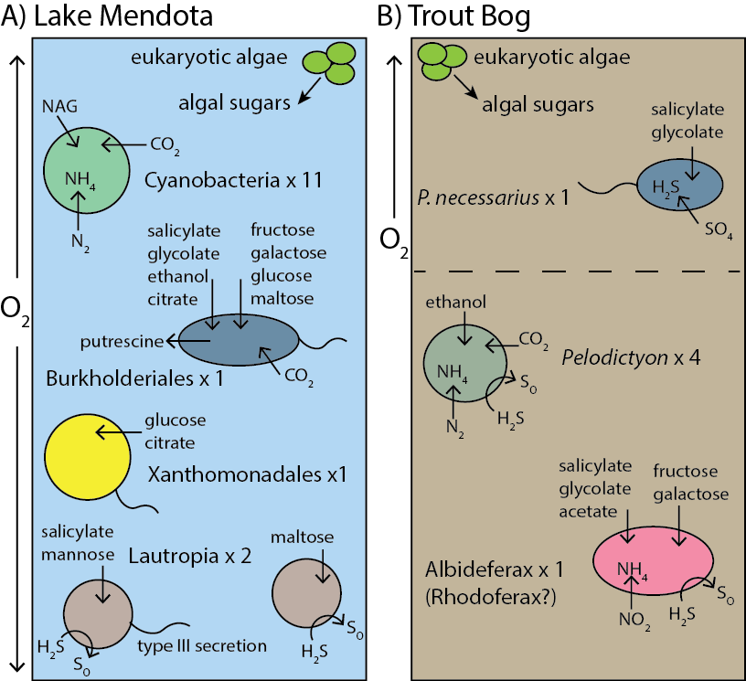.

**Figure 2. Photosynthesis in Lake Mendota and Trout Bog.** Both systems contain photoautotrophs and photoheterotrophs, but taxa and pathways vary between lakes. Lake Mendota phototrophs are aerobic and fix carbon via the RuBisCo enzyme, while Trout Bog phototrophs include anaerobes and fix carbon via the reductive TCA cycle. Both lakes host anoxygenic photosynthesis and a variety of photoheterotrophs.

## Degradation of Aquatic and Terrestrial Carbon

Many steps in the carbon cycle are shared between Trout Bog and Lake Mendota. As previously mentioned, algal sugars are a common carbon source, and photoautotrophs such as Cyanobacteria and Chlorobi fuel productivity. However, the taxa and pathways performing these processes are often different. Allocthonous, or terrestrial, carbon degradation is defined here as degradation of aromatic and cellulose-derived compounds. Because of differences in the surrounding landscape, the two lakes have different terrestrial carbon inputs. Lake Mendota’s terrestrial input is urban and agricultural, while Trout Bog receives large amounts of humic and fluvic acids from its surrounding mat of sphagnum. Members of Verrumicrobia, Bacteroidetes, and Burkholderiales degrade allochthonous carbon in both lakes. Tenericutes and Cyanobacteria degrade this type of carbon in Lake Mendota, while it is degraded by Gallionella, Solirubrobacterales, and Actinobacteria in Trout Bog. Both lakes contain pathways for the degradation of cellulose and aromatic compounds such as salicylate.

Another type of carbon degradation in freshwater is methylotrophy, the degradation of one carbon compounds such as methane, methanol, formaldehyde, or methylamines. Well-studied methylotrophs Methylococcales and Methylophilaceae are present in both lakes. Lake Mendota additionally contains methylotrophs belonging to Planctomyces and Rhodocyclaceae, while additional methylotrophs in Trout Bog include Burkholderiales, Rhizobiales, Nitrosomonadales, Geobacteraceae, and Solirubrobacterales.

A final carbon source to consider in freshwater is cannibalization of bacteria. A MAG from bacterial predator Bdellovibrionales was recovered from Trout Bog, and genes encoding pathways for the degradation of chitin, chitobiose, and NAG are widespread in both systems. Verrucomicrobia and Bacteroidetes can degrade these compounds in both lakes, while Lake Mendota additionally contains degraders from Cyanobacteria, Planctomyces, and Actinobacteria and Trout Bog contains degraders from Holophagales, Ignavibacteria, and Helicobacterales.

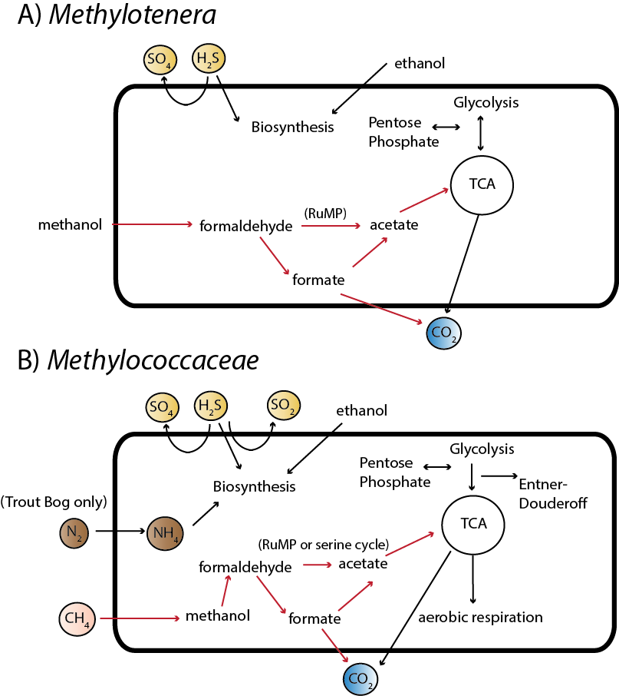

**Figure 3. Methylotrophy in freshwater.** *Methylococcaceae* and *Methylotenera* are taxa capable of methylotrophy in both Lake Mendota and Trout Bog. Methanol degradation by *Methylotenera* has been extensively studied in freshwater sediments; our genomes show similar pathways. *Methylococcaceae* also shows pathways consistent with cultured relatives.

**Nitrogen Cycling**

While carbon cycling is relatively similar between lakes, the drastically different concentrations of nitrogen in Trout Bog versus Mendota lead to altered nitrogen cycling. In Mendota, very few MAGs have the ability to fix nitrogen and they belong mainly to Cyanobacteria. Conversely, many MAGs in Trout Bog contain nitrogenase genes, and they are in phylogenetically diverse populations. Similarly, no MAGs were found in Lake Mendota with the genes for nitrification or denitrification, while many were found with both processes in Trout Bog.

Non-proteinogenic amino acids and polyamines have been suggested as a major pool of dissolved organic nitrogen in freshwater. Pathways for biosynthesis of putrescine, spermidine, and canavanine, as well as their corresponding transporters, were widespread in both lakes, supporting the importance of non-proteinogenic amino acids and amino acid derivatives in these systems.

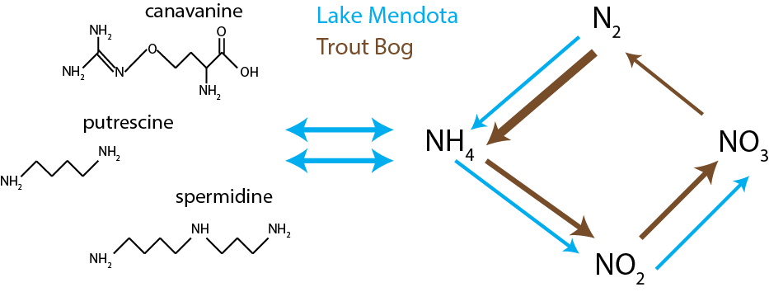

**Figure 4. Nitrogen cycling in Trout Bog and Lake Mendota.** Nitrogen fixation is found more frequently and in more phylogenetically diverse taxa than in Lake Mendota. Nitrification, while found in both lakes, is observed more frequently in Trout Bog, while no denitrification genes were found in MAGs from Lake Mendota. Many MAGs from both lakes contain genes encoding biosynthesis, degradation, and transport of non-proteinogenic amino acids and polyamines including canavanine, putrescine, and spermidine.

**Sulfur Cycling**

Sulfur cycling is again relatively similar between Trout Bog and Lake Mendota in broad functions, if not the taxa responsible. Assimilatory sulfates reduction (where sulfates are incorporated into cell components) was more common than dissimilatory sulfate reduction (where sulfate is used as a terminal electron acceptor and sulfide is expelled outside the cell) in both systems. More pathways for sulfide oxidation were found in Trout Bog than in Lake Mendota.

**Table 2. Sulfur cycling in Lake Mendota and Trout Bog.** Sulfur oxidation and reduction are found in both lakes. However, Lake Mendota contains more pathways for reduction than oxidation, while Trout Bog leans towards oxidation of reduced sulfur.

|  |  |  |
| --- | --- | --- |
|  | ME | TB |
| Sulfate reduction (assimilatory) | Planctomyces, Mycobacteraceae, Cyanobacteria, Verrucomicrobia, Sphingobacterales, unclassified, Acidimicrobiales, Rhodocyclaceae, Methylophilales, Methylococcales, Chloroflexi, Sphingomonadales, Chlamydiales, Burkholderiales, Xanthomonadales | Methylococcales, Verrucomicrobia, Burkholderiaceae, Chlorobiales, Methylophilaceae, Acidimicrobiaceae, Actinobacteria, Solibacterales, Helicobacteracaea, Sphingobacterales, Holophagales, Geobacteraceae, Ignavibacteriaceae, Bacteroidales |
| Sulfate reduction (dissimilatory) | None | Gallionellaceae, Desulfobacterales |
| Sulfide oxidation | Burkholderiales, Planctomyces, Rhodocyclaceae, Methylophilales, Acidimicrobia, Actinomycetales | Methylococcales, Burkholderiales, Chlorobi, Methylophilaceae, Actinobacteria, Holophagales, Helicobacteraceae, Sphingobacterales, Gallionellaceae, Solirubrobacterales, Ignavibacteraceae, Bacteroidales, Nitrosomonadales, Gammaproteobacteria |

**Unusual microbes**

Although our primary goal was to use genome content to investigate differences in nutrient cycling between lakes, we recovered the genomes of unusual micro-organisms in this process and report their genome content here. One MAG from Elusimicrobiales was recovered from Trout Bog. While this genome is only 44% complete, we can propose that uses sugars such as maltooligosaccharides, maltose, and arabinogalactan as a carbon source. This population of Elusimicrobiales reduces sulfate via the assimilatory pathway. It also contains one nitrogenase subunit, suggesting that it may be capable of fixing nitrogen.

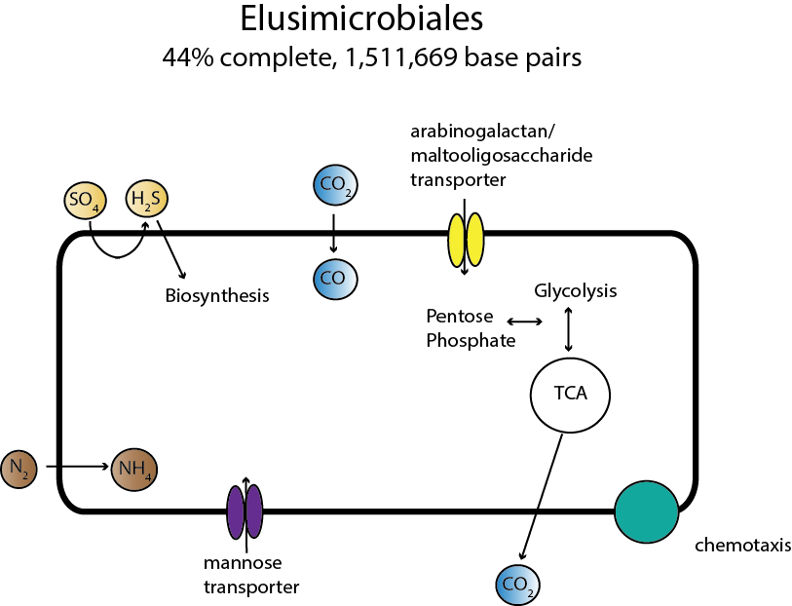

**Figure 5. Metabolism of Elusimicrobiales.**Members of Elusimicrobiales are likely ultra-small bacteria with limited metabolisms. We assembled one genome from this group and found that it likely degrades sugars such as mannose, arabinogalactan, or maltooligosaccharide. It reduces sulfate via the assimilatory pathway, and contains a single subunit of nitrogenase, suggesting that it can fix nitrogen. Several genes relating to chemotaxis were identified, but it is not clear what molecule would be detected.

Thirteen MAGs classified as Planctomycetes were recovered from Lake Mendota. A significant number of metagenomics reads in Lake Mendota were also classified as Planctomycetes, suggesting that this is an abundant group. While some Planctomycetes isolates have been known to perform anammox or degrade one-carbon compounds, no genes encoding the enzymes necessary for this pathway were found in the Lake Mendota MAGs. The gene content of a Planctomyces MAG from Trout Bog, however, suggested methylotrophy. The Plantcomycetes MAGs contained genes encoding glucoside hydrolases and sulfatase enzymes. These pathways could be used to break down complex polysaccharides, such as those produced by Cyanobacteria or eukaryotic algae. This suggests a new potential role for Planctomyces in freshwater as a specialist in polysaccharide degradation.

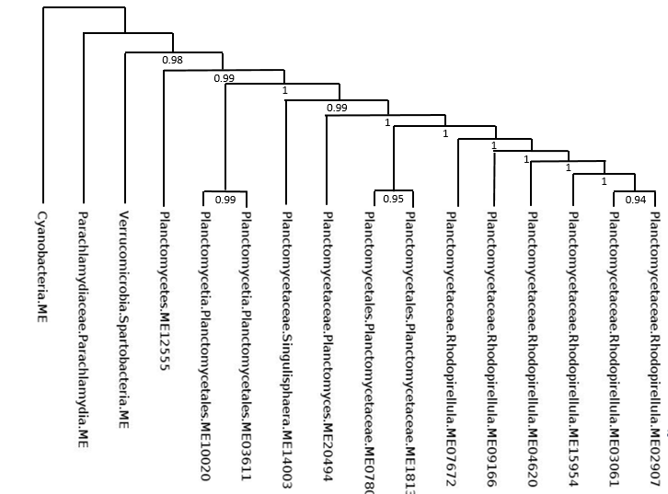

**Figure 6A.**

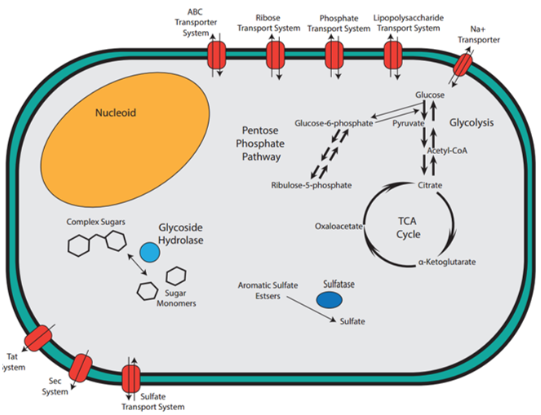

**Figure 6B. Proposed functions of Planctomycetes in freshwater.** Observation of genes annotated as glycoside hydrolases and sulfatases suggest a role for Planctomycetes as polysaccharide degraders.

Methods (last)