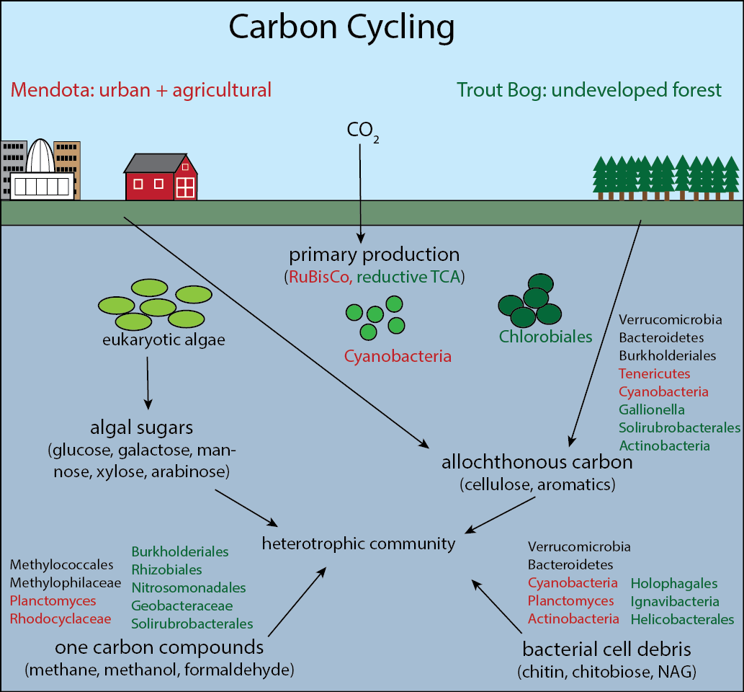**Figure 1. Carbon cycling in Lake Mendota and Trout Bog.** The carbon cycle in both lakes contains similar processes such as primary production, allocthonous carbon degradation, and methylotrophy. However, the taxa and pathways performing these processes are often different.

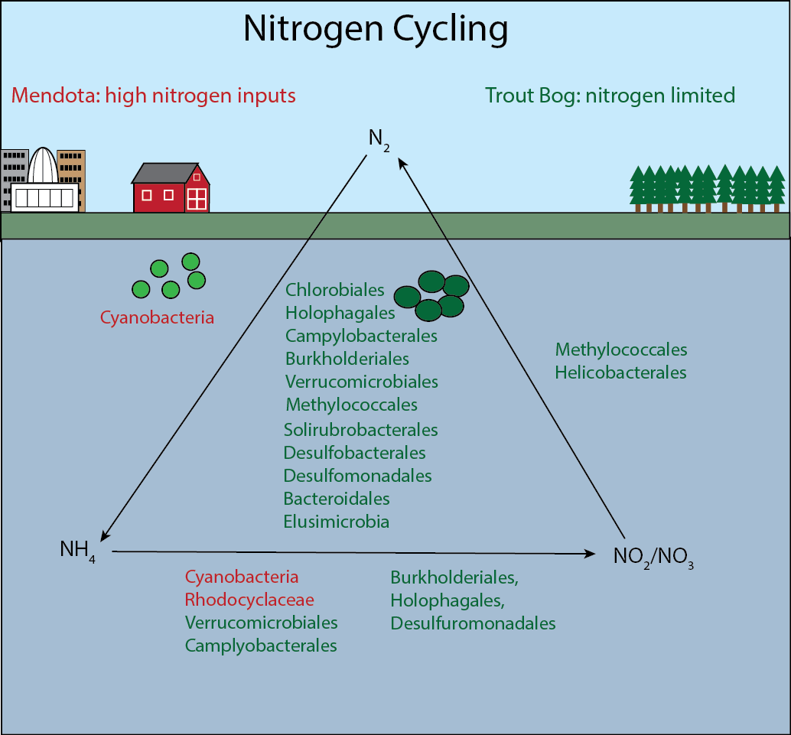**Figure 2. Nitrogen cycling in Lake Mendota and Trout Bog.** Trout Bog has a complete nitrogen cycle with many taxa participating. There are a large number of taxa capable of nitrogen fixation, consistent with the nitrogen limitation in this lake. Lake Mendota, which receives nitrogen from urban and agriculture run-off, has an incomplete nitrogen cycle mediated mainly by Cyanobacteria.

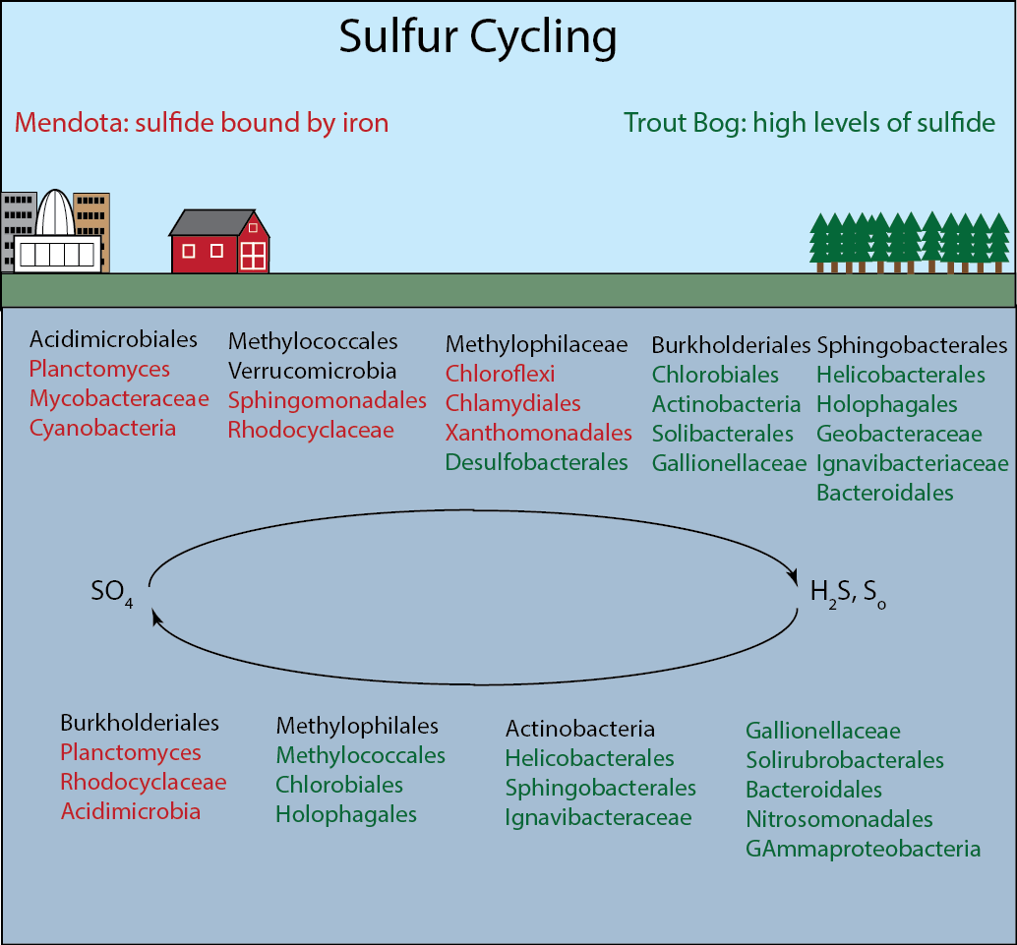**Figure 3. Sulfur cycling in Lake Mendota and Trout Bog.** Sulfur oxidation and reduction are found in both lakes. However, Lake Mendota contains more pathways for reduction than oxidation, while Trout Bog leans towards oxidation of reduced sulfur. This is consistent with what we know about the sulfur compounds in each lake.

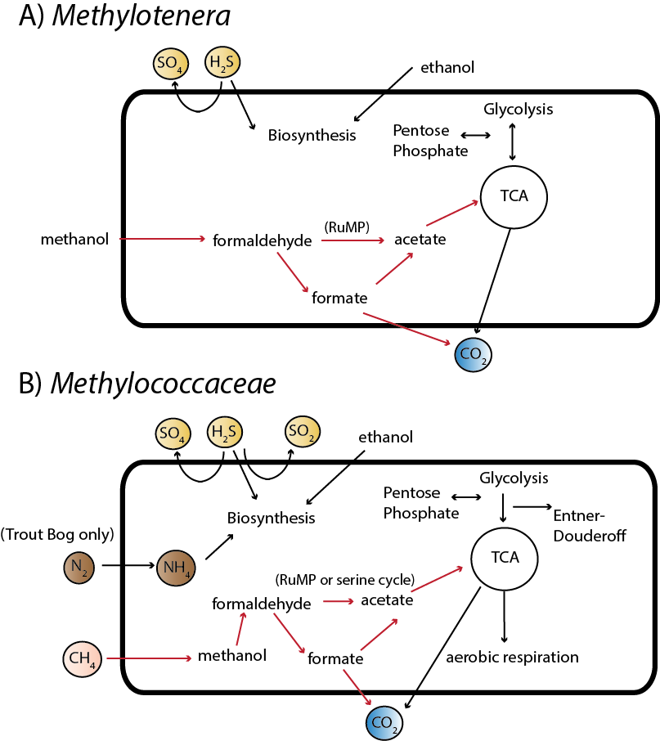

**Figure 4. Methylotrophy in freshwater.** *Methylococcaceae* and *Methylotenera* are taxa capable of methylotrophy in both Lake Mendota and Trout Bog. Methanol degradation by *Methylotenera* has been extensively studied in freshwater sediments; our genomes show similar pathways, with the exception that methylamine degradation was not detected in any genome. *Methylococcaceae* also shows pathways consistent with cultured relatives. Nitrogen fixation in this group is found only in Trout Bog, the nitrogen-limited system.

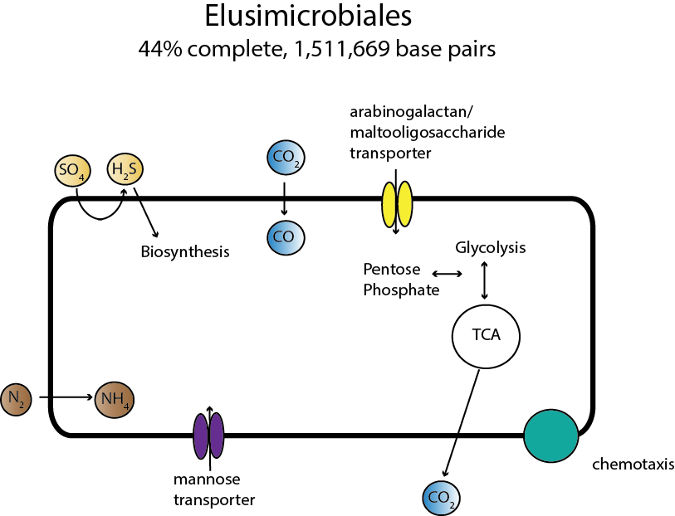

**Figure 5. Metabolism of Elusimicrobiales.**Members of Elusimicrobiales are likely ultra-small bacteria with limited metabolisms. We assembled one genome from this group and found that it likely degrades sugars such as mannose, arabinogalactan, or maltooligosaccharide. It reduces sulfate via the assimilatory pathway, and contains a single subunit of nitrogenase, suggesting that it can fix nitrogen. Several genes relating to chemotaxis were identified, but it is not clear what molecule would be detected.