# Building ecosystem functioning from bacterial populations

Alex Linz, JGI people, Katherine McMahon

## Introduction

* Importance of nutrient cycling in lake ecosystems

**Table 1. Characteristics of lakes included in this study.** Lake Mendota is eutrophic, meaning it has high levels of nitrogen and phosphorus. Trout Bog Lake is a humic lake or dystrophic, meaning it has high levels of dissolved organic carbon, largely in the form of humic acids.

|  |  |  |
| --- | --- | --- |
|  | Lake Mendota | Trout Bog Lake |
| Location | Madison, WI | Boulder Junction, WI |
| Depth | 25 meters | 7 meters |
| Surface Area | Really big | Really tiny |
| DOC range | Medium | High |
| TN/TDN range | High | Low |
| TP/TDP range | High | Low |

* How bacteria participate in freshwater nutrient cycles
* Eutrophic vs bog lakes
* We used MAGs to investigate genome-level differences between a eutrophic lake and a bog lake
* Advantages of genome level analysis are better phylogenetic assignment (can use Phylosift and set of core genes, rather than a single gene that may be frequently transferred or highly conserved) and can identify which genes are contained within the same population
* Disadvantages are incompleteness of genomes, we don’t have every single genome from the lake, no data on eukaryotes, and genomes are from populations rather than individuals

## Methods

* Sample collection
* Sequencing + JGI’s sequence analysis pipeline (mostly cite Sarah’s paper)
* Assembly
* Metapathways

## Results

Broad overview of dataset – how representative are our genomes? What else should go in an overview?



**Figure 1. Phylogenetic assignments of reads in metagenomes pooled by lake.** Even at the phylum level, differences in community composition are apparent in these two ecosystems. The phylogenetic distribution of our genomes is roughly consistent with the phylogenetic distribution of reads. (How can I represent that on the plots?)

1. Primary production
   1. Mendota has mainly Cyanobacteria, Trout Bog has mainly Chlorobi
   2. The Cyanobacteria use the CBB carbon fixation pathway while the Chlorobi use the reductive TCA cycle (more commonly seen in extreme environments) (well characterized in cultured Chlorobi)
   3. Aerobic anoxygenic photosynthesis? (No evidence for this occurring, sorry Trina)
2. One-carbon compound metabolism
   1. Methylococcales and Methylophilales found in both lakes
   2. Methylococcales consumes methane, also has nitrogen fixation. Methylophilales cannot use methylamines like previously cultivated strains
3. Nitrogen metabolism
   1. Nitrogen fixation is only found in Cyanobacteria in Mendota, but is phylogenetically widespread in Trout Bog
   2. Urea cycle is the most common method of acquiring nitrogen in both lakes
   3. Polyamine synthesis (putrescine and spermidine) common and widely distributed across taxa in both lakes
4. Polysaccharide degradation
   1. Cellulose degradation – Cyanobacteria in Mendota, Rickettsiales in Trout Bog. Not common in either lake. May be false positives.
   2. Bacteroidetes degrades chitin in both lakes
   3. Several starch degraders in Mendota and Trout Bog hypo, but not Trout Bog epi. Mainly Cyanobacteria, Bacteroidetes, and Verrucomicrobia.
   4. Polynucleobacter and other Burkholderiales may be using aromatic humic acids as carbon sources
5. Sulfur metabolism
   1. Sulfur reduction and thiosulfate disproportionation found in both lakes, in many taxa
   2. Sulfur oxidation rare in Mendota, common in Trout Bog

**Figure 2. Differences and similarities in pathway content between ecosystems.** Many similar functions, such as primary production or polysaccharide degradation, are shared between Lake Mendota and Trout Bog. However, these functions are performed by different bacterial taxa with subtle yet important differences such as the enzyme used or the oxygen relationships.

I just lifted this out of my poster. How can it be improved for a manuscript? Reduce the text info? Break up into smaller figures?

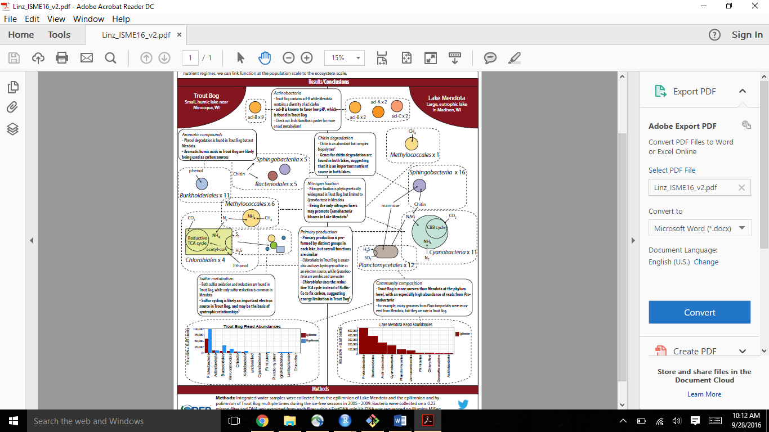

**Figure 3. Distribution of functions varies by lake.** Some functions are widely distributed among taxa, while others are confined to certain phylogenetic groups. How widely dispersed a trait is often differs by lake.

This is a mock-up tree of the intended figure. The final version will have three panels for TB epi, TB hypo, and Mendota, with a total of about 200 genomes. The traits I’d like to show are nitrogen fixation and sulfur oxidation. Make 6 panels or I can add two circles on each tip?

## Discussion

* Overall, many functions are shared between lakes, despite differences in the taxa performing those functions.
* Many functions are widely dispersed across phylogeny. (Which are not?)
* Trout Bog is energy limited compared to Mendota based on using reductive TCA vs CBB.
* Despite larger methane emissions from bog lakes, one carbon compound metabolism is present in both lakes. Emphasizes importance of freshwater in global carbon cycling.
* Mendota’s only nitrogen fixers are Cyanobacteria. This could contribute to bloom events when nitrogen levels drop (cite Lucas’ paper)
* Sulfur oxidation is an important process in Trout Bog and less important in Mendota. Could be due to high levels of hydrogen sulfide in bogs (related to iron/humic electron transfer?) or due to higher energy electron sources in Mendota. (What S species are in Trout Bog vs Mendota? – update: EStan says no one’s looked beyond the SO4 measurements on the LTER website)