Seasonal mixing as a barrier to the development of stable bacterial communities in bog lakes

Alexandra M. Linz, Benjamin Crary, Ashley Shade, Cristina M. Herren, Sarah Owens, Jack A. Gilbert, Rob Knight, and Katherine D. McMahon

Supplemental Materials

**Table S1. Trends and differences in connectedness bog lake bacterial communities.** A linear model was applied to the calculated connectedness metric in order to identify trends over time and between lakes. The model was applied only to communities from Mary Lake, Trout Bog, and North Sparkling Bog. The adjusted R-squared of the model was 0.85, and all coefficients are in comparison to the intercept (Mary Lake, 2005).

$$Y=\ln\left(Connectedness+1\right)\sim Year+Lake+Mixing variable*Julian date$$

|  |  |  |  |
| --- | --- | --- | --- |
|  | Estimate | t value | p - value |
| (Intercept) | 9.68 | 34.73 | < 2.00 e -16 *** |
| 2007 | -1.29 | -6.00 | 5.49 e -09 *** |
| 2008 | -1.51 | -7.00 | 1.60 e -11 *** |
| 2009 | -1.91 | -7.15 | 5.67 e -12 *** |
| North Sparkling | -4.80 | -32.27 | < 2.00 e -16 *** |
| Trout Bog | -3.73 | -26.34 | < 2.00 e -16 *** |
| Mixing variable | -0.03 | -0.68 | 0.50 |
| Date | -0.01 | -5.42 | 1.16 e -7 *** |
| Mixing : Date | 1.64 e -3 | 3.6 | 3.68 e -4 *** |

Number of samples in each category:

|  |  |  |  |  |  |
| --- | --- | --- | --- | --- | --- |
|  | 2005 | 2007 | 2008 | 2009 | Total by Lake |
| Mary Lake | 20 | 50 | 17 | 16 | **103** |
| Trout Bog | 22 | 80 | 50 | 14 | **166** |
| North Sparkling Bog | 0 | 40 | 58 | 35 | **133** |
| Total by Year | **42** | **170** | **125** | **65** | **402** |

**Figure S1. Evenness by lakes.**

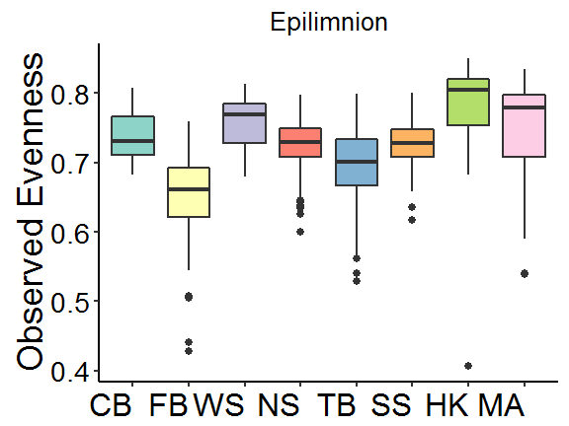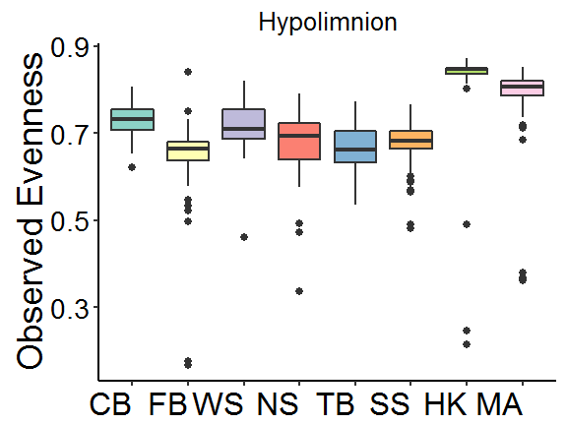

**Figure S2. Evenness over time.**

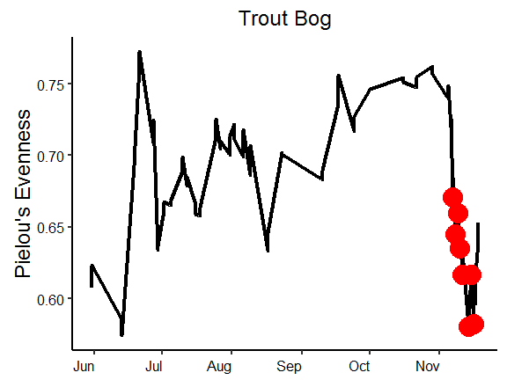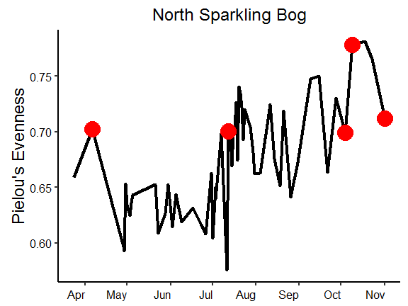

**Figure S3. Phylum-level abundances.**

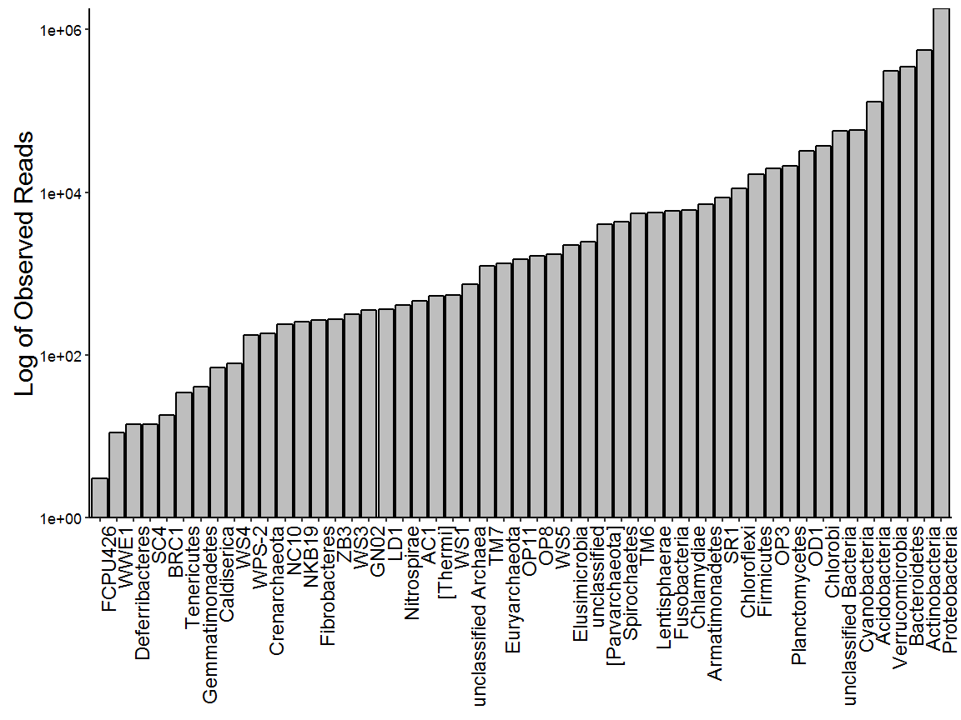

**Figure S4. Phylum-level community composition.**

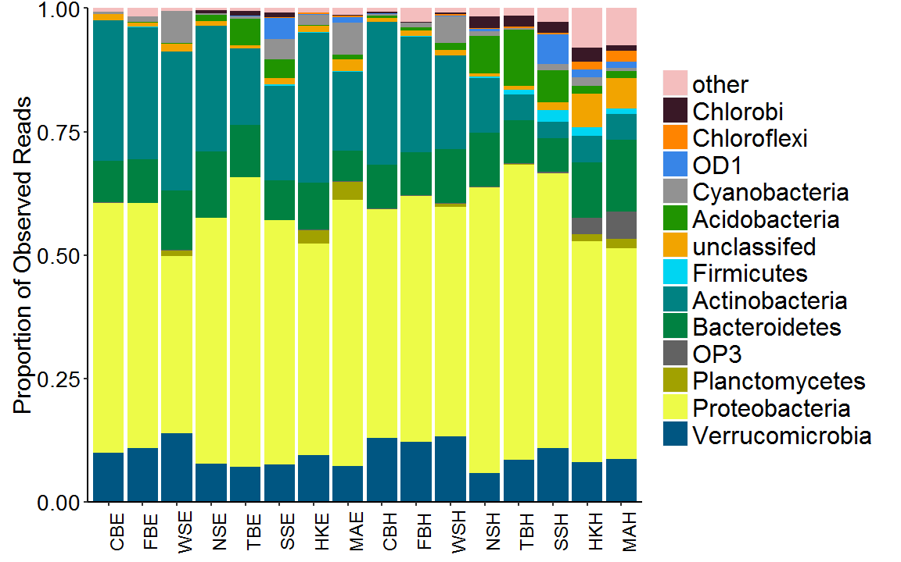

**Figure S5. Rank abundance of the 20 most abundant clades in epilimnia and hypolimnia samples.**

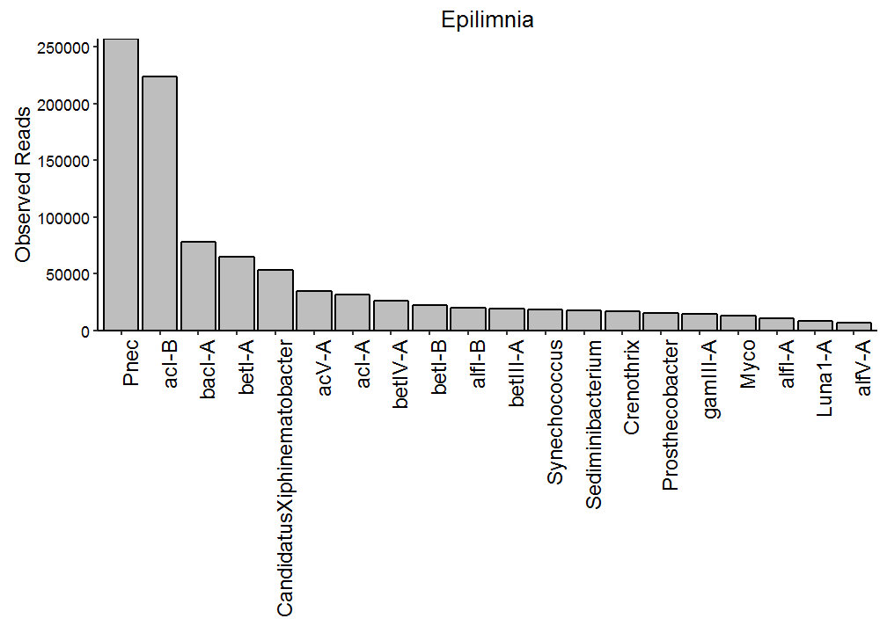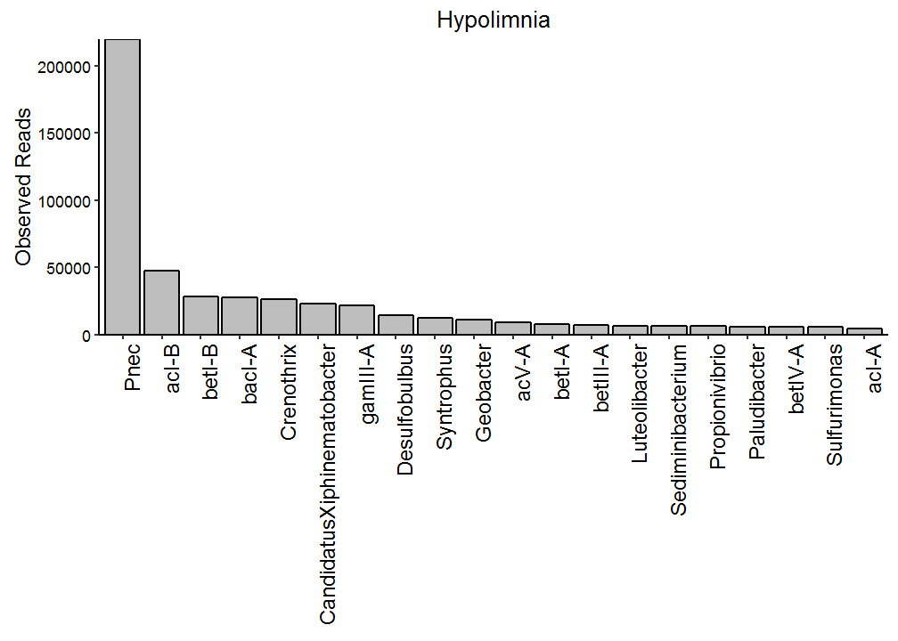

**Figure S6. Connectivity within hypolimnia**.

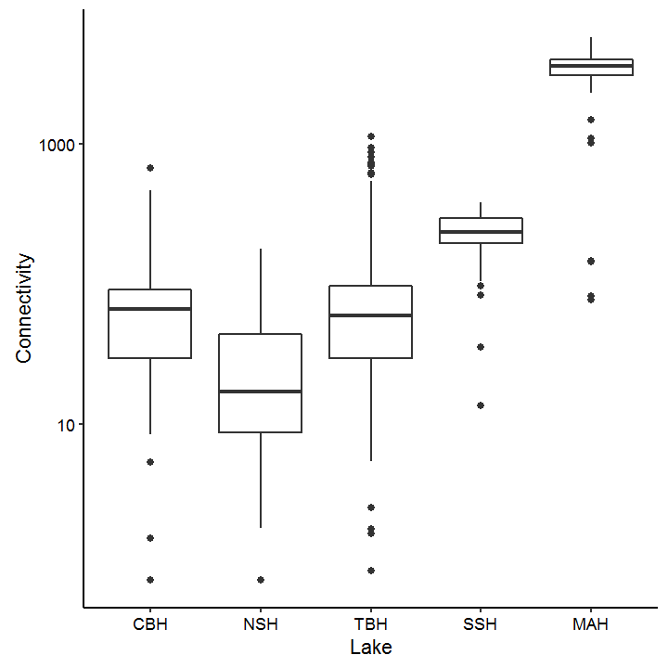

**Figure S7. Annual variation within lakes.**

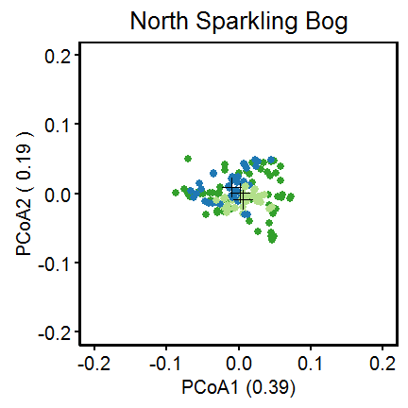

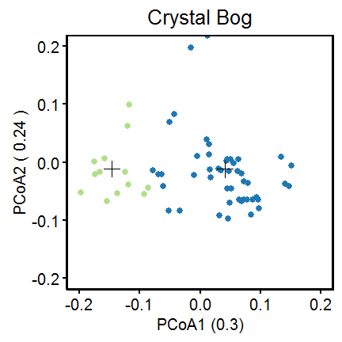

**Figure S8. Representative Mary Lake hypolimnion samples.**

