Freshwater lineages show consistent traits, but variable abundance patterns

Alexandra M. Linz, Benjamin Crary, Ashley Shade, Sarah Owens, Jack A. Gilbert, Rob Knight, and Katherine D. McMahon*

* corresponding author: Katherine McMahon, Departments of Civil and Environmental Engineering, and Bacteriology, University of Wisconsin 1550 Linden Drive Room 5552 Madison, WI 53706, Email: trina.mcmahon@wisc.edu

Running title: Freshwater lineages show consistent traits

Keywords:

Abstract word count: 217

Importance word count: 146

Article word count: 3851

## Abstract

Bacteria play a key role in freshwater biogeochemical cycling, but controls on long-term freshwater bacterial community composition and dynamics are not well characterized. We use a multi-year time series of 16S rRNA gene sequencing data from eight bog lakes to observe annual trends in bacterial communities. Each lake and layer contains a unique bacterial community, with indicator taxa that reflect the environmental conditions of each site. These site differences in community composition are likely the result of environmental filtering. The community present in each year in each site is also unique, and taxa do not show the same abundance trends each summer. But despite high interannual variability in community composition, each freshwater lineage within the communities shows consistent levels of persistence, abundance, and variability between lakes and years. The interannual variability observed in this dataset may be explained by unmeasured environmental variables, biotic interactions, or stochastic community assembly. While this introduces new challenges for the prediction of bacterial community dynamics, we found that interannual variability operates within the confines of environmental filtering, and that freshwater lineages have stable traits. The results of our analysis emphasize the importance of long-term observations, as analyzing only a single year of data would have led us to drastically different conclusions, and lay the foundation for further predictive modeling in freshwater systems.

## Importance

Lakes are excellent systems for investigating bacterial community dynamics because they have clear boundaries, strong environmental gradients, and well-characterized seasonal changes. The results of our research demonstrate that bacterial community dynamics operate on multi-year timescales, a finding which likely applies to other ecosystems and would have large implications for study design and interpretation. Understanding the drivers and controls of bacterial communities on long time scales would improve both our knowledge of fundamental properties of bacterial communities, and our ability to predict community states. In this specific ecosystem, bog lakes play a disproportionately large role in global carbon cycling, and the information presented here may help refine carbon budgets for these lakes. Finally, all data and code in this study are publically available. We hope that this will serve as a resource to anyone seeking to answer their own microbial ecology questions using a multi-year time series.

## Introduction

One of the major goals of microbial ecology is to predict bacterial community composition. The need for prediction can be demonstrated in situations such as the connection between disease and the human microbiome (1), the detrimental impacts of cyanobacterial blooms in freshwater (2), and a variety of industrial applications including chemical production (3), biofuel production (4), wastewater treatment (5), and food science (6). However, we have only a cursory knowledge of the factors that would allow us to predict bacterial community dynamics. Many microbial ecology studies sample large numbers of sites to draw conclusions about how bacterial communities are structured, a pursuit which has greatly benefitted our field. But in addition to space, time must also be considered.

Long-term studies of the bacterial communities are less common due their logistical difficulties and the need for stable funding, but results from the Microbial Observatory projects are promising. As a few examples among many, the San Pedro North Pacific - Microbial Observatory contributed to our understanding of heterogeneity of bacterial communities across space and time (7), while research at the Sapelo Island – Microbial Observatory has led the field in linking genomic data to metadata (8) and in the sampling and analysis of environmental RNA (9). In our own North Temperate Lakes – Microbial Observatory, based in Wisconsin, USA, a multi-year time series of metagenomic data was used to study sweeps in diversity at the genome level (10), adding to our knowledge of how genetic mutation influences bacterial communities. Long-term microbial ecology studies have a time-tested role in the quest to forecast bacterial communities.

In this research, we present 16S amplicon data from the North Temperate Lakes – Microbial Observatory. This dataset includes over 1,300 samples, spanning four years, eight lakes, and two depths. The lakes included in this study are all bog lakes in the boreal region of northern Wisconsin near Minocqua. The well-defined boundaries and environmental gradients of bog lakes make them excellent study systems for microbial ecology, but bog lakes are important ecosystems in their own right. Bogs and wetlands play a crucial role in the global carbon cycle by releasing and consuming methane and carbon dioxide (11). These greenhouse gases are produced and consumed by the bacterial communities. The amount of carbon stored and emitted by wetlands is highly significant on a global scale (12). Understanding how bacterial communities change over time could improve our understanding of carbon cycling in freshwater, and therefore our global estimates of natural carbon emission and capture.

We use our Microbial Observatory 16S dataset to analyze bacterial community composition along both space and time. The communities within each lake and layer are compared, and taxa with preferences for certain environmental conditions are identified. We also investigate seasonal trends, and find that broad metrics repeat annually, but abundance patterns of individual taxa do not. Finally, we examine traits in the abundance and presence/absence patterns of taxa in order to determine if these groups behave in a consistent manner each year. The results of our analysis can be used to guide future attempts to predict bacterial community composition.

## Methods

**Sample Collection**

Water was collected from eight bog lakes during the summers of 2005, 2007, 2008 and 2009, as previously described (13). Briefly, the epilimnion and hypolimnion layers were collected separately using an integrated water column sampler. Dissolved oxygen and temperature profiles were measured at the time of collection using a handheld YSI 550A (YSI Inc., Yellow Springs, OH). After transport to the laboratory, approximately 150 mL from each well-mixed sample was filtered through a 0.22 micron polyethersulfone filter (Supor 200, Pall, Port Washington, NY). Filters were stored at -80C until DNA extraction using FastDNA Spin Kit for Soil (MP Biomedicals, Santa Ana, CA), with minor modifications (14). The sampling sites are located near Boulder Junction, WI, and were chosen to include lakes represent the three mixing regimes of polymictic (multiple mixing events per year), dimictic (two mixing events per year, usually in spring and fall), and meromictic (no record mixing events) (Table 1). Trout Bog and Crystal Bog are also primary study sites for the North Temperate Lakes - Long Term Ecological Research Program, which measures a suite of chemical limnology parameters fortnightly during the open water season. The NTL-LTER also maintains autonomous sensing buoys on Trout Bog and Crystal Bog, allowing for more refined mixing event detection based on thermistor chain measurements.

|  |  |  |  |  |  |  |  |  |
| --- | --- | --- | --- | --- | --- | --- | --- | --- |
|  | Forestry Bog | Crystal Bog | North Sparkling Bog | West Sparkling Bog | Trout Bog | South Sparkling Bog | Hell’s Kitchen | Mary Lake |
| ID | FB | CB | NS | WS | TB | SS | HK | MA |
| Depth *(m)* | 2.0 | 2.5 | 4.5 | 4.6 | 7.0 | 8.0 | 19.3 | 21.5 |
| Surface area *(m2)* | 1300 | 5600 | 4700 | 11900 | 10100 | 4400 | 30000 | 12000 |
| Mixing regime | Polymictic | Polymictic | Dimictic* | Polymictic | Dimictic | Dimictic | Meromictic | Meromictic |
| GPS coordinates | 46.047776, -89.651248 | 46.007639, -89.606341 | 46.004819, -89.705214 | 46.004633, -89.709082 | 46.041140, -89.686352 | 46.041140, -89.709082 | 46.186674, -89.702510 | 46.250764, -89.900419 |
| Years sampled | 2007 | 2007, 2009 | 2007, 2008, 2009 | 2007 | 2005, 2007, 2008, 2009 | 2007, 2008, 2009 | 2007 | 2005, 2007, 2008, 2009 |
| DIC (ppm) |  | 0.69, 1.72 | 1.12, 2.31 |  | 1.73, 4.47 | 1.97, 6.42 |  | 5.54, 12.38 |
| DOC (ppm) |  | 15.47, 13.6 | 10.05, 10.40 |  | 19.87, 20.58 | 12.40, 21.92 |  | 20.63, 67.10 |
| TN (ppb) |  | 621, 846 | 629, 809 |  | 738, 1121 | 814, 1498 |  | 1333, 3652 |
| TP (ppb) |  | 30, 39 | 78, 135 |  | 51, 53 | 49, 69 |  | 78, 304 |
| TDN (ppb) |  | 1290, 490 | 442, 587 |  | 583, 820 | 452, 1180 |  | 1025, 3220 |
| TDP (ppb) |  | 84, 15 | 70, 23 |  | 35, 32 | 16, 18 |  | 71, 228 |

**Table 1. Location and characteristics of bog lakes included in this study.** All lakes are located near Boulder Junction, WI, in the southern boreal region of North America. The mixing regime indicates the frequency of mixing of the two stratified layers, the epilimnion and hypolimnion. Polymictic lakes mix multiple times each summer, dimictic lakes mix twice per year, and meromictic lakes do not mix. Nutrient concentrations are reported for the epilimnion first, then the hypolimnion, and represent the average concentration measured in 2008. Abbreviations: dissolved inorganic carbon (DIC), dissolved organic carbon (DOC), total nitrogen (TN), total phosphorus (TP), total dissolved nitrogen (TDN), and total dissolved phosphorus (TDP).

*North Sparkling Bog was artificially mixed in July of 2008

**Sequencing**

1,510 DNA samples, including 547 biological replicates, were sequenced by the Earth Microbiome Project according to their standard protocols (15). Briefly, the V4 region was amplified and sequenced using Illumina HiSeq, resulting in 77,517,398 total sequences with an average length of 150 base pairs. To reduce the number of erroneous sequences, QIIME’s “deblurring” algorithm for reducing sequence error in Illumina data was applied (<https://github.com/biocore/deblur>, manuscript in preparation). Based on the sequencing error profile, this algorithm removes reads that are likely to be sequencing errors if those reads are both low in abundance and highly similar to a high abundance read. Reads occurring less than 25 times in the entire dataset were removed after deblurring, leaving 9,856 unique sequences. These sequences are considered operational taxonomic units (OTUs).

570 sequences with long homopolymer runs, ambiguous base calls, or incorrect sequence lengths were found and removed via mothur v1.34.3 (16). Thirty-three chimeras and 340 chloroplast sequences (based on pre-clustering and classification with the Greengenes 16S database, May 2013) (17) were removed. Samples were rarefied to 2,500 reads; samples with less than 2,500 reads were omitted, resulting in 1,387 remaining samples. The rarefaction cutoff used was determined based on the results of simulation; 2,500 reads was chosen to maximize the number of samples retained, while maintaining sufficient quality for downstream analysis of diversity metrics.

Representative sequences for each OTU were classified in either our curated freshwater database (18) or the Greengenes database based on the output of NCBI-BLAST (blast+ 2.2.3.1) (19). Representative sequences from each OTU were randomly chosen. The program blastn was used to compare representative sequences to full-length sequences in the freshwater database. OTUs matching the freshwater database with a percent identity greater than 98% were classified in that database, and remaining sequences were classified in the Greengenes database. Both classification steps were performed in mothur using the Wang method (20), and classifications with less than 70% confidence were not included. A detailed workflow for quality control and classification of our sequences is available at (<https://github.com/McMahonLab/16STaxAss> ) (manuscript in prep).

**Statistics**

Statistical analysis was performed in R v3.2.1 (R Development Core Team (2008). R: A language and environment for statistical computing.). Similarity between samples was compared using UniFrac distances, as implement in “phyloseq” (21) (P.J. McMurdie and S. Holmes (2013). phyloseq: An R Package for reproducible interactive analysis and graphic of microbiome census data). Weighted and unweighted Unifrac distance was compared with Bray-Curtis Dissimilarity and Jaccard Similarity, implemented in “vegan” (J. Oksanen,. (2016). vegan: Community Ecology Package). Weighted UniFrac distances were chosen for principle coordinates analysis, performed by betadisper() in “vegan”, because it explained the greatest amount of variation in the first two axes. Significant clustering by year in PCoA was tested using PERMANOVA with the function adonis() in “vegan.”

Indicator species analysis was performed using “indicspecies” (22). Only taxa with read abundances in the top 25% of the entire dataset were used for this analysis. The group-normalized coefficient of correlation was chosen for this analysis because it measures both positive and negative habitat preferences and accounts for differences in the number of samples from each site. All taxonomic levels were included in this analysis to determine which level of resolution was the best indicator for each taxonomic group.

Plots were generated using “ggplot2” (Wickham. (2009). ggplot2: Elegant Graphics for Data Analysis). “reshape2” was used for data formatting (H. Wickham (2007). Reshaping Data with the reshape Package). Data and code from this study can be downloaded from the R package “OTUtable” and the McMahon Lab GitHub repository “North_Temperate_Lakes-Microbial_Observatory.”

## Results

**Overview of community composition**

A multi-year time series of 16S data from multiple lakes was used to investigate bacterial community dynamics over long time scales. 8,795 OTUs were detected in 1,387 samples. In this time series, *Proteobacteria, Actinobacteria, Bacteroidetes,* and *Verrucomicrobia* were the most abundant phyla. Within these phyla, OTU abundance is highly uneven. For example, much of the abundance of *Proteobacteria* can be attributed to OTUs belonging to the well-known freshwater groups *Polynucleobacter* and *Limnohabitans,* and the freshwater clade acI contributes disproportionately to the observed abundance of *Actinobacteria*. Unevenness is a recurring theme in this dataset, which has a long rare tail of OTUs and trends driven largely by the most abundant OTUs. Observed richness is significantly different between lakes of each mixing regime, with meromictic hosting the most taxa and polymictic the least (Figure S1). Phylum-level composition also differs by lake and layer (Figure S2)

**Clusters of community composition**

When differences in community composition are quantified using weighted UniFrac distance, several trends emerge (Figure 1). Communities from the epilimnion and hypolimnion layers are distinct from each other in all lakes. Epilimnia have a higher proportion of OTUs classified using the established freshwater taxonomy, while hypolimnion communities have more OTUs that cannot be classified past the family level. OTUs belonging to candidate phyla are more frequently observed in hypolimnia. These differences are less pronounced in lakes that mix frequently, and likely reflect the bias in freshwater microbial ecology towards the surface waters of lakes. Within layers, mixing regime is the next driver of community composition. This effect is stronger in hypolimnia, which experience major changes in oxygen content during mixing events. One exception is that Crystal Bog, a polymictic lake, clusters with other polymictic hypolimnia (West Sparkling Bog and Forestry Bog) in 2007, but appears more similar to dimictic hypolimnia in 2009. High resolution buoy data for Crystal Bog is available through the North Temperate Lakes Long Term Ecological Research Project, and this data shows that Crystal Bog mixed multiple times in 2007, but only twice in 2009.

The stark contrast between years in Crystal Bog is mirrored to a lesser extent in the other lakes in this study. Each year of sampling from the same lake is unique and distinct, particularly in hypolimnia. While the change in Crystal Bog can be attributed to mixing frequency, the reasons for this trend in other lakes is less clear. Some possible drivers could include climatic factors, landscape level events, differences in geography, or stochastic community assembly.

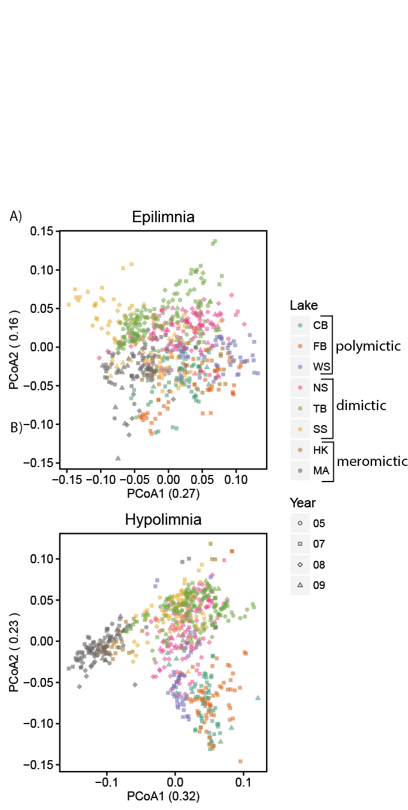

**Figure 1. Principal components analysis based on weighted UniFrac distance of samples split by layer.** Clustering by lake, mixing regime, and year are observed in both layers, although the effect is stronger in hypolimnia (r2 = 0.34 by lake and 0.20 by regime in epilimnia, r2 = 0.49 by lake and 0.22 in hypolimnia, all significant at p < 0.05 using PERMANOVA). This suggests that environmental filtering is occurring based on parameters unique to each site.

**Indicator taxa**

To further investigate potential drivers of the differences in community composition between mixing regime, we performed indicator analysis (Table S1). This technique identifies taxa that are found significantly more often in one group of samples than another; in this case, the groups were defined by layer and mixing regime. There is substantial overlap between the indicator taxa of polymictic epilimnia and hypolimnia, which makes sense as this group is defined by high mixing frequency. The presence of taxa endemic to each mixing regime likely reflects the environmental filtering taking place in these ecosystems. For example, Desulfobulbaceae and Syntrophobacterales are indicators for the anoxic, sulfur-rich samples from dimictic and meromictic hypolimnia, consistent with their probable function of anaerobic sulfur reduction. In contrast, Actinobacteria and particularly its freshwater generalist acI are indicators exclusively for epilimnia and polymictic hypolimnia, where they can likely take full advantage of sunlight to power actinorhodopsins. Interestingly, candidate phyla Omnitrophica (OP3) and Aminicenantes (OP8) were found to be indicators of meromictic hypolimnia, consistent with their detection in anoxic freshwater (23, 24). Parcubacteria (OD1), a candidate phylum previously identified in bog lakes (25), was not an indicator of mixing regime as it was found predominantly in a single lake, South Sparkling Bog.

**Seasonal trends**

Despite distinct community compositions each year, there are high level seasonal trends. Both biodiversity and evenness increase over time while stratification is in place (Figure S3). Sharp decreases in both properties are observed during the well-sampled Trout Bog 2007 fall mixing event and the North Sparkling Bog artificial mixing event. At the phylum level, the abundance of *Proteobacteria* is particularly high in the few winter samples in this dataset

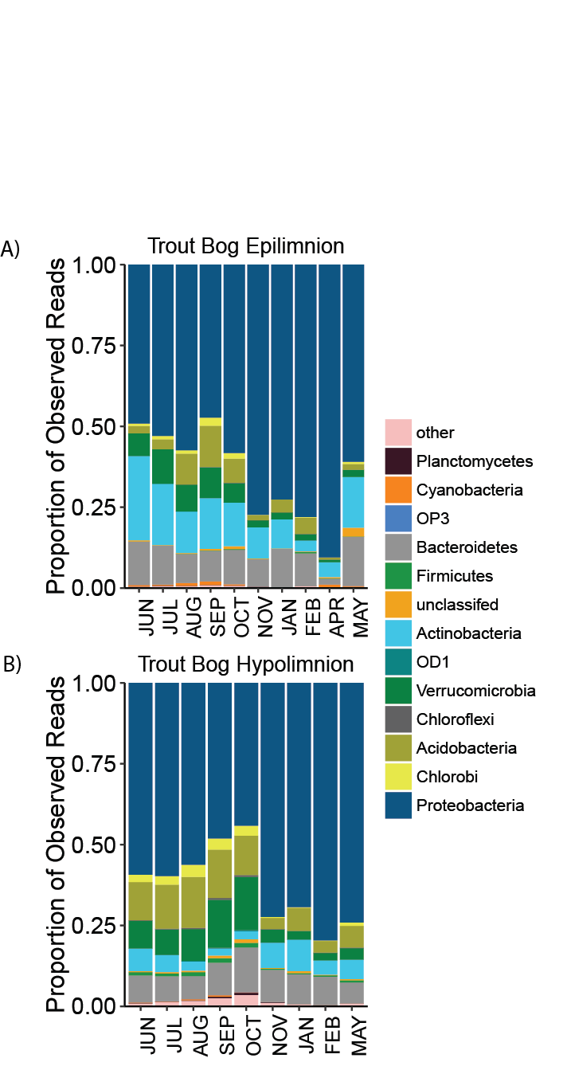**Figure 2. Phylum-level seasonal trends.** The proportion of Proteobacteria is highest in winter, early spring, and fall, but decreases during the stratified summer months. Most other phyla show the opposite trend. Because this is based on relative abundance data, this trend likely reflects the observed increase in biodiversity with time, and suggests that members of Proteobacteria are even more dominant when bog lakes are not stratified.

and during mixing events. After spring stratification, the abundance of *Proteobacteria* decreases as the abundances of other phyla increase. Because this is relative abundance data, this trend may reflect the observed increase in biodiversity over time, and the survivability of dominant Proteobacterial groups *Polynucleobacter* and *Limnohabitans* during the ice-on period of the year. Similar seasonal trends at the phylum level are seen in other lakes as well (Figure S4).

However, seasonal trends break down at lower taxonomic levels. In other aquatic ecosystems, OTUs show repeatable trends in abundance each year, resulting in high similarity between samples collect during the same season but different years. We analyzed seasonal trends by plotting a beta diversity metric such as UniFrac distance between samples versus the time between sample collection (Figure 3, Figure S5). Based on previous marine studies (26, 27), this was expected to produce a sine wave-like pattern with decreasing amplitude. When we perform the same analysis on this dataset, we do not see that pattern. Instead, we see similarity decreasing over time in a logarithmic fashion, so that samples close together in time decrease in similarity quickly and that samples taken a year apart are as dissimilar as samples taken four years apart. The only instance of a sine wave-like pattern is observed in Trout Bog, which has increases in similarity at approximately 1 year and 2 years. This pattern is driven by the higher number of fall, winter, and spring samples collected from Trout Bog than from other lakes. Samples from these times of year are more similar from year to year, while samples collected during the summer stratification period do not show annual trends at the OTU level.

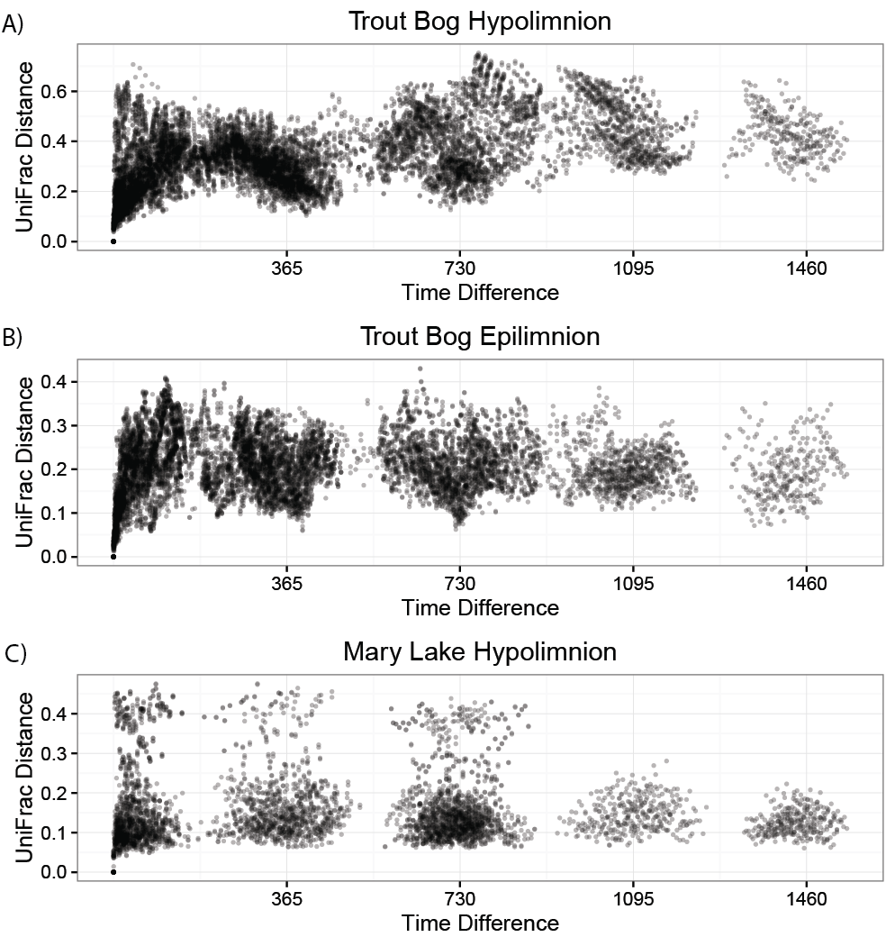

**Figure 3. Lack of seasonal trends at the OTU level.** Despite strong seasonal climatic factors in the studied systems, repeatable seasonal trends were not observed in community composition at the phylum level. If repeatable seasonal trends were occurring, we would expect to see large numbers of samples with increased similarity at approximately 1 year intervals. The only observed increased similarity on annual scales was in Trout Bog, but high numbers of fall, winter, and spring samples contribute to this trend. Gaps in sample coverage are observed because sampling did not occur year-round. Plots for additional lakes and layers are in Figure S5.

**Trends in specific OTUs do not repeat annually**

As suggested by the lack of similarity in community composition between samples taken one year apart, trends in OTU abundance over time do not repeat annually (Figure 4, Figure S6). They do not peak in abundance at consistent times of year or show the same relationship to time each year. OTUs would likely show a consistent response to mixing events because this is such a large disturbance; however, this dataset does not capture a sufficient number of mixing events to demonstrate this. To further complicate OTU abundances, closely related OTUs have different interactions in different years. We have observed the same OTUs to be strongly correlated in some years while strongly anti-correlated in other years. The reasons for these observations are unclear; with only four years of data, differences between years cannot be linked to climatic factors, events in the surrounding landscape, or changes in nutrient levels. It is also possible that biotic drivers and stochastic community assembly are at play in these ecosystems.

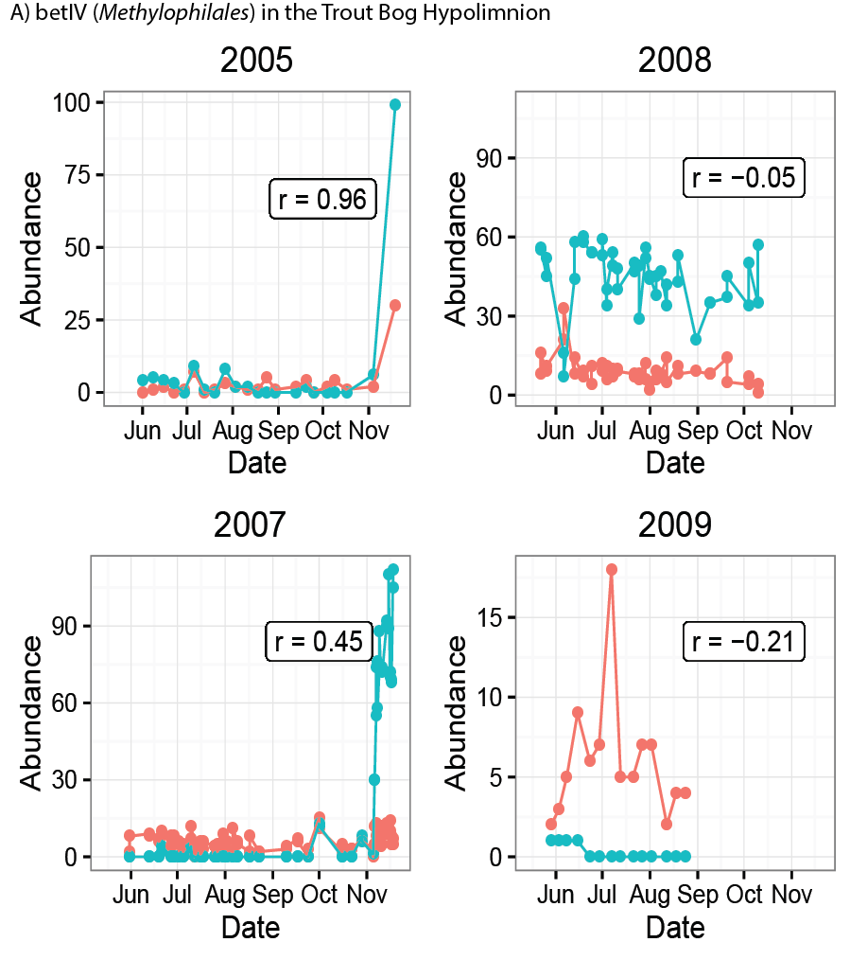

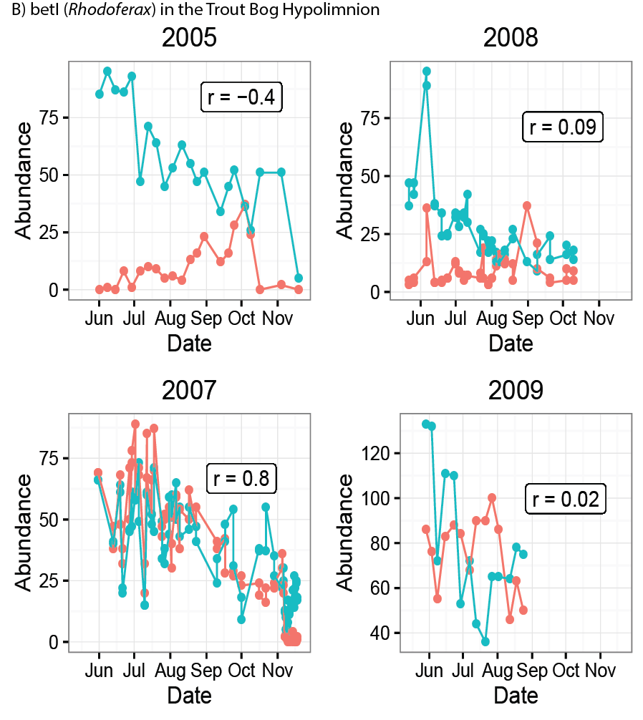

**Figure 4. Examples of different trends in abundance with closely related OTUs.** Panel 1 shows two OTUs (red and blue lines) in the clade betIV of Methylophilales in the Trout Bog Hypolimnion. In Panel 2, two OTUs in the Rhodo clade are shown. The relative abundance trends over time in each OTU differs from year to year. Correlations between closely related OTUs also vary, with significant negative correlations in some years but significant positive correlations in others. Examples of more clades and lakes can be found in Figure S6.

**Consistent traits of OTUs**

Even though OTUs do not show the same trends each year, they do have traits that are consistent between years and lakes. We quantified mean abundance when present, persistence, and the coefficient of variation for clades classified using the freshwater taxonomy, metrics which have been previously used to categorize OTUs (28, 29). Using only these well-defined freshwater groups allowed better taxonomic resolution. This analysis showed that low persistence is associated with high variability, and that low variability is associated with high abundance (Figure 5, Figure S7). We rarely observe “bloomers,” situations where a clade has both high abundance and low persistence. Most freshwater clades are highly persistent at low abundances with low variability. Clade gamIII of the Gammaproteobacteria is an exception, with low persistence, low abundance, and high variability. Clades gamI and verI-A occasionally also exhibit this profile. Clades betII and acI are highly abundant and persistent with low variability, consistent with their profile as ubiquitous freshwater generalists. Knowledge of consistent clade traits can begin to shed light on their lifestyles and the reasons for their observed abundance trends.

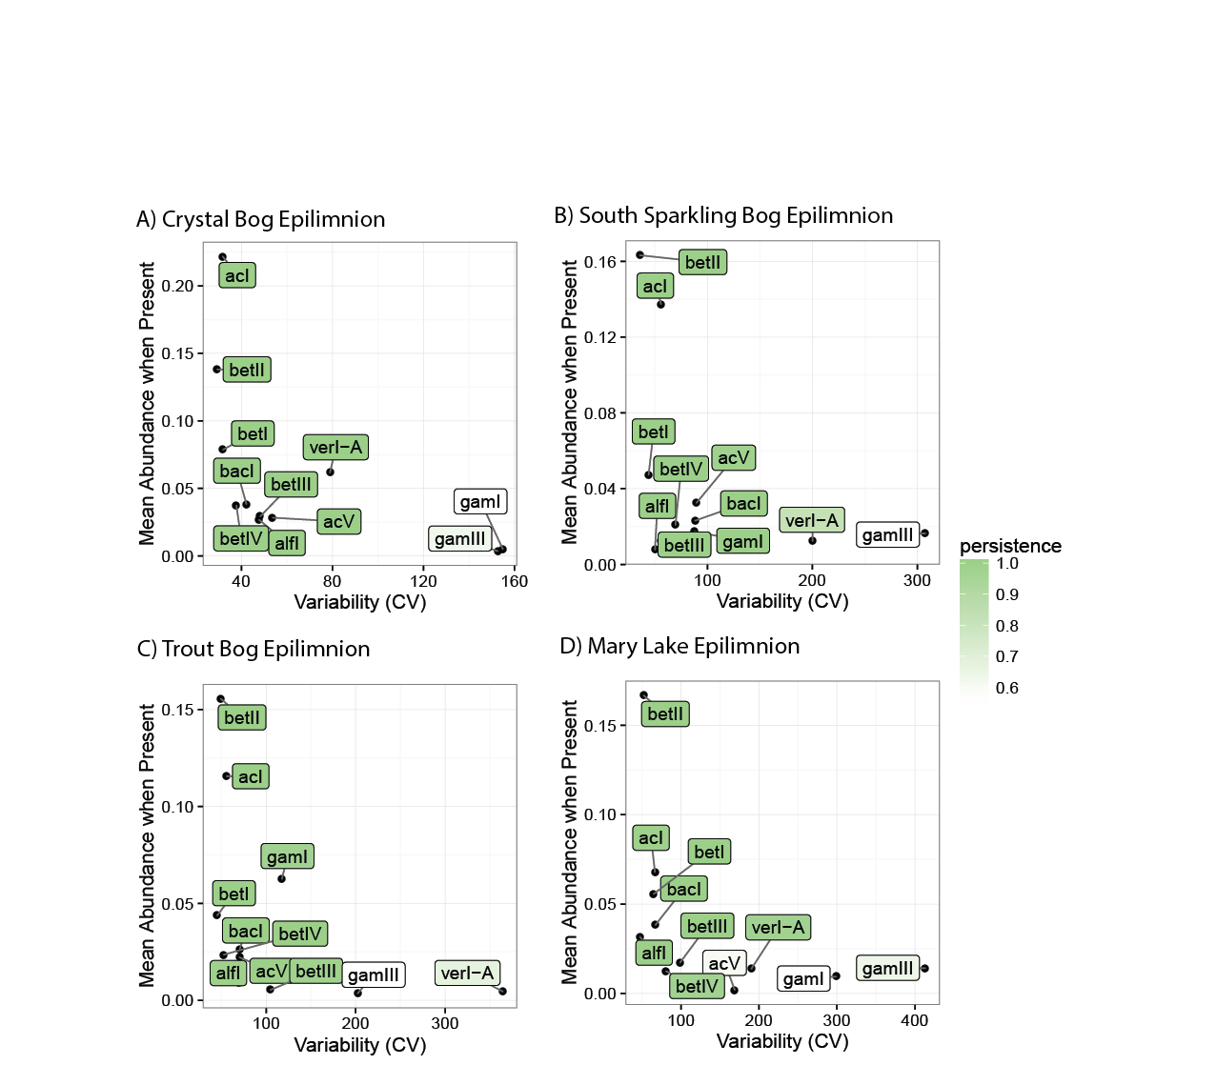

**Figure 5. Traits of freshwater clades.** These well-defined freshwater clades show similar persistence, variance, and abundance in each year and lake, despite different abundance patterns. Data from clades in the Trout Bog epilimnion are shown here. Mean abundance is represented as the average percentage of reads attributed to each clade when that clade is present. Variability is measured as the coefficient of variation. Persistence (shaded color) shows the percentage of samples containing each clade. This consistency in abundance patterns suggests that unknown functions or metabolic characteristics drive a stable lifestyle. Additional plots of clade traits by lake and year can be found in Figure S7.

## Discussion

North temperate lakes experience strong seasonal climatic drivers that we expected to shape bacterial community composition. However, we found that any potential seasonal trends were masked by high levels of interannual variability. Each year in each lake contained a unique community, within the environmental parameters of the study site and depth. Despite the observed interannual variability, freshwater clades themselves have predictable traits. We see that persistence, abundance, and coefficient of variance of freshwater groups are relatively consistent between years and lakes. If this is the case, then why is there such strong differences between years?

Based on the large differences in community composition between epilimnia and hypolimnia, and between lakes, environmental filtering likely has a strong effect in bog lakes. This is consistent with previous research on these bog lakes (13) and supported by increased phylogenetic clustering in all samples compared to what would be expected if phylogeny was random (30) (Figure S8). This is supported by the identities and probable functions of indicator taxa in each mixing regime. But while the presence of taxa endemic to specific sites is consistent from year to year, their abundance trends are highly variable.

One possibility is that there are abiotic drivers not measured that vary strongly from year to year. These bog lakes, being small compared to other studied freshwater systems such as Lake Mendota in Madison, WI, are more at the mercy of their surrounding landscape (31). Changes in the terrestrial ecosystem surround the aquatic systems studied may have profound impacts on bacterial community composition. Another potential driver of annual variation is biotic interactions. Bacterial communities have been shown to take part in complex networks (32), and forces such as competition and cooperation may be structuring community composition in addition to environmental filtering. This study does not include information on phytoplankton or dinoflagellate abundances, which have been shown to influence bacterial community composition in bog lakes (33, 34). Finally, stochastic community assembly may occur after the disturbances of mixing events, the winter ice-on period appears to be a bottleneck reducing the alpha diversity of the bacterial community (35). The emergence of distinctive epilimnia and hypolimnia communities after the spring thaw and mixing event may introduce an element of chance in community assembly, resulting in unique communities each year.

If it is true that annual trends do not repeat in bog lakes, why has this not been seen in other aquatic ecosystems? Previous studies in these same lakes found seasonal trends, but were using higher level community traits such as richness or rate of change rather than direct community composition (36, 37). One of the major taxa found in this dataset, *Polynucleobacter,* was found to have consistent annual trends in Lake Mondsee (38). This is actually consistent with our study, which found seasonal trends in Proteobacterial groups *Polynucleobacter* and *Limnohabitans*, particularly in fall, winter, and spring samples. Interestingly, we detect opposite trends in abundance over time, likely because of our use of relative abundance data instead of absolute abundance data rather than a true biological difference.

There is a large body of work on predictable seasonal trends in oceans, rivers, and freshwater lakes (27, 39–41). One major difference between these sites and ours is that these other systems are larger and contain currents or other water movement, while bog lakes are more stagnant and are connected to other aquatic systems via only groundwater. Bacterial communities that are constantly moving through an ecosystem may experience stronger environmental filtering, reducing variability and the importance of biotic interactions in community assembly. Another difference is that many of the systems studied do not experience the temperature extremes that boreal bog lakes do. The impact of winter freezing and mixing events may prevent formation of a stable community each year. The study most similar to ours is a seasonal analysis of Lake Mendota (14). Lake Mendota freezes annually and is close to the observed study sites geographically, but is a lot bigger than the bogs, is part of a larger chain of lakes with more water exchange, and doesn’t stratify as quickly. The Mendota study notes that late summer samples are more difficult to predict than fall, winter, or early spring samples. Similarly, a comparison of seasonal trends between Lake Mendota and Crystal Bog found stable bacterial community composition in spring and fall, but “dramatic changes” in composition during summer (36). Since the bog lake dataset is dominated by stratified summer samples, this would make annual prediction far more difficult.

Perhaps the biggest implication of this research is the importance of long-term time series. A similar dataset spanning only a single year would have produced drastically different conclusions about the seasonality of freshwater bacterial communities. Clearly, the factors driving community composition in bog lake ecosystems are more complex than we had originally thought. It’s possible that trends may repeat on scales greater than the five years covered in this dataset, or that annual differences are driven by environmental factors that do not occur every year. Biotic interactions between bacterial taxa may also contribute to interannual variability. Understanding the factors that contribute to a lack of repeatable seasonal trends in bog lakes will lead to improved predictive modelling in freshwater systems, allowing forecasting of bloom events and guiding better management strategies. Additionally, these highly variable systems may be ideal for addressing some of the core questions in microbial ecology, such as how community assembly occurs, how interactions between taxa shape community composition, and how resource partitioning drives the lifestyles of bacterial taxa.

To answer these questions and more, we are continuing to collect and sequence samples for the North Temperate Lakes – Microbial Observatory, and we are expanding our sequencing repertoire beyond 16S sequencing. All of the 16S data we have currently generated can be found in the R package “OTUtable” which is available on CRAN for installation via the R command line, or on our GitHub page. We hope that this dataset and its future expansion will be used as a resource for researchers investigating their own questions about how bacterial communities behave on long time scales.

**Conclusion**

Using a multi-year, multi-lake time series, we find depth and mixing frequency to be major drivers of community composition, and identify specific bacterial taxa associated with each environmental condition. Seasonal trends that are consistent annually are observed in community metrics such as richness and evenness, and in community composition at the phylum level. However, repeatable trends in abundance over time are not identified at lower taxonomic levels. Each year in each lake harbors a unique bacterial community, within the confines of its environmental conditions. While this initially appears to pose a challenge to the prediction of bacterial community composition, we also demonstrate that traits such as persistence, abundance, and variation are consistent in freshwater taxa despite large annual differences. Interannual variability could be due to either environmental factors that operate on long time scales, or due to stochastic community assembly as the bacterial community establishes after the spring thaw. Our results emphasize the importance of long term time series in microbial ecology in order to draw accurate conclusions. More research is needed to be able to predict bacterial community composition, but the information we have gathered on traits of bacterial taxa and environmental filtering bring us closer to this ultimate goal.

## Acknowledgements

We thank the North Temperate Lakes Microbial Observatory 2005, 2007, 2008, and 2009 field crews, UW-Trout Lake Station, the UW Center for Limnology, and the Global Lakes Ecological Observatory Network for field and logistical support. Special thanks to Sara Paver and Sara Yeo for coordinating field crews in 2009. We thank Greg Caporaso for contributions during early stages of data analysis and Barvaz Sini for early access to the deblurring algorithm. We thank McMahon Lab members Robin Rohwer and Joshua Hamilton for early access to a workflow used to assign taxonomies to OTUs using a custom 16S training set. We acknowledge efforts by many McMahon Lab undergrads and technicians related to sample collection and DNA extraction, particularly Georgia Wolfe.

## References

1. **Cho I**, **Blaser MJ**. 2012. The human microbiome: at the interface of health and disease. Nat Rev Genet **13**:260–270.

2. **Rastogi RP**, **Madamwar D**, **Incharoensakdi A**. 2015. Bloom Dynamics of Cyanobacteria and Their Toxins: Environmental Health Impacts and Mitigation Strategies. Front Microbiol **6**:1–22.

3. **Logan BE**, **Rabaey K**. 2012. Conversion of Wastes into Bioelectricity and Chemicals by Using Microbial Electrochemical Technologies. Science (80- ) **337**:686–690.

4. **Lopes T**, **Gouveia L**, **Reis A**. 2013. Integrated microbial processes for biofuels and high value-added products : the way to improve the cost effectiveness of biofuel production. Appl Microbiol Biotechnol.

5. **Ferrera I**, **Sánchez O**. 2016. Insights into microbial diversity in wastewater treatment systems: How far have we come? Biotechnol Adv in press.

6. **Bourdichon F**, **Casaregola S**, **Farrokh C**, **Frisvad JC**, **Gerds ML**, **Hammes WP**, **Harnett J**, **Huys G**, **Laulund S**, **Ouwehand A**, **Powell IB**, **Prajapati JB**, **Seto Y**, **Ter E**, **Boven A Van**, **Vankerckhoven V**, **Zgoda A**, **Tuijtelaars S**, **Bech E**. 2012. Food fermentations: Microorganisms with technological beneficial use. Int J Food Microbiol **154**:87–97.

7. **Hewson I**, **Steele JA**, **Capone DG**, **Fuhrman JA**. 2006. Remarkable heterogeneity in meso- and bathypelagic bacterioplankton assemblage composition **51**:1274–1283.

8. **Sheldon WM**, **Moran MA**, **Hollibaugh JT**. 2000. Efforts to Link Ecological Metadata with Bacterial Gene Sequences at the Sapelo Island Microbial Observatory.

9. **Hollibaugh JT**, **Gifford SM**, **Moran MA**, **Ross MJ**, **Sharma S**, **Tolar BB**. 2014. Seasonal variation in the metatranscriptomes of a Thaumarchaeota population from SE USA coastal waters. ISME J **8**:685–98.

10. **Bendall ML**, **Stevens SLR**, **Chan L**, **Malfatti S**, **Schwientek P**, **Tremblay J**, **Schackwitz W**, **Martin J**, **Pati A**, **Bushnell B**, **Froula J**, **Kang D**, **Tringe SG**, **Bertilsson S**, **Moran MA**, **Shade A**, **Newton RJ**, **Mcmahon KD**, **Malmstrom RR**. 2016. Genome-wide selective sweeps and gene-specific sweeps in natural bacterial populations. ISME J 1–13.

11. **Riera JL**, **Schindler JE**, **Kratz TK**. 1999. Seasonal dynamics of carbon dioxide and methane in two clear-water lakes and two bog lakes in northern Wisconsin, U.S.A. Can J Fish Aquat Sci **274**:1–10.

12. **Mitsch WJ**, **Bernal B**, **Nahlik AM**, **Mander Ü**, **Zhang L**, **Anderson CJ**, **Jørgensen SE**, **Brix H**. 2013. Wetlands, carbon, and climate change. Landsc Ecol **28**:583–597.

13. **Shade A**, **Jones SE**, **McMahon KD**. 2008. The influence of habitat heterogeneity on freshwater bacterial community composition and dynamics. Environ Microbiol **10**:1057–1067.

14. **Shade A**, **Kent AD**, **Jones SE**, **Newton RJ**, **Triplett EW**, **McMahon KD**. 2007. Interannual dynamics and phenology of bacterial communities in a eutrophic lake. Limnol Oceanogr **52**:487–494.

15. **Caporaso JG**, **Lauber CL**, **Walters WA**, **Berg-Lyons D**, **Huntley J**, **Fierer N**, **Owens SM**, **Betley J**, **Fraser L**, **Bauer M**, **Gormley N**, **Gilbert JA**, **Smith G**, **Knight R**. 2012. Ultra-high-throughput microbial community analysis on the Illumina HiSeq and MiSeq platforms. ISME J **6**:1621–1624.

16. **Schloss PD**, **Westcott SL**, **Ryabin T**, **Hall JR**, **Hartmann M**, **Hollister EB**, **Lesniewski RA**, **Oakley BB**, **Parks DH**, **Robinson CJ**, **Sahl JW**, **Stres B**, **Thallinger GG**, **Van Horn DJ**, **Weber CF**. 2009. Introducing mothur: Open-source, platform-independent, community-supported software for describing and comparing microbial communities. Appl Environ Microbiol **75**:7537–7541.

17. **DeSantis TZ**, **Hugenholtz P**, **Larsen N**, **Rojas M**, **Brodie EL**, **Keller K**, **Huber T**, **Dalevi D**, **Hu P**, **Andersen GL**. 2006. Greengenes, a chimera-checked 16S rRNA gene database and workbench compatible with ARB. Appl Environ Microbiol **72**:5069–5072.

18. **Newton RJ**, **Jones SE**, **Eiler A**, **McMahon KD**, **Bertilsson S**. 2011. A guide to the natural history of freshwater lake bacteria. Microbiol Mol Biol Rev **75**:14–49.

19. **Camacho C**, **Coulouris G**, **Avagyan V**, **Ma N**, **Papadopoulos J**, **Bealer K**, **Madden TL**. 2009. BLAST plus : architecture and applications. BMC Bioinformatics **10**:-.

20. **Wang Q**, **Garrity GM**, **Tiedje JM**, **Cole JR**. 2007. Naive Bayesian Classifier for Rapid Assignment of rRNA Sequences into the New Bacterial Taxonomy. Appl Environ Microbiol **73**:5261–5267.

21. **Lozupone C**, **Knight R**. 2005. UniFrac : a New Phylogenetic Method for Comparing Microbial Communities UniFrac : a New Phylogenetic Method for Comparing Microbial Communities. Appl Environ Microbiol **71**:8228–8235.

22. **De Cáceres M**, **Legendre P**. 2009. Associations between species and groups of sites: indices and statistical inference. Ecology **90**:3566–3574.

23. **Gies EA**, **Konwar KM**, **Beatty JT**, **Hallam SJ**. 2014. Illuminating microbial dark matter in meromictic Sakinaw Lake. Appl Environ Microbiol **80**:6807–6818.

24. **Glöckner J**, **Kube M**, **Shrestha PM**, **Weber M**, **Glöckner FO**, **Reinhardt R**, **Liesack W**. 2010. Phylogenetic diversity and metagenomics of candidate division OP3. Environ Microbiol **12**:1218–1229.

25. **Peura S**, **Eiler A**, **Bertilsson S**, **Nyka H**, **Tiirola M**, **Jones RI**. 2012. Distinct and diverse anaerobic bacterial communities in boreal lakes dominated by candidate division OD1. ISME J J **6**:1640–1652.

26. **Fuhrman JA**, **Hewson I**, **Schwalbach MS**, **Steele JA**, **Brown M V**, **Naeem S**. 2006. Annually reoccurring bacterial communities are predictable from ocean conditions. Proc Natl Acad Sci USA **103**:13104–13109.

27. **Gilbert JA**, **Steele JA**, **Caporaso JG**, **Steinbruck L**, **Reeder J**, **Temperton B**, **Huse S**, **McHardy AC**, **Knight R**, **Joint I**, **Somerfield P**, **Fuhrman JA**, **Field D**. 2012. Defining seasonal marine microbial community dynamics. ISME J **6**:298–308.

28. **Herren CM**, **Webert KC**, **McMahon KD**. 2016. Environmental Disturbances Decrease the Variability of Microbial Populations within Periphyton. mSystems **1**:1–14.

29. **Shade AL**, **Gilbert JA**. 2015. Temporal patterns of rarity provide a more complete view of microbial diversity. Trends Microbiol **23**:335–340.

30. **Kembel SW**. 2009. Disentangling niche and neutral influences on community assembly : assessing the performance of community phylogenetic structure tests. Ecol Lett **12**:949–960.

31. **Hanson PC**, **Pace ML**, **Carpenter SR**, **Cole JJ**, **Stanley EH**. 2015. Integrating Landscape Carbon Cycling: Research Needs for Resolving Organic Carbon Budgets of Lakes. Ecosystems **18**:363–375.

32. **Eiler A**, **Heinrich F**, **Bertilsson S**. 2012. Coherent dynamics and association networks among lake bacterioplankton taxa. ISME J **6**:330–42.

33. **Newton RJ**, **Kent AD**, **Triplett EW**, **McMahon KD**. 2006. Microbial community dynamics in a humic lake: Differential persistence of common freshwater phylotypes. Environ Microbiol **8**:956–970.

34. **Graham JM**, **Kent AD**, **Lauster GH**, **Yannarell AC**, **Graham LE**, **Triplett EW**. 2004. Seasonal dynamics of phytoplankton and planktonic protozoan communities in a northern temperate humic lake: Diversity in a dinoflagellate dominated system. Microb Ecol **48**:528–540.

35. **Roguet A**, **Laigle GS**, **Therial C**, **Bressy A**, **Soulignac F**, **Catherine A**, **Lacroix G**, **Jardillier L**, **Bonhomme C**, **Lerch TZ**, **Lucas FS**. 2015. Neutral community model explains the bacterial community assembly in freshwater lakes. FEMS Microbiol Ecol **91**:1–11.

36. **Yannarell AC**, **Kent AD**, **H. LG**, **Kratz TK**, **Triplett EW**. 2003. Temporal Patterns in Bacterial Communities in Three Temperate Lakes of Different Trophic Status. Microb Ecol **46**:391–405.

37. **Kent AD**, **Yannarell AC**, **Rusak JA**, **Triplett EW**, **McMahon KD**. 2007. Synchrony in aquatic microbial community dynamics. ISME J **1**:38–47.

38. **Wu QL**, **Hahn MW**. 2006. High predictability of the seasonal dynamics of a species-like Polynucleobacter population in a freshwater lake. Environ Microbiol **8**:1660–1666.

39. **Cram J**, **Chow C**, **Sachdeva R**, **Needham D**, **Parada A**, **Steele J**, **Fuhrman J**. 2015. Seasonal and interannual variability of the marine bacterioplankton community throughout the water column over ten years. ISME J **9**:563–580.

40. **Crump BC**, **Peterson BJ**, **Raymond PA**, **Amon RMW**, **Rinehart A**, **McClelland JW**, **Holmes RM**. 2009. Circumpolar synchrony in big river bacterioplankton. Proc Natl Acad Sci USA **106**:21208–12.

41. **Shade A**, **Chiu CY**, **McMahon KD**. 2010. Seasonal and episodic lake mixing stimulate differential planktonic bacterial dynamics. Microb Ecol **59**:546–554.

## Supplemental Figures

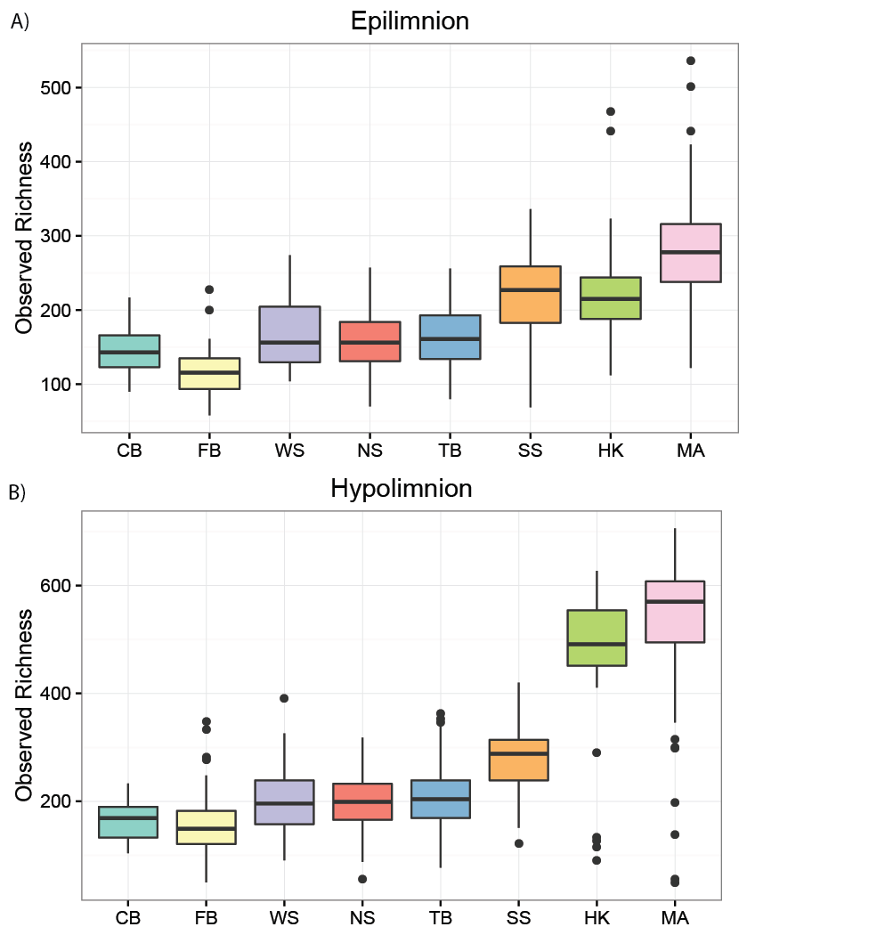

**Figure S1. Observed richness by lake.** Observed richness is correlated with the depth of the lake. This effect is stronger in hypolimnia. Differences in richness between lakes of different mixing regimes are significant at p > 0.05 using a pairwise Wilcoxon Test with a Bonferroni adjustment.

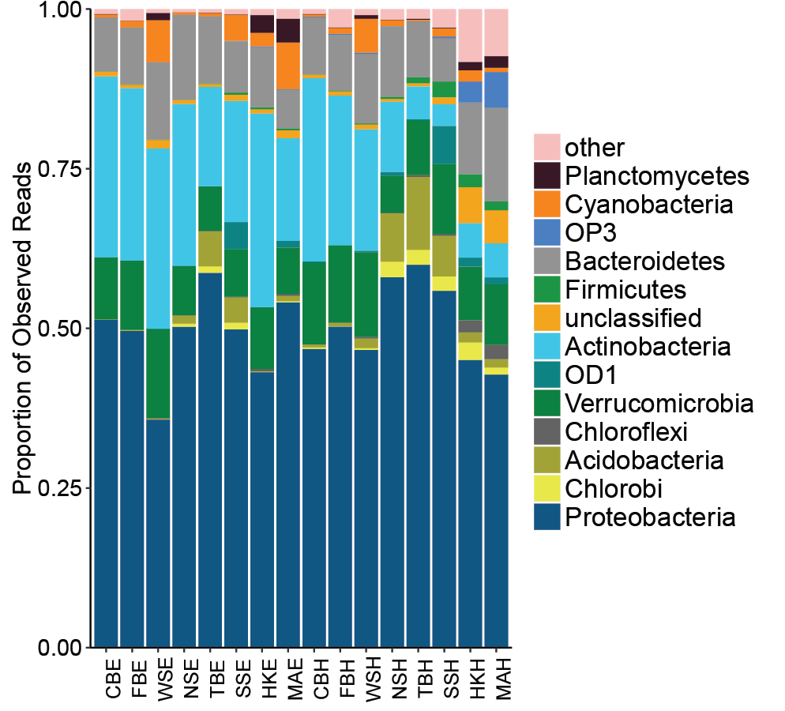

**Figure S2. Phylum composition by lake and layer.** Phylum composition differs by sampling site. A few phyla dominate everywhere, including Proteobacteria, Verrucomicrobia, Actinobacteria, and Bacteroidetes. However, proportions of these phyla decrease in meromicticlakes, which have greater proportions of Planctomyces, OP3, and all lower abundance and other phyla. OD1 is found primarily in South Sparkling Bog, and Acidobacteria are more abundant in dimictic lakes South Sparkling, North Sparkling, and Trout Bog.

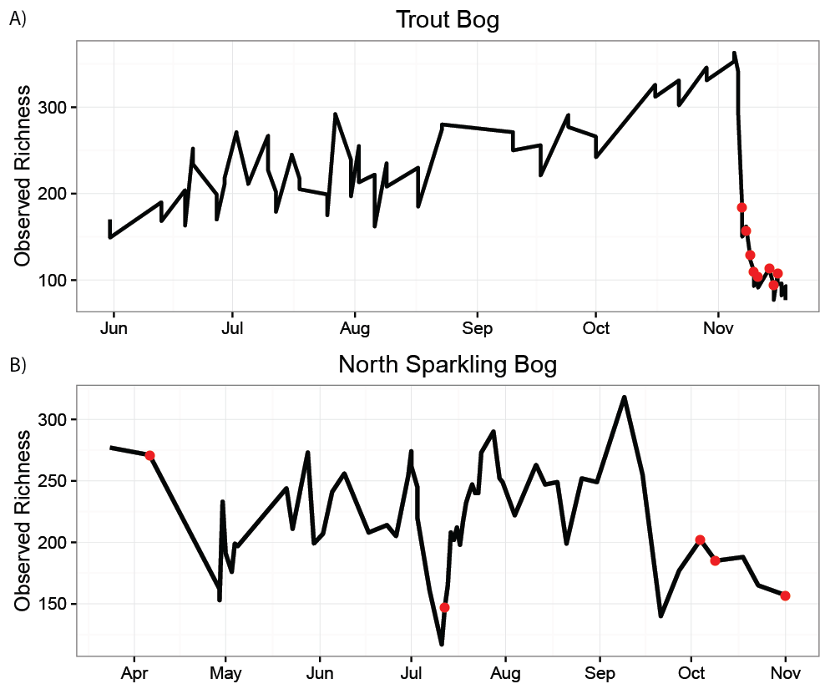

**Figure S3. Observed richness over time.** Richness tended to decrease during mixing events, marked here in red. In Trout Bog, richness increased steadily during 2007 until the fall mixing event. In North Sparkling Bog, 2008, both the fall mixing event and the artificial mixing event in July show lower richness than the rest of the year.

**Table S1. Indicator taxa of layers and mixing regimes.** Indicator analysis was used to identify taxa with a preference for sites defined by layer and mixing regime. OTUs were grouped into higher taxonomic levels, and all levels were used for this analysis at once. The lowest classification of each indicator taxa is reported below.

|  |  |
| --- | --- |
| **Polymictic epilimnia** | **Polymictic hypolimnia** |
| 1. Actinobacteria;Actinobacteria; Actinomycetales;acI;acI-B;acI-B3 2. Verrucomicrobia;Spartobacteria; Chthoniobacterales;verI-A 3. Proteobacteria;Betaproteobacteria;Burkholderiales;betI;betI-A;Lhab-A4 4. Proteobacteria;Betaproteobacteria;Methylophilales 5. Actinobacteria;Actinobacteria;Actinomycetales;acI;acI-B;acI-B3 6. Proteobacteria;Betaproteobacteria;Burkholderiales;betI;betI-A 7. Verrucomicrobia;Spartobacteria 8. Actinobacteria;Actinobacteria;ActinomycetalesMycobacteriaceae;Mycobacterium 9. Actinobacteria;Actinobacteria;Actinomycetales;acI 10. Proteobacteria;Betaproteobacteria;Burkholderiales;betII;Pnec;PnecC | 1. Actinobacteria;Actinobacteria;Actinomycetales 2. Actinobacteria 3. Proteobacteria;_Betaproteobacteria;Burkholderiales;betI;betI-A 4. Verrucomicrobia;Spartobacteria;Chthoniobacterales;verI-A 5. Bacteroidetes;Saprospirae 6. Proteobacteria;Alphaproteobacteria;Rhizobiales 7. Proteobacteria;Betaproteobacteria;Burkholderiales;betII;Pnec;PnecC 8. Actinobacteria;Acidimicrobiia;Acidimicrobiales 9. Actinobacteria;Acidimicrobiia;Acidimicrobiales 10. Proteobacteria;Alphaproteobacteria |
| **Dimictic epilimnia** | **Dimictic hypolimnia** |
| 1. Proteobacteria;Betaproteobacteria;Methylophilales 2. Actinobacteria;Acidimicrobiia;Acidimicrobiales;acV 3. Actinobacteria;Actinobacteria;Actinomycetales;acI;acI-B;acI-B2 4. Bacteroidetes;Saprospirae;Saprospirales;Chitinophagaceae 5. Bacteroidetes;Sphingobacteriia;Sphingobacteriales;bacVI;bacVI-A;Muci 6. Proteobacteria;Betaproteobacteria;Burkholderiales;betI;betI-B;Rhodo 7. Acidobacteria 8. Proteobacteria;Alphaproteobacteria;Rickettsiales;Rickettsiaceae 9. Chlorobi;Chlorobia 10. Proteobacteria;Alphaproteobacteria;Rickettsiales;Rickettsiaceae | 1. Acidobacteria;Holophagae;Holophagales;Holophagaceae 2. Acidobacteria 3. Proteobacteria;Betaproteobacteria;Burkholderiales;betII;Pnec;PnecC 4. Proteobacteria;Betaproteobacteria;Methylophilales 5. Verrucomicrobia;Pedosphaerae;Pedosphaerales;Ellin515 6. Proteobacteria;Betaproteobacteria 7. Proteobacteria;Deltaproteobacteria;Desulfobacterales;Desulfobulbaceae;Desulfobulbus 8. Proteobacteria;Betaproteobacteria;Burkholderiales;betI;betI-B;Rhodo 9. Proteobacteria;Betaproteobacteria;Methylophilales;Methylophilaceae 10. Proteobacteria;Deltaproteobacteria;Desulfobacterales;Desulfobulbaceae |
| **Meromictic epilimnia** | **Meromictic hypolimnia** |
| 1. Planctomycetes 2. Actinobacteria;Actinobacteria;Actinomycetales;acTH2 3. Proteobacteria;Betaproteobacteria;Burkholderiales;betI;betI-A;Lhab-A11 4. Actinobacteria;Actinobacteria;Actinomycetales;acI;acI-A;acI-A6 5. Proteobacteria;Alphaproteobacteria;Rhizobiales;alfI;alfI-B;alfI-B21 6. Proteobacteria;Betaproteobacteria;Burkholderiales;betIII;betIII-A;betIII-A1 7. Actinobacteria;Actinobacteria;Actinomycetales;acI;acI-A 8. Proteobacteria;Gammaproteobacteria;Xanthomonadales;Sinobacteraceae 9. Proteobacteria;Alphaproteobacteria;Rickettsiales 10. Proteobacteria;Betaproteobacteria;Burkholderiales;betI;betI-A;Lhab-A1 | 1. Proteobacteria;Deltaproteobacteria;Syntrophobacterales 2. Proteobacteria;Deltaproteobacteria;Syntrophobacterales;Syntrophaceae 3. OP3;BD4-9 4. OP3 5. Verrucomicrobia;Verruco-5;WCHB1-41 6. Proteobacteria;Deltaproteobacteria;Desulfobacterales;Desulfobacteraceae 7. Planctomycetes 8. Archaea;Parvarchaeota 9. Verrucomicrobia;Verruco-5 10. OP8;OP8_1 |

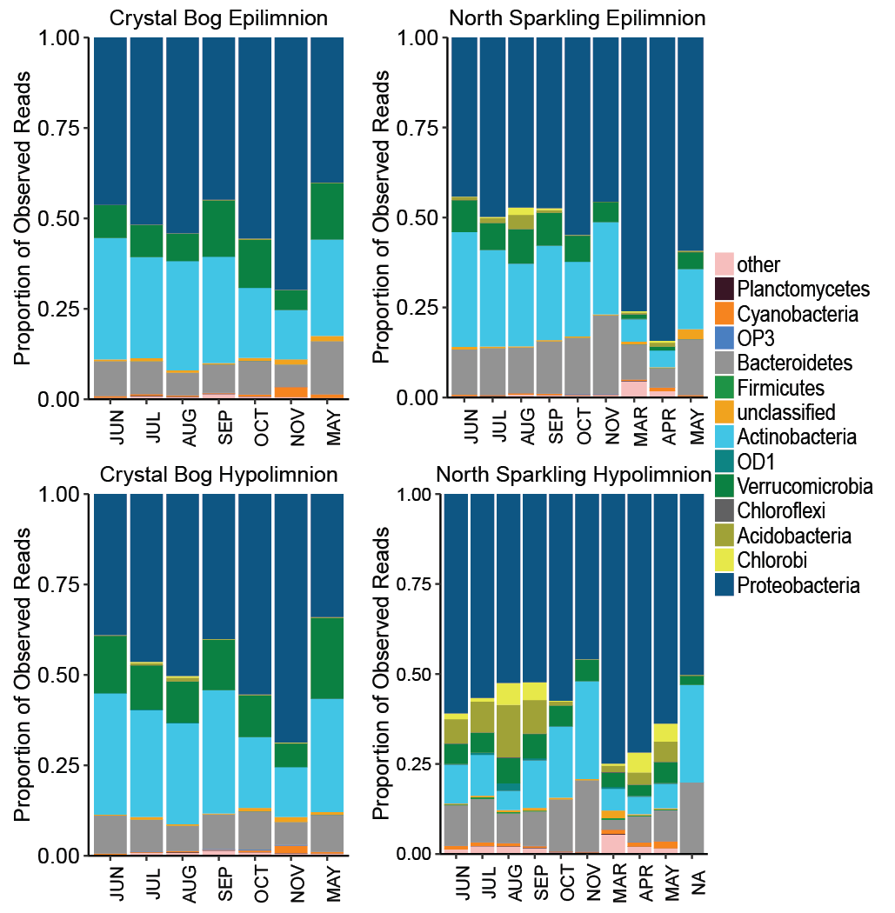

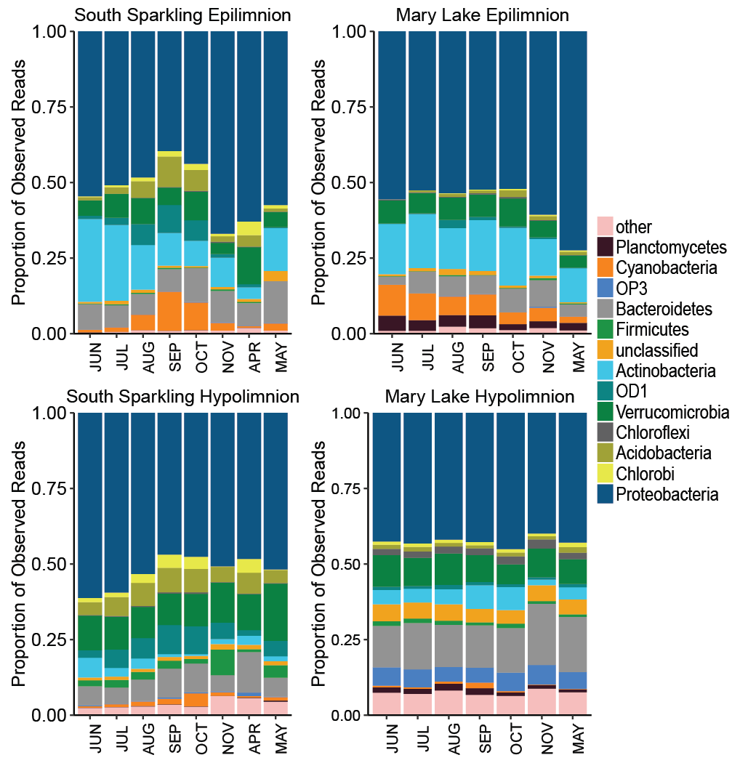

**Figure S4. Phylum composition by month by lake.** Seasonal trends, largely driven by Proteobacteria, are found in nearly all lakes and layers. Sites with multiple years of sampling are shown above. Most sites show a slight increase or no clear trend in the proportion of Proteobacteria over time, with the exception of Crystal Bog, which shows increased proportions of Proteobacteria over time. The Mary Lake hypolimnion, which has no recorded mixing events, has a stable community composition at the phylum level over seasons.

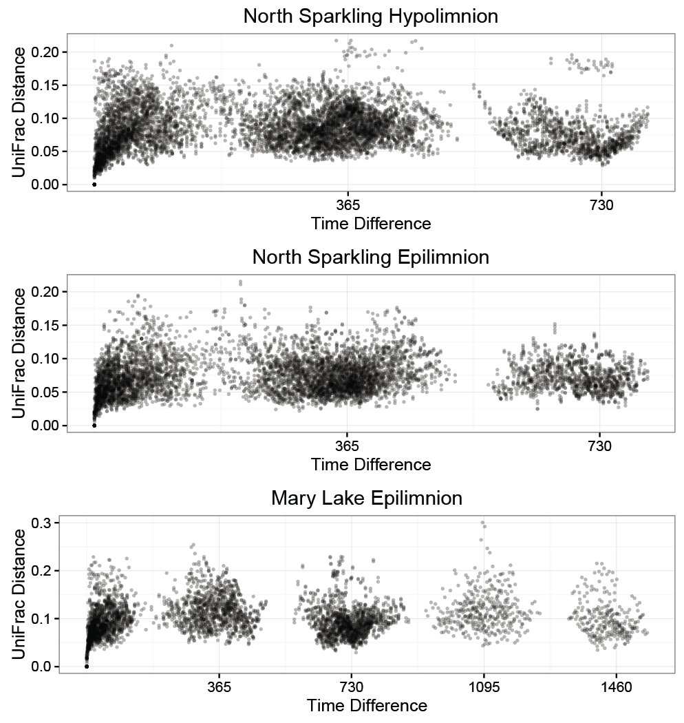

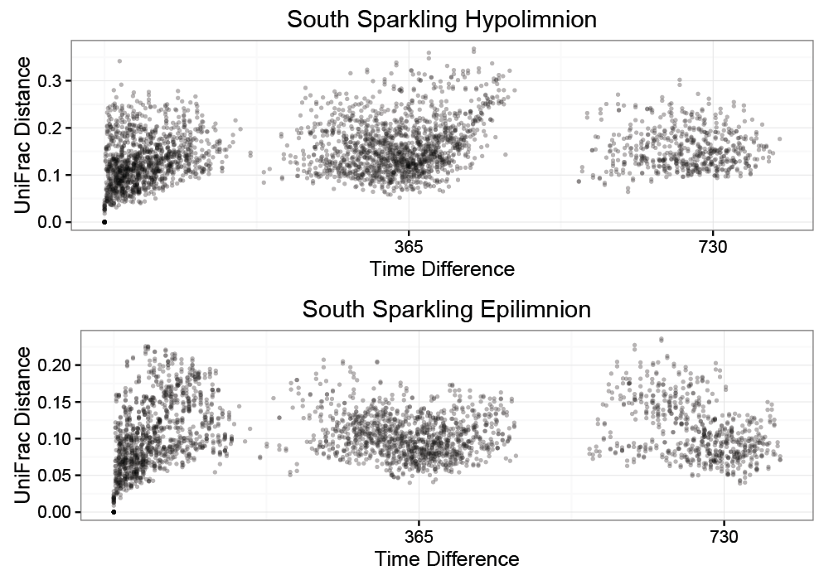

**Figure S5. Additional plots of UniFrac distance vs time between samples.** As seen in Figure 3, there is no increase in similarity between samples taken 1 year or multiples of 1 year apart. Trends appear logarithmic, with similarity between samples rapidly decreasing at first, then approaching an asymptote. This indicates that community composition does not repeat annually.

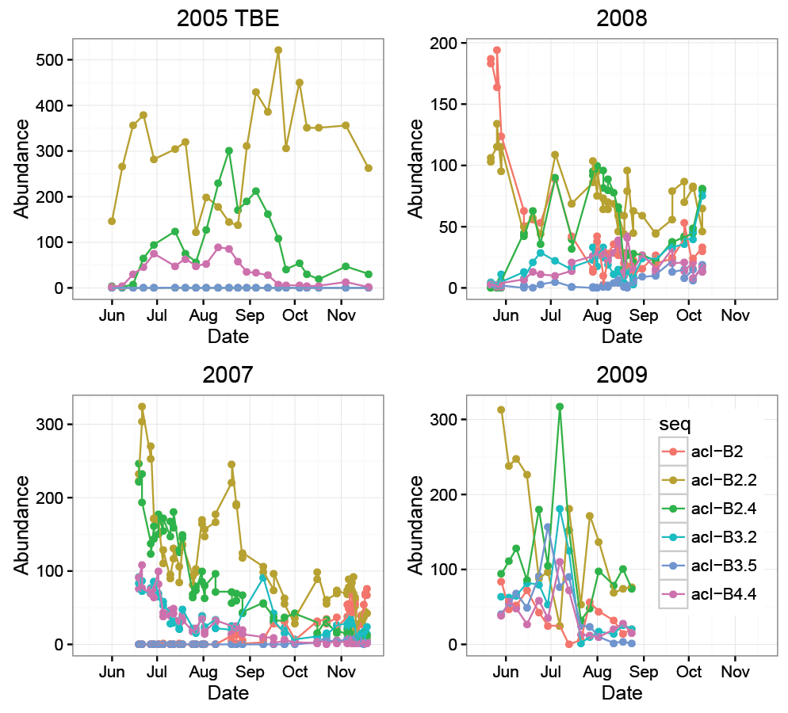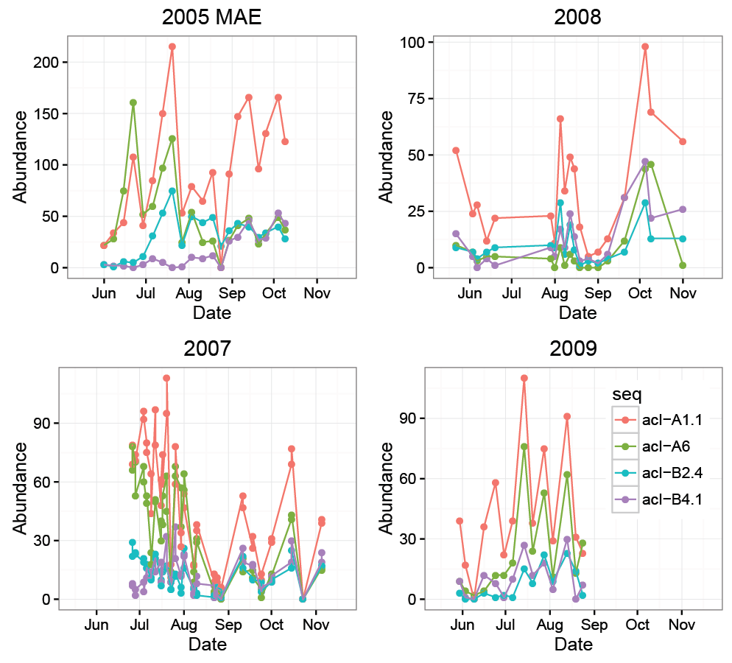

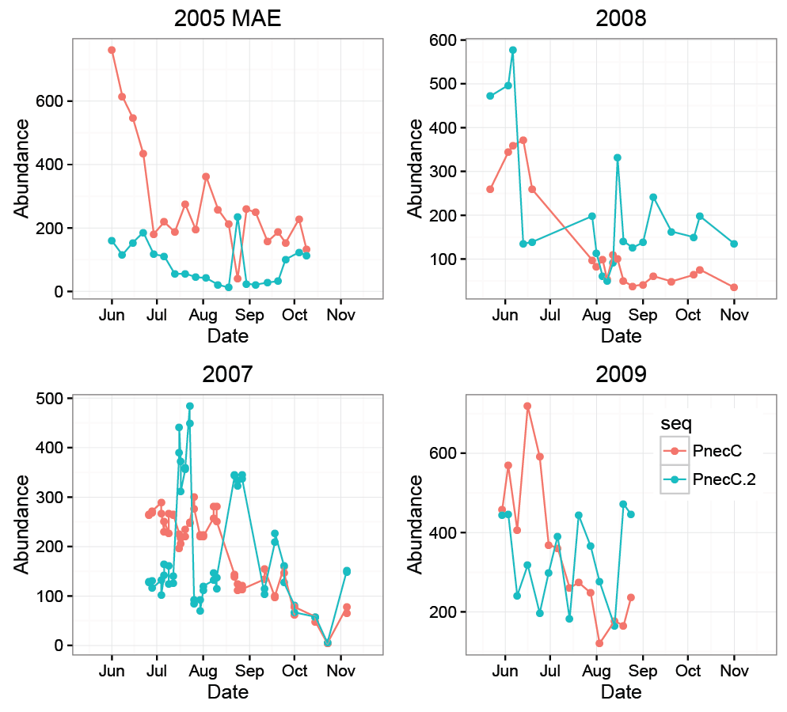

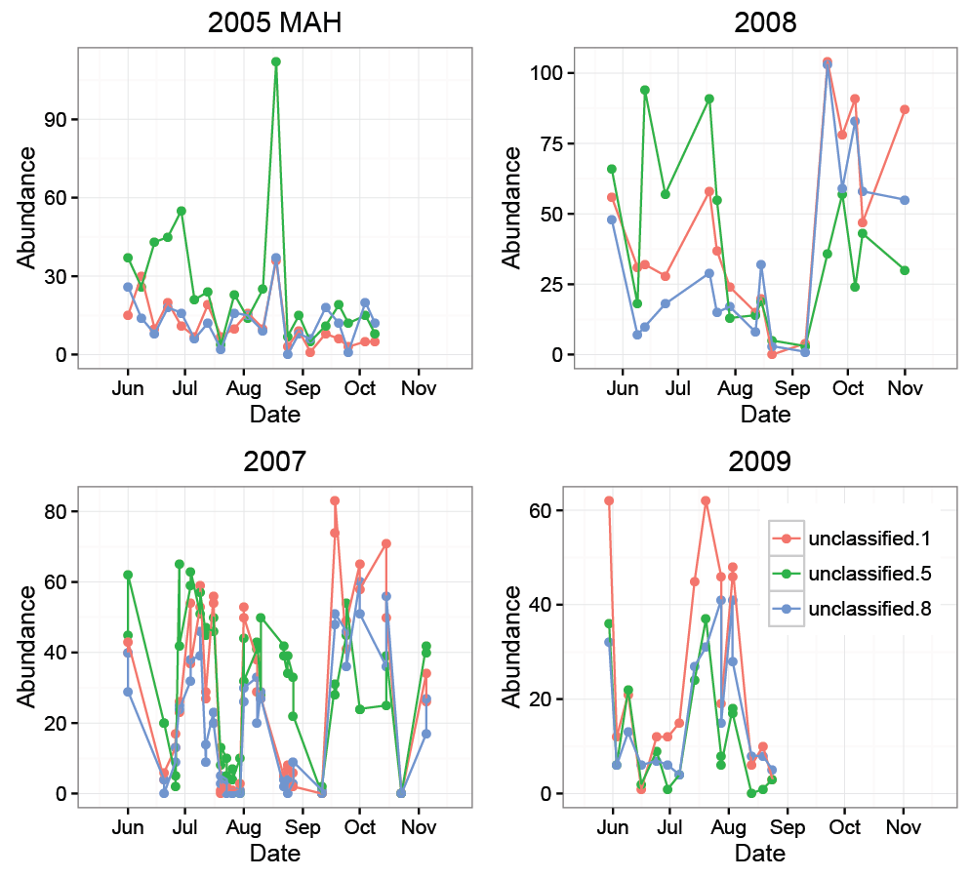

**Figure S6. Trends over time in OTUs.** Additional abundance trends of closely related OTUs by year are shown above. In Trout Bog, both acI-B and PnecC have different trends amount OTUs classified as the same tribe, and the relationships between OTUs varies from year to year. In Mary Lake, closely related OTUs of acI and betII show highly similar abundance patterns to each other, although these trends still vary from year to year. This may be due to Mary Lake’s lack of mixing disturbance and strong vertical gradients.

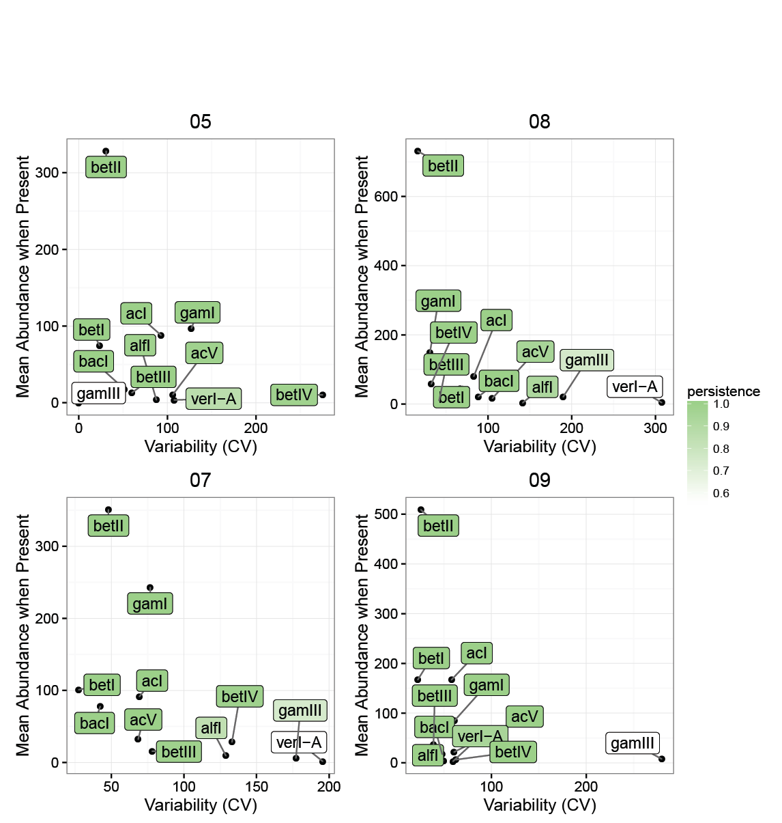

**Figure S7. Lineage traits by year.** Figure 5 demonstrates that lineages show consistent traits in different lakes; this plot shows that those traits are relatively consistent between years as well, as in the Trout Bog hypolimnion.

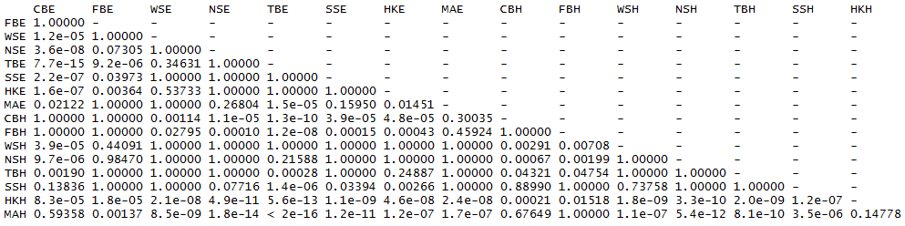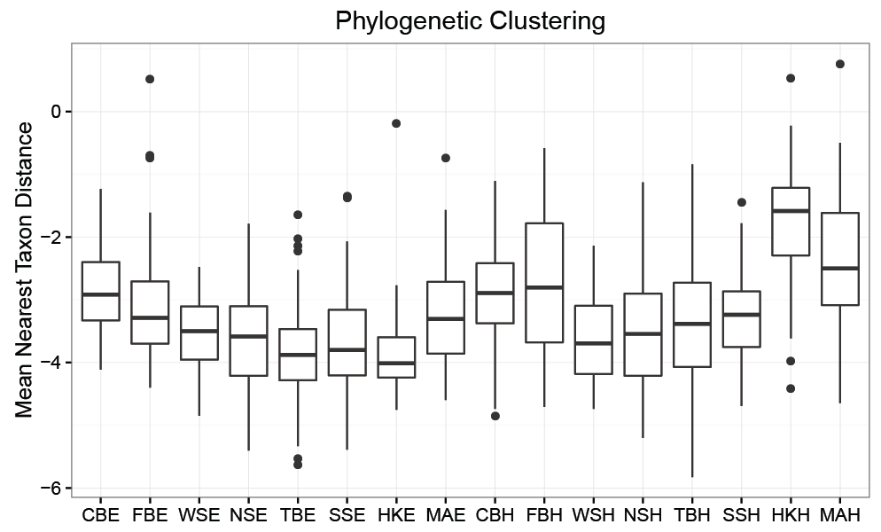

**Figure S8. Phylogenetic clustering by lake.** The mean nearest taxon distance quantifies the phylogenetic relatedness of taxa in a species compared to a null model. Negative values indicate underdispersal – that is, more phylogenetic clustering than would be expected if phylogeny was randomly distributed. This indicates that environmental filtering is a strong driver of community composition in all sites. Dimictic lakes are significantly more clustered than polymictic or meromictic lakes, as tested by a pairwise Wilcoxon test with Bonferroni adjustment.