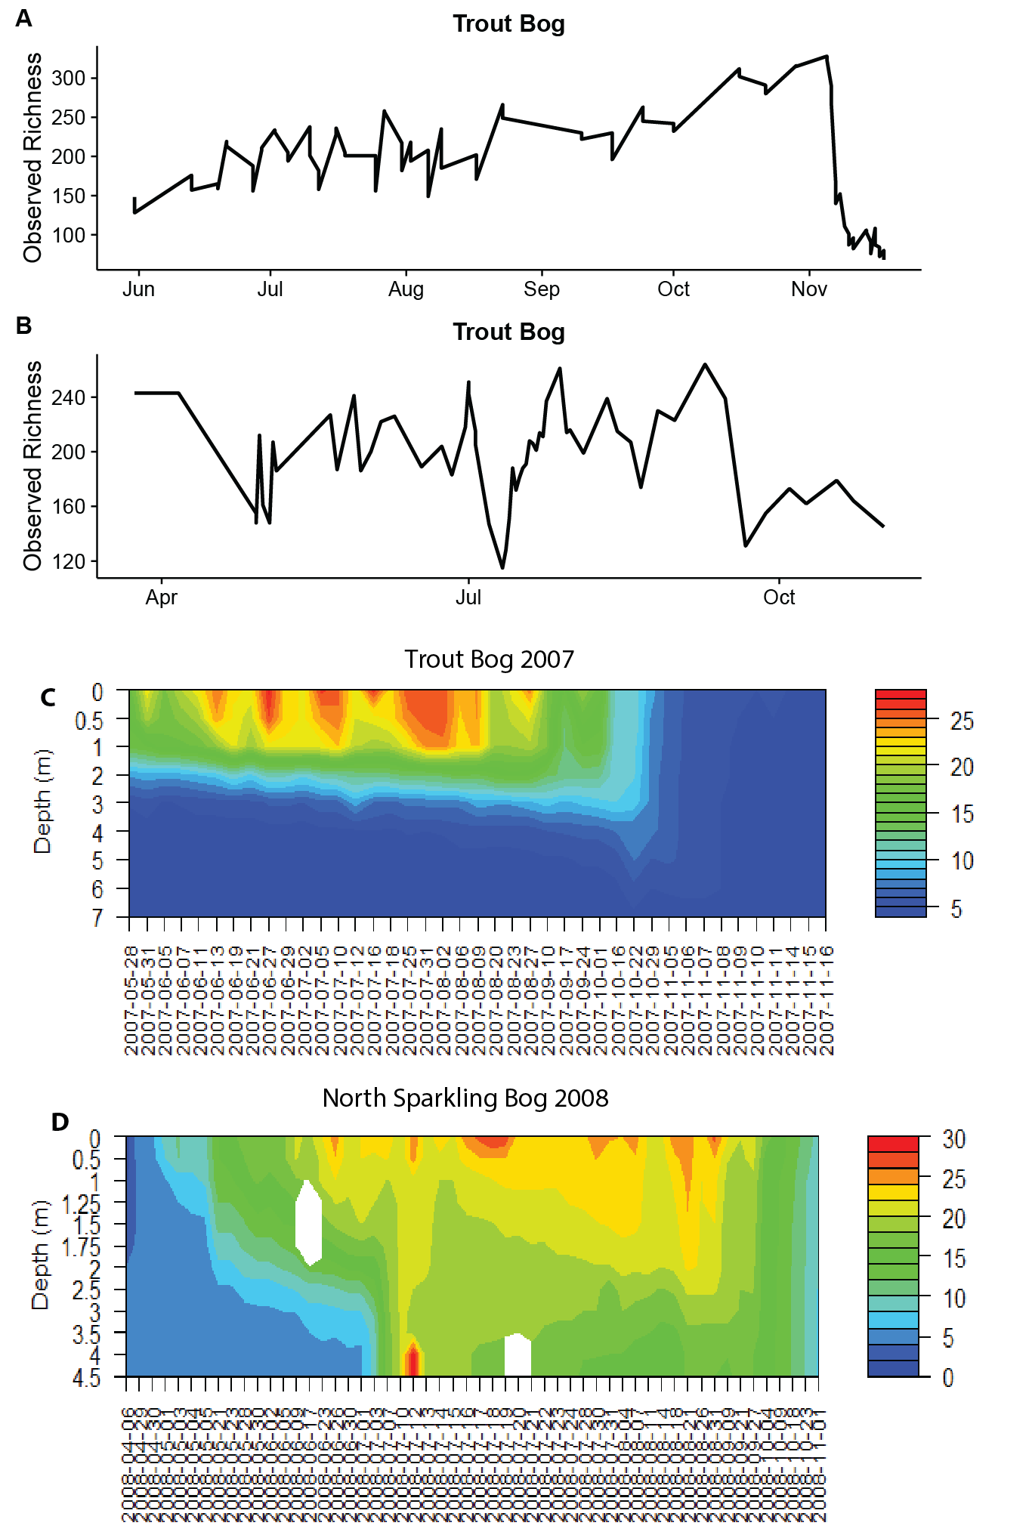**Figure S3. Richness over time during mixing events.**

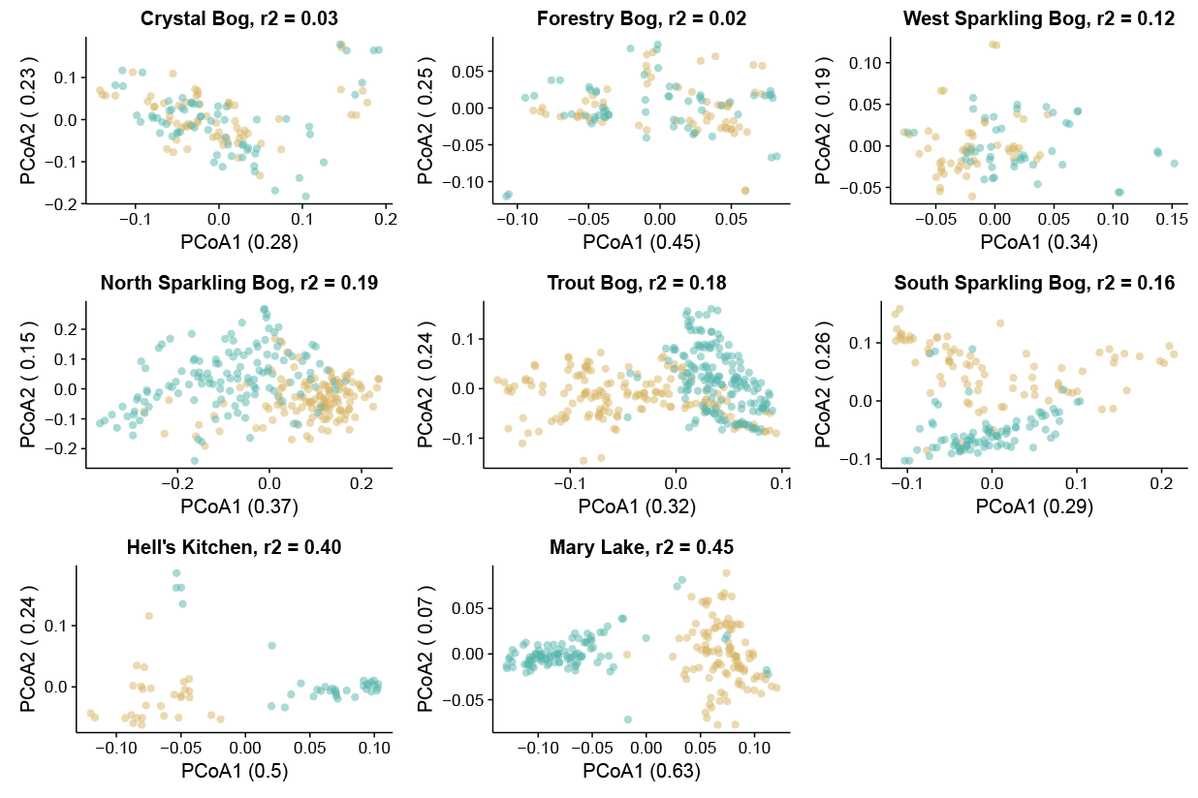

**Figure S5. Layers cluster within lakes**.

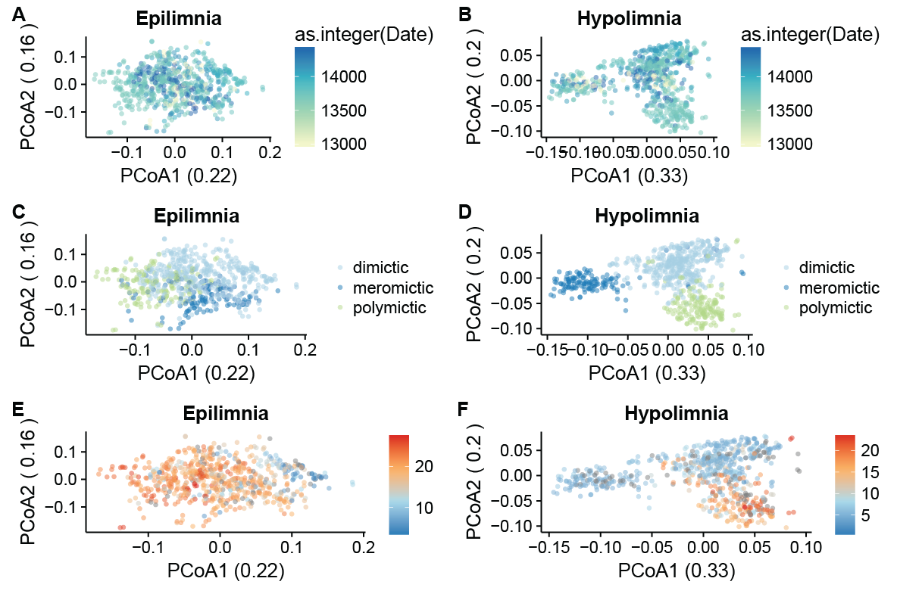**Figure S6. Alternative colorations of Figure 2.**

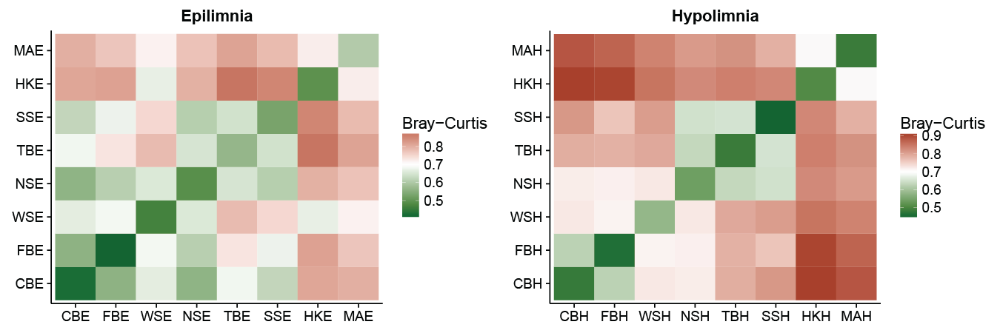

**Figure S7. Pairwise Bray-Curtis Dissimilarity between sites.**

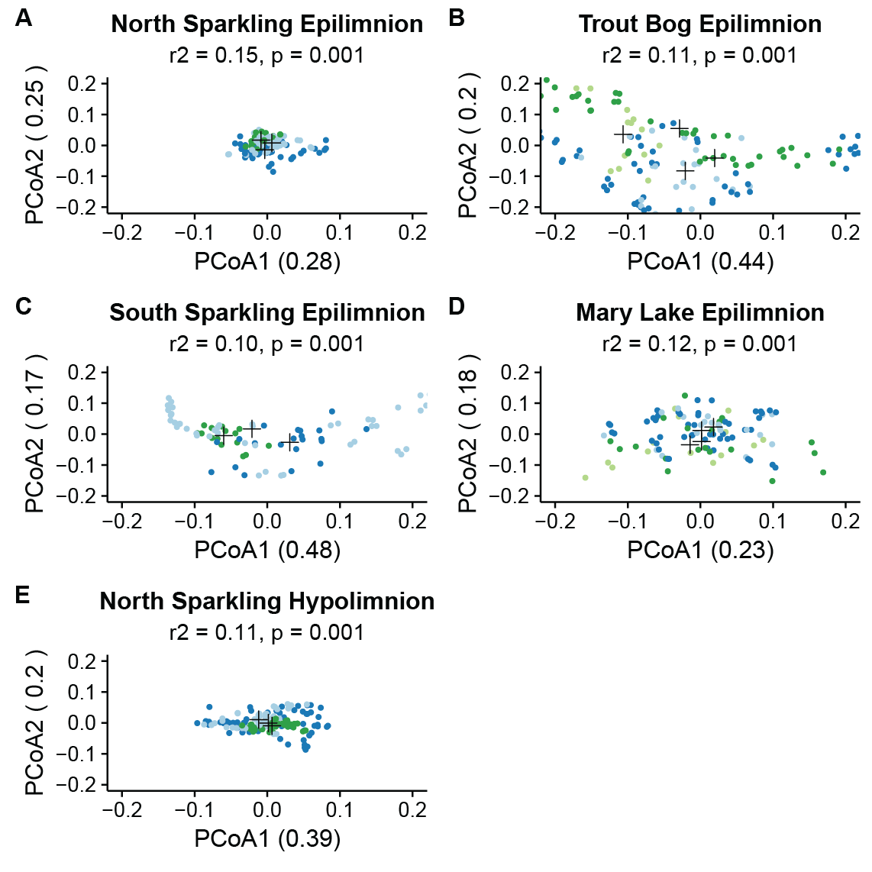**Figure S8. PCoA of epilimnia and hypolimnia by lake by year**.

**Figure S9. Time decay plots.**

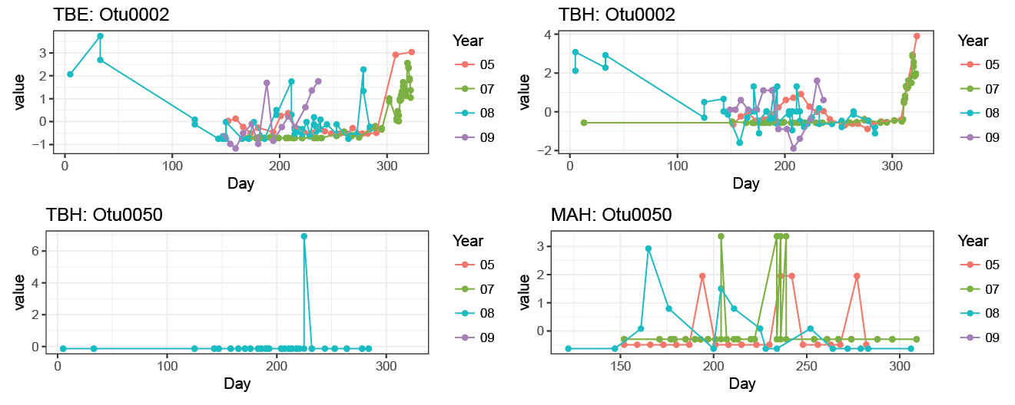

**Figure S10. Annual trends in OTUs.**

library(OTUtable) # You will need these three packages

library(ggplot2)

library(reshape2)

data(otu_table) # Load the OTU table

# Write function to plot multiple years at once.

annual_trends <- function(lake, otu){

bog <- bog_subset(lake, otu_table)

year1 <- year_subset("05", bog)

year2 <- year_subset("07", bog)

year3 <- year_subset("08", bog)

year4 <- year_subset("09", bog)

# Since sites have different years sampled, these if statements identify which years are present

if(dim(year1)[2] > 0){

# Once years present are identified, normalize and combine into a single table

year1 <- zscore(year1)

year2 <- zscore(year2)

year3 <- zscore(year3)

year4 <- zscore(year4)

ztable <- cbind(year1, year2, year3, year4)

}else if(dim(year1)[2] == 0 & dim(year3)[2] > 0){

year2 <- zscore(year2)

year3 <- zscore(year3)

year4 <- zscore(year4)

ztable <- cbind(year2, year3, year4)

}else if(dim(year1)[2] == 0 & dim(year3)[2] == 0 & dim(year4)[2] > 0){

year2 <- zscore(year2)

year4 <- zscore(year4)

ztable <- cbind(year2, year4)

}else{

ztable <- zscore(year2)

}

# Format the final table

ztable <- melt(ztable)

ztable$Year <- substr(ztable$Var2, start = 9, stop = 10)

ztable$Day <- format(extract_date(ztable$Var2), format = "%j")

# Save the results for plotting

plot <- ggplot(data = ztable[which(ztable$Var1 == otu), ], aes(x = Day, y = value, group = Year, color = Year)) + geom_point() + geom_line() + theme_bw() + labs(title = paste(lake, otu, sep = ": "))

return(plot)

}

# Example Usage – 3 letter site code includes 1st 2 for site (see Table 1) and letter 3 for layer (E = epilimnion, H = hypolimnion. OTU designation is case sensitive, and number must contain 4 digits.

plot_this <- annual_trends(“TBE”, “Otu0012”)

plot_this

# You may get warning messages about points being removed. That means the OTU was not present in those points

# If all points were removed and no plot is produced, it was not present in that site

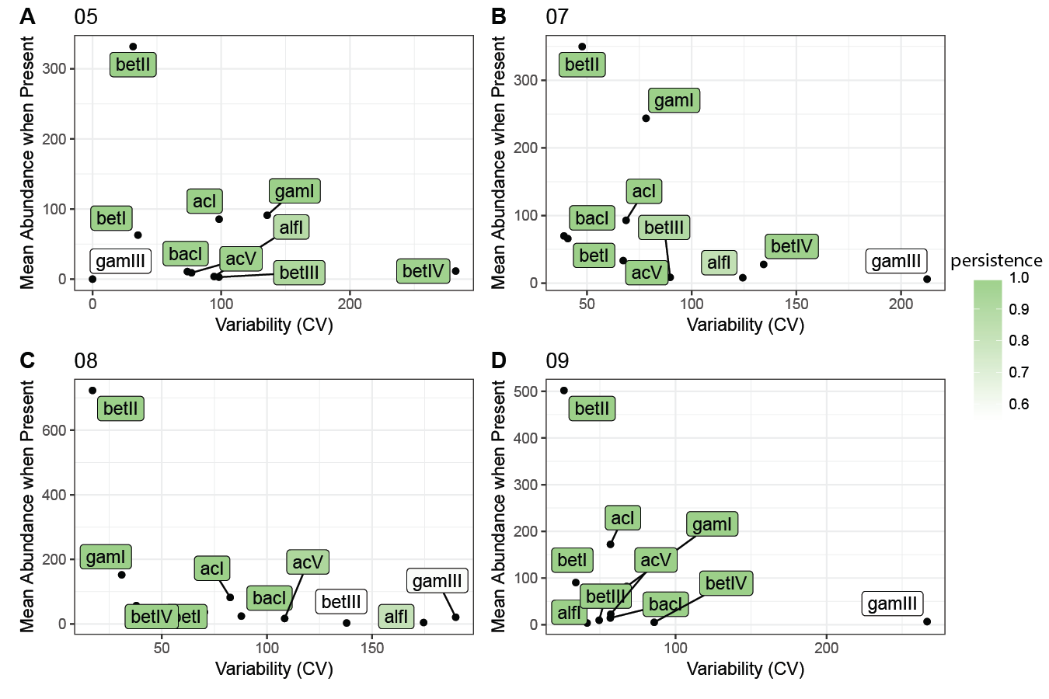

**Figure S12. Lineage traits by year.**