Dr. Alexandra Linz

University of Wisconsin - Madison

(414) 630-7850

[amlinz@wisc.edu](mailto:amlinz@wisc.edu)

Dr. Ramon Massana Molera

Special Issue Guest Editor

Limnology & Oceanography

June 14, 2019

Dear Dr. Massana Molera,

Thank you for the opportunity to revise our manuscript “Time-series metatranscriptomes reveal conserved patterns between phototrophic and heterotrophic microbes in diverse freshwater systems” for consideration in Limnology & Oceanography’s special issue on microbial metagenomics. The reviewer comments were insightful, and we incorporated many in our revisions. We have included detailed responses to the reviewers’ points below, with our responses marked in red.

A major critique of our manuscript was that we did not sufficiently explore the novelty of our dataset, specifically in regards to the time series aspect. To remedy this, we have performed new analyses focusing on the timing of expression in various functional categories, presented in the new figures 3 and 4, and we have substantially revised the text to incorporate these new results. We now present more of the nuances of this research. Additionally, we have removed all discussion of comparisons between lakes, as we agree with the reviewers that one lake of each type is not a large enough sample size to draw conclusions about differences due to trophic status. Finally, we have clarified our methods throughout the text, as directed by the reviewer comments.

We thank the reviewers for their work towards improving our manuscript. All co-authors have approved these revisions. Please let us know if any further revisions are required.

Sincerely,

Alexandra Linz

REVIEWER COMMENTS TO AUTHORS:

Reviewer: 1

Comments to the Author

This manuscript by Linz and colleagues reports diel patterns in gene expression (via

metatranscriptomics) linked to taxon and functional gene abundance and biogeochemistry in

three freshwater lakes over two days. Lakes were sampled 12 times at 4-hour intervals over a

two-day period. The trends are interesting, though not surprising (generally, more photosynthesis

during the day). A third sampling day would have helped to bolster these analyses, and replicates

by lake type or three of the same type of lake would have helped too. As it is, this is n=1 for each

type of lake, making lake-to-lake comparisons difficult. Still, this is a relatively thoroughly

sampled dataset, considering the labor and expense involved in collecting and analyzing these

types of data.

There is not a very clear visual presentation of the day vs. night trends within and among lakes.

The closest representation of this is in Figure 3, which shows some of this information for one

lake. Given that these diel gene expression trends seem to be the key point that the authors wish

to communicate, I recommend making these trends more visually clear, e.g., with an additional

figure or additional figure panels added to Figure 3 (more details below).

I commend the authors for placing detailed laboratory protocols in the supplement.

Specific comments:

Title: Given that the “ecological interactions” are speculative parts of the discussion, as opposed

to conclusions from clearly presented results (see below), please remove this part of the title.

This change has been made.

Ln 193-194: Hopefully, this was also the seed sequence for the cluster. As in, hopefully the

contigs file was sorted in descending order of contig length prior to clustering with CD-HIT.

Either way, please indicate here whether or not this was done.

Yes, sequences were first sorted in descending order, and the longest sequence was the seed sequence for each cluster. This has been clarified in the text.

Ln 197-198\*: “The longest gene in each cluster (used as the seed sequence to generate each cluster) was chosen as the representative sequence and used as the mapping reference.”

\*Throughout our response, line numbers refer to the revised document.

Ln 197-201: I do not understand this description of how taxonomy was assigned. Was the best

hit for each coding region considered, and then some “most frequent” taxonomy identified for

the whole contig? In the case of relatively complete genome bins, a more standard approach

would have been construction of a phylogenetic tree from single-copy genes. Was this not

possible due to relatively incomplete bins in most cases? Please clarify this section.

Reviewer 1 is correct that the standard phylogeny-based classification methods would not work well in our case because of incomplete bins and short contigs. To approximate taxonomy without being able to use conserved single-copy gene sets, we looked at the best hits for coding regions in each contig/bin and aggregated their classifications. Where classifications of coding regions were consistent across a contig/bin, we assigned that taxonomy to the contig or bin. If the classifications of coding regions conflicted, we assigned the lowest consensus taxonomy possible or, in many cases, no taxonomy was assigned. This method has been clarified in the text:

Ln 201-209: “Many bins were incomplete, and many contigs were too short to classify using the phylogeny of single-copy genes; therefore, we aggregated the taxonomic assignments of coding regions in each contig/bin to classify these sequences. Coding regions were first classified based on their best hit in the Integrated Microbial Genomes database (IMG, accessed Jan. 2017) (Markowitz et al. 2012). Bins and unbinned contigs from the metagenome assemblies were classified by taking the consensus taxonomy of the best hit for each coding region on a contig/bin using in-house McMahon Lab scripts. If contigs or bins were too short to classify or had conflicting coding region classifications, we assigned no classification. In these cases, each coding region retained the IMG-derived classification of its best hit”

Additionally, the Python scripts used for this classification method can be found at <https://github.com/McMahonLab/geodes/tree/master/bioinformatics_workflow/scripts>

.

Ln 218-219: Please provide exact numbers for these “many samples from day two in the TB time

series [that] failed to meet quality control standards,” and do you have any insights as to why

these particular samples might have failed more often than others?

The specific quality metric these sample failed on was low yield. There was insufficient material to sequence, even using a low input protocol. We have changed the sentence quoted by the reviewer above to include this information, along with the number of missing samples and timepoints in the Trout Bog time series:

Ln 231-232: “Nine samples from day two in the Trout Bog time series were not analyzed due to insufficient yield, resulting in two lost timepoints.”

We are not sure why Trout Bog samples tended to fail more often than others, but some ideas include interference of humic acids with the extraction protocol, RNase contamination during either sampling or extraction that specifically impacted these samples, or insufficient pressure in the peristaltic pumps used to filter the samples (which had been in use for several days and were having trouble maintaining battery charge). Because we do not have any reasons beyond speculation, we prefer not to comment on this in the text.

Ln 231: Maybe this acronym was already spelled out, but I couldn’t find it in a quick scan back

through the paper. What is PAR?

This abbreviation, which stands for photosynthetically active radiation, was defined in Ln 144.

Ln 265-271: Please place these clade names in larger taxonomic context.

We recognize that the established freshwater taxonomy needs context for those who do not work directly in this area, and apologize for this oversight. Therefore, we have added Linnean taxonomy at the finest resolution available wherever freshwater groups are mentioned in the text.

Ln 253-256: “Many of the most highly expressed non-photosynthetic genes in Lake Mendota belonged to *Actinobacteria* (acI-A and acI-B clades, both members of *Actinomycetales*), including translation elongation factors, a sodium:solute transporter, and a sugar transporter.”

Ln 269-281: “Genes from members of *Actinobacteria* acI-B (*Actinomycetales)* were expressed and abundant in all lakes, but especially Trout Bog. This is consistent with previous research identifying acI-B2 as an acidic lake specialist (Newton et al. 2007). The betIV-A clade (LD28, *Methylophilales*) contributed a surprising number of expressed genes in Lake Mendota, as did the alfV-A clade (Candidatus Fonsibacter, a sister clade to the marine SAR11) and the acI-A clade (*Actinomycetales)*. Genes from the bacIII-B clade (*Sphingobacteriales)* was highly expressed in Sparkling Lake, but had low abundance. Genes from members of betIV-A were abundant in Trout Bog, but not proportionally highly expressed. Pnec clade (*Polynucleobacter)* genes, known to be endemic to bog lakes and particularly Trout Bog, were not as expressed or abundant as we had expected it to be (Jezberová et al. 2010; Linz et al. 2017). However, we noted many additional transcripts classified as *Burkholderiales* that may be Pnec, but could not be classified to the clade level, likely due to the high diversity of this group (Jezberová et al. 2010; Hahn et al. 2016).”

Ln 305-306: This is not particularly obvious in the data in Tables 2-4. It could be because of the

different categories of sugar transporters (i.e., some categories show differences while others do

not, and the categories that do differ by lake). A more useful description in the text would be

how many and which categories of sugar transporters exhibited significant diurnal cycles for

each lake. Some of this information appears in subsequent sentences in this section, but I

recommend reworking this section to make it clear that sugar transporters were not always

significantly different day vs. night, and in fact, many were not.

To address Reviewer 2’s comments regarding the lack of insight from the day vs. night analyses, we have removed Tables 2-4 and replaced them with plots showing the time of maximal expression for both cyclic and non-cyclic genes (new Figure 3). This also addresses Reviewer 1’s comment that we need to make it clear that not all sugar transporters were significantly differentially expressed.

Ln 345-346: There is no presentation of data on potential metabolic handoffs within the Results

section. Is the implication that the authors plan to speculate on this in the Discussion section? If

so, please make that more clear, otherwise delete this.

We have removed this sentence.

Ln 361 and 376: Change “genes” to “some genes” (see comments above related to Ln 305-306)

This change has been made here and throughout the text.

Ln 364-375: As mentioned above, you have n=1 for each lake type with no within-type

replicates. At a minimum, that should be mentioned as an explicit caveat here, but I recommend

deleting any interpretations related to comparisons across lake trophic statuses.

This comment makes sense, and we have deleted the entire paragraph in the discussion detailing lake differences.

Ln 407-408: If you are going to evoke the “Black Queen Hypothesis,” please explain what it is.

We have added the following explanation of the Black Queen Hypothesis to this sentence:

Ln 394-397: “The origin of metabolic exchanges that lead to co-dependencies has been postulated to be an important driver of evolution in aquatic communities, as in the “Black Queen Hypothesis,” where interdependencies among microbial community members leads to genome reduction (Morris et al. 2012).”

Figure 1: Without color, this is not much more useful than a table. The reader needs to consult

the list beside each figure to understand the order of points, and there is no easy way to visually

compare between lakes. Perhaps journal color charges are part of the consideration here, but if

not, please color the points in each graph (e.g., one color each for photosynthesis-related, sugar

metabolism-related, and other, or whatever groupings are most meaningful). I may have missed

color figures elsewhere in the reviewer packet, but they were not in the bundle with main text,

figures, and supplement. It would also be useful to number the non-autotrophic genes in panels

D-F by their actual rank numbers, instead of 1-10. Given that hypotheticals/unknown function

can exist in both lists, it seems like the first lists (A-C) should overlap more with the second lists

(D-F); I suggest instead to remove hypotheticals/unknowns, at least from the second lists (though

Ln 244 suggests that unannotated genes were removed, so I am not sure how those were defined,

considering that unknowns are still showing up here?). Panel E: How is phycoeurythrin not

considered at least somewhat photosynthesis-related?

We have followed Reviewer 1’s advice on this figure and added color to make this figure more informative. Rather than color-coding by inferred function, we have chosen to color code by phylum instead. We believe this is more informative and relies on fewer assumptions about the most expressed genes. We have also re-numbered the non-autotrophic genes to reflect their rank in the full dataset, and have removed unknown genes and phycoerythrin from this list. We have elected to retain unannotated genes in panels A-C to demonstrate how many of the most expressed genes in our dataset are unannotated and/or unclassified.

However, per Reviewer 2’s comments, we have moved this figure to Supplemental Figure S1.

Figure 2: Same comments about color. I do not understand what the clades are in D-F; please

explain these labels in the figure caption. The figures should be stand-alone without requiring

consultation of the main manuscript text to understand labels.

We have once again added color indicating phylogeny – in panels A-C, the color indicates kingdom, while color indicates phylum in panels D-F. This also helps provide context for the clades presented in panels D-F, which we have further clarified in the figure legend.

Figure 3: This is a nice figure aesthetically, but I wonder how well it actually represents

meaningful data. The color-coding by the maximum peak would seem to artificially select for a

visual trend. For comparative purposes, could the authors prepare the same figure for all three

lakes, either as three panels here or with the other two panels in the supplement? Otherwise, it

seems like there is the potential for cherry-picking the data that look nice. It could also be useful

to see this as an all-genes comparison of the top x (100?) most highly expressed genes across the

dataset in the supplement. I suspect that most of those genes will not show diel trends, which is

fine, but that will help to put the genes that do show patterns in better context.

To address this comment, we have revised this figure to include 3 panels, one for each lake. All lakes exhibit cyclic trends in photosynthesis genes. Below, we have generated a version of the Mendota cyclic trends figure with no color-coding by maximum peak. We feel that without the color, it is difficult for readers to trace lines over time, and have opted to retain this color-coding for better comprehension.

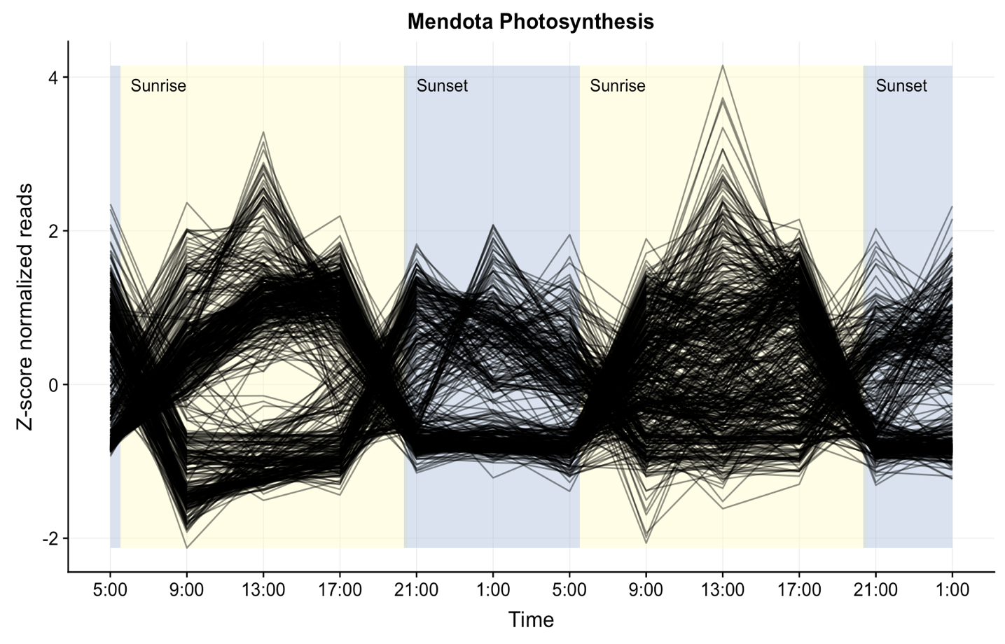We have also generated plots showing the top 100 most abundant genes and 100 randomly selected genes from the dataset (below). Although 100 genes were tested, we are only plotting the few that were significantly cyclic. These plots show that cyclic trends are not found throughout the entire dataset. In the interest of space, we have chosen not to include these plots in the supplemental figures.

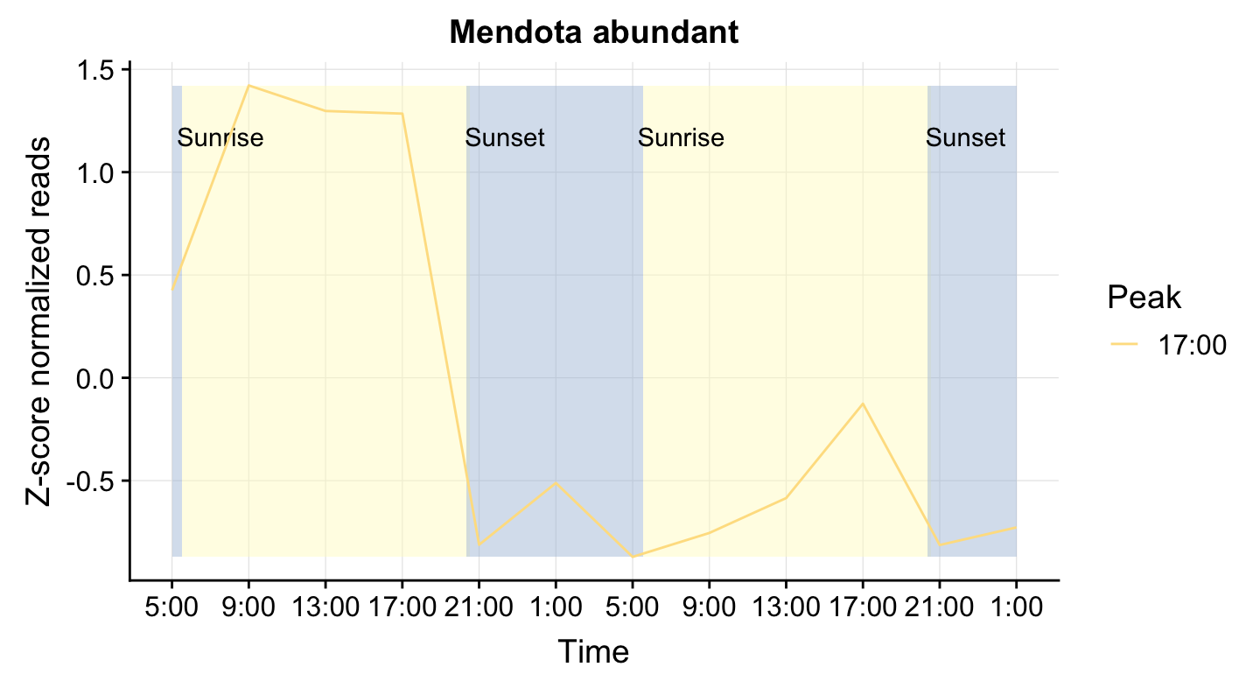

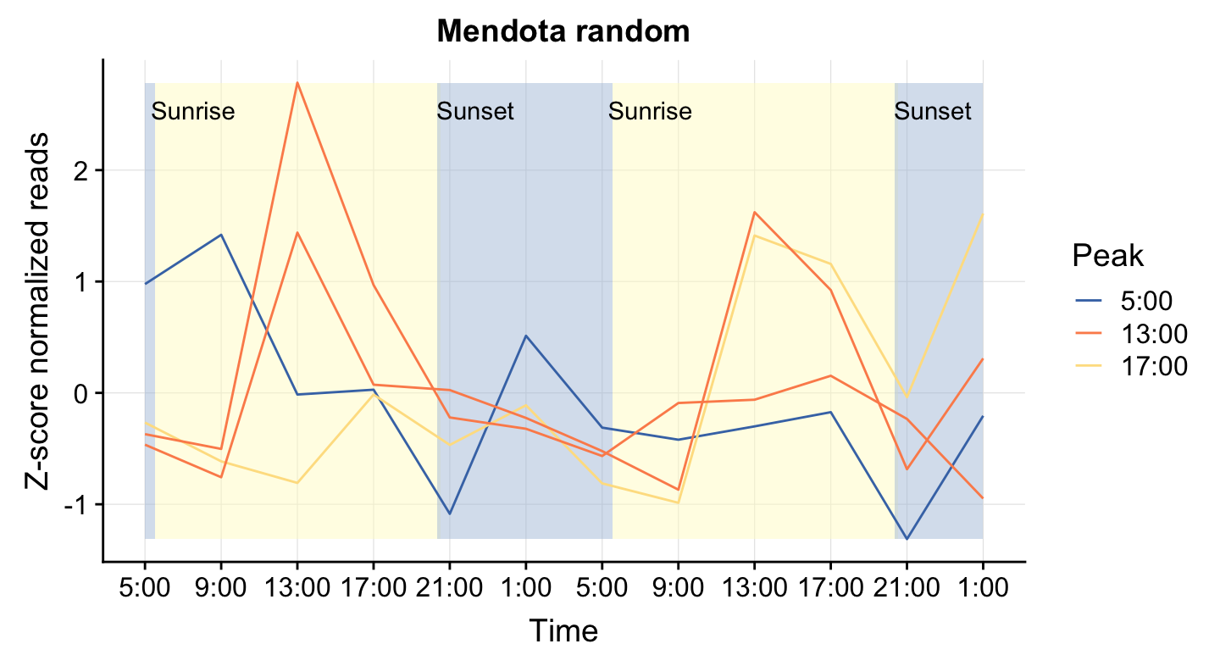

Reviewer: 2

Comments to the Author

This is an amazing dataset. But I couldn’t find important information about study design and data

analysis that would have allowed me to understand the analyses better. I may have missed some

of this information, and I apologize if that’s the case.

The two critical issues for me are:

1) The authors indicate that they used internal standards in the methods, but never mention when

they are used in data analysis presented in the paper and when they aren’t. Because the diel

cycling of gene expression is a major focus of this paper, it is important to know when the data

are actual counts per volume of lake water and when they are percentages. If the latter, the genes

that appear to have higher night time expression may simply arise from the large change in

photosynthesis transcripts. The units for Fig. 3, in particular, aren’t explained.

All data presented was converted to transcripts/L using the internal standard. We have clarified this in the methods section and figures.

2) The analysis yields no real insights. The major points seem to be that photosynthesis occurs in

the day and heterotrophic bacteria take up sugars made by phytoplankton (Line 32 and 351,

particularly). Since this is one of the largest metatranscriptome analyses yet done, and the study

design is really nice, there must be some substantive insights to be gleaned from the data. Line

35 in the abstract seems to say that this paper discovered that photosynthesis occurs at different

times during a diel cycle. I’m sure there is more nuance to the findings, but they do not come

through in the manuscript.

To address this comment, we have replaced the day vs. night differential expression analysis with a more sophisticated time-of-maximal-expression analysis. This better reveals differences in when each functional category is most expressed, and how this expression differs by lake. We have removed Tables 2-4, which reported results of the day vs. night analysis, and modified Figure 4, which showed the taxonomy of each functional category in day vs. night, to reflect this change. We made these changes with the goal of better demonstrating the nuanced findings of this dataset.

Regarding the comment about reporting patterns that might have already been expected based on first principles (e.g. photosynthesis genes expressed in the daytime), such results may not seem exciting because they lack a "surprise", but if they have not been explicitly documented before *in situ*, the analysis is still valuable. We should not take for granted that such patterns exist without measuring them. We agree that the dataset could be mined for many more stories, but to keep this current manuscript focused, we opted to focus on the story that matched our original hypotheses going into the study.

Major comments:

Line 126: How many replicates for each lake and each time point? This info is particularly

necessary to interpret the section on within versus between sample diversity.

This is an excellent point, and we apologize for the oversight. We have also added a new supplemental document with information on how many and which filters were sequenced for which timepoints.

Ln 148-150: “To collect RNA, water from the integrated epilimnion sample was pumped through four 0.22-m polyethylene filters (Pall, Port Washington, NY, USA).”

Ln 211-215: “Three samples from each timepoint were submitted for metatranscriptomic sequencing at the JGI. Some samples failed to pass quality control standards and were replaced by the fourth filter from that timepoint. When we were unable to sequence three samples for a timepoint, we replaced those samples with the fourth replicate for other timepoints, resulting in between one and four replicate metatranscriptomes for each timepoint (Table S2).”

Line 235. This section and Figure 1 are uninformative. A laundry list of highly expressed genes

does not do justice to this novel dataset.

We feel that this overview of the dataset is necessary to provide context before getting into the more detailed findings. As Reviewer 2 notes, this dataset is novel, largely because there are only a handful of existing metatranscriptomic datasets from freshwater systems. Although the annotations and classifications of the top expressed genes in our dataset seem obvious given what we know about freshwater bacteria, expression data on these systems has not previously been reported.

However, we recognize that reading a laundry list is not particularly compelling, so we have significantly reduced the level of detail in this section (Ln 258-281) and cut its length by ~50%. We have moved former Figure 1 to supplemental Figure S1 (with modifications suggested by Reviewer 1).

Line 305 paragaraph: Are the genes present in the genomes but not expressed, or they are

missing from the genomes? For example, it’s stated that the Actinobacteria only have R/S/M

transporters differentially expressed; do they have ribose transporters that they aren’t expressed

differentially, or do they not have ribose transporters? The first option indicates differential

transport by the Actinos but the second indicates genetic capability differences between

taxonomic groups. Several statements in this paragraph could be interpreted either way. Also see

Line 370 for another section where it’s not clear if this is due to differences in gene expression or

differences in genome content.

To capture the greatest amount of functional potential in this dataset, we mapped to genes, not genomes. Therefore, we cannot determine if no expression indicates that a gene is present in a taxonomic group but not expressed or that a gene is absent in a taxonomic group. In the case of *Actinobacteria* in SP, we do see expression of ribose transports, but they are not differentially expressed in day vs. night.

Line 342: I didn’t see evidence for ‘generalizable interactions’. Upregulation of photosynthesis

during the day and phytoplankton supporting heterotrophic bacteria are already generalized and

can’t be claimed as a new finding here. Also, Line 362: bacterial uptake of sugars released from

phytoplankton has been known for many decades.

We have removed the statement about generalizable interactions and changed Line 341 to:

“In this study, we sought to identify diel trends in freshwater microbial community gene expression to hypothesize metabolic interactions between community members.”

Although bacterial uptake of phytoplankton sugars has been known to occur in lab-based mesocosms and has been hypothesized to drive community composition, there is little evidence that this metabolic exchange takes place in naturally occurring communities. Our metatranscriptomic data provides important support for this hypothesis and furthermore, provides information on what specific types of sugars might be exchanged *in situ*.

Line 365: N=1 for each lake type, so this isn’t the right dataset to address differences across

major categories of lakes. The distinctions between these particular lakes might hold up across

the classes if more data were available, but multiple types of each class would be needed to draw

these conclusions. I don’t mean to minimize the effort it took to get these data, just that this is

not a hypothesis that can be robustly addressed.

We have removed this section of the discussion per Reviewer 1’s comments as well.

Line 417: This study did not measure algal exudates. That might be a hypothesis to explain the

diel transcription patterns, but this sentence goes beyond that.

We have removed this sentence.

Line 293: Why did you decide to lump all the day and night samples together for the statistical

analyses? Since you have a high coverage, time-resolved dataset, why not to take advantage of

this? Previous work (Ottesen and Aylward, for example) have found shifts in timing of gene

expression during the day that have been really interesting. Perhaps novel findings will emerge if

you change this to a full time-series analysis.

As discussed in Reviewer 2’s major comments section, we have replaced day vs. night analyses with a more nuanced time of maximum expression analysis. We originally did not include this analysis due to concerns over false positives in this very large dataset, but by aggregating by functional category, we have more confidence in these results.

To reflect this change, we have also substantially rewritten the Results section “Diel trends in gene expression” and modified Figure 4 to include a time component.

Figure 4 confused me. Why are the categories in different places for each lake? For example, if

photosynthesis was in the upper left for all three, it would be easy to compare among the lakes.

Some gene categories may be analyzed for only two lakes, but they could still be lined up with a

blank region where no analysis was done (presumably because that gene category had no

significant differences in that lake?). Did you try plotting these as total reads? It would be

interesting to see how the number of transcripts being made by a taxonomic group changes

between night and day.

Because we have replaced the day vs. night analysis, we have substantially modified Figure 4. It now shows consistent plots across lakes.

Picky things:

Line 63: The term phototroph typically includes photoautotrophs and photoheterotrophs. There

are some of both in this dataset. Defining phototrophs for this paper as just the photosynthetic

microbes is confusing. Where do the photoheterotrophs fit in?

Limnology research has typically focused on phytoplankton (photoautotrophs) vs. bacterioplankton (heterotrophs), and previous research on connections within aquatic microbial communities used these categories. While there are indeed photoheterotrophs, we cannot determine co-existence of phototrophy and heterotrophy in a single organism, or even phototrophy and autotrophy, in our gene-based analysis. Therefore, we prefer to use the terms phototrophic (indicating that we know it’s photosynthetic, but don’t know about its carbon metabolism) and heterotrophic (indicating that we know it uses external carbon source, but we don’t know if it is photosynthetic or not).

However, Reviewer 2 is correct that photoheterotrophy may be an important and diel metabolism in freshwater, and we have added more information on two potential types of photoheterotrophy observed in our dataset (opsin-related genes and aerobic anoxygenic photosynthesis genes). These metabolisms are discussed in Ln 112-115, Ln 319-324, and Ln 353-357. They have also been added to the new Figure 3.

Line 98: 80% release of carbon as DOC is super high. I don’t doubt that someone reported it

somewhere, but the general consensus in the literature is ~20%. 99% doesn’t even make sense,

since there is nothing left for the phytoplankton for cell maintenance or division.

We thank the reviewer for clarifying this, and we have revised this number to 20% in Ln 98.

Line 257: Confusing wording; the genes of these taxonomic groups were expressed, not the

taxonomic groups themselves.

We have changed this wording to clarify that we are discussing genes (Ln 258-281).

Line 292: This is a key section for which the units on graphs should be make clear: are these

percents of a pool, or transcript numbers normalized to volume filtered, or something else?

We clarified units through the figures and their legends to reflect when we used transcripts/L or a different metric. The particular line referenced here was removed as part of previous revisions.

Line 321: 15% of the ROS genes, or 15% of all genes?

This sentence was removed as part of the above revisions.