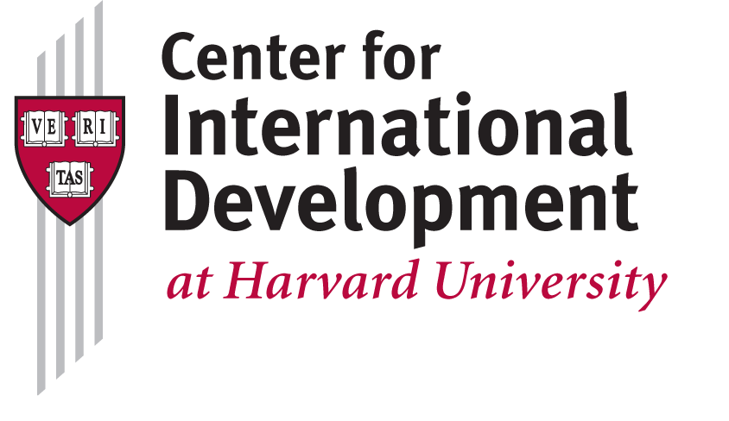**Web Developer**

Center for International Development at Harvard University – Cambridge, MA

The Center for International Development at Harvard University (CID) has an immediate opening for a full-time front-end web developer with extensive project management and client experience to manage the successful implementation of web-based projects within the Growth Lab. Projects usually involve open-source, data intensive web platforms that allow users around the world to get the insights from CID’s research that can help them improve their livelihoods and their economies. Projects may involve international travel (Mexico, Colombia, other).

This is a position where the successful candidate will:

* Work with our UI designer to implement designs in clean, modern cross-browser, mobile friendly, and standards-compliant HTML5 / CSS / Javascript
* Organize current code bases and optimize loading speed in coordination with the backend developer (Django / Python)
* Help build and integrate new visualizations for large amounts of data into websites
* Work with users to understand profile and needs and utilize good communication to translate complex technological concepts to lay users.

**Required skills and experience:**

* Strong working knowledge of the modern web front-end stack (HTML5 / CSS3 / Javascript)
* Unix/Linux and Git (we use Github for everything: https://github.com/cid-harvard/)
* Ability to communicate day to day design issues with programmers and non-programmers
* Ability to read and understand code written by others
* Strong understanding of design patterns and object oriented programming
* Excellent debugging and troubleshooting skills
* Strong organizational skills and understanding of software lifecycle
* Working with clients/users; implementing projects on-site
* Bachelors in Computer Science and 3+ years of equivalent work experience

**Desired skills and experience:**

* Frontend testing experience (Selenium etc.)
* Curiosity and awareness towards the developments within your field(s) of expertise
* Basic familiarity with the Python / Django environment
* Visualization (d3.js for us) skills

**Salary range**

* Competitive salary based on your experience
* + generous Harvard benefits

Our team consists of a strong group of interdisciplinary researchers and academics, alongside a small but growing number of technologists. You are expected to be a self-starter who is able to fulfill tasks without micromanagement, and you are encouraged to be involved in all parts of the ideation and development process. It’s an environment that places a premium on creativity and good humor.

The position is full-time and based in Cambridge, MA.

**How to Apply**

Candidates should send cover letter, resume and examples of relevant project(s) to Chuck McKenney at [cid@hks.harvard.edu](mailto:cid@hks.harvard.edu?subject=Atlas%20Developer) with ‘Atlas Developer’ in the subject line.

**Department Summary**

The Center for International Development at Harvard University (CID) is recognized as a global leader in research to advance human well-being and economic progress in the developing world by expanding the understanding of development challenges and offering viable solutions to global poverty.