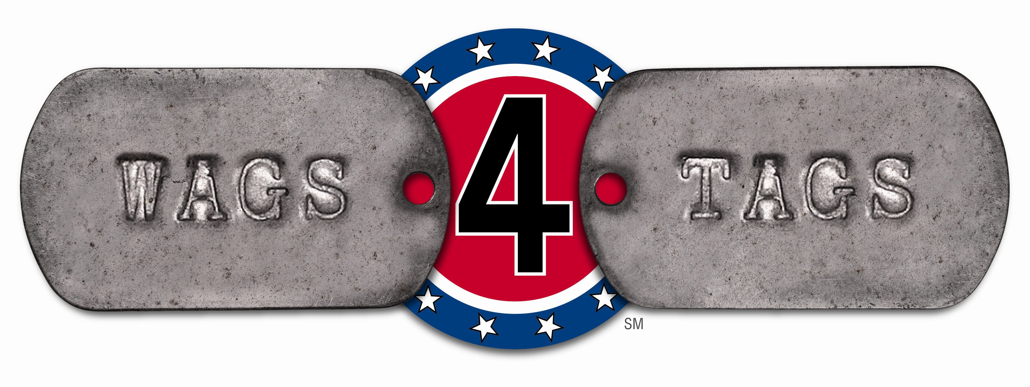

VOLUNTEER APPLICATION & LIABILITY RELEASE

PART A

First Name:_________________________ Last Name:______________________

Primary Contact #:___________________ Secondary contact #:_______________
Are you over 18 years of age?__________ (Y/N)

Home address:______________________________________________________________
(Street, City, State, Zip Code)

Email address:______________________________________________

Employer:___________________________________________________________________
(Name & address)

PART B
*Availability to volunteer: (Ex., weekends, weekdays, evenings, events) _________________________
______________________________________________________________________

*Type of volunteer work you are interested in (check all that apply and explain experience in each):

___ General Administration (database, web maintenance, bookkeeping, volunteers admin) ______
___________________________________________________________________________.
___ Animal Care (train, foster, transport, groom). _________________________________________
____________________________________________________________________________.
IF “YES” PLEASE COMPLETE EITHER TRAINER APPLICATION OR FOSTER APPLICATION FOUND ON WEBSITE

___ Fundraising (organizing/working events, grant writing, public relations)_________________________
_____________________________________________________________________________.

___ Social Work (therapist, psychologist, liaison with VA Hospitals/Military) _____________________
_____________________________________________________________________________.

___ Other (explain)____________________________________________________________________.

*What special skills, talent, experience or interests do you have that would help us: (ex., photography, clinical research, corporate liaisons, foreign language)____________________________________________
_________________________________________________________________________________
*Anything else we need to know about you? (ex., are you a Veteran, memberships, experience working with animals or persons with disabilities)___________________________________________________
_______________________________________________________________________________.

PART C

*How did you learn about Wags 4 Tags? (ex.,Media, Presentation, Event, Web)_____________________
_____________________________________________________________________________.
*What do you know about Wags 4 Tags? ___________________________________________
_______________________________________________________________________________.

*Do you drive or have regular access to a car? ________________________________________________.
*List previous Volunteer work, if applicable___________________________________________________
_______________________________________________________________________________.
*Why do you want to volunteer for Wags 4 Tags?_____________________________________________
________________________________________________________________________________.

PART D

*Do you consent to a routine background check?___________(Y/N)

*Have you ever been reported to/subject of State or Federal investigation or disciplinary proceedings?
_______ (Y/N)
If “Y”, explain:____________________________________________________________________
________________________________________________________________________________

*Have you ever been convicted of a felony or misdemeanor?______ (Y/N).
If “Y”, explain:____________________________________________________________________
________________________________________________________________________________.
*Initial next to each statement:
_______ I understand that Wags 4 Tags reserves the right to perform criminal history background checks as deemed appropriate.
_______ I understand that this is an application for volunteer position and not a contract of employment. I agree that as a Wags 4 Tags Volunteer, I may not accept payment for my services and that I will incur the cost of transportation.
________ I understand that as a volunteer I am required to abide by all rules and regulations of the Organization.
________ Wags 4 Tags complies with local, State and Federal equal employment opportunity regulations; qualified Volunteers are considered for all positions without regard to race, creed, color, religion, sexual orientation, age, disability, or any categories protected local, State or Federal laws.
________ I, my family, heirs and representatives release Wags 4 Tags from any and all liability for any and all damages (including bodily injury or property damages) that may result in the performance of direct or indirect volunteer services for and on behalf of Wags 4 Tags.
_______I agree to conduct myself in a professional manner at all times while representing Wags 4 Tags and will follow policies and directions provided by the President, Vice President or Board of Advisors
_______I agree that I will not be compensated for any promotional appearances (to include print, media, internet) however allow Wags 4 Tags to use my name, image, likeness for promotional purposes for the betterment of the Organization.
_______ I attest that the statements made on this Volunteer Application area true, complete and correct. I understand that any misrepresentation, omission of information or misleading and incomplete information shall result in a possible disqualification from consideration or dismissal as a volunteer. Wags 4 Tags retains the right of refusal or acceptance, and this application does not ensure that volunteer placement will be made.

___________________________________ ______________________
Applicant Signature Date
____________________________________ __________________________
Parent Signature (if applicant is under 18) Date

Permission to Use Photographs and/or Video
I, __________________________________________ grant
WAGS 4 TAGS, INC. the right to take my photographs and/or video in connection with the above-identified organization. I authorize WAGS 4 TAGS, INC., its assigns and transferees to copyright, use and publish the same in print and/or electronically.
I further grant WAGS 4 TAGS, INC. royalty-free permission to use such photographs or videos of me with or without my name for any lawful purpose as it pertains to the aforementioned organization.
I have read, understand and hereby approve this document:
Signature _________________________________
Printed name ______________________________
Address __________________________________
Date _____________________________________
Signature, parent or guardian _______________________
(if under age 18)

