Unit 3: Organic Chemistry, Structure & Bonding

Unit 3.01 Orgo – Line drawings

Q#: | 19
Serial #: | T2_2024_Q19_D75_S3.01
Unit | 3.01 Orgo - Bonding
Used | T2_2024, ^0.85, *0.75
Stem | How many valence lone pairs of electrons are present in the zwitterionic form of asparagine?
A) | 9 | 0.06
B) | 7 | 0.11
C) | 6 | 0.08
D) | 8 | *0.75
Ans: | D
Variants
Comments

Q#: | 20
Serial #: | T2_2023_Q20_D79_S3.01
Unit | 3.01 Orgo - Bonding
Used | T2_2023, ^0.75, *0.79
Stem | How many valence lone pairs of electrons exist in this molecule?
A) | 6 | 0.11
B) | 5 | 0.06
C) | 8 | 0.05
D) | 7 | *0.79
Ans: | D
Variants
Comments

Q#: | 19
Serial #: | T2_2023_Q19_D44_S3.01
Unit | 3.01 Orgo - Bonding
Used | T2_2023, ^0.70, *0.44
Stem | Which of the following species is correctly represented using line-bond convention?
A) |  | *0.44
B) |  | 0.18
C) |  | 0.20
D) |  | 0.18
Ans: | A
Variants
Comments

Q#: | 16
Serial #: | T2_2023_Q16_D79_S3.01
Unit | 3.01 Orgo - Bonding
Used | T2_2023, ^0.65, *0.79
Stem | Assuming all atoms have complete octets, what best describes the formal charges in this molecule?
A) | It contains both a positive and negative formal charge | *0.79
B) | It contains a single positive formal charge | 0.05
C) | It contains a single negative formal charge | 0.11
D) | It contains no formal charges | 0.05
Ans: | A
Variants
Comments

Q#: | 13
Serial #: | Ex_2023_Q13_D93_S3.01
Unit | 3.01 Orgo – Bonding
Used | Ex_2023, ^0.85, *0.93
Stem | What is the total number of lone pairs of electrons in all the following structures, combined?
A) | 11 | 0.02
B) | 10 | 0.04
C) | 12 | 0.01
D) | 9 | *0.93
Ans: | D
Variants
Comments

Q#: | 378
Serial #: | T2_2015_Q30_D90_S3.01
Unit | 3.01 Orgo - Line drawings
Used | T2_2015
Stem | Which of the following is NOT an acceptable representation for propane?
A) |  | 0.09
B) |  | 0.006
C) |  | 0.006
D) |  | *0.90
Ans: | D
Variants
Comments

Q#: | 379
Serial #: | T2_2016_Q29_D72_S3.01
Unit | 3.01 Orgo - Line drawings
Used | T2_2016
Stem | Which of the following structures are drawn incorrectly?  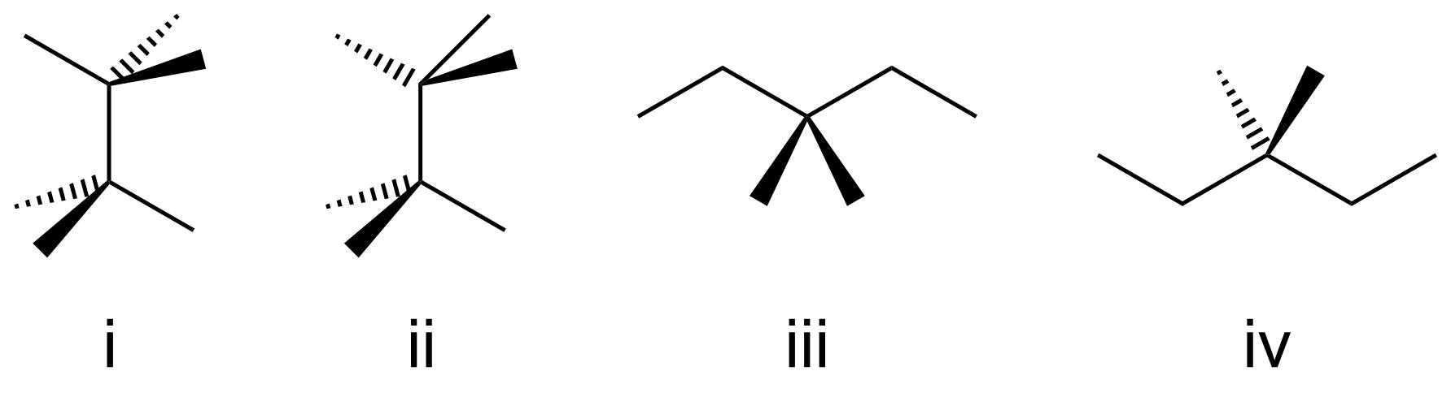
A) | i, iii | 0.05
B) | iii, iv | 0.20
C) | ii, iii | *0.72
D) | ii, iv | 0.03
Ans: | C
Variants
Comments

Q#: | 63
Serial #: | Ex_2019_Q09_D92_S3.01
Unit | 3.01 Orgo - Line drawings
Used | Ex_2019, *0.92
Stem | Which of the following is not an acceptable representation for ethanol?
A) |  | 0.00
B) |  | *0.92
C) |  | 0.02
D) |  | 0.06
Ans: | B
Variants
Comments

Q#: | 65
Serial #: | T2_2011_Q24_D53_S3.01
Unit | 3.01 Orgo – Line drawings
Used | Ex_2019, ^0.9, *0.53  T2_2011
Stem | Which of the following statements regarding compounds (i) to (v) is incorrect?
A) | (i) and (ii) are different molecules | *0.53
B) | (iii) and (v) are identical | 0.34
C) | (i) and (iv) are different molecules | 0.03
D) | (iv) and (v) are different molecules | 0.10
Ans: | A
Variants
Comments

Q#: | 70
Serial #: | T2_2022_Q20_D82_S3.01
Unit | 3.01 Orgo - Line drawings
Used | T2_2022
Stem | Aspartame is an artificial low calorie sweetener often used in coffee. Which of the following statements is true?  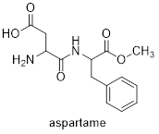
A) | It contains 5 π bonds and 12 lone pairs.
B) | It contains 6 π bonds and 12 lone pairs. | *0.82
C) | It contains 5 π bonds and 10 lone pairs.
D) | It contains 6 π bonds and 10 lone pairs.
Ans: | B
Variants
Comments

Q#: | 71
Serial #: | T2_2022_Q17_D75_S3.01
Unit | 3.01 Orgo - Line drawings
Used | T2_2022
Stem | How many lone pairs exist on the molecule shown below?  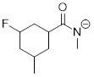
A) | 6
B) | 7 | *0.75
C) | 8
D) | 9
Ans: | B
Variants
Comments

Q#: | 72
Serial #: | T2_2022_Q18_D64_S3.01
Unit | 3.01 Orgo - Line drawings
Used | T2_2022
Stem | Assuming all atoms have a full octet, which statement about the molecule below is true?  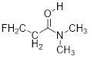
A) | It contains no formal charges
B) | It contains a single formal positive charge | *0.64
C) | It contains a single formal negative charge
D) | It contains both a formal positive charge and a formal negative charge
Ans: | B
Variants
Comments

Q#: | 73
Serial #: | T2_2022_Q19_D57_S3.01
Unit | 3.01 Orgo - Line drawings
Used | T2_2022
Stem | Which of the following compounds is correctly represented using line bond convention?
A) | 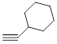
B) | 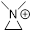 | *0.57
C) | 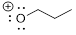
D) | 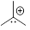
Ans: | B
Variants
Comments

Q#: | 69
Serial #: | T2_2021_Q18V1_D75_S3.01
Unit | 3.01 Orgo - Line drawings
Used | T2_2021, *0.75 / ^0.75
Stem | How many atoms in the structures below have a formal positive charge? (All lone pair electrons are shown.)  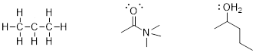
A) | 0
B) | 1
C) | 2
D) | 3 | *0.75
Ans: | D
Variants
Comments

Q#: | 69
Serial #: | T2_2021_Q18V2_D75_S3.01
Unit | 3.01 Orgo - Line drawings
Used | T2_2021, *0.75 / ^0.75
Stem | How many atoms in the structures below have a formal positive charge? (All lone pair electrons are shown.)  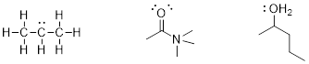
A) | 0
B) | 1
C) | 2
D) | 3 | *0.75
Ans: | C
Variants
Comments

Q#: | 69
Serial #: | T2_2021_Q18V3_D75_S3.01
Unit | 3.01 Orgo - Line drawings
Used | T2_2021, *0.75 / ^0.75
Stem | How many atoms in the structures below have a formal negative charge? (All lone pair electrons are shown.)  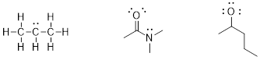
A) | 0
B) | 1
C) | 2
D) | 3 | *0.75
Ans: | C
Variants
Comments

Q#: | 69
Serial #: | T2_2021_Q18V4_D75_S3.01
Unit | 3.01 Orgo - Line drawings
Used | T2_2021, *0.75 / ^0.75
Stem | How many atoms in the structures below have a formal positive charge? (All lone pair electrons are shown.)  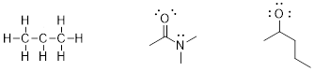
A) | 0
B) | 1
C) | 2
D) | 3 | *0.75
Ans: | B
Variants
Comments

Q#: | 67
Serial #: | Ex_2021_Q13_D80_S3.01
Unit | 3.01 Orgo - Line drawings
Used | Ex_2021, *0.80; Ex_2020
Stem | Which statement is false?
A) | 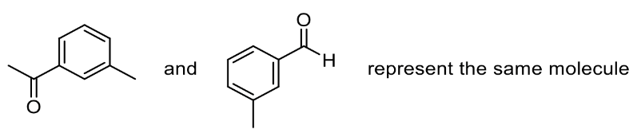 | *0.80
B) | 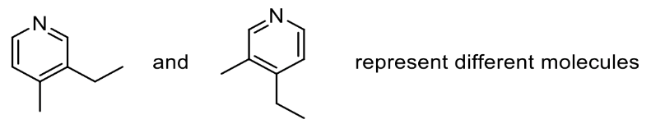 | 0
C) | 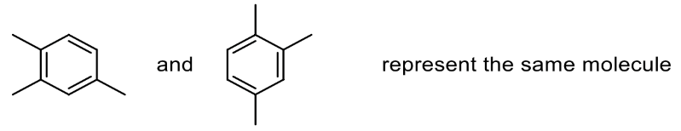 | 0
D) | 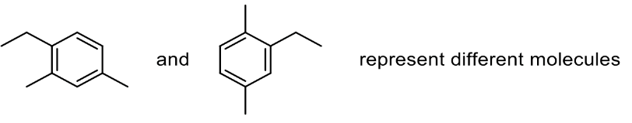 | 0
Ans: | A
Variants
Comments

Q#: | 68
Serial #: | T2_2021_Q19V1_D79_S3.01
Unit | 3.01 Orgo - Line drawings
Used | T2_2021, *0.79 / ^0.80
Stem | How many carbon atoms and how many hydrogen atoms are in the structure below?
A) | 9 carbons, 8 hydrogens | *0.79
B) | 8 carbons, 8 hydrogens
C) | 9 carbons, 6 hydrogens
D) | 8 carbons, 6 hydrogens
Ans: | A
Variants
Comments

Q#: | 68
Serial #: | T2_2021_Q19V2_D79_S3.01
Unit | 3.01 Orgo - Line drawings
Used | T2_2021, *0.79 / ^0.80
Stem | How many carbon atoms and how many hydrogen atoms are in the structure below?
A) | 9 carbons, 10 hydrogens | *0.79
B) | 8 carbons, 10 hydrogens
C) | 9 carbons, 8 hydrogens
D) | 8 carbons, 8 hydrogens
Ans: | A
Variants
Comments

Q#: | 68
Serial #: | T2_2021_Q19V3_D79_S3.01
Unit | 3.01 Orgo - Line drawings
Used | T2_2021, *0.79 / ^0.80
Stem | How many carbon atoms and how many hydrogen atoms are in the structure below?
A) | 8 carbons, 8 hydrogens | *0.79
B) | 7 carbons, 8 hydrogens
C) | 8 carbons, 6 hydrogens
D) | 7 carbons, 6 hydrogens
Ans: | A
Variants
Comments

Q#: | 68
Serial #: | T2_2021_Q19V4_D79_S3.01
Unit | 3.01 Orgo - Line drawings
Used | T2_2021, *0.79 / ^0.80
Stem | How many carbon atoms and how many hydrogen atoms are in the structure below?
A) | 8 carbons, 6 hydrogens | *0.79
B) | 7 carbons, 6 hydrogens
C) | 8 carbons, 5 hydrogens
D) | 7 carbons, 5 hydrogens
Ans: | A
Variants
Comments

Q#: | 70
Serial #: | T2_2021_Q21V1_D69_S3.01
Unit | 3.01 Orgo - Line drawings
Used | T2_2021, *0.69 / ^0.85
Stem | How many lone pairs of electrons are on the molecule below?
A) | 5
B) | 6 | *0.69
C) | 7
D) | 8
Ans: | B
Variants
Comments

Q#: | 70
Serial #: | T2_2021_Q21V2_D69_S3.01
Unit | 3.01 Orgo - Line drawings
Used | T2_2021, *0.69 / ^0.85
Stem | How many lone pairs of electrons are on the molecule below?
A) | 5
B) | 6
C) | 7 | *0.69
D) | 8
Ans: | C
Variants
Comments

Q#: | 70
Serial #: | T2_2021_Q21V3_D69_S3.01
Unit | 3.01 Orgo - Line drawings
Used | T2_2021, *0.69 / ^0.85
Stem | How many lone pairs of electrons are on the molecule below?
A) | 5
B) | 6
C) | 7 | *0.69
D) | 8
Ans: | C
Variants
Comments

Q#: | 72
Serial #: | T2_2021_Q17V1_D63_S3.01
Unit | 3.01 Orgo - Line drawings
Used | T2_2021, *0.63
Stem | Which of the following molecules is drawn correctly using line-angle drawing conventions?
A) | i
B) | ii
C) | iii | *0.63
D) | iv
Ans: | C
Variants
Comments

Q#: | 72
Serial #: | T2_2021_Q17V2_D63_S3.01
Unit | 3.01 Orgo - Line drawings
Used | T2_2021, *0.63
Stem | Which of the following molecules is drawn correctly using line-angle drawing conventions?
A) | i | *0.63
B) | ii
C) | iii
D) | iv
Ans: | A
Variants

Q#: | 72
Serial #: | T2_2021_Q17V3_D63_S3.01
Unit | 3.01 Orgo - Line drawings
Used | T2_2021, *0.63
Stem | Which of the following molecules is drawn correctly using line-angle drawing conventions?
A) | i
B) | ii | *0.63
C) | iii
D) | iv
Ans: | B
Variants

Q#: | 72
Serial #: | T2_2021_Q17V4_D63_S3.01
Unit | 3.01 Orgo - Line drawings
Used | T2_2021, *0.63
Stem | Which of the following molecules is drawn correctly using line-angle drawing conventions?
A) | i | *0.63
B) | ii
C) | iii
D) | iv
Ans: | A
Variants

Q#: | 72
Serial #: | T2_2021_Q17V5_D63_S3.01
Unit | 3.01 Orgo - Line drawings
Used | T2_2021, *0.63
Stem | Which of the following molecules is drawn correctly using line-angle drawing conventions?
A) | i
B) | ii
C) | iii | *0.63
D) | iv
Ans: | D
Variants

Q#: | 73
Serial #: | Ex_2021_Q11_D60_S3.01
Unit | 3.01 Orgo - Line drawings
Used | Ex_2021, *0.60  Ex_2020
Stem | Which of the structures below are drawn correctly using the conventions of line angle drawings? Note: lone pairs are not always shown in these diagrams; you may have to add lone pairs of electrons.
A) | i and ii
B) | ii and iv
C) | i and iii | *0.60
D) | iii and iv
Ans: | C
Variants
Comments

Q#: | 47
Serial #: | T2_2020_Q25_D62_S3.01
Unit | 3.01 Orgo - Line drawings
Used | T2_2020, ^0.7, *0.62
Stem | This is Efavirenz, an HIV drug. Which statement is false?  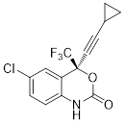
A) | There are 14 carbon atoms. | 0.10
B) | Each heteroatom has a formal charge of zero. | 0.13
C) | There are 9 hydrogen atoms. | 0.15
D) | There are 16 lone pairs of electrons in the molecule. | *0.62
Ans: | D
Variants | Up to slide ~20.
Comments

Q#: | 48
Serial #: | T2_2020_Q24_D56_S3.01
Unit | 3.01 Orgo - Line drawings
Used | T2_2020, ^0.6, *0.56
Stem | Which molecule is drawn correctly, using the proper conventions for line-angle drawings?
A) | 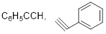 | 0.17
B) | 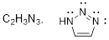 | 0.19
C) | 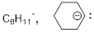 | *0.56
D) | 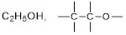 | 0.09
Ans: | C
Variants
Comments

Unit 3.02 Orgo - Hybridization

Q#: | 25
Serial #: | T2_2024_Q25_D78_S3.02
Unit | 3.02 Orgo - Hybridization
Used | T2_2024, ^0.85, *0.78
Stem | How many sp hybridized carbons and total carbon atoms are in the structure below?  sp hybridized carbons total carbons
A) | 5 11 | 0.11
B) | 2 9 | 0.05
C) | 5 9 | 0.05
D) | 2 11 | *0.78
Ans: | D
Variants
Comments

Q#: | 24
Serial #: | T2_2024_Q24_D41_S3.02
Unit | 3.02 Orgo - Hybridization
Used | T2_2024, ^0.75, *0.41
Stem | Methamphetamine is a central nervous system stimulant commonly used as a recreational drug. How many s–sp³ bonds are present?
A) | 9 | 0.32
B) | 14 | 0.13
C) | 10 | *0.41
D) | 15 | 0.14
Ans: | C
Variants
Comments

Q#: | 23
Serial #: | T2_2024_Q23_D75_S3.02
Unit | 3.02 Orgo - Hybridization
Used | T2_2024, ^0.85, *0.75
Stem | Which statement about capsaicin is false?
A) | The molecular formula for capsaicin is C₁₈H₂₇NO₃. | 0.11
B) | There are 8 sp² hybridized carbon atoms. | *0.75
C) | There are 7 valence lone pairs of electrons in the molecule. | 0.10
D) | There are five π bonds in the molecule. | 0.04
Ans: | B
Variants
Comments

Q#: | 21
Serial #: | T2_2024_Q21_D81_S3.02
Unit | 3.02 Orgo - Hybridization
Used | T2_2024, ^0.75, *0.81
Stem | Which of the following statements about the structures of organic molecules is false?
A) | But-2-yne has 4 carbon atoms arranged linearly. | 0.06
B) | A nitrogen atom with 3 s−sp³ bonds and one sp³−sp³ bond has a formal charge of +1. | 0.10
C) | A carbon atom with two sp³−sp³ bonds, one s−sp³ bond, and a lone pair of electrons has a formal charge of +1. | *0.81
D) | An sp²-hybridized atom has a trigonal planar electron geometry. | 0.02
Ans: | C
Variants
Comments

Q#: | 26
Serial #: | Ex_2024_Q26_D93_S3.02
Unit | 3.02 Orgo - Hybridization
Used | Ex_2024, ^0.75, *0.93
Stem | Which of the following functional groups contain an sp² hybridized atom?
A) | alkyne | 0.02
B) | ether | 0.03
C) | primary alcohol | 0.02
D) | aldehyde | *0.93
Ans: | D
Variants
Comments

Q#: | 25
Serial #: | T2_2023_Q25_D85_S3.02
Unit | 3.02 Orgo - Hybridization
Used | T2_2023, ^0.60, *0.85
Stem | Which statement regarding hybridization is true?
A) | An sp² hybridized atom has trigonal planar geometry due to mixing of 4 atomic orbitals. | 0.08
B) | An sp² hybridized atom has trigonal planar geometry due to mixing of 3 atomic orbitals. | *0.85
C) | An sp² hybridized atom has tetrahedral geometry due to mixing of 3 atomic orbitals. | 0.03
D) | An sp² hybridized atom has tetrahedral geometry due to mixing of 4 atomic orbitals. | 0.05
Ans: | B
Variants
Comments

Q#: | 24
Serial #: | T2_2023_Q24_D72_S3.02
Unit | 3.02 Orgo - Hybridization
Used | T2_2023, ^0.60, *0.72
Stem | What best describes the C−C π bond in ethene?
A) | It is weaker than the C−C σ bond and is formed through side-on overlap of p-orbitals. | *0.72
B) | It is stronger than the C−C σ bond and is formed through side-on overlap of p-orbitals. | 0.12
C) | It is weaker than the C−C σ bond and is formed through end-on overlap of p-orbitals. | 0.12
D) | It is stronger than the C−C σ bond and is formed through end-on overlap of p-orbitals. | 0.03
Ans: | A
Variants
Comments

Q#: | 23
Serial #: | T2_2023_Q23_D59_S3.02
Unit | 3.02 Orgo - Hybridization
Used | T2_2023, ^0.75, *0.59
Stem | How many carbon atoms in caffeine exist in a tetrahedral geometry?
A) | 3 | *0.59
B) | 5 | 0.10
C) | 0 | 0.14
D) | 8 | 0.17
Ans: | A
Variants
Comments

Q#: | 18
Serial #: | T2_2023_Q18_D67_S3.02
Unit | 3.02 Orgo - Hybridization
Used | T2_2023, ^0.70, *0.67
Stem | How many carbon and hydrogen atoms does the molecule below possess?  carbons hydrogens
A) | 7 11 | *0.67
B) | 6 11 | 0.10
C) | 7 12 | 0.21
D) | 6 12 | 0.02
Ans: | A
Variants
Comments

Q#: | 17
Serial #: | T2_2023_Q17_D74_S3.02
Unit | 3.02 Orgo - Hybridization
Used | T2_2023, ^0.75, *0.74
Stem | What best describes bonding and hybridization in this molecule?
A) | It contains 3 π bonds and the nitrogen is sp hybridized | *0.74
B) | It contains 2 π bonds and the nitrogen is sp² hybridized | 0.06
C) | It contains 3 π bonds and the nitrogen is sp² hybridized | 0.14
D) | It contains 2 π bonds and the nitrogen is sp hybridized | 0.05
Ans: | A
Variants
Comments

Q#: | 16
Serial #: | Ex_2023_Q16_D89_S3.02
Unit | 3.02 Orgo - Hybridization
Used | Ex_2023, ^0.75, *0.89
Stem | Zolpidem is a sedative used to treat insomnia. How many carbon atoms are sp² hybridized?
A) | 4 | 0.01
B) | 13 | 0.07
C) | 5 | 0.03
D) | 14 | *0.89
Ans: | D
Variants
Comments

Q#: | 10
Serial #: | Ex_2023_Q10_D70_S3.02
Unit | 3.02 Orgo - Hybridization
Used | Ex_2023, ^0.85, *0.70
Stem | Which statement about the structure below is false?
A) | Each of the sp hybridized carbon atoms has 2 σ bonds and 2 π bonds. | 0.12
B) | Each of the sp² hybridized carbon atoms has 3 σ bonds and 1 π bond. | 0.02
C) | Each of the sp hybridized carbon atoms has 2 π bonds that are oriented 180° relative to one another. | *0.70
D) | Each of the sp² hybridized carbon atoms has 3 σ bonds that are 120° relative to one another. | 0.15
Ans: | C
Variants
Comments

Q#: | 52
Serial #: | Ex_2022_Q10_D83_S3.02
Unit | 3.02 Orgo - Hybridization
Used | Ex_2022, ^0.90, *0.83
Stem | In the compound 2,3,6-trimethylheptane, which statement is false about the number of primary, secondary, tertiary, and quaternary carbon atoms?
A) | This compound has 5 primary carbon atoms. | 0.09
B) | This compound has 3 tertiary carbon atoms. | 0.06
C) | This compound has 0 quaternary carbon atoms. | 0.02
D) | This compound has 3 secondary carbon atoms. | *0.83
Ans: | D
Variants
Comments

Q#: | 53
Serial #: | Ex_2022_Q14_D81_S3.02
Unit | 3.02 Orgo - Hybridization
Used | Ex_2022, ^0.7, *0.81
Stem | Which statement concerning the structure of progesterone (below) is false?  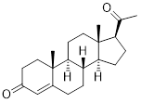
A) | There are 4 sp² hybridized carbon atoms. | 0.07
B) | There are 28 hydrogen atoms. | *0.81
C) | There are three methyl (CH₃) groups. | 0.08
D) | There are 6 π electrons. | 0.05
Ans: | B
Variants
Comments

Q#: | 54
Serial #: | T2_2022_Q21_D62_S3.02
Unit | 3.02 Orgo - Hybridization
Used | T2_2022
Stem | Azidothymidine (shown below) was one of the first drugs used to treat AIDS. Which statement concerning this structure is false?  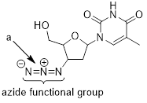
A) | The nitrogen atom labeled a is sp² hybridized. | *0.62
B) | The structure has 13 lone pairs of electrons.
C) | There are 6 carbon atoms with sp³ hybridization.
D) | In the azide group there are two π bonds oriented at 90° to one another.
Ans: | A
Variants
Comments

Q#: | 55
Serial #: | Ex_2022_Q13_D55_S3.02
Unit | 3.02 Orgo - Hybridization
Used | Ex_2022, ^0.8, *0.55
Stem | Which of the following statements about this molecule is true?  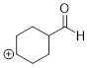
A) | It contains 1 sp² hybridized carbon atom and 11 hydrogen atoms. | 0.32
B) | It contains 2 sp² hybridized carbon atoms and 11 hydrogen atoms. | *0.55
C) | It contains 2 sp² hybridized carbon atoms and 12 hydrogen atoms. | 0.04
D) | It contains 1 sp² hybridized carbon atom and 12 hydrogen atoms. | 0.10
Ans: | B
Variants
Comments

Q#: | 56
Serial #: | T2_2022_Q23_D41_S3.02
Unit | 3.02 Orgo - Hybridization
Used | T2_2022
Stem | Capsaicin (C₁₈H₂₇O₃N) is the molecule responsible for the spiciness of chili peppers. It contains C–C single bonds and C=C double bonds. Its structure is shown below, but some of the double bonds have been omitted. In total, how many carbon atoms are sp² hybridized?  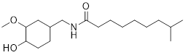
A) | 9 | *0.41
B) | 11
C) | 7
D) | 5
Ans: | A
Variants
Comments

Q#: | 57
Serial #: | T2_2022_Q22_D40_S3.02
Unit | 3.02 Orgo - Hybridization
Used | Ex_2017, T2_2022
Stem | Which statement concerning acrylonitrile (below) is false?  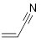
A) | In the CN group, the sideways overlap between the 2p orbitals of nitrogen and carbon produces two π-bonds.
B) | In the CN group, the end-to-end overlap between the sp hybrid orbitals of carbon and nitrogen produces one σ-bond.
C) | In the C=C group, the sideways overlap between the sp² hybrid orbitals of carbon atoms produces one π-bond. | *0.40
D) | Each carbon atom in the C=C group forms three σ-bonds and one π-bond.
Ans: | C
Variants
Comments

Q#: | 446
Serial #: | Ex_2013_Q24_D95_S3.02
Unit | 3.02 Orgo - Hybridization
Used | Ex_2013
Stem | Which of the following statements about bonding and orbitals is FALSE?
A) | In ammonia the lone pair of electrons is in an sp³ - hybridized orbital. | 0.014
B) | A π (pi) bond can be formed between an H atom and a C atom. | *0.95
C) | The methyl carbocation is sp² - hybridized at C. | 0.02
D) | The C-C sigma bond in ethyne is formed by the overlap of sp hybrid orbitals. | 0.016
Ans: | B
Variants
Comments

Q#: | 447
Serial #: | Ex_2012_Q20_D83_S3.02
Unit | 3.02 Orgo - Hybridization
Used | Ex_2012
Stem | For the following molecule, how many sp³ - and sp² - hybridized carbon atoms are there, and how many π- and σ–bonds are there?
A) | sp³ - 5  sp² - 4  π-bonds - 9  σ-bonds - 2 | 0.008
B) | sp³ - 5  sp² - 4  π-bonds - 2  σ-bonds - 23 | *0.83
C) | sp³ - 5  sp² - 4  π-bonds - 2  σ-bonds - 10 | 0.14
D) | sp³ - 4  sp² - 5  π-bonds - 2  σ-bonds - 10 | 0.03
Ans: | B
Variants
Comments

Q#: | 448
Serial #: | Ex_2017_Q26_D78_S3.02
Unit | 3.02 Orgo - Hybridization
Used | Ex_2017
Stem | How many sp³ – sp³ carbon – carbon bonds are present in the compound carfentanil?
A) | 9 | 0.14
B) | 6 | *0.78
C) | 1 | 0.04
D) | 0 | 0.04
Ans: | B
Variants
Comments

Q#: | 449
Serial #: | Ex_2016_Q18_D77_S3.02
Unit | 3.02 Orgo - Hybridization
Used | Ex_2016
Stem | Which statement regarding the hybridization scheme shown below is FALSE?
A) | The energy of a carbon atom’s sp orbital is equal to the weighted average of the 2s and 2p orbital energies. | 0.05
B) | Carbon sp orbitals can form covalent bonds by overlapping with s, sp, sp² or sp³ orbitals. | 0.12
C) | Hybridization of atomic orbitals allows carbon atoms to form more covalent bonds. | 0.06
D) | Hybridization, as shown above, does not require energy input. | *0.77
Ans: | D
Variants
Comments

Q#: | 450
Serial #: | Ex_2017_Q21_D73_S3.02
Unit | 3.02 Orgo - Hybridization
Used | Ex_2017
Stem | Nitryl fluoride, FNO₂, is used as a fluorinating agent in organic synthesis. The fluorine and oxygen atoms are bonded to the nitrogen atom. Which of the following statements is FALSE?
A) | The sideways overlap between the 2p orbitals of the nitrogen atom and the oxygen atoms produces π-bonding. | 0.08
B) | The sideways overlap of the 2p orbital of fluorine with the 2p orbital of nitrogen produces a π-bond. | *0.73
C) | The end-to-end overlap between the sp² orbitals of the nitrogen atom and the oxygen atoms produces σ-bonding. | 0.09
D) | The N−O bond order is 3/2. | 0.10
Ans: | B
Variants
Comments

Q#: | 451
Serial #: | Ex_2011_Q12_D72_S3.02
Unit | 3.02 Orgo - Hybridization
Used | Ex_2011
Stem | An isolated orbital is pictured below. The lone pair electrons of the nitrogen atom in pyridine occupy this type of orbital, but the lone pairs in water do not. This type of orbital occurs somewhere in cyclohexene. What type of orbital is it?  
A) | p | 0.16
B) | sp | 0.06
C) | sp² | *0.72
D) | sp³ | 0.06
Ans: | C
Variants
Comments

Q#: | 452
Serial #: | Ex_2018_Q30_D70_S3.02
Unit | 3.02 Orgo - Hybridization
Used | Ex_2018
Stem | Which of the following statements is incorrect regarding the molecule shown?
A) | Because there are 22 π-electrons in this molecule, all of its rings are aromatic. | *0.70
B) | The bond lengths of the bonds labelled “a” and “b” are the same. | 0.19
C) | All atoms in the rings are sp² - hybridized. | 0.04
D) | The lone pair of electrons on the nitrogen atom is in an sp² - hybrid orbital. | 0.07
Ans: | A
Variants
Comments

Q#: | 453
Serial #: | Ex_2013_Q19_D67_S3.02
Unit | 3.02 Orgo - Hybridization
Used | Ex_2013
Stem | Indicate the total number of carbon-oxygen sigma bonds plus carbon-nitrogen sigma bonds in aspartame (shown below). Note: Me = methyl (CH₃).
A) | 11 | 0.07
B) | 15 | 0.005
C) | 7 | 0.25
D) | 9 | *0.67
Ans: | D
Variants
Comments

Q#: | 454
Serial #: | Ex_2012_Q15_D67_S3.02
Unit | 3.02 Orgo - Hybridization
Used | Ex_2012
Stem | Which statement about hybridization is incorrect?
A) | In alkenes the unhybridized p-orbitals form a π-bond and force the substituents attached to the alkene C atoms to become eclipsed. | 0.19
B) | sp² - hybridized orbitals are lower in energy than sp³ - hybridized orbitals. | 0.10
C) | sp-, sp² -, and sp³ - hybridized orbitals can sometimes form π-bonds. | *0.67
D) | For a carbon atom the angle between sp² - hybrid orbitals is greater than the angle between sp³ - hybrid orbitals. | 0.04
Ans: | C
Variants
Comments

Q#: | 455
Serial #: | Ex_2016_Q19_D65_S3.02
Unit | 3.02 Orgo - Hybridization
Used | Ex_2016
Stem | How many sp² – sp² sigma bonds are present in 11-Z-retinal?
A) | 11 | *0.65
B) | 4 | 0.09
C) | 13 | 0.07
D) | 7 | 0.19
Ans: | A
Variants
Comments

Q#: | 456
Serial #: | Ex_2018_Q16_D60_S3.02
Unit | 3.02 Orgo - Hybridization
Used | Ex_2018
Stem | Which statement about propadiene, H₂C=C=CH₂, is false?
A) | None of the carbon atoms are sp³ - hybridized. | 0.03
B) | There are two π bonds oriented at 90° to one another. | 0.29
C) | All the carbon atoms are sp² - hybridized. | *0.60
D) | There are six σ bonds in this molecule. | 0.08
Ans: | C
Variants
Comments

Q#: | 457
Serial #: | Ex_2018_Q15_D60_S3.02
Unit | 3.02 Orgo - Hybridization
Used | Ex_2018
Stem | The structure of tetracycline, an antibiotic, is shown below. How many sp³ (C) – sp² (C) bonds are there?  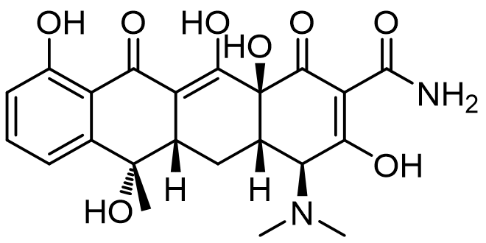
A) | 4 | 0.20
B) | 5 | *0.60
C) | 8 | 0.16
D) | 11 | 0.05
Ans: | B
Variants
Comments

Q#: | 459
Serial #: | Ex_2014_Q14_D57_S3.02
Unit | 3.02 Orgo - Hybridization
Used | Ex_2014
Stem | How many π-electrons are there in C₁₈H₁₆, assuming the molecule contains 4 rings, and no triple bonds?
A) | 14 | *0.57
B) | 12 | 0.17
C) | 10 | 0.11
D) | 16 | 0.15
Ans: | A
Variants
Comments

Q#: | 460
Serial #: | Ex_2015_Q29_D33_S3.02
Unit | 3.02 Orgo - Hybridization
Used | Ex_2015
Stem | Which of the following statements about hybridization is FALSE?
A) | Carbon is not the only atom that undergoes hybridization. | 0.03
B) | The ideal angle between sp³ - hybridized orbitals is 109.5°. | 0.55
C) | Energy is released when a carbon atom goes from a ground state (gas-phase) electron configuration to a hybridized configuration. | *0.33
D) | In carbon, electrons in an sp² - hybridized orbital are higher in energy than those in an sp - hybridized orbital. | 0.09
Ans: | C
Variants
Comments

Q#: | 461
Serial #: | Ex_2016_Q23_D44_S3.02
Unit | 3.02 Orgo - Hybridization
Used | Ex_2016
Stem | Which statement regarding hybridization and multiple bonds in the structures below is FALSE?  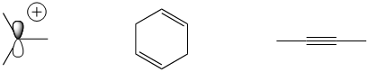
A) | In the three structures, there is a combined total of eight π electrons. | 0.14
B) | In the three structures, all the π bonds have the same bond energy. | *0.44
C) | Only one of the structures will react with distilled water. | 0.17
D) | In the three structures, there is a combined total of five sp² - hybridized carbon atoms. | 0.25
Ans: | B
Variants
Comments

Q#: | 73
Serial #: | Ex_2019_Q26_D87_S3.02
Unit | 3.02 Orgo - Hybridization
Used | Ex_2019, ^0.75, *0.87  Ex_2017
Stem | How many sp³ – sp³ carbon – carbon bonds are present in the compound tetrahydrocannabinol (THC)?  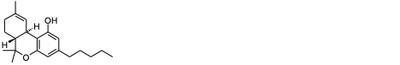
A) | 4 | 0.06
B) | 10 | *0.87
C) | 21 | 0.01
D) | 13 | 0.06
Ans: | B
Variants
Comments

Q#: | 74
Serial #: | Ex_2019_Q17_D44_S3.02
Unit | 3.02 Orgo - Hybridization
Used | Ex_2019, ^0.6, *0.44  Ex_2014
Stem | Estrogen, C₁₈H₂₄O₂, contains two hydroxyl functional groups, and is a typical steroid containing four fused rings (shown below, without any multiple bonds). There are no other rings in the molecule. The ring substituents are not shown. How many π-bonds are there in estrogen?
A) | 3 | *0.44
B) | 2 | 0.38
C) | 4 | 0.08
D) | 1 | 0.10
Ans: | A
Variants
Comments

Q#: | 49
Serial #: | Ex_2021_Q10_D74_S3.02
Unit | 3.02 Orgo - Hybridization
Used | Ex_2021, *0.74  Ex_2020
Stem | Which statement about the compound below is false?  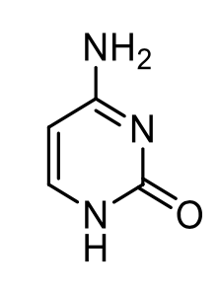
A) | Two C−H bonds involve an sp² − s orbital overlap.
B) | There are 13 σ−bonds in this molecule.
C) | Exactly three carbon atoms are sp² - hybridized. | *0.74
D) | There are three π−bonds in this molecule.
Ans: | C
Variants
Comments

Q#: | 50
Serial #: | Ex_2021_Q09_D66_S3.02
Unit | 3.02 Orgo - Hybridization
Used | Ex_2021, *0.66  Ex_2020
Stem | Which statement about the charge-minimized Lewis structure of azide (N₃⁻) is true? (Charges not shown in the Lewis structure.)  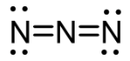
A) | The central nitrogen is sp-hybridized.
B) | There are two σ-bonds oriented at 120° to one another. | *0.66
C) | There are two π-bonds oriented at 180° to one another.
D) | There is one formal negative charge.
Ans: | A
Variants
Comments

Q#: | 51
Serial #: | T2_2021_Q22V1_D50_S3.02
Unit | 3.02 Orgo - Hybridization
Used | T2_2021, *0.50 / ^0.70
Stem | Which statement regarding hybridization and bonding is false?
A) | Hybrid orbitals containing two electrons (a lone pair) cannot participate in forming covalent bonds. | *0.50
B) | Mixing an s and a p atomic orbital forms exactly two sp-hybridized orbitals.
C) | Carbon atom hybridization involves mixing the 2s orbital with one, two, or three of the 2p orbitals.
D) | Carbon-carbon σ-bonds are stronger than carbon-carbon π-bonds.
Ans: | A
Variants
Comments

Unit 3.03 Orgo - IUPAC Nomenclature

Q#: | 20
Serial #: | T2_2024_Q20_D38_S3.03
Unit | 3.03 Orgo - IUPAC Nomenclature
Used | T2_2024, *0.73, *0.38  T2_2017
Stem | Which of the names below does not follow the IUPAC nomenclature rules?
A) | 4-bromo-3,5-diethyl-2-methylhexane | *0.38
B) | 3-ethyl-2,4-dimethylheptane | 0.19
C) | 2-bromo-2-chloro-1,1,1-trifluoroethane | 0.39
D) | 3,4,6-trimethyloctane | 0.04
Ans: | A
Variants
Comments

Q#: | 21
Serial #: | T2_2023_Q21_D61_S3.03
Unit | 3.03 Orgo - IUPAC Nomenclature
Used | T2_2023, ^0.80, *0.61
Stem | What is the IUPAC name of this molecule?
A) | 4-methoxy-4-methylpentan-2-one | *0.61
B) | 2-methoxy-2-methylpentan-4-one | 0.26
C) | 2-methoxy-2-methylpentan-4-al | 0.09
D) | 4-methoxy-4-methylpentan-2-al | 0.05
Ans: | A
Variants
Comments

Q#: | 11
Serial #: | Ex_2023_Q11_D76_S3.03
Unit | 3.03 Orgo - IUPAC Nomenclature
Used | Ex_2023, ^0.80, *0.76
Stem | What is the IUPAC name of this molecule?
A) | 6-isopropylheptan-3-ol | 0.06
B) | 6,7-dimethyloctan-3-ol | *0.76
C) | 2,3-dimethyloctan-6-ol | 0.15
D) | 2-isopropylheptan-5-ol | 0.03
Ans: | B
Variants
Comments

Q#: | 50
Serial #: | Ex_2022_Q09_D87_S3.03
Unit | 3.03 Orgo - IUPAC Nomenclature
Used | Ex_2022, ^0.90, *0.87
Stem | What is the IUPAC name for the following compound?  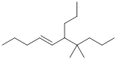
A) | (Z)-7,7-dimethyl-6-propyldec-4-ene | 0.06
B) | (E)-7-methyl-6,7-dipropyloct-4-ene | 0.02
C) | (E)-2-methyl-2,3-dipropyloct-4-ene | 0.06
D) | (E)-7,7-dimethyl-6-propyldec-4-ene | *0.87
Ans: | D
Variants
Comments

Q#: | 46
Serial #: | Ex_2021_Q07V1_D88_S3.03
Unit | 3.03 Orgo - IUPAC Nomenclature
Used | Ex_2021, *0.88
Stem | What is the name of the following compound?  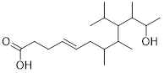
A) | (E)-11-hydroxy-9-isopropyl-7,8,10-trimethyldodec-4-enoic acid | *0.88
B) | (E)-3-ethyl-11-hydroxy-2,4,5-trimethyldodec-7-enoic acid
C) | (E)-11-hydroxy-3-isopropyl-2,4,5-trimethyldodec-7-enoic acid
D) | (E)-9-ethyl-11-hydroxy-7,8,10-trimethyldodec-4-enoic acid
Ans: | A

Q#: | 46
Serial #: | Ex_2021_Q07V2_D88_S3.03
Unit | 3.03 Orgo - IUPAC Nomenclature
Used | Ex_2021, *0.88
Stem | What is the name of the following compound?  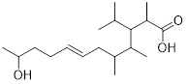
A) | (E)-11-hydroxy-9-isopropyl-7,8,10-trimethyldodec-4-enoic acid
B) | (E)-3-ethyl-11-hydroxy-2,4,5-trimethyldodec-7-enoic acid
C) | (E)-11-hydroxy-3-isopropyl-2,4,5-trimethyldodec-7-enoic acid | *0.88
D) | (E)-9-ethyl-11-hydroxy-7,8,10-trimethyldodec-4-enoic acid
Ans: | C

Q#: | 46
Serial #: | Ex_2021_Q07V3_D88_S3.03
Unit | 3.03 Orgo - IUPAC Nomenclature
Used | Ex_2021, *0.88
Stem | What is the name of the following compound?  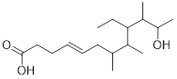
A) | (E)-11-hydroxy-9-isopropyl-7,8,10-trimethyldodec-4-enoic acid
B) | (E)-3-ethyl-11-hydroxy-2,4,5-trimethyldodec-7-enoic acid
C) | (E)-11-hydroxy-3-isopropyl-2,4,5-trimethyldodec-7-enoic acid
D) | (E)-9-ethyl-11-hydroxy-7,8,10-trimethyldodec-4-enoic acid | *0.88
Ans: | D

Q#: | 46
Serial #: | Ex_2021_Q07V4_D88_S3.03
Unit | 3.03 Orgo - IUPAC Nomenclature
Used | Ex_2021, *0.88
Stem | What is the name of the following compound?  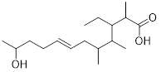
A) | (E)-11-hydroxy-9-isopropyl-7,8,10-trimethyldodec-4-enoic acid
B) | (E)-3-ethyl-11-hydroxy-2,4,5-trimethyldodec-7-enoic acid | *0.88
C) | (E)-11-hydroxy-3-isopropyl-2,4,5-trimethyldodec-7-enoic acid
D) | (E)-9-ethyl-11-hydroxy-7,8,10-trimethyldodec-4-enoic acid
Ans: | B

Q#: | 400
Serial #: | Ex_2012_Q16_D99_S3.03
Unit | 3.03 Orgo - IUPAC Nomenclature
Used | Ex_2012
Stem | Indicate the correct condensed structural formula for 3-bromopentane.
A) | (CH₃)₃CHBrCH₂CH₃ | 0.005
B) | CH₃CH₂CHBrCH₂CH₃ | *0.99
C) | CH₃CHBrCH₂CH₂CH₃ | 0.003
D) | CH₃CH₂CHBrCH₂CH₂CH₃ | 0.005
Ans: | B
Variants
Comments

Q#: | 401
Serial #: | T2_2012_Q28_D95_S3.03
Unit | 3.03 Orgo - IUPAC Nomenclature
Used | T2_2012
Stem | What is the correct IUPAC name for the following structure?
A) | 3,5-dimethyloctane | *0.95
B) | 2-ethyl-3-methyldecane | 0.000
C) | 2-ethyl-3-methylheptane | 0.015
D) | 4-methyl-6-ethylheptane | 0.04
Ans: | A
Variants
Comments

Q#: | 403
Serial #: | Ex_2018_Q21_D86_S3.03
Unit | 3.03 Orgo - IUPAC Nomenclature
Used | Ex_2018
Stem | What is the name of this compound?  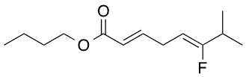
A) | 3E,6Z-pentyl-6-fluoro-7-methylocta-3,6-dienoate | 0.018
B) | 2E,5E-pentyl-6-fluoro-7-methylocta-2,5-dienoate | 0.06
C) | 2E,5Z-butyl-6-fluoro-7-methylocta-2,5-dienoate | *0.86
D) | 3E,6E-butyl-6-fluoro-7-methylocta-3,6-dienoate | 0.06
Ans: | C
Variants
Comments

Q#: | 409
Serial #: | T2_2017_Q27_D73_S3.03
Unit | 3.03 Orgo - IUPAC Nomenclature
Used | T2_2017
Stem | Which of the names below does NOT follow the IUPAC nomenclature rules?
A) | 3,4,6-trimethyloctane | 0.017
B) | 2-bromo-2-chloro-1,1,1-trifluoroethane | 0.19
C) | 4-bromo-3,5-diethyl-2-methylhexane | *0.73
D) | 3-ethyl-2,4-dimethylheptane | 0.06
Ans: | C
Variants
Comments

Q#: | 411
Serial #: | Ex_2013_Q26_D57_S3.03
Unit | 3.03 Orgo - IUPAC Nomenclature
Used | Ex_2013
Stem | What is the correct name for the following molecule?
A) | (Z)-3-chloro-4-methylhex-3-en-4-ol | 0.02
B) | (E)-3-chloro-2-ethyl-1-hydroxypent-2-ene | 0.12
C) | (E)-3-chloro-4-methylhex-3-en-4-ol | 0.28
D) | (E)-3-chloro-2-ethylpent-2-enol | *0.57
Ans: | D
Variants
Comments

Q#: | 412
Serial #: | Ex_2013_Q30_D53_S3.03
Unit | 3.03 Orgo - IUPAC Nomenclature
Used | Ex_2013
Stem | Which of the following molecules has the lowest molecular weight and is correctly named?
A) | 2-isopropylcyclopentene | 0.17
B) | 2-isopropylpropane | 0.22
C) | 2-isopropylbuta-1,3-diene | *0.53
D) | 2-isopropylprop-2-enal | 0.08
Ans: | C
Variants
Comments

Q#: | 47
Serial #: | T2_2021_Q23V1_D82_S3.03
Unit | 3.03 Orgo - IUPAC Nomenclature
Used | T2_2021, *0.82 / ^0.85 (0.67 →.92)
Stem | What is the correct IUPAC name for this structure?  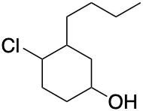
A) | 3-butyl-4-chlorocyclohexanol | *0.82
B) | 2-butyl-4-hydroxychlorocyclohexane
C) | 2-chloro-3-hydroxybutylcyclohexane
D) | 1-chloro-2-butyl-4-hydroxycyclohexane
Ans: | A
Variants
Comments

Q#: | 47
Serial #: | T2_2021_Q23V2_D82_S3.03
Unit | 3.03 Orgo - IUPAC Nomenclature
Used | T2_2021, *0.82 / ^0.85 (0.67 →.92)
Stem | What is the correct IUPAC name for this structure?  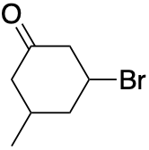
A) | 3-bromo-5-methylcyclohexanone | *0.82
B) | 3-methyl-5-bromocyclohexane
C) | 3-oxo-5-methylbromocyclohexane
D) | 3-methyl-5-oxobromocyclohexane
Ans: | A
Variants
Comments

Q#: | 47
Serial #: | T2_2021_Q23V3_D82_S3.03
Unit | 3.03 Orgo - IUPAC Nomenclature
Used | T2_2021, *0.82 / ^0.85 (0.67 →.92)
Stem | What is the correct IUPAC name for this structure?  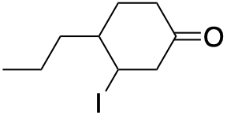
A) | 3-iodo-4-propylcyclohexanone | *0.82
B) | 3-oxo-6-propyliodocyclohexane
C) | 2-butyl-5-oxoiodocyclohexane
D) | 2-iodo-4-oxopropylcyclohexane
Ans: | A
Variants
Comments

Q#: | 47
Serial #: | T2_2021_Q23V4_D82_S3.03
Unit | 3.03 Orgo - IUPAC Nomenclature
Used | T2_2021, *0.82 / ^0.85 (0.67 →.92)
Stem | What is the correct IUPAC name for this structure?  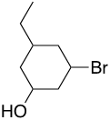
A) | 3-bromo-5-ethylcyclohexanol | *0.82
B) | 3-ethyl-5-bromocyclohexanol
C) | 3-ethyl-5-hydroxycyclohexylbromide
D) | 3-hydroxy-5-ethylcyclohexylbromide
Ans: | A
Variants
Comments

Unit 3.04 Orgo - Functional groups

Q#: | 22
Serial #: | T2_2024_Q22_D70_S3.04
Unit | 3.04 Orgo - Functional groups
Used | T2_2024, *0.80, *0.70  T2_2014
Stem | Which statement regarding the structure below is false?
A) | It contains an aldehyde group. | *0.70
B) | The molecular formula is C₂₁H₃₀O. | 0.09
C) | It contains an isopropyl substituent. | 0.09
D) | It contains a phenyl substituent. | 0.12
Ans: | A
Variants
Comments

Q#: | 1
Serial #: | T2_2024_Q01_D67_S3.04
Unit | 3.04 Orgo - Functional groups
Used | T2_2024, ^0.90, *0.67
Stem | Which functional group is not present in capsaicin?
A) | amide | 0.15
B) | ketone | *0.67
C) | ether | 0.12
D) | phenol | 0.06
Ans: | B
Variants
Comments

Q#: | 21
Serial #: | Ex_2024_Q21_D67_S3.04
Unit | 3.04 Orgo - Functional groups
Used | Ex_2024, ^0.75, *0.67
Stem | Which of the following statements are true ?  - A C–Br bond is polar.  (ii) A compound with formula C₂H₈N carries an overall charge of +1.  (iii) The formal charge is more important than the octet rule in determining the best Lewis structure of a compound.  (iv) A compound with formula C₄H₆ could be an alkene or alkyne.
A) | i, ii, iv | *0.67
B) | i, iv | 0.13
C) | i, ii, iii | 0.16
D) | ii, iii | 0.04
Ans: | A
Variants
Comments

Q#: | 9
Serial #: | Ex_2024_Q09_D91_S3.04
Unit | 3.04 Orgo - Functional groups
Used | Ex_2024, ^0.75, *0.91
Stem | Which of the following functional groups is not present in the following molecule?
A) | tertiary alcohol | 0.01
B) | secondary alkyl halide | *0.91
C) | carboxylic acid | 0.06
D) | aldehyde | 0.02
Ans: | B
Variants
Comments

Q#: | 22
Serial #: | T2_2023_Q22_D85_S3.04
Unit | 3.04 Orgo - Functional groups
Used | T2_2023, ^0.65, *0.85
Stem | Which functional groups contain a carbon atom with a trigonal planar geometry?  - ketone  - carboxylic acid  - alkyne
A) | ii, iii | 0.04
B) | i, iii | 0.05
C) | i, ii, iii | 0.05
D) | i, ii | *0.85
Ans: | D
Variants
Comments

Q#: | 1
Serial #: | Ex_2023_Q01_D82_S3.04
Unit | 3.04 Orgo – Functional groups
Used | Ex_2023, ^0.95, *0.82
Stem | Which functional group is not found in Demerol®, an analgesic?
A) | aryl | 0.06
B) | ester | 0.07
C) | ether | *0.82
D) | amine | 0.06
Ans: | C
Variants
Comments

Q#: | 51
Serial #: | Ex_2022_Q01_D70_S3.04
Unit | 3.04 Orgo - Functional groups
Used | Ex_2022, ^0.95, *0.70
Stem | Which functional groups occur in the molecule below?  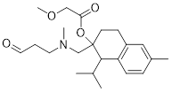
A) | carboxylic acid, ether, amine, ketone | 0.03
B) | ester, ether, amine, ketone | 0.25
C) | ester, ether, amine, aldehyde | *0.70
D) | ester, carboxylic acid, amine, ketone | 0.03
Ans: | C
Variants
Comments

Q#: | 432
Serial #: | Ex_2015_Q24_D97_S3.04
Unit | 3.04 Orgo - Functional groups
Used | Ex_2015
Stem | Which of the following is NOT an alkane?
A) | C₇H₁₆ | 0.003
B) | CH₄ | 0.018
C) | C₄H₁₀ | 0.005
D) | C₁₂H₂₄ | *0.97
Ans: | D
Variants
Comments

Q#: | 433
Serial #: | Ex_2013_Q23_D97_S3.04
Unit | 3.04 Orgo - Functional groups
Used | Ex_2013
Stem | Identify the correct list of functional groups found in the Ciprofloxacin analog (antibiotic) shown below:
A) | alkene, amide, aryl halide, carboxylic acid, ester | 0.014
B) | alkene, amine, aryl halide, carboxylic acid, ketone | *0.97
C) | ketone, alkyne, amine, carboxylic acid, aldehyde | 0.005
D) | alcohol, amide, amine, aryl halide, carboxylic acid, ketone | 0.008
Ans: | B
Variants
Comments

Q#: | 434
Serial #: | Ex_2012_Q24_D92_S3.04
Unit | 3.04 Orgo - Functional groups
Used | Ex_2012
Stem | The functional groups present in Lipitor® (shown below) include:
A) | phenol, carboxylic acid, aldehyde | 0.03
B) | alkene, carboxylic acid, anhydride, ether | 0.03
C) | ester, ketone, arene | 0.014
D) | alcohol, aryl halide, amide | *0.92
Ans: | D
Variants
Comments

Q#: | 435
Serial #: | Ex_2016_Q25_D90_S3.04
Unit | 3.04 Orgo - Functional groups
Used | Ex_2016
Stem | In which of the following examples are the name and the structure CORRECTLY matched?  (i) ester (ii) aldehyde  (iii) acid chloride (iv) carboxylic acid  (v) amide
A) | i, iv, v | *0.90
B) | iii, iv, v | 0.02
C) | ii, iv, v | 0.02
D) | i, iii, iv | 0.05
Ans: | A
Variants
Comments

Q#: | 437
Serial #: | Ex_2018_Q13_D86_S3.04
Unit | 3.04 Orgo - Functional groups
Used | Ex_2018
Stem | The structure of tetracycline, an antibiotic, is shown below. Which functional group is not found in tetracycline?
A) | carboxylic acid | *0.86
B) | ketone | 0.016
C) | arene | 0.07
D) | amine | 0.05
Ans: | A
Variants
Comments

Q#: | 438
Serial #: | Ex_2015_Q20_D84_S3.04
Unit | 3.04 Orgo - Functional groups
Used | Ex_2015
Stem | Which of the following molecular formulas could represent a compound that would show a peak in an IR spectrum corresponding to a carbonyl group (1650 to 1750 cm^{–1})?
A) | C₅H₁₂O | 0.04
B) | C₃H₆O | *0.84
C) | C₂H₆O₂ | 0.09
D) | C₇H₁₆ | 0.04
Ans: | B
Variants
Comments

Q#: | 439
Serial #: | Ex_2017_Q25_D82_S3.04
Unit | 3.04 Orgo - Functional groups
Used | Ex_2017
Stem | Aspartame is an artificial sweetener. Which functional group is NOT found in aspartame?
A) | amide | 0.07
B) | ketone | *0.82
C) | ester | 0.05
D) | arene | 0.06
Ans: | B
Variants
Comments

Q#: | 440
Serial #: | Ex_2015_Q15_D81_S3.04
Unit | 3.04 Orgo - Functional groups
Used | Ex_2015
Stem | Indicate the FALSE statement regarding morphine, shown below.  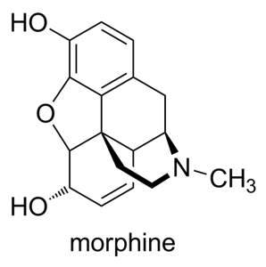
A) | Morphine contains an ester group. | *0.81
B) | Morphine contains an amine group. | 0.07
C) | Reacting morphine with excess acetic anhydride leads to formation of two ester groups. | 0.06
D) | There are exactly 8 sp² -hybridized atoms in morphine. | 0.06
Ans: | A
Variants
Comments

Q#: | 441
Serial #: | Ex_2011_Q15_D77_S3.04
Unit | 3.04 Orgo - Functional groups
Used | Ex_2011
Stem | Which functional group DOES NOT appear in the molecule below?  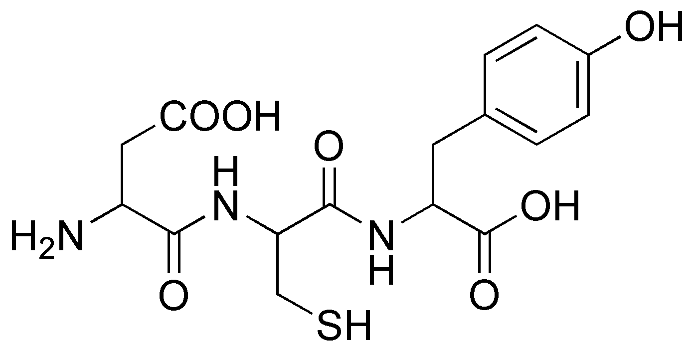
A) | phenol | 0.07
B) | amine | 0.06
C) | amide | 0.10
D) | alcohol | *0.77
Ans: | D
Variants
Comments

Q#: | 442
Serial #: | Ex_2016_Q17_D75_S3.04
Unit | 3.04 Orgo - Functional groups
Used | Ex_2016
Stem | Which functional group is absent from the structure below?
A) | ether | 0.06
B) | amide | 0.13
C) | E-alkene | *0.75
D) | amine | 0.06
Ans: | C
Variants
Comments

Q#: | 48
Serial #: | Ex_2021_Q02_D81_S3.04
Unit | 3.04 Orgo - Functional groups
Used | Ex_2021, *0.81  Ex_2020
Stem | Which functional group(s) or substituent(s) is/are found in the compound below? Check all that apply.  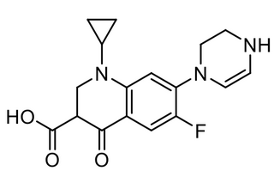  - Alkene  - Amine  - Ester  - Amide
A) | i and ii | *0.81
B) | i and iv
C) | ii and iii
D) | iii and iv
Ans: | A
Variants
Comments

Q#: | 71
Serial #: | Ex_2019_Q10_D91_S3.04
Unit | 3.04 Orgo - Functional groups
Used | Ex_2019, *0.91  Ex_2018
Stem | This is ampicillin, an antibiotic. Which functional group is not present?  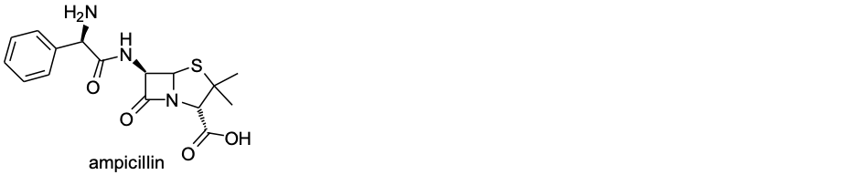
A) | amine | 0.02
B) | amide | 0.06
C) | ketone | *0.91
D) | carboxylic acid | 0.02
Ans: | C
Variants
Comments

Unit 3.05 Orgo - Geometric isomers (E/Z)

Q#: | 25
Serial #: | Ex_2024_Q25_D81_S3.05
Unit | 3.05 Orgo - Geometric isomers (E/Z)
Used | Ex_2024, ^0.75, *0.81
Stem | Which of the following molecules is / are Z-alkenes?
A) | I only | *0.81
B) | Both I and II | 0.04
C) | II only | 0.04
D) | Neither I nor II | 0.10
Ans: | A
Variants
Comments

Q#: | 8
Serial #: | Ex_2024_Q08_D58_S3.05
Unit | 3.05 Orgo - Geometric isomers (E/Z)
Used | Ex_2024, ^0.65, *0.58
Stem | Which of the following molecules would be expected to have the highest melting point?
A) | i | 0.01
B) | iii | 0.04
C) | iv | 0.38
D) | ii | *0.58
Ans: | D
Variants
Comments

Q#: | 9
Serial #: | Ex_2023_Q09_D53_S3.05
Unit | 3.05 Orgo – Geometric isomers (E/Z)
Used | Ex_2023, ^0.90, *0.53
Stem | What are the E/Z configurations of the alkene groups in this molecule (from left to right)?
A) | E, E | *0.53
B) | Z, E | 0.41
C) | Z, Z | 0.01
D) | E, Z | 0.06
Ans: | A
Variants
Comments

Q#: | 48
Serial #: | Ex_2022_Q12_D74_S3.05
Unit | 3.05 Orgo - Geometric isomers (E/Z)
Used | Ex_2022, ^0.85, *0.74
Stem | What are the configurations of the double bonds labelled A, B, and C?  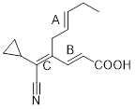
A) | A: Z  B: Z  C: Z | 0.03
B) | A: E  B: E  C: Z | *0.74
C) | A: Z  B: E  C: Z | 0.04
D) | A: E  B: E  C: E | 0.20
Ans: | B
Variants
Comments

Q#: | 49
Serial #: | Ex_2022_Q11_D72_S3.05
Unit | 3.05 Orgo - Geometric isomers (E/Z)
Used | Ex_2022, ^0.80, *0.72
Stem | Which of the following fatty acids has the higher melting point?  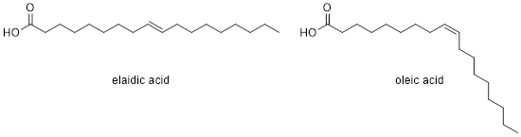
A) | Oleic acid has a higher melting point because it allows for less efficient packing. | 0.13
B) | Elaidic acid has a higher melting point because it allows for more efficient packing. | *0.72
C) | Elaidic acid has a higher melting point because it allows for less efficient packing. | 0.03
D) | Oleic acid has a higher melting point because it allows for more efficient packing. | 0.13
Ans: | B
Variants
Comments

Q#: | 391
Serial #: | Ex_2011_Q23_D87_S3.05
Unit | 3.05 Orgo - Geometric isomers (E/Z)
Used | Ex_2011
Stem | Assign the E/Z configurations for the alkene functional groups in the molecule below (from left to right):  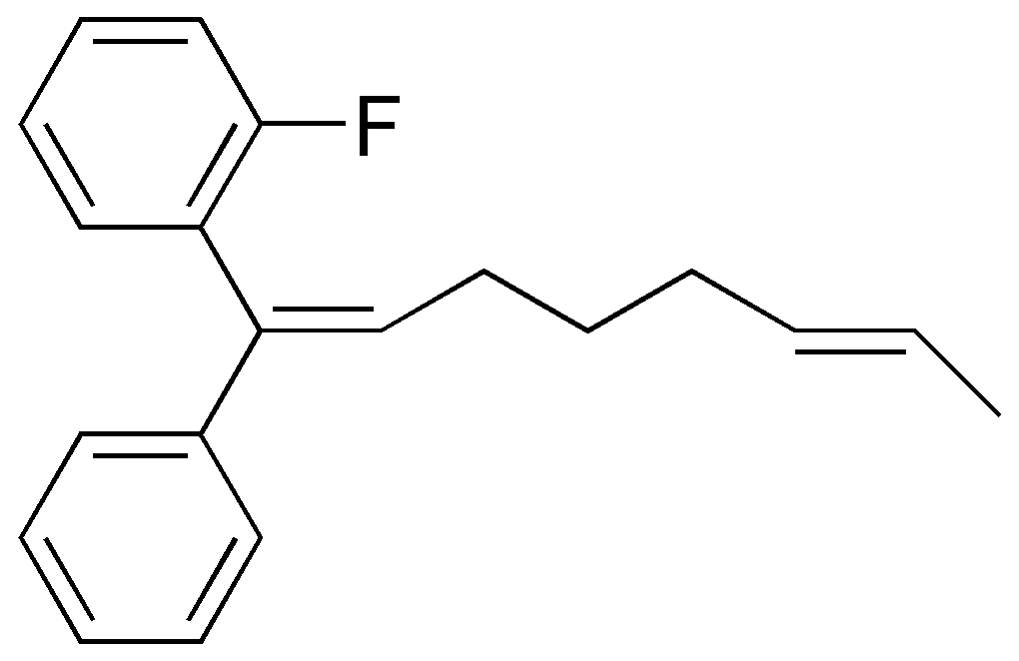
A) | E,E | 0.04
B) | E,Z | 0.07
C) | Z,E | *0.87
D) | Z,Z | 0.014
Ans: | C
Variants
Comments

Q#: | 392
Serial #: | Ex_2012_Q28_D80_S3.05
Unit | 3.05 Orgo - Geometric isomers (E/Z)
Used | Ex_2012
Stem | Identify the incorrect statement about E/Z isomers:
A) | E and Z are different configurations that a molecule can have. | 0.03
B) | E-isomers of alkenes generally have higher melting points than their Z-isomers. | 0.09
C) | 1-bromocyclopentene can only exist as the E-isomer. | 0.08
D) | A -CH₂CH₃ group has higher priority than an -OH group because it has a higher mass. | *0.80
Ans: | D
Variants
Comments

Q#: | 393
Serial #: | Ex_2018_Q14_D64_S3.05
Unit | 3.05 Orgo - Geometric isomers (E/Z)
Used | Ex_2018
Stem | How many of the following molecules have E-configurations?
A) | 2 | *0.64
B) | 1 | 0.22
C) | 3 | 0.09
D) | 0 | 0.05
Ans: | A
Variants
Comments

Q#: | 394
Serial #: | Ex_2015_Q16_D54_S3.05
Unit | 3.05 Orgo - Geometric isomers (E/Z)
Used | Ex_2015
Stem | How many of the double bonds in the molecules below have an E-configuration?  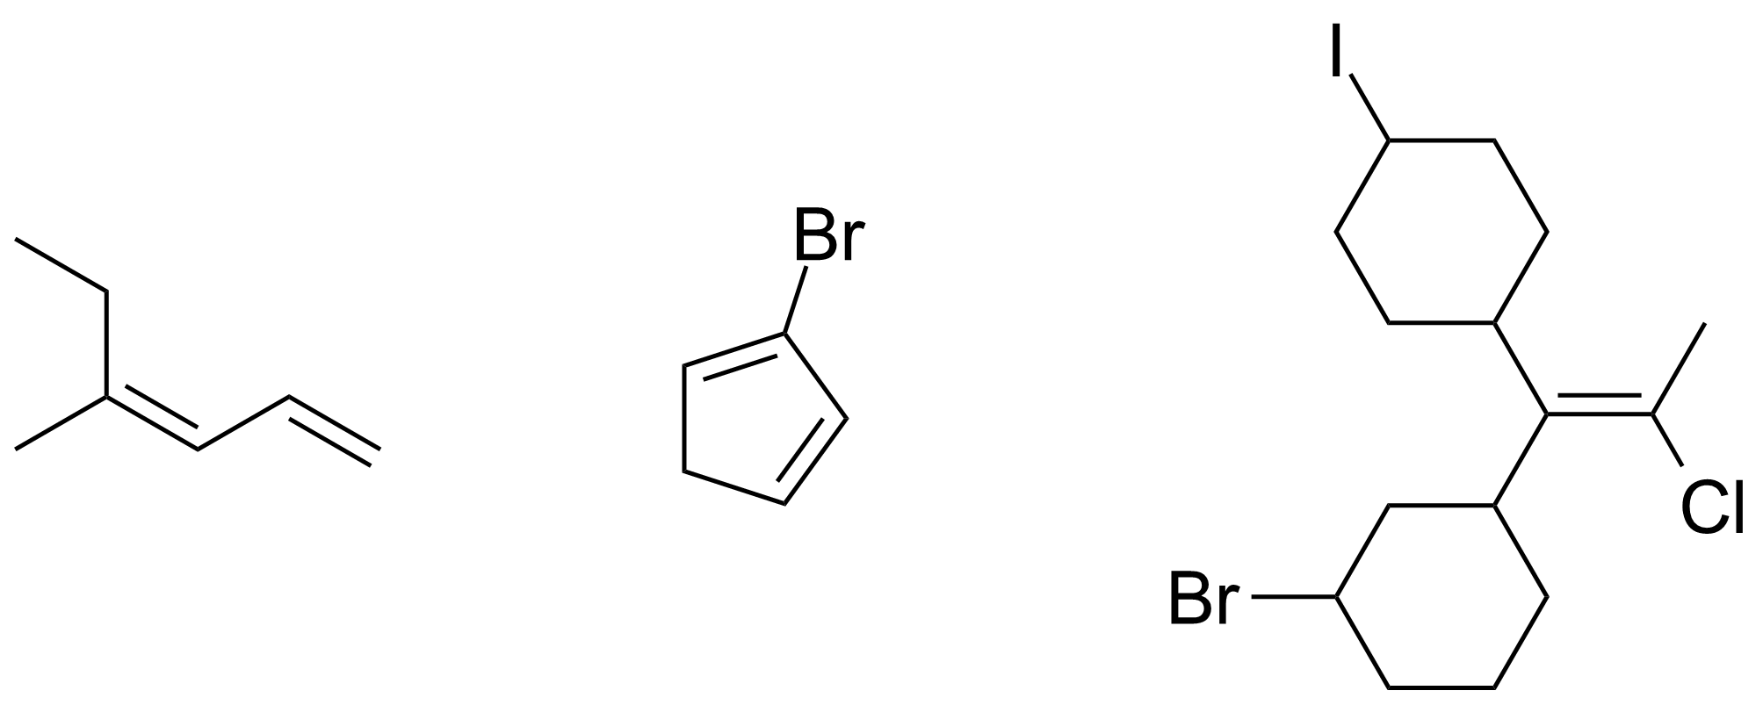
A) | 3 | 0.10
B) | 4 | 0.03
C) | 2 | 0.34
D) | 1 | *0.54
Ans: | D
Variants
Comments

Q#: | 395
Serial #: | Ex_2017_Q30_D52_S3.05
Unit | 3.05 Orgo - Geometric isomers (E/Z)
Used | Ex_2017
Stem | How many of the following structures have a Z-configuration?
A) | 1 | 0.08
B) | 2 | *0.52
C) | 4 | 0.04
D) | 3 | 0.36
Ans: | B
Variants
Comments

Q#: | 397
Serial #: | Ex_2016_Q12_D37_S3.05
Unit | 3.05 Orgo - Geometric isomers (E/Z)
Used | Ex_2016
Stem | What is the total, combined number of all E-alkene groups in all the structures below, combined?  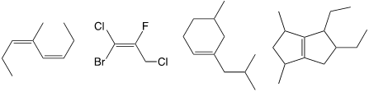
A) | 1 | 0.48
B) | 2 | *0.37
C) | 4 | 0.04
D) | 3 | 0.12
Ans: | D
Variants
Comments

Q#: | 66
Serial #: | Ex_2017_Q15_D78_S3.05
Unit | 3.05 Orgo - Geometric isomers (E/Z)
Used | Ex_2017
Stem | Which of the following compounds does not have any geometric (E / Z) isomers?
A) | 3-hexene | 0.09
B) | 1-fluoropropene | 0.08
C) | 2-chloropropene | *0.78
D) | 1,2-dibromoethene | 0.06
Ans: | C
Variants
Comments

Q#: | 66
Serial #: | Ex_2019_Q22_D78_S3.05
Unit | 3.05 Orgo - Geometric isomers (E/Z)
Used | Ex_2019, ^0.75, *0.78  Ex_2017
Stem | Which of the following compounds does not have any geometric (E / Z) isomers?
A) | 3-hexene | 0.09
B) | 2,4-hexadiene | 0.08
C) | 2-methyl-2-butene | *0.78
D) | 1-bromo-1-butene | 0.06
Ans: | C
Variants
Comments

Q#: | 67
Serial #: | Ex_2019_Q14_D31_S3.05
Unit | 3.05 Orgo - Geometric isomers (E/Z)
Used | Ex_2019, ^0.5, *0.31  Ex_2014
Stem | How many constitutional (structural) + geometric (E, Z) isomers exist for the two molecular formulae below?  C₃H₈O  C₄H₈
A) | C₃H₈O = 4  C₄H₈= 6 | 0.04
B) | C₃H₈O = 2  C₄H₈= 4 | 0.19
C) | C₃H₈O = 3  C₄H₈= 4 | 0.46
D) | C₃H₈O = 3  C₄H₈= 6 | *0.31
Ans: | D
Variants
Comments

Unit 4: Organic Chemistry, Reactivity

Unit 4.01 Reactions

Q#: | 24
Serial #: | Ex_2024_Q24_D71_S4.01
Unit | 4.01 Orgo - Organic reactions
Used | Ex_2024, ^0.70, *0.71  Ex_2016
Stem | What reagents will transform the alkyne below into pentane?  - 2 equivalents of H₂ over Pt or Pd/C.  - H₂ over Lindlar's catalyst followed by H₂ over Pt or Pd/C.  - 2 equivalents of H₂ over Lindlar's catalyst.
A) | i, ii, iii | 0.17
B) | i, iii | 0.06
C) | i, ii | *0.71
D) | ii, iii | 0.07
Ans: | C
Variants
Comments

Q#: | 23
Serial #: | Ex_2024_Q23_D81_S4.01
Unit | 4.01 Orgo - Reactions
Used | Ex_2024, ^0.75, *0.81  Ex_2018
Stem | Which reduction reaction below is incorrect?
A) | ii | *0.81
B) | iv | 0.06
C) | i | 0.12
D) | iii | 0.02
Ans: | A
Variants
Comments

Q#: | 22
Serial #: | Ex_2024_Q22_D84_S4.01
Unit | 4.01 Orgo - Reactions
Used | Ex_2024, ^0.80, *0.84
Stem | What is the major product formed when 1-methylcyclohexene reacts with HCl?
A) | 1-chloro-2-methylcyclohexene | 0.03
B) | 1-chloro-1-methylcyclohexane | *0.84
C) | 1-chloro-2-methylcyclohexane | 0.05
D) | 1-chloro-1-methylcyclohexene | 0.08
Ans: | B
Variants
Comments

Q#: | 20
Serial #: | Ex_2024_Q20_D84_S4.01
Unit | 4.01 Orgo - Reactions
Used | Ex_2024, ^0.8, *0.84  Ex_2014
Stem | Which statement about hydrogenation is false?
A) | Hydrogenation of propyne or propene using excess H₂ with Pt leads to propane. | 0.04
B) | Hydrogenation of 1,2-dimethylcyclohexene adds hydrogen atoms to the same face of the ring. | 0.08
C) | Hydrogenation of alkynes using Lindlar's catalyst leads to E-alkenes. | *0.84
D) | Hydrogenations are addition reactions. | 0.04
Ans: | C
Variants
Comments

Q#: | 19
Serial #: | Ex_2024_Q19_D85_S4.01
Unit | 4.01 Orgo - Reactions
Used | Ex_2024, *0.83, *0.85  Ex_2018
Stem | Which sequence of reagents / conditions would result in the product shown?  1 2
A) | H₃O⁺ NaBH₄ | 0.05
B) | HCl K₂Cr₂O₇ | 0.03
C) | 10% aq. H₂SO₄ PCC/CH₂Cl₂ | *0.85
D) | HBr KMnO₄ | 0.06
Ans: | C
Variants
Comments

Q#: | 18
Serial #: | Ex_2024_Q18_D84_S4.01
Unit | 4.01 Orgo - Reactions
Used | Ex_2024, ^0.75, *0.84
Stem | Which product is formed through the reaction of the Grignard reagent, CH₃MgBr, with carbon dioxide?
A) | ethanol | 0.08
B) | ethanoic acid | *0.84
C) | ethanal | 0.05
D) | propan-2-one | 0.03
Ans: | B
Variants
Comments

Q#: | 17
Serial #: | Ex_2024_Q17_D88_S4.01
Unit | 4.01 Orgo - Reactions
Used | Ex_2024, ^0.7, *0.88
Stem | Which of the compounds below is/are the correct Markovnikov addition products to 1-isopropylcyclohexene?
A) | iii | *0.88
B) | i, iv | 0.05
C) | ii | 0.06
D) | iii, iv | 0.02
Ans: | A
Variants
Comments

Q#: | 15
Serial #: | Ex_2024_Q15_D82_S4.01
Unit | 4.01 Orgo - Reactions
Used | Ex_2024, ^0.70, *0.82
Stem | Which of the following reactions is correct? Only the main organic products are shown.
A) | iv | *0.82
B) | iii | 0.07
C) | ii | 0.05
D) | i | 0.06
Ans: | A
Variants
Comments

Q#: | 22
Serial #: | Ex_2023_Q22_D90_S4.01
Unit | 4.01 Orgo - Reactions
Used | Ex_2023, *0.90, *0.90  Ex_2017
Stem | Which of the following is the product of the reaction of pent-1-ene with hydrobromic acid?
A) |  | 0.03
B) |  | 0.01
C) |  | 0.06
D) |  | *0.90
Ans: | D
Variants
Comments

Q#: | 20
Serial #: | Ex_2023_Q20_D42_S4.01
Unit | 4.01 Orgo - Reactions
Used | Ex_2023, ^0.75, *0.42
Stem | Which scheme(s) can be used to produce an ester?
A) | scheme (ii) only | 0.36
B) | scheme (i) only | 0.15
C) | neither scheme (i) nor scheme (ii) | 0.07
D) | both scheme (i) and scheme (ii) | *0.42
Ans: | D
Variants
Comments | <<Add “heat” to scheme ii.>>

Q#: | 19
Serial #: | Ex_2023_Q19_D85_S4.01
Unit | 4.01 Orgo - Reactions
Used | Ex_2023, ^0.75, *0.85
Stem | Which method(s) can be used to form a carboxylic acid?  - Oxidation of a primary alcohol with PCC  - Oxidation of a secondary alcohol with KMnO₄  - Reaction of carbon dioxide with a Grignard followed by acidic work-up.
A) | i only | 0.03
B) | iii only | *0.85
C) | ii only | 0.06
D) | i and iii | 0.07
Ans: | B
Variants
Comments

Q#: | 58
Serial #: | Ex_2022_Q17_D90_S4.01
Unit | 4.01 Orgo - Reactions
Used | Ex_2022, ^0.85, *0.90
Stem | Which of the following reactions is incorrect as shown?
A) | 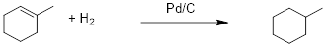 | 0.04
B) | 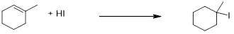 | 0.02
C) | 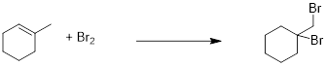 | *0.90
D) | 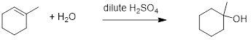 | 0.04
Ans: | C
Variants
Comments

25. | 466
Serial #: | Ex_2011_Q25_D83_S4.01
Unit | 4.01 Orgo - Reactions
Used | Ex_2011
Stem | Alkynes undergo hydrohalogenation reactions with two molecules of HCl, first forming a haloalkene, then a dihaloalkane. The reaction follows the Markovnikov rule for both steps. For the reaction below, what is the product?  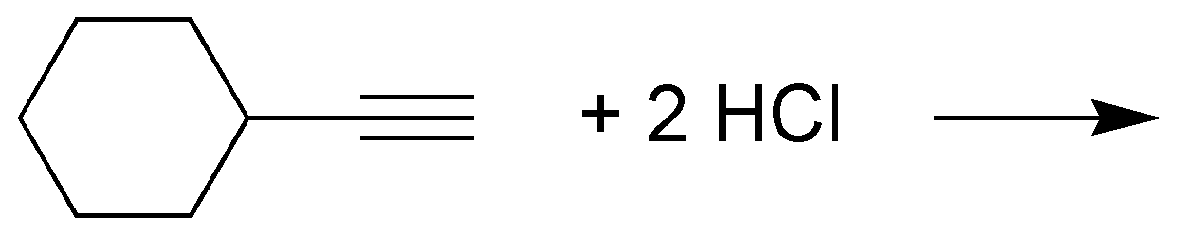
A) | 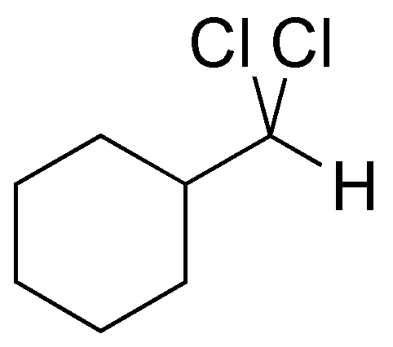 | 0.05
B) | 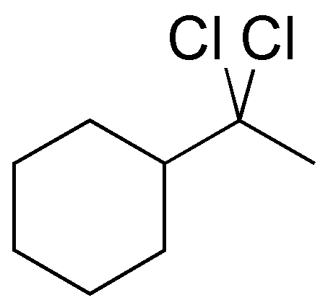 | *0.83
C) | 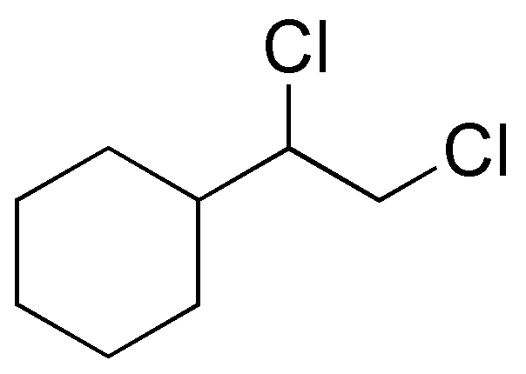 | 0.08
D) | 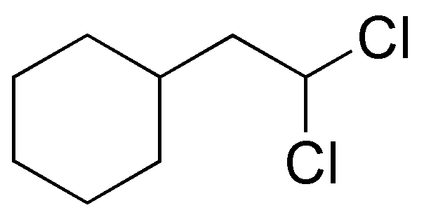 | 0.03
Ans: | B
Variants
Comments

Q#: | 63
Serial #: | Ex_2022_Q20_D61_S4.01
Unit | 4.01 Orgo - Reactions
Used | Ex_2022, ^0.75, *0.61
Stem | Which of the following reactions is not a reduction reaction?
A) | 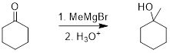 | 0.20
B) | 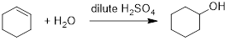 | *0.61
C) | 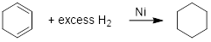 | 0.18
D) | 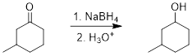 | 0.02
Ans: | B
Variants
Comments

Q#: | 64
Serial #: | Ex_2022_Q24_D60_S4.01
Unit | 4.01 Orgo - Reactions
Used | Ex_2022, ^0.60, *0.60
Stem | What is the product of the following reaction scheme?  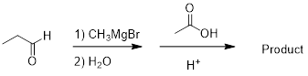
A) |  | 0.04
B) | 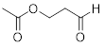 | 0.11
C) | 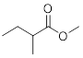 | 0.25
D) | 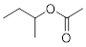 | *0.60
Ans: | D
Variants
Comments

Q#: | 462
Serial #: | Ex_2017_Q24_D90_S4.01
Unit | 4.01 Orgo - Reactions
Used | Ex_2017
Stem | Which of the following is the product of the reaction of hex-1-ene with hydrobromic acid?
A) | 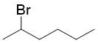 | *0.90
B) |  | 0.05
C) | 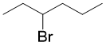 | 0.005
D) | 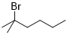 | 0.05
Ans: | A
Variants
Comments

Q#: | 466
Serial #: | Ex_2011_Q25_D83_S4.01
Unit | 4.01 Orgo - Reactions
Used | Ex_2011
Stem | Alkynes undergo hydrohalogenation reactions with two molecules of HCl, first forming a haloalkene, then a dihaloalkane. The reaction follows the Markovnikov rule for both steps. For the reaction below, what is the product?  
A) |  | 0.05
B) |  | *0.83
C) |  | 0.08
D) |  | 0.03
Ans: | B
Variants
Comments

Q#: | 467
Serial #: | Ex_2012_Q22_D82_S4.01
Unit | 4.01 Orgo - Reactions
Used | Ex_2012
Stem | What would the product be for the reaction of excess HI with the molecule below?
A) |  | 0.08
B) |  | *0.82
C) |  | 0.05
D) |  | 0.05
Ans: | B
Variants
Comments

Q#: | 468
Serial #: | Ex_2015_Q23_D81_S4.01
Unit | 4.01 Orgo - Reactions
Used | Ex_2015
Stem | Which word describes the conversion of ethanal to ethanol?
A) | hydration | 0.07
B) | oxidation | 0.08
C) | reduction | *0.81
D) | hydrolysis | 0.03
Ans: | C
Variants
Comments

Q#: | 470
Serial #: | Ex_2014_Q20_D80_S4.01
Unit | 4.01 Orgo - Reactions
Used | Ex_2014
Stem | Identify the FALSE statement regarding hydrogenations.
A) | Hydrogenation of 1,2-dimethylcyclohexene adds hydrogen atoms to the same face of the ring. | 0.09
B) | Hydrogenation of alkynes using Lindlar’s catalyst leads to Z - alkenes. | 0.07
C) | Hydrogenation of propyne or propene using excess H₂ with Pt leads to propane. | 0.05
D) | Hydrogenations are substitution reactions. | *0.80
Ans: | D
Variants
Comments

Q#: | 471
Serial #: | Ex_2018_Q24_D79_S4.01
Unit | 4.01 Orgo - Reactions
Used | Ex_2018
Stem | Which statement about the oxidation of alcohols is false?
A) | Primary alcohols can be oxidized to form either an aldehyde or a carboxylic acid. | 0.03
B) | Ketones and tertiary alcohols cannot be oxidized using KMnO₄ or K₂Cr₂O₇. | 0.11
C) | Primary alcohols can be oxidized using permanganate, dichromate, or PCC/CH₂Cl₂. | 0.08
D) | PCC/CH₂Cl₂ can be used to selectively oxidize secondary alcohols to aldehydes. | *0.79
Ans: | D
Variants
Comments

Q#: | 473
Serial #: | Ex_2016_Q20_D78_S4.01
Unit | 4.01 Orgo - Reactions
Used | Ex_2016
Stem | Which of the compounds below are the CORRECT Markovnikov addition products to the diene?
A) | ii, iii | 0.04
B) | i | *0.78
C) | i, ii | 0.06
D) | i, iii | 0.11
Ans: | B
Variants
Comments

Q#: | 474
Serial #: | Ex_2013_Q22_D78_S4.01
Unit | 4.01 Orgo - Reactions
Used | Ex_2013
Stem | Identify the FALSE statement regarding the oxidation/reduction of organic molecules:
A) | Oxidation of alcohols is usually done under acidic or basic conditions to facilitate electron transfer. | 0.11
B) | Reaction of a ketone with a Grignard reagent in ether, followed by dilute acid work-up, produces a tertiary alcohol. | 0.06
C) | All alcohols can be oxidized to form one of an aldehyde, ketone, or carboxylic acid. | *0.78
D) | PCC will not oxidize an aldehyde to a carboxylic acid. | 0.05
Ans: | C
Variants
Comments

Q#: | 475
Serial #: | Ex_2018_Q20_D77_S4.01
Unit | 4.01 Orgo - Reactions
Used | Ex_2018
Stem | What is the product of the reaction of 2,4-dimethyl-2-pentene with dilute sulfuric acid?
A) | 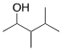 | 0.07
B) |  | *0.77
C) | 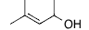 | 0.03
D) | 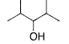 | 0.13
Ans: | B
Variants
Comments

Q#: | 478
Serial #: | Ex_2013_Q20_D76_S4.01
Unit | 4.01 Orgo - Reactions
Used | Ex_2013
Stem | Which of the following reactions is incorrect as shown?
A) | 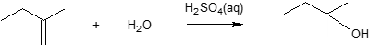 | 0.16
B) | 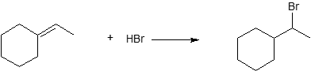 | *0.76
C) | 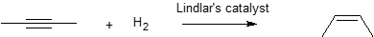 | 0.04
D) | 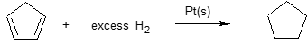 | 0.03
Ans: | B
Variants
Comments

Q#: | 479
Serial #: | Ex_2017_Q17_D73_S4.01
Unit | 4.01 Orgo - Reactions
Used | Ex_2017
Stem | Which of the following reactions is INCORRECT?
A) | 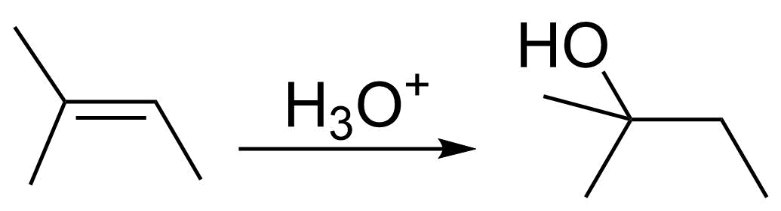 | 0.12
B) | 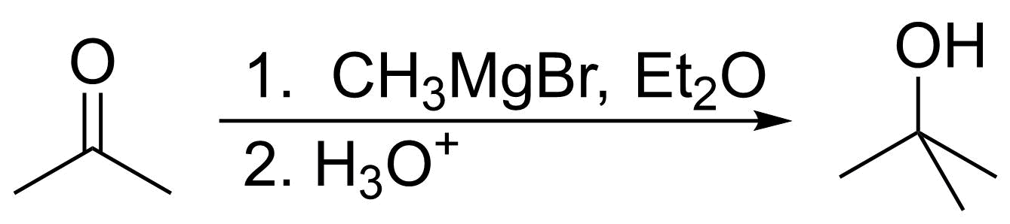 | 0.06
C) | 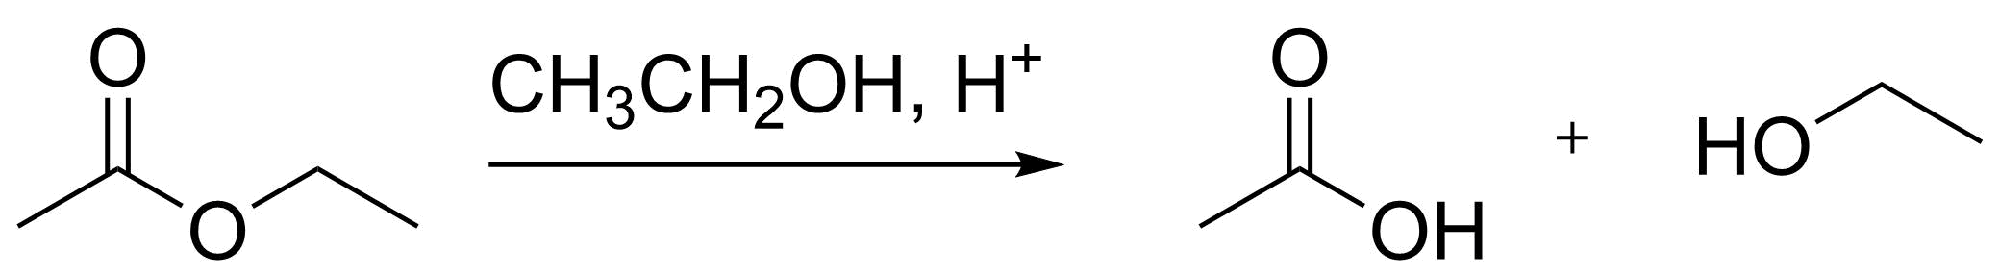 | *0.73
D) | 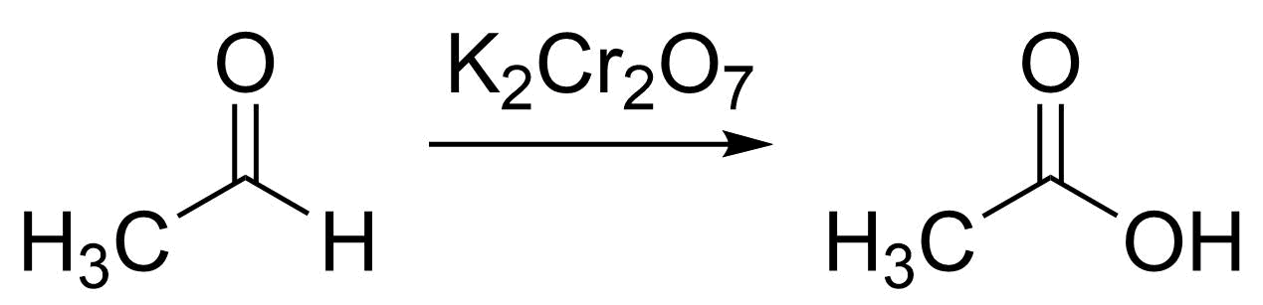 | 0.09
Ans: | C
Variants
Comments

Q#: | 489
Serial #: | Ex_2014_Q13_D64_S4.01
Unit | 4.01 Orgo - Reactions
Used | Ex_2014
Stem | Choose the FALSE statement regarding organic redox reactions.
A) | Alkenes are oxidized when they undergo catalyzed hydrogenation (addition of H₂). | *0.64
B) | A secondary alcohol can be converted to a tertiary alcohol by oxidation, followed by reaction with a Grignard reagent and acid work-up. | 0.16
C) | A primary alcohol can be converted to a carboxylic acid by reaction with K₂Cr₂O₇ in dilute H₃O⁺(aq). | 0.08
D) | In the formation of a Grignard reagent from an alkyl halide, the carbon atom bearing the halide is reduced. | 0.12
Ans: | A
Variants
Comments

Q#: | 491
Serial #: | Ex_2012_Q13_D57_S4.08
Unit | 4.08 Orgo - Organic reactions
Used | Ex_2012
Stem | Solid CO₂ (0.35 mol) is reacted with CH₃MgBr (0.28 mol) in ether solvent. The product of the reaction is isolated in aqueous solution (assume 100% yield) and excess CO₂(s) is removed. Then, HCl(aq) (0.16 mol) is added. What is the pH of the solution that results?  Data:  pK_{a} (CH₃COOH) = 4.74
A) | 4.74 | 0.08
B) | 4.53 | 0.21
C) | 4.88 | 0.14
D) | 4.62 | *0.57
Ans: | D
Variants
Comments

Q#: | 497
Serial #: | Ex_2017_Q19_D44_S4.01
Unit | 4.01 Orgo - Reactions
Used | Ex_2017
Stem | How many of the following are addition reactions?  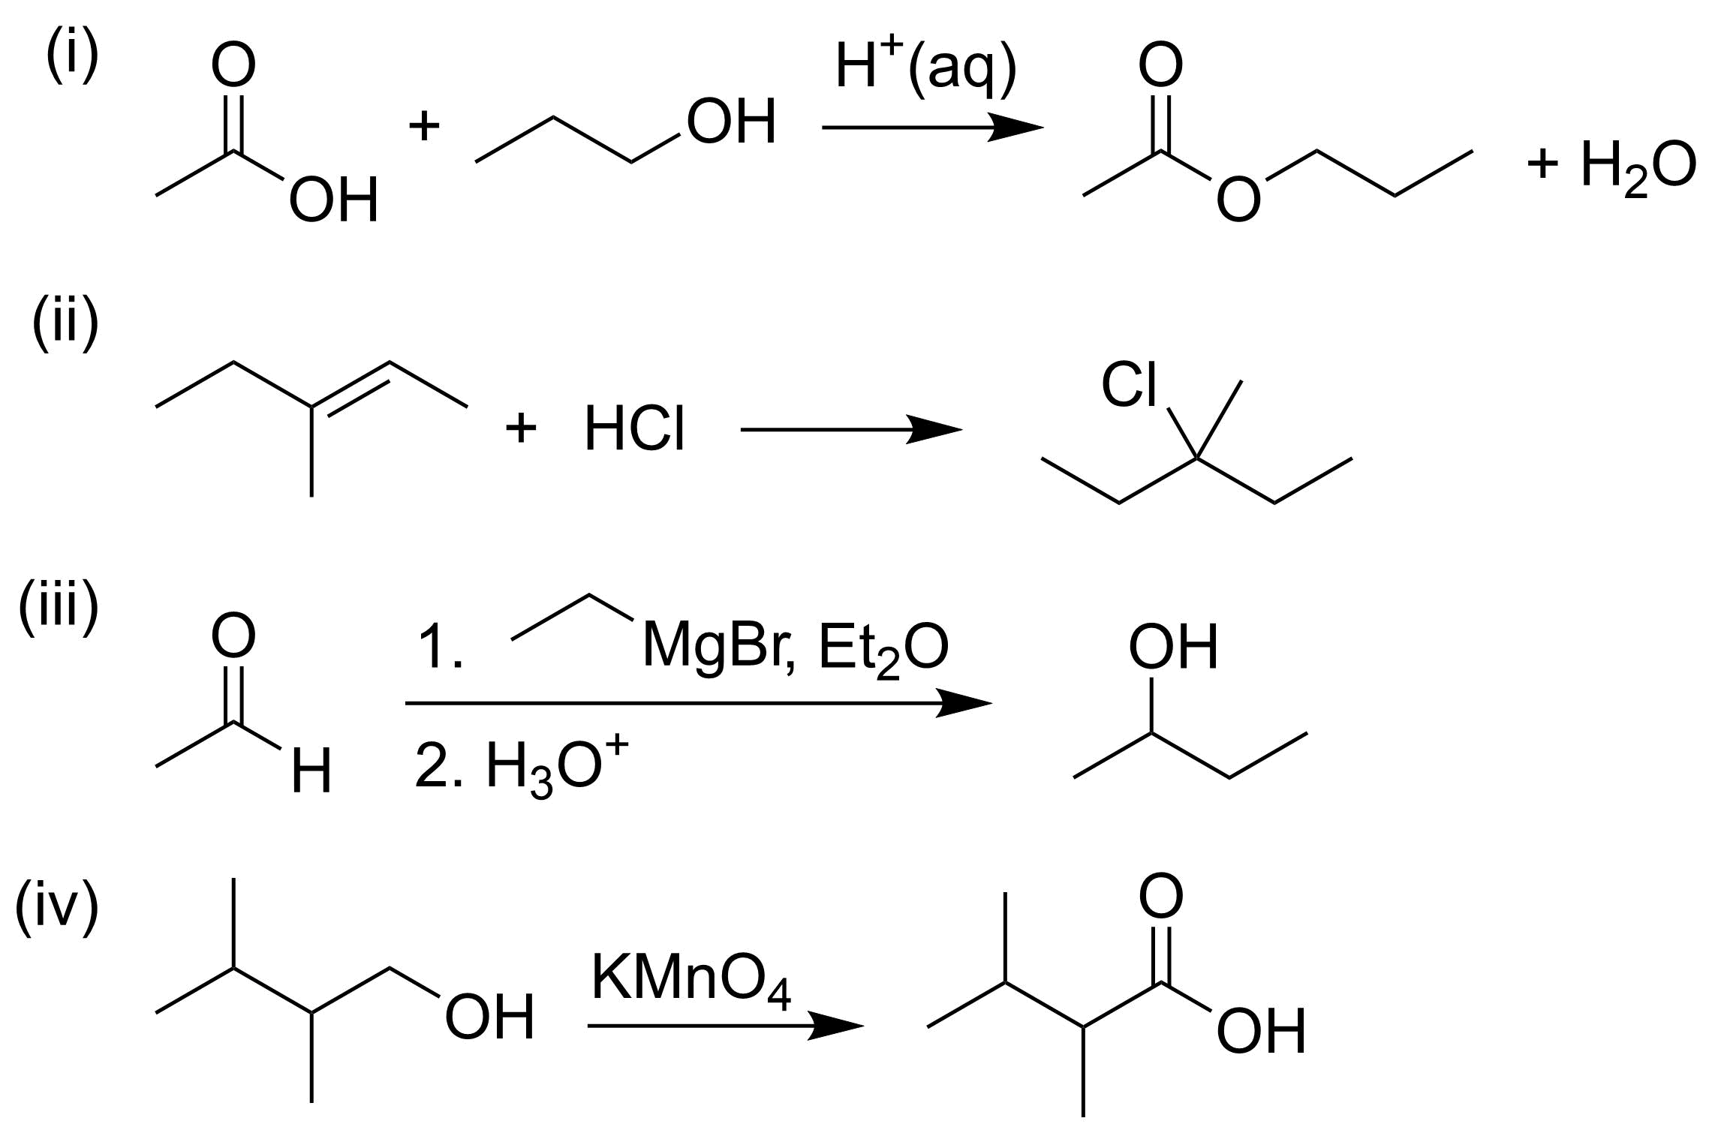
A) | 3 | 0.21
B) | 1 | 0.32
C) | 4 | 0.03
D) | 2 | *0.44
Ans: | D
Variants
Comments

Q#: | 498
Serial #: | Ex_2012_Q27_D40_S4.01
Unit | 4.01 Orgo - Reactions
Used | Ex_2012
Stem | Which of the following are addition reactions?
A) | ii only | 0.40
B) | i, ii | 0.08
C) | ii, iii | *0.40
D) | i, iii | 0.12
Ans: | C
Variants
Comments

Q#: | 499
Serial #: | Ex_2016_Q24_D37_S4.01
Unit | 4.01 Orgo - Reactions
Used | Ex_2016
Stem | Which of the following statements regarding the interconversion of the compounds below is FALSE?
A) | Compounds i, ii, and iv can all be reduced to iii with excess H₂ over Pt or Pd/C. | 0.08
B) | Hydrogenation of ii over Pt or Pd/C can consume twice as much hydrogen as the equivalent amount of i. | 0.15
C) | Compound ii can be converted to iv by reduction with H₂ over Lindlar’s catalyst. | *0.37
D) | Triple bonds are more reactive than double bonds. | 0.40
Ans: | C
Variants
Comments

Q#: | 501
Serial #: | Ex_2012_Q23_D29_S4.01
Unit | 4.01 Orgo - Reactions
Used | Ex_2012
Stem | A student reacts a long chain carboxylic acid (oleic acid; 1.250 g, MW 282.46 g mol⁻¹) with an alcohol in the presence of a catalytic amount of acid. After work-up and purification, the result is a solid (1.238 g), obtained in 75.1% yield. What was the alcohol?
A) | hexanol | 0.37
B) | benzyl alcohol | *0.29
C) | isopropanol | 0.17
D) | phenol | 0.17
Ans: | B
Variants
Comments

Q#: | 75
Serial #: | Ex_2019_Q20_D85_S4.01
Unit | 4.01 Orgo - Reactions
Used | Ex_2019, ^0.85, *0.85
Stem | Which of the following reaction schemes is incorrect?
A) |  | 0.03
B) |  | *0.85
C) |  | 0.07
D)
Ans: | B
Variants
Comments

Q#: | 77
Serial #: | Ex_2019_Q25_D73_S4.01
Unit | 4.01 Orgo - Reactions
Used | Ex_2019, *0.73  Ex_2015
Stem | 2-Bromo-3-methylbutane was reacted with magnesium in diethyl ether, followed by addition of an equimolar amount of 2-propanone, and an acid workup. What was the product?
A) |  | 0.08
B) |  | 0.08
C) |  | *0.73
D) |  | 0.12
Ans: | C
Variants
Comments

Q#: | 52
Serial #: | Ex_2021_Q18_D82_S4.01
Unit | 4.01 Orgo - Reactions
Used | Ex_2021, *0.82  Ex_2020
Stem | What product is expected in the following reaction:  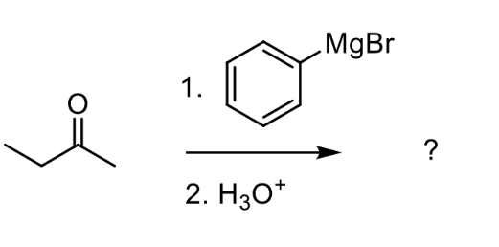
A) | 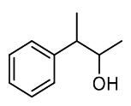
B) | 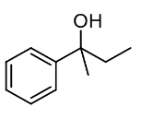 | *0.82
C) | 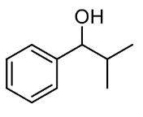
D) | 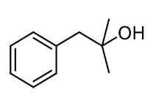
Ans: | B
Variants
Comments

Q#: | 53
Serial #: | Ex_2021_Q20_D79_S4.01
Unit | 4.01 Orgo - Reactions
Used | Ex_2021, *0.79  Ex_2020
Stem | Which two of the following processes are reductions?  I 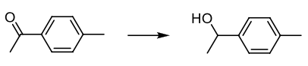  II 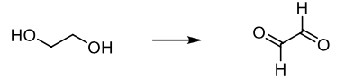  III 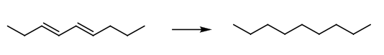  IV 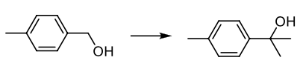
A) | I and III | *0.79
B) | II and IV
C) | I and II
D) | III and IV
Ans: | A
Variants
Comments

Q#: | 54
Serial #: | Ex_2021_Q15V1_D78_S4.01
Unit | 4.01 Orgo - Reactions
Used | Ex_2021, *0.78
Stem | Which of the following reaction products are correct as drawn?
A) |  | *0.78
B)
C)
D)
Ans: | A
Variants
Comments

Q#: | 54
Serial #: | Ex_2021_Q15V2_D78_S4.01
Unit | 4.01 Orgo - Reactions
Used | Ex_2021, *0.78
Stem | Which of the following reaction products are correct as drawn?
A)
B) |  | *0.78
C)
D)
Ans: | B
Variants
Comments

Q#: | 54
Serial #: | Ex_2021_Q15V3_D78_S4.01
Unit | 4.01 Orgo - Reactions
Used | Ex_2021, *0.78
Stem | Which of the following reaction products are correct as drawn?
A)
B)
C) | 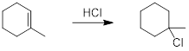 | *0.78
D)
Ans: | C
Variants
Comments

Q#: | 54
Serial #: | Ex_2021_Q15V4_D78_S4.01
Unit | 4.01 Orgo - Reactions
Used | Ex_2021, *0.78
Stem | Which of the following reaction products are correct as drawn?
A)
B)
C)
D) | 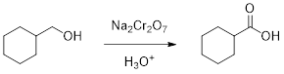 | *0.78
Ans: | D
Variants
Comments

Q#: | 55
Serial #: | Ex_2021_Q19_D75_S4.01
Unit | 4.01 Orgo - Reactions
Used | Ex_2021, *0.75  Ex_2020
Stem | Which of the following statements is true?
A) | Primary alcohols can be oxidized to carboxylic acids with KMnO₄. | *0.75
B) | Grignard reagent addition to ethanal generates a primary alcohol after neutralization.
C) | Sodium borohydride reduction of propanal generates a secondary alcohol.
D) | Acid-catalyzed hydration of an alkene goes through the least highly substituted carbocation intermediate.
Ans: | A
Variants
Comments

Q#: | 504
Serial #: | Ex_2018_Q19_D89_S4.01
Unit | 4.01 Orgo - Reactions
Used | Ex_2018
Stem | Which Grignard reaction below is incorrect?
A) |  | 0.013
B) |  | 0.005
C) |  | *0.89
D) |  | 0.09
Ans: | C
Variants
Comments

Q#: | 517
Serial #: | Ex_2011_Q18_D69_S4.01
Unit | 4.01 Orgo – Reactions
Used | Ex_2011
Stem | Which reaction(s) will not proceed as shown?  (i) 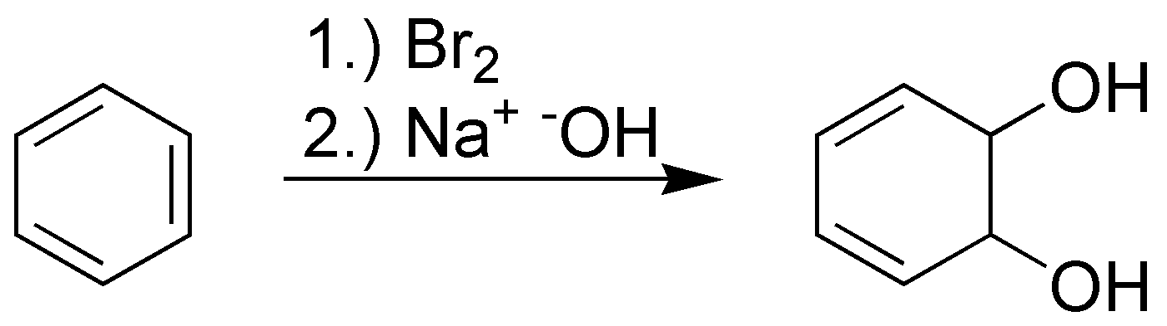  (ii) 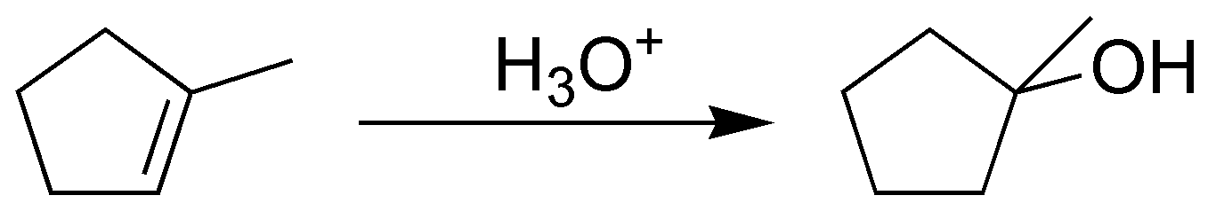  (iii) 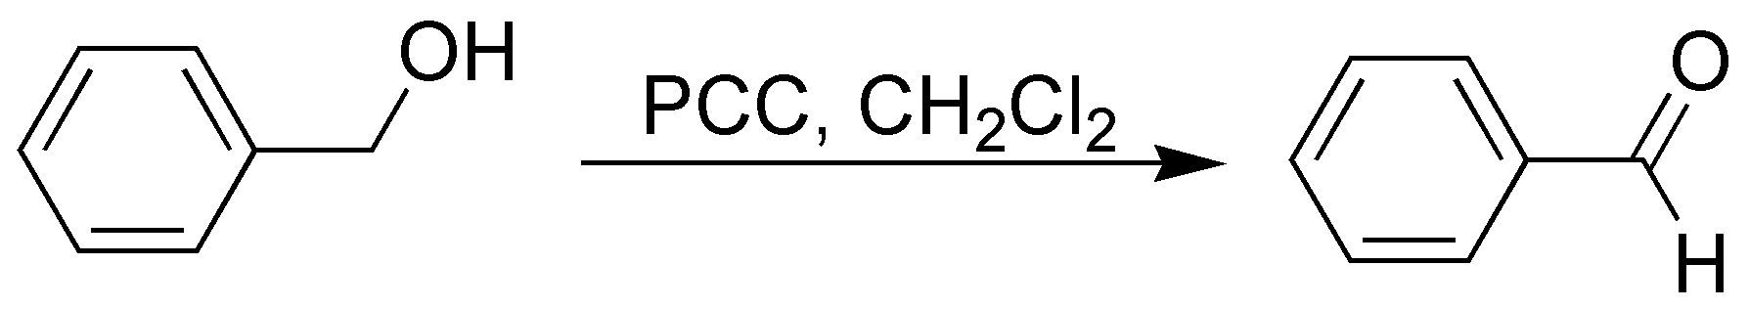
A) | iii | 0.06
B) | i, iii | 0.11
C) | ii | 0.15
D) | i | *0.69
Ans: | D
Variants
Comments

Q#: | 521
Serial #: | Ex_2018_Q27_D63_S4.01
Unit | 4.01 Orgo - Reactions
Used | Ex_2018
Stem | Which reduction reaction below is incorrect?
A) |  | *0.63
B) |  | 0.03
C) |  | 0.26
D) |  | 0.09
Ans: | A
Variants
Comments

Unit 4.02 Mechanisms

Q#: | 29
Serial #: | Ex_2024_Q29_D64_S4.02
Unit | 4.02 Orgo - Mechanisms
Used | Ex_2024, ^0.65, *0.64
Stem | Which statement regarding organic redox reactions is false?
A) | A secondary alcohol can be converted to a tertiary alcohol by oxidation, followed by reaction with a Grignard reagent and acid work-up. | 0.18
B) | In the formation of a Grignard reagent from an alkyl halide, the carbon atom bearing the halide is oxidized. | *0.64
C) | Alkenes are reduced when they undergo catalytic hydrogenation. | 0.07
D) | A primary alcohol can be converted to a carboxylic acid by reaction with K₂Cr₂O₇ in dilute H₃O⁺. | 0.11
Ans: | B
Variants
Comments

Q#: | 28
Serial #: | Ex_2024_Q28_D86_S4.02
Unit | 4.02 Orgo - Mechanisms
Used | Ex_2024, ^0.75, *0.86  Ex_2014
Stem | In which option below are the arrows drawn incorrectly?
A) | i | 0.03
B) | i, ii, iii | 0.06
C) | ii | *0.86
D) | iii | 0.05
Ans: | C
Variants
Comments

Q#: | 16
Serial #: | Ex_2024_Q16_D90_S4.02
Unit | 4.02 Orgo - Mechanisms
Used | Ex_2024, ^0.80, *0.90  Ex_2017
Stem | Which of the following species/reaction steps involved in a Grignard reaction is incorrect? The species can be a reactant, intermediate, transition state, product, or byproduct.
A) |  | 0.03
B) | H₃O⁺ | 0.02
C) |  | *0.90
D) |  | 0.05
Ans: | C
Variants
Comments

Q#: | 14
Serial #: | Ex_2024_Q14_D72_S4.02
Unit | 4.02 Orgo - Mechanisms
Used | Ex_2024, ^0.80, *0.72
Stem | Which carbocation is most likely to be formed through an S_{N}1 mechanism and why?
A) | I because the methyl groups stabilize the positive charge by withdrawing electron density. | 0.21
B) | II because the hydrogen atoms stabilize the positive charge by donating electron density. | 0.03
C) | II because the hydrogen atoms stabilize the positive charge by withdrawing electron density. | 0.04
D) | I because the methyl groups stabilize the positive charge by donating electron density. | *0.72
Ans: | D
Variants
Comments

Q#: | 13
Serial #: | Ex_2024_Q13_D80_S4.02
Unit | 4.02 Orgo - Mechanisms
Used | Ex_2024, ^0.70, *0.80
Stem | Which is the correct reaction profile for the following reaction?  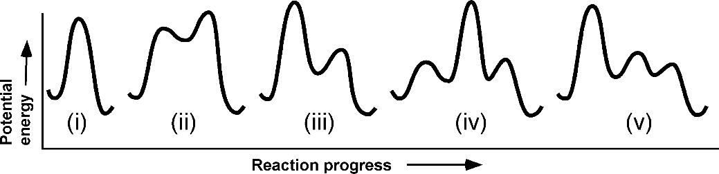
A) | ii or iii | 0.13
B) | i | *0.80
C) | v | 0.07
D) | iv | 0.01
Ans: | B
Variants
Comments

Q#: | 12
Serial #: | Ex_2024_Q12_D90_S4.02
Unit | 4.02 Orgo - Mechanisms
Used | Ex_2024, ^0.85, *0.90
Stem | How likely are the following compounds to react through an S_{N}2 nucleophilic substitution, from least to most likely?
A) | I < II < III | 0.01
B) | III < I < II | 0.04
C) | III < II < I | 0.04
D) | II < III < I | *0.90
Ans: | D
Variants
Comments

Q#: | 11
Serial #: | Ex_2024_Q11_D91_S4.02
Unit | 4.02 Orgo - Mechanisms
Used | Ex_2024, ^0.80, *0.91
Stem | What is the nucleophile in the reaction of 1-chloropropane to propan-1-ol?
A) | chloride | 0.03
B) | propan-1-ol | 0.01
C) | hydroxide | *0.91
D) | 1-chloropropane | 0.05
Ans: | C
Variants
Comments

Q#: | 10
Serial #: | Ex_2024_Q10_D82_S4.02
Unit | 4.02 Orgo - Mechanisms
Used | Ex_2024, ^0.7, *0.82
Stem | Which statement about the following reaction is false?
A) | It follows a second-order rate law. | *0.82
B) | It produces a tertiary alcohol. | 0.03
C) | An alcohol product would be formed after three steps. | 0.09
D) | It proceeds via a carbocation intermediate. | 0.06
Ans: | A
Variants
Comments

Q#: | 27
Serial #: | Ex_2023_Q27_D57_S4.02
Unit | 4.02 Orgo - Mechanisms
Used | Ex_2023, *0.53, *0.57  Ex_2022, ^0.7, *0.53
Stem | Which of the following statements about the reduction of an aldehyde by sodium borohydride is true?
A) | The aldehyde group acts as an electrophile and the intermediate has a positive charge. | 0.21
B) | The aldehyde group acts as a nucleophile and the intermediate has a negative charge. | 0.14
C) | The aldehyde group acts as an electrophile and the intermediate has a negative charge. | *0.57
D) | The aldehyde group acts as a nucleophile and the intermediate has a positive charge. | 0.08
Ans: | C
Variants
Comments

Q#: | 26
Serial #: | Ex_2023_Q26_D67_S4.02
Unit | 4.02 Orgo - Mechanisms
Used | Ex_2023, ^0.55, *0.67
Stem | Which of the following represents the most stable intermediate of the reaction scheme shown below (D = ²H, a heavy isotope of hydrogen)?
A) |  | 0.22
B) |  | 0.07
C) |  | *0.67
D) |  | 0.04
Ans: | C
Variants
Comments

Q#: | 24
Serial #: | Ex_2023_Q24_D64_S4.02
Unit | 4.02 Orgo - Mechanisms
Used | Ex_2023, ^0.75, *0.64
Stem | What best describes the mechanism of the reaction shown below?
A) | The reaction has 2 steps and goes through the least substituted carbocation intermediate. | 0.11
B) | The reaction has 2 steps and goes through the most substituted carbocation intermediate. | 0.15
C) | The reaction has 3 steps and goes through the least substituted carbocation intermediate. | 0.10
D) | The reaction has 3 steps and goes through the most substituted carbocation intermediate. | *0.64
Ans: | D
Variants
Comments

Q#: | 23
Serial #: | Ex_2023_Q23_D83_S4.02
Unit | 4.02 Orgo - Mechanisms
Used | Ex_2023, ^0.60, *0.83
Stem | Which of the following statements about alcohol formation is incorrect?
A) | They can be formed through an S_{N}2 reaction of a primary alkyl halide with a hydroxide. | 0.04
B) | They can be formed through an acid-catalyzed hydration reaction of an alkene with water. | 0.04
C) | They can be formed through the reduction of an aldehyde with PCC. | *0.83
D) | They can be formed through the hydrolysis of an ester with aqueous acid. | 0.09
Ans: | C
Variants
Comments

Q#: | 21
Serial #: | Ex_2023_Q21_D80_S4.02
Unit | 4.02 Orgo - Mechanisms
Used | Ex_2023, ^0.70, *0.80
Stem | What is the role of H₃O⁺ in Grignard reaction of ketones?
A) | To protonate the oxygen in the alkoxide intermediate. | *0.80
B) | To protonate the Grignard starting material. | 0.01
C) | To protonate the oxygen in the ketone starting material. | 0.15
D) | To protonate the carbon in the ketone starting material. | 0.05
Ans: | A
Variants
Comments

Q#: | 18
Serial #: | Ex_2023_Q18_D76_S4.02
Unit | 4.02 Orgo - Mechanisms
Used | Ex_2023, *0.67, *0.76  Ex_2022, ^0.8, *0.67
Stem | Which of the following statements about the 2-step mechanism shown below is/are true?
A) | Only the second step is drawn correctly. | 0.04
B) | Neither step is drawn correctly. | 0.08
C) | Only the first step is drawn correctly. | *0.76
D) | Both steps are drawn correctly. | 0.12
Ans: | C
Variants
Comments

Q#: | 17
Serial #: | Ex_2023_Q17_D88_S4.02
Unit | 4.02 Orgo - Mechanisms
Used | Ex_2023, ^0.70, *0.88
Stem | What best describes the role of a carbocation intermediate in S_{N}1 nucleophilic substitution and alkene hydrohalogenation reactions?
A) | proton acceptor | 0.05
B) | electrophile | *0.88
C) | nucleophile | 0.05
D) | leaving group | 0.01
Ans: | B
Variants
Comments

Q#: | 15
Serial #: | Ex_2023_Q15_D77_S4.02
Unit | 4.02 Orgo – Mechanisms
Used | Ex_2023, ^0.85, *0.77
Stem | What is the likelihood of these molecules undergoing an S_{N}2 nucleophilic substitution reaction, from least to most likely?
A) | i, ii, iii | 0.02
B) | ii, i, iii | 0.03
C) | ii, iii, i | *0.77
D) | i, iii, ii | 0.18
Ans: | C
Variants
Comments

Q#: | 14
Serial #: | Ex_2023_Q14_D86_S4.02
Unit | 4.02 Orgo – Mechanisms
Used | Ex_2023, ^0.80, *0.86
Stem | Which intermediate would result from the electron movement shown?
A) | C | 0.07
B) | D | 0.04
C) | B | 0.02
D) | A | *0.86
Ans: | D
Variants
Comments

Q#: | 12
Serial #: | Ex_2023_Q12_D86_S4.02
Unit | 4.02 Orgo – Mechanisms
Used | Ex_2023, ^0.70, *0.86
Stem | Which of the following reactions is drawn incorrectly?
A) | C | *0.86
B) | D | 0.03
C) | A | 0.06
D) | B | 0.04
Ans: | A
Variants
Comments

Q#: | 61
Serial #: | Ex_2022_Q21_D68_S14.02
Unit | 4.02 Orgo - Mechanisms
Used | Ex_2022, ^0.75, *0.68
Stem | Which of the following statements about this 2-step reaction scheme is true?  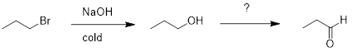
A) | The first step goes through an S_{N}1 mechanism, and the second step requires PCC in CH₂Cl₂. | 0.15
B) | The first step goes through an S_{N}2 mechanism, and the second step requires PCC in CH₂Cl₂. | *0.68
C) | The first step goes through an S_{N}1 mechanism, and the second step requires KMnO₄. | 0.08
D) | The first step goes through an S_{N}2 mechanism, and the second step requires KMnO₄. | 0.09
Ans: | B
Variants
Comments

Q#: | 62
Serial #: | Ex_2022_Q18_D68_S4.02
Unit | 4.02 Orgo - Mechanisms
Used | Ex_2022, ^0.7, *0.68
Stem | Which of the following is not an intermediate, transition state, or mechanistic step in the nucleophilic substitution reaction of 2-bromo-2-methylbutane with NaN₃?
A) | 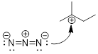 | 0.05
B) | 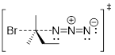 | *0.68
C) | 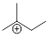 | 0.05
D) | 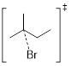 | 0.23
Ans: | B
Variants
Comments

Q#: | 65
Serial #: | Ex_2022_Q22_D53_S4.02
Unit | 4.02 Orgo - Mechanisms
Used | Ex_2022, ^0.7, *0.53
Stem | Which of the following statements about the reduction of an aldehyde by sodium borohydride is true?
A) | The aldehyde acts as a nucleophile and the intermediate has a negative charge. | 0.15
B) | The aldehyde acts as an electrophile and the intermediate has a positive charge. | 0.20
C) | The aldehyde acts as a nucleophile and the intermediate has a positive charge. | 0.13
D) | The aldehyde acts as an electrophile and the intermediate has a negative charge. | *0.53
Ans: | D
Variants
Comments

Q#: | 66
Serial #: | Ex_2012_Q22_D53_S4.02
Unit | 4.02 Orgo - Mechanisms
Used | Ex_2022, *0.82, *0.53  Ex_2012
Stem | Which of the following structures would be one of the major intermediates in this reaction?  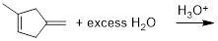
A) | 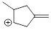 | 0.07
B) | 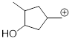 | 0.12
C) | 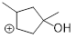 | 0.27
D) | 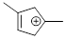 | *0.53
Ans: | D
Variants
Comments

Q#: | 463
Serial #: | Ex_2017_Q14_D90_S4.02
Unit | 4.02 Orgo - Mechanisms
Used | Ex_2017
Stem | Which of the following statements regarding organic reactions is FALSE?
A) | The nucleophile is the electron donor, and is a Lewis base. | 0.04
B) | When writing a mechanism, the tail of the double-barbed curly arrow is at the electrophile while the arrowhead is at the nucleophile. | *0.90
C) | Nucleophiles and electrophiles must be properly aligned with each other for the reaction to occur. | 0.03
D) | Forming a bond in a nucleophilic substitution reaction involves electrons moving from the nucleophile to the electrophile. | 0.03
Ans: | B
Variants
Comments

Q#: | 464
Serial #: | Ex_2013_Q29_D86_S4.02
Unit | 4.02 Orgo - Mechanisms
Used | Ex_2013
Stem | For the reaction between 3-methylpent-2-ene and HBr, which of the following structures correspond to the intermediate(s) and product(s) formed?  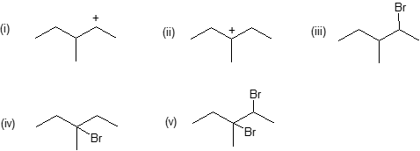
A) | i, iii | 0.04
B) | all will be formed | 0.014
C) | ii, iv | *0.86
D) | i, ii, iii, iv | 0.09
Ans: | C
Variants
Comments

Q#: | 472
Serial #: | Ex_2017_Q29_D79_S4.02
Unit | 4.02 Orgo - Mechanisms
Used | Ex_2017
Stem | Rank the following alkyl halides from most to least likely to undergo an S_{N}1 nucleophilic substitution:  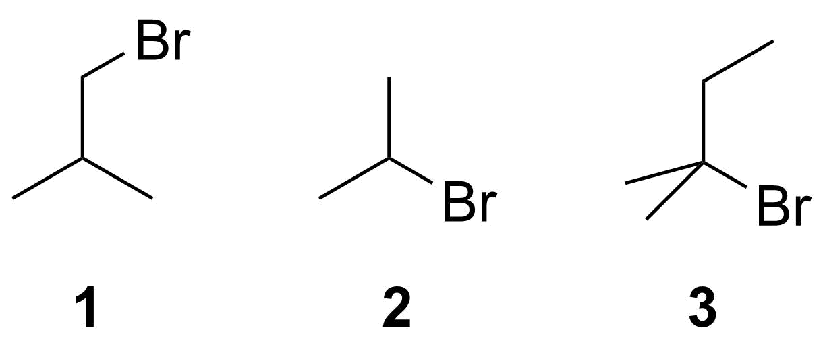
A) | 2 > 1 > 3 | 0.04
B) | 1 > 2 > 3 | 0.08
C) | 3 > 1 > 2 | 0.09
D) | 3 > 2 > 1 | *0.79
Ans: | D
Variants
Comments

Q#: | 476
Serial #: | Ex_2018_Q18_D77_S4.02
Unit | 4.02 Orgo - Mechanisms
Used | Ex_2018
Stem | What is the relative stability of the carbocations formed by loss of Br⁻ from the compounds shown below? (From most to least stable.)
A) | ii > i ≈ iv > iii | *0.77
B) | i ≈ ii > iv > iii | 0.10
C) | iv ≈ ii > i > iii | 0.06
D) | iii > iv ≈ i > ii | 0.06
Ans: | A
Variants
Comments

Q#: | 477
Serial #: | Ex_2011_Q17_D77_S4.02
Unit | 4.02 Orgo - Mechanisms
Used | Ex_2011
Stem | Indicate the FALSE statement regarding alkynes.
A) | Reaction of propyne with excess bromine would result in formation of 1,1,2,2-tetrabromopropane. | 0.09
B) | The carbon-carbon triple bond in ethyne is three times as strong as the carbon-carbon single bond in ethane. | *0.77
C) | Alkynes are linear functional groups because both carbon atoms in the triple bond are sp-hybridized. | 0.11
D) | Cyclopentyne is less stable than cyclopentene. | 0.03
Ans: | B
Variants
Comments

Q#: | 484
Serial #: | Ex_2015_Q26_D67_S4.02
Unit | 4.02 Orgo - Mechanisms
Used | Ex_2015
Stem | Which of the following species are NOT intermediates or products in the acid-catalyzed hydration of 2-methyl-but-2-ene?  (i) 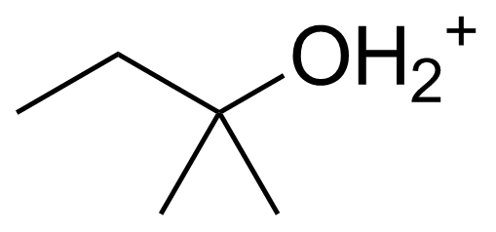  (ii) 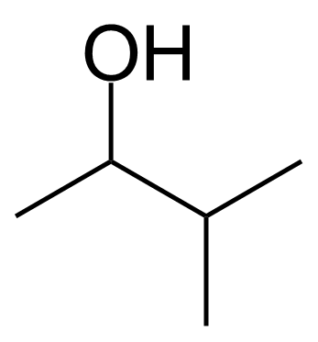  (iii) 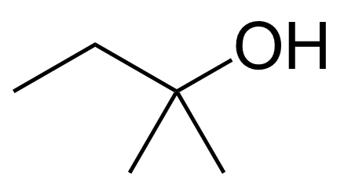  (iv) 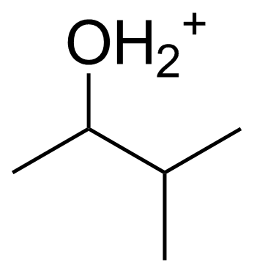
A) | ALL of i − iv | 0.06
B) | NONE of i − iv | 0.06
C) | i, iii | 0.21
D) | ii, iv | *0.67
Ans: | D
Variants
Comments

Q#: | 500
Serial #: | Ex_2016_Q30_D33_S4.02
Unit | 4.02 Orgo - Mechanisms
Used | Ex_2016
Stem | Which of the following figures is not drawn correctly?
A) | 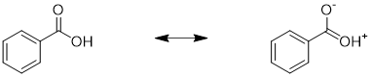 | 0.25
B) | 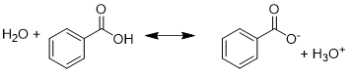 | *0.33
C) | 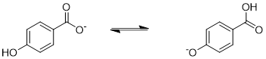 | 0.27
D) | 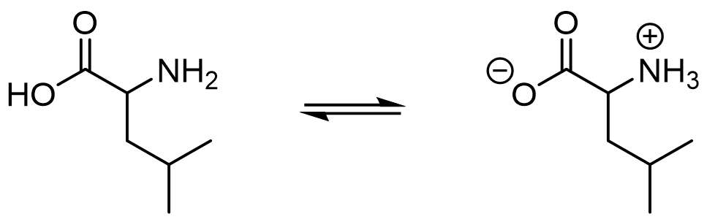
Ans: | B
Variants
Comments

Q#: | 56
Serial #: | Ex_2021_Q26_D68_S4.02
Unit | 4.02 Orgo - Mechanisms
Used | Ex_2021, *0.68
Stem | Indicate the false statement concerning organic reactions:
A) | In the reaction of H₂O with ClC(CH₃)₃, doubling [ClC(CH₃)₃] will not double the rate of reaction. | *0.68
B) | S_{N}1 reactions of tertiary alkyl halides are faster than S_{N}1 reactions of secondary alkyl halides.
C) | The reaction of HO⁻ with ClCH₂CH₃ does not involve a carbocation intermediate.
D) | S_{N}2 reactions become nine times faster when [nucleophile] and [electrophile] both increase by a factor of three.
Ans: | A
Variants
Comments

Q#: | 67
Serial #: | Ex_2022_Q19_D87_S4.02
Unit | 4.02 Orgo - Mechanisms
Used | Ex_2022, ^0.5, *0.87
Stem | Compound 1 acts as an anti-cancer drug by damaging an adenine base in DNA. Which statement about the reaction scheme below is false?  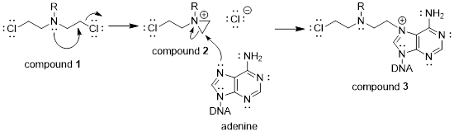
A) | In the first step, the nitrogen atom of compound 1 behaves as a nucleophile. | 0.05
B) | The first step of the reaction is a concerted reaction because bond breaking and bond forming occur simultaneously. | 0.05
C) | In the second step of the reaction, adenine behaves as the electrophile. | *0.87
D) | The second step of the reaction mechanism is bimolecular. | 0.04
Ans: | C
Variants
Comments

Q#: | 68
Serial #: | Ex_2022_Q23_D72_S4.02
Unit | 4.02 Orgo - Mechanisms
Used | Ex_2022, ^0.75, *0.72
Stem | Which of the following is an intermediate of the transformation shown below?  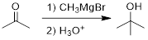
A) | 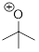 | 0.13
B) | 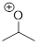 | 0.05
C) | 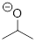 | 0.10
D) | 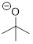 | *0.72
Ans: | D
Variants
Comments

Q#: | 69
Serial #: | Ex_2022_Q25_D67_S4.02
Unit | 4.02 Orgo - Mechanisms
Used | Ex_2022, ^0.8, *0.67
Stem | Which statement about the two-step mechanism below is true?  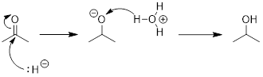
A) | The second step is drawn incorrectly. | *0.67
B) | Both steps are drawn correctly. | 0.12
C) | The first step is drawn incorrectly. | 0.11
D) | Both steps are drawn incorrectly. | 0.10
Ans: | A
Variants
Comments

Q#: | 59
Serial #: | Ex_2021_Q25_D77_S4.02
Unit | 4.02 Orgo - Mechanisms
Used | Ex_2021, *0.77
Stem | Charges are not shown in the following proposed halogenation mechanism. What are the charge states in intermediates Int1 and Int2?  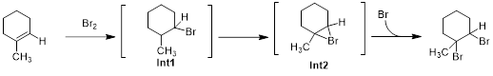
A) | Both Int1 and Int2 possess a bromine atom with a formal positive charge.
B) | Both Int1 and Int2 possess a carbon atom with a formal positive charge.
C) | Int1 has a formal positive charge on carbon. Int2 has a formal positive charge on bromine. | *0.77
D) | Int1 has a formal positive charge on bromine. Int2 has a formal positive charge on carbon.
Ans: | C
Variants
Comments | <<Options and answers are the same in every version.>>

Q#: | 63
Serial #: | T2_2021_Q20V1_D55_S4.02
Unit | 4.02 Orgo - Mechanisms
Used | T2_2021, *0.55 / ^0.60
Stem | Charges are not shown in the following hydrohalogenation mechanism with a formal charge missing on carbon A of Int1. What is the charge state and hybridization of carbon A in intermediate Int1?  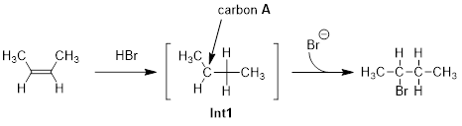
A) | Carbon A is positively charged and sp²-hybridized. | *0.55
B) | Carbon A is positively charged and sp³-hybridized.
C) | Carbon A is negatively charged and sp²-hybridized.
D) | Carbon A is negatively charged and sp³-hybridized.
Ans: | A
Variants
Comments

Q#: | 510
Serial #: | Ex_2011_Q13_D80_S4.02
Unit | 4.02 Orgo - Mechanisms
Used | Ex_2011
Stem | Which halide compounds below are expected to undergo nucleophilic substitution by an S_{N}1 mechanism, rather than S_{N}2?  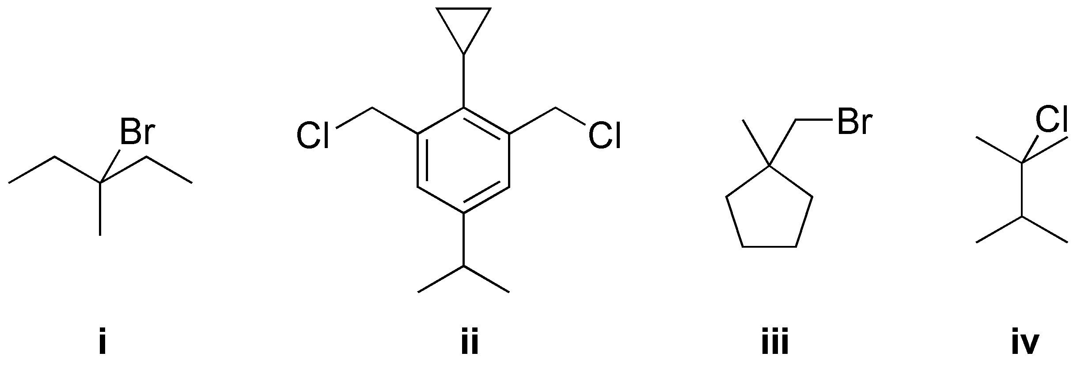
A) | ii, iii | 0.12
B) | ii, iv | 0.02
C) | i, iii | 0.06
D) | i, iv | *0.80
Ans: | D
Variants
Comments

Q#: | 511
Serial #: | Ex_2017_Q23_D79_S4.02
Unit | 4.02 Orgo - Mechanisms
Used | Ex_2017
Stem | Which of the following species/reaction steps involved in a Grignard reaction is INCORRECT? The species can be a reactant, intermediate, transition state, product, or byproduct.
A) | 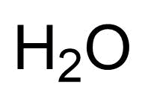 | 0.09
B) | 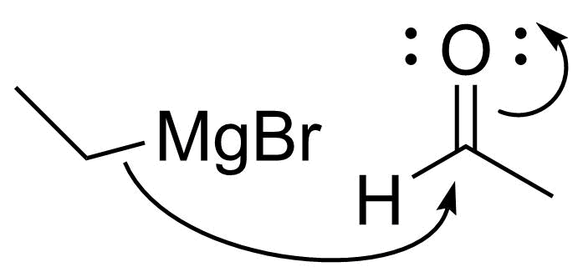 | 0.04
C) | 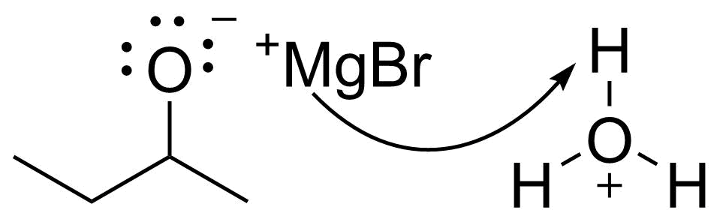 | *0.79
D) | 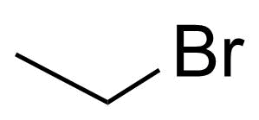 | 0.07
Ans: | C
Variants
Comments

Q#: | 514
Serial #: | Ex_2014_Q17_D72_S4.02
Unit | 4.02 Orgo - Mechanisms
Used | Ex_2014
Stem | In which of the options below are all the arrows drawn correctly?  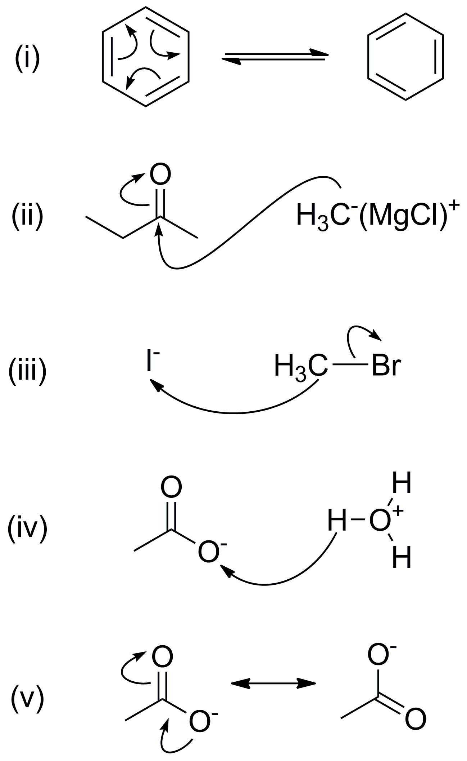
A) | ii, v | *0.72
B) | ii, iii | 0.08
C) | iv, v | 0.09
D) | i, iv | 0.10
Ans: | A
Variants
Comments

Q#: | 518
Serial #: | Ex_2011_Q19_D67_S4.02
Unit | 4.02 Orgo - Mechanisms
Used | Ex_2011
Stem | Which statement regarding S_{N}2 nucleophilic substitution reactions is FALSE?
A) | Increasing steric crowding around the electrophilic carbon will tend to favour an S_{N}1 over S_{N}2 mechanism. | 0.12
B) | S_{N}2 reactions become nine times faster when [nucleophile] and [electrophile] both increase by a factor of three. | 0.16
C) | S_{N}2 reactions consist of a slow first step followed by a fast second step. | *0.67
D) | S_{N}2 reactions may involve charged or neutral nucleophiles. | 0.05
Ans: | C
Variants
Comments

Q#: | 524
Serial #: | Ex_2012_Q14_D52_S4.02
Unit | 4.02 Orgo - Mechanisms
Used | Ex_2012
Stem | Given the following structures, which of the statements below is incorrect?  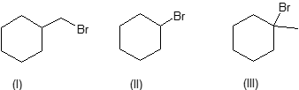
A) | Molecule II can react with some nucleophiles via an S_{N}1 mechanism. | 0.15
B) | When II undergoes a successful substitution reaction with CH₃COONa (where CH₃COO– is a nucleophile) the product is an ester. | 0.22
C) | Molecule I will react with nucleophiles via a two-step substitution mechanism. | *0.52
D) | Reaction of III with water will produce an alcohol via an S_{N}1 mechanism. | 0.10
Ans: | C
Variants
Comments

Q#: | 528
Serial #: | Ex_2014_Q24_D23_S4.02
Unit | 4.02 Orgo - Mechanisms
Used | Ex_2014
Stem | Which of the following reaction mechanisms is the least plausible?
A) | CH₃CH=CH₂ + H₃O⁺ → (CH₃)₂CH⁺ + H₂O  (CH₃)₂CH⁺ + Cl– → (CH₃)₂CHCl | 0.35
B) | CH₃CH₂Cl + Mg + CO₂ → CH₃CH₂COO– + Mg²⁺ + Cl–  CH₃CH₂COO– + H₃O⁺ → CH₃CH₂COOH + H₂O | *0.23
C) | ClC(CH₃)₃ → C(CH₃)₃⁺ + Cl–  C(CH₃)₃⁺ + H₂O → H₂OC(CH₃)₃⁺  H₂OC(CH₃)₃⁺ + H₂O → HOC(CH₃)₃ + H₃O⁺ | 0.23
D) | CH₃CH₂C(O)H + H– → CH₃CH₂CH₂O–  CH₃CH₂CH₂O– + H₃O⁺ → CH₃CH₂CH₂OH + H₂O | 0.19
Ans: | B
Variants
Comments

Q#: | 78
Serial #: | Ex_2013_Q28_D85_S4.02
Unit | 4.02 Orgo - Mechanisms
Used | Ex_2019, *0.85  Ex_2013
Stem | Rank the following carbocations in order of increasing likelihood to be found as intermediates in an S_{N}1 reaction (from least likely to most likely):
A) | iv ≈ i < iii < ii | 0.04
B) | i ≈ iv < ii < iii | *0.85
C) | ii < i ≈ iv < iii | 0.09
D) | iv < ii < i < iii | 0.02
Ans: | B
Variants
Comments

Q#: | 64
Serial #: | Ex_2021_Q14_D54_S4.02
Unit | 4.02 Orgo - Mechanisms
Used | Ex_2021, *0.54  Ex_2020
Stem | Which of the following statements are true?  - An S_{N}2 mechanism goes through a trigonal bipyramidal transition state.  - H₃O⁺-catalyzed hydration of an alkene goes through a carbocation intermediate.  - An S_{N}1 mechanism goes through a trigonal bipyramidal intermediate.  - Grignard addition to an aldehyde goes through a carbocation intermediate.
A) | (i) and (ii) | *0.54
B) | (i) and (iv)
C) | (ii) and (iii)
D) | (iii) and (iv)
Ans: | A
Variants
Comments

Q#: | 65
Serial #: | Ex_2021_Q16V1_D51_S4.02
Unit | 4.02 Orgo - Mechanisms
Used | Ex_2021, *0.51
Stem | When 3-iodo-3-methylpentane is placed in liquid methanol, a reaction occurs to generate a neutral product. Which of the following species are intermediates in the mechanism?
A) | (i) and (ii) | *0.51
B) | (i) and (iii)
C) | (ii) and (iv)
D) | (iii) and (iv)
Ans: | A
Variants
Comments

Q#: | 65
Serial #: | Ex_2021_Q16V2_D51_S4.02
Unit | 4.02 Orgo - Mechanisms
Used | Ex_2021, *0.51
Stem | When 2-bromo-2,3-dimethylbutane is placed in liquid ethanol, a reaction occurs to generate a neutral product. Which of the following species are intermediates in the mechanism?
A) | (i) and (ii) | *0.51
B) | (i) and (iii)
C) | (ii) and (iv)
D) | (iii) and (iv)
Ans: | A
Variants
Comments

Q#: | 80
Serial #: | Ex_2019_Q21_D77_S4.02
Unit | 4.02 Orgo - Mechanisms
Used | Ex_2019, *0.77  Ex_2011
Stem | Which of the following is an incorrect representation of a reaction mechanism? (Hint: You may assume that lone pairs of electrons are present, as necessary, for the structures to be correct.)
A) |  | 0.02
B) |  | 0.03
C) |  | 0.18
D) |  | *0.77
Ans: | D
Variants
Comments

Q#: | 66
Serial #: | Ex_2021_Q23V1_D51_S4.02
Unit | 4.02 Orgo - Mechanisms
Used | Ex_2021, *0.51
Stem | On the lowest energy pathway to form the product of the following reaction, which species is a plausible transition state? (Dotted lines represent bonds in the process of forming or breaking.)  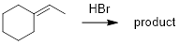
A) | 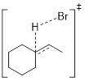
B) | 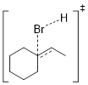
C) | 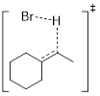 | *0.51
D) | 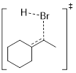
Ans: | C
Variants
Comments

Q#: | 66
Serial #: | Ex_2021_Q23V2_D51_S4.02
Unit | 4.02 Orgo - Mechanisms
Used | Ex_2021, *0.51
Stem | On the lowest energy pathway to form the product of the following reaction, which species is a plausible transition state? (Dotted lines represent bonds in the process of forming or breaking.)  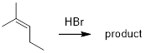
A) | 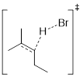
B) | 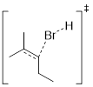
C) | 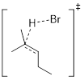
D) | 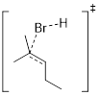
Ans: | A
Variants
Comments

Q#: | 66
Serial #: | Ex_2021_Q23V3_D51_S4.02
Unit | 4.02 Orgo - Mechanisms
Used | Ex_2021, *0.51
Stem | On the lowest energy pathway to form the product of the following reaction, which species is a plausible transition state? (Dotted lines represent bonds in the process of forming or breaking.)  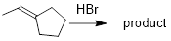
A) | 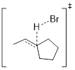
B) | 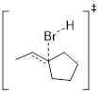
C) | 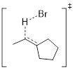
D) | 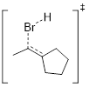
Ans: | C
Variants
Comments

Q#: | 66
Serial #: | Ex_2021_Q23V4_D51_S4.02
Unit | 4.02 Orgo - Mechanisms
Used | Ex_2021, *0.51
Stem | On the lowest energy pathway to form the product of the following reaction, which species is a plausible transition state? (Dotted lines represent bonds in the process of forming or breaking.)  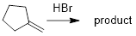
A) | 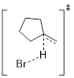
B) | 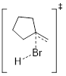
C) | 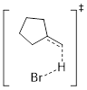
D) | 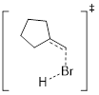
Ans4: | C
Variants
Comments

Q#: | 529
Serial #: | Ex_2017_Q22_D59_S4.02
Unit | 4.02 Orgo - Mechanisms
Used | Ex_2017
Stem | Which is the correct reaction profile for the following reaction?  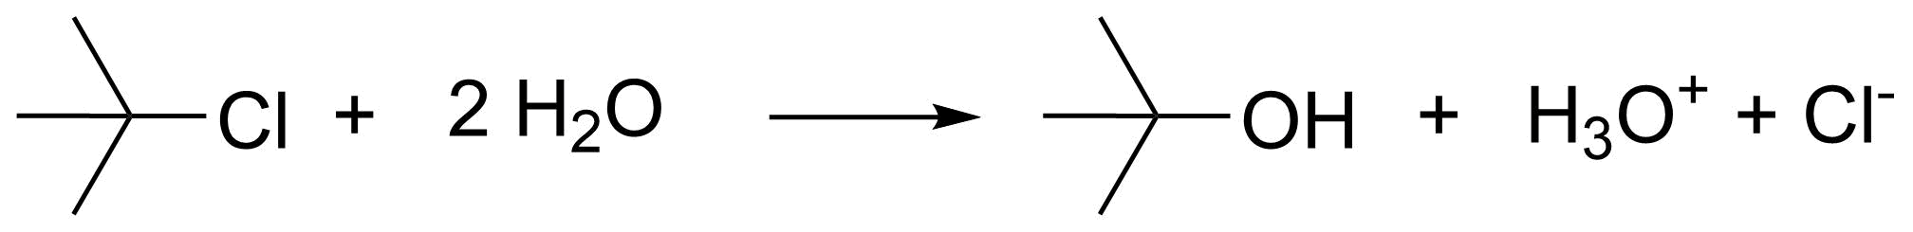  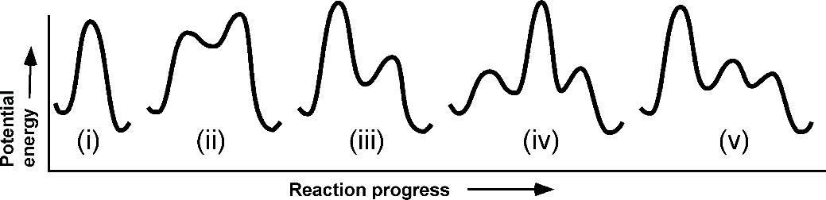
A) | i | 0.05
B) | v | *0.59
C) | iv | 0.06
D) | iii | 0.30
Ans: | B
Variants
Comments

Q#: | 530
Serial #: | Ex_2016_Q06_D25_S4.02
Unit | 4.02 Orgo - Mechanisms
Used | Ex_2016
Stem | Which of the following reactions are consistent with the reaction profile shown below?  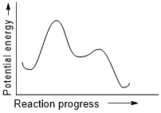  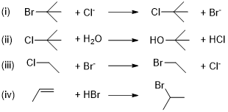
A) | ii, iv | 0.45
B) | ii, iii | 0.12
C) | i, iv | *0.25
D) | i, iii | 0.18
Ans: | C
Variants
Comments

Unit 4.03 Synthesis

Q#: | 28
Serial #: | Ex_2023_Q28_D86_S4.03
Unit | 4.03 Orgo - Synthesis
Used | Ex_2023, ^0.45, *0.86
Stem | Which of the following represents the major product of the multistep pathway shown below?
A) |  | *0.86
B) |  | 0.04
C) |  | 0.09
D) |  | 0.01
Ans: | A
Variants
Comments

Q#: | 25
Serial #: | Ex_2023_Q25_D65_S4.03
Unit | 4.03 Orgo - Synthesis
Used | Ex_2023, ^0.40, *0.65
Stem | Which of the following represents the major product of the multistep synthesis shown below?
A) |  | *0.65
B) |  | 0.24
C) |  | 0.07
D) |  | 0.03
Ans: | A
Variants
Comments

Q#: | 60
Serial #: | Ex_2022_Q26_D71_S4.03
Unit | 4.03 Orgo - Synthesis
Used | Ex_2022, ^0.75, *0.71
Stem | Which of the following reactions or conditions are correct to yield the products shown?  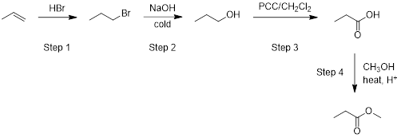
A) | Steps 1 and 2. | 0.18
B) | Steps 3 and 4. | 0.06
C) | Steps 2 and 4. | *0.71
D) | Steps 1 and 3. | 0.05
Ans: | C
Variants
Comments

Q#: | 490
Serial #: | Ex_2011_Q24_D61_S4.03
Unit | 4.03 Orgo - Synthesis
Used | Ex_2011
Stem | Indicate the correct reaction types for the reactions shown below:  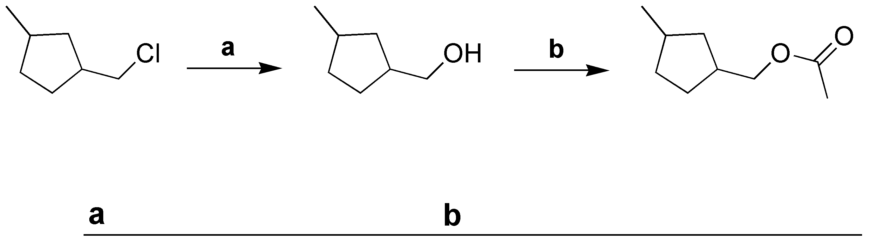
A) | a) hydration  b) esterification | 0.27
B) | a) hydration  b) Grignard | 0.05
C) | a) nucleophilic substitution  b) Grignard | 0.07
D) | b) nucleophilic substitution  b) esterification | *0.61
Ans: | D
Variants
Comments

Q#: | 76
Serial #: | Ex_2019_Q18_D78_S4.03
Unit | 4.03 Orgo - Synthesis
Used | Ex_2019, ^0.85, *0.78
Stem | What is product C, given the reaction sequence below?
A) |  | 0.08
B) |  | 0.11
C) |  | 0.03
D) |  | *0.78
Ans: | D
Variants
Comments

Q#: | 57
Serial #: | Ex_2021_Q24V1_D62_S4.03
Unit | 4.03 Orgo - Synthesis
Used | Ex_2021, *0.62
Stem | Thiols (R-SH) can act as nucleophiles. What is the expected final product (compound II) in this reaction?
A) |  | *0.62
B)
C)
D)
Ans: | A
Variants
Comments

Q#: | 57
Serial #: | Ex_2021_Q24V2_D62_S4.03
Unit | 4.03 Orgo - Synthesis
Used | Ex_2021, *0.62
Stem | Thiols (RSH) can act as a nucleophile. What is the expected final product (compound II) in this reaction?
A) |  | *0.62
B)
C)
D)
Ans: | A
Variants
Comments

Q#: | 57
Serial #: | Ex_2021_Q24V3_D62_S4.03
Unit | 4.03 Orgo - Synthesis
Used | Ex_2021, *0.62
Stem | Thiols (RSH) can act as a nucleophile. What is the expected final product (compound II) in this reaction?
A) |  | *0.62
B)
C)
D)
Ans: | A
Variants
Comments

Q#: | 57
Serial #: | Ex_2021_Q24V4_D62_S4.03
Unit | 4.03 Orgo - Synthesis
Used | Ex_2021, *0.62
Stem | Thiols (RSH) can act as a nucleophile. What is the expected final product (compound II) in this reaction?
A) |  | *0.62
B)
C)
D)
Ans: | A
Variants
Comments

Q#: | 58
Serial #: | Ex_2021_Q28V1_D52_S4.03
Unit | 4.03 Orgo - Synthesis
Used | Ex_2021, *0.52
Stem | A combinatorial library was constructed by performing a Grignard reaction with every alkyl halide below and every aldehyde / ketone, followed by acid work-up. The products were then reacted with KMnO₄.  Which compound below is not part of the resulting combinatorial library?
A) |  | *0.52
B)
C)
D)
Ans: | A
Variants
Comments

Q#: | 58
Serial #: | Ex_2021_Q28V2_D52_S4.03
Unit | 4.03 Orgo - Synthesis
Used | Ex_2021, *0.52
Stem | A combinatorial library was constructed by performing a Grignard reaction with every alkyl halide below and every aldehyde / ketone, followed by acid work-up. The products were then reacted with KMnO₄.  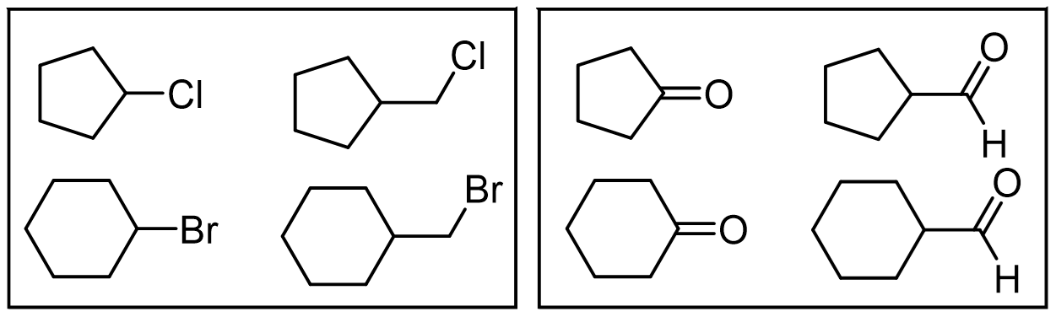  Which compound below is not part of the resulting combinatorial library?
A) |  | *0.52
B)
C)
D)
Ans: | A
Variants
Comments

Q#: | 58
Serial #: | Ex_2021_Q28V3_D52_S4.03
Unit | 4.03 Orgo - Synthesis
Used | Ex_2021, *0.52
Stem | A combinatorial library was constructed by performing a Grignard reaction with every alkyl halide below and every aldehyde / ketone, followed by acid work-up. The products were then reacted with KMnO₄.  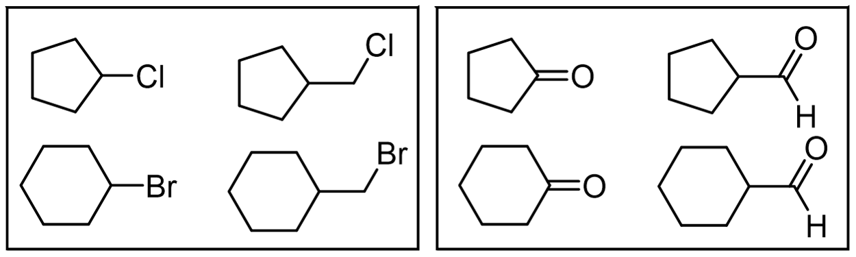  Which compound below is not part of the resulting combinatorial library?
A) |  | *0.52
B)
C)
D)
Ans: | A
Variants
Comments

Q#: | 58
Serial #: | Ex_2021_Q28V4_D52_S4.03
Unit | 4.03 Orgo - Synthesis
Used | Ex_2021, *0.52
Stem | A combinatorial library was constructed by performing a Grignard reaction with every alkyl halide below and every aldehyde / ketone, followed by acid work-up. The products were then reacted with KMnO₄.    Which compound below is not part of the resulting combinatorial library?
A) |  | *0.52
B)
C)
D)
Ans: | A
Variants
Comments

Q#: | 60
Serial #: | Ex_2021_Q17V1_D74_S4.03
Unit | 4.03 Orgo - Synthesis
Used | Ex_2021, *0.74
Stem | Reacting 1-butanol with pyridinium chlorochromate (PCC) in dichloromethane generates compound I. Compound I is then reacted with ethylmagnesium bromide in diethyl ether, followed by aqueous acidic workup (H₃O⁺) to generate compound II. What is the name of compound II?
A) | 3-hexanol | *0.74
B) | 3-pentanol
C) | ethyl butanoate
D) | ethyl butyl ether
Ans: | A
Variants
Comments

Q#: | 60
Serial #: | Ex_2021_Q17V2_D74_S4.03
Unit | 4.03 Orgo - Synthesis
Used | Ex_2021, *0.74
Stem | Reacting 2-butanol with pyridinium chlorochromate (PCC) in dichloromethane generates compound I. Compound I is then reacted with ethylmagnesium bromide in diethyl ether, followed by aqueous acidic workup (H₃O⁺) to generate compound II. What is the name of compound II?
A) | 3-methyl-3-pentanol
B) | 3-hexanol
C) | ethyl 2-butanoate
D) | ethyl 2-butyl ether
Ans: | A
Variants
Comments

Q#: | 60
Serial #: | Ex_2021_Q17V3_D74_S4.03
Unit | 4.03 Orgo - Synthesis
Used | Ex_2021, *0.74
Stem | Reacting 2-pentanol with pyridinium chlorochromate (PCC) in dichloromethane generates compound I. Compound I is then reacted with ethylmagnesium bromide in diethyl ether, followed by aqueous acidic workup (H₃O⁺) to generate compound II. What is the name of compound II?
A) | 3-methyl-3-hexanol
B) | 3-heptanol
C) | ethyl 2-pentanoate
D) | ethyl 2-pentyl ether
Ans: | A
Variants
Comments

Q#: | 60
Serial #: | Ex_2021_Q17V4_D74_S4.03
Unit | 4.03 Orgo - Synthesis
Used | Ex_2021, *0.74
Stem | Reacting 1-pentanol with pyridinium chlorochromate (PCC) in dichloromethane generates compound I. Compound I is then reacted with ethylmagnesium bromide in diethyl ether, followed by aqueous acidic workup (H₃O⁺) to generate compound II. What is the name of compound II?
A) | 3-heptanol
B) | 3-hexanol
C) | ethyl pentanoate
D) | ethyl pentyl ether
Ans: | A
Variants
Comments

Q#: | 505
Serial #: | Ex_2011_Q32_D86_S4.03
Unit | 4.03 Orgo - Synthesis
Used | Ex_2011
Stem | Indicate suitable reagents for the reactions shown in the scheme below.  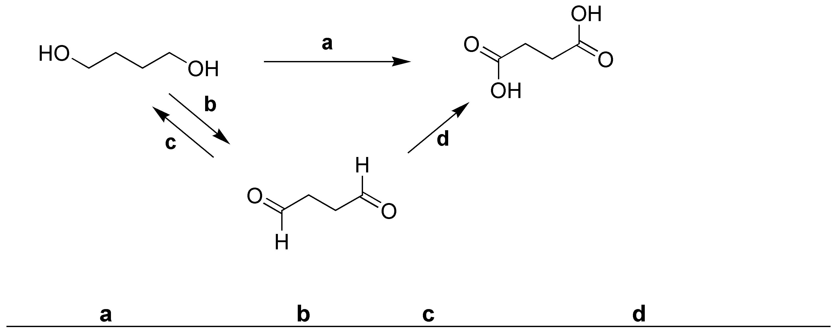
A) | a) K₂Cr₂O₇  b) PCC  c) 1. NaBH₄, 2. H₃O⁺  d) PCC | 0.08
B) | a) K₂Cr₂O₇  b) K₂Cr₂O₇  c) PCC  d) KMnO₄ | 0.04
C) | a) 1. NaBH₄, 2. H₃O⁺  b) KMnO₄  c) PCC  d) 1. NaBH₄, 2. H₃O⁺ | 0.03
D) | a) KMnO₄  b) PCC  c) 1. NaBH₄, 2. H₃O⁺  d) KMnO₄ | *0.86
Ans: | D
Variants
Comments

Q#: | 506
Serial #: | Ex_2018_Q17_D83_S4.03
Unit | 4.03 Orgo - Synthesis
Used | Ex_2018
Stem | Which sequence of reagents / conditions would result in the product shown?  1 2
A) | 1) HCl  2) K₂Cr₂O₇ | 0.05
B) | 1) 10% aq. H₂SO₄  2) PCC/CH₂Cl₂ | *0.83
C) | 1) HBr  2) KMnO₄ | 0.06
D) | 1) H₃O⁺  2) NaBH₄ | 0.06
Ans: | B
Variants
Comments

Q#: | 507
Serial #: | Ex_2012_Q18_D83_S4.03
Unit | 4.03 Orgo - Synthesis
Used | Ex_2012
Stem | Which reagents are needed to carry out the following synthesis?  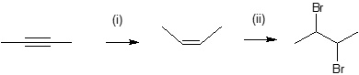
A) | i) excess H₂, Pd/C  ii) Br₂, hv | 0.08
B) | i) excess H₂, Lindlar’s catalyst  ii) HBr | 0.07
C) | i) excess H₂, Lindlar’s catalyst  ii) Br₂ | *0.83
D) | i) excess H₂, Ni  ii) Br₂ | 0.03
Ans: | C
Variants
Comments

Q#: | 508
Serial #: | Ex_2017_Q28_D82_S4.03
Unit | 4.03 Orgo - Synthesis
Used | Ex_2017
Stem | What reagents and conditions are needed for this synthetic scheme?  (i) (ii) (iii) (iv)
A) | i) H₂, Pd/C z  ii) Mg, Et₂O, CO₂  iii) cold dilute NaOH  iv) H⁺ | *0.82
B) | i) H₂, Lindlar’s catalyst  ii) KMnO₄  iii) H₂O  iv) H⁺ | 0.03
C) | i) H₂, Pt(s)  ii) KMnO₄  iii) H₂O  iv) H₃O⁺ | 0.07
D) | i) H₂, Pd/C  ii) PCC, CH₂Cl₂  iii) H₂O  iv) CH₃OH, H⁺ | 0.08
Ans: | A
Variants
Comments

Q#: | 509
Serial #: | Ex_2013_Q15_D82_S4.03
Unit | 4.03 Orgo - Synthesis
Used | Ex_2013
Stem | Which of the following reagents would NOT be used when converting Molecule 1 into Molecule 2?  Molecule 1 Molecule 2
A) | NaBH₄ | *0.82
B) | NaOH | 0.06
C) | CH₃OH | 0.04
D) | H₂SO₄ | 0.08
Ans: | A
Variants
Comments

Q#: | 520
Serial #: | Ex_2014_Q18_D66_S4.03
Unit | 4.03 Orgo - Synthesis
Used | Ex_2014
Stem | Select the reagents and conditions needed to convert propene to 2-methylpropanoic acid.
A) | i) HCl  ii) Mg, ether  iii) CO₂  iv) dil. H₃O⁺(aq) | *0.66
B) | i) H₂, Pt  ii) Br₂, hν  iii) H₂C=O  iv) conc. H₂SO₄ | 0.11
C) | i) Cl₂  ii) Mg, ether  iii) H₂C=O  iv) conc. H₂SO₄ | 0.10
D) | i) H₂, Ni  ii) Cl₂, Δ  iii) CO₂  iv) Mg, ether, dil. H₃O⁺(aq) | 0.13
Ans: | A
Variants
Comments

Q#: | 525
Serial #: | Ex_2012_Q29_D48_S4.03
Unit | 4.03 Orgo - Synthesis
Used | Ex_2012
Stem | Which reagents are needed to carry out the following synthesis?  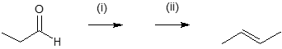
A) | i) CH₃MgBr / ether  ii) dilute HCl(aq) | 0.03
B) | i) H₂, Pt  ii) conc. H₂SO₄(aq) | 0.05
C) | i) (1) NaBH₄, (2) H₃O⁺(aq)  ii) conc. H₂SO₄(aq) | 0.45
D) | i) (1) CH₃MgBr / ether, (2) H₃O⁺(aq)  ii) conc. H₂SO₄(aq) | *0.48
Ans: | D
Variants
Comments

Q#: | 527
Serial #: | Ex_2013_Q13_D46_S4.03
Unit | 4.03 Orgo - Synthesis
Used | Ex_2013
Stem | Which reagents would you use when converting Molecule 1 into Molecule 2?  Molecule 1 Molecule 2
A) | Step 1: Mg, Et₂O  Step 2: dilute H₂SO₄ | 0.05
B) | Step 1: Mg, Et₂O  Step 2: i) CO₂, ii) dilute H₂SO₄ | *0.46
C) | Step 1: NaOH  Step 2: KMnO₄ | 0.41
D) | Step 1: NaOH  Step 2: i) CO₂, ii) dilute H₂SO₄ | 0.08
Ans: | B
Variants
Comments

Q#: | 79
Serial #: | Ex_2012_Q25_D84_S4.03
Unit | 4.03 Orgo - Synthesis
Used | Ex_2019, *0.84  Ex_2012
Stem | Which statement regarding the synthetic steps below is incorrect?  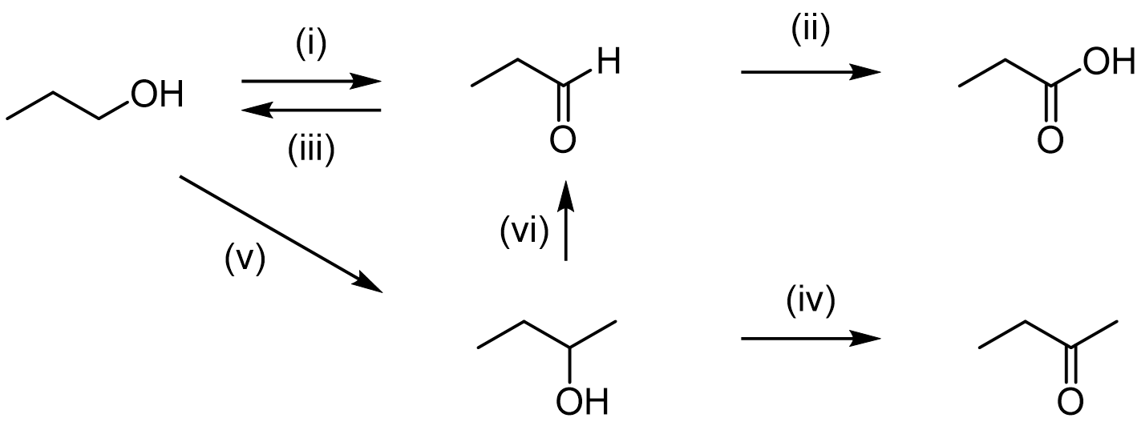
A) | Step (iii) can be achieved by reaction with NaBH₄ followed by addition of H₃O⁺(aq). | 0.03
B) | Steps (ii) and (iv) can both be achieved by reaction with KMnO₄(aq). | 0.04
C) | Step (v) can be achieved via an oxidation reaction, followed by a Grignard reaction and acid work-up. | 0.08
D) | Step (vi) can be achieved by reaction with H₂O, and H₃O⁺(aq). | *0.84
Ans: | D
Variants
Comments

Q#: | 627
Serial #: | Ex_2011_Q14_D72_S4.03
Unit | 4.03 Orgo - Synthesis
Used | Ex_2011
Stem | A student in the lab is given an organic compound with a molecular formula C₉H₈O₃. Treating this compound with concentrated HCl at high temperature gives the odour of vinegar. In a separate test, the compound does not react with PCC in CH₂Cl₂, but it does react with KMnO₄. The product of the reaction with KMnO₄ reacts with NaHCO₃, giving CO₂. What is the compound?
A) | 3-acetylphenol | 0.12
B) | 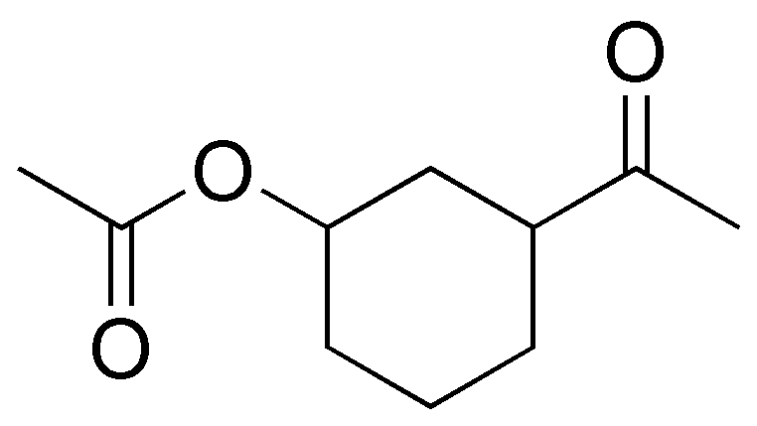 | 0.05
C) | H₃C-O-(CH₂)₇ -COOH | 0.11
D) | 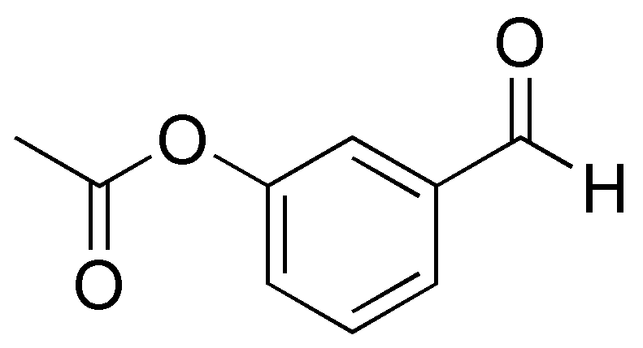 | *0.72
Ans: | D
Variants
Comments

Q#: | 624
Serial #: | Ex_2014_Q21_D75_S4.03
Unit | 4.03 Orgo - Synthesis
Used | Ex_2014
Stem | A student in the lab is given an unknown organic compound. Reaction of the compound at high temperature in the presence of dilute H₂SO₄ gives a vinegar odour. A separate test of the compound with PCC/CH₂Cl₂ provides no indication of reaction, but the product of reaction with KMnO₄ reacts with NaHCO₃ to give CO₂. What is a reasonable structure for the compound?
A) | 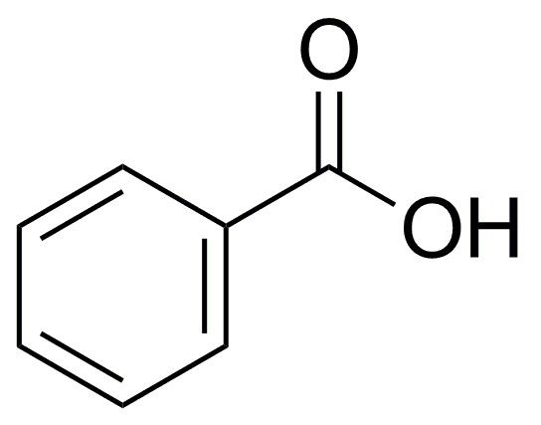 | 0.12
B) | 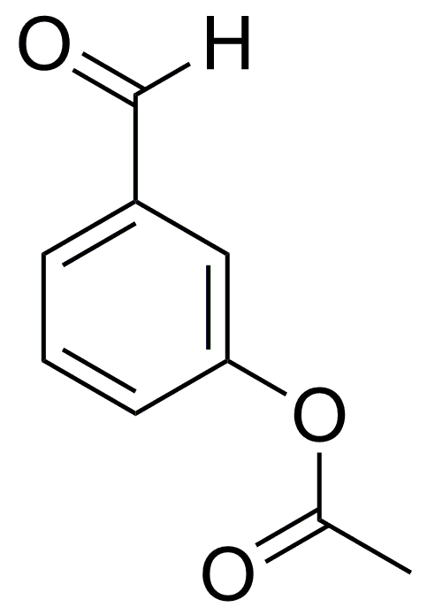 | *0.75
C) | 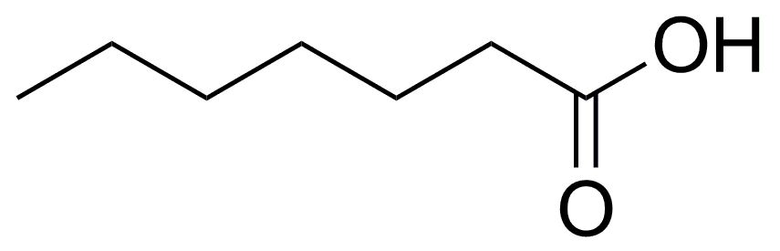 | 0.06
D) | 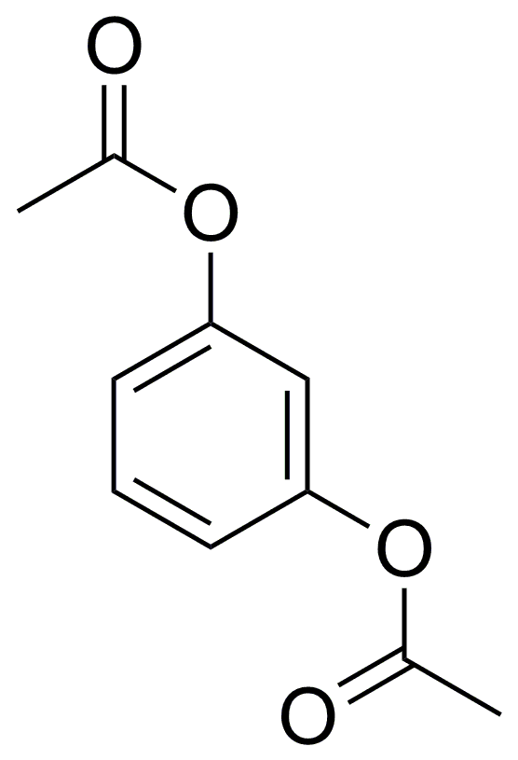 | 0.06
Ans: | B
Variants
Comments

