**Using ROBEX for Skull stripping**

* Project page found at <https://www.nitrc.org/projects/robex/>
* Can use Windows or Linux version
  + When trying to perform skull stripping on very large images like those in the SMets data, I was running out of memory on my computer when using the Windows version of the tool, thus I recommend using the Linux version as I did not run into memory issues when using it
  + Download the newest Windows/Linux version of the tool here <https://www.nitrc.org/frs/?group_id=622>
* Inputs should be in nii or nii.gz format
* You can automatically run both the skull stripping commands detailed below for many input images on both Windows and Linux by creating powershell/bash scripts
  + I show how to use a Linux bash script I created for doing this, however it requires some knowledge of Linux/bash scripting to understand what I am doing

Windows

* Extract the downloaded folder ROBEXv12.win.zip
* Open power shell and use the tool by running the runROBEX.bat script
  + Use the script as follows runROBEX.bat inputfilepath outputfilepath
  + An example of how to run the tool is seen below, I call the runROBEX.bat script and pass it the path to the input nii file and give it the output file I want to be created



Linux

* Run the below commands in order to download and create the ROBEX folder
  + curl "https://www.nitrc.org/frs/download.php/5994/ROBEXv12.linux64.tar.gz//?i_agree=1&download_now=1" --output robex.tar.gz
  + tar -xvzf robex.tar.gz
* Run the skull stripping by running below command
  + ./ROBEX/runROBEX.sh inputfilepath outputfilepath
* If you want to automatically use ROBEX on all files with a certain name in a directory, you can use the below code
  + replace ../../mnt/d/SanDiskSecureAccess/SMets_FSPGR/ with the directory containing the files you want to have skull stripped, and replace 3D_Ax_T1_FSPGR with whatever identifying string the names of the files you want to be skull stripped have
  + the find command will locate all files in the given directory and any subdirectories whose names match the given string (in this example they will start with 3D_Ax_T1_FSPGR and end with .nii)
  + the files will then be replaced with their skull stripped versions

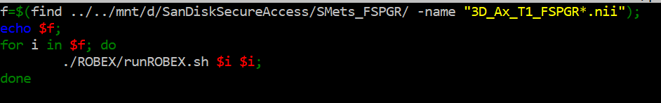

* + To run this code, create a file/script containing these lines of code named filename.sh
  + Change the permissions of the file such that it can be executed using the command sudo chmod 777 filename.sh
  + Run the script by running the command ./filename.sh