**BU21EECE0100394**

**CHALLA SANTHOSH**

**Voltage Measurement and LCD displaying(8051)**

**Learning objective :-**

* Measuring the voltage variations
* According to the voltage variations display the leds
* Displaying the voltage variations status in LCD display

**Inputs and Outputs:-**

* Inputs is potentiometer
* Outputs are LEDs and LCD display

**Logic :-**

* Make the connections to ADC,LCD,8051
* 5v power supply to the ADC 0808
* ADC will convert analog signal to digital signal and pass to micro-controller
* Based on the digital signal we need to perform in the 8051 and display the voltage variations in the LCD display
* Make sure that integer value we can’t able to print directly for that we nee to give ASCII value top the function

**Common mistakes :-**

* while writing the program code give the port names according to the circuit don’t mismatch
* Make sure that connections are made properly if miss one connections data will loss and no output
* while making the connections make sure that give proper input it’s high are low input

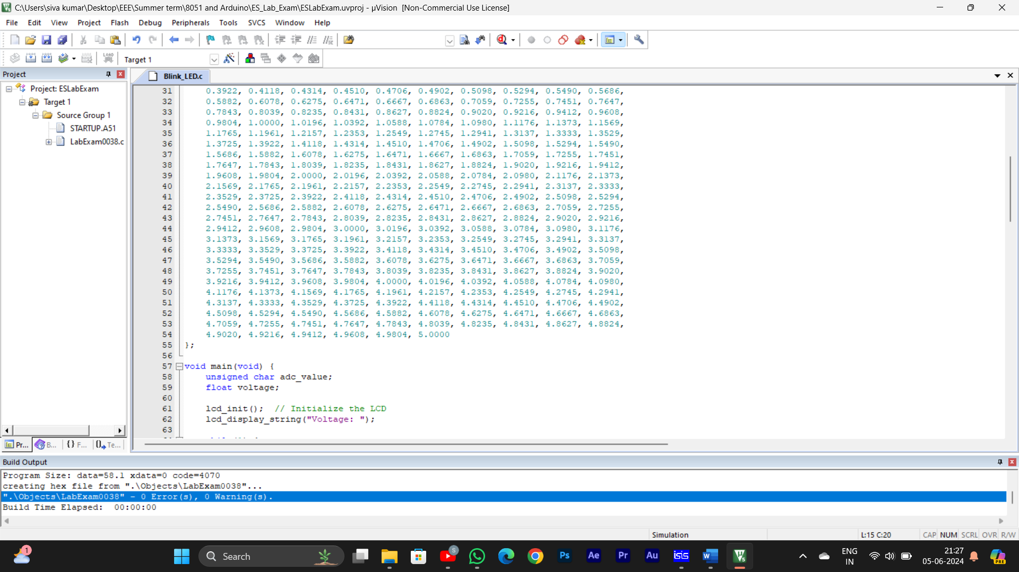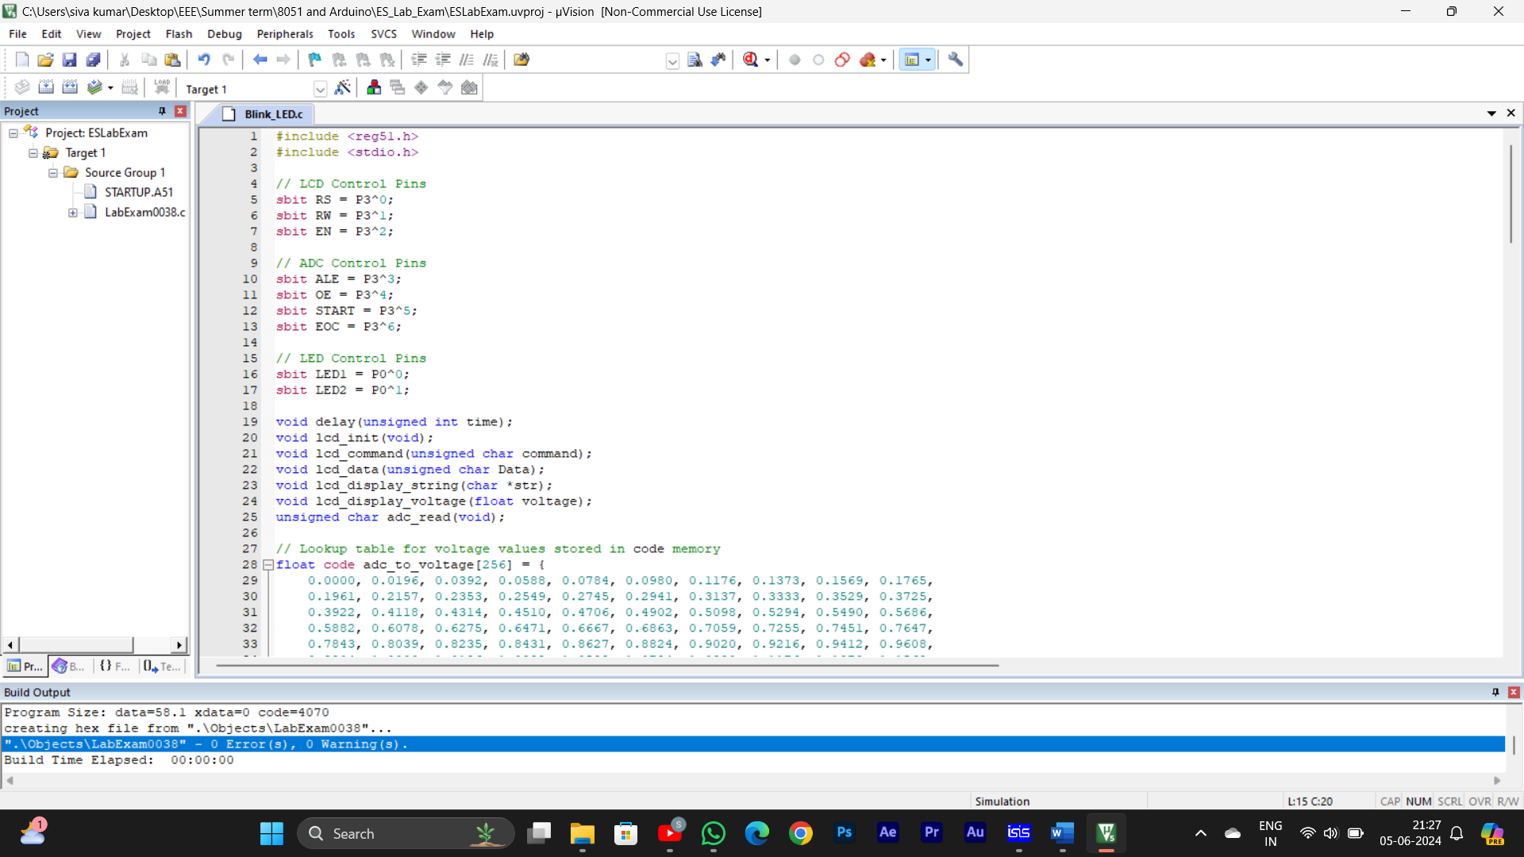**Result:-**

