PaperBulb is web based publication platform, which enables researches and developers to show their research findings to the world.

The following documents describes all at the platform available functionality. The different implemented functions are numbered for a better overview.

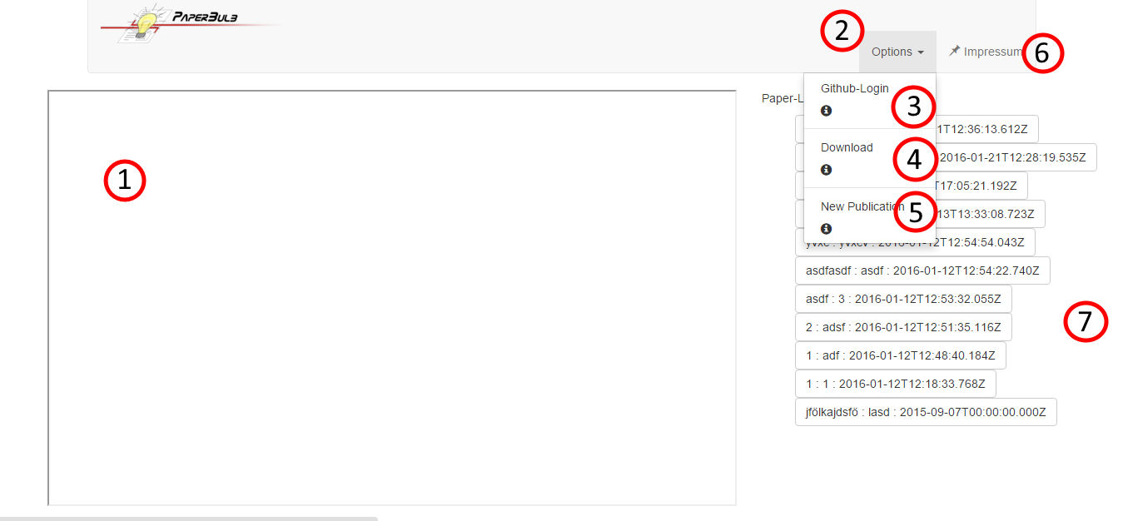

1. Publication Text-Field

After the reader has selected a published publication from the publication list, the content is displayed in the text field next to the publication list.

1. Options Dropdown-Menu

The Dropdown-Menu “Options” hides all the necessary options for publishers in order to publish their publications

1. Github-Login

In order to login successfully the user has to be currently logged in on github.com, when clicking on the “Github-Login”-button in order for it to work

1. Download

Every person has the option to download every publication. This is done by clicking the Download Button while the user is displaying the desired publication. The publication is downloaded as a zip file and can from now on read offline by the User (if he has all the necessary software installed.

1. New Publication

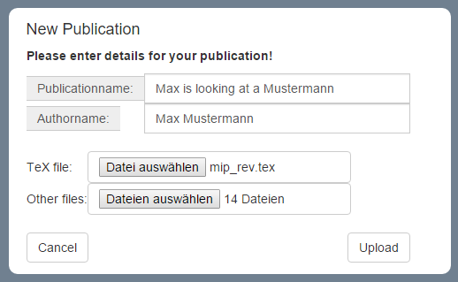

When a publisher has entered a “Publicationname” and a “Authorname” and has selected the main "TeX file” and the corresponding “Other files” a publication can be uploaded. It might take a moment, be patient.

(See Further Information for hints how to prepare a publication for the upload)

1. About

The “About”-Page gives general information about the Authors of this Software and used technologies. Display it by clicking on the link.

1. Publication-List

The publication list show all the successfully uploaded publications by Name, Author and Upload date in downward order. Select one by clicking on it and have fun reading ☺