In the lab with Andrea and Saquib and Mio

Turn on TISa at 12:00. Now it is 17:30. We try to make a pulse at 935, it looks pretty rough- why?

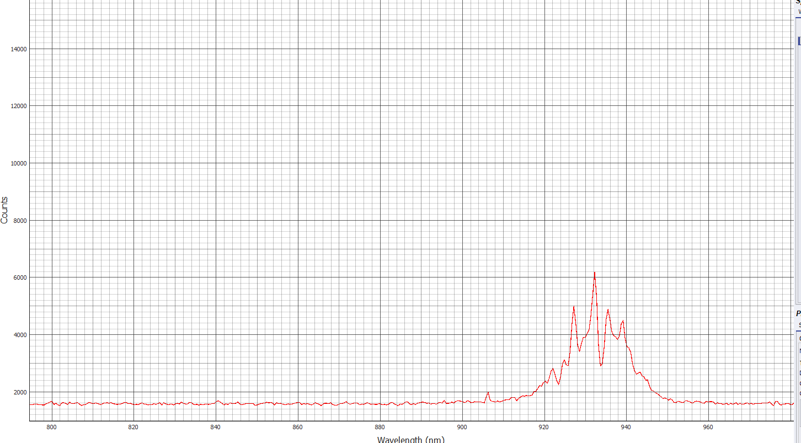

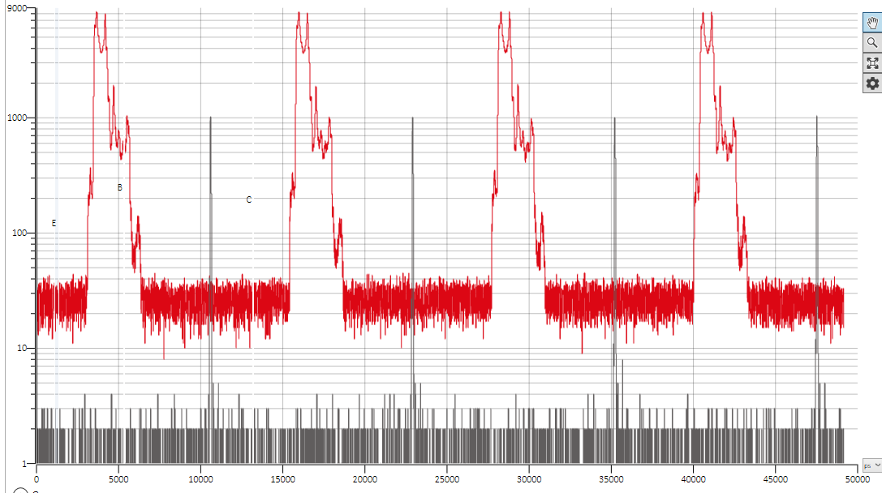

Pulses too messed up… Let’s go back to other wavelength.

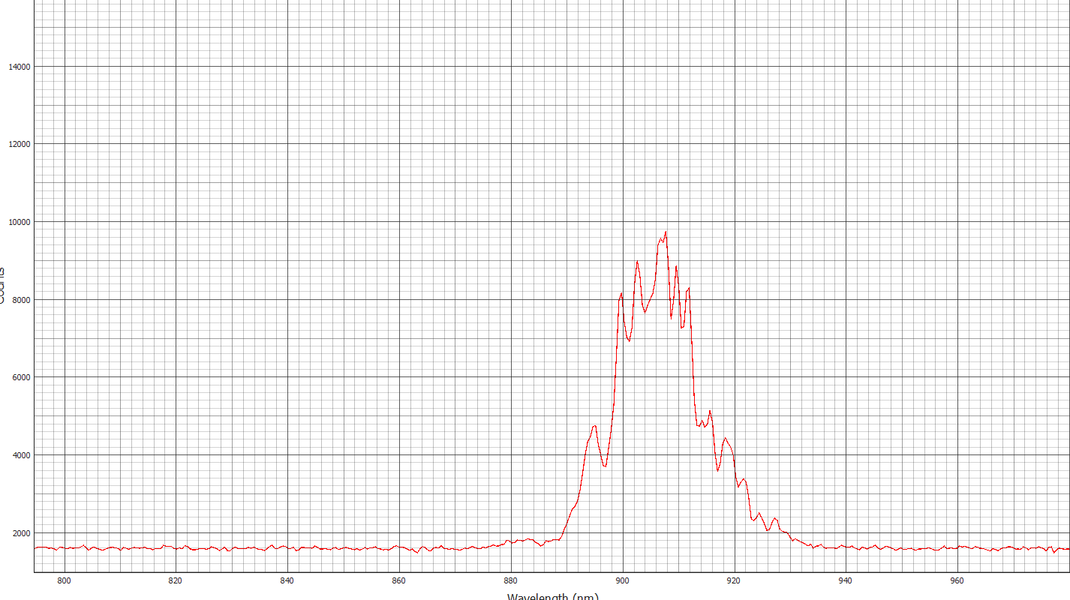

Sometimes the lights on the channel flash amber, this is due to a lost signal. In our case, we set the threshold temperature for the SNSNPDs too low: 2.1K instead of 2.2 or so; the bias making box craps out.

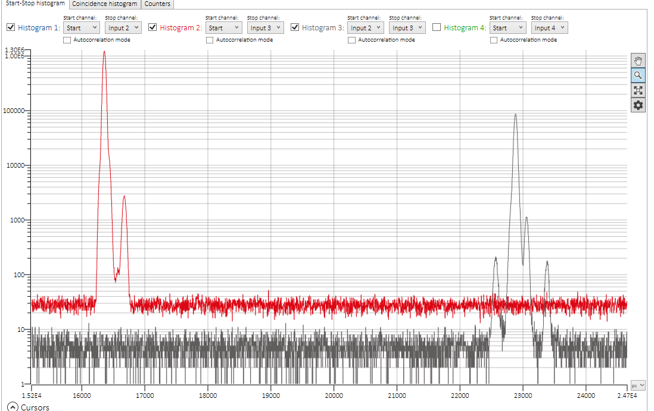

500s Measurements being taken in this current setup (**BELOW**)

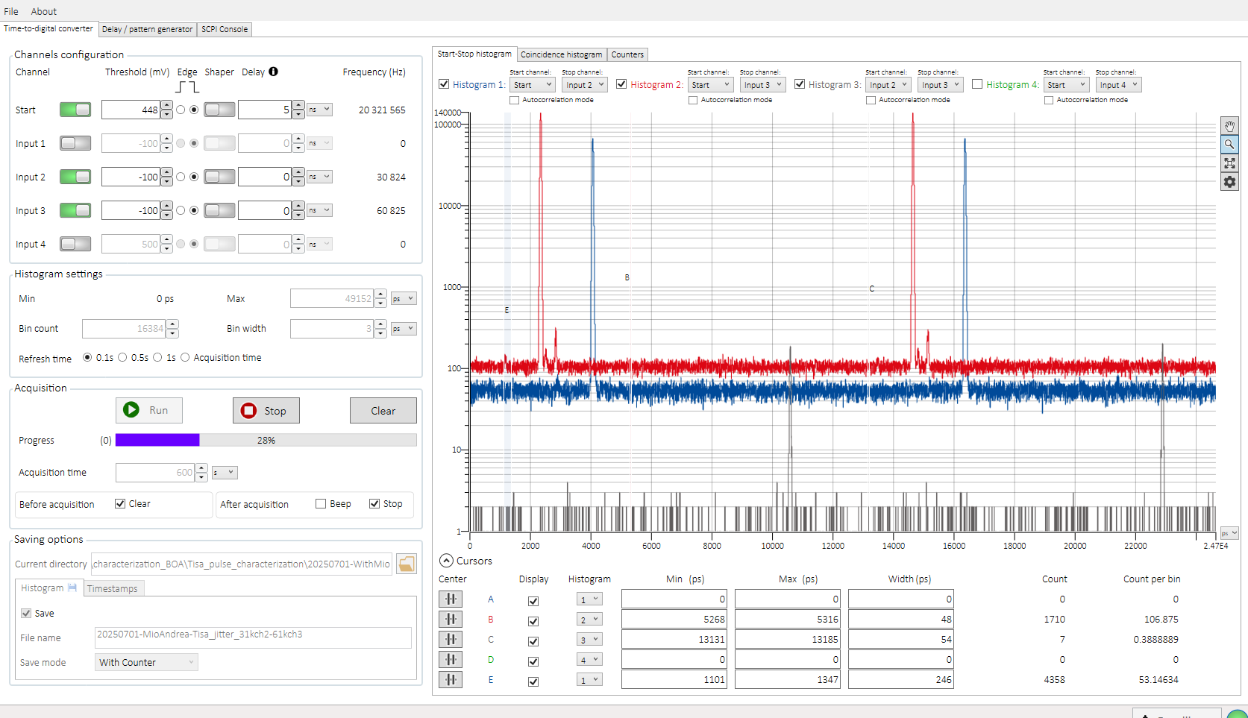  
  
  
Few Observations : We are actually still seeing side peaks, but also we are currently collecting so much background due to what we suppose to be stray light.  
We do Observe the main side peak in the TCSPC Start Stop related to the detector 3, confirming what we saw also in the previous takes, when we always saw the third detector as the most noisy one

Of the two that we are actually using in this experiment.

PLEASE NOTE THAT IN THESE MEASUREMENTS WE ARE ACTUALLY USING A DIFFERENT SETTING FOR THE BIN WIDTH, ***ELEVATING THE PREVIOUS VALUE SETTED AT 1 PS TO THE CURRENT 3 PS !!***

This is what it looks like the screen at the end of the second 10-min measurements (Taken with counter option enabled in order to sum up the measurements with the previous 10-minutes one !!)

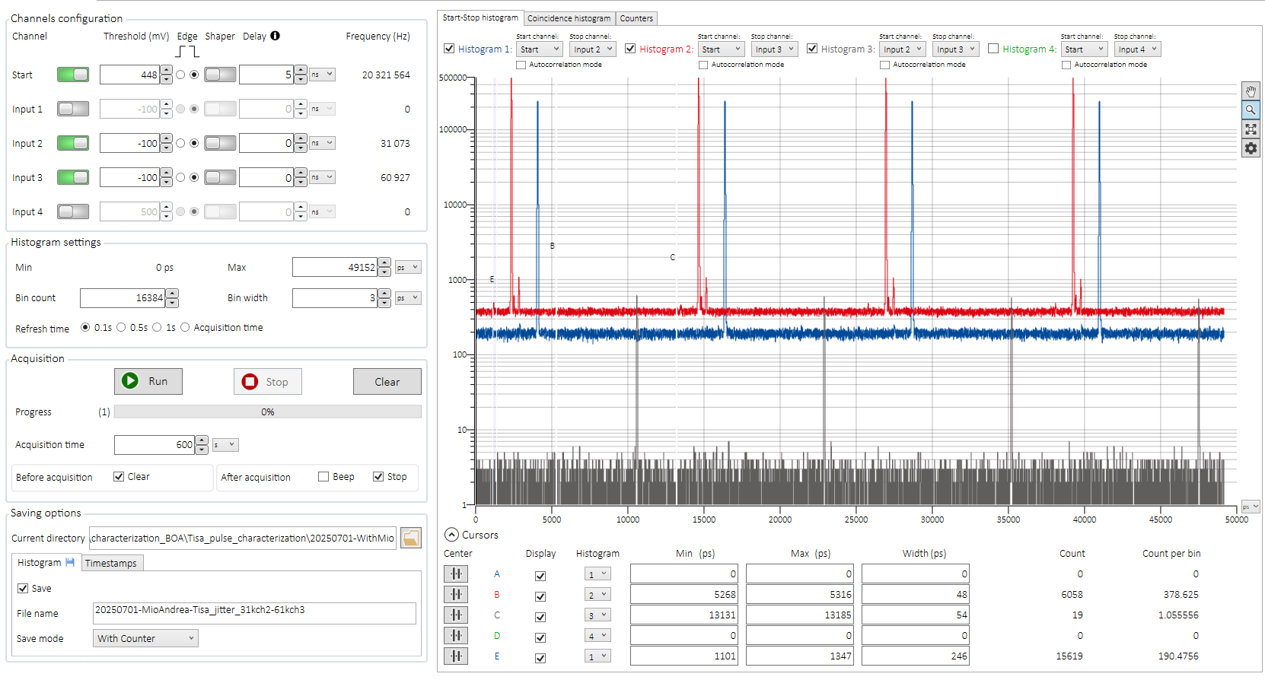

In detail :

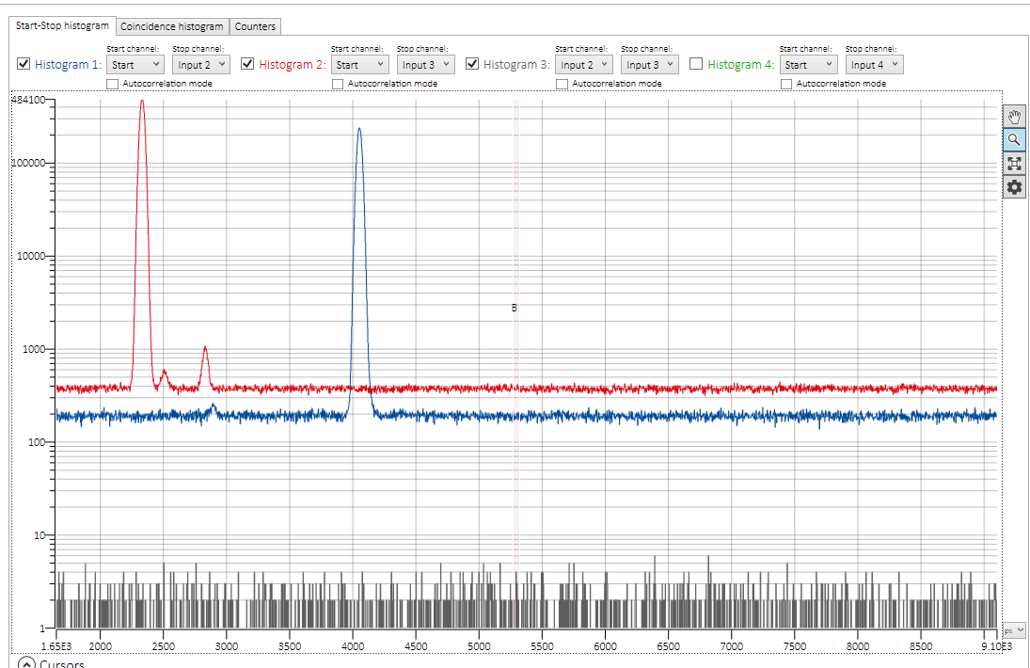

First 2 counters are related to the 10minutes ones !!!!!!!!!!!

Before switching down the light !!!!!!!!!!!!!!!!!!!!!!!!!!

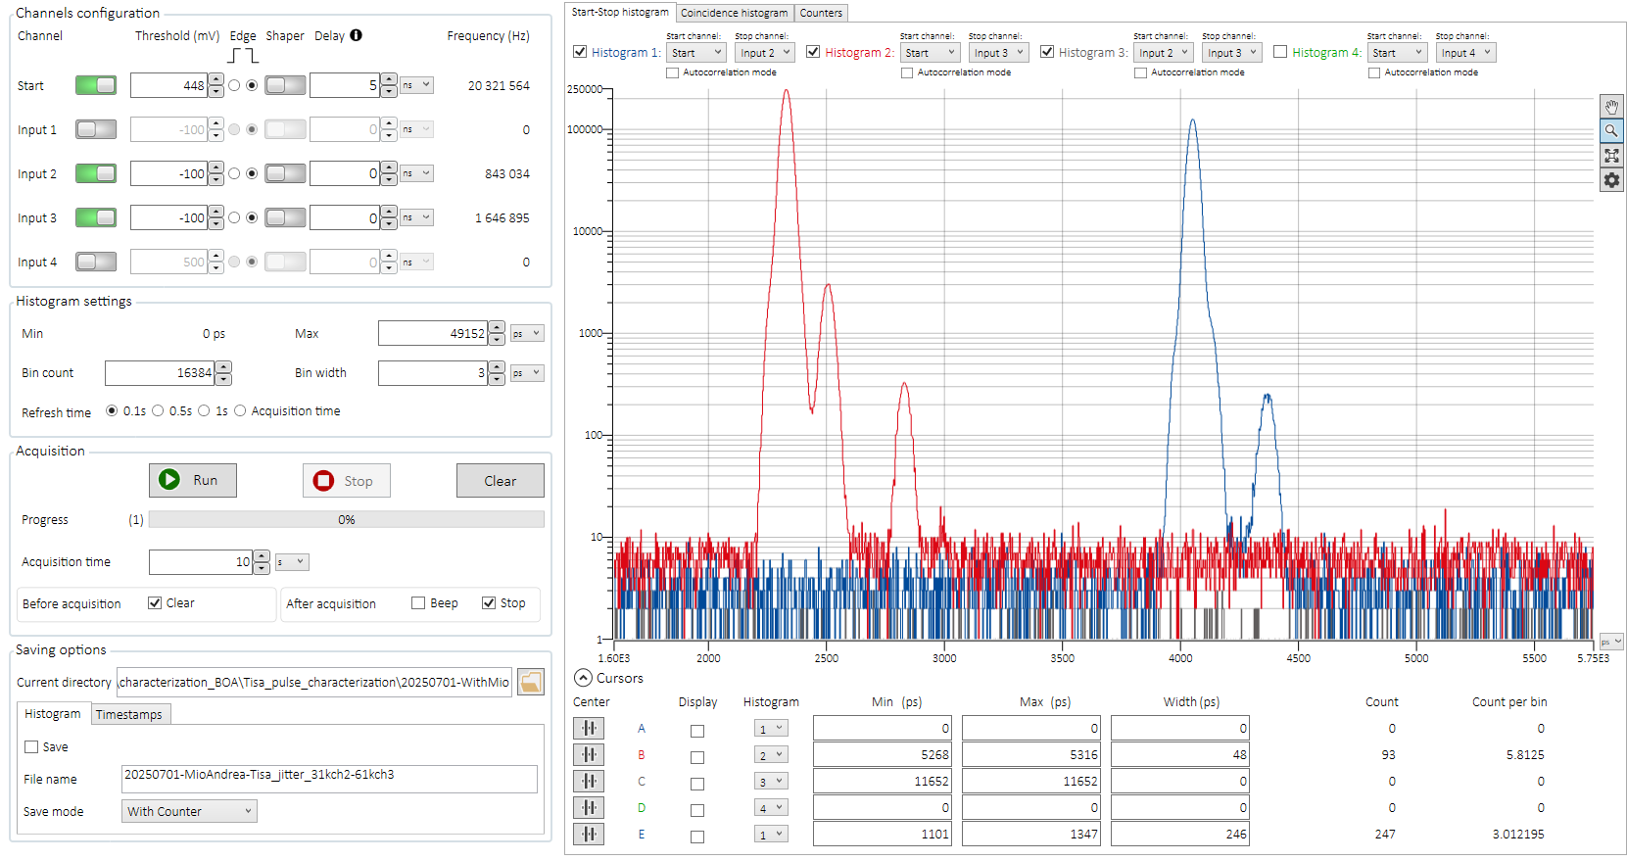

After increasing the number of counts !! (Wolfgang Joins !)

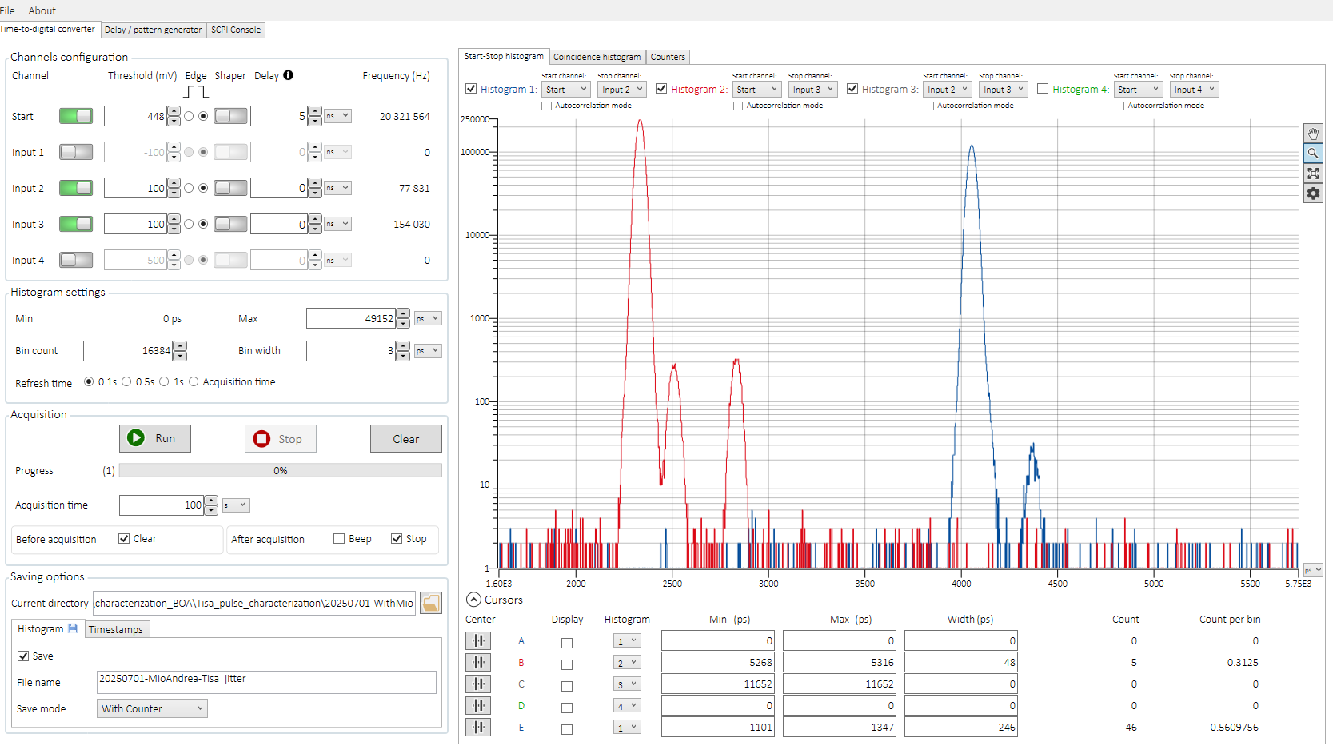

KEEP IN MIND THAT ALL THESE MEASUREMENTS WERE ACTUALLY TAKEN With a not so good pulse, and we forget to take a screenshot of the spectrometer before shutting it off !!! (we have to remember this for the next time !!!!!!!!!!)

Notes for the next measurement : switch the fibers to assess the side peak happening only on one detector (Det.3)

Add Fiber ?

Change the Trigger levels of the detectors to the point of maximum steepness (According also to the Oscilloscope Screenshot that we take !!!)