20250702 Andrea, Saqib

After looking at the scope to the pulse of the detector 3 we did discover that the previously set threshold of -100mV is not enough to ignore the small reflection that we do appreciate

Here below it can be seen the screenshot from the oscilloscope using the math green line as the derivative of the yellow line to identify the point of maximum steepness where to actually put the threshold

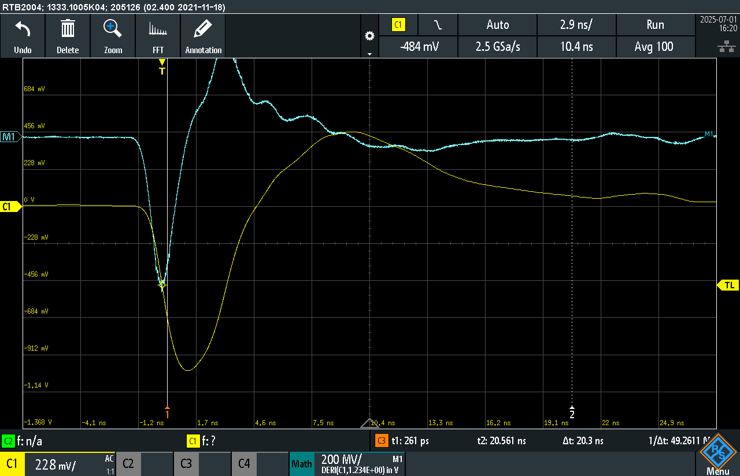

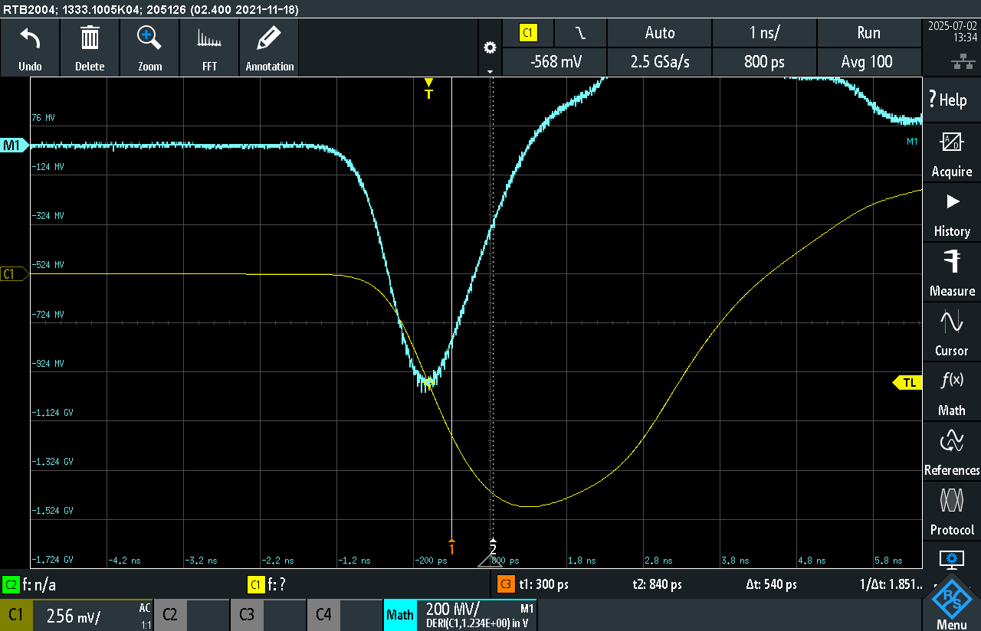

This was the spectrum at the moment of the measurement. This same data are also in a csv file in this folder !!!

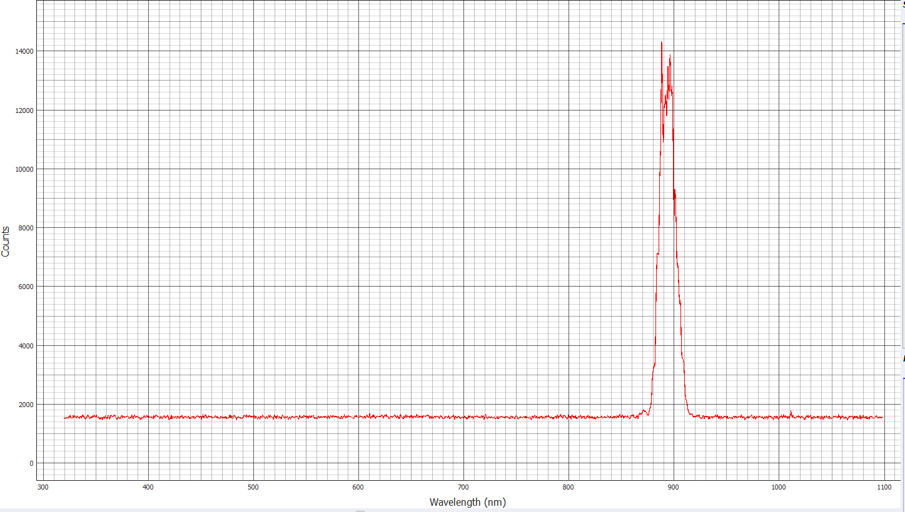

After asking Wolfgang to reoptimize the Ti:Sa, the sync pulsing started working again !

I then proceded with a new measurement, with the adjusted thresholds from the scope sightings, and at low counts to try to minimize the sidepeaks.

Measurement lasted for approximately 11 Minutes, running at 20kHz for detector2 and 43kHz for Detector3

Here as follows the screenshot of what will be included in the CSV file of the measurement !!

ALSO NOTABLE REMARK : LIGHT HAS BEEN TURNED OFF INSIDE THE LAB IN ORDER TO MINIMIZE THE AMOUNT OF STRAY LIGHT GOING INSIDE THE DETECTOR !!!

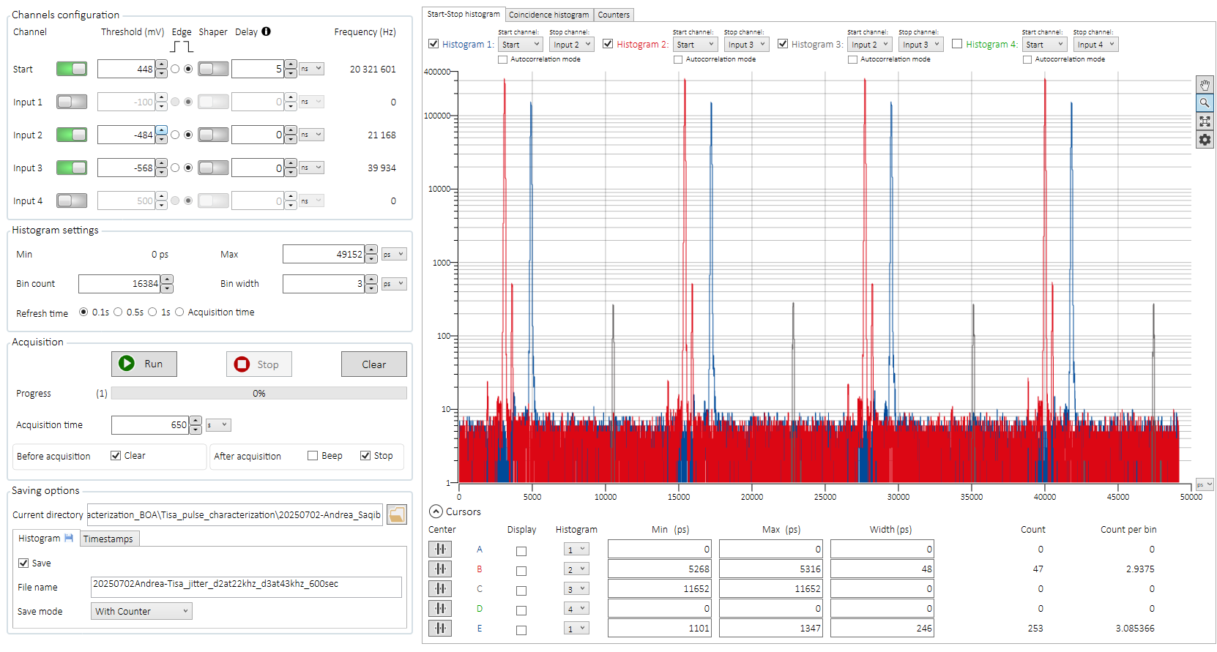

Observations : The presence of side peaks is **not solved yet** with the intuition that we had about fixing the thresholds.

What we do see instead is the presence of a stronger side peak in the TCSPC Stat Stop Histogram of Detector 3 !!!

Here as follows a zoom on the two tcspc Histograms

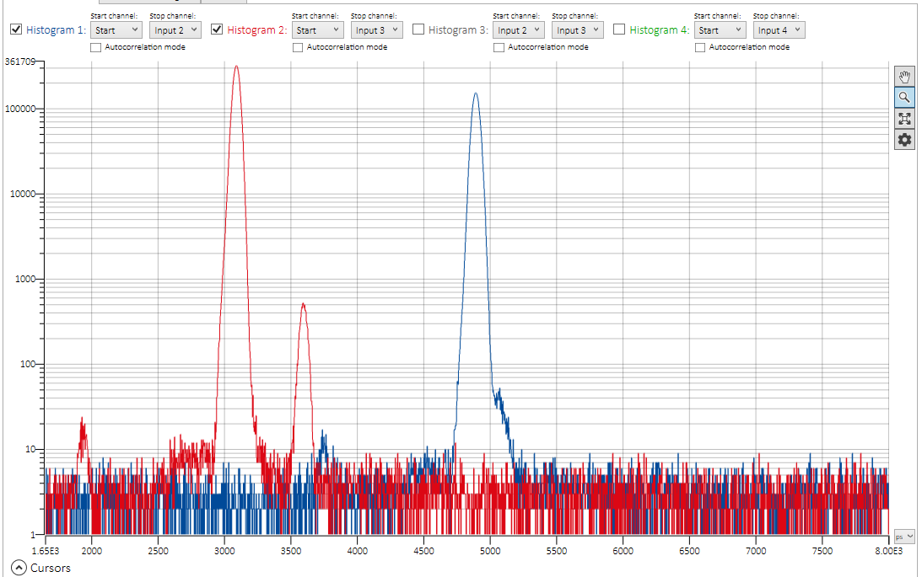

I’ll take now two more measurements., this time more short in acquisition time, but with higher counts !  
  
Here as follows will be attached the number of counts for these ones !!!

***2nd one taken at 169kHz D2 and 325kHz D3 Over an acquisition time of 40sec***

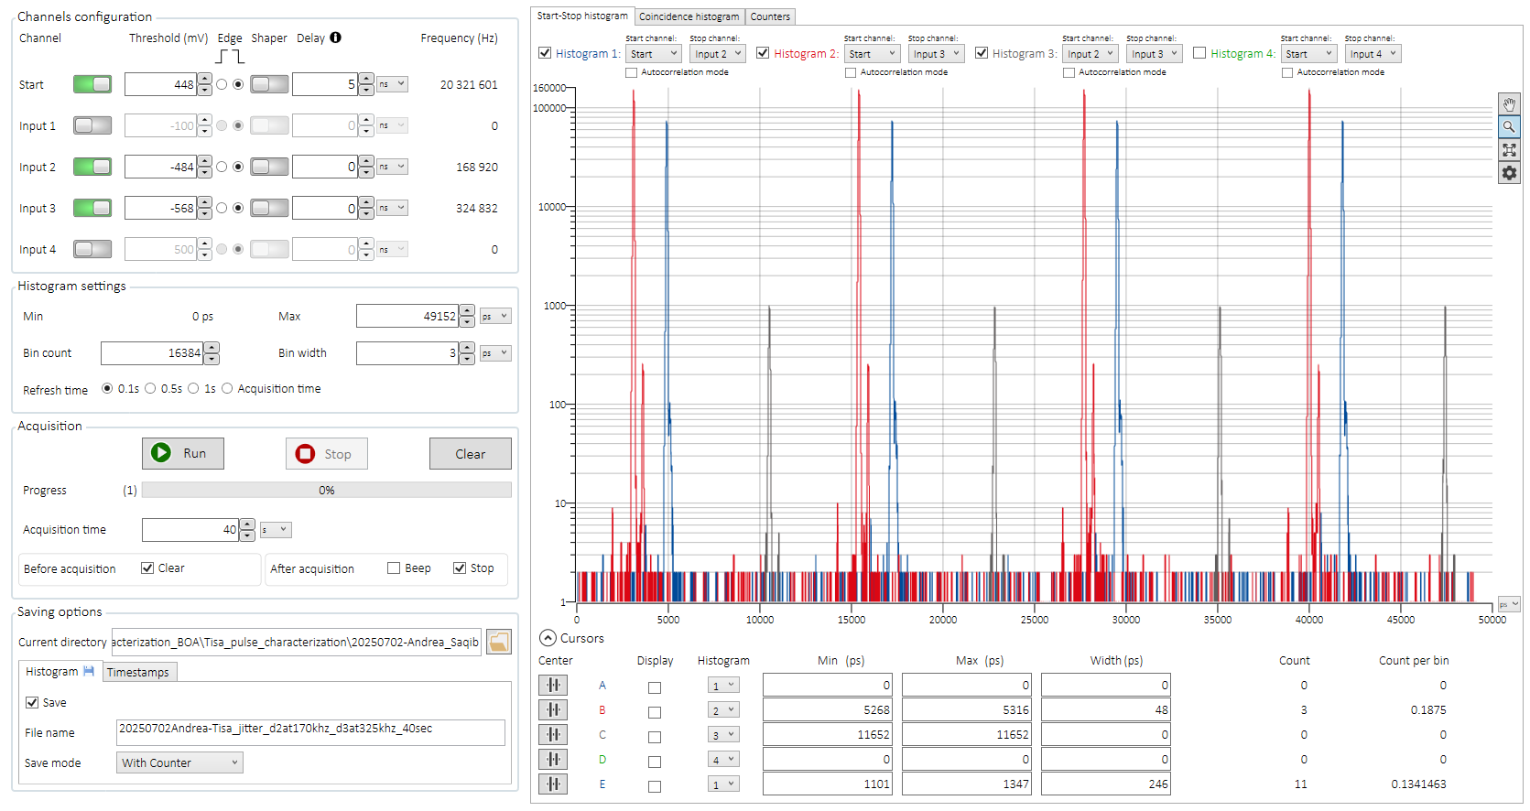

Zoomed in :

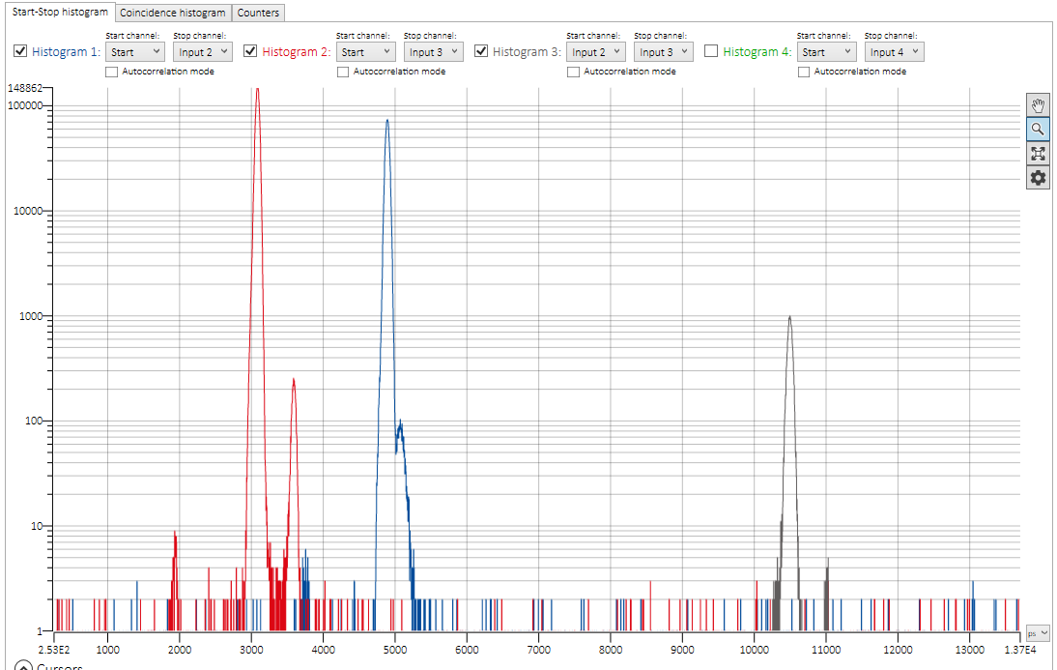

3RD set at 1.1 MHz and 1.7-2.0 MHz 40sec acquisition Time

3rd detector is NOT STABLE since it has a number of counts that is not steady at all. And there is sometimes a blinking red activity on the time controller

This is whato the manual of the BOX says

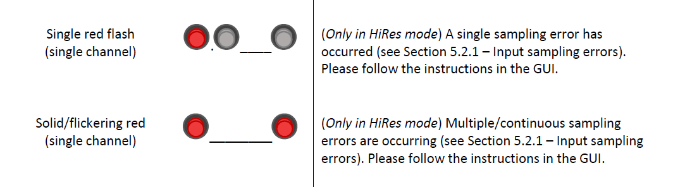

And this is the screenshot of the screen

**DATA NOT SAVED NOW DUE TO THE DETECTED INSTABILITY !!!!!**

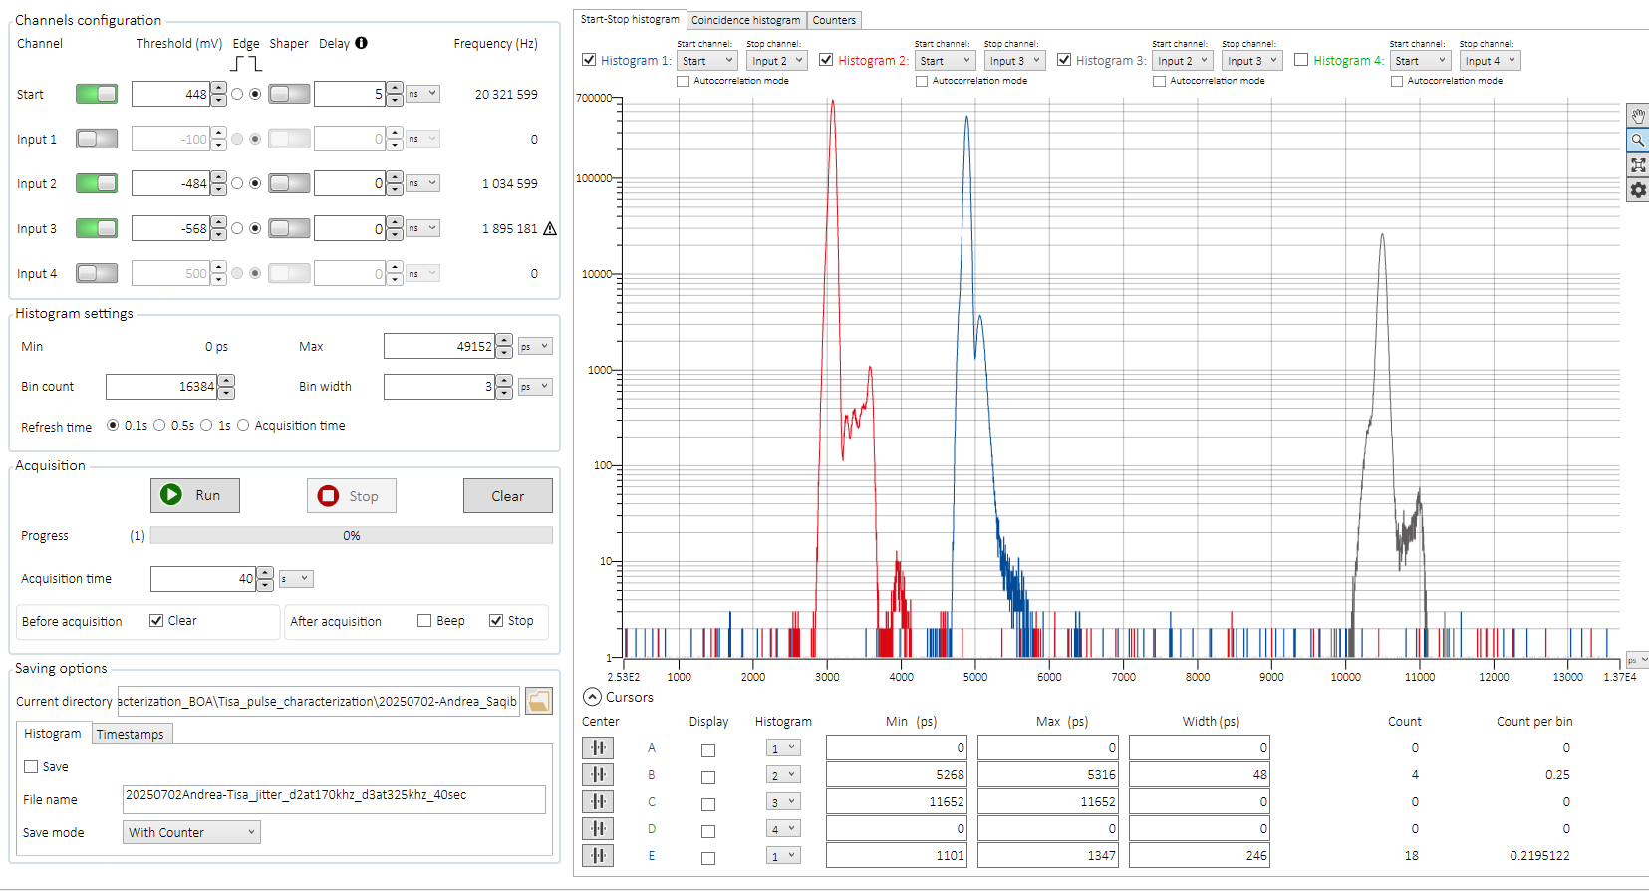

20250703 Andrea & Saqib

Using These new thresholds that we took from the Oscilloscope view :

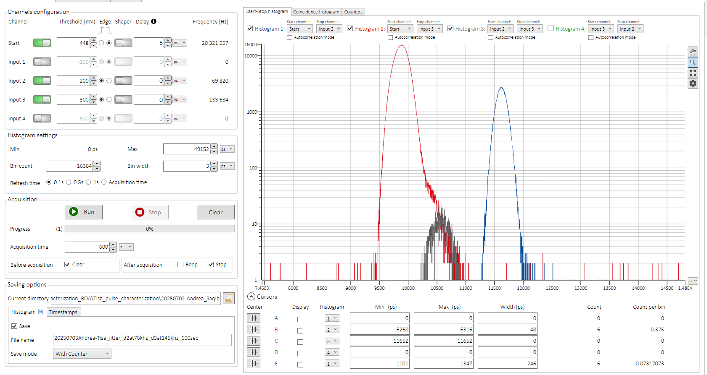

We do get stable values and we proceed to run a 600s measurement.

Il’ll be saved under this name : 20250703Andrea-Tisa_jitter_d2at76khz_d3at145khz_600sec

Changed Once again the trigger levels

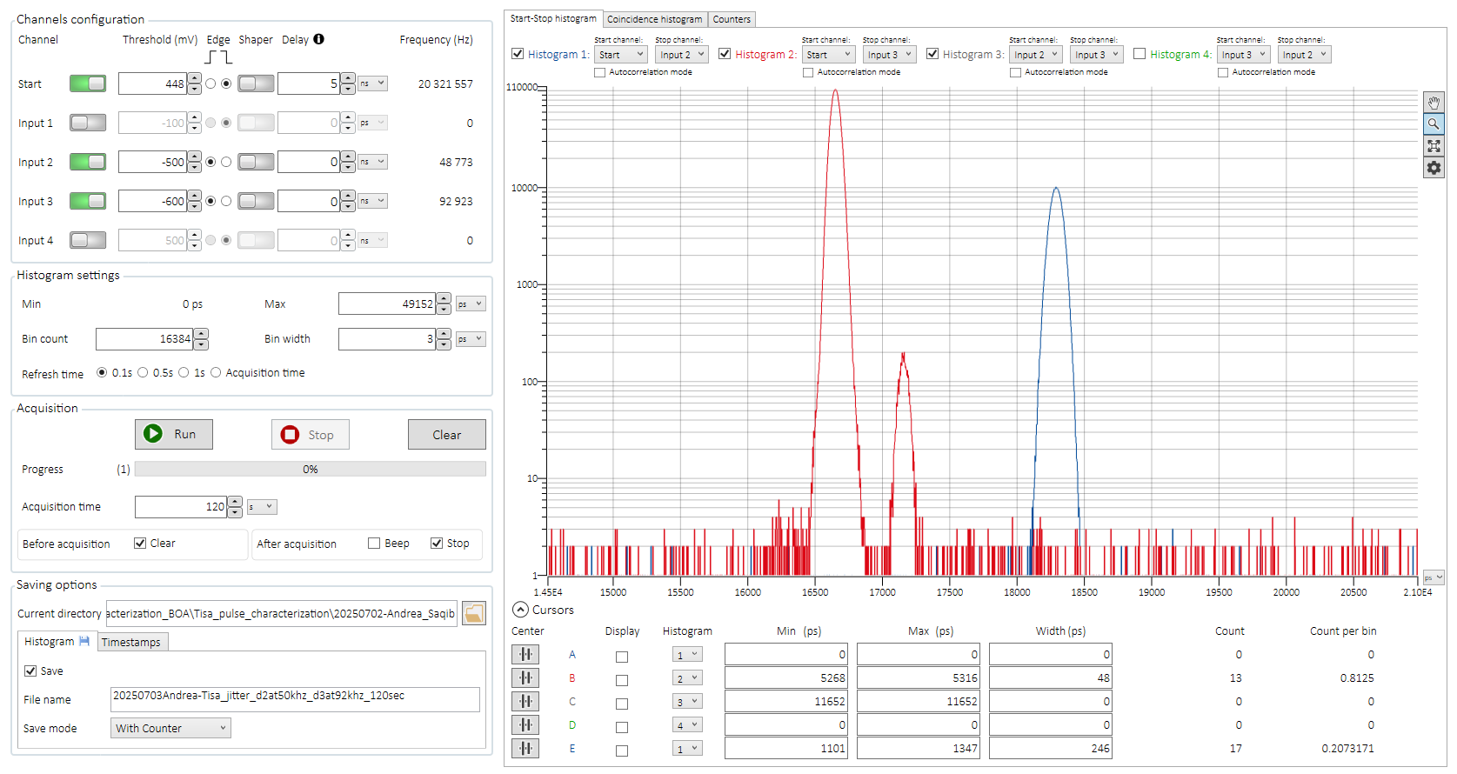

**From this point on we Changed the order of the SMF Fibers going into the SNSPD, achieving for the first time in two weeks values of counts almost identical in both of the detectors !!!!!!!!!!!!!**

***Checkpoint “Bravo”*** {SEE BELOW TO UNDERSTAND THE MEANING !!}

Trigger falling edge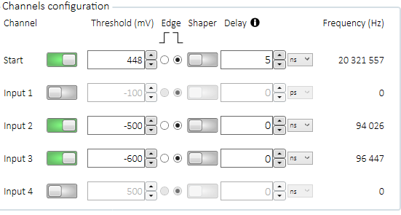

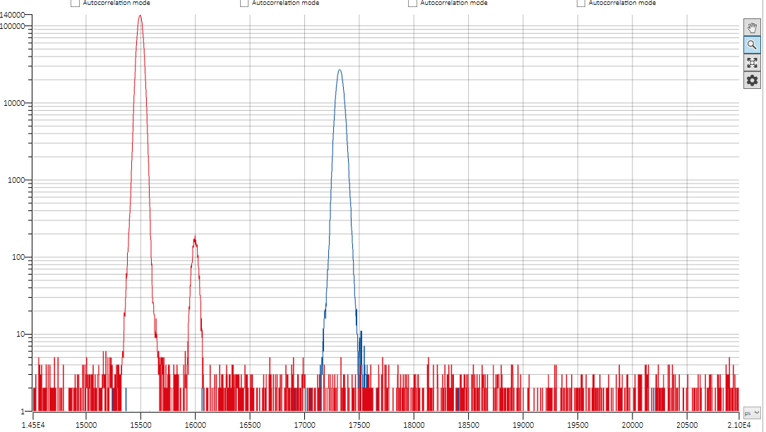

Trigger rising edge: 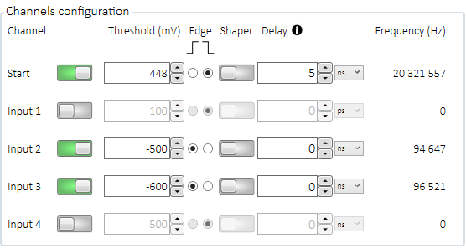

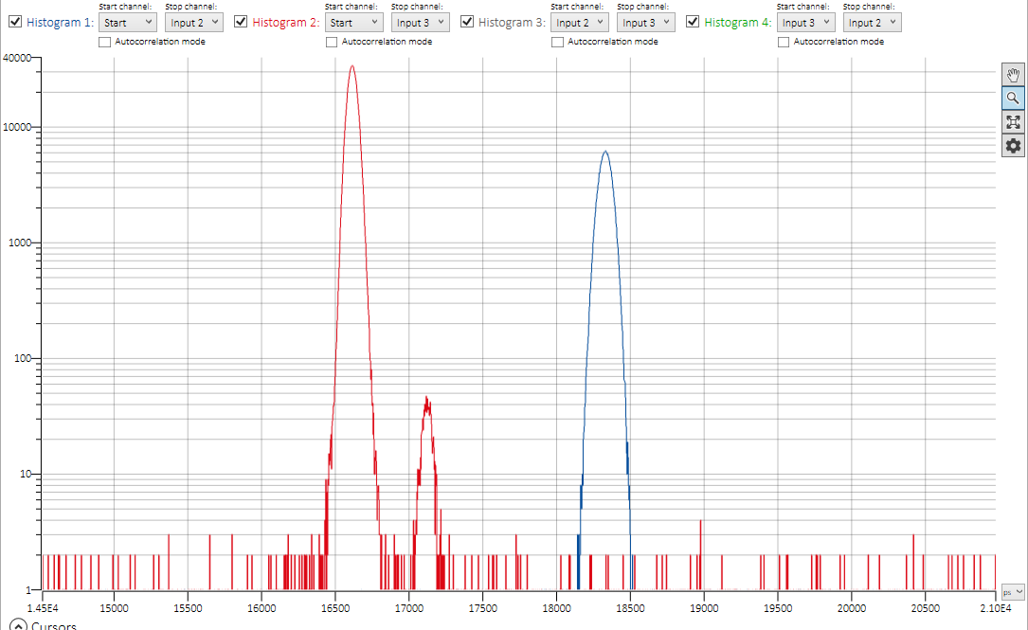

New one 120sec, Thresholds chosen with the scope inquiri conducted with 50 Ohms Z

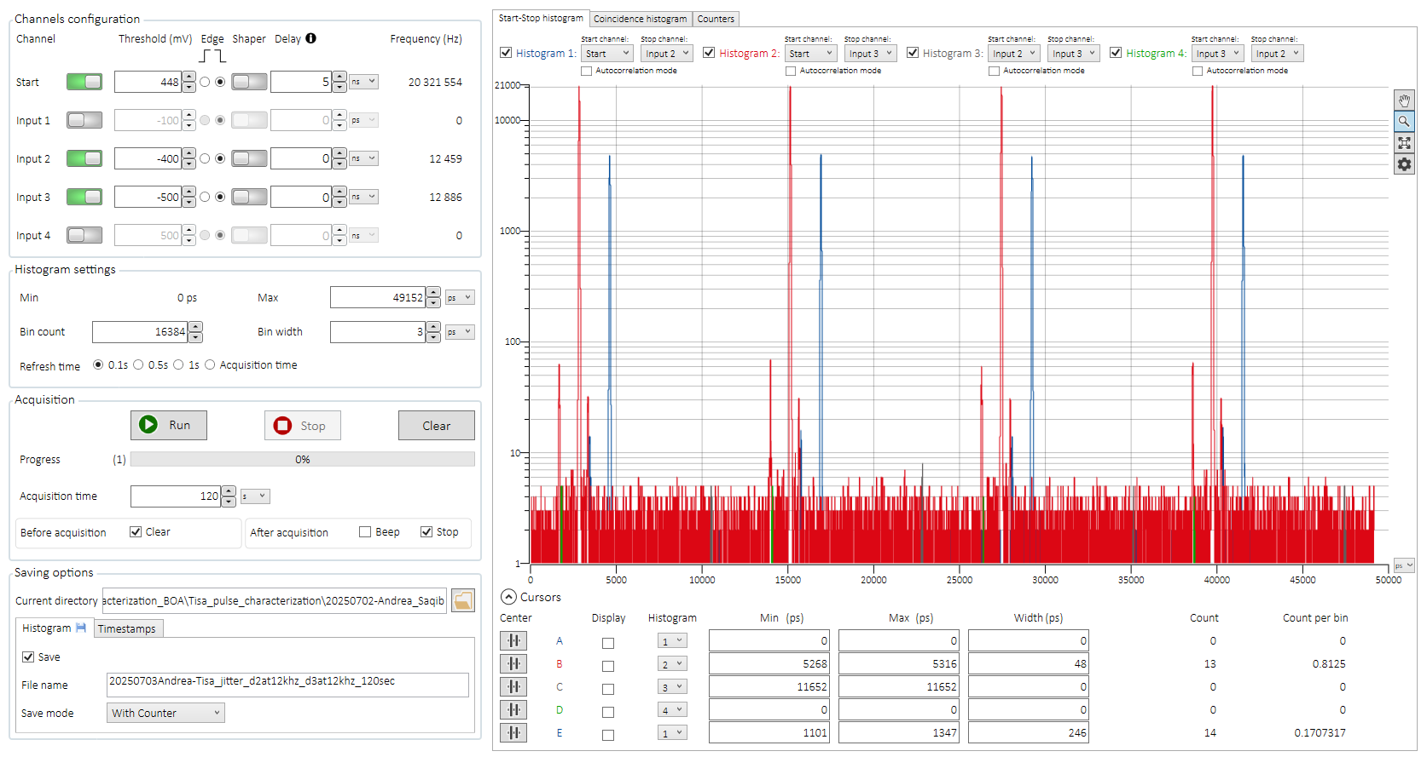

Now Exchanged on the box the cables that arrive from the detectors, so that what is displayed as detector 3 is indeed Input2 and vice versa.  
Taken a 500sec measurement with this current setting this file is under the name of 20250703Andrea-Tisa_jitter_d2at280khz_d3at269khz_500secRUN2WithThingsChabgedbox

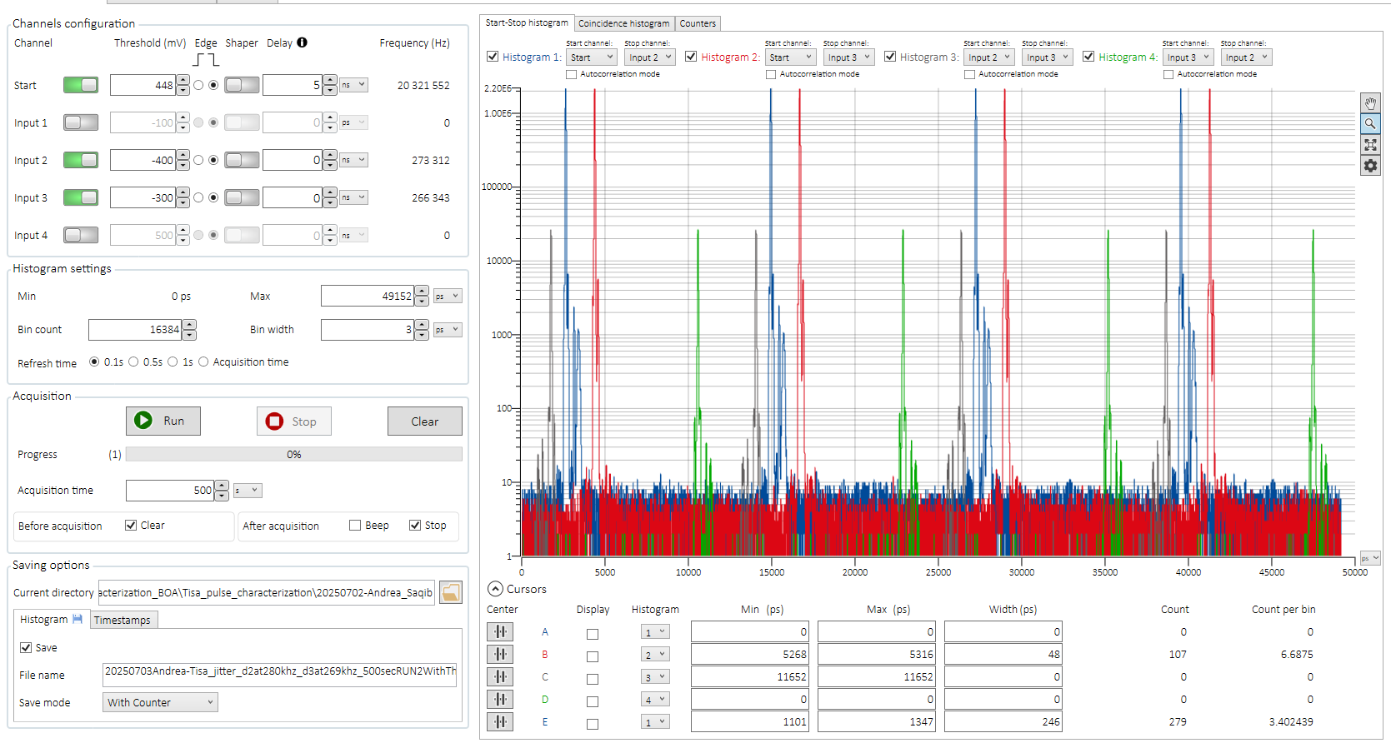

I will now proceed doing this same measurement with other two count frequencies, this time lower than this to possibly see some relations

Here as follows the image for 75 & 72 kHz (Det 2 and 3 respectively)

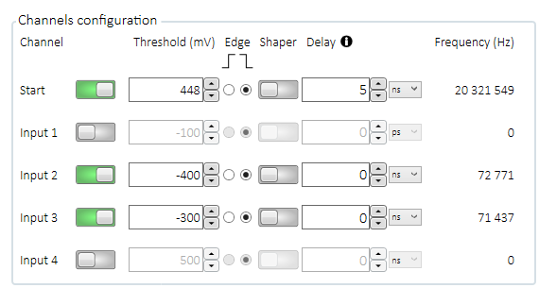

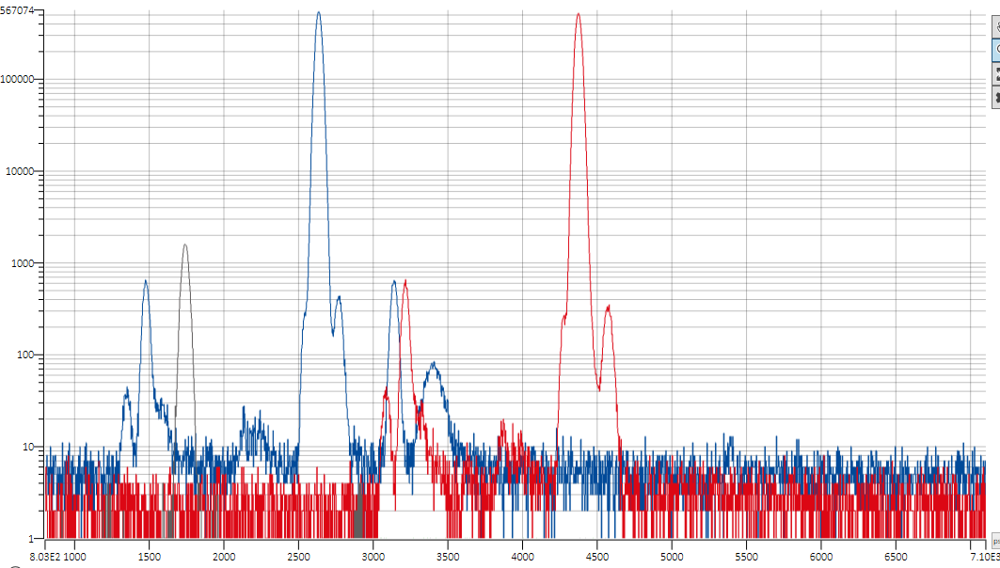

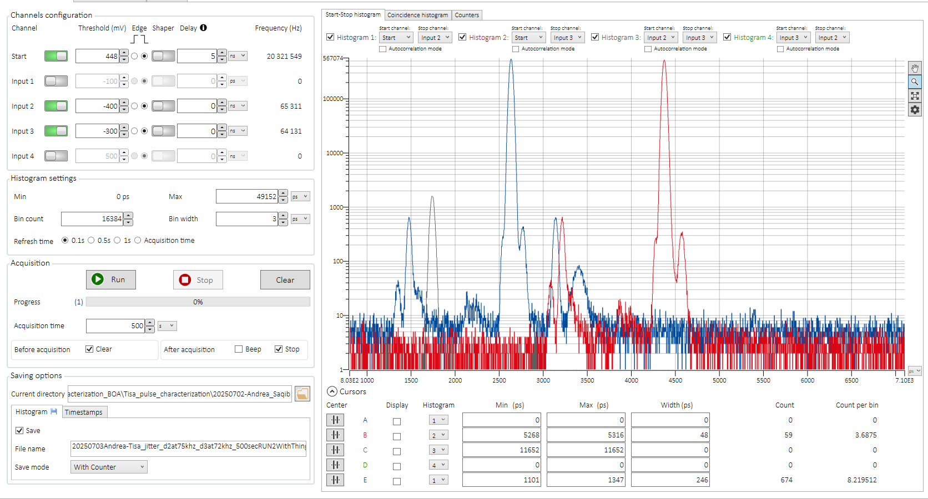

And finally with 160kHz each

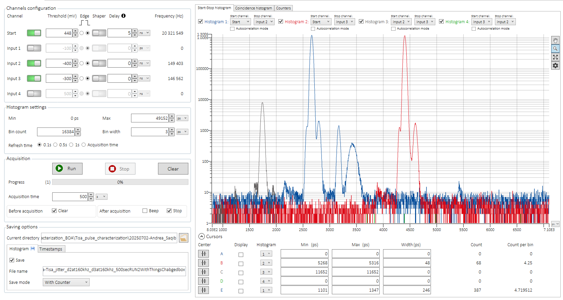

Eventually, at the end with this setup of switched cables on the box I did take data with this three countrates : 250kHz, 160kHz and finally 75kHz all these three measurements were achieved with 500s of acquisition time

I NOW proceed to SWITCH BACK TO THEIR ORIGINAL POSITIONS THE TWO CABLES THAT GOES INTO THE BOX !!!

Now I go back to ***Checkpoint “Bravo” se***ttings (about the thresholds) and I recover three measurements with roughly the same counts of before ! (Since there is still the second peak in the third detector at least I will gain some statistics)

20250703Andrea-Tisa_jitter_d2at150khz_d3at150khz_500sec_CheckpointBRAVO

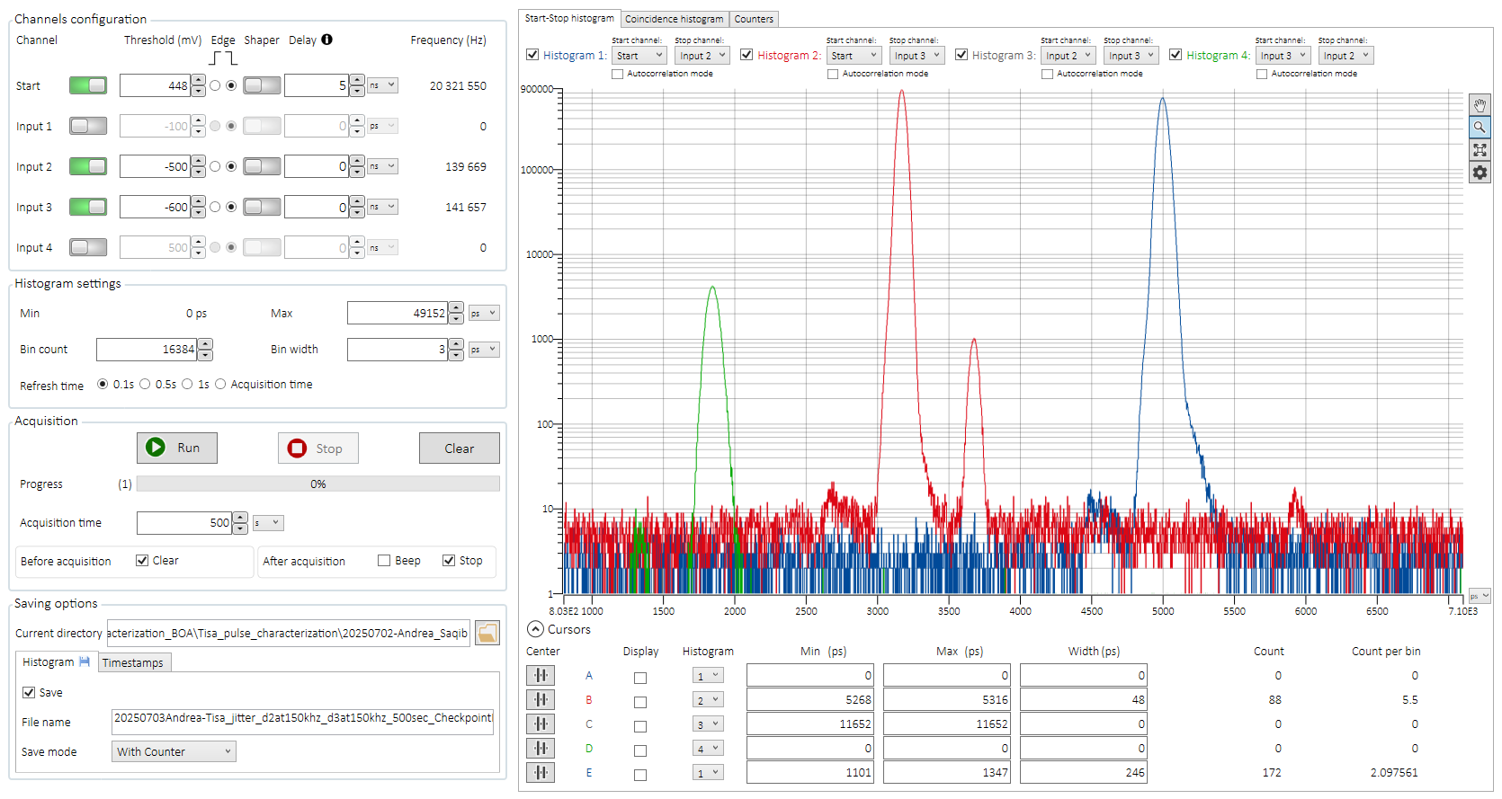

Next one at 238 and at 242 kHz

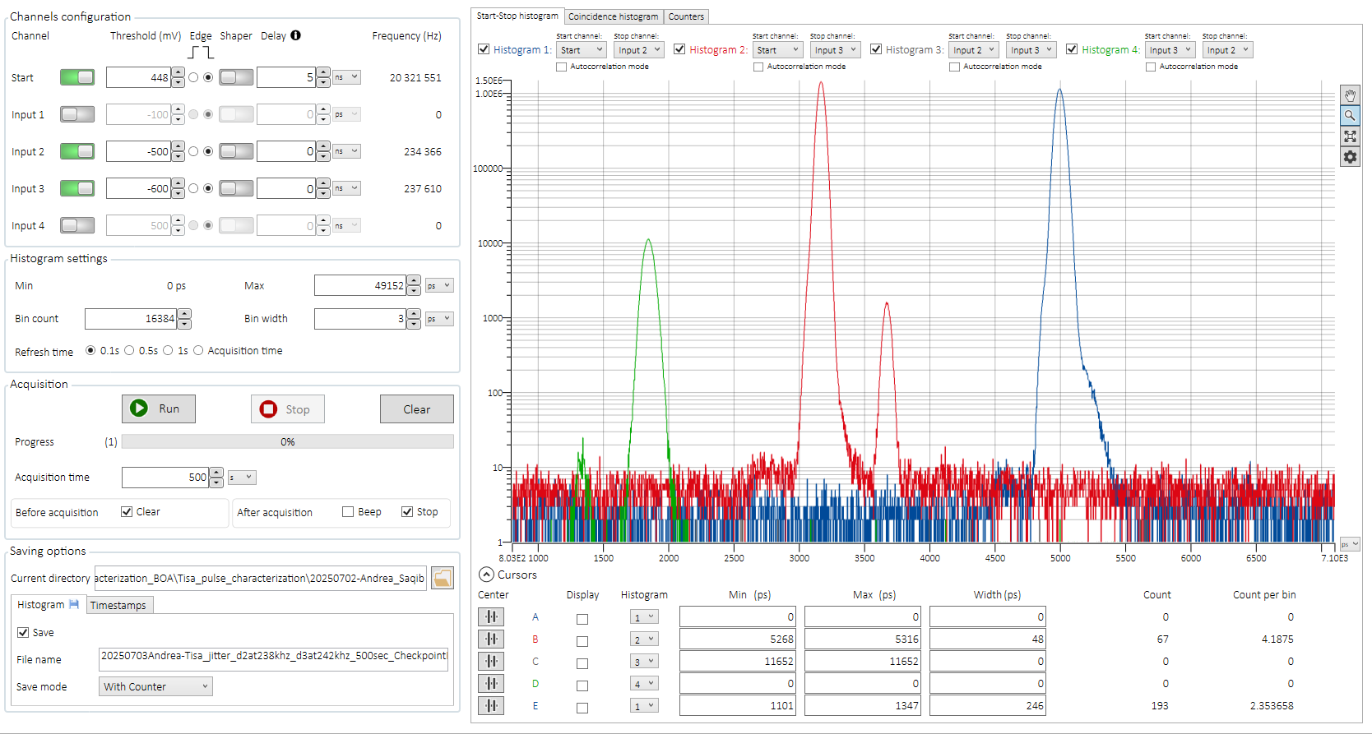

For instance for all these measurements of today I had this spectrum : (Also being saved in the current folder !)

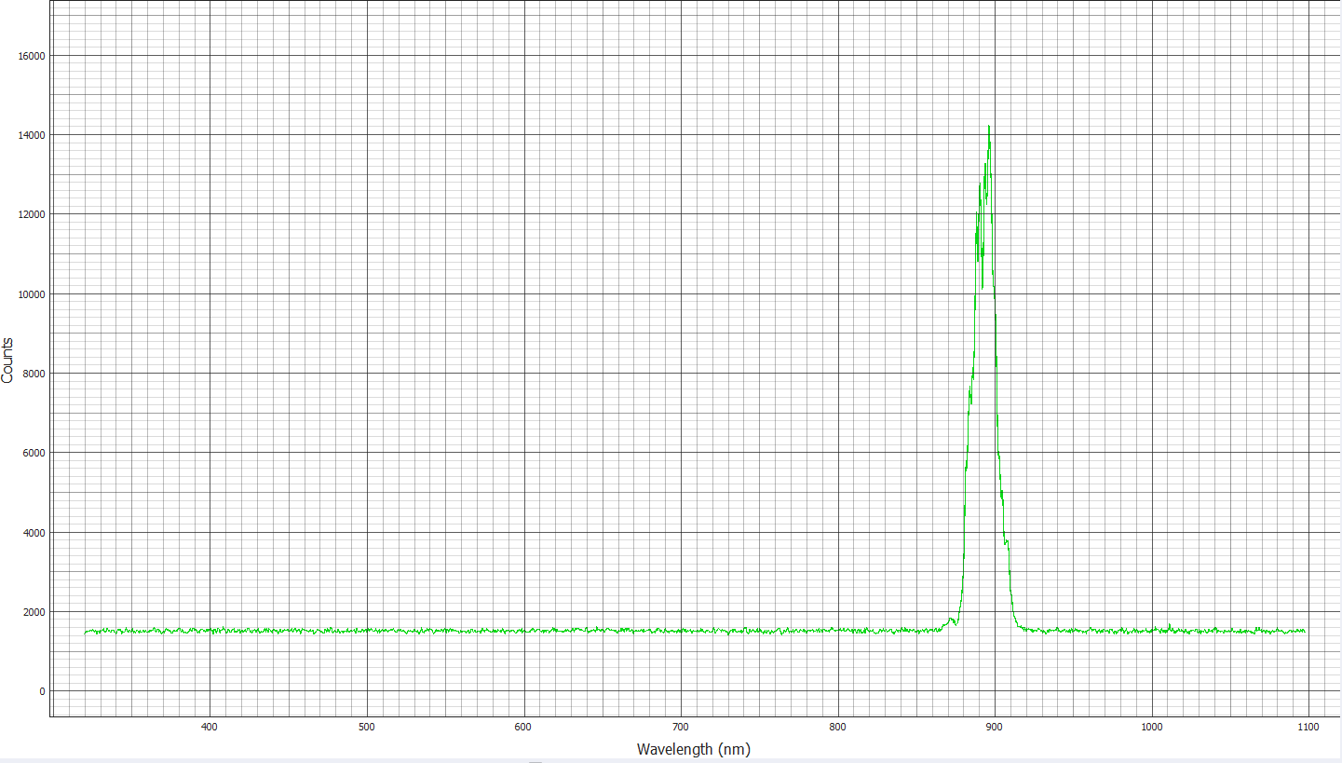

I Now proceed to take the final set of measures, before leaving the lab !!!

This final measure will be taken with **84kHz** approx. on both detectors !

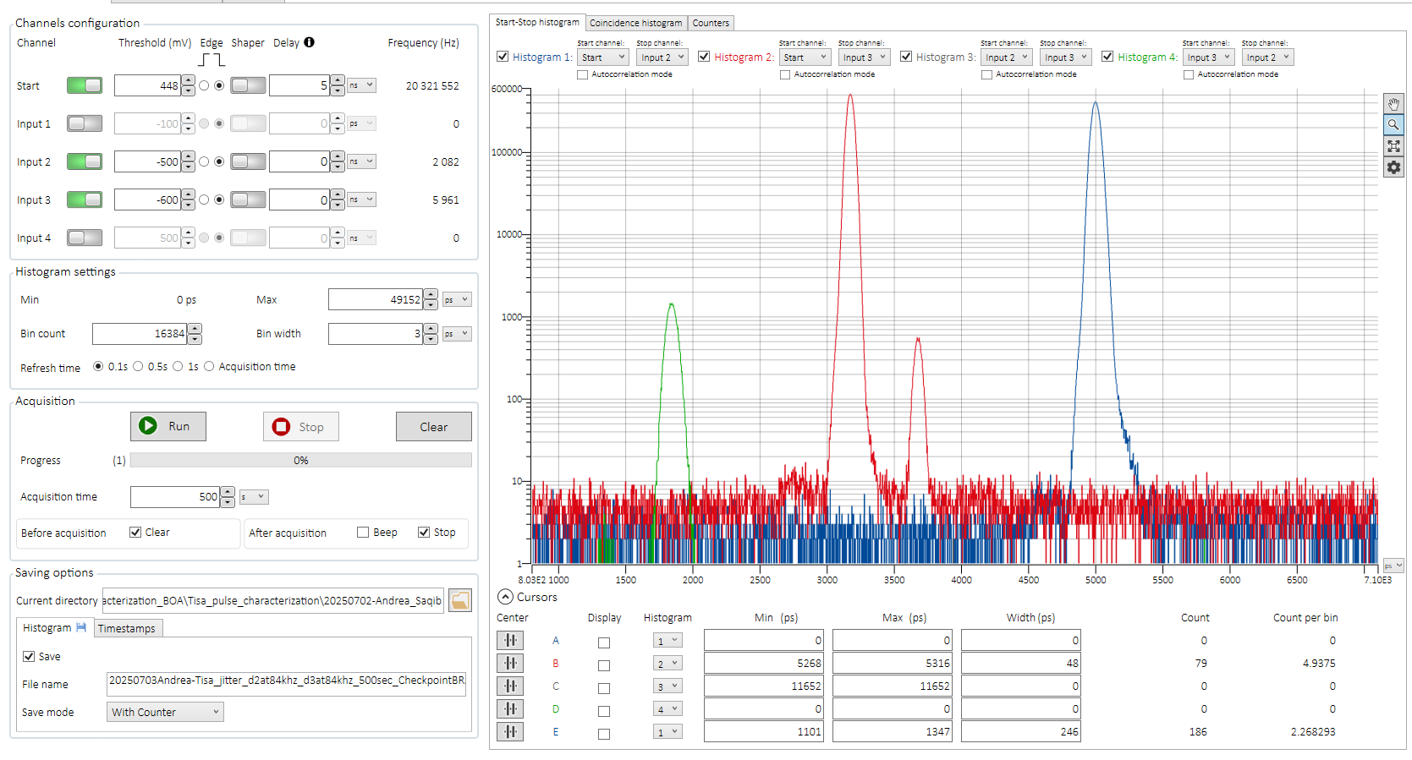

At the END I did acquire with ***Checkpoint “Bravo”*** thresholds settings and the fibers in the positions in which the counts are similar measurements with these count rates **{84kHz, 150kHz, 242kHz}**

**Finally on 20250703@18:28 I proceed to TURN OFF THE LASER BY TURNING THE KEY** (After of course having closed the laser with the powermeter **wearing the glasses**)