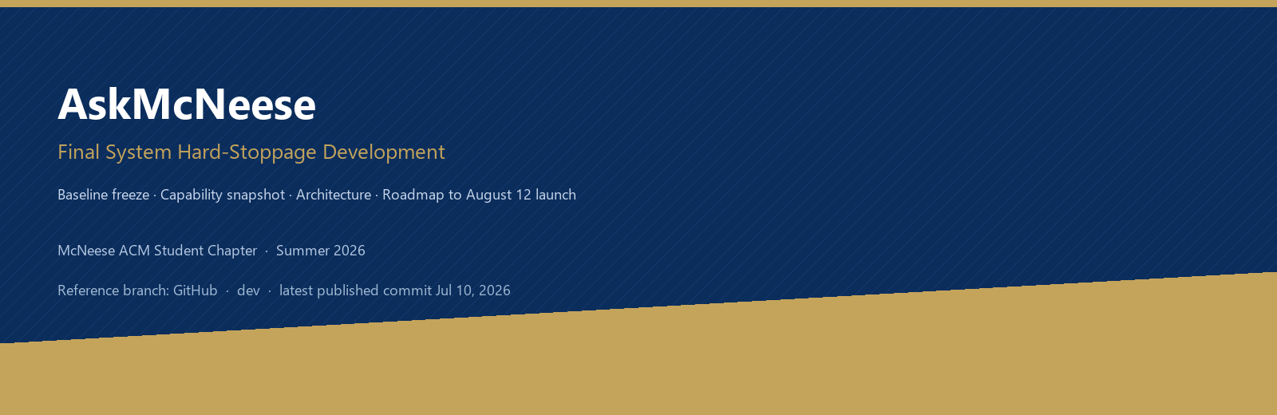
Document type: System freeze & roadmap brief for leadership / ACM / builders
Hard stoppage meaning (in everyday words)
This is the point where we say: “Here is what AskMcNeese already is,” freeze that picture for stakeholders, and clearly list what we still must build before and after the August 12 first launch. It is not a claim that coding stops forever — it is a clean baseline for the next chapter.

A. What AskMcNeese is today (GitHub · dev)
The latest commit published on the GitHub repository’s dev branch (as of this hard-stoppage snapshot) is from July 10, 2026. That published baseline is a working public campus Q&A prototype — not a full student portal yet.
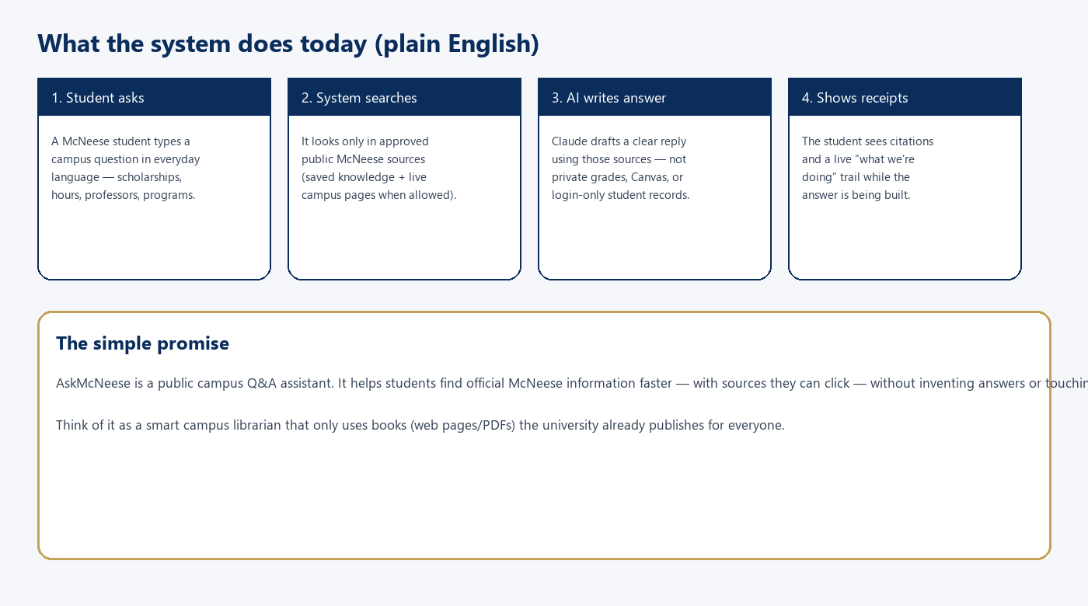
A1. One-paragraph product summary
AskMcNeese is a campus AI chat helper for McNeese State University, built with the McNeese ACM Student Chapter. A student asks a normal question — scholarships, admissions, a professor, campus services — and the system looks through approved public McNeese web pages and documents, then uses Claude to write a clear answer with clickable sources. There is no student login in this baseline. Chat history stays in the browser. Private systems like Canvas grades or personal records are intentionally out of reach.
A2. What already works on that published baseline
- Public assistant: Chat UI where students ask questions and read answers.
- Knowledge pipeline: Offline crawler that fetches approved pages/PDFs into a local knowledge store (ChromaDB).
- Ask API: FastAPI backend that retrieves relevant pieces and asks Claude to answer with citations.
- Source control: Approved URL registry so answers stay grounded in public McNeese information.
- Live web mode: Optional live mcneese.edu fetching in addition to the saved knowledge base.
- Ops basics: Health/status checks and basic query logging for operators.
A3. What that baseline deliberately does not include
- No university SSO / student accounts.
- No Canvas / private course data.
- No ACM member dashboards or class schedule product.
- No production hardening claim (CORS, hosting, analytics still open items).
B. What we built after the latest GitHub commit
After the July 10 published commit, the team continued substantial work locally on the same dev line. This hard-stoppage brief treats that work as “completed / in hand” for planning, even where it is still awaiting a clean push to GitHub.
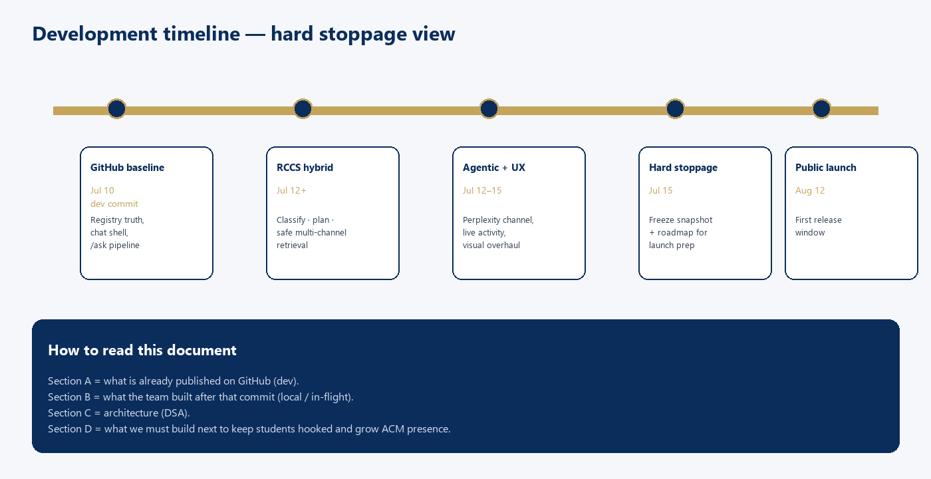
B1. Smarter retrieval: RCCS hybrid
We added a Retrieval Control & Channel Selection (RCCS) layer. In plain terms: the system first figures out what kind of question you asked, then chooses the right mix of places to look — saved campus knowledge, live official McNeese pages, and carefully gated companion sites (for example professor rating sources). It is selective and allowlist-safe, not “search the whole internet.”
B2. Agentic mode (Perplexity)
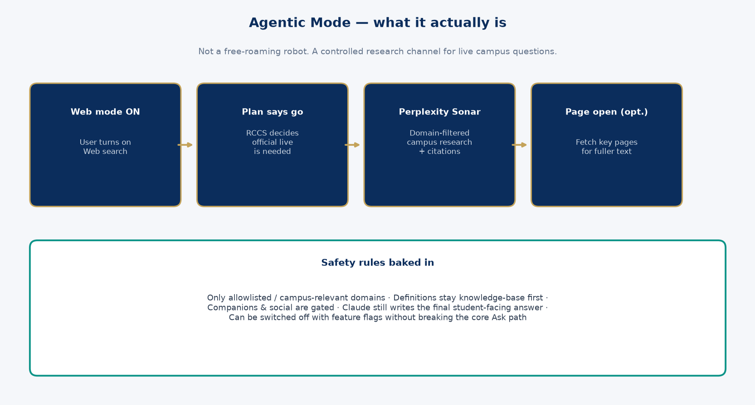
Agentic mode is a controlled research helper. When web search is on and the plan needs fresh official information, Perplexity Sonar Pro can research across campus-relevant domains, return citations, and optionally open key pages for fuller text. Claude still writes the final student answer. Flags can turn this channel off without breaking core Ask.
B3. Trust, activity, and answer quality
- Activity events: Live “what we’re doing” trail (searching, found sources, writing) over SSE.
- Structured answers: Clearer sectioned answers (facts, steps, warnings) when the model can extract them.
- Citation integrity: Stronger citation validation against allowlists; prompt-injection hardening.
- Capability answers: Honest replies when someone asks what the assistant can or cannot search.
- Supervisor (optional): Optional supervisor orchestration path (default off) for deeper plan→execute flows.
B4. Product surface & visual system
- Major chat UI overhaul — glass shell, premium motion, mobile nav, composer docking.
- System status, settings, and feedback panels.
- About / team command-chain and related ACM-facing content pages.
- Design system docs, visual validation records, and frontend test coverage growth.
B5. Engineering hygiene
- Large unit/test suite growth around RCCS, activity events, structured answers, and UI wiring.
- Design records and implementation reports for auditability (RCCS, core stabilization, motion).
- Companion source registry governance separate from official campus sources.
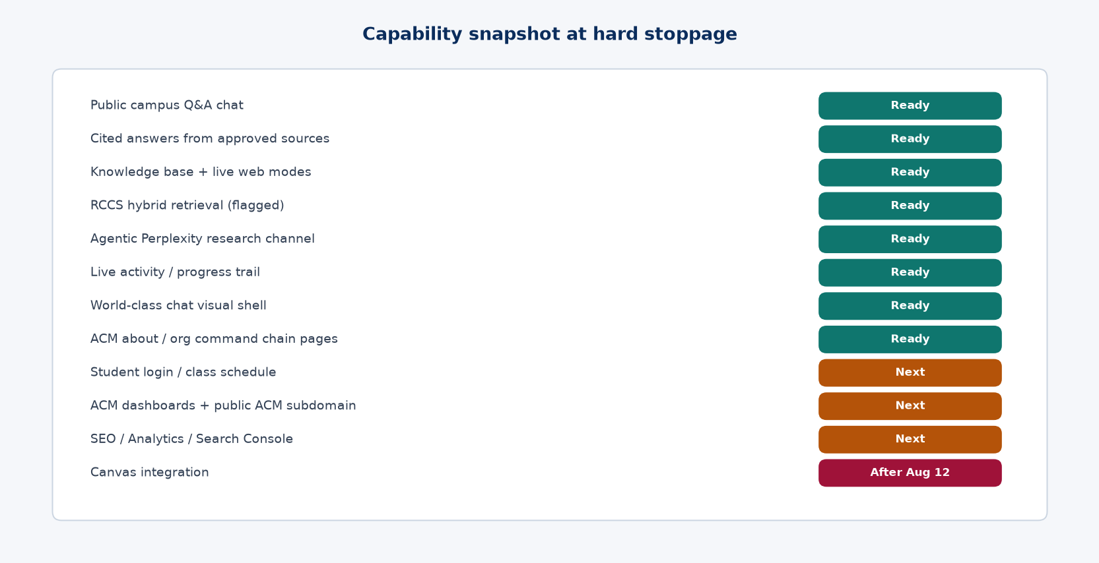
C. DSA — Data & System Architecture
DSA here means the program’s data and system architecture: the moving parts, who writes what, and how a student question becomes a cited answer. The diagram below is the hard-stoppage picture of the stack.
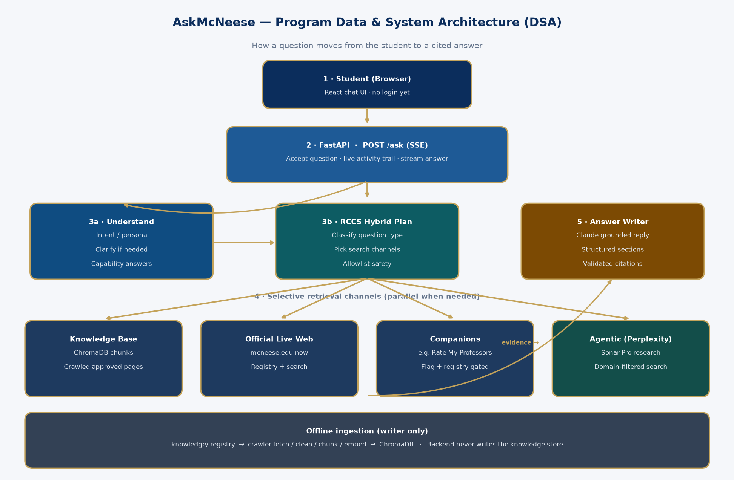
C1. Layers in plain language
Layer | Job | Everyday analogy
Frontend | Chat screen students use | The front desk
API (/ask) | Takes the question, streams progress + answer | The dispatcher
RCCS + retrieval | Decides where to look and gathers evidence | The research desk
LLM (Claude) | Writes the student-facing answer from evidence | The librarian writing a brief
Knowledge + crawler | Offline: approved pages → searchable chunks | The library stacks

C2. End-to-end question flow
- 1. Student types a question in the chat.
- 2. Frontend sends it to POST /ask (streaming).
- 3. Backend may clarify, detect persona, or answer capability questions.
- 4. If RCCS is on: classify → plan → run selective channels in parallel.
- 5. Evidence is cleaned, ranked, trust-separated, and citation-checked.
- 6. Claude writes the answer; frontend shows markdown, citations, and activity trail.
- 7. Conversation can stay in the browser (localStorage) — no server account yet.
C3. Non-negotiable safety idea
Approved public sources only
The crawler is the only writer to the knowledge store. The backend reads at ask-time. Live and agentic channels still pass through allowlists / domain filters. Private student systems stay out until a later, deliberate integration (Canvas after August 12).

C4. Mermaid source (for engineering wikis)
The visual above is the stakeholder view. Engineers can paste the following Mermaid into GitHub or Notion:
flowchart TD
U[Student question] --> FE[React chat UI]
FE --> API[FastAPI POST /ask SSE]
API --> UND[Understand: intent / persona / clarify]
UND --> RCCS[RCCS classify + plan]
RCCS --> KB[Knowledge Base Chroma]
RCCS --> LIVE[Official live McNeese]
RCCS --> COMP[Companions gated]
RCCS --> AG[Agentic Perplexity]
KB --> EV[Evidence merge + rank]
LIVE --> EV
COMP --> EV
AG --> EV
EV --> LLM[Claude grounded answer]
LLM --> FE2[Citations + activity trail]
REG[knowledge registry] --> CR[Crawler offline]
CR --> KB
D. What we still have to work on
These are the intentional next products after hard stoppage. They are chosen to keep students inside the McNeese ecosystem, grow ACM’s real operating surface, and measure whether people can find and use us.
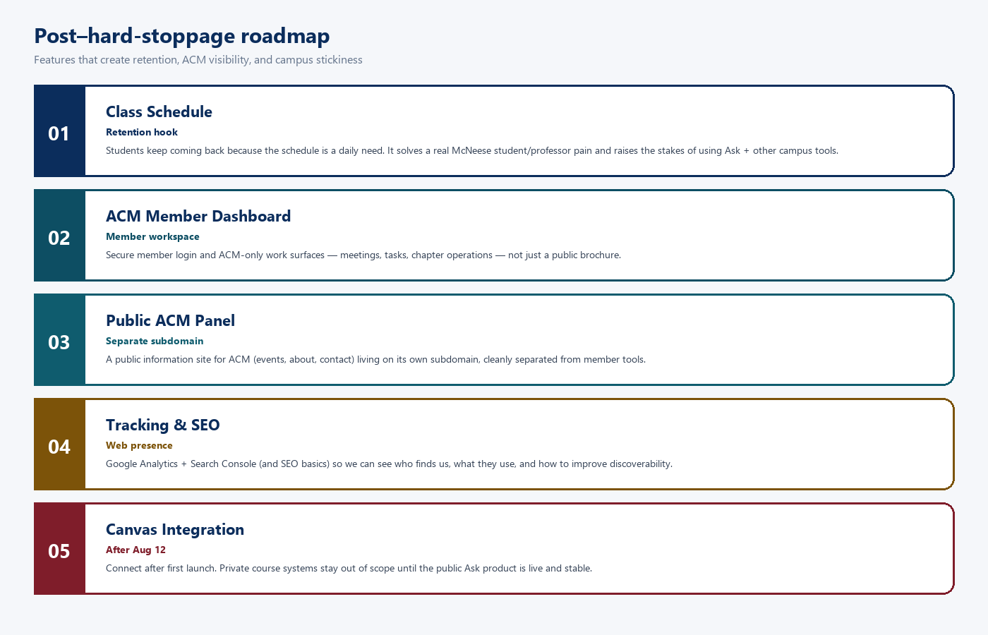
D1. Class schedule — retention hook
A class schedule feature is not a nice-to-have. It is the daily habit that keeps students returning. When AskMcNeese helps with “What’s my week look like?” / section times / professor-linked schedule needs, students stay in our McNeese ecosystem instead of bouncing to random tools. That higher daily use raises the stakes of discovering Ask, ACM, and other campus features. It should genuinely solve a McNeese student or professor problem — not feel like a gimmick.
D2. ACM dashboards — member work
ACM needs an internal dashboard with member login and member-only work: chapter operations, explicit ACM tasks, and the tools members actually use. This is separate from the public Ask chat.
D3. Public ACM panel — different subdomain
There should also be a public ACM information panel (about the chapter, events, how to join) living on its own subdomain. Public marketing/info and authenticated member work must not be mashed into one muddy screen. Subdomains make the separation obvious for students and for SEO.
D4. Tracking & monitoring — SEO + analytics
After we ship something people can visit, we must measure it. Plan: search-engine basics (SEO), Google Analytics for usage behavior, and Google Search Console for search presence and indexing health. Without this, we cannot tell if AskMcNeese or ACM pages are discoverable or useful in the wild.
D5. Canvas integration — after August 12
Canvas touches private course space. We intentionally sequence it after the first launch window (August 12). Launch the public, source-grounded Ask experience first; integrate Canvas only when the product, trust model, and access controls are ready.
D6. Priority table
Priority | Workstream | Why it matters | Timing
P0 | Class schedule | Daily retention / ecosystem hook | Post hard-stop → launch prep
P0 | ACM dashboards | Member login + real chapter work | Parallel with schedule
P1 | Public ACM panel | Separate subdomain for ACM info | With ACM surface work
P1 | SEO + Analytics + GSC | Know usage & web presence | At/after public deploy
P2 | Canvas integration | Private course systems | After Aug 12 launch

E. Hard-stoppage decision & next actions
Freeze statement
As of July 15, 2026, AskMcNeese is declared at hard-stoppage for planning: a cited public campus Q&A system with hybrid retrieval and agentic research capability in hand, plus a modern chat product surface. The next development chapter is retention (class schedule), ACM dual surfaces (member + public subdomain), measurement (SEO/analytics), then Canvas after the August 12 first launch.

Immediate recommended actions
- Publish the post–Jul-10 local stack to GitHub when review-ready (RCCS, agentic, UI).
- Lock August 12 launch scope: public Ask + measurement; schedule/ACM can stage behind flags.
- Start class-schedule discovery with students/professors (what pain is highest-stakes?).
- Draft ACM subdomain + auth boundary (public panel vs member dashboard).
- Prepare Analytics + Search Console property checklist before public DNS goes live.
- Keep Canvas explicitly parked until after first launch.
Document control
Title | AskMcNeese Final System Hard-Stoppage Development
Baseline reference | GitHub McNeeseACMChapter/askmcneese · branch dev · commit 11e81ca (Jul 10, 2026)
In-hand advances | RCCS hybrid, Perplexity agentic, activity SSE, visual overhaul, ACM about surfaces, tests/docs
Audience | ACM leadership, project advisor, PM, builders
Date | July 15, 2026

— End of hard-stoppage brief —

