**Code 1:**

def reverse_string(s):

reversed = ""

for i in range(len(s) - 1, -1, -1):

reversed += s[i]

return reversed

def main():

input_string = "Hello, world!"

reversed_string = reverse_string(input_string)

print(f"Reversed string: {reversed_string}")

if __name__ == "__main__":

main()

**Output:**

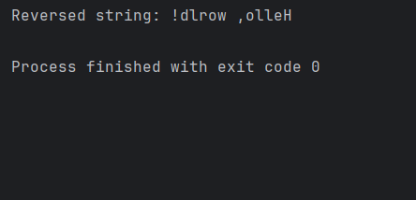

**Code 2:**

def get_age():  
 age = input("Please enter your age: ")

**#converted age from string to integer**  
 if age.isnumeric() and int(age) >= 18:   
 return int(age)  
 else:  
 return None  
def main():  
 age = get_age()  
 if age:  
 print(f"You are {age} years old and eligible.")  
 else:  
 print("Invalid input. You must be at least 18 years old.")  
if __name__ == "__main__":  
 main()

**Output:** 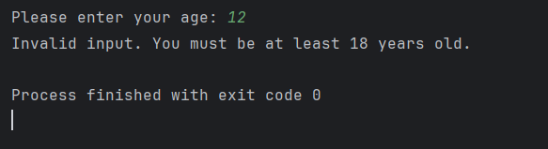

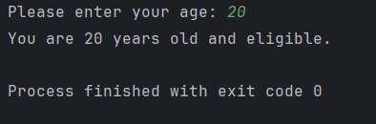

**Code 3:**

def read_and_write_file(filename):  
 try:  
 with open(filename, 'r') as file:  
 content = file.read()  
 with open(filename, 'w') as file:  
 file.write(content.upper())  
 print(f"File '{filename}' processed successfully.")  
 except Exception as e:  
 print(f"An error occurred: {str(e)}")  
def main():  
 filename = "sample.txt"  
 read_and_write_file(filename)  
if __name__ == "__main__":  
 main()

**output:**

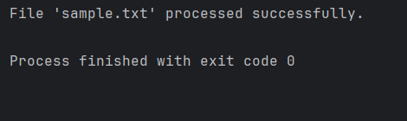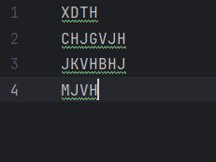

**Code 4:**

def merge_sort(arr):  
 if len(arr) <= 1:  
 return arr  
 mid = len(arr) // 2  
 left = arr[:mid]  
 right = arr[mid:]  
 merge_sort(left)  
 merge_sort(right)  
 i = j = k = 0  
 while i < len(left) and j < len(right):  
 if left[i] < right[j]:  
 arr[k] = left[i]  
 i += 1  
 else:  
 arr[k] = right[j]  
 j += 1  
 k += 1  
 while i < len(left):  
 arr[k] = left[i]  
 i += 1  
 k += 1  
 while j < len(right):  
 arr[k] = right[j]  
 j += 1  
 k += 1

**# added a return statement**  
 return arr   
arr = [38, 27, 43, 3, 9, 82, 10]  
merge_sort(arr)  
print(f"The sorted array is: {arr}")

**Output:**

