hiro_jiren

NA

Author: NA

Revision: 0.1

|  |  |
| --- | --- |
| NA |  |
| NA | Date: May 20, 2019 |

**Revision History**

|  |  |  |  |
| --- | --- | --- | --- |
| **Revision** | **Date** | **Reason For Changes** | **Author** |
| 1.0 | NA | NA | NA |
| 0.1 | NA | NA | NA |
|  |  |  |  |

**Table of Contents**

Microsoft Word users please click here and press F9 to create Table of Contents.

OpenOffice.org users please remove this text and select Insert Table of Content from menu.

**Table of Figures**

Microsoft Word users please click here and press F9 to create Table of Contents.

OpenOffice.org users please remove this text and select Insert Table of Content from menu.

**Executive Summary**

This section previews the main points of a report. The executive summary contains enough information for a reader to get familiarized with what is discussed in the full report without having to read it.

# Introduction

## Purpose

<This document provides requirements with their properties including requirement id, requirement name, requirement text and the dependencies.>

## Scope

<Provide a short description of the system being specified and its purpose, including relevant benefits, objectives, and goals.>

## Overview

<Describe what the document contains and explain how the document is organized>

# Requirements

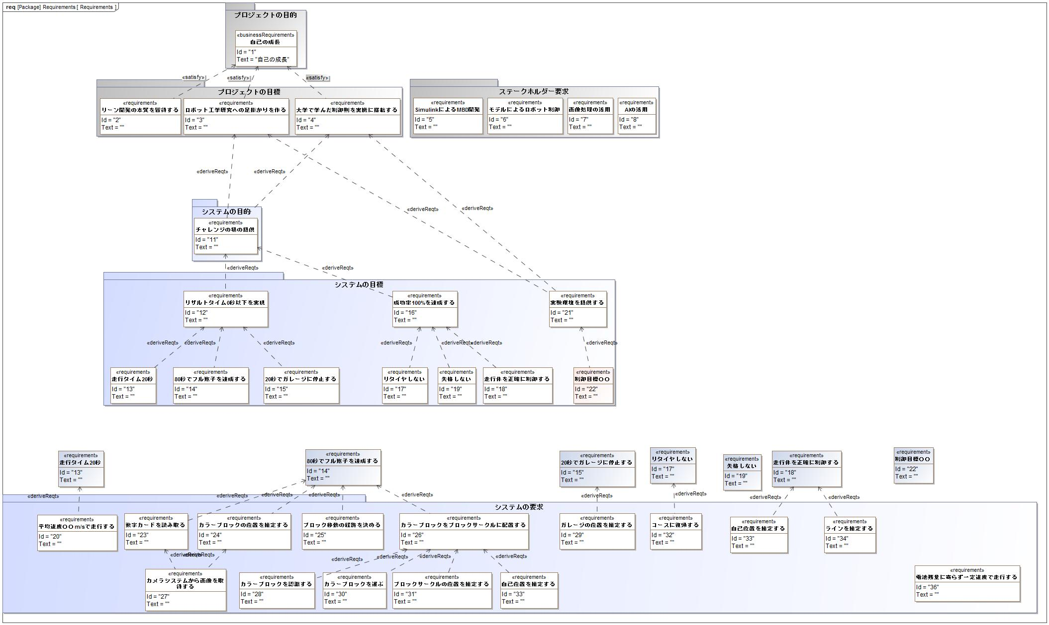

1. Requirements

List of Requirement