Model Comparison Tool

A parser for model comparison trees

Creator/Developer: Monika Jaskolka

# Introduction

Differencing between two models is natively supported in Simulink via the [Simulink Comparison tool](https://www.mathworks.com/help/matlab/matlab_env/compare-xml-files.html). This tool relies on XML comparison techniques to generate a Word or HTML report displaying the changes that occur between models. Unfortunately, for large industrial models, these generated reports are not readable. As an alternative, the comparison tool can output the comparison results to the MATLAB base workspace as an xmlcomp.Edits object that is structured as a tree. An example of this object’s structure can be seen in Figure 1.

Unfortunately, MathWorks provides no built-in commands to be able to easily query or parse this tree from the command line. In order to do so, the Model Comparison tool was created. Some useful commands provided by this tool are:

* find_node - Search comparison tree for nodes with specific block types, changes, etc.
* summaryOfChanges - Print a summary report to the command window of the changes in the comparison tree.
* getHandle - Get the handle of the model element associated with the node from the comparison tree.
* printChildren - Print to the command window the names of all children of the node.

Many other commands are included but are not listed here.

Added

Modified (Property)

Deleted

Renamed

*After*

*(right-subtree)*

*Before*

*(left sub-tree)*

Figure 1 Example xmlcomp.Edits object as returned by the Simulink Comparison tool

# How to Perform a Comparison

To create an xmlcomp.Edits object at the command line without opening the Comparison Tool, enter:

Edits = slxmlcomp.compare(*modelname_A*, *modelname_B*)

Two example models, test1_orig.slx and test1_diff.slx, are provided.

Edits = slxmlcomp.compare(test1_orig.slx, test1_diff.slx)

The xmlcomp.Edits object is a root node that links to two n-ary sub-trees (in blue in Figure 1) of differences between two models. The nodes in blue correspond to actual elements in the Simulink models.

# About xmlcomp.Edits Objects

An xmlcomp.Edits object contains information about the comparison, including file names, filters applied, and most importantly, the **hierarchical nodes that differ between the two models**. This hierarchy is shown in Figure 1. An Edits object has the fields: Filters, LeftFileName, LeftRoot, RightFileName, RightRoot, TimeSaved, Version. See Figure 2 for more details. The LeftRoot and RightRoot link to the xmlcomp.Node objects that make up each sub-tree representing each model.

# About xmlcomp.Node Objects

Each element that is an xmlcomp.Node represents a block, line, annotation, port, mask, etc. from the Simulink model that has been changed. Simulink model elements which have not been changes are not included in the tree, unless they are a subsystem block that is needed to preserve the hierarchy (e.g. Subsystem1 and Subsystem2 in Figure 1).

A Node object has the fields: Children, Edited, Name, Parameters, Parent, Partner. See Figure 2 for more details.

* Note that the “Edited” field is only set when the node itself is different in the tree hierarchy (deleted, added, moved). It is not set when a node property (block parameter) is changed. Do not rely on this as an accurate indicator of change in the model.

The placement in the tree is important for understanding how the element has changed.

|  |  |
| --- | --- |
| Change Type | How it is represented in the tree |
| Added | Node exists in the right sub-tree, but not the left |
| Deleted | Node exists in the left sub-tree, but not the right |
| Modified | Node exists in the left and right sub-trees, and it is partnered |
| Renamed | Node exists in the left and right sub-trees, and it is not partnered |

It is important to look at the whole Edits object to understand the changes. By only looking at the left sub-tree, a node that exists in the left sub-tree can be either deleted or renamed (but definitely not added or modified). By only looking at the right-subtree, a node that exists in the right-subtree can be added or modified (but definitely not deleted).

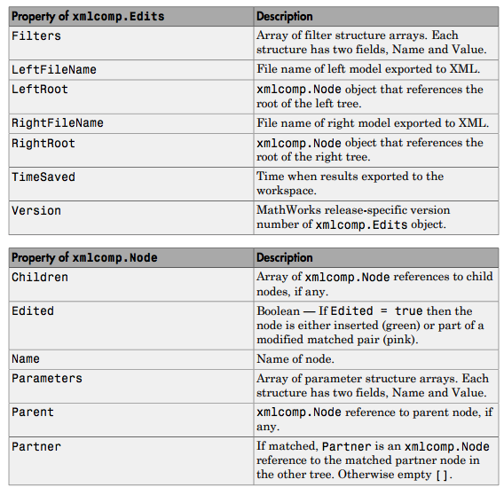

Figure 2 Properties of comparison objects