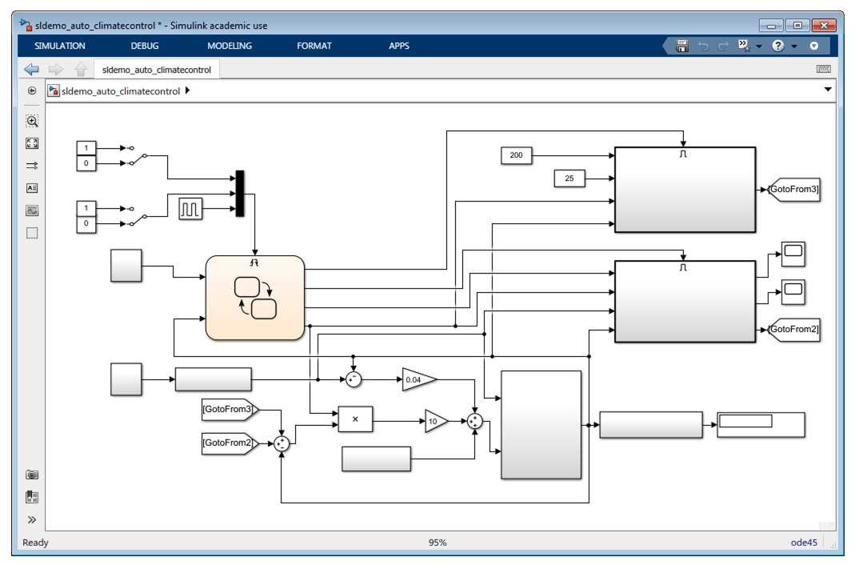

Removed Mask

Renamed Goto/From Tag

Removed Annotation

Hidden Port Labels

Hidden Block Names

Removed Color